SIMATS ENGINEERING
ASSESSMENT TOOL 2: INDUSTRY PROBLEM SOLVING TASK
Course Name | Cloud Computing and Big Data Analytics
Course Code | CSA1513
Course Outcome | CO4: Analyze big data characteristics and challenges across domains including security and application aspects. (BL4)
Duration | 60 Minutes
Total Marks | 40 (5 Questions x 8 Marks)

Question 1 — Retail Data Optimization Problem
A retail chain spanning physical stores and an online platform needs real-time inventory tracking, demand forecasting, and personalized marketing. The solution below outlines a unified big data architecture combining streaming and batch pipelines with ML-driven analytics.

Understanding the Industry Context
Omnichannel retail generates three distinct but related data types: transactional (POS/online sales), operational (inventory/warehouse), and behavioral (browsing, loyalty). The business goals — live stock visibility, accurate forecasting, and 1:1 personalization — require both low-latency processing and deep historical analysis, so a hybrid (Lambda-style) architecture is appropriate.

Proposed Architecture & Tools
- Ingestion: Apache Kafka captures real-time POS transactions and online clickstream events; Apache Sqoop or NiFi handles scheduled batch extraction from ERP/warehouse management systems.
- Storage: A data lake (HDFS or Amazon S3) retains raw historical data cost-effectively; Apache Cassandra provides a low-latency, high-write-throughput store for live inventory counts; a NoSQL store (MongoDB) holds flexible customer profiles.
- Processing: Spark Streaming continuously recalculates stock levels per SKU/store as sales occur; Spark MLlib or a specialized library such as Prophet handles time-series demand forecasting using seasonal and promotional patterns.
- Personalization: A collaborative-filtering or hybrid recommendation model, trained on purchase and browsing history, drives targeted marketing pushed via CRM/email/app channels.
- Serving: Power BI/Tableau dashboards connect to the warehouse layer for inventory and sales visibility; the recommendation service is exposed via an API to the marketing and app teams.

Analytics Models
- Time-series forecasting (ARIMA/Prophet or LSTM) for demand prediction per SKU and location.
- Collaborative filtering / market-basket analysis (association rule mining) for cross-sell recommendations.
- Real-time aggregation (streaming SQL) for live stock-out alerts and reorder triggers.

Security & Risk Considerations
- Encrypt customer PII (payment details, addresses) both at rest and in transit.
- Apply role-based access so store staff, marketing, and analytics teams only see relevant data slices.
- Build resilience against data pipeline failure (e.g., Kafka consumer lag) so stockout alerts aren't delayed.
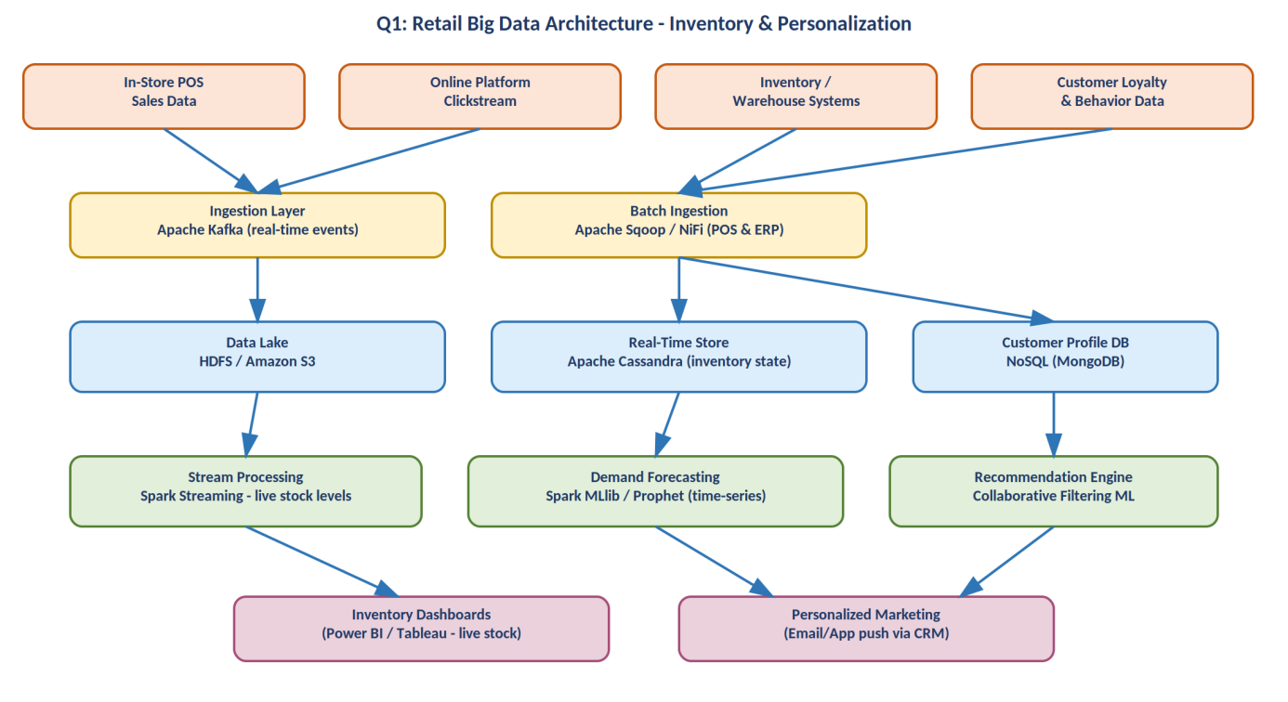
Figure 1: Proposed retail big data architecture for real-time inventory and personalization.

Question 2 — Social Media Fraud & Misinformation Detection
A social media platform processing billions of daily interactions needs to detect fake accounts and misinformation in near real time. This requires a scalable stream-first architecture with ML models embedded directly in the processing path.

Understanding the Industry Context
At this scale, batch-only detection is too slow — fake accounts and viral misinformation can cause damage within minutes. The solution must therefore process interaction events (posts, comments, likes, shares) as a continuous stream, scoring accounts and content as events arrive, while still retaining historical data for model retraining and investigation.

Proposed Architecture & Tools
- Ingestion: Apache Kafka absorbs the full event firehose across data centers, partitioned by user/account ID for ordered, parallel consumption.
- Stream Processing: Apache Flink (or Spark Streaming) computes rolling behavioral features — posting frequency, account age, interaction velocity — feeding them into ML models with sub-second latency.
- Feature & Graph Stores: A Redis feature store serves low-latency lookups; a graph database (Neo4j) models account relationships, since fake-account rings and coordinated inauthentic behavior show up as unusual graph structures (e.g., dense clusters, shared devices).
- Archival: A data lake (HDFS/S3) retains the full raw event history for offline model training and audits.

Role of Machine Learning & Stream Processing
- Fake-account classification: A supervised model (Random Forest or a Graph Neural Network operating on the relationship graph) scores new/existing accounts using behavioral and network features.
- Misinformation detection: An NLP classifier (transformer-based, e.g., BERT fine-tuned for claim detection) flags posts matching known misinformation patterns or spreading unusually fast relative to source credibility.
- Anomaly detection: Unsupervised techniques (Isolation Forest, clustering) catch novel fraud patterns that supervised models haven't seen yet.
Stream processing is what makes this actionable: features and scores must be computed continuously so suspicious accounts/posts can be throttled or queued for review before they reach a large audience.

Security & Risk Considerations
- False positives risk suspending genuine users — a human-in-the-loop review queue (Trust & Safety dashboard) mitigates this rather than fully automated bans.
- Adversarial actors adapt quickly, so models need continuous retraining and monitoring for drift.
- User privacy must be protected even while analyzing behavioral graphs — access to raw identifiers should be restricted to the fraud/safety team.
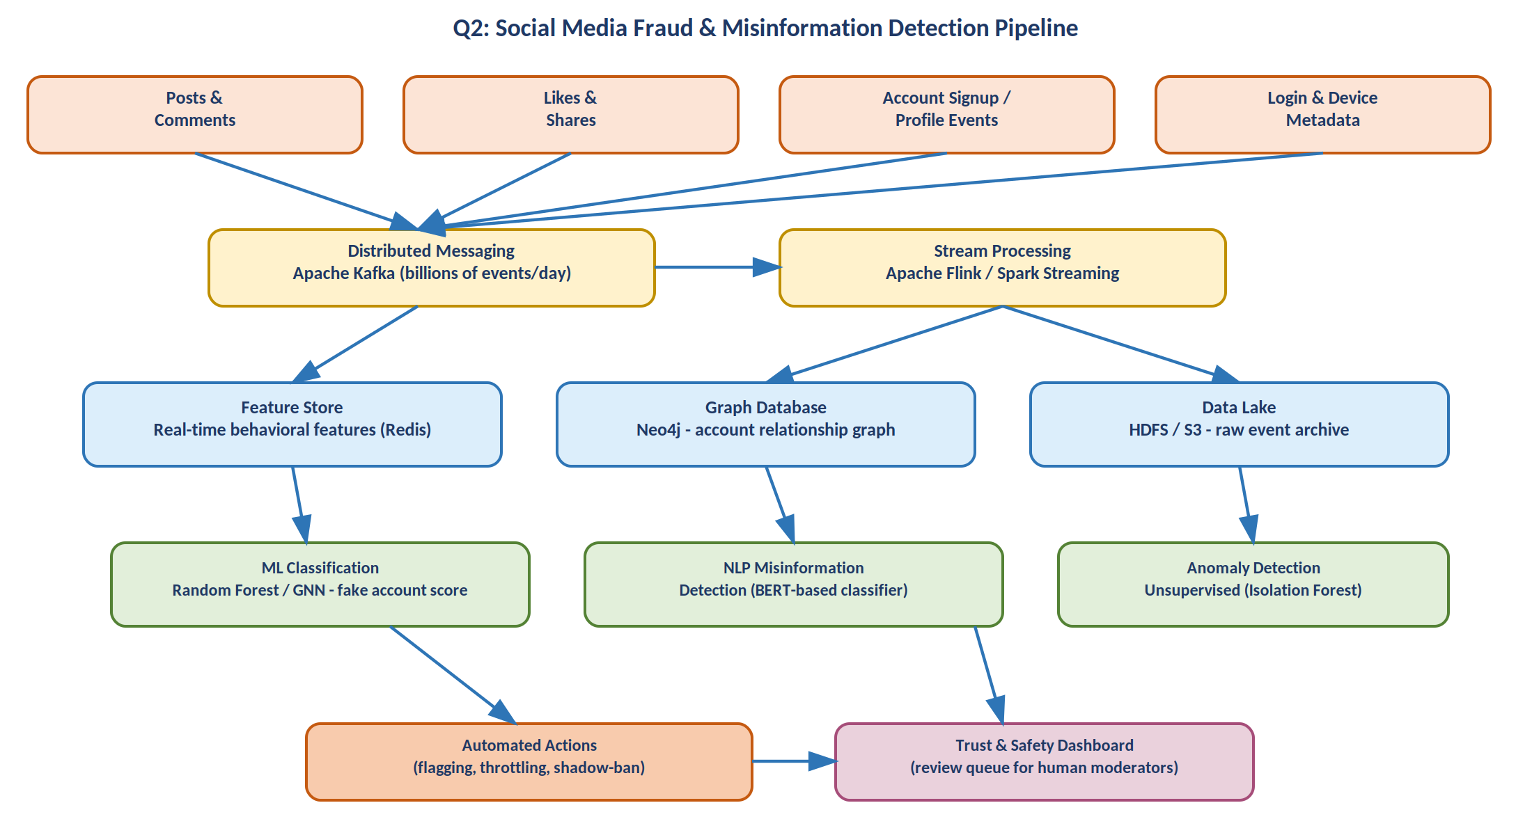
Figure 2: Proposed real-time fraud and misinformation detection pipeline.

Question 3 — Government Data Platform Problem
A national data platform integrating census, economic, and geospatial datasets across departments demands a governance-first design, since interoperability and strict privacy/security requirements are the primary constraints — not raw processing speed.

Understanding the Industry Context
Unlike commercial systems, a government data platform must balance broad interoperability (many departments, many legacy systems) against strict data-protection obligations and public accountability. Data ownership typically stays with originating departments even as data is shared centrally, so governance and access control are the central design concern.

Proposed Architecture & Governance Strategy
- Data Integration: An ETL/API gateway layer standardizes formats from each department's source systems into common schemas before they enter the shared platform.
- Interoperability: Open standards (e.g., OGC/GeoJSON for geospatial data, common statistical classification codes for census/economic data) ensure datasets from different agencies can be joined meaningfully.
- Central Storage: A government-cloud-hosted data lake (HDFS or a sovereign cloud equivalent) holds integrated data, with a dedicated geospatial store (PostGIS) for location-based datasets.
- Metadata & Governance Registry: A data catalog records data lineage, ownership, sensitivity classification, and usage policies for every dataset — the backbone of accountable governance.

Privacy & Security Strategy
- Role-Based and Attribute-Based Access Control (RBAC/ABAC) so each department/user only accesses data authorized for their role and purpose.
- Differential privacy or k-anonymity techniques applied before releasing aggregated statistics publicly, protecting individual citizen identities.
- Comprehensive audit logging of every access and query, supporting transparency and regulatory compliance.
- Data minimization — only the fields needed for a specific inter-agency use case are shared, rather than full raw datasets.

Shared Analytics & Access Model
A shared analytics layer sits above the governed data, allowing authorized cross-department queries without departments losing control of their source data (a 'data mesh'-like federated approach). Public-facing dashboards or an open-data portal expose only the anonymized, approved subset of insights to citizens and researchers.
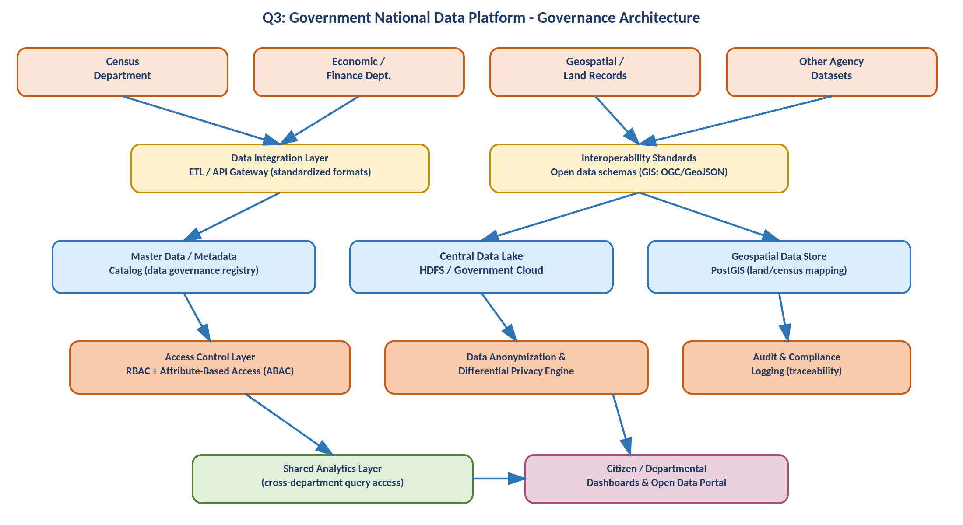
Figure 3: Proposed governance-centric architecture for the national data platform.

Question 4 — Banking Fraud Detection Problem
A bank processing millions of transactions per minute needs real-time fraud detection with low latency and high accuracy, combining streaming inference with historical model training.

Understanding the Industry Context
Banking fraud detection has an unusually strict latency budget — a transaction must typically be scored in well under a second, at the point of authorization, without introducing friction for legitimate customers. This rules out purely batch approaches and requires a streaming-first pipeline with a pre-trained model deployed for real-time inference.

Proposed Big Data Pipeline
- Ingestion: Apache Kafka ingests card, UPI, ATM, and online-banking transaction events at high throughput, while a parallel batch loader (Spark) brings in historical transaction archives for model training.
- Stream Processing: Apache Flink computes real-time features (transaction velocity, location-change speed, deviation from spending pattern) and feeds them to the scoring model with minimal latency.
- Feature Store: A Redis in-memory store serves recent customer behavioral features instantly so the model isn't waiting on slow database reads during scoring.
- ML Scoring: A gradient-boosted model (XGBoost) or Random Forest, trained offline on the historical warehouse data and periodically retrained, scores each transaction in real time; more complex cases may route to a secondary deep-learning model.

Algorithms & Technologies
- XGBoost / Random Forest for supervised fraud scoring using labeled historical fraud cases.
- Autoencoders or Isolation Forest for unsupervised anomaly detection catching novel fraud patterns.
- Rule-based guardrails (e.g., hard transaction limits) running alongside ML scores as a safety net.

Handling Latency & Accuracy Trade-offs
A two-stage design is common: an ultra-fast rule/lightweight-model layer makes an initial pass within milliseconds, escalating only ambiguous cases to a heavier model or human analyst via a case-management system — balancing speed against detection accuracy.

Security & Risk Considerations
- End-to-end encryption of transaction data and strict key management given regulatory (PCI-DSS) obligations.
- Model explainability (e.g., SHAP values) is important so flagged transactions can be justified to regulators and customers.
- A human review/appeals process avoids over-blocking legitimate high-value transactions, protecting customer trust.
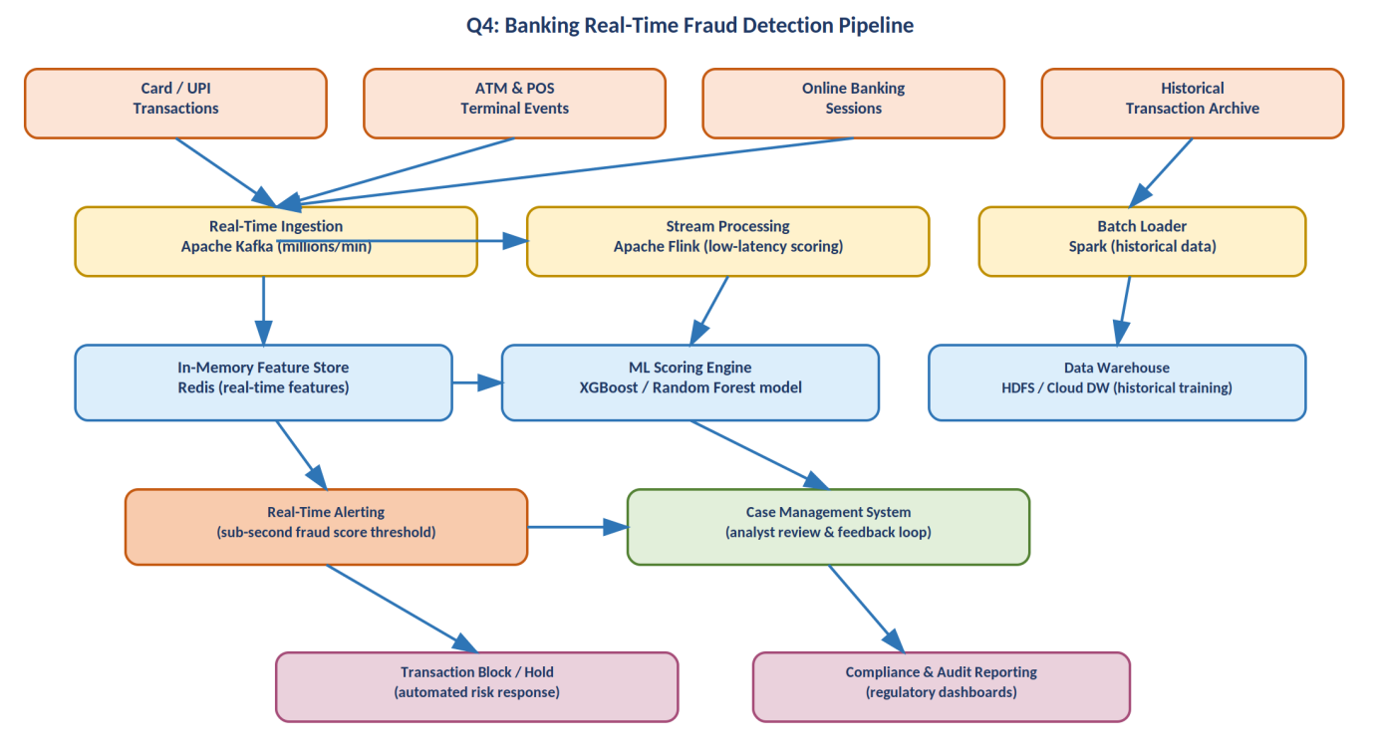
Figure 4: Proposed real-time banking fraud detection pipeline.

Question 5 — Agriculture Smart Farming Problem
A precision agriculture system collecting soil, weather, and crop data from distributed sensors and drones needs a big data solution that turns raw field data into actionable, farmer-facing insights.

Understanding the Industry Context
Farm data sources are physically distributed (multiple fields, sensors, drones) with intermittent connectivity, so an edge-to-cloud design is appropriate: local pre-processing at the farm reduces bandwidth needs, while cloud-scale analytics support prediction and long-term decision-making.

Proposed Architecture & Tools
- Edge Layer: An edge gateway at the farm aggregates readings from soil moisture, nutrient, and weather sensors locally before transmission, reducing bandwidth and enabling offline operation during connectivity gaps.
- Ingestion: MQTT (lightweight IoT protocol) feeds sensor data into Apache Kafka for durable, scalable ingestion into the cloud pipeline; drone imagery goes through a dedicated image-processing pipeline for preprocessing (stitching, calibration) before storage.
- Storage: A time-series database (InfluxDB) holds high-frequency sensor readings; a cloud data lake (HDFS/S3) stores imagery and telemetry; a geospatial store (PostGIS) supports field-level mapping and zone-based analysis.
- Analytics: Regression/ML models predict yield from historical soil/weather/crop patterns; an irrigation-optimization engine combines rule-based logic with ML on soil-moisture and weather forecasts; a CNN-based computer-vision model analyzes drone imagery for crop health/disease detection.

How Analytics Supports Decision-Making
- Yield prediction models help farmers plan harvest logistics and anticipate resource needs in advance.
- Irrigation optimization reduces water waste by recommending precise watering schedules per field zone rather than uniform irrigation.
- Crop health detection from drone imagery enables early identification of disease or pest stress, before it's visible to the naked eye, allowing targeted intervention.
- Aggregated dashboards translate raw sensor/ML output into simple, actionable recommendations delivered via a mobile app, accessible even to non-technical farmers.

Security & Risk Considerations
- Secure device authentication prevents spoofed sensor readings from corrupting the dataset or triggering false automated actions.
- Automated actuator control (e.g., irrigation valves) should include manual override and fail-safe defaults in case of connectivity loss or erroneous predictions.
- Farm data ownership and privacy should be respected — data should not be shared with third parties (e.g., insurers, input suppliers) without farmer consent.
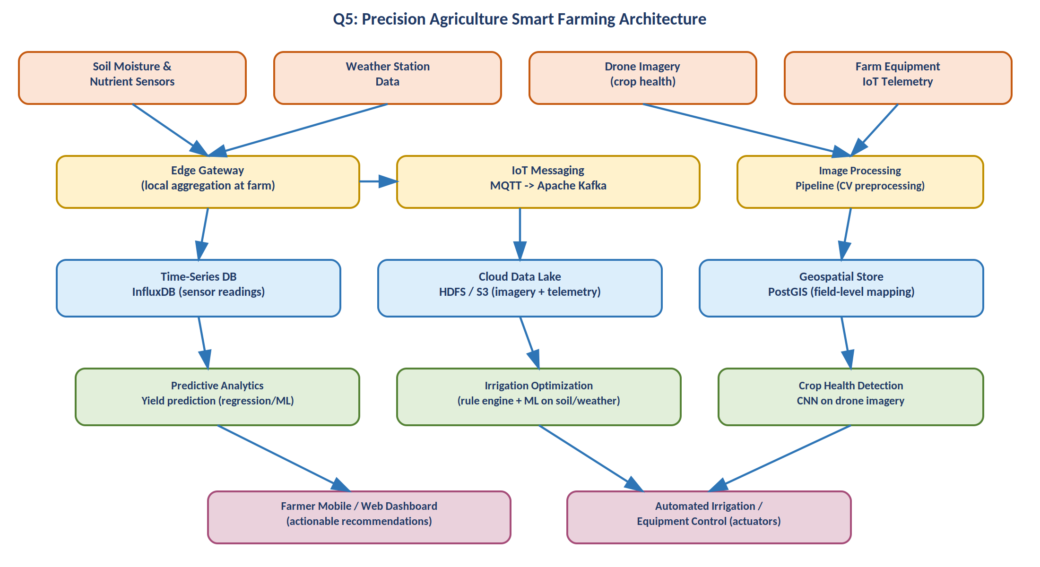
Figure 5: Proposed edge-to-cloud architecture for precision agriculture.

