SIMATS ENGINEERING
ASSESSMENT TOOL 3: REVERSE ENGINEERING TASK
Course Name | Cloud Computing and Big Data Analytics
Course Code | CSA1513
Course Outcome | CO4: Analyze big data characteristics and challenges across domains including security and application aspects. (BL4)
Total Marks | 30 (5 Questions x 6 Marks)

Question 1 — Web-Scale Big Data Platform (Clicks, Mobile, Transactions)
The platform ingests billions of website clicks, mobile interaction events, and transactional records daily. Reverse-engineering this scenario points to a classic Lambda/Kappa-style big data pipeline combining distributed storage, batch and stream processing, and a serving layer for BI.

Distributed Storage, Ingestion & Batch Processing
- Ingestion: High-throughput event producers (web/mobile SDKs) most likely publish click and interaction events to Apache Kafka (or AWS Kinesis), chosen for its durability, partition-based ordering, and ability to decouple producers from downstream consumers at massive scale.
- Change Data Capture: Transactional (RDBMS) data is probably synced using Sqoop or Debezium-based CDC connectors so relational updates flow into the lake without impacting the OLTP system.
- Distributed Storage: Raw and processed data likely lands in a data lake built on HDFS or Amazon S3 — inexpensive, horizontally scalable, and schema-agnostic, which suits the variety of click, mobile, and transaction data.
- Batch Processing: Apache Spark (or Hadoop MapReduce for legacy jobs) is the probable engine for nightly aggregation, deduplication, and feature computation over the full historical dataset.

Separation & Indexing of Structured vs Semi-Structured Data
- Structured data (transaction records) is inferred to be modeled in relational or columnar warehouse tables with well-defined schemas, partitioned by date for efficient querying.
- Semi-structured data (JSON click/event logs) is likely stored schema-on-read in the lake and indexed separately using Elasticsearch or Apache Solr, enabling fast full-text and attribute search without rigid upfront schema design.
- A metadata/catalog layer (e.g., Hive Metastore or AWS Glue) probably unifies both, letting query engines treat lake files as queryable tables.

Real-Time Stream Processing Engines
- Apache Spark Streaming or Apache Flink is the most probable real-time engine, consuming directly from Kafka topics to compute rolling metrics (active users, click-through rate) with low latency for dashboards and alerting.
- A serving store such as Redis or Apache Druid likely holds the latest aggregates so dashboards read pre-computed rollups instead of scanning raw events.

Scalability & Partitioning Strategy
- Kafka topics are probably partitioned by user/session ID to preserve event ordering per user while parallelizing across brokers.
- HDFS/S3 data is likely partitioned by date (and possibly event type), allowing partition pruning during batch scans and reducing query cost.
- Horizontal auto-scaling of Spark/Flink clusters is the likely strategy for handling traffic spikes, backed by a resource manager such as YARN or Kubernetes.
- Replication (3x in HDFS, multi-AZ in S3) provides fault tolerance for petabyte-scale workloads.

Dashboard & BI Connectivity
Aggregated tables in a warehouse (Hive, Redshift, or BigQuery) are the probable feed for BI tools such as Tableau or Power BI, connected via JDBC/ODBC or native connectors. Elasticsearch's aggregation API likely powers the real-time operational dashboards, while the warehouse layer supports deeper historical/ad-hoc analysis — a two-speed architecture balancing freshness against analytical depth.
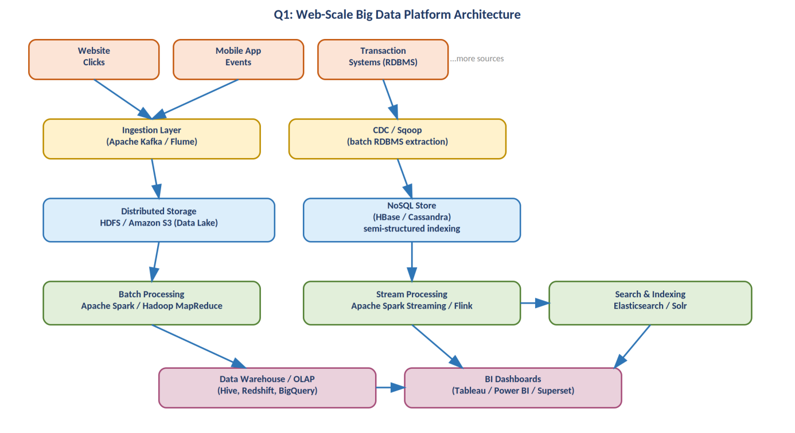
Figure 1: Inferred architecture for the web-scale big data ingestion and analytics platform.

Question 2 — E-commerce Real-Time Personalization Platform
The platform tracks cart additions, abandoned checkouts, product views, and payments across regions. This points to an event-driven architecture optimized for low-latency personalization alongside durable transactional recording.

Event Streaming, Profiling Database & Recommendation Workflow
- Event Streaming: Apache Kafka is the probable backbone capturing clickstream and cart events as an ordered, replayable log, decoupling the web/app front end from downstream consumers.
- Customer Profiling Database: A NoSQL store (MongoDB or Cassandra) likely maintains flexible, frequently-updated customer profiles (browsing history, preferences) since profile schemas evolve and require high write throughput.
- Recommendation Workflow: A batch model-training stage (Spark MLlib collaborative filtering or a gradient-boosted model) probably runs periodically on historical data, while a lightweight real-time scoring service serves recommendations using the trained model plus session context.

Synchronizing Session, Clickstream & Transaction Data
- Session data is likely cached in Redis (in-memory, low-latency) so personalization services can read a shopper's live state within milliseconds.
- Clickstream logs and order/payment records probably converge in a data lake, joined using a common session/customer ID and event timestamp to build a unified view of the customer journey.
- A stream-join pattern (e.g., Kafka Streams or Flink's windowed joins) is the probable mechanism for correlating a 'view' event with a later 'purchase' event in near real time.

Caching, Query Engines & ML Stages
- Redis or Memcached for hot-path session/recommendation caching.
- Presto or Spark SQL as the distributed query engine for ad-hoc analytics across the lake and warehouse.
- A staged ML pipeline: feature engineering → offline training → model registry → online inference, likely orchestrated with Airflow and served via a REST/gRPC microservice.

Merging Structured Order Data with Semi-Structured Browsing Data
Structured order data (fixed schema: order ID, SKU, amount) probably resides in a relational warehouse table, while semi-structured browsing/clickstream JSON is stored in the lake. An ETL/ELT job likely flattens and joins the two on customer/session ID into a denormalized 'customer 360' table used both for BI and as ML training input — reconciling schema-strict and schema-flexible sources into one analytics-ready view.

Scalability & Fault Tolerance
- Kafka partitioning by customer/session ID for parallel, ordered consumption.
- Stateless microservices behind a load balancer, auto-scaled based on traffic (important during sales events).
- Replicated NoSQL clusters and multi-region deployment to tolerate node/region failure without losing cart or session state.

Dashboards & KPI Monitoring
Sales and funnel-conversion KPIs are probably computed via scheduled Spark/warehouse jobs and visualized in Tableau or Power BI, while operational KPIs (cart abandonment rate, latency) likely flow through the same streaming path feeding a real-time monitoring dashboard (e.g., Grafana on top of time-series metrics).
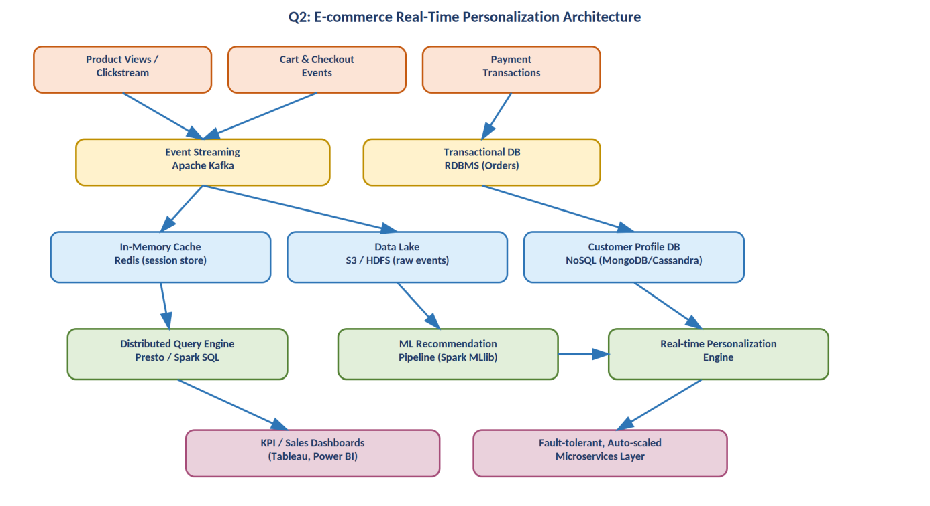
Figure 2: Inferred architecture for the e-commerce real-time personalization pipeline.

Question 3 — Big Data Healthcare System (Records, Images, Sensors, Prescriptions)
This system processes patient histories, diagnostic images, wearable sensor streams, and prescription records — a highly heterogeneous, compliance-sensitive workload that implies a hybrid storage and processing architecture.

Hybrid Database Architecture
- Structured data (patient demographics, prescriptions) is probably kept in a relational database (PostgreSQL/Oracle) for transactional integrity (ACID compliance is critical in healthcare).
- Unstructured/large binary data (diagnostic images such as DICOM files) is likely stored in an object store or PACS system backed by HDFS/S3, since images are large and not naturally relational.
- Semi-structured sensor streams from wearables are probably held in a NoSQL/time-series store (MongoDB, InfluxDB) suited to high-frequency, schema-flexible readings.

Data Integration Across Hospitals, Labs & Insurers
Given multiple independent institutions, an interoperability standard such as HL7 or FHIR is the most probable integration layer, with an engine like Apache NiFi or Mirth Connect orchestrating message routing, transformation, and validation between hospital EHRs, lab information systems, and insurance claim systems.

Streaming & ML Frameworks for Prediction and Monitoring
- Kafka (or MQTT for device telemetry) ingesting continuous wearable sensor readings.
- Spark Streaming/Flink computing rolling vitals and triggering threshold-based alerts.
- Trained ML models (likely logistic regression, random forest, or deep learning for image-based diagnostics) deployed for disease prediction, probably retrained periodically on the batch layer.

Privacy, Encryption & Compliance
- Encryption at rest (AES-256) and in transit (TLS) is almost certainly enforced given HIPAA/GDPR-equivalent obligations.
- Role-based access control (RBAC) and field-level masking likely restrict who can view identifiable patient data.
- Comprehensive audit logging is probably maintained to satisfy regulatory traceability requirements (who accessed what, when).
- De-identification/anonymization pipelines likely run before data is used for population-level research.

Analytics Pipeline for Clinical Decisions & Population Health
Real-time streams likely feed clinician-facing dashboards for immediate decision support (e.g., early sepsis warning), while the batch layer aggregates de-identified records for population health studies, probably surfaced through BI tools to hospital administrators and public-health researchers.
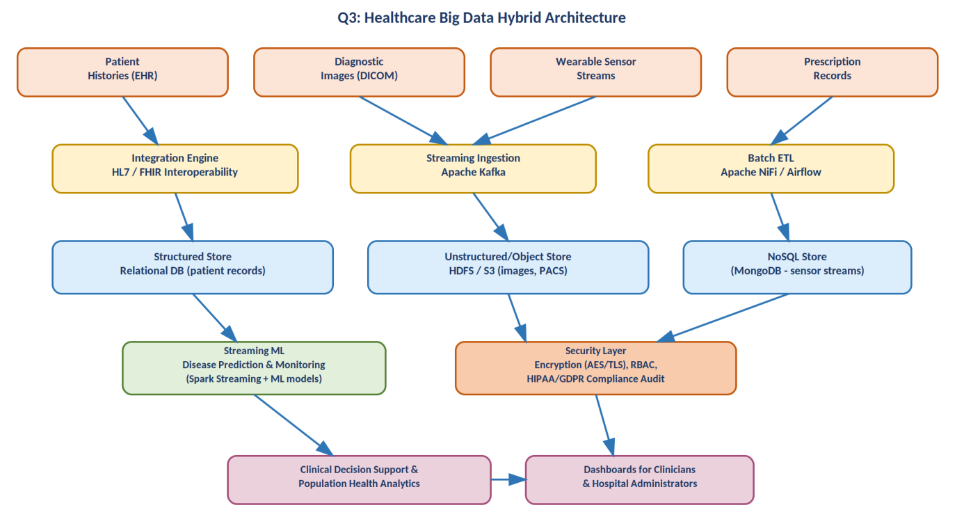
Figure 3: Inferred hybrid architecture for the healthcare big data platform.

Question 4 — Smart City Platform (Traffic, CCTV, Weather, Transport)
Continuous feeds from traffic sensors, CCTV metadata, weather updates, and public transport imply an edge-to-cloud IoT architecture designed for both real-time control and long-term urban planning analytics.

Edge Computing, Messaging & Centralized Storage
- Edge computing: Given the volume and latency sensitivity of traffic/CCTV data, local edge nodes (e.g., NVIDIA Jetson-class devices or roadside gateways) probably pre-filter and compress data before transmission, reducing bandwidth and enabling instant local reactions (e.g., signal changes).
- Distributed messaging: MQTT is the likely protocol for lightweight sensor/device communication, bridging into Apache Kafka for durable, scalable ingestion into the cloud/data-center tier.
- Centralized storage: A cloud data lake (HDFS/S3) probably retains raw historical data for batch analytics and compliance retention.

Geospatial Analytics & Congestion Prediction
A geospatial-capable store — PostGIS or Elasticsearch with geo-queries — is the probable choice for location-aware querying, while a streaming engine (Apache Flink, chosen for its strong event-time and windowing support) likely computes rolling traffic-density metrics per road segment to predict congestion minutes ahead.

Time-Series & Location-Aware Databases
- InfluxDB or TimescaleDB for high-frequency sensor time-series (traffic counts, weather readings).
- PostGIS/geo-indexed Elasticsearch for spatial joins (e.g., 'which sensors lie within this district').

Combining Batch & Real-Time Analytics for Urban Planning
Real-time stream analytics likely support immediate operational decisions (adaptive signal timing, incident alerts), while nightly/weekly Spark batch jobs over the data lake probably generate longer-term trend reports used for infrastructure and urban-planning decisions — a two-tier analytics approach balancing immediacy with depth.

Security & Access Control
- Device-level authentication (certificates/API keys) to prevent spoofed sensor data.
- Encrypted transport (TLS/DTLS) for MQTT and Kafka channels.
- Anonymization of CCTV metadata (e.g., blurring or hashing identifiers) to protect citizen privacy while retaining analytical value.
- RBAC restricting operational control systems (e.g., traffic signal actuation) to authorized city personnel only.

Visualization for Live Operational Intelligence
A GIS-based operations dashboard (built on tools like Kibana, Grafana, or a custom map-based UI) probably renders live sensor and traffic overlays for city control-room staff, sourced from the streaming layer, with drill-down into the historical warehouse for planning reports.
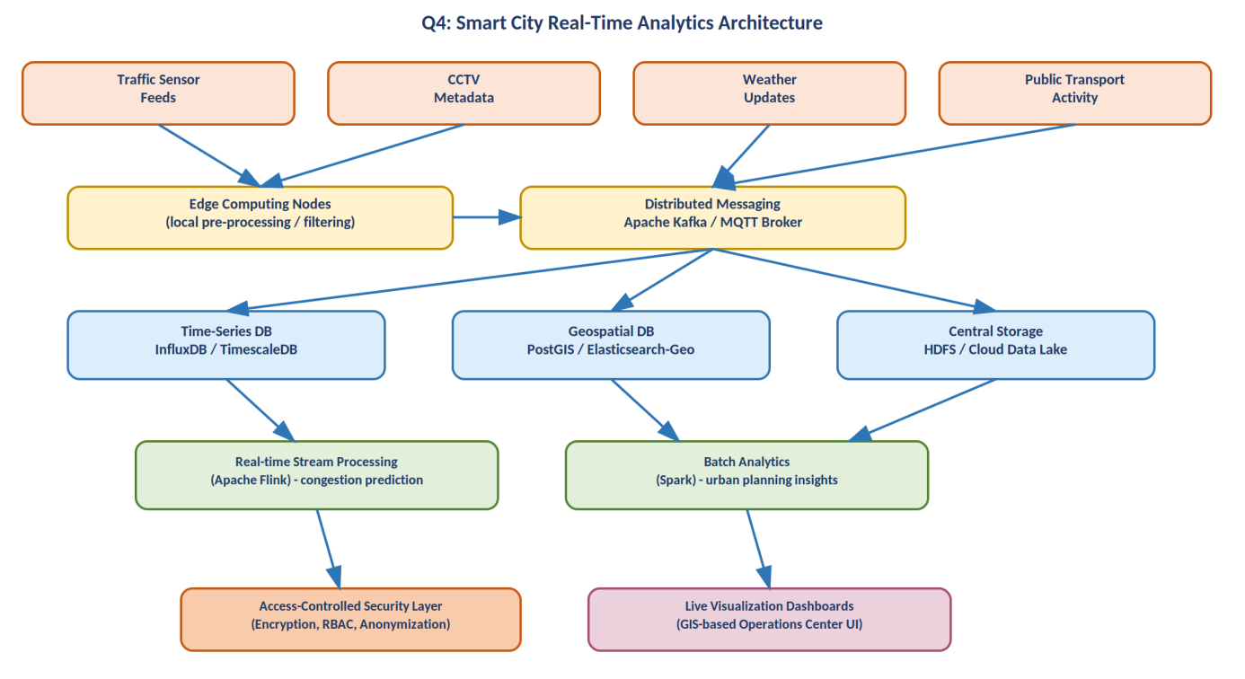
Figure 4: Inferred edge-to-cloud architecture for the smart city analytics platform.

Question 5 — Healthcare Analytics System (Records, Wearables, Labs, Appointments)
This system integrates patient records, wearable readings, lab reports, and appointment histories for population-level and predictive analytics — closely related to Q3 but emphasizing ETL/interoperability, governance, and diagnostic ML.

Hybrid Storage Architecture
- Structured store: A relational database likely anchors core EHR data (patient IDs, appointments, lab result values) where referential integrity matters.
- Unstructured/semi-structured store: Object storage or a NoSQL database probably holds scanned documents, free-text clinical notes, and high-frequency wearable readings that don't fit a rigid schema.
- An audit/compliance store (often a write-once, append-only log) is likely maintained separately to record every access/modification for governance purposes.

ETL Pipelines & Interoperability Standards
Apache NiFi or a workflow tool like Talend/Airflow probably orchestrates extraction from disparate hospital/clinic systems, transforming records into a common schema. HL7 v2 or FHIR is the likely interoperability standard bridging heterogeneous source systems (different EHR vendors) into the unified pipeline.

Real-Time Monitoring & Predictive Analytics
- Streaming ingestion (Kafka) of wearable vitals enables near real-time threshold alerts (e.g., abnormal heart rate).
- A predictive layer, likely built with Spark MLlib or a Python-based model server, scores incoming data against trained risk models continuously.

Role of Distributed Processing in Population-Level Analysis
Apache Spark is the probable engine for large-scale joins and aggregations across millions of patient records — computing cohort statistics, risk stratification, and epidemiological trends that would be infeasible on a single-node system.

Encryption, Compliance & Audit Mechanisms
- End-to-end encryption (at rest and in transit) protecting personally identifiable and health information.
- Consent management and RBAC controlling which caregivers/researchers can access identifiable vs de-identified data.
- Immutable audit logs supporting regulatory audits (HIPAA/GDPR-style obligations) and breach investigation.

ML Models for Diagnosis Risk Scoring & Treatment Recommendation
Supervised models (e.g., gradient-boosted trees or neural networks) trained on historical labeled outcomes likely generate risk scores (e.g., readmission risk, disease onset probability), while a recommendation layer probably suggests candidate treatment pathways based on similar historical patient cohorts — always positioned as clinician decision support rather than an autonomous diagnostic authority.
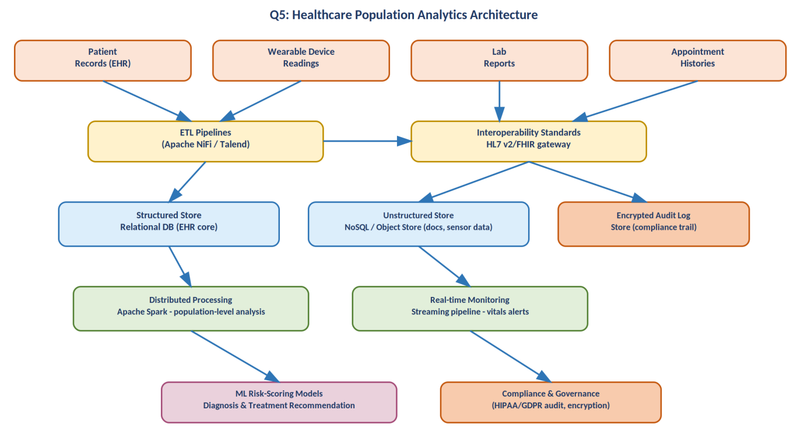
Figure 5: Inferred architecture for the healthcare population analytics and risk-scoring system.

