Microservices

1. Account Microservice

pom.xml
<?xml version="1.0" encoding="UTF-8"?>
<project ...>
<artifactId>account</artifactId>
<dependencies>
<dependency>
<groupId>org.springframework.boot</groupId>
<artifactId>spring-boot-starter-web</artifactId>
</dependency>
</dependencies>
</project>

AccountController.java
package com.cognizant.account.controller;
import org.springframework.web.bind.annotation.*;
@RestController
public class AccountController {
@GetMapping("/accounts/{number}")
public String getAccountDetails(@PathVariable String number) {
return "{ \"number\": \"" + number + "\", \"type\": \"savings\", \"balance\": 234343 }";
}
}

Output
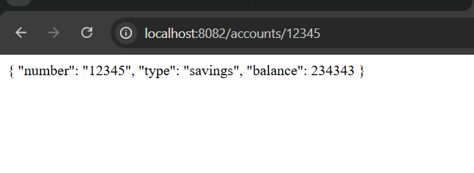

2. Loan Microservice

pom.xml
<?xml version="1.0" encoding="UTF-8"?>
<project ...>
<artifactId>loan</artifactId>
<dependencies>
<dependency>
<groupId>org.springframework.boot</groupId>
<artifactId>spring-boot-starter-web</artifactId>
</dependency>
</dependencies>
</project>

LoanController.java
package com.cognizant.loan.controller;
import org.springframework.web.bind.annotation.*;
@RestController
public class LoanController {
@GetMapping("/loans/{number}")
public String getLoanDetails(@PathVariable String number) {
return "{ \"number\": \"" + number + "\", \"type\": \"car\", \"loan\": 400000, \"emi\": 3258, \"tenure\": 18 }";
}
}

Output
