Cognizant Deepskilling: PL/SQL Exercises

Exercise 1: Control Structures
Scenario 1: Apply a 1% discount to loan interest rates for customers above 60 years old.

Ex1_Scenario1.sql
DECLARE
CURSOR c_customers IS
SELECT c.CustomerID, l.LoanID, c.DOB, l.InterestRate
FROM Customers c
JOIN Loans l ON c.CustomerID = l.CustomerID;
v_age NUMBER;
BEGIN
FOR r IN c_customers LOOP
v_age := TRUNC(MONTHS_BETWEEN(SYSDATE, r.DOB) / 12);
IF v_age > 60 THEN
UPDATE Loans
SET InterestRate = InterestRate - 1
WHERE LoanID = r.LoanID;
DBMS_OUTPUT.PUT_LINE('Discount applied for Customer: ' || r.CustomerID);
END IF;
END LOOP;
COMMIT;
END;
/
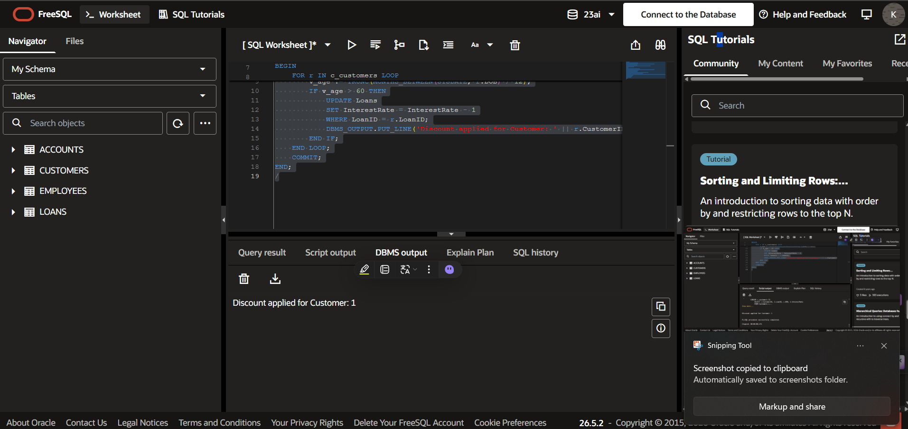
Scenario 2: Set a flag IsVIP to TRUE for customers with a balance over $10,000.

Ex1_Scenario2.sql
DECLARE
CURSOR c_customers IS SELECT CustomerID, Name, Balance FROM Customers;
v_isVIP BOOLEAN;
BEGIN
FOR r IN c_customers LOOP
IF r.Balance > 10000 THEN
v_isVIP := TRUE;
DBMS_OUTPUT.PUT_LINE('Customer ' || r.Name || ' is VIP: TRUE');
ELSE
v_isVIP := FALSE;
DBMS_OUTPUT.PUT_LINE('Customer ' || r.Name || ' is VIP: FALSE');
END IF;
END LOOP;
END;
/
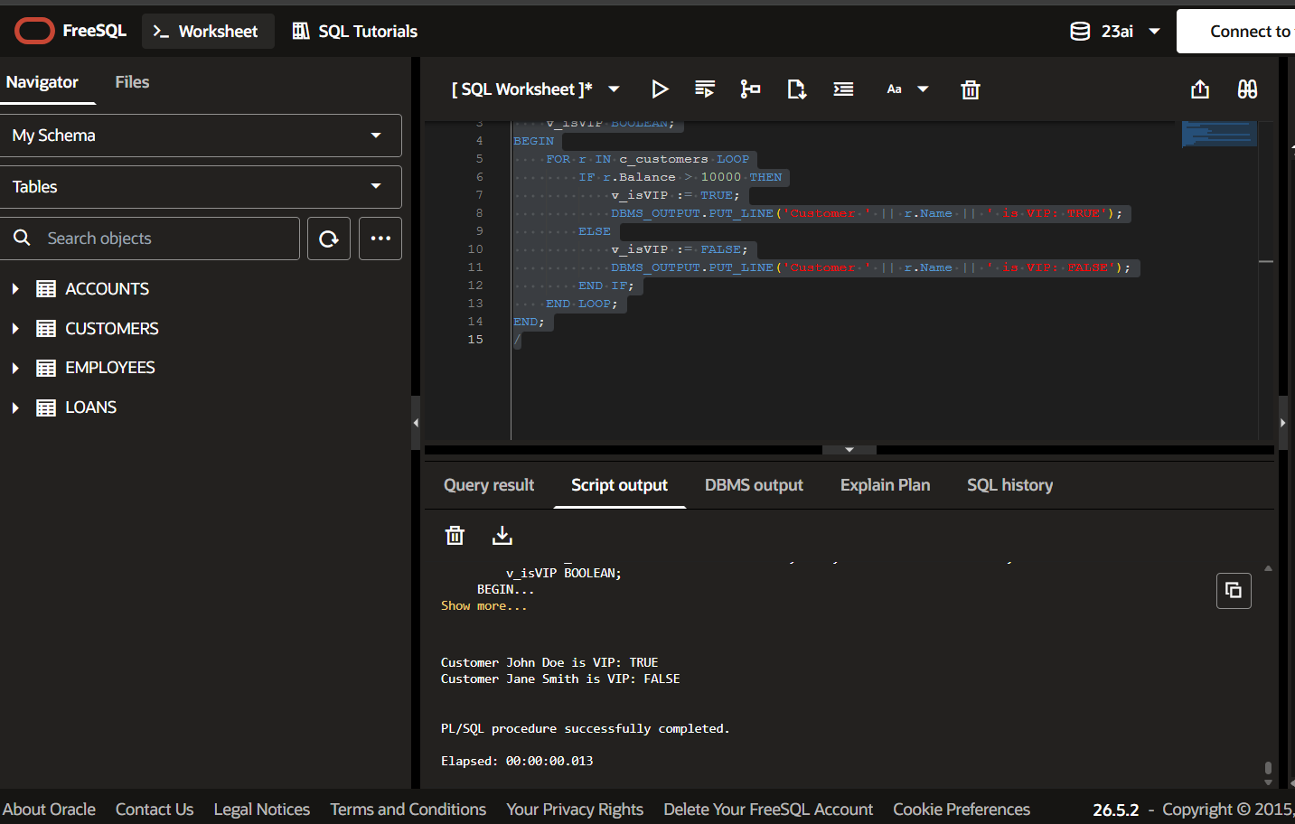
Scenario 3: Send reminders to customers whose loans are due within the next 30 days.

Ex1_Scenario3.sql
DECLARE
CURSOR c_due_loans IS
SELECT c.Name, l.LoanID, l.EndDate
FROM Customers c
JOIN Loans l ON c.CustomerID = l.CustomerID
WHERE l.EndDate BETWEEN SYSDATE AND SYSDATE + 30;
BEGIN
FOR r IN c_due_loans LOOP
DBMS_OUTPUT.PUT_LINE('Reminder: Customer ' || r.Name ||
' has a loan (ID: ' || r.LoanID ||
') due on ' || TO_CHAR(r.EndDate, 'YYYY-MM-DD'));
END LOOP;
END;
/
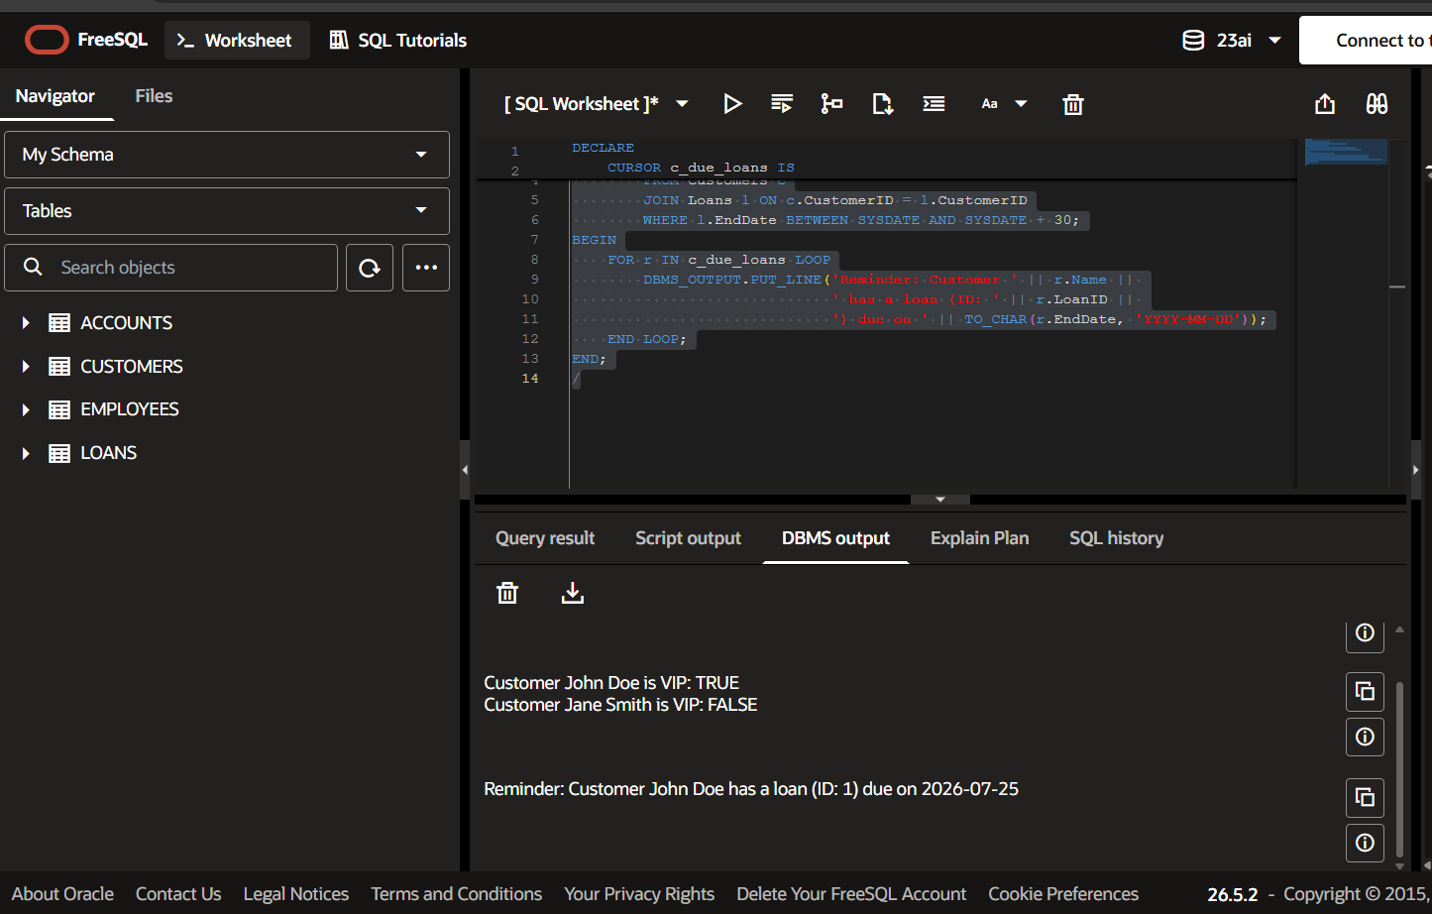

Exercise 3: Stored Procedures
Scenario 1: Process monthly interest for all savings accounts (1% interest).

Ex3_Scenario1.sql
CREATE OR REPLACE PROCEDURE ProcessMonthlyInterest IS
BEGIN
UPDATE Accounts
SET Balance = Balance + (Balance * 0.01)
WHERE AccountType = 'Savings';
DBMS_OUTPUT.PUT_LINE('Monthly interest processed for all Savings accounts.');
COMMIT;
END;
/
-- To Execute:
-- EXEC ProcessMonthlyInterest;
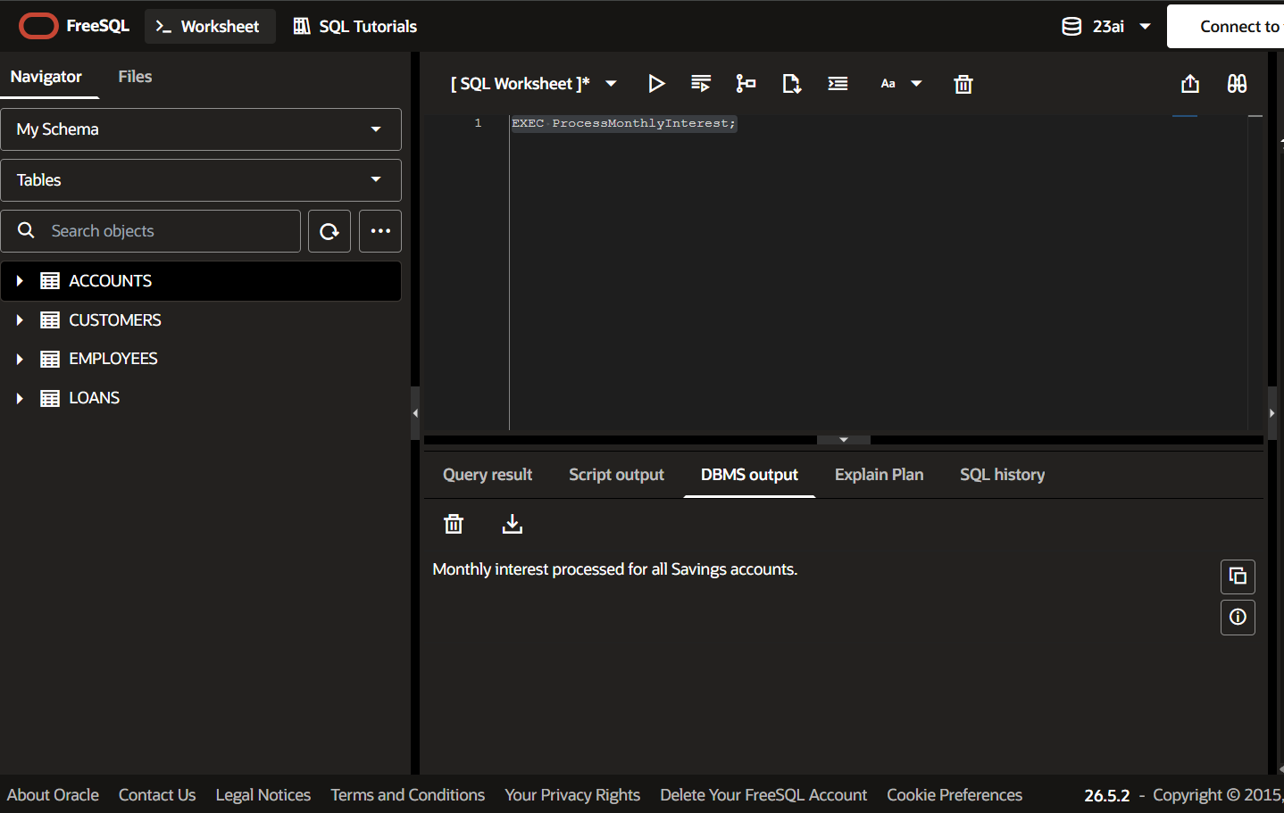
Scenario 2: Implement a bonus scheme for employees based on their performance/department.

Ex3_Scenario2.sql
CREATE OR REPLACE PROCEDURE UpdateEmployeeBonus (
p_department IN VARCHAR2,
p_bonus_percent IN NUMBER
) IS
BEGIN
UPDATE Employees
SET Salary = Salary + (Salary * (p_bonus_percent / 100))
WHERE Department = p_department;
DBMS_OUTPUT.PUT_LINE('Bonus of ' || p_bonus_percent ||
'% applied to department: ' || p_department);
COMMIT;
END;
/
-- To Execute:
-- EXEC UpdateEmployeeBonus('IT', 5);
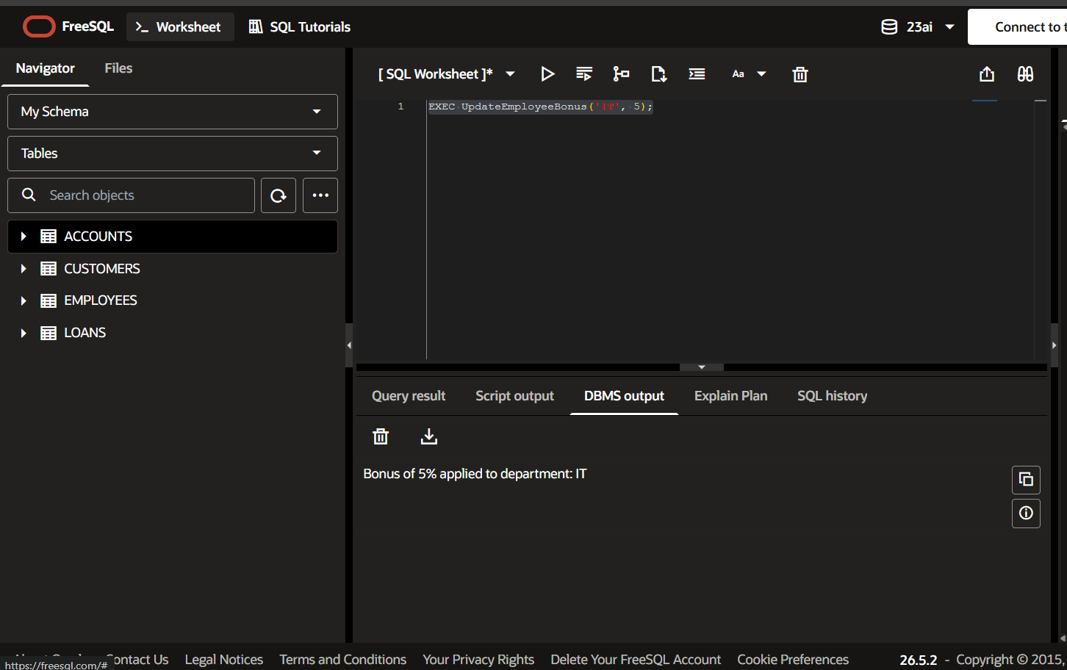
Scenario 3: Transfer funds between accounts checking sufficient balance.

Ex3_Scenario3.sql
CREATE OR REPLACE PROCEDURE TransferFunds (
p_from_account IN NUMBER,
p_to_account IN NUMBER,
p_amount IN NUMBER
) IS
v_balance NUMBER;
BEGIN
-- Check balance of the source account
SELECT Balance INTO v_balance FROM Accounts WHERE AccountID = p_from_account;
IF v_balance >= p_amount THEN
-- Deduct from source
UPDATE Accounts SET Balance = Balance - p_amount WHERE AccountID = p_from_account;
-- Add to destination
UPDATE Accounts SET Balance = Balance + p_amount WHERE AccountID = p_to_account;
DBMS_OUTPUT.PUT_LINE('Transfer of $' || p_amount || ' successful.');
COMMIT;
ELSE
DBMS_OUTPUT.PUT_LINE('Error: Insufficient funds for transfer.');
END IF;
EXCEPTION
WHEN NO_DATA_FOUND THEN
DBMS_OUTPUT.PUT_LINE('Error: Invalid Account ID provided.');
END;
/
-- To Execute:
-- EXEC TransferFunds(1, 2, 500);
