History
Version 1.0: created at 10/7/2019 by Weijian Zong;
Version 1.0 illustration: created at 24/7/2019 by Weijian Zong;

Introduction
Too lazy to write this part

Function Instruction
Input definition:
- transform Matrix ( .mat), the matlab file used to do the piece-wise transformation of the images (Raw data) or digital position data (Raw position);
- Grid Date ( .tif), Grid image used to find the referencing anchor point pairs;
- Anchor point pairs ( .csv), referencing anchor point pairs indicate the distorted (in raw date) and the original (in correcred data) position of the same points in either images;
- FOV (.csv), the field of view (um) and pixel size (um/pixel) information of the corrected images;
- Raw data (.tif), raw mini2P images (singe, dual-channel, timelapse or Z-stack);
- Raw position (.csv), interesting points in the raw image with the digital format saved in .csv file.

Output definition:
- transform Matrix ( .mat), same as above, can be loaded in to the program;
- Grid Date ( .tif), same as above, can be loaded in to the program;
- Anchor point pairs ( .csv), same as above, can be loaded in to the program;
- FOV (.csv), same as above, can be loaded in to the program;
- Corrected data (.tif), Same size and format as the raw data, and located in an automatically generated folder with timestamp and the same file path as the raw data;
- Correcred position (.csv), Same size and format as the raw position, and located in an automatically generated folder with timestamp and the same file path as the raw position;

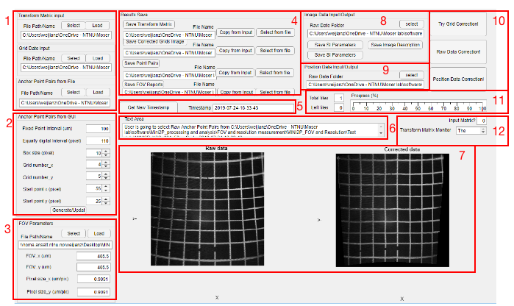
Figure 1. Whole program.

Panel 1: Correction reference input.
There are three different correction files that you can load in to apply the correction: transform Matrix ( .mat), Grid Date ( .tif) or Anchor point pairs ( .csv). Please check the example for each in Test data.zip to be familiar with what they look like. Only one of them is needed to successful apply the correction.
The Transform Matrix and Anchor point pairs could be generated or updated by the program (see bellow). The first time to run the program, you should always start with inputting the Grid Date to generate the other two files (see bellow fig.2). You can load in these three kinds of files as many times as you can.
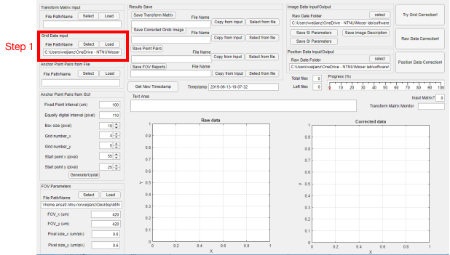
Figure 2. Load in the Grid image.

Panel 2: Anchor Point Pairs generation or update.
Generate or update the draggable anchor point pairs in the interactive figure (comes out when you press the “Generate/Update” button, see bellow fig.3 and fig.4).

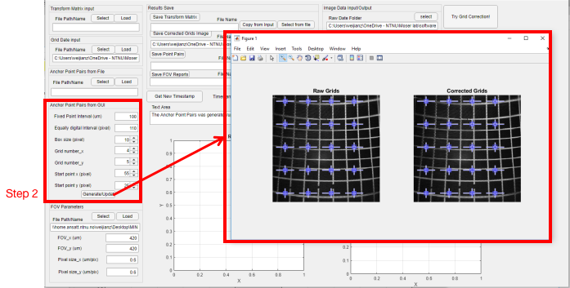
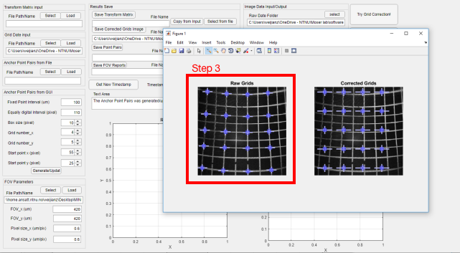
Figure 3. Generate of update the anchor point pairs in an interactive figure.

Figure 4. drag the anchor points in raw Grids to the right positions.

Panel 3: FOV parameters.
The parameters in this panel can be automatically generated when you do the Grid image correction (press “Try Grid Correction!” button) , filled in manually or loaded in from the FOV .csv file (see bellow). When you save the corrected images (press “Raw data correction”), the FOV information will be automatically written into the Tiff head file and can be read by ImageJ or that standard image processing software.

Panel 4: Result save.
The transform Matrix ( .mat), Grid Date ( .tif), Anchor point pairs ( .csv) and FOV (.csv) can be saved and loaded in. Please check bellow figure (Fig.x) and the example for each in Test data.zip to be familiar with what they look like.
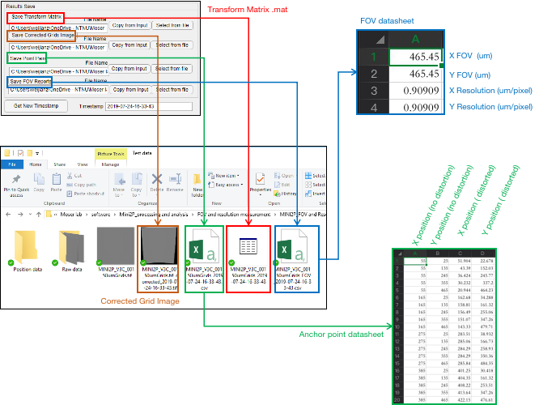
Figure 5. output files and their definitions.

Panel 5: Get timestamp.
In default, all the output file will have the same timestamp when you first time press the “ try Grids Correction!” button. But user can always generate a new timestamp when they want. The timestamp will be automatically added in the end of the file name of each output files.
Panel 6: prompt box.
Give you some useful information. Good for beginner.
Panel 7: Image preview.
Check the correction results.
Panel 8: Data (images) input and output.
You could also use this function to extract and save the ScanImage-specific image information in the Tiff-head of the images (under developing, will be ready soon.
Panel 9: Position (digital) input and output.
General digital data based correction. No raw images are needed. Be super useful if you just want to do the position correction after you have done the neuron identification using Suit2P and got the position of each neuron (must saved in .csv), without touching the monster-big raw data.
Panel 10: RUN buttons.
When press “ Try Grids Correction”, program will do the correction on the Grid image based on the user-assigned correction reference (transform Matrix, Grid Date, or Anchor point pairs). The corrected Grids in the interactive figure will be updated to the corrected version and both image will be put into the Image preview panel (panel 7, see bellow fig. 6). At the same time, the FOV parameters will be generated, the first timestamp will be generated, new corrected Grid image, transform Matrix and Anchor point pairs will be generated. This step is used to check if user is satisfied with the correction results based on the user-assigned correction reference. If not, user can re-do this as many time as you can (may need new correction reference by either re-loading from files or re-generating in Panel 2).
When press “ Raw data Correction”, program will do the real correction on the raw data based on the correction reference. When the correction is finished ( this can be monitored both in Panel 5 or Panel 11). it will automatically generate a folder including corrected images in the same folder as the raw image data (see bellow fig.7).
When press “ Position data Correction”, program will do the real correction on the raw position data based on the correction reference. When the correction is finished ( this can be monitored both in Panel 5 or Panel 11). it will automatically generate a folder including corrected .csv date in the same folder as the raw image position data (see bellow fig.8).

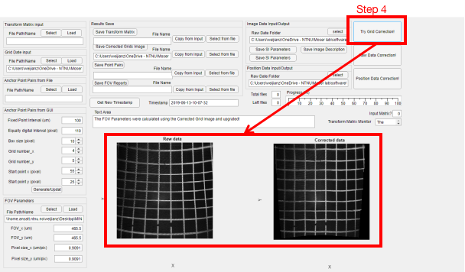
Figure 6. Grid Correction.
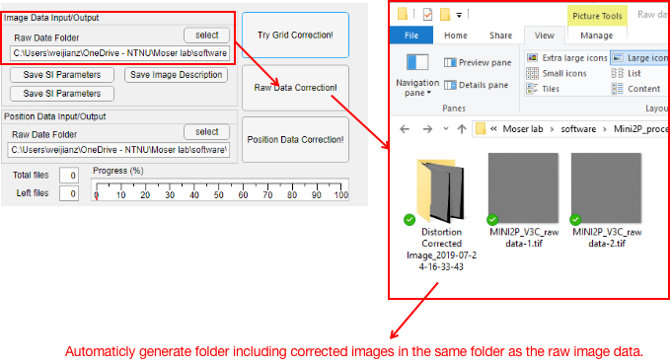
Figure 7. Image data correction.
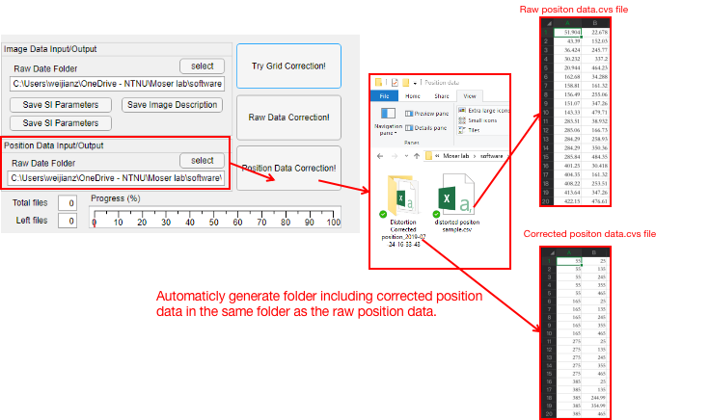
Figure 8. Position data correction.

Panel 11: Progress monitor.
Check the correction progress.
Panel 12: Matrix monitor.
Whichever correction reference you selected (transform Matrix, Grid Date, or Anchor point pairs), you need to make sure you successful generated the transform matrix in the memory of the program, don`t you ??? So please often check this monitor!

