My volunteer project involved a lot of parts and was not easy. My project was designed to involve future volunteers to expand this project through the use of a repository in which I created for public access. My original project proposal was deemed too complex by the professor as it would involve various complex tasks, so I honed my contribution to creating a public repository on GitHub and designing the potential splash pages for the hotspot project. A lot of variables changed throughout the project such as hardware work. First off, there were many designs and different approaches to integrating hotspot software with the hardware.

One option is to use third party software that integrates with a specific router. The third-party software uses a user-friendly GUI to customize and modify hotspot splash pages with the ability to integrate YouTube videos to generate ad revenue to covers a sponsor’s costs. Such third-party software requires a monthly subscription and may not work with every wireless router. A separate wireless router could be purchased so that the sponsor’s private wireless transmission is separate from the public hotpot project’s broadcast. The software can cost around $40-$50 a year, and a separate router may cost $50-$100.

Another option that can be found is through a business’s ISP provider. Depending on the provider and the subscription plan, some ISPs allow for the customization of a business’s landing page when guests connect to the wireless router. The issue is that only some ISPs offer this solution, and it may require a subscription to the highest tier plan. The benefits are that instead of relying on separate third parties, this approach is seamless with the equipment already installed by the internet service provider.

There are many pros and cons to the different approaches, however, I learned that implementing the hardware designs with my sponsor posed a risk, as my sponsor was more comfortable with someone else handling the network hardware equipment due to possible liability risks and to limit alterations that her service provider technician is not very familiar with. I came to realize while performing my work that not every sponsor of the project is comfortable with an approach or having a volunteer work on certain aspects. This is the leading reason why the project proposal was not the concrete plan as instead of focusing on the hardware, I focused more on the repository and creating sample splash pages themselves.

Another point to be made was that in my original proposal, I intended that the sponsor could have costs paid through ad revenue from YouTube ads imbedded on splash pages. When working with the sponsor, I realized that instead of focusing on ad revenue from videos or paid embedded ads, the sponsor preferred a hotspot registration to collect user information from a registration form, Facebook login, or twitter login. The sponsor would rather use such information to push her own ads through Facebook to push her new daycare.

I spent 1 hour to find my sponsor. I wanted to find an ideal location to start the project and found my sponsor, who is a daycare owner next to an empty parking lot where I have observed people just parking in the area. I spent 2 hours on my own trying out a 3rd party software at my house. I had an old Linksys wireless router that was capable with a trial software to test the splash page. However, as mentioned sponsor had different equipment and concerns so I resorted to building mobile splash pages and html pages. This would still be an option if additional volunteers wanted to contribute to building their own hotspot system. I spent at least 4 hours working on the html splash pages and an example mobile php page with the registration options. I spent at least 3 hours creating the GitHub repository and organizing it to add files and information. (~10 hours)

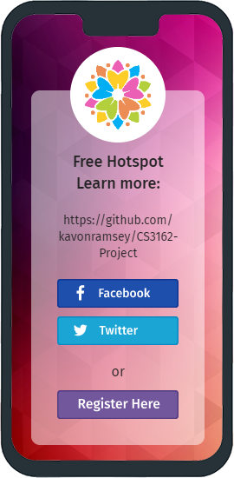

<https://github.com/kavonramsey/CS3162-Project>

These are examples of the work I created.

As mentioned, the goal is that in the future, more people can contribute to the project. For now, I focused on the setup of the repository, finding the ideal location, designing some splash pages, testing possible 3rd party software that could be used in lieu of building an html splash page or mobile splash page from scratch. As of now it was only me, the sponsor, and the people using the wi-fi that are impacted.

My contact sponsor is **Rozita Nasiri (682)-351-9492**. I worked between 2/19/2021 and completed my goal of the project 2/25/2021. I hope to expand on the project and hope that I can continue to work on my project beyond this semester. I plan to make uploads and updates continually moving forward in hopes that more people can participate in creating a hotspot in public areas near businesses so that those impacted with the pandemic or even storms that occurred even recently can have access to the internet when other sources are not available. This project helped me learn more about computer networks and helped refresh me on how to write HTML.

