Nnnn



*f*

*A, E, ν*

0

*l*

*x*

(*x’, y’*)

(*x, y*)

*y'*

*y*

*y*cos(*y', y*)=*y*cos*θ*

*y*

*x*

*x'*

90°*θ*

*y*

*y'*

*x'*

*θ*

*θ*

90°*θ*

*x'*

*θ*

*x*cos(*x', x*)= *x*cos*θ*

*x*

*y*cos(*x', y*)= *y*cos(90°*θ*)= *y*sin*θ*

*x*cos(*y', x*)= *x*cos(90°*θ*)= *x*sin*θ*

*x*

*x'*2

*x*2

*u*2

*u*1

*u*2cos(*x'*2*,x*2)=*u*2cos*θ*

**u**

*u'*1

*θ*

*u*2

*u'*2

*x'*1

*u'*1

**e**2

*u*1cos(*x'*1*,x*1)= *u*1cos*θ*

*θ*

*x*1

**e**1

*u*1

*u*2cos(*x'*1*,x*2)= *u*2sin*θ*

*u*1cos(*x'*2*,x*1)= *u*1sin*θ*

*x*2

*v*2

**w**

*u*1

*v*1

*w*2

**u**

*u*2

*u*2

*v*2

**v**

**e**2

*x*1

**e**1

*u*1

*w*1

*v*1

*x*3

2*u*3

*u*3

2**u**

**u**

**e**3

2*u*2

*u*2

**e**2

**e**1

*x*2

**u**s

*u*1

2**u**s

2*u*1

*x*1

*x*3

*u*3

**u**

**e**3

*x*2

*u*2

**e**2

**e**1

**u**s

*x*1

*u*1

*x*3

*f*3

**f**

**e**3

**e**2

**e**1

*f*2

*x*2

**f**s

*x*1

*f*1

*q*

*r*

Δ*fr*

Δ*fq*

Δ**f***s*

Plane *P*

Δ*fn*

Δ**f**

**n**

Δ*A*

*p*

**s**

*A*

Δ**f***s*

**f**1

**f**2

**f**3

Plane *P*

Δ*Fn*

Δ**F**

**n**

Δ*A*

*p*

**s**

*A*

Δ**F***s*

**F**1

**F**2

**F**3

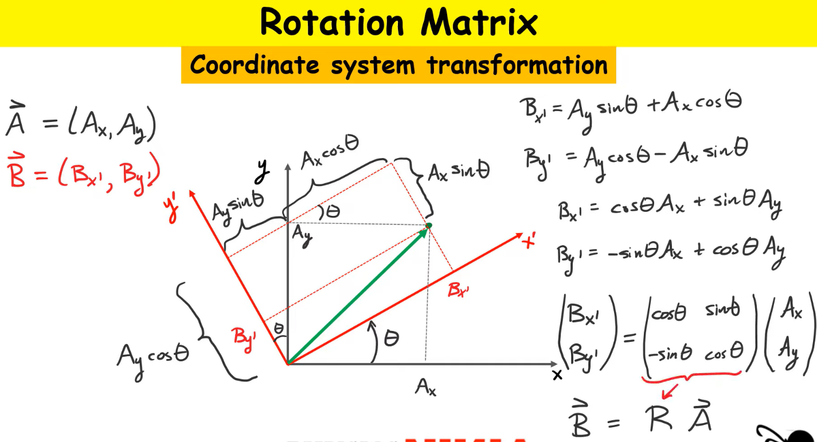

By [Nevit Dilmen](https://commons.wikimedia.org/wiki/User:Nevit)

* [CC BY-SA 3.0](http://creativecommons.org/licenses/by-sa/3.0/)view terms
* File:Plastic Protractor Polarized 05375.jpg
* Created: 1 January 2004

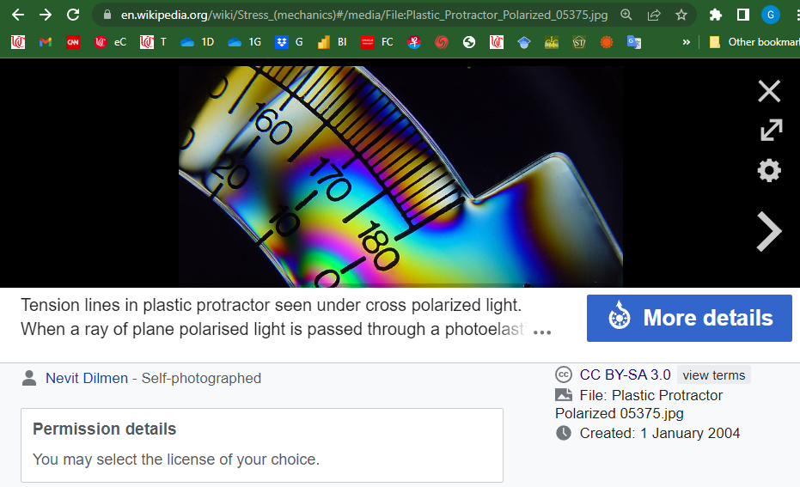

nnnn

[Sanpaz](https://commons.wikimedia.org/wiki/User:Sanpaz) - Own work

Tetrahedron for deriving the expression of the stress vector on any plane with normal vector n as a function of the components of the stress tensor.

* [CC BY-SA 3.0](https://creativecommons.org/licenses/by-sa/3.0)
* File:Cauchy tetrahedron.svg
* Created: 4 July 2009

