Nnnn

*y*

*y*

** is constant

*x*

*y*

**

**

*x*

**

*P*

tangent of ** at *P*

** is constant

**

0

*x*

*y*

**

*r*

A

**

A’

0

*a*

*a*

0

**

*x*

*y*

*X*

*Y*

**

**

A’

*a*

*a*

A

0

**

*x*

*y*

*X*

*Y*

**

*c*

B

**

A’

*b*

A

0

B’

*a*

**

*x*

*y*

** is constant

** is constant

**

**

0

**0 (constant)

at boundary

*R*2

(*a*)

*R*

(*b*)

*R*2

*R*1

*O*2

*R*2

*M*2

*z*2

*r*

*z*2

*O*

*z*1

`

*M*1

*r*

*z*1

*R*1

*O*1

N

d*A*

*p*

d**

W

0

E

*r*

*a*

d*r*

S

*p*

*r*

0

*rrz*

*zzz*

M

*rrz*

*z*

*zzz*

*z*

d*s*

m

*s*

**

d**

d*A*

**

*a*

n

M

0

*r*

*p*

*p*

0

*a*

*r*

**

**

M

m

n

d*A*

d*s*

d**

*s*

*P*

0

*r*

*y*

*x*

*x*

*R*

*z*

(*x, y, z*)

*y*

*z*

*P*

0

*r*

*y*

*x*

*x*

*R*

*z*

(*x, y, z*)

*y*

*z*

0

*y*

**

*P*

**

**

**

*r*

*x*

0

*y*

**

*P*

**

*r*

**

**

A

A’

d**

*rr*

*r*d**

*x*

*y*

0

*z*

*d*

*Mz*

*P*

*x*

*z*

*x*

*Vy*

(*a*)

0

*z*

*y*

*P*0= *Vy*

*M*0=*Mz*

*x*

*z*

*x*

(*b*)

*y*

0

*z*

*P*0

*M*0

*x*

*z*

*x*

*y*

*P*

*z*

*x*

d*x*

*x*

0

*y*

*L/*2

*L/*2

*p*

*x*

0

*z*

*x*

d*x*

*x'*

*q*

A

*r*

d*r*

*a*

*l*

*q*

*x*

0

*bz*

*d*

*z*

*P*

0

*y*

*r*

**

d**

*rr*

*r*d**

WedgeSrr

A’

A

*x*

*P*

0

*y*

**

*dp*

*r*

*d*

A’

A

*x*

*y*

**

*b*

*r*

**

**

A

B’

B

*a*

0

A’

*x*

*x*

*y*

* *

*y*

*r*

*b*

*x*

**

*a*

*b*

*r*

0

*a*

*pi*

*p*o

*y*

*P*

*x*

0

*z*

*L x*

*x*

*L*

*y*

*Vx*

*Mx*

0

*x*

*x*

*L*

d*x*

(a)

*y*

** =0

** =0

(c)

*A*′

**

**d

*ty*

*y*

*z*

**

*z*

*x*

*z*

*x*

0

*A*

Neutral axis

(b)

*y*

*Vx*

*z*

*Mx*

0

*x*

*x*

*L*

** =0

d*x*

(a)

*y*

** =0

(c)

*q=* t

*A*′

**

**d

*ty*

*y*

*z*

**

*z*

*C*

Neutral axis

*x*

*x*

*z*

0

*x*

(b)

*z*

*z*

*x*

*s*

*r*

*xr*

*xs*

B′

D′

*P*

d*A*

*P*

C

D

C

B

*y*

*h/*2

**

*z*

**max

0

*h/*2

*PL*

*M*

*ML*

0

*L x*

*x*

*x*

*y*

*PL*

*ML*

*x*

0

*L x*

*x*

*L*

*y*

*P*

*p*

*x*

0

*L x*

*x*

*L*

*y*

*L x*

*L*

*p*

*x*

0

*x*

(a)

*y*

*p*

*x*

0

*L x*

*x*

*R*

(b)

*y*

*F*

*p*

*M*

*x*

0

*L x*

*x*

*L*

*F*2

*F*1

*y*

*L/*2

*L/*2

*x*

*x*

0

C

A

B

*x*

*L/*2* x*

*L x*

*y*

*P*

*x*

d*x*

0

*L x*

*x*

*L*

*m*2

*m*1

*k*2

*k*1

*F*2

*F*1

*D*2

*D*1

*y*

D

C

d*y*

B

A

**n**

d*l*

*A*

0

d*x*

*x*

*t*

*w*

**

*x*

*w*1

0

*p*

*S*

*S*

*y*

**n**

D

C

d*y*

*s*

B

A

d*x*

0

*x*

*w*

*S*

**d**

*p*

**

*S*

*x*

0

*z*

*zy*

*y*

*zr* = 0

d*s*

**

d*y*

**

*zx*

P

d*x*

**n**

d*s*

**

d*y*

P

d*x*

*s*

*z*

0

*x*

*y*

*s*

d*y*

*B*

*A*

*y*

0

*x*

*y*

*s*

d*y*

*A*

*B*

*y*

*x*

0

*y*

*a*

*h*/3

*h*

*a*

0

*x*

*a*

*y*

*y*

*b*

*b*

*h*

*w*

*h*

0

*x*

*w*

*x*

*p*

*y'*

B

*tw*

Plane of

loading

*n*

*hb*

**

*x*

**P**

**

0

**

*tf*

C

*'*

*x'*

*Y*

*y*

A

*X*

*n*

0'

*wf*

*y'*

*y*

*wft*

*Ft*

*tft*

*V*

*tw*

*b*

*e*

*hb*

*h*

*x*

*z*

*Fw*

*C*

0

*wfb*

*tfb*

*Fb*

*x'*

0'

*y'*

*y*

*wf*

*tf*

*x*

*hb*

0

*tw*

0'

*x'*

*z*

*y*

0

C

B'

B

*V*

*V*

*z*

*y*

0

*hb*

*tft*

*tw*

*wfb*

*tfb*

*wft*

C

T

T'

B'

B

*y*

*qD*2

*qD*3

*qD*2

*qD*3

3

2

3

2

T'

T

T'

T

D

D

D

*q* =0

*q* =0

*q* =0

*qD*'4

5

4

1

*qD*'5

*x*

D'

(*a*)

(*b*)

*qmax*

*qD*'5

*qD*'4

*qD*'1= *qD*'4+ *qD*'5

*q* =0

*q* =0

*q* =0

D'

*qD*1= *qD*2+ *qD*3

5

4

1

(*a*)

*x*

*x*

*z*

0

C

B'

B

D'

*y*

*y*

*z*

*x*

A

*z*

*x*

*V*

*e*

P

A

*tT*

*tL*

*VR*

*VL*

*tR*

*h*

S

Q

0

0

C

0

(*b*)

(*a*)

*tB*

*b*

B

B

R

B

A

P

R

*qA*

*qP*

*V*

*e*

B

A

P

R

B

A

P

R

S

Q

Q

S

(*c*)

*qR*

(*a*)

(*b*)

*qP*

1

1

B

A

P

R

B

A

P

R

*qR*

1

1

Axis of symmetry

C

C

C

C

C

C

(*c*)

(*b*)

(*a*)

*z*

*y*

0

C

B'

B

*z*

*y*

0

*hb*

*tft*

*tw*

*wfb*

*tfb*

*wft*

C

T

T'

B'

B

*y*

*V*

*V*

3

2

*A*'

T'

T

T'

T

*s*

D

D

D

*A*'

** =0

** =0

** =0

5

4

1

*hwu*

(*c*)

(*b*)

(*a*)

*s*

*x*

*x*

*x*

*z*

0

C

B'

B

D'

D'

*y'*

*wft*

*y*

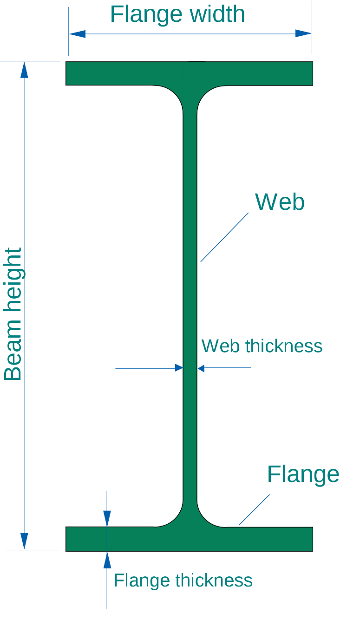

*x'*

*tfb*

*tft*

*wfb*

*tw*

*hb*

0

0'

*x*

*y*

*A*′

*h/*2

*yc*

*y*

*z*

0

*h/*2

*b*

*y'*

*y*

*x*

d*A*

*x'*

*y*

*x*

*h*

*y'*

0

0'

*x'*

*b*

*y*

*P*

0

*y*

*b*

*x*

*h*

**

*x*

*b*

*h*

*b*

*h*

*y*

*b*

*a*

*x*

0

*x*

*b*

*A, J*

0

*a*

*r*

*y*

*x*

*r*

*a*

*A, J*

*x*

*zy*

*zx*

*y*

*y*

=

*x*

*y*

0

*y*

*x*

**P**A

A

**M**A

*n*

Neutral axis

*e*

C

0

**

*e*

B

Centroid axis

**

*x*

C

0

Shear-center axis

**M***x*

*z*

**

*x*

Loading plane

*y*

**M***y*

**M**

*y*

*n*

d*A*

*x*

zzd*A*

*z*

*y*

**T**

*z*

*x*

B

A

**T**

*z*

B*

0

*y*

*L*

B

C

A

*d*2*1*

**T**1

**T**2

*d*1*1*

0

*x*

*L*1

*L*2

B

A

0

**T**

*yzz*

*zyz*

*z*

d*z*

B*

*a*

*x*

*y*

*L*

*d*

0

**T**

*x*

d*x*

*L*

*y*

*P*

*p*

0

*x*

d*x*

*L*

*p*

0

*P*

*x*

d*x*

*L*