HarvardDataverse_EDA_S226102069

Dataset URL : https://dataverse.harvard.edu/file.xhtml?fileId=13147440&version=2.0

Part C
Total No of Rows : 439,940
Total No of Columns : 31
Numerical Variables : 28
Categorical Variables : 3 (This includes a latest processed at datetime variable as well as it processed as string with UTC time)
Missing Values : There are missing values in 6 columns out of the 31 columns in the dataset as listed in below
two_party_margin_raw 644
republican_pct_two_party_raw 644
democrat_pct_two_party_raw 644
democrat_pct_two_party_imp 4
two_party_margin_imp 4
republican_pct_two_party_imp 4

Part D

Selected Categorical variable and Numerical variables are as follows
# Category Variable :company_name,
# First Numeric Variable : avg_match_quality
# Second Numeric Variable : employee_count

Part E
As per the above plot it seems for the selected 10 rows by head(10) argument added in the code company names are evenly/uniformly distributed. Where for each row is coming from a different company_name hence it seems like a balance distribution in company_name

Part F
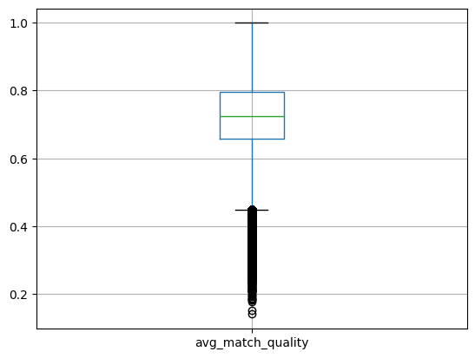
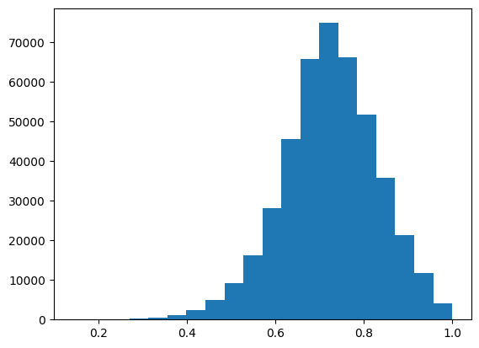

This seems to be a left/negatively skewed distribution as the tail tends to be on the left side. And the Skew value result of avg_match_quality(-0.2863029544181897) variable confirms it.
and the shapiro wilk test result (P-value <0.05) confirms that the data are not normal frp avg_match_quality variable.

And regarding outliers it seems to be lot of outliers on 0 - 0.4 range as it can be seen in the plotted boxplot

Part G

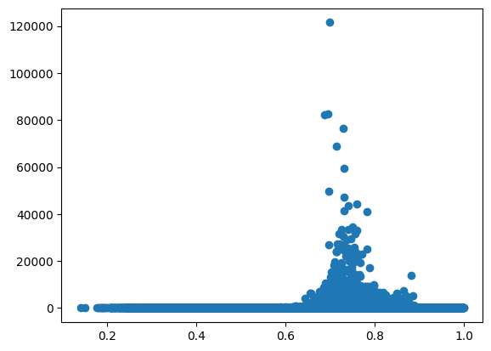
Correlation: 0.004711268178613951 , P-value: 0.0017786724000946781
As per the above plot and and the correlation co-efficient value and the P-value (<0.05) from pearson test it can be stated that these two numerical variables (avg_match_quality, employee_count) are not correlated under 95% significance

Part H
Mean : 0.7230094043743687
Median : 0.7248109154451354
St. Dev. : 0.10802111121052542
Min : 0.140379780722866
Max : 0.9993965607860658

As per the above statistics it seems avg_match_quality variable has almost same mean and median hence giving the approximately symmetric distribution. And all values are in between 0.14 and 0.99 approximately. As standard deviation is 0.108 most values will be between (0.724 - 0.108, 0.724 + 0.108) = (0.616, 0.832)

Part I

Dataset & Objective
This is a CSV dataset from Harward dataverse site regarding industry year panel dataset taken from VRscores 2024 release covering years from 2012 to 2024. Each row represents an O NET SOC occupation with at least five matched workers across any year. While this contains 439,940 total rows with 31 columns and only 6 columns contain missing values. And the objective is to use this dataset to explore the python functions and formulas related EDA while grasping what are the information that can be derived from from this dataset.

Data Overview & Cleaning
This is a panel dataset. While the year was kept in the numerical format only datetime field which was originally read as a string field was converted into a datetime field even though it was not used in this EDA for the cleaner / transformed data.
And for the missing values as it’s a minor percentage compared to 400,000+ entries those missing values can be dropped in further analysis. And outlier were seen in the box plot analysis as well for the avg_match_quality variable as well.

Results
Regarding the results on EDA main focus was given to understanding the data first which was extracted from df.describe() command which have the summary statics of the dataset column wise. From the count values it could be seen that the missing values are available in some field hence the missing values count has been analysed by the following command which identified that only 6 columns indicates missing values and the percentage is a negligible amount compared to the total number of the rows (439,940). df.isnull().sum().sort_values(ascending=False).head(10)
And from the summary statistics it turned out that Year field is an constant variable as the standard deviation of it was 0 as well as Min and Max values were 2015 as well.
And then to get an idea on the distribution of the company name top 10 rows frequency distribution was plotted in a bar chart which turned out to be an uniform distribution.
Same approach was taken to analyze the distribution of avg_match_quality by using a histogram which interpreted that the distribution is not normal and also Shapiro wilk test’s P-value proved it by rejecting null hypothesis. And the skewness of the field turns out to be -0.29 approximately which was a light skewness which explained why the avg_match_quality’s both Median and Mean values are almost at same value.
And to evaluate the relationship between avg_match_quality and employee_count scatterplot was plotted and pearson correlation was calculated as well. And both scatterplot and the p-value(0.0017) in correlation test as well as correlation value (0.004711) results were analysed which gave the interpretation while correlation coefficient is significant but as the value is almost zero there no strong linear relationship between the two variables.

Conclusion and Limitations
This EDA was executed focusing on understanding the structure and the quality of the dataset using the summary statistics and basic visualization such as scatterplots, barcharts and histograms. Missing value analysis summarised that only six variables contained missing values, accounting for a negligible proportion relative to the total number of observations (439,940).
And the Year variable was identified as constant, with zero variability (SD =0). Futhermore analysis of the distributions of the selected numerical variables revealed a uniform distribution for company names, while avg_match_quality was non-normal, supported by histogram analysis and the Shapiro–Wilk test.
Despite a statistically significant Pearson correlation (p = 0.0017) between avg_match_quality and employee_count, the near-zero correlation coefficient indicates no meaningful linear relationship.

