**Kavya Verma** 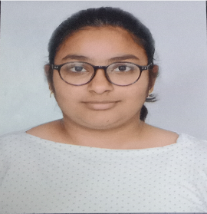

Address: - Plot no.1 Navsheel Dham,

Kalyanpur, Kanpur,208017

Contact no.: - 8890353356

Email: - kavyaverma20973.dpskalyanpur@gmail.com

GitHub: - https://github.com/kavu-08

**Academic Qualification**

* CBSE (Xth Boards): - Delhi Public school, Kalyanpur 2019-2020
* CBSE (XIIth Boards): - Delhi Public School, Kalyanpur 2021-2022
* Bachelor of engineering, Electronics and Communication: -

Banasthali Vidyapeeth, Rajasthan 2022-2025 (expected)

**Skills**

* Programming: - C, C++, JavaScript
* Backend: - Node.js, React.js, Python, MongoDB, Express.js
* Frontend: - HTML, CSS
* Others: - MySQL, PHP, Linux, OOPs, Git, Electronic: -Circuit Diagram, PCB Design, Verilog, VHDL , MS-Excel, MS-office

**Work Experience**

#### Project intern, IIT Kanpur – Kanpur, UP, India

May 2023- June 2023

#### Project Intern, AICTE - Bangalore, India

May 2024- July 2024

Web development project.

Digital Guest Onboarding System project, Sending an Email using Nodejs.

Smart Luggage bag using Arduino Uno, Banasthali Vidyapeeth

**Profile Summary**

With a strong foundation in Electronics and communication, bringing experience in software engineering, developing and AI Research. Looking for a challenging position in a progressive organization to develop my skills and gain experience so that I can become more profitable to the organization.