Business Requirements Document — Product Feature
Product: Product Feature
Product Canvas Summary:
## Feature
This feature allows you to pay your electricity bills usin
BRD
Version 1.0 | Draft / Confidential

Revision History
Sr. No. | Version No. | Date of Change | Change By | Reviewed By | Remarks
1 | 1.0 | 15 April 2026 | Chief Product Officer |  | Initial draft

Table of Contents
Update field to refresh entries and page numbers.

i. Current State
Currently, the Unified Payments Interface (UPI) ecosystem operates through a collaborative framework involving multiple participants, each playing a distinct role in facilitating seamless digital transactions. The primary participants include the National Payments Corporation of India (NPCI), which manages the UPI switch and Common Library, Payment Service Provider (PSP) Banks that host UPI applications, Issuer Banks that authenticate and debit payer accounts, and Beneficiary Banks that credit recipient accounts. The UPI App, such as PhonePe or GPay, serves as the customer-facing interface, enabling users to initiate and authorize transactions. The standard UPI transaction flow involves capturing the customer's authentication details through the UPI App, which are then encrypted and sent via the PSP Bank to NPCI for processing.
In the current system, once a payment request is initiated, the NPCI routes the transaction through a series of stages. Initially, the authentication details are verified, followed by a debit request sent to the Issuer Bank, which then debits the payer's account. Upon successful debit, the NPCI forwards a credit request to the Beneficiary Bank, which credits the recipient's account. The transaction concludes with a confirmation message sent back to both the payer's and payee's PSPs.
This process ensures a secure and efficient transaction flow, with NPCI acting as the central routing engine, ensuring that all messages are accurately processed and routed between the involved parties. The current system is designed to handle typical transaction scenarios efficiently, ensuring that funds are transferred promptly and securely.

ii. Limitations / Challenges
The current UPI system, while robust, faces several limitations that hinder its potential for growth and efficiency. These challenges not only affect the operational capabilities of the ecosystem participants but also pose risks to user experience and regulatory compliance. Addressing these limitations is crucial for enhancing the system's security, scalability, and overall functionality.
- Security Gaps: Affects PSP Banks and Issuer Banks. Current encryption methods may not be sufficient against evolving cyber threats, potentially leading to unauthorized access and data breaches.
- Friction Points: Affects UPI App users. The multi-step authentication process can lead to user drop-off, reducing transaction completion rates and affecting user satisfaction.
- Scalability Concerns: Affects NPCI. The existing infrastructure may struggle to handle the increasing volume of transactions, leading to potential delays and system downtimes.
- Regulatory Gaps: Affects Compliance Teams. Current processes may not fully align with emerging regulatory requirements, risking non-compliance and potential penalties.

iii. Why the Proposed Change
The proposed change is driven by the need to align with recent RBI guidelines that mandate enhanced security measures for digital payment systems. These guidelines emphasize the importance of biometric authentication to mitigate fraud risks and ensure secure transactions. By integrating biometric capabilities into the UPI ecosystem, we not only comply with regulatory requirements but also strengthen the overall security framework. This change is crucial for maintaining user trust and safeguarding sensitive financial data, which is a top priority for all stakeholders, including NPCI, PSP Banks, and Issuer Banks.
From a business perspective, the adoption of biometric authentication is expected to significantly enhance the user experience by providing a seamless and secure transaction process. This approach was chosen over traditional methods due to its ability to offer both convenience and robust security. Unlike PIN-based systems, biometric authentication reduces the risk of unauthorized access and enhances transaction speed, thus improving customer satisfaction. Furthermore, this change positions the UPI platform as a leader in payment innovation, setting a benchmark for future developments in the digital payments landscape.

i. Product Description
The new feature enhances the UPI payment ecosystem by introducing a streamlined biometric authentication process for transaction approvals. This feature allows users to authenticate transactions using biometric data, such as fingerprints or facial recognition, directly through the UPI App. The primary business outcome of this feature is to increase the security and convenience of UPI transactions, thereby encouraging higher adoption rates and reducing the risk of fraudulent activities. By leveraging biometric authentication, users can experience faster transaction processing without compromising on security.
This feature impacts several key participants within the UPI ecosystem, including the NPCI, PSP Banks, Issuer Banks, and Beneficiary Banks. NPCI will manage the integration of biometric authentication within the Common Library (CL) and ensure secure data transmission through the UPI switch. PSP Banks will need to update their UPI Apps to support biometric data capture and processing, while Issuer Banks will be responsible for verifying and authorizing transactions based on biometric credentials. Beneficiary Banks will continue to handle the crediting of funds, but with enhanced security measures in place.
From a business perspective, this feature addresses the growing demand for more secure and user-friendly payment methods. By reducing reliance on traditional PIN-based authentication, the feature mitigates the risk of unauthorized access due to compromised credentials. It also aligns with regulatory requirements for strong customer authentication, thereby ensuring compliance and fostering trust among users. Overall, the introduction of biometric authentication in UPI transactions is expected to enhance user experience, increase transaction volumes, and strengthen the overall security framework of the digital payment landscape.

ii. Product Construct: Setting / Enrollment
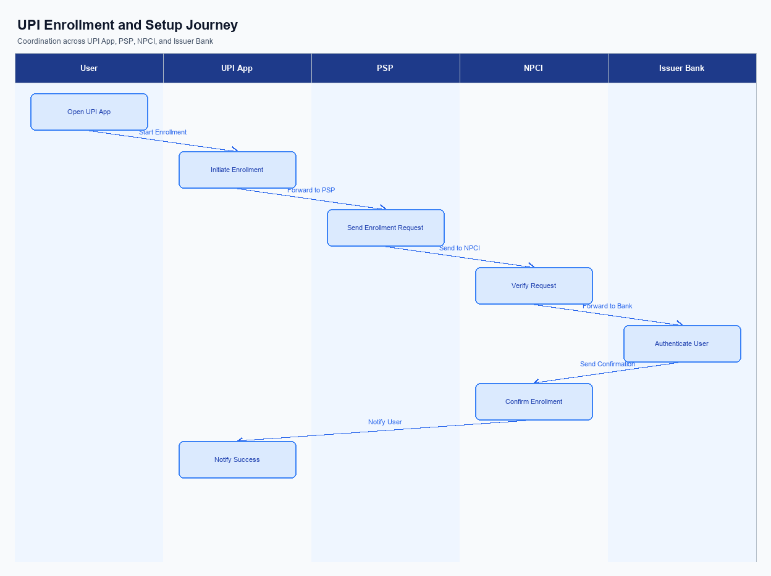
Figure: Enrollment / setting journey across UPI App, PSP, NPCI, and Issuer Bank
The enrollment process for new users on the UPI platform is designed to be seamless and user-friendly, ensuring that users can quickly and securely set up their accounts. The process begins with the user accessing the UPI App, where the option to enroll is prominently displayed on the main dashboard for easy access. Consent capture is a critical component, and users are required to explicitly agree to the terms and conditions before proceeding. This ensures compliance with regulatory requirements and enhances user trust.
The indicative user journey involves several key steps. Initially, the user selects the enrollment option on the UPI App, which triggers the process. The app then guides the user through a series of screens to input necessary details such as mobile number and bank account information. The PSP Bank plays a crucial role by securely transmitting this information to NPCI, which verifies the details and initiates the authentication process.
The Issuer Bank is responsible for authenticating the user and confirming their account details. Once all checks are passed, the user receives a confirmation message, completing the enrollment process.
Step | Activity | Responsible
Pre-Check | Verify user eligibility and app readiness | UPI App
Step 1 | User selects enrollment option | UPI App
Step 2 | Capture user consent and input details | UPI App
Step 3 | Transmit user details for verification | PSP Bank
Step 4 | Verify user details and initiate authentication | NPCI
Step 5 | Authenticate user and confirm account details | Issuer Bank
Post Response | Send confirmation message to user | UPI App

iii. Product Construct: Transaction Flow
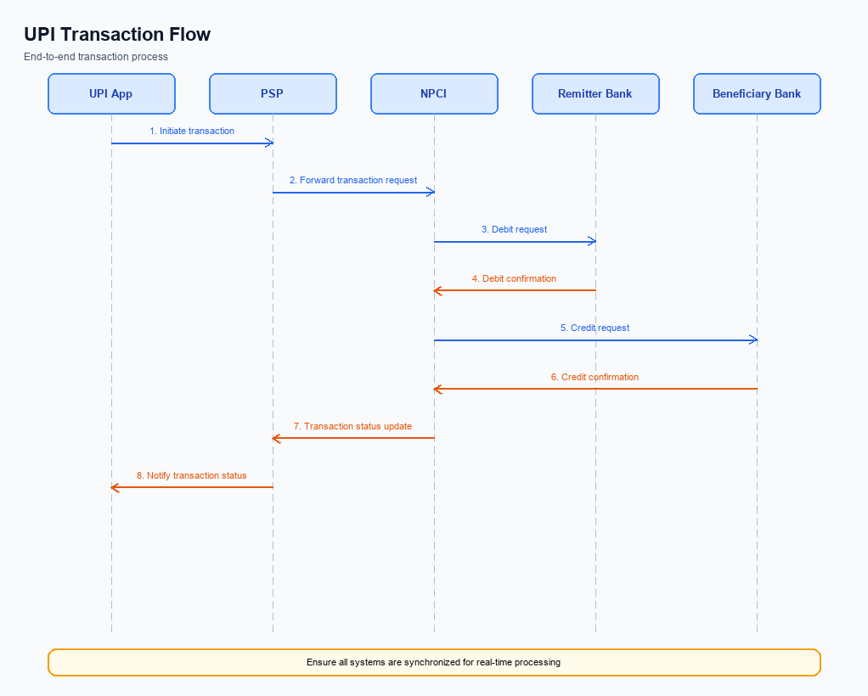
Figure: Transaction flow: UPI App → PSP → NPCI → Remitter Bank → Beneficiary Bank → NPCI → PSP
The transaction flow for a UPI payment begins once the customer has successfully enrolled and linked their bank account through a UPI App. The process is initiated when the customer triggers a payment request by entering the payee's Virtual Payment Address (VPA) and the amount to be transferred. The UPI App captures the customer's authentication credentials, such as a PIN or biometric data, which are then encrypted by the Common Library (CL) and sent to the Payment Service Provider (PSP) Bank. The PSP Bank forwards the payment request to NPCI, which acts as the central switch for routing the transaction.
Upon receiving the payment request, NPCI sends an authentication request to the Issuer Bank to verify the customer's credentials. Once authenticated, the Issuer Bank debits the customer's account and sends a debit confirmation back to NPCI. NPCI then routes a credit request to the Beneficiary Bank, which credits the payee's account and confirms the transaction to NPCI. Finally, NPCI sends a confirmation message to both the PSP Bank and the UPI App, completing the transaction flow.
This seamless process ensures secure and efficient fund transfers across the UPI network.
Step | Activity | Responsible
Pre-Check | Customer initiates payment request via UPI App | Customer
Step 1 | UPI App encrypts credentials and sends to PSP Bank | UPI App
Step 2 | PSP Bank forwards payment request to NPCI | PSP Bank
Step 3 | NPCI sends authentication request to Issuer Bank | NPCI
Step 4 | Issuer Bank authenticates and debits customer account | Issuer Bank
Step 5 | NPCI routes credit request to Beneficiary Bank | NPCI
Step 6 | Beneficiary Bank credits payee account and confirms | Beneficiary Bank
Post Response | NPCI sends transaction confirmation to PSP Bank and UPI App | NPCI

Other Salient Points
This section covers Other Salient Points.
Details to be elaborated further.

Dispute Management
This section covers Dispute Management.
Details to be elaborated further.

Functional Requirements
This section covers Functional Requirements.
Details to be elaborated further.
ID | Requirement | Priority
FR-01 | The system shall satisfy the integration behaviour described in this document. | High
FR-02 | The system shall expose observability suitable for production support (logging, tracing). | Medium
FR-03 | The system shall enforce security and data-handling policies defined by the program. | High

A. NPCI (UPI Platform & CL) — Setting / Schema / Registration Changes
This section covers A. NPCI (UPI Platform & CL) — Setting / Schema / Registration Changes.
Details to be elaborated further.

B. NPCI (UPI Platform & CL) — Transaction Flow / Processing Changes
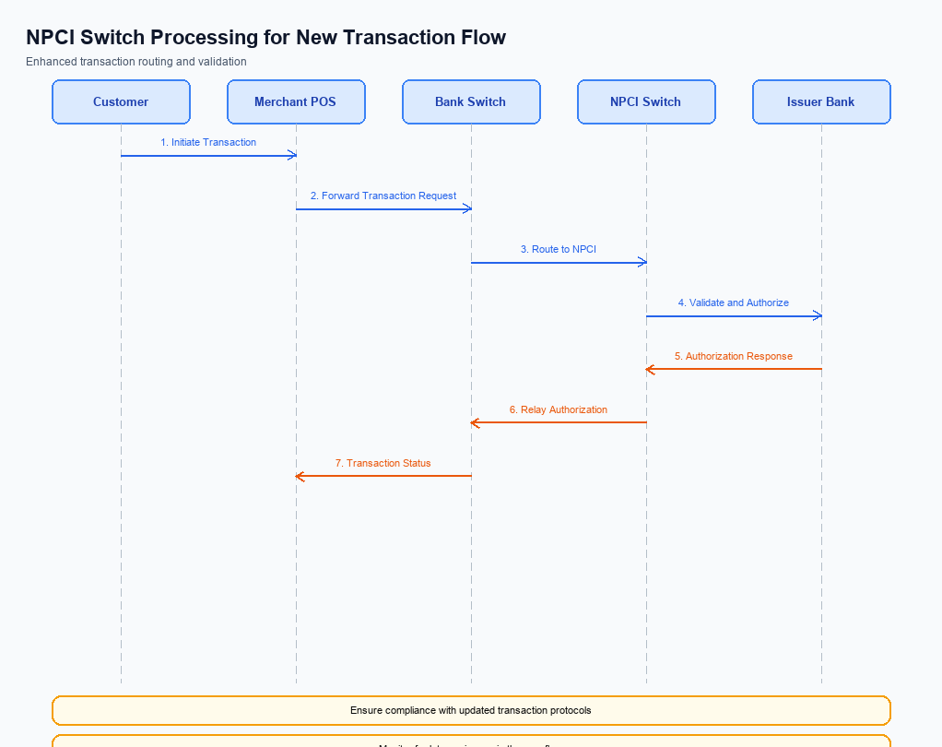
Figure: NPCI switch processing changes for the new transaction flow
The NPCI, as the central authority managing the UPI switch and Common Library, is implementing several changes to enhance the transaction flow and processing capabilities. These changes are designed to improve the efficiency and security of payment transactions, ensuring compliance with the latest industry standards. The modifications will affect various aspects of transaction routing, credential validation, and response handling, which are critical for seamless payment processing.
The updates will specifically address the handling of refCategory transactions, ensuring that biometric-authenticated payments are processed with the highest level of security. Additionally, enhancements in credential validation will be implemented to strengthen the authentication process. Changes in switch routing will optimize the flow of transactions across the network, while response handling improvements will ensure timely and accurate feedback to all parties involved in the transaction.
- 1. NPCI will implement enhanced handling for refCategory='05' transactions, ensuring that biometric-authenticated payments are processed with priority and additional security checks.
- 2. NPCI will update the credential validation process within the Common Library to include advanced encryption techniques, ensuring that all authentication data is securely handled and transmitted.
- 3. NPCI will modify the switch routing logic to optimize the flow of transactions, reducing latency and improving the overall efficiency of the UPI network.
- 4. NPCI will enhance response handling mechanisms to provide more accurate and timely feedback to PSP Banks, Issuer Banks, and Beneficiary Banks, ensuring that all parties are promptly informed of transaction statuses.

A. UPI App / PSP — App-side Changes
The UPI App and PSP are required to implement several changes on the app side to facilitate seamless enrollment, consent capture, and device binding. These changes are essential to ensure compliance with NPCI guidelines and to enhance user experience. The modifications will involve updates to the user interface, invocation of the Common Library (CL) SDK, and adjustments to local key storage and device check logic.
The following requirements outline the necessary changes that the UPI App and PSP must undertake. Each change is designed to ensure that the app functions optimally within the UPI ecosystem, providing secure and efficient payment processing. These changes will be critical for maintaining the integrity and security of user transactions and data.
- The UPI App must update its user interface to include a new enrollment screen where users can provide consent for data sharing and device binding. This screen should clearly display terms and conditions and capture user consent explicitly.
- The PSP is responsible for invoking the CL SDK during the enrollment process to securely handle authentication data. This invocation must be integrated seamlessly into the app's workflow to ensure a smooth user experience.
- The UPI App must implement local key storage using the device's secure enclave or trusted execution environment (TEE). This ensures that sensitive authentication data is stored securely and is protected against unauthorized access.
- The PSP must incorporate device check logic to verify the device's integrity and compatibility before proceeding with enrollment and consent capture. This logic should include checks for device rooting or jailbreaking to prevent potential security breaches.

B. UPI App / PSP — Transaction-time Changes
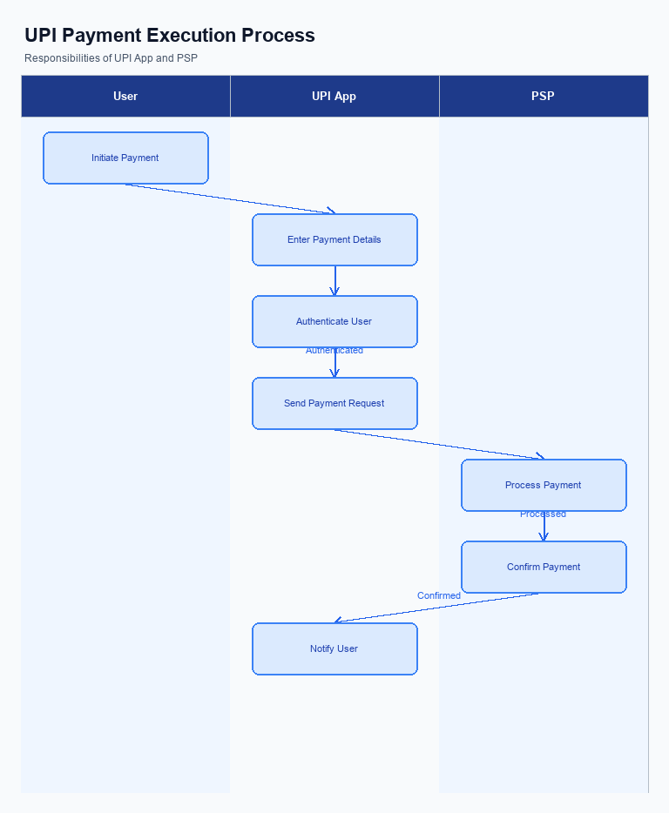
Figure: UPI App and PSP responsibilities during payment execution
This section covers B. UPI App / PSP — Transaction-time Changes.
Details to be elaborated further.

A. Issuer Bank — Auth / Registration Changes
This section covers A. Issuer Bank — Auth / Registration Changes.
Details to be elaborated further.

B. Issuer Bank — Transaction Flow Changes
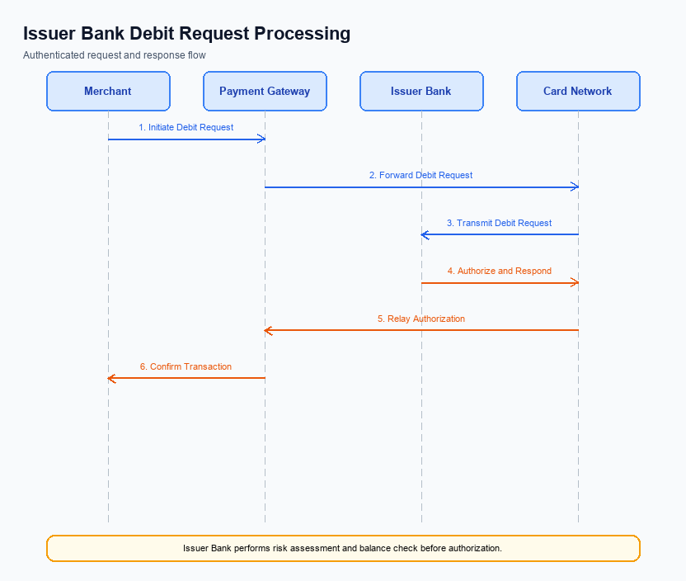
Figure: Issuer bank processing of authenticated debit requests and response flow
The Issuer Bank plays a critical role in the UPI transaction flow, particularly in processing authenticated debit requests. As part of the enhancements under this feature, several changes are being introduced to ensure seamless and secure processing. These changes are aimed at improving the efficiency of credential and authentication validation, optimizing debit processing, and enhancing the handling of response codes and timeouts.
The changes outlined below are designed to align with the latest specifications issued by NPCI and are intended to provide a robust framework for managing authenticated debit requests. Each change is numbered for clarity and will require the Issuer Bank's compliance and integration efforts to ensure successful implementation.
- 1. Credential and Authentication Validation: The Issuer Bank must validate the encrypted credential block (CRED Block) received from NPCI. This involves decrypting the credentials using the secure enclave and ensuring that the authentication data aligns with the standards set by NPCI.
- 2. Debit Processing: Upon successful validation of credentials, the Issuer Bank is responsible for executing the debit transaction. This includes checking account balance sufficiency and applying any relevant transaction limits before proceeding with the debit.
- 3. Response Codes: The Issuer Bank must return specific response codes to NPCI upon completion of the debit process. These codes should accurately reflect the transaction status, such as success, insufficient funds, or authentication failure, to facilitate accurate transaction tracking.
- 4. Timeout Handling and Fallback: In cases where a transaction times out, the Issuer Bank must implement a robust timeout handling mechanism. This includes retry logic and fallback procedures to ensure that transactions are either completed or appropriately flagged for manual review.

