Business Requirements Document — Product Feature
Product: Product Feature
Product Canvas Summary:
## Feature
**What the Feature Does:**
This new feature allows users t
BRD
Version 1.0 | Draft / Confidential

Revision History
Sr. No. | Version No. | Date of Change | Change By | Reviewed By | Remarks
1 | 1.0 | 16 April 2026 | Chief Product Officer |  | Initial draft

Table of Contents
Update field to refresh entries and page numbers.

i. Current State
The current UPI payment flow involves several key participants: the NPCI, PSP Bank, Issuer Bank, Beneficiary Bank, and the UPI App. The process begins when a customer initiates a payment request through their UPI App, which is hosted by the PSP Bank. The UPI App captures the customer's authentication details, such as a PIN or biometric data, which are then encrypted using the Common Library provided by NPCI. This encrypted credential block is sent to the NPCI, which operates the central switch responsible for routing the payment request to the appropriate banks.
Once the NPCI receives the payment request, it sends an authentication request to the Issuer Bank, which is responsible for verifying the customer's credentials and debiting the customer's account. Upon successful authentication and debit, the NPCI routes the credit request to the Beneficiary Bank, which credits the recipient's account. The Beneficiary Bank then sends a confirmation back to the NPCI, which in turn notifies both the Payer PSP and the Payee PSP of the transaction's completion. This process ensures secure and efficient fund transfers between the payer and the payee, with each participant playing a critical role in the transaction lifecycle.

ii. Limitations / Challenges
The current UPI system, while robust and widely adopted, faces several limitations that hinder its optimal performance and user experience. These limitations pose challenges across various aspects such as security, user convenience, scalability, and regulatory compliance. Addressing these issues is crucial for enhancing the system's efficiency and ensuring it meets the evolving needs of stakeholders, including banks, users, and regulatory bodies.
- Security Vulnerabilities: The Issuer Bank faces potential security gaps due to outdated encryption methods, which can lead to increased risk of unauthorized access and fraud.
- User Experience Friction: PSP Banks encounter user drop-offs during the payment authentication process, as the current system requires multiple steps, leading to a cumbersome user experience.
- Scalability Constraints: NPCI's existing infrastructure struggles to handle the increasing volume of transactions during peak times, resulting in delayed processing and potential transaction failures.
- Regulatory Compliance Gaps: Beneficiary Banks may face challenges in meeting evolving regulatory requirements, as the current system lacks the flexibility to quickly adapt to new compliance standards.

iii. Why the Proposed Change
The proposed change is driven by the need to align with the latest Reserve Bank of India (RBI) guidelines, which emphasize enhanced security measures and improved user authentication processes in digital payments. As digital transactions continue to grow, the RBI has mandated stricter compliance to ensure the safety and integrity of financial data. This change also addresses the increasing demand for robust biometric authentication, which is seen as a more secure alternative to traditional PIN-based methods. By implementing these changes, NPCI and participating banks aim to reduce fraud risks and enhance trust in the UPI ecosystem, thereby supporting the broader regulatory framework and promoting financial inclusion.
From a technical standpoint, the proposed change offers significant benefits in terms of user experience and security. By integrating biometric authentication, users can enjoy a more seamless and secure transaction process, reducing the friction often associated with PIN entry. This approach was chosen over alternatives due to its ability to leverage existing hardware capabilities, such as TEE and secure enclaves, which provide a high level of security without requiring additional infrastructure. Moreover, the use of nonce-based challenges further mitigates the risk of replay attacks, ensuring that each transaction is unique and secure.
This comprehensive approach not only meets regulatory requirements but also positions the UPI system as a leader in secure digital payments.

i. Product Description
The new feature enhances the UPI payment ecosystem by introducing an advanced biometric authentication mechanism for transaction approvals. This feature leverages biometric data to authenticate users, providing a more secure and user-friendly experience. It primarily affects the PSP Banks, Issuer Banks, and Beneficiary Banks by integrating biometric authentication into the existing UPI transaction flow. The introduction of this feature aims to reduce fraud and enhance the security of transactions, thereby increasing user trust and adoption of UPI services.
This feature addresses the growing need for robust security measures in digital payments by utilizing biometric data, such as fingerprints or facial recognition, as an additional layer of authentication. By doing so, it mitigates the risks associated with traditional PIN-based authentication, which can be susceptible to theft or misuse. The integration of biometric authentication is expected to streamline the transaction process, reduce the incidence of unauthorized transactions, and ultimately improve the overall efficiency and reliability of the UPI payment system.
From a business perspective, the implementation of biometric authentication is anticipated to enhance customer satisfaction by providing a seamless and secure payment experience. It also positions the participating banks and UPI apps as leaders in payment security innovation, potentially attracting more users to their platforms. The feature is strategically designed to align with regulatory compliance requirements, ensuring that all participants adhere to the highest standards of data protection and privacy.

ii. Product Construct: Setting / Enrollment
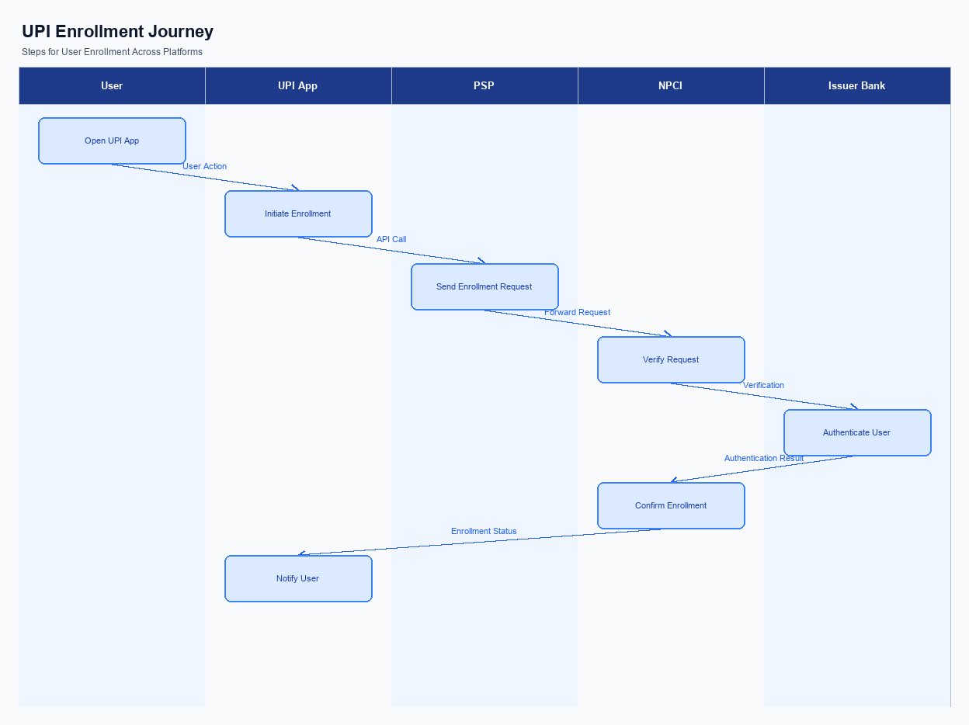
Figure: Enrollment / setting journey across UPI App, PSP, NPCI, and Issuer Bank
The enrollment process for UPI services is designed to ensure a seamless and secure user experience. Initially, the user accesses the UPI App, where the option to enroll in UPI services is prominently displayed on the home screen. The user is required to provide explicit consent for the enrollment process, which is captured through a consent form within the app interface. This consent is crucial for compliance with regulatory requirements and ensures that the user is fully informed about the terms and conditions of using UPI services.
The user journey begins with the user selecting the 'Enroll in UPI' option on the app. Following this, the UPI App prompts the user to enter their mobile number and select their bank from a list. The app then communicates with the PSP to initiate the enrollment process. The PSP, in turn, sends a request to NPCI to verify the user's mobile number and bank details.
Once verified, the Issuer Bank is contacted to authenticate the user and link their bank account to the UPI system. The process concludes with a confirmation message displayed to the user, indicating successful enrollment.
Step | Activity | Responsible
Pre-Check | Ensure UPI App is updated and user has active internet connection | User
Step 1 | User selects 'Enroll in UPI' option on the app | UPI App
Step 2 | Capture user's mobile number and bank selection | UPI App
Step 3 | Send enrollment request to PSP | UPI App
Step 4 | Verify mobile number and bank details with NPCI | PSP
Step 5 | Authenticate user and link bank account | Issuer Bank
Post Response | Display enrollment confirmation to user | UPI App

iii. Product Construct: Transaction Flow
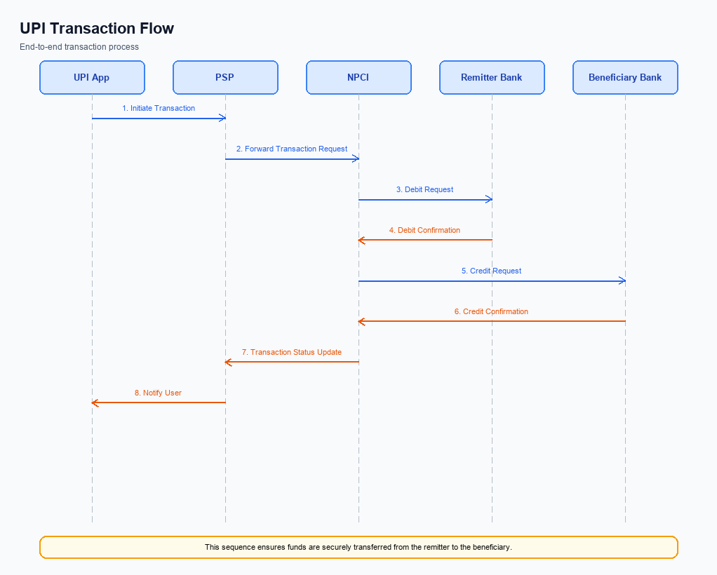
Figure: Transaction flow: UPI App → PSP → NPCI → Remitter Bank → Beneficiary Bank → NPCI → PSP
The transaction flow for a UPI payment begins once a user has successfully enrolled in the UPI system via their chosen UPI App. The process is initiated when the user triggers a payment request by entering the recipient's Virtual Payment Address (VPA) and the amount to be transferred. The UPI App then captures the user's authentication credentials, such as a PIN or biometric data, and securely transmits this information to the Payment Service Provider (PSP) Bank. The PSP Bank, in turn, sends a REQ_PAY message to the NPCI switch, which orchestrates the subsequent steps of the transaction.
Following the initiation, the authentication path is established as the NPCI sends a REQ_AUTH_DETAILS message to the Acquirer Bank, which is responsible for verifying the user's credentials. Once authentication is confirmed, the NPCI directs a debit request to the Issuer Bank, which debits the specified amount from the user's account. Upon successful debit, the NPCI routes a credit request to the Beneficiary Bank, which credits the recipient's account. Finally, confirmation messages are sent back through the NPCI to both the payer's and payee's PSPs, completing the transaction.
Step | Activity | Responsible
Pre-Check | User initiates payment request via UPI App | User
Step 1 | Capture and encrypt user authentication data | UPI App
Step 2 | Transmit REQ_PAY message to NPCI | PSP Bank
Step 3 | Authenticate user credentials | Acquirer Bank
Step 4 | Debit user account | Issuer Bank
Step 5 | Credit recipient account | Beneficiary Bank
Post Response | Send confirmation to payer and payee PSPs | NPCI

Other Salient Points
- 1. Users must have the option to opt-in or opt-out of biometric authentication for UPI transactions, with the ability to change their preference at any time through the UPI App.
- 2. Devices must support hardware-backed secure storage (TEE or Secure Enclave) to enable biometric authentication; otherwise, fallback to PIN-based authentication is mandatory.
- 3. In the event of a transaction failure due to network issues, the UPI App should implement a retry logic that attempts the transaction up to two additional times before notifying the user of the failure.
- 4. Users must be able to withdraw consent for data sharing related to UPI transactions at any time, and the UPI App must provide a clear and accessible mechanism for this withdrawal.
- 5. All new features must maintain backward compatibility with existing UPI specifications to ensure seamless integration and operation across all participant banks and UPI Apps.
- 6. Exception handling must include a mechanism for notifying users of any transaction status changes, such as DEEMED status, with clear instructions for resolution or further action.

Dispute Management
The introduction of this feature does not alter the existing dispute management process within the UPI framework. The standard UPI dispute resolution procedures will continue to apply, ensuring consistency and reliability across all transactions. This decision has been made to maintain the integrity and efficiency of the current system, which is well-understood by all ecosystem participants.
Under the standard UPI dispute framework, the liability for any transaction disputes is typically assigned based on the stage of the transaction where the issue occurred. The PSP Bank is responsible for initial customer support and dispute logging, while the Issuer Bank is liable for authentication and debit-related disputes. The Beneficiary Bank handles disputes related to crediting issues. The Service Level Agreement (SLA) for dispute resolution remains as per the existing guidelines, with a maximum resolution time of T+3 days.
Escalation paths involve the PSP Bank escalating unresolved issues to NPCI, which then coordinates with the involved banks to ensure timely resolution.

Functional Requirements
The functional requirements for the new UPI feature are outlined below. These requirements ensure that the system operates effectively and meets the needs of all stakeholders, including product managers, engineers, and compliance teams. Each requirement is designed to be testable, ensuring that the implementation can be validated against specific criteria. The priority of each requirement is indicated to guide development efforts and resource allocation.
ID | Requirement | Priority
FR-01 | The system shall encrypt all transaction data using the Common Library before transmission to ensure data security. | High
FR-02 | The system shall authenticate users via biometric or PIN as per the clVersion specification for enhanced security. | High
FR-03 | The system shall process REQ_PAY messages within 2 seconds to ensure timely transaction processing. | High
FR-04 | The system shall support VPA validation through REQ_VAL_ADD to verify the recipient's payment address. | Medium
FR-05 | The system shall provide transaction status updates using REQ_CHK_TXN to resolve any timeout issues. | Medium
FR-06 | The system shall handle asynchronous settlement for DEEMED status transactions to ensure eventual consistency. | Medium
FR-07 | The system shall log all transaction attempts with a unique identifier for audit and compliance purposes. | High
FR-08 | The system shall support mandate creation via REQ_MANDATE for recurring payments. | Low

A. NPCI (UPI Platform & CL) — Setting / Schema / Registration Changes
This section covers A. NPCI (UPI Platform & CL) — Setting / Schema / Registration Changes.
Details to be elaborated further.

B. NPCI (UPI Platform & CL) — Transaction Flow / Processing Changes
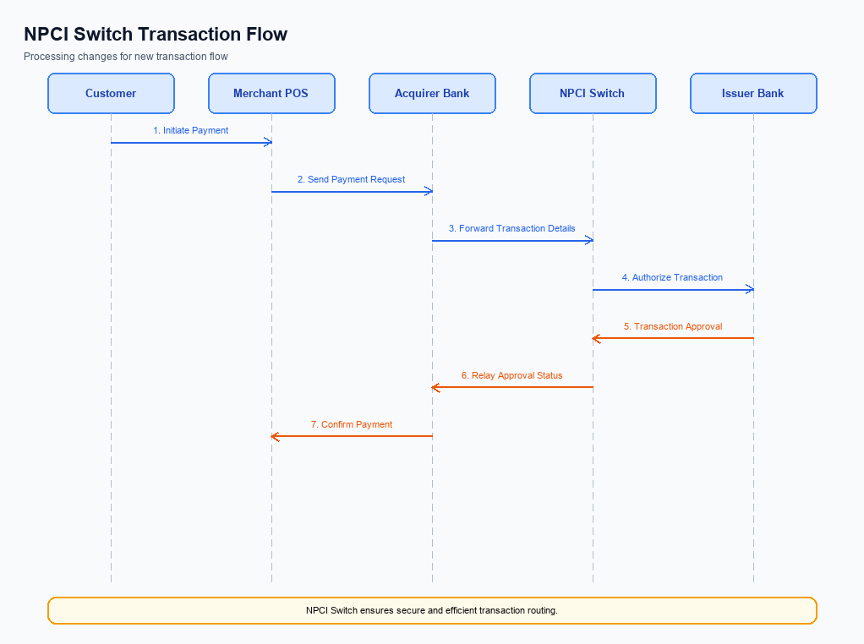
Figure: NPCI switch processing changes for the new transaction flow
The NPCI is responsible for managing the UPI platform and ensuring seamless transaction processing. Recent updates necessitate changes in routing, processing, and validation to enhance transaction security and efficiency. These changes are designed to optimize the handling of payment transactions, including the management of credential validation and response handling. The following enumerates the specific changes NPCI will implement in the transaction flow.
These changes are critical for maintaining the integrity and reliability of the UPI system. By refining the handling of refCategory and credential validation, NPCI aims to bolster security measures. Additionally, switch routing changes and response handling improvements will streamline transaction processing, ensuring timely and accurate transaction completion. Each requirement is outlined below with clear ownership and expected outcomes.
- 1. NPCI will implement enhanced handling for refCategory='05' to ensure that biometric-authenticated transactions are processed with additional security checks. This will involve verifying the biometric data against the registered credentials before proceeding with the transaction.
- 2. NPCI will update the credential validation process to include a nonce-based challenge mechanism. This change is aimed at preventing replay attacks by ensuring that each transaction request is unique and cannot be reused.
- 3. NPCI will modify the switch routing logic to prioritize transactions flagged with DEEMED status. This will ensure that such transactions are settled asynchronously, reducing the risk of delays in credit confirmation.
- 4. NPCI will enhance response handling by implementing a more robust error-checking mechanism. This will involve detailed logging and tracking of transaction responses to quickly identify and resolve any discrepancies or failures in the transaction flow.

A. UPI App / PSP — App-side Changes
The UPI App and PSP must implement several changes to facilitate seamless enrollment, consent capture, and device binding. These changes are critical to ensure compliance with regulatory standards and enhance the user experience. The modifications will involve updates to the user interface, invocation of the Common Library (CL) SDK, and enhancements in device security protocols.
The following requirements outline the necessary app-side changes. Each requirement is designed to enhance the security and functionality of the UPI App, ensuring that users can enroll and bind their devices efficiently. The PSP is responsible for implementing these changes in collaboration with the UPI App development team.
- The UPI App must update its user interface to include a dedicated section for user consent capture during enrollment. This section should clearly display terms and conditions, ensuring users can provide informed consent. The UPI App is responsible for designing and implementing this UI change.
- The PSP must integrate the latest version of the CL SDK to facilitate secure authentication and device binding. This integration should ensure that all biometric and PIN-based authentications are processed through the CL, leveraging its encryption capabilities.
- The UPI App must implement local key storage using the device's TEE or Secure Enclave. This will ensure that sensitive authentication keys are stored securely, reducing the risk of unauthorized access. The UPI App development team is tasked with this implementation.
- The PSP must enhance device check logic to verify device integrity before proceeding with enrollment or transaction processing. This includes checking for rooted or jailbroken devices and ensuring that the UPI App operates in a secure environment.

B. UPI App / PSP — Transaction-time Changes
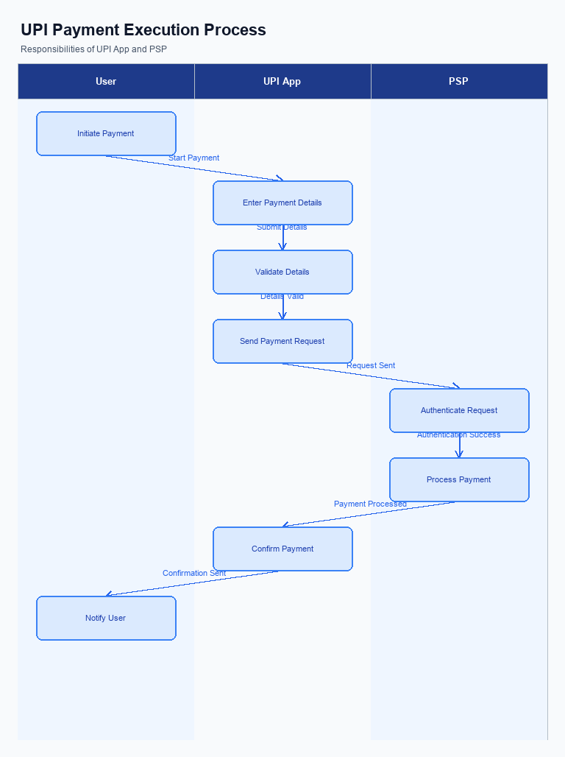
Figure: UPI App and PSP responsibilities during payment execution
To enhance the transaction processing capabilities of the UPI App and the PSP Bank, several changes are required at the time of payment. These changes aim to streamline credential capture, ensure secure invocation of the Common Library (CL), improve fallback handling, and optimize the presentation of transaction responses. By implementing these modifications, the PSP Bank can provide a more seamless and secure payment experience for users, while also maintaining compliance with NPCI standards.
The changes outlined below are critical for ensuring that the UPI App and PSP Bank can effectively manage transaction-time processes. Each requirement addresses a specific aspect of the transaction flow, from the initial credential capture to the final response presentation. These enhancements are designed to reduce transaction failures, improve user satisfaction, and ensure the integrity of the payment process.
- The UPI App must capture user credentials, such as PIN or biometric data, and securely transmit this information to the PSP Bank using the encrypted CRED Block. This ensures that sensitive data is protected during the transaction.
- The PSP Bank is required to invoke the Common Library (CL) provided by NPCI to encrypt the credentials and prepare them for transmission to the NPCI switch. This step is crucial for maintaining the security and integrity of the transaction data.
- In the event of a transaction timeout or failure, the PSP Bank must implement a robust fallback handling mechanism. This includes sending a REQ_CHK_TXN message to NPCI to verify the status of the transaction and ensure timely resolution.
- The UPI App should present the transaction response to the user in a clear and concise manner. This includes displaying the success or failure status, transaction ID, and any relevant error messages, to keep the user informed about the outcome of their payment.

A. Issuer Bank — Auth / Registration Changes
The Issuer Bank plays a crucial role in the authentication and registration processes within the UPI ecosystem. To enhance security and streamline operations, specific changes are required in how the Issuer Bank manages authentication credentials and registration data. These changes are designed to ensure that the bank can effectively validate and store necessary information while responding promptly to authentication requests.
The following enumerated changes outline the specific requirements for the Issuer Bank. Each change is aimed at improving the bank's ability to handle authentication and registration processes efficiently. By implementing these changes, the Issuer Bank will enhance its capability to manage customer credentials securely and ensure compliance with UPI standards.
- The Issuer Bank must store encrypted credential blocks securely, ensuring that all authentication data received from the PSP Bank is protected against unauthorized access.
- The Issuer Bank is required to validate the authenticity of the CRED Block using the NPCI-provided Common Library, ensuring that all credentials are verified before processing any transaction.
- The Issuer Bank must respond to REQ_AUTH_DETAILS messages promptly, providing necessary authentication details to the PSP Bank to facilitate the completion of the transaction.
- The Issuer Bank should implement a secure mechanism to manage and rotate biometric data, ensuring that any changes in biometric authentication are captured and updated in real-time.

B. Issuer Bank — Transaction Flow Changes
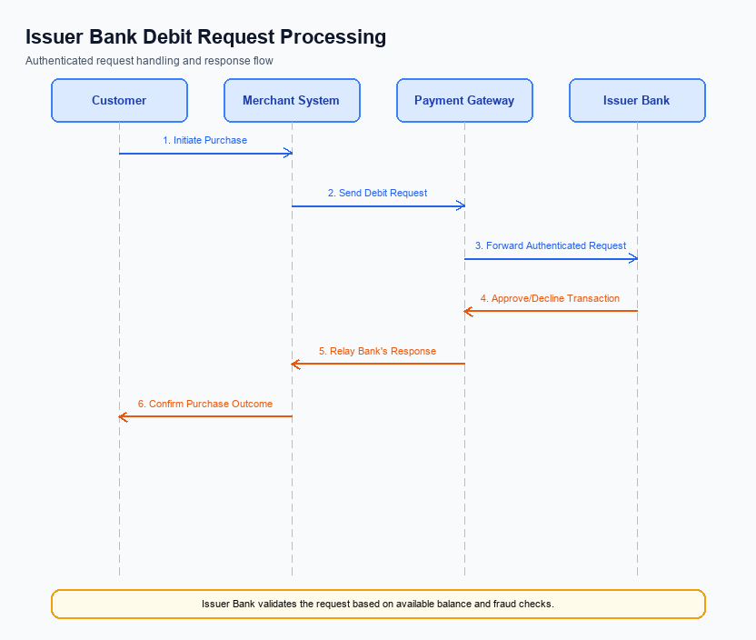
Figure: Issuer bank processing of authenticated debit requests and response flow
The Issuer Bank plays a critical role in processing authenticated debit requests within the UPI ecosystem. This section outlines the necessary changes to the transaction flow that the Issuer Bank must implement to ensure seamless processing of these requests. These changes are designed to enhance the security, efficiency, and reliability of the debit transaction process, aligning with the latest UPI specifications.
The Issuer Bank must adapt its systems to accommodate new authentication methods and ensure robust handling of debit requests. This includes validating credentials, processing debits, managing response codes, and implementing effective timeout and fallback mechanisms. These changes are essential for maintaining compliance with NPCI standards and ensuring a smooth user experience.
- The Issuer Bank must validate credentials using the updated CRED Block, ensuring that all authentication data is securely processed and verified before proceeding with any debit transaction.
- Debit processing systems at the Issuer Bank must be enhanced to handle transactions authenticated through biometric methods, as indicated by the refCategory='05'. This includes ensuring compatibility with the clVersion field for biometric support.
- Response codes must be updated to reflect the new transaction statuses accurately. The Issuer Bank should ensure that all response codes are aligned with NPCI's latest specifications to facilitate clear communication across the UPI network.
- Timeout handling procedures must be revised to incorporate a more robust fallback mechanism. The Issuer Bank should implement a REQ_CHK_TXN message flow to resolve any timeout issues, ensuring that transactions are either completed or appropriately flagged for further investigation.

