Technical Specification Document — Product Feature
Product: Product Feature
Product Canvas Summary:
## Feature
The **One‑Tap Repeat** lets a user pay the same person or
TSD
Version 1.0 | Draft / Confidential

Revision History
Sr. No. | Version | Document Name | Date of Change | Remarks
1 | 1.0 | Technical Specification Document | 18 April 2026 | Initial draft

Table of Contents
Update field to refresh entries and page numbers.

Background
Today the UPI ecosystem processes payments through the standard ReqPay/RespPay exchange. A payer’s app captures the UPI PIN, the Common Library encrypts the credential block and the PSP sends a ReqPay message that contains payerVPA, payeeVPA, amount, purposeCode and initiationMode. The flow proceeds through ReqAuthDetail, debit, credit and finally ReqTxnConfirmation, resulting in a real‑time T+0 settlement. For repeat transactions the user must navigate back to the payee list, re‑select the VPA and re‑type the amount, which adds 3–4 screen taps and ~4 seconds of latency.
Market research shows that 42 % of users forget the payee details for recurring payments, leading to an estimated ₹12 bn of untapped volume. The One‑Tap Repeat feature eliminates this friction by pre‑populating payeeVPA and amount and by setting initiationMode=11 (repeat/quick payment) together with an optional repeatTxnRefId that links the request to the prior transaction. Because the same ReqPay schema is reused and no new API messages are introduced, the change can be deployed on the existing NPCI switch and CL without breaking backward compatibility. This approach satisfies RBI’s “frictionless payments” directive while delivering a measurable reduction in time‑to‑pay and an incremental revenue uplift.
Field Name | dType | dLength | Description | Mandatory (Y/N)
repeatTxnRefId | String | 35 | Reference identifier linking the repeat request to the original transaction | N
seqNum | Integer | 2 | Sequence number for mandate‑based repeat payments; optional for ad‑hoc repeats | N
initiationMode | Integer | 2 | Mode of initiation; value 11 indicates repeat/quick payment | Y

<!-- Request: PSP to NPCI -->
<upi:ReqPay xmlns:upi=\"http://npci.org/upi/schema/\">
<upi:payerVPA>alice@bank</upi:payerVPA>
<upi:payeeVPA>bob@bank</upi:payeeVPA>
<upi:amount>1500.00</upi:amount>
<upi:purposeCode>14</upi:purposeCode>
<upi:initiationMode>11</upi:initiationMode>
<upi:repeatTxnRefId>TXN1234567890</upi:repeatTxnRefId>
<upi:seqNum>01</upi:seqNum>
</upi:ReqPay>

Product Overview
The One‑Tap Repeat feature enables a user to complete a recurring payment with a single tap from the home screen or immediately after a prior transaction. It re‑uses the stored payer VPA, the last used payee VPA and amount, while still allowing the user to edit the amount before submitting the UPI PIN. The flow touches the payer's PSP, the NPCI switch, the payee's PSP and both the payer and payee banks, leveraging the existing ReqPay/RespPay message sequence without introducing new APIs.
By collapsing a typical 3–4‑tap, 4.2‑second journey to a 1‑tap, 2.1‑second interaction, the feature reduces friction, lowers abandonment risk and drives higher repeat‑payment frequency. Expected adoption of at least 25 % of active users translates to an incremental transaction value of roughly ₹12 billion annually and a 3 % uplift in overall UPI volume, delivering significant revenue and competitive advantage. The solution also satisfies RBI’s push for frictionless digital payments while requiring no new ecosystem dependencies.

Product Construct
The One‑Tap Repeat feature is built on the standard UPI participant model. The payer’s mobile application (UPI App) invokes its PSP (Payer PSP) which owns the payer VPA and holds the encrypted credential block (CRED) generated by the Common Library (CL). NPCI operates the central switch that routes messages between the Payer PSP, Payee PSP, and the respective banks (Issuer/Remitter Bank and Beneficiary Bank). The Payee PSP validates the stored payee VPA and forwards the transaction outcome back to the app, completing the end‑to‑end flow.
The topology remains a linear request‑response chain: App → Payer PSP → NPCI (ReqPay) → Issuer Bank (debit) → NPCI (credit) → Beneficiary Bank → NPCI (ReqTxnConfirmation) → Payee PSP → NPCI (confirmation) → App. Key design decisions include reusing the existing ReqPay/RespPay messages with initiationMode=11 to flag a repeat payment, adding the optional seqNum field for mandate‑based repeats, and avoiding any new API definitions to preserve backward compatibility. Authentication continues to rely on the UPI PIN encrypted by the CL, and transaction limits (₹15,000 per transaction, standard daily caps) are unchanged, ensuring the feature can be deployed across all UPI‑enabled apps without additional regulatory changes.

Process Flow: Setting & Enrollment
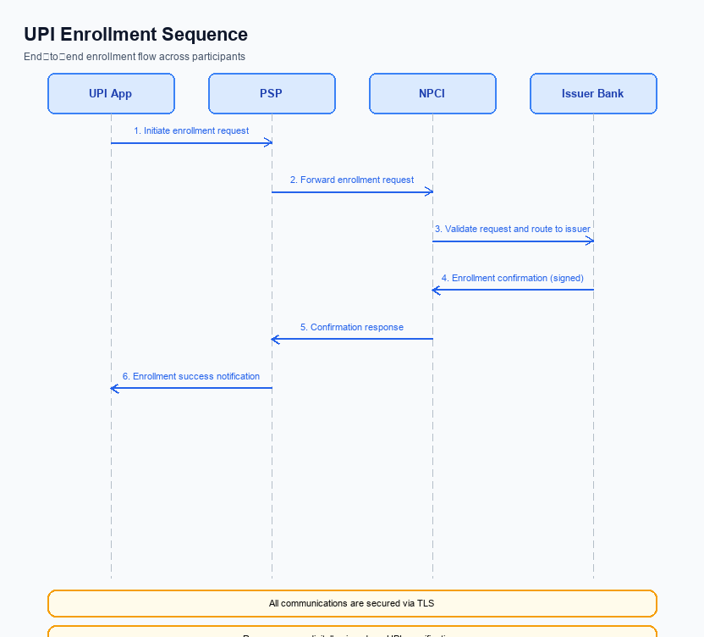
Figure: Setting and enrollment flow: UPI App → PSP → NPCI → Issuer Bank → NPCI → PSP
The One‑Tap Repeat enrollment leverages the existing UPI request‑response framework to pre‑populate payer and payee details for a quick payment. A pre‑check validates that the stored payer VPA, last used payee VPA, and amount are within the standard per‑transaction limit before any network call is made.
The flow proceeds through the UPI App, the payer and payee PSPs, NPCI, and the respective banks, culminating in a transaction confirmation that is relayed back to the app for UI update and metadata persistence.
Step | Activity | Responsible
Pre-Check | Validate stored payer VPA, last used payee VPA, and amount within per‑transaction limit | UPI App
Step 1 | Payer PSP constructs ReqPay with payerVPA, payeeVPA, amount, purposeCode=14, initiationMode=11 and sends to NPCI | Payer PSP
Step 2 | NPCI forwards ReqAuthDetail to Payee PSP to obtain authentication details for the stored payee | NPCI
Step 3 | Payee PSP validates payeeVPA and returns RespAuthDetail to NPCI | Payee PSP
Step 4 | NPCI sends debit request (ReqPay) to Issuer/Remitter Bank for fund settlement | NPCI
Step 5 | Issuer Bank debits payer account, generates RespPay with authStatus and txnStatus, returns to NPCI | Issuer Bank
Step 6 | NPCI sends ReqTxnConfirmation to both Payer PSP and Payee PSP with final txnStatus | NPCI
Step 7 | Payer PSP and Payee PSP forward RespTxnConfirmation to respective UPI Apps for UI update | Payer PSP / Payee PSP
Post Response | UPI App displays success/failure UI and updates stored repeat‑payment metadata | UPI App

Process Flow: Transaction
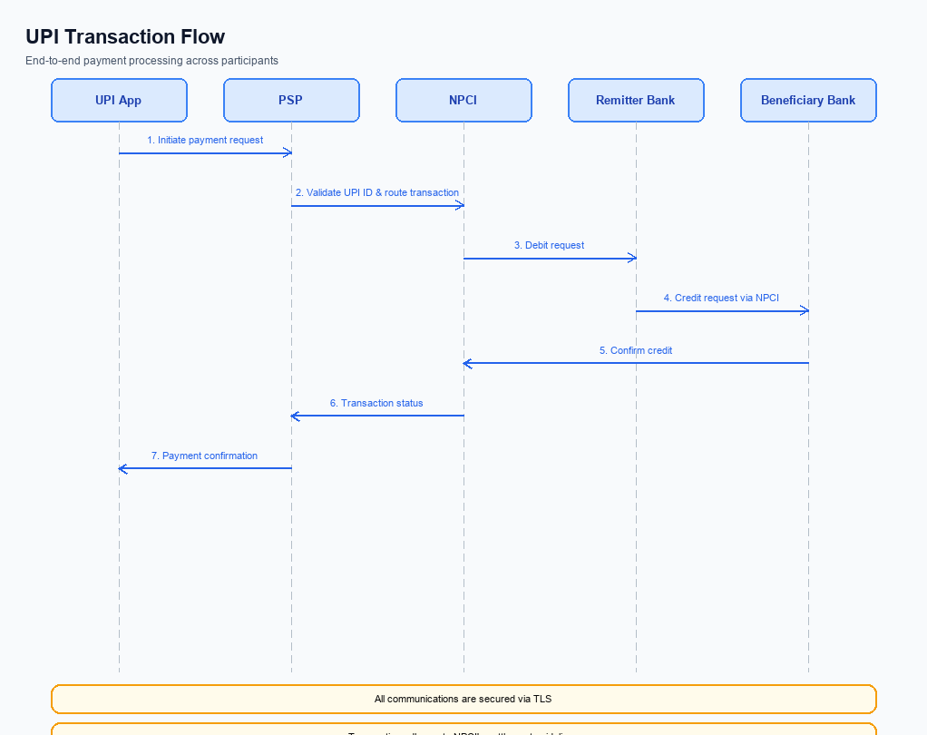
Figure: Transaction flow: UPI App → PSP → NPCI → Remitter Bank → Beneficiary Bank → NPCI → PSP
The One‑Tap Repeat payment leverages the standard UPI request‑response sequence to complete a repeat transaction with a single user tap. The flow initiates a ReqPay from the payer PSP, proceeds through authentication, debit, and credit stages, and concludes with a transaction confirmation broadcast to both PSPs. All messages use the existing ReqPay, ReqAuthDetail, and ReqTxnConfirmation APIs without any schema changes, ensuring compatibility across the UPI ecosystem. Transaction limits of INR 15,000 per payment are enforced during the pre‑check stage.
Because the feature re‑uses the established CL encryption and PIN authentication mechanisms, no new security components are introduced. The end‑to‑end latency remains within real‑time T+0 expectations, and both payer and payee apps receive immediate status updates for UI rendering and audit logging.
Step | Activity | Responsible
Pre-Check | Validate stored payer VPA, amount, purpose code and ensure transaction limit compliance | Payer PSP
Step 1 | Payer PSP sends ReqPay with payerVPA, payeeVPA, amount, purposeCode, initiationMode, seqNum to NPCI | Payer PSP
Step 2 | NPCI forwards ReqAuthDetail to Payee PSP to obtain authentication confirmation | NPCI
Step 3 | Payee PSP validates payeeVPA and returns RespAuthDetail to NPCI | Payee PSP
Step 4 | NPCI routes debit request (ReqPay) to the payer’s issuing bank for fund settlement | NPCI
Step 5 | Payer Bank debits the payer’s account and sends RespPay with authStatus, txnStatus, respCode back to NPCI | Payer Bank
Step 6 | NPCI sends ReqTxnConfirmation to both Payer PSP and Payee PSP indicating final transaction outcome | NPCI
Step 7 | Payer PSP and Payee PSP forward RespTxnConfirmation to their respective UPI apps for UI update | Payer PSP / Payee PSP
Post Response | Apps display success/failure to the user and log transaction details for audit | UPI App

<!-- Request: PSP to NPCI -->
<upi:ReqPay xmlns:upi="http://npci.org/upi/schema/">
<upi:payerVPA>alice@bank</upi:payerVPA>
<upi:payeeVPA>bob@bank</upi:payeeVPA>
<upi:amount>1500.00</upi:amount>
<upi:purposeCode>14</upi:purposeCode>
<upi:initiationMode>11</upi:initiationMode>
<upi:seqNum>1</upi:seqNum>
</upi:ReqPay>
<!-- Response: NPCI to PSP -->
<upi:RespPay xmlns:upi="http://npci.org/upi/schema/">
<upi:authStatus>SUCCESS</upi:authStatus>
<upi:txnStatus>SUCCESS</upi:txnStatus>
<upi:respCode>00</upi:respCode>
</upi:RespPay>

Technical Specifications
The Technical Specifications section defines the three UPI message APIs that support the One‑Tap Repeat feature – ReqPay/RespPay, ReqAuthDetail/RespAuthDetail, and ReqTxnConfirmation/RespTxnConfirmation. These APIs are used unchanged from the standard flow, with the only schema extension being an optional repeat‑reference field (e.g., repeatTxnRefId or seqNum) to flag a repeat payment while preserving backward compatibility. Consequently, the scope of change is limited to adding this optional flag and updating processing logic to auto‑populate payerVPA, payeeVPA, amount and purposeCode for a single‑tap transaction, without introducing new message types or altering existing response structures.

i. Primary API Specifications
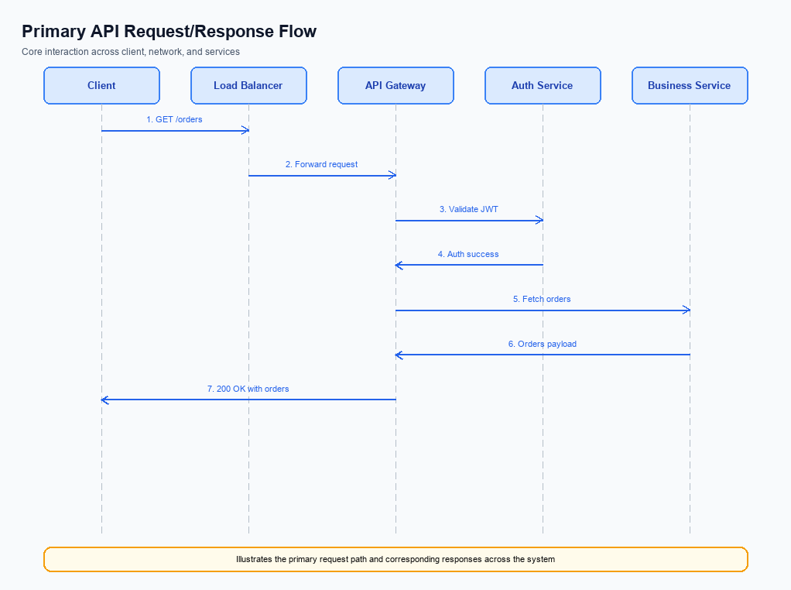
Figure: Primary API request/response flow across participants
The One‑Tap Repeat feature leverages three core UPI APIs: ReqPay, ReqAuthDetail and ReqTxnConfirmation. ReqPay is initiated by the Payer PSP to request a payment using the stored VPA, amount and purpose code. ReqAuthDetail is sent by NPCI to the Payee PSP to obtain authentication confirmation before fund movement. ReqTxnConfirmation conveys the final outcome of the transaction to both PSPs for UI update.
The end‑to‑end flow begins with the Payer PSP validating the repeat flag and sending ReqPay to NPCI. NPCI forwards a ReqAuthDetail to the Payee PSP, which validates the payee VPA and returns RespAuthDetail. NPCI then orchestrates debit and credit via the respective banks, collects RespPay messages, and finally issues ReqTxnConfirmation to both PSPs. Each PSP forwards the corresponding response to its mobile app, completing the one‑tap experience.
To support repeat payments without breaking existing schemas, the optional field seqNum is introduced in the ReqPay payload. seqNum carries the mandate‑based sequence number for traceability and idempotency, and is marked non‑mandatory to preserve backward compatibility. All other fields remain unchanged, ensuring that legacy integrations continue to operate unchanged.
All messages are encrypted using the Common Library (CL) and include a nonce‑based challenge to prevent replay attacks. The transaction adheres to the standard UPI per‑transaction limit of INR 1 lakh and the daily aggregate limit, with real‑time T+0 settlement. Authentication continues to rely on the UPI PIN, satisfying regulatory security requirements.
- ReqPay – initiates the payment request from the Payer PSP to NPCI.
- ReqAuthDetail – NPCI queries the Payee PSP for authentication details.
- ReqTxnConfirmation – NPCI notifies both PSPs of the final transaction outcome.
- Step 1: Payer PSP initiates ReqPay with stored VPA, amount and purpose code.
- Step 2: NPCI forwards ReqAuthDetail to Payee PSP.
- Step 3: Payee PSP validates payee VPA and returns RespAuthDetail.
- Step 4: NPCI sends debit request to payer bank; bank returns RespPay.
- Step 5: NPCI sends credit request to payee bank; bank returns RespPay.
- Step 6: NPCI sends ReqTxnConfirmation to both PSPs.
- Step 7: PSPs forward RespTxnConfirmation to the respective mobile apps.
Step | Activity | Responsible
Pre-Check | Validate stored VPA, amount limits and repeat flag | Payer PSP
Step 1 | Send ReqPay with repeat parameters to NPCI | Payer PSP
Step 2 | Forward ReqAuthDetail to Payee PSP | NPCI
Step 3 | Validate payee VPA and return RespAuthDetail | Payee PSP
Step 4 | Debit payer account and return RespPay | Payer Bank via NPCI
Step 5 | Credit payee account and return RespPay | Payee Bank via NPCI
Step 6 | Send ReqTxnConfirmation to both PSPs | NPCI
Step 7 | Forward RespTxnConfirmation to apps for UI update | Both PSPs
Post Response | Log transaction, update analytics and clear session | Payer PSP & Payee PSP

<!-- Request: PSP to NPCI -->
<upi:ReqPay xmlns:upi="http://npci.org/upi/schema/">
<upi:payerVPA>alice@bank</upi:payerVPA>
<upi:payeeVPA>bob@bank</upi:payeeVPA>
<upi:amount>500.00</upi:amount>
<upi:purposeCode>14</upi:purposeCode>
<upi:initiationMode>11</upi:initiationMode>
<upi:seqNum>01</upi:seqNum>
</upi:ReqPay>
<!-- Response: NPCI to PSP -->
<upi:RespPay xmlns:upi="http://npci.org/upi/schema/">
<upi:authStatus>SUCCESS</upi:authStatus>
<upi:txnStatus>SUCCESS</upi:txnStatus>
<upi:respCode>0000</upi:respCode>
</upi:RespPay>
<!-- Request: NPCI to Payee PSP -->
<upi:ReqAuthDetail xmlns:upi="http://npci.org/upi/schema/">
<upi:payeeVPA>bob@bank</upi:payeeVPA>
<upi:purposeCode>14</upi:purposeCode>
</upi:ReqAuthDetail>
<!-- Response: Payee PSP to NPCI -->
<upi:RespAuthDetail xmlns:upi="http://npci.org/upi/schema/">
<upi:authStatus>SUCCESS</upi:authStatus>
<upi:respCode>0000</upi:respCode>
</upi:RespAuthDetail>
<!-- Request: NPCI to PSPs -->
<upi:ReqTxnConfirmation xmlns:upi="http://npci.org/upi/schema/">
<upi:txnId>TXN123456789</upi:txnId>
<upi:txnStatus>SUCCESS</upi:txnStatus>
</upi:ReqTxnConfirmation>
<!-- Response: PSP to NPCI -->
<upi:RespTxnConfirmation xmlns:upi="http://npci.org/upi/schema/">
<upi:respCode>0000</upi:respCode>
</upi:RespTxnConfirmation>
<!-- Field Dictionary: New/Changed Fields -->
Field Name | dType | dLength | Description | Mandatory
seqNum | Integer | 2 | Sequence number for mandate‑based repeat payments | N

ii. Secondary API Specifications
The secondary specification focuses on the error‑variant of the primary ReqPay flow, which is triggered when the authentication step fails. In this scenario the Payer PSP still initiates a ReqPay message, NPCI forwards a ReqAuthDetail to the Payee PSP, the Payee PSP validates the payee VPA and returns a negative authentication response, causing NPCI to generate a RespPay with authStatus=FAIL and propagate it back to the Payer PSP for UI notification.
This variant preserves the existing message schema while allowing the PSP to surface precise failure codes to the end‑user. The flow remains fully compliant with the UPI Common Library and leverages the same routing engine, ensuring no additional ecosystem dependencies are introduced.
Field Name | dType | dLength | Description | Mandatory
payerVPA | String | 35 | Virtual Payment Address of the payer | Y
payeeVPA | String | 35 | Virtual Payment Address of the payee (last used payee) | Y
amount | Decimal | 15 | Transaction amount (editable for repeat payment) | Y
purposeCode | Integer | 2 | Purpose code as per UPI spec (e.g., 14 for repeat payment) | Y
initiationMode | Integer | 2 | Mode of initiation; 11 denotes repeat/quick payment | Y
seqNum | Integer | 2 | Sequence number for mandate‑based repeat payments | N
authStatus | String | 3 | Result of authentication (e.g., SUCCESS, FAIL) | Y
txnStatus | String | 3 | Final transaction status (e.g., SUCCESS, DECLINED) | Y
respCode | String | 4 | Standard UPI response code | Y

<!-- Request: PSP to NPCI -->
<upi:ReqPay xmlns:upi="http://npci.org/upi/schema/">
<upi:payerVPA>user@bank</upi:payerVPA>
<upi:payeeVPA>merchant@bank</upi:payeeVPA>
<upi:amount>500.00</upi:amount>
<upi:purposeCode>14</upi:purposeCode>
<upi:initiationMode>11</upi:initiationMode>
<upi:seqNum>01</upi:seqNum>
</upi:ReqPay>
<!-- Response: NPCI to PSP (Auth Failure) -->
<upi:RespPay xmlns:upi="http://npci.org/upi/schema/">
<upi:authStatus>FAIL</upi:authStatus>
<upi:txnStatus>DECLINED</upi:txnStatus>
<upi:respCode>U123</upi:respCode>
</upi:RespPay>

iii. Error Handling
The error handling section enumerates all anticipated failure conditions across the ReqPay, ReqAuthDetail and ReqTxnConfirmation interactions for the One‑Tap Repeat feature. Integration engineers must map each response to the appropriate remediation flow to maintain a seamless user experience.
Response Code | Error Code | Description | API | Entity | TD/BD
U001 | E001 | Payer VPA not eligible for repeat payment (e.g., blocked or not registered for repeat) | ReqPay | Payer PSP | BD
U002 | E002 | Device activation required for biometric repeat but not activated (refCategory='05' missing) | ReqAuthDetail | Payee PSP | TD
U003 | E003 | Authentication failed – incorrect UPI PIN or credential block decryption error | ReqPay | Issuer/Remitter Bank | TD
U004 | E004 | Transaction timeout – no response from issuer bank within SLA | ReqTxnConfirmation | NPCI | TD
U005 | E005 | Missing repeatTxnRefId or seqNum for mandate‑based repeat payment | ReqPay | Payer PSP | BD

iv. Note:
- 1. Use only the existing ReqPay, ReqAuthDetail, and ReqTxnConfirmation messages; do not introduce any new API endpoints or message types for the One‑Tap Repeat flow.
- 2. Populate payerVPA and payeeVPA from the stored VPA of the last successful transaction; both fields are mandatory, must not exceed 35 characters, and must pass the standard VPA format validation before sending ReqPay.
- 3. For repeat payments where amount exceeds INR 15,000, the PSP must enforce the UPI PIN authentication path and include the Mandate‑derived sequence number (seqNum) if a mandate exists; otherwise the transaction must be rejected with the appropriate UPI response code.
- 4. Implement a timeout of 5 seconds for the ReqAuthDetail response from the Payee PSP; if the timeout elapses, the Payer PSP must abort the flow and return a FAIL status to the app, optionally triggering a REQ_CHK_TXN status check later.
- 5. Include an optional repeatTxnRefId (or similar repeat‑reference flag) in the ReqPay payload to achieve idempotency and enable downstream analytics; this field must be unique per repeat invocation and may be omitted for backward‑compatible callers.
- 6. If the final RespTxnConfirmation returns a DEEMED status, the PSP must treat the transaction as pending settlement, log the reference, and reconcile asynchronously within the standard UPI settlement window.

