Business Requirements Document — Product Feature
Product: Product Feature
Product Canvas Summary:
## Feature
**Unified UPI Loyalty Ecosystem** creates a single, portab
BRD
Version 1.0 | Draft / Confidential

Revision History
Sr. No. | Version No. | Date of Change | Change By | Reviewed By | Remarks
1 | 1.0 | 16 April 2026 | Chief Product Officer |  | Initial draft

Table of Contents
Update field to refresh entries and page numbers.

i. Current State
This section covers i. Current State.
Details to be elaborated further.

ii. Limitations / Challenges
This section covers ii. Limitations / Challenges.
Details to be elaborated further.

iii. Why the Proposed Change
This section covers iii. Why the Proposed Change.
Details to be elaborated further.

i. Product Description
This section covers i. Product Description.
Details to be elaborated further.

ii. Product Construct: Setting / Enrollment
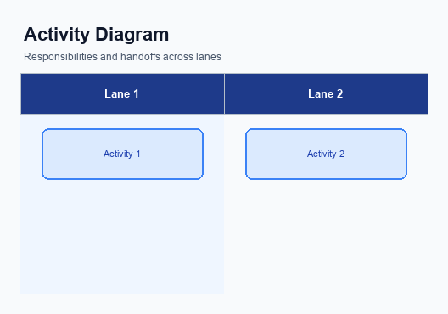
Figure: Enrollment / setting journey across UPI App, PSP, NPCI, and Issuer Bank
This section covers ii. Product Construct: Setting / Enrollment.
Details to be elaborated further.
Step | Activity | Responsible
Pre-Check | Validate prerequisites and participant readiness | Initiating client / gateway
Step 1 | Submit request and route to the next hop per integration rules | Gateway / orchestrator
Step 2 | Process, validate, and forward or respond | Core platform
Post Response | Return outcome and persist audit trail | Client / gateway

iii. Product Construct: Transaction Flow
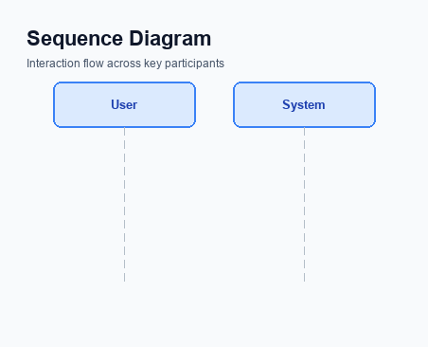
Figure: Transaction flow: UPI App → PSP → NPCI → Remitter Bank → Beneficiary Bank → NPCI → PSP
This section covers iii. Product Construct: Transaction Flow.
Details to be elaborated further.
Step | Activity | Responsible
Pre-Check | Validate prerequisites and participant readiness | Initiating client / gateway
Step 1 | Submit request and route to the next hop per integration rules | Gateway / orchestrator
Step 2 | Process, validate, and forward or respond | Core platform
Post Response | Return outcome and persist audit trail | Client / gateway

Other Salient Points
This section covers Other Salient Points.
Details to be elaborated further.

Dispute Management
This section covers Dispute Management.
Details to be elaborated further.

Functional Requirements
This section covers Functional Requirements.
Details to be elaborated further.
ID | Requirement | Priority
FR-01 | The system shall satisfy the integration behaviour described in this document. | High
FR-02 | The system shall expose observability suitable for production support (logging, tracing). | Medium
FR-03 | The system shall enforce security and data-handling policies defined by the program. | High

A. NPCI (UPI Platform & CL) — Setting / Schema / Registration Changes
This section covers A. NPCI (UPI Platform & CL) — Setting / Schema / Registration Changes.
Details to be elaborated further.

B. NPCI (UPI Platform & CL) — Transaction Flow / Processing Changes

Figure: NPCI switch processing changes for the new transaction flow
This section covers B. NPCI (UPI Platform & CL) — Transaction Flow / Processing Changes.
Details to be elaborated further.

A. UPI App / PSP — App-side Changes
This section covers A. UPI App / PSP — App-side Changes.
Details to be elaborated further.

B. UPI App / PSP — Transaction-time Changes

Figure: UPI App and PSP responsibilities during payment execution
This section covers B. UPI App / PSP — Transaction-time Changes.
Details to be elaborated further.

A. Issuer Bank — Auth / Registration Changes
This section covers A. Issuer Bank — Auth / Registration Changes.
Details to be elaborated further.

B. Issuer Bank — Transaction Flow Changes

Figure: Issuer bank processing of authenticated debit requests and response flow
This section covers B. Issuer Bank — Transaction Flow Changes.
Details to be elaborated further.

