Product Note — Product Feature
Product: Product Feature
Product Canvas Summary:
## Feature
**Unified UPI Loyalty Ecosystem** creates a single, portab
PRODUCT NOTE
Version 1.0 | Draft / Confidential

Revision History
Sr. No. | Version | Document Name | Date of Change | Remarks
1 | 1.0 | Product Note | 16 April 2026 | Initial draft

Table of Contents
Update field to refresh entries and page numbers.

Document Overview
This section covers Document Overview.
Details to be elaborated further.

Background
This section covers Background.
Details to be elaborated further.

Product Overview - Feature Description
This section covers Product Overview - Feature Description.
Details to be elaborated further.

Product Construct: Setting / Enrollment
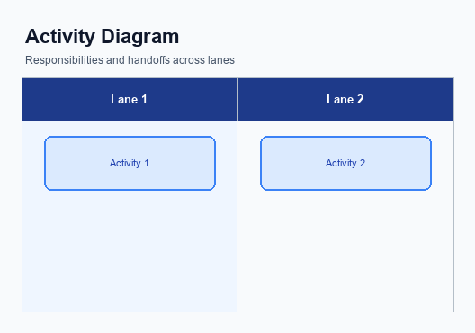
Figure: Enrollment and setting journey across key participants
This section covers Product Construct: Setting / Enrollment.
Details to be elaborated further.
Step | Activity | Responsible
Pre-Check | Validate prerequisites and participant readiness | Initiating client / gateway
Step 1 | Submit request and route to the next hop per integration rules | Gateway / orchestrator
Step 2 | Process, validate, and forward or respond | Core platform
Post Response | Return outcome and persist audit trail | Client / gateway

Product Construct: Transaction Flow
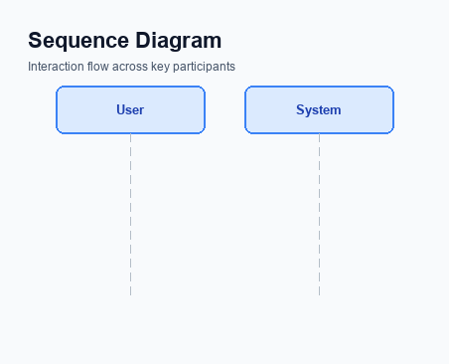
Figure: Transaction flow across key participants and system components
This section covers Product Construct: Transaction Flow.
Details to be elaborated further.
Step | Activity | Responsible
Pre-Check | Validate prerequisites and participant readiness | Initiating client / gateway
Step 1 | Submit request and route to the next hop per integration rules | Gateway / orchestrator
Step 2 | Process, validate, and forward or respond | Core platform
Post Response | Return outcome and persist audit trail | Client / gateway

Key Considerations & Policy Rules
This section covers Key Considerations & Policy Rules.
Details to be elaborated further.

Other Salient Points
This section covers Other Salient Points.
Details to be elaborated further.

Dispute Management
This section covers Dispute Management.
Details to be elaborated further.

Testing, Certification & Audits
This section covers Testing, Certification & Audits.
Details to be elaborated further.
Scenario | Objective | Owner
Happy path | Validate primary success flow end-to-end | Integration lead
Negative path | Validate failure handling and user-visible outcomes | QA / Platform
Recovery | Validate retry, timeout, and reconciliation behaviour | Operations

Annexure: Pre-Checks
This section covers Annexure: Pre-Checks.
Details to be elaborated further.

