Technical Specification Document — Product Feature
Product: Product Feature
Product Canvas Summary:
## Feature
**Unified UPI Loyalty Ecosystem** creates a single, portab
TSD
Version 1.0 | Draft / Confidential

Revision History
Sr. No. | Version | Document Name | Date of Change | Remarks
1 | 1.0 | Technical Specification Document | 16 April 2026 | Initial draft

Table of Contents
Update field to refresh entries and page numbers.

Background
This section covers Background.
Details to be elaborated further.

Product Overview
This section covers Product Overview.
Details to be elaborated further.

Product Construct
This section covers Product Construct.
Details to be elaborated further.

Process Flow: Setting & Enrollment
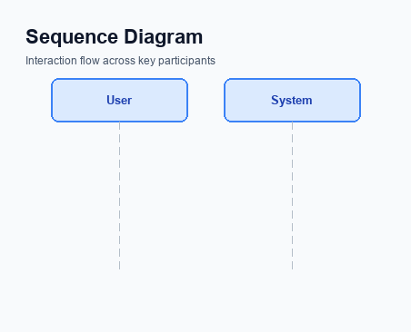
Figure: Setting and enrollment flow: UPI App → PSP → NPCI → Issuer Bank → NPCI → PSP
This section covers Process Flow: Setting & Enrollment.
Details to be elaborated further.
Step | Activity | Responsible
Pre-Check | Validate prerequisites and participant readiness | Initiating client / gateway
Step 1 | Submit request and route to the next hop per integration rules | Gateway / orchestrator
Step 2 | Process, validate, and forward or respond | Core platform
Post Response | Return outcome and persist audit trail | Client / gateway

Process Flow: Transaction

Figure: Transaction flow: UPI App → PSP → NPCI → Remitter Bank → Beneficiary Bank → NPCI → PSP
This section covers Process Flow: Transaction.
Details to be elaborated further.
Step | Activity | Responsible
Pre-Check | Validate prerequisites and participant readiness | Initiating client / gateway
Step 1 | Submit request and route to the next hop per integration rules | Gateway / orchestrator
Step 2 | Process, validate, and forward or respond | Core platform
Post Response | Return outcome and persist audit trail | Client / gateway

Technical Specifications
This section covers Technical Specifications.
Details to be elaborated further.

i. Primary API Specifications

Figure: Primary API request/response flow across participants
This section covers i. Primary API Specifications.
Details to be elaborated further.
Field / Element | Type | Length | Description | Mandatory
schemaVersion | string | var | Replace with normative version field for your API. | Yes
requestId | string | var | Correlation id for tracing; replace with your idempotency key if used. | Yes
payload | object | n/a | Replace with message-specific body per your specification. | Yes

ii. Secondary API Specifications
This section covers ii. Secondary API Specifications.
Details to be elaborated further.
Field / Element | Type | Length | Description | Mandatory
schemaVersion | string | var | Replace with normative version field for your API. | Yes
requestId | string | var | Correlation id for tracing; replace with your idempotency key if used. | Yes
payload | object | n/a | Replace with message-specific body per your specification. | Yes

iii. Error Handling
This section covers iii. Error Handling.
Details to be elaborated further.
Response Code | Error Code | Description | Operation | Component | TD/BD
E1 | E1 | Eligibility or precondition failed | Pre-check | Originating service | BD
E2 | E2 | Activation or registration failed | Setup | Credential service | TD
E3 | E3 | Authentication or validation failed | Transaction | Issuer / verifier | TD
E4 | E4 | Credential mismatch or replay detected | Transaction | Issuer / verifier | TD
TO | TO | Timeout waiting for downstream response | Any | Switch / broker | TD

iv. Note:
This section covers iv. Note:.
Details to be elaborated further.

