Block Chain Technology

UNIT-1

What is Blockchain?
A Blockchain is a decentralized and distributed digital ledger that records transactions across multiple computers in a secure, transparent, and tamper-resistant manner.
These blocks link together in a permanent chain using cryptography

Traditional Database vs Blockchain
Traditional Database | Blockchain
Centralized | Decentralized
Single administrator | Multiple participants
Records can be modified | Records are immutable
Easy to tamper | Highly secure
Limited transparency | High transparency

Features of Blockchain

• Decentralization: Data is shared across a network instead of being stored in one single place.

• Transparency: Every user on the network can view transaction histories and verify details openly.

• Immutability: Once data is written, it cannot be changed or deleted by anyone.

• Security: Advanced cryptography protects all records from hackers and unauthorized access.

• Consensus Mechanism: Network nodes agree on the validity of transactions before adding them.

• Distributed Ledger: A synchronized database is updated and shared across multiple computer nodes.

• Traceability: You can easily track the complete history and origin of any asset or transaction.

• Fault Tolerance: The network keeps running even if some computers or nodes stop working.

Cryptocurrency: Powers digital currencies like Bitcoin for peer-to-peer payments without traditional banks.

Banking: Speeds up cross-border payments and reduces transaction fees by eliminating middlemen.

Healthcare: Secures and shares patient medical records safely across authorized hospitals and clinics.

Supply Chain: Tracks goods from production to delivery to verify product authenticity and reduce fraud.

Voting Systems: Enables secure, tamper-proof digital voting to eliminate fraud and automate count verification.

Identity Management: Gives individuals control over their digital IDs to prevent identity theft and forgery.

IoT: Connects and secures smart devices to allow safe, direct communication without a central server.

Insurance: Uses automated smart contracts to process and pay out claims instantly without paperwork.

1. History of Bitcoin and Origins of Blockchain
Blockchain wasn't invented overnight; it was the culmination of decades of research in cryptography, distributed systems, and digital cash.
- The Precursors (1980s–2000s): Before Bitcoin, multiple attempts at digital currencies failed due to centralization or the inability to solve the Double-Spending Problem (the risk that a digital token can be spent more than once, like copying a digital file). Key historical milestones include:
  - David Chaum’s DigiCash (1989): Focused on privacy using blind signatures but relied on a central bank or server.
  - Adam Back’s Hashcash (1997): Introduced the concept of Proof-of-Work (PoW) to prevent email spam. This exact mechanism would later become Bitcoin's mining engine.
  - Nick Szabo’s Bit Gold (1998) & Wei Dai’s b-money (1998): Formulated early frameworks for decentralized digital currencies, though neither was fully implemented.
- The 2008 Genesis: In the wake of the global financial crisis, an anonymous individual or group named Satoshi Nakamoto published the seminal whitepaper: "Bitcoin: A Peer-to-Peer Electronic Cash System."
- The 2009 Launch: Nakamoto mined the first block (the Genesis Block or Block 0) on January 3, 2009. Embedded in this block was a news headline from The Times: "The Times 03/Jan/2009 Chancellor on brink of second bailout for banks", signaling the political and economic motivation behind a decentralized currency.

Evolution Timeline
Year | Event
1991 | Stuart Haber and Scott Stornetta proposed cryptographically secured chains of blocks
1998 | Wei Dai proposed B-Money
2004 | Hal Finney introduced Reusable Proof of Work (RPoW)
2008 | Satoshi Nakamoto published the Bitcoin Whitepaper
2009 | Bitcoin network launched
2013 | Ethereum proposed
2015 | Ethereum launched with smart contracts
Present | Blockchain used in finance, healthcare, IoT, logistics, and government

Bitcoin

Bitcoin is the first decentralized digital cryptocurrency.
Created by:Satoshi Nakamoto
Bitcoin solved the double-spending problem without requiring a trusted third party.
Introduced in a 2008 whitepaper by the pseudonymous creator Satoshi Nakamoto, it relies on a public, immutable ledger called a blockchain rather than a central bank. As of July 2026, Bitcoin is valued at approximately $63,957 USD (around ₹6.18 million INR).

Why Bitcoin Needed Blockchain
Problems in Digital Currency:
- Double Spending
- Centralized control
- Fraud
- Lack of transparency
Blockchain solved these using:
- Distributed Ledger
- Consensus
- Cryptography
- Proof of Work
Traditional Problem | Blockchain Solution | How It Works Mechanically
DoubleSpending (Copying digital cash) | Distributed Ledger | Every node on the network maintains an identical, live copy of the ledger. If a user tries to send the same coin to two different people, the network compares the transaction history across thousands of computers and immediately rejects the second attempt.
CentralizedControl (Banks&Single point  of failure) | Consensus Mechanisms | Decisions, transaction validation, and ledger updates are handled by a distributed network of peers using rules built into the software. No single CEO, government, or bank can freeze accounts, alter data, or print more currency arbitrarily.
Fraud (Identity theft  & Data tampering) | Cryptography | Transactions are secured using asymmetric (public/private) key cryptography. Only the owner of the private key can authorize a transfer, and once a block of transactions is hashed and linked to the previous block, changing even one digit requires re-mining the entire chain.
Lack of Transparency (Hidden ledger entries & auditing issues) | Proof of Work (PoW) | PoW forces miners to expend massive computational energy to secure a block of transactions. This energy expenditure makes the ledger mathematically immutable; bad actors cannot retroactively alter past data because the cost to rewrite the history exceeds any potential stolen reward.

ORIGIN OF BLOCLCHAIN:

1. THE FOUNDATIONAL MILESTONES (1991–1998)

1991: The Chronological Chain (Haber & Stornetta)
Introduced cryptographically linked batches of data (blocks) to prevent the tampering or backdating of digital documents.

1992: Scalability via Merkle Trees (Haber, Stornetta, & Bayer)
Integrated Merkle Trees into the chain, allowing thousands of documents to be compressed into a single cryptographic hash for rapid verification.

1997: Proof-of-Work (Adam Back)
Created Hashcash, a system requiring computational power to solve mathematical puzzles. Originally designed to combat email spam, it introduced the concept of digital scarcity.

1998: Decentralized Asset Blueprints (Dai & Szabo)
b-money and Bit Gold outlined the first theoretical models for decentralized electronic cash and automated "smart contracts," though they lacked a mechanism to prevent network takeover.

2. THE NAKAMOTO SYNTHESIS (2008–2009)

2008: Solving the Double-Spending Problem
The anonymous entity Satoshi Nakamoto published the Bitcoin Whitepaper, combining linked blocks with Proof-of-Work to eliminate the need for central clearing intermediaries (banks).

2009: The Genesis Block (Block 0)
On January 3, 2009, the first block was mined, hardcoding a structural zero baseline for the "Previous Hash" field.

The Historical Anchor
Nakamoto embedded a headline into Block 0: "The Times 03/Jan/2009 Chancellor on brink of second bailout for banks," proving the network's launch date and establishing its ideological purpose.

3. SOFTWARE EXPANSION & MODERN EVOLUTION (2013–Present)

2013–2015: Blockchain 2.0 & Smart Contracts (Vitalik Buterin)
The launch of Ethereum expanded blockchain utility beyond currency by introducing a programmable ledger that executes automated computer code.

The Consensus Shift (Proof-of-Stake)
Modern networks transitioned from energy-intensive hardware mining (Proof-of-Work) to capital-backed validation (Proof-of-Stake), reducing infrastructure energy consumption by over 99%.

2. Fundamentals of Blockchain & Key Components
c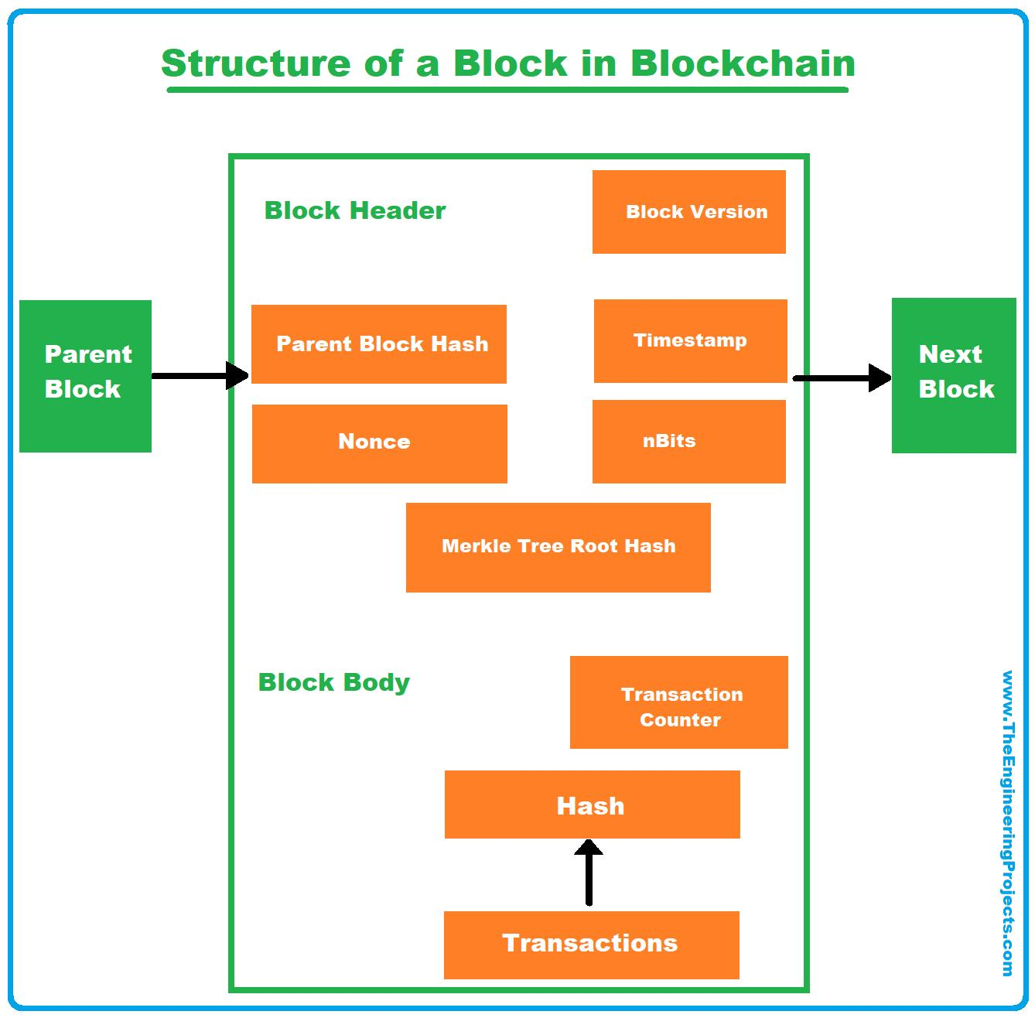
External Connections (The Chain)
- Parent Block: The preceding block in the network that connects directly to the current block's header.
- Next Block: The upcoming block that will read the cryptographic output of the current block to continue the sequence

Each block stores:
- Transactions
- Timestamp
- Previous Block Hash
- Current Block Hash
- Nonce
- Merkle Root

How Blockchain Works
- User requests transaction.
- Transaction is broadcast.
- Network validates transaction.
- Transactions grouped into block.
- Block validated.
- Block added to blockchain.
- Ledger updated.

Key Structural Components
- Blocks: The data containers. Each block contains:
  - Data/Transactions: The actual records (e.g., "Alice sent Bob 2 BTC").
  - Hash: A unique fingerprint of the current block.
  - Previous Hash: The cryptographic fingerprint of the prior block. This creates the unbreakable "chain."
- Nodes: The individual computers connected to the blockchain network that store copies of the ledger and validate transactions.
- Consensus Mechanism: The protocol or set of rules that all nodes follow to agree on the valid state of the blockchain (e.g., Proof of Work, Proof of Stake). It prevents bad actors from rewriting history.
- Distributed Ledger Technology (DLT): The overarching infrastructure where a database is independently replicated and synchronized across a decentralized network.

3. Permissioned vs. Permissionless Platforms
Blockchain networks follow distinct rules regarding who can read data, write transactions, and help maintain the network.
Feature | Permissionless (Public) | P’lermissioned (Private/Consortium)
Access & Participation | Anyone can join, read data, write transactions, and run a node. | Access is restricted. Only pre-authorized or invited entities can join.
Anonymity | High anonymity (pseudonymous using public keys). | Known identities (participants are vetted and authenticated).
Consensus Speed | Slower (requires massive decentralized agreement). | Faster (fewer nodes, trust is highly concentrated).
Security Mechanism | Relies on crypto-economics (e.g., Proof of Work). | Relies on traditional access control and crash fault tolerance.
Examples | Bitcoin, Ethereum, Solana | Hyperledger Fabric, Corda, Ripple

Permissionless Blockchain
Anyone can:
- Join
- Read
- Write
- Validate
Examples
- Bitcoin
- Ethereum
Advantages
- High decentralization
- Transparency
- Security
Disadvantages
- Slow
- High energy consumption

Permissioned Blockchain
Access controlled.
Only authorized users participate.
Examples
- Hyperledger Fabric
- Corda
- Quorum
Advantages
- Faster
- Better privacy
- Low energy
Disadvantages
- Less decentralized
Comparison
Feature | Permissionless | Permissioned
Access | Open | Restricted
Speed | Low | High
Privacy | Low | High
Consensus | PoW/PoS | PBFT/Raft
Examples | Bitcoin, Ethereum | Hyperledger, Corda

4. Introduction to Cryptography: Hashing and Encryption

What is Cryptography?
Cryptography is the science of protecting information using mathematical algorithms.
Goals
- Confidentiality
- Integrity
- Authentication
- Non-repudiation
Digital ledgers remain secure and private because they rely on advanced mathematics rather than human trust.

5. SHA-256 and ECDSA
Blockchain frameworks rely on two distinct cryptographic tools to protect data integrity and assign ownership.

SHA-256 (Secure Hash Algorithm 256-bit)
SHA-256 takes any data input and returns a fixed 256-bit string (represented as 64 hex characters). It provides the core security layer for blockchain data due to four distinct properties:
- Deterministic: The same input will always produce the exact same output string.
- Pre-image Resistant: You cannot determine the original transaction data by looking at its SHA-256 output hash.
- Avalanche Effect: Altering even a single comma or capitalization mark in the transaction input completely changes the resulting hash output.
- Collision Resistant: It is practically impossible to find two different inputs that yield the exact same hash output.

SHA-256

SHA-256 (Secure Hash Algorithm 256-bit) is a widely used cryptographic hash function developed by the NSA. It takes any amount of input data and deterministically maps it to a unique, fixed 256-bit (32-byte) string, creating an irreversible "digital fingerprint" used for data integrity and security.
Key Characteristics
- Fixed Output: Regardless of whether the input is a single word or the entire contents of a hard drive, the hash output is always exactly 256 bits.
- Avalanche Effect: Changing even a single character in the input data results in a completely different 256-bit hash, making patterns impossible to guess.
- One-way & Irreversible: You cannot decrypt or reverse a SHA-256 hash back into the original input.
- Collision Resistant: It is computationally infeasible for two distinctly different inputs to produce the same hash.
Common Use Cases
- Data Integrity: Verifying that files downloaded from the internet have not been tampered with or corrupted.
- Blockchain & Cryptocurrency: Securing networks like Bitcoin by verifying transactions and mining blocks.
- Digital Signatures & Certificates: Ensuring the authenticity and origin of digital communications (e.g., SSL/TLS).
Developed by
National Security Agency

ECDSA (Elliptic Curve Digital Signature Algorithm)
ECDSA is the asymmetric cryptographic engine used by networks like Bitcoin to generate keys and verify account ownership.

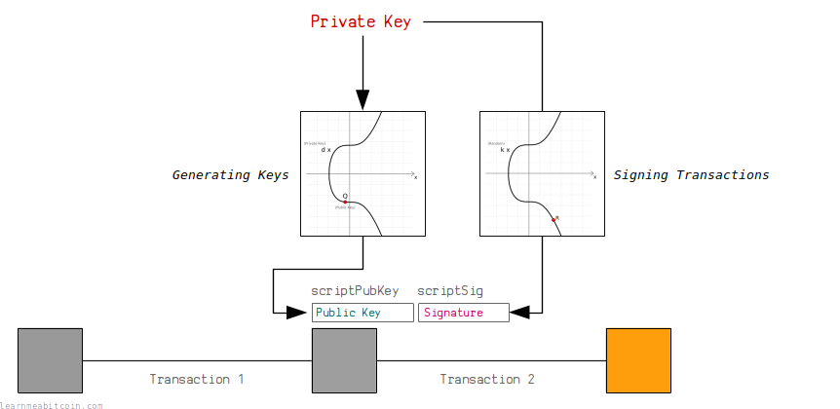

Bitcoin uses a digital signature system called ECDSA to control the ownership of bitcoins.

In short, a digital signature system allows you to generate your own private/public key pair. You can then use the private key to generate signatures that prove you are the owner of the public key, without having to reveal the private key.

This system is used in Bitcoin to allow people to receive and send bitcoins in transactions.

Anyone can generate their own pair of keys, and then anyone can send (or "lock") an output to your public key. Nobody can steal these bitcoins, because only the person with the correct private key for this public key is able to generate valid signatures to "unlock" the bitcoins and use them as an input in a future transaction.

Hashing

Definition
A hash in blockchain is a unique, fixed-length digital fingerprint of data. Generated by a mathematical algorithm called a hash function, it acts as a tamper-evident seal. If even a single character in the input data is changed, the entire output hash changes completely, protecting the blockchain's integrity
How Hashing Works
Hashes rely on a specific mathematical algorithm—most commonly SHA-256 (Secure Hash Algorithm 256-bit). No matter how much data you input (whether it is a single word or the entire history of transactions), the resulting hash will always be exactly 64 characters long
Characteristics
- Fixed length
- One-way function
- Collision resistant
- Avalanche effect

Uses in Blockchain
- Block Hash
- Transaction Hash
- Password Storage
- Digital Signature
- Merkle Tree

Encryption

Blockchain encryption utilizes advanced cryptographic algorithms and hashing to secure Cryptocurrency and verify network transactions Cryptography in Blockchain - GeeksforGeeks. It guarantees data Immutability and prevents unauthorized access by employing public-private key pairs and mathematical hash functions
1. Symmetric-key Encryption: It focuses on a similar key for encryption as well as decryption. Most importantly, the symmetric key encryption method is also applicable to secure website connections or encryption of data. It is also referred to as secret-key cryptography. The only problem is that the sender and receiver exchange keys in a secure manner. The popular symmetric-key cryptography system is Data Encryption System(DES). The cryptographic algorithm utilizes the key in a cipher to encrypt the data and the data must be accessed. A person entrusted with the secret key can decrypt the data. Examples: AES, DES, etc.
Features:
- It is also known as Secret key cryptography.
- Both parties have the same key to keeping secrets.
- It is suited for bulk encryptions.
- It requires less computational power and faster transfer.
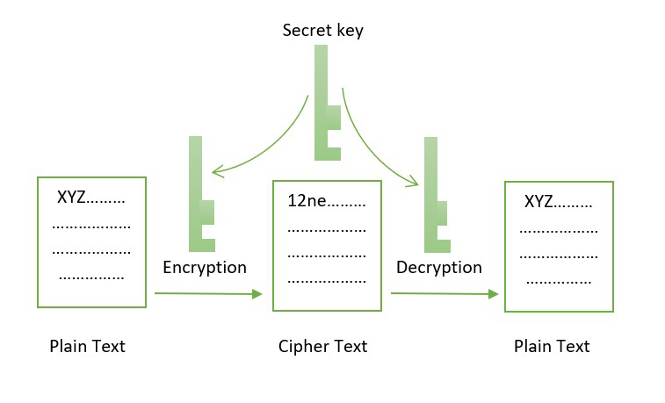Symmetric Cryptography
2. Asymmetric-key Encryption: This cryptographic method uses different keys for the encryption and decryption process. This encryption method uses public and private key methods. This public key method help completely unknown parties to share information between them like email id. private key helps to decrypt the messages and it also helps in the verification of the digital signature. The mathematical relation between the keys is that the private key cannot be derived from the public key, but the public key can be derived from the private key. Example: ECC,DSS etc.
Features:
- It is also known as Public-key cryptography.
- It is often used for sharing secret keys of symmetric cryptography.
- It requires a long processing time for execution.
- Plays a significant role in website server authenticity.

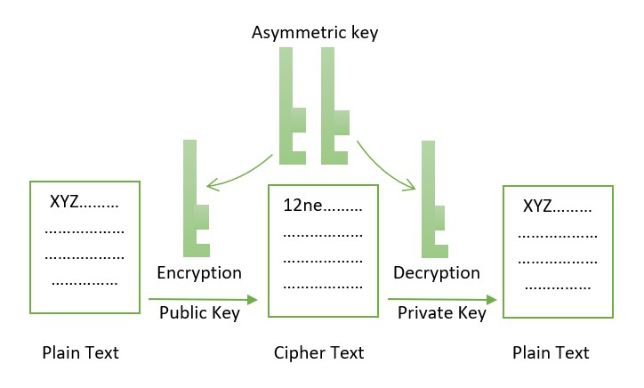Asymmetric Cryptography

Hashing vs. Encryption
- Hashing: A one-way function. It takes an input of any length (a word, a book, a file) and turns it into a fixed-length string of characters. It is mathematically impossible to reverse a hash to reveal the original input.
- Encryption: A two-way function. It scrambles clear text into unreadable ciphertext to keep data confidential. The text can be returned to its readable form using an appropriate secret key.

Symmetric vs. Asymmetric Keys
- Symmetric Encryption: The exact same secret key is used to lock (encrypt) and unlock (decrypt) the data. Both sides must securely share this exact key.
- Asymmetric Encryption: Uses a mathematically linked Key Pair consisting of a Public Key and a Private Key.
As visualized below, asymmetric keys allow secure communication and transaction authorization without requiring users to share their underlying passwords.
- Public Key: Shared openly across the blockchain network. It acts like an account number or email address that others use to route assets to you.
- Private Key: Kept entirely secret by the user. It acts like a digital signature or password used to authorize outbound transactions.

