**SMART GUARDIAN**

Project ID: 19-099

Design and Development of Drown Prevention & Flood Prediction System

Final Report

K.D. Samarasinghe, P. M. De Silva, T.U. Mudalige, Gamage M. K. I

Bachelor of Science Special (Honors) in Information Technology

Department of Information Technology

Sri Lanka Institute of Information Technology

Sri Lanka

September 2019

**SMART GUARDIAN**

Project ID: 19-099

Design and Development of Drown Prevention & Flood Prediction System

Final Report

(Final Report documentation submitted in partial fulfillment of the requirement for the

Degree of Bachelor Science Special (honors)

In Information Technology)

Bachelor of Science Special (Honors) in Information Technology

Department of Information Technology

Sri Lanka Institute of Information Technology

Sri Lanka

September 2019

**DECLARATION, COPYRIGHT STATEMENT AND THE STATEMENT OF THE SUPERVISOR**

We declare that this is our own work and this proposal does not incorporate without acknowledgement any material previously submitted for a degree or diploma in any other university or Institute of higher learning and to the best of our knowledge and belief it does not contain any material previously published or written by another person except where the acknowledgement is made in the text.

|  |  |  |
| --- | --- | --- |
| Name | Student ID | Signature |
| K.D.Samarasinghe | IT16059214 |  |
| P.M.De Silva | IT16041080 |  |
| T.U Mudalige | IT16102842 |  |
| Gamage M.K.I | IT16105812 |  |

The supervisor/s should certify the proposal report with the following declaration

The above candidates are carrying out research for the undergraduate Dissertation under my supervision

Signature of the supervisor: Date:

**ABSTRACT**

Internet of Thing (IOT) becomes major momentous element to connect all over the world via the internet. It is more rewarding to improve data collection, data sharing for customer engagement with more flexibility to detect problems or processes. When IoT embedded to our project environment, this concept can be applied incorporated to make it smarter, safer and automated.

‘Smart Guardian’ represent two main IoT devices subsist with sensors and monitoring system.

”The worst thing is watching someone drown and not being able to rescue”, to prevent aforementioned conception we come up with **'Smart Guardian’.** This project support for children or teenagers to survive from the threats which is caused by water such as drowning and also this is may help for people to survive from the natural disaster like flooding. These are the major problems we are addressing through our project.

This thesis is concerning style, simulation associated testing of an underwater modem using transducers, waterproof wearable device and floating device using various sensors and systematical flood alert . The thesis work combines a theoretical half, whose objective is to grasp the appropriate techniques to modify the characteristics of the targeted channel, simulations and a sensible half relating to the system readying and experimental tests.

Keywords : *Flood monitoring system; Under Water Communication; IoT systems, SARIMA , Naïve-Bayes, Werable Device, Floating Device*

**ACKNOWLEDGMENT**

We would prefer to take opportunity to precise our feeling to any or all of those who have helped us and provided their support. We would first prefer to impart our supervisor Dr. Pradeep Abeygunawardhana for providing us with this opportunity. You have got provided us with continual support and knowledge, allowing us the liberty to pursue our analysis in the method we assumed best whereas still being there to supply a smart word of recommendation once needed. We cannot many thanks enough for the support and commitment that you simply have shown to us throughout my studies.

We would like to thank CDAP panel, for the valuable effort made through during this course, in order to achieve us a great experience of outcome a successful software project at the end. For the support, they had given towards the success of this project and for giving us the domain knowledge and providing necessary information and documents regarding the project.

Sri Lanka Institute of Information Technology, Department of Information Technology and its panel of dedicated lecturers would be acknowledged our thankfulness for the knowledge and the wisdom we have gathered while being students in there.

We are also grateful to our family and friends, for supporting and encouraging me to complete this project successfully.

Finally, we would like to thank all the colleagues at Sri Lanka Institute of Information Technology who have been with us in all difficult times with suggestions and supportive words which carry us to make this project a reality I am truly humbled and grateful to have so many extraordinary people in my life

Table of Contents

1 Introduction 7

1.1 Background & Literature Review 7

1.1.1 Background 7

1.1.2 Literature Review 9

1.2 Research Gap 13

1.3 Research Problem 13

1.4 Research Objectives 15

1.4.1 Main Objectives 15

1.4.2 Sub Objectives 16

2 Methodology 16

2.1 Methodology 16

2.1.1 Design and Development of Wearable device to Estimate depth and Detect drowning user 18

2.1.2 Floating Device as Intermediary source for underwater communication and server 20

2.1.3 An Ultrasonic Transducer-Based Underwater Data Communication 22

2.1.4 Flood Detection and Security enhancement of Floating devices 23

2.2 Commercialization aspects of the product 25

2.3 Testing & Implementation 26

2.3.1 Wearable device Implementation 26

2.3.2 Floating Device Implementation 26

2.3.3 Underwater Communication Implementation 26

2.3.4 Flood prediction Implementation 29

3 Results & Discussions 35

3.1 Result and Discussions 35

3.1.1 Results obtained from the Wearable Device 35

3.1.2 Results obtained from the Floating Device 35

3.1.3 Results obtained from the Underwater communication 35

3.1.4 Results obtained from the SARIMA Prediction Algorithm 35

3.1.5 Results obtained from the Naïve-Bayes & SARIMA Algorithm combination 39

3.2 Research Findings 39

3.3 Summary of each student contribution 39

4 Conclusion 40

5 References 41

6 Glossary 42

7 Appendices 42

List Of Figures

Figure 2.1.1 System Architecture 18

Figure 2.1.2 Depth Measurement structure 19

Figure 2.1.3 Trigonometry Depth Estimation 19

Figure 2.1.4 Position of device to get the accurate measurement 20

Figure 2.1.5 Structure of underwater communication 22

Figure 2.1.6 Structure of flood prediction 23

Figure 2.3.1 Circuit of ultrasonic data receiver 27

Figure 2.3.2 Flow of flood prediction system 31

Figure 2.3.3 Frontend Interface 01 - Flood Dashboard 32

Figure 2.3.4Frontend Interface 02 - Flood Probability Results 32

Figure 2.3.5 Frontend Interface 03 - Floating Device Tracking Dashboard 33

Figure 2.3.6 Frontend Interface 04 - Current data of each attribute comes from floating device 33

Figure 2.3.7 Frontend Interface 05 - View All factors real data 34

Figure 2.3.8Frontend Interface 06 - View predicted flood factors with real data 34

Figure 3.1.1 RainFall 7 Days Calibration 35

Figure 3.1.2 RainFall 15 Days Calibration 36

Figure 3.1.3 RainFall 30 days Calibration 36

Figure 3.1.4 Water Depth 7 days Calibration 37

Figure 3.1.5 Water Depth 15 days Calibration 37

Figure 3.1.6 Water Depth 30 days Calibration 38

Figure 3.1.7 Flood Prediction results in percentage 39

List Of Tables

Table 1 Research Gap 13

Table 2 Collected Data set for Flood 24

List of Equations

Equation 1 Depth Calculation 20

Equation 2 Distance Calculation 21

Equation 3 SARIMA Notation 29

Equation 4 Bayes Theorem Notation 30

Equation 5 Flood Probability Calculation 31

# Introduction

## Background & Literature Review

### Background

Initially as a project, to elect a specific area and concept is a challengeable task as a team. Therefore, we elect a concept of safeness when being in water. One of the most important factors is keep in safety while we are entertaining ourselves at aquatic environment. Accidents can be happens in several way but in this project we generally focused on the Accidents caused due to ‘Drown’ and ‘Flood’.

Drowning is the second leading cause of accidental deaths in the world, next to road accidents. Even WHO highlighted drowning, as a major cause of death in the Global Report on Drowning (2014). According to researches, a child drowns every minute in the world. However, there is not a specific product to prevent people drowning from the aquatic body. Especially for the drowning from the ocean or a lake or a river. Most of them are children, teenagers and female. If we analyze the causes of a number of deaths reported daily, the root cause for them is negligence. Ocean looks so calm that it seems fascinating, but at times, it is so rough and threatens to bring death to a few lives.

This project communication is transmitted via the underwater. In recent year’s communication technologies underwater has become a lively space of analysis because of its vital applications in military, oceanographic knowledge assortment, disaster hindrance, and pollution watching. Communication is a very important method that permits an associate exchange of knowledge transfer between two or a lot of entities or nodes. Underwater wireless communications gift new and distinct challenges when putting next to wired and wireless communication through the atmosphere, requiring sophisticated communication devices to achieve comparatively low transmission rates, even over short distances. Indeed, the underwater environment possesses a variety of identifying options that make it distinctive and rather completely different from terrestrial radio propagation wherever ancient communication systems are deployed. Underwater, many phenomena may inﬂuence communications, like salt concentration, pressure, temperature, amount of light-weight, winds and their effects on waves

Flood is aging natural disaster that any humankind could not refrain. Flooding may result due to the body of water in river or lake by increasing the volume. According to the seasonal changes in perception, strong winds, heavy rain and other geological fact, volume of the water in aquatic environment of river or lake can be changed. It would be a result to overflow the water area into the land. In Sri Lanka flood is the mostly affected natural disaster for people. Recent fact for this is heavy strong winds and heavy rain caused over the Bay of Bengal. According to the Ministry of Disaster Management in Sri Lanka approximately 35 deaths , over 700 buildings were utterly destroyed and over 85000 peoples were evacuated from flooded prone areas reported between May 11th 2018 to January 2nd 2019.

The main motive of this document is to acknowledge the behavior and conjointly the implementation of the wearable device with the flood detection and coordination generation.

Therefore by considering all those facts we come up with ‘Smart Guardian’ to detect the drowning user condition and warning the nearby lifesaver for the person survive and to detect the flood prediction for the residents in flood prone area to evacuate before confront to impending flood situation. We were surveyed how could be this SmartGuardian convenient for the human kind.

### Literature Review

Internet of things dramatically improves our world in many ways. Higher output and increased productivity have been two of the biggest reasons in justifying the use of IOT. This chapter describes the previous and up to date existing styles in many studies of various research related our project and additionally offers a broad understanding associated with this project work supported the literature, conferences papers, books, journals, and publishers. . It additionally is a reference supported that the thesis work is allotted. . Despite the fact that most of the options are completely different whereas comparison with the projected product, much vital data is gathered through those papers because the main focus is the same. With the advancement of the technology in IT industry, some people have focused their consideration on proposed project functionality concept. Here describe existing systems and therefore the means they move with this part. This the section explains what reasonably neutral use this methodology and therefore the means they operate this methodology.

Referring to this document, developers, and users can merely understand, however, this part goes on. This section describes offered constraints, assumptions and therefore the means this part communicates with various components, etc.

We first reviewed the information in the 2013 iSwimband. This has been developed by Paul Chu [1].This is a waterproof device is known as the iSwimband. It sits around the head of a child and has a Bluetooth-enabled sensor at the front. When the device detects the kid has fallen into water, it sends associate in nursing alert right away to the parent so that they will come back and rescue them. For the interactive features, such as sensor is paired with a compatible Bluetooth-enabled smart device running the free iSwimband app. It has a battery life of hundreds of hours of active monitoring [1].

Then another research has been done to implement an inflatable wrist band system SNS College of Technology Coimbatore, India[2]. Which triggers to open a small air bag when the user is drowning. In here only the person wearing the wrist band knows that he/she is drowning . Included features for our proposed product wearable device enable to estimate the depth of water and it measure the pulse rate of the person to determine the user’s heart condition while at water.

In 2015 a style of Low-Power modem for underwater communication has been developed by Jagdale M.R.1, Puranik V.G [3]. This has been developed primarily by specializing in networks of times rely upon acoustic communication, that poses a number of disputes for reliable information transmission. primarily has many interactive options like to transmitted Signals within the ultrasonic Transmitter and received Signals within the ultrasonic receiver transforms the mechanism for analog signals into digital signals, code sampling methodology to interpret signals because of the original signals, frequency generators, ampliﬁers, ultrasonic sensors and lots of methods with sensors are employed in this project.

In 2015 another modem for underwater communication has been made by Slamet Indriyanto, Ian Yosef Matheus Edward [4]. This analysis was supported underwater modem with ultrasonic frequency victimization Frequency Shift Keying (FSK) Modulation. The designed system includes FSK electronic equipment, microcontroller, electronic equipment, and electrical device. Waterproof ultrasonic sensors JSN-SR04T area unit used as transducers for designed modems. a number of the options area unit enclosed in our projected product in addition.

Another an ultra-Low Power and flexible Acoustic Modem design to develop energy-efficient underwater sensor networks was developed by Pedro Yuste, Angel Perles and Juan José Serrano in 2012 [5]. This is focused on the description of the physical layer of a new acoustic modem called ITACA. The modem architecture includes as a major novelty an ultra-low power asynchronous wake-up system implementation for underwater acoustic transmission that is based on a low-cost off-the-shelf RFID peripheral integrated circuit.

The analysis work of Akylildiz, Pompili, and Melodia describes the state of art of underwater detector networks beside some analysis challenges for readying of underwater acoustic detector networks (UASN) [6]. It describes the various applications of the underwater acoustic detector networks such a number of the main challenges within the style of UWASN’s are mentioned like information measure (BW) limitation, high bit error rates followed by shadow zones, limitation in battery power and fouling corrosion. completely different UWASN architectures or topologies like 2D static and 3D underwater detector networks are delineated.

In the work of Wills, Lolo and Heidemann, the first aim was to style and develop a reasonable electronic equipment that's affordable for purchase and for readying of the many detector nodes. The target worth of this method is alleged to be 100$ and therefore, the electronic equipment is specially designed for short-range communication of vary 50m-500m. The digital hardware platform used may be a straightforward 8-bit Atmel Atmega 128L microcontrollers and this style makes every of the detector node development price cheaper. The modulation theme used for information transmission here is FSK. A BER of 10-5 was seen once the transmitter and receiver were unbroken getting ready to one another. (Wills, Wei dynasty Ye and Heidemann, 2006).[7]

In the work of Num and Sunshin an, they developed a low power based acoustic modem that basically operates with 3.3V power supply and has a capability of digital data communication. The modulation scheme used in this work is amplitude shift keying (ASK). The system tested to show a data rate of 100 bps, the communication distance of the modem is approximately 3m, however the exact range of the acoustic modem could not be found due to the lack of test facilities. The system has made use of piezo-transducers i.e. Sounder/ projector/speaker at the transmitter and hydrophones at the receiver end, however some problems that needs to be considered for this modem for future work is directional property, reflection and refraction. In addition, this acoustic modem will become the basis for the underwater wireless sensor networks (Num and Sunshin, 2007).[8]

Advance Flood Detection and Notification System based on Sensor Technology and Machine Learning Algorithm was developed by Mohammed Khalaf, Abir Jaafar Hussain, Dhiya Al-Jumeily in 2014 [9]. This basically flood detection system designed for immediate notification to the native authorities. It determined the present water level victimisation sensing element network, that provides notification via SMS and internet base public network such Facebook and Twitters through GSM electronic equipment. SMS and internet base public network area unit valuable alert communication tools, which will distribute the knowledge to the floods victims among specific space. Four machine-learning algorithms were utilized to classify flood knowledge. For our project, we applied some of the features such as GSM module , PS module to track the location etc.

Another research reviewed SMS Flood Alerting System in Flood Affected Area was developed by Kirti Bhausaheb Gavali in 2015[10]. It proposed a system that can early warn about the upcoming flash floods for the upstream and downstream areas. It used solar cells as the main power then transmitter the data via the SMS by analysing the water level data. It support us to apply some of the feature for our project GSM module and other relatable modules.

SYN Flood Detection Algorithms has been produced by Matt Beaumont-Gay [11]. He implemented three SYN flood detection algorithms such as SynFinDiff, SynRate, and PCF.SynFinDiff has good detection speed but takes a very long time to return to a non-alert state. SynRate is significantly and negatively affected by attacks that create high variance in the traffic rate, but is faster than SynFinDiff at signalling the end of an attack and PCF performs very well with regards to both detection time and quiescence time. In our proposed product, developing flood detection algorithm by using some of the features.

The Implementation of an IoT-Based Flood Alert System developed by the Wahidah Md. Shah , F. Arif , A.A. Shahrin and Aslinda Hassan in 2018.[12] It proposed the a flood warning system that can detect the water level and measure the speed of the rise of water level. To give the society an earlier notification to evacuate before the water rises to the dangerous level, the measurement result is sent as the alert to a mobile phone through Short Message Service (SMS).

In 2015 Forecasting Monthly Perception is developed using ARIMA Model by Shabari, M.T Rahman, M.M Hussain and Sourav Ray [13]. It is a prediction model that used to forecast long term rainfall in Sylhet. Four basic chronological steps namely: identification, estimation, diagnostic, checking, and forecasting were fitted out in developing the model. It is expected that this long term prediction will help decision makers in efficient scheduling of flood prediction, urban planning, rainwater harvesting and crop management.

Include features in our proposed product such as Estimating the depth of water using Sonar Signals and Gyro and Accelerometer Sensors, Underwater Communication Modem using a Sonar Signals, Flood Detection and Floating Device to collect data transmitted from Wearable and Send data to server which is mobile app is connected, Collect pulse rate of the user and water level and water flow from sensors and predict User condition and Potential Flood using Machine Learning algorithm.

## Research Gap

|  |  |  |
| --- | --- | --- |
| **Product** | **Features** | **Novelty Features of Proposed project** |
|  |  |  |

Table 1 Research Gap

## Research Problem

The ‘SmartGuardian’ has several important functions included to run the process. This product is hinge on two main scenarios. Those are Drown prevention and Flood prediction scenarios. Therefore, overall The ‘Smart Guardian’ product concept mainly focused on few problems. There are,

* How to prevent person from drowning?
* How to know the depth of water where person stands at water?
* How to do the underwater communication to transmit data to server?
* How to locate the affected person?
* How to predict the flood?
* How to identify the interrupted service in devices?

When comes to the each main functions segment, we come across with different set of problems other than the main problems. In drown prevention scenario it estimate the depth of water where the persons stands at to know the how deep that person is going and detecting the drowning person using pulse rate. When we are working on this we analyzed several problem. There are,

* How to get reliable depth measure by considering positions of hand?
* How to determine user condition when the pulse rate is not accruable?

When it ’comes to the “An Ultrasonic Transducer-Based Underwater Data Communication” come across with different set of problems.

* Technique of sending and receiving message below water
* How to do the hardware implementation both RX and TX?
* How to find the data is received successfully?
* How to do the error checking?

When consider the “Intermediate source for under water communication and server ” segment we come across different problems,

* How to set floating devices still without those floating all over the place?
* How to locate the floating devices?
* How to maintain the power of the floating device?

In Flood prediction scenario, prediction is depends on several parameter such rainfall, depth of water and stream flow speed. To estimate the flood occurrence in near future we need to increase the accuracy of collected data via the floating devices. While achieving above mentioned goals, several research problems were identified. Those are,

* How to come up with an algorithm, which will have the prediction goals by considering the parameters?
* How to increase the accuracy of the prediction via the algorithm parameters?
* How to eliminate the annoying alerts and data received from devices?
* How to estimate the best-case scenario level for alert?
* How to determine the flooded area?
* How to identify the service down floating devices?

To overcome above issues, several information and details are gathered through so many resources like internet, research papers, articles and etc. As well, in the developing process, many numbers of sensors have to be used and we have to develop this project in most feasible manner.

## Research Objectives

### Main Objectives

In our proposed project, we are focusing on two accidental scenarios that occur from water. According to the ‘Drown Prevention’ function is to detect the drowning person before it lead to another death and ‘Flood Prediction’ function is to evacuate the people from the flooded area before confront to impending flooded situation. From this module, we are trying to gather sufficient time for the people to acknowledge life savior to rescue from drowning and assemble residents who are living in flood prone area to survive. Hence, as the main objective we want to reduce the no of deaths due to Drown and flood.

### Sub Objectives

On each function in proposed project there are several sub objectives were introduced other than the main objective.

* Person can determine how deep that he/she going at water area
* To conduct literature review on acoustic signals, existing underwater acoustic modems, underwater channel characteristics, modulation schemes, and error detection, correction schemes
* To model the underwater Ultrasonic Transducer (TX & RX) and analyzing the device performance.
* To design, model and simulate the underwater device using appropriate simulation tool for the desired specifications.
* To realize the designed system in hardware for accurate data communication
* To test and analyze the performance of the developed system
* User can know the weather level in any area where the river or lake exist.
* Admins can determine the interrupted service of floating device to fix.

# Methodology

## Methodology

Proposed product is specially designed to mitigate the death due to drowning and floods. With the use of previous facts and routine the project will forecast the user condition and flood.

Wearable device is consisting with sensor technology to monitor user heart rate and to estimate the depth of water. This device is used to predict the user condition. It supports to aware about the person when a person is in critical condition. With the use of previous facts and data of pulse rate, create a pattern to estimate the condition.

Floating device is the intermediary source to communicate with two mediums. When communicating with different medium directly possibility of discarding of data is high. Through the underwater communication we transmit data to floating device and check for the error prone schema for successful transmission.

Floating device is collecting data for the flood prediction through the sensors connected to it. Rather than forecasting the heavy rain duration device collecting the water depth, stream flow peed and rainfall. By considering the previous data create a pattern to predict the flood occurrence in a percentage manner. Flood will predict for the two weeks advanced climate situation for the chosen geographic area.

To perform the communication in between the wearable and the floating device, underwater acoustic communication will be used. To perform underwater communication sonar signal is used. Wearable device will be transmitting the pulse and estimated depth of the frontal area while floating device will be receiving the transmitted data. Such that an underwater acoustic modem will be created, and the transmitter part of the underwater acoustic modem will be implemented in the wearable device while receiver part of the device will be implemented on the floating device.

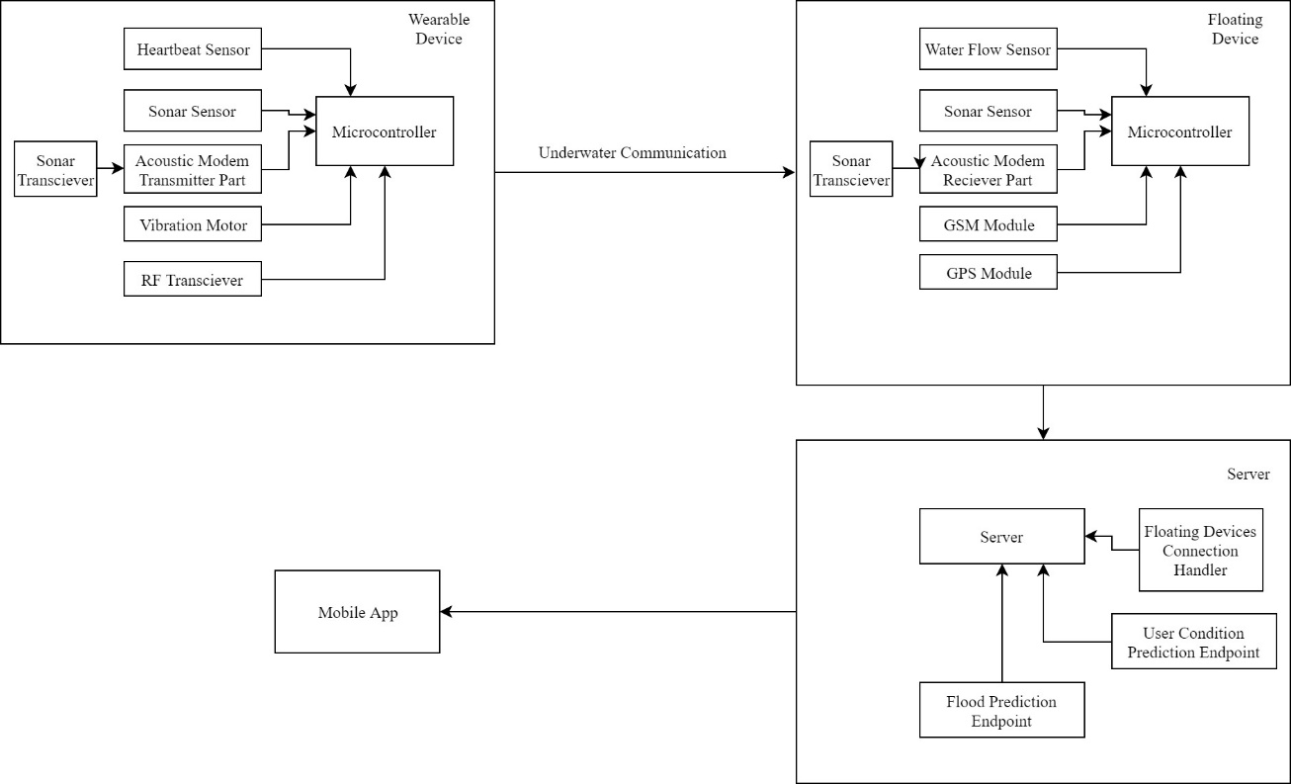

Figure 2.1.1 System Architecture

### Design and Development of Wearable device to Estimate depth and Detect drowning user

#### A. Estimating the Depth of Water

People are basically unaware about the depth of the water where they are stands. Hence, this could be have a higher probability of drowning. The wearable device is capable of measure the depth of the water. If the user is going through deeper area, it will trigger an alert through vibration of the device. This wearable device is waterproof and it feasible to use any user.

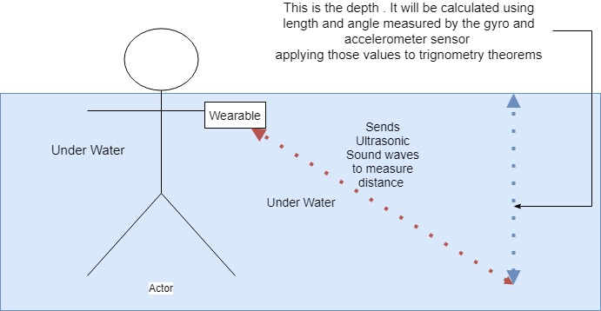

Figure 2.1.2 Depth Measurement structure

Sonar sensor is used to measure the distance from the wearable device and the bottom of the water body (riverbed, ocean floor and lakebed) assume that distance as x.

Imagine a triangle as in figure 3, the slant of the triangle will be x. therefore, to find the estimated depth (h) in the front area, we have to use trigonometry.

Degree of angle (m) is calculated by the Gyro and Accelerometer Sensor (MPU-6050).

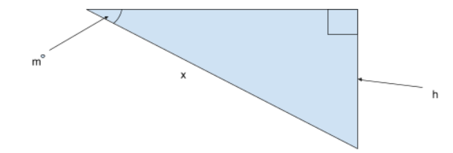

Figure 2.1.3 Trigonometry Depth Estimation

Since we acquire the degree of angle and the slant (hypotenuse) using the respective sensors we can estimate the depth of the water (side opposite) according to trigonometry using below formula.

*Sin(m) = h/x*

*Hence, h = x.Sin(m)*

Equation 1 Depth Calculation

Wearable device should be turned on while it in the water and for more accurate estimation device should be positioned as it in the Figure 3.5.

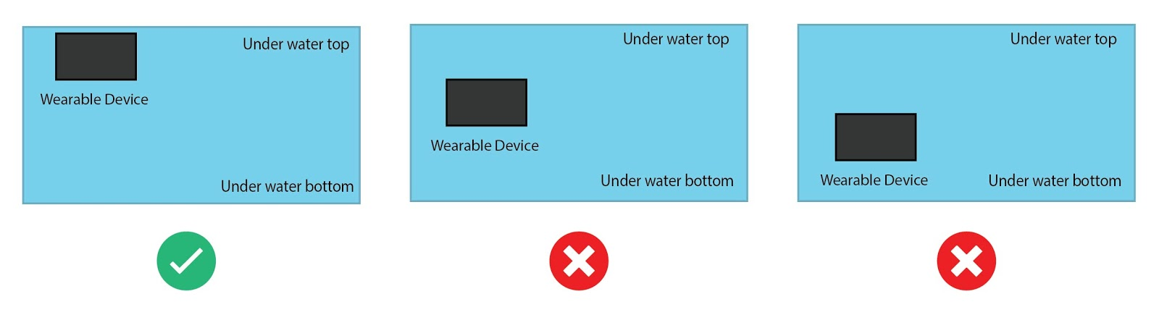

Figure 2.1.4 Position of device to get the accurate measurement

Wearable device has a small screen to display the depth of the water and once the device identify the depth as dangerous it will vibrate the device according to the alert

#### B. Detect the Drowning Person

### Floating Device as Intermediary source for underwater communication and server

We implement this device because the server could not be able to communicate with the devices, which are in the water. The floating device in with a set of sensors for each task. To determine the depth of the water it has a sensor called depth-sensing sonar sensor and to determine the speed of the water flow it has a sensor called the water flow sensor. Floating device capture the data, which are received from the wearable device at the same time sends all data to the server.

This is not the only purpose of this device, which is capable of doing. If someone's drowning, we trigger the alert to our mobile application. However, we need to locate the affected person. Therefore keeping track of a person in the underwater is an essential part of this process. To achieve this we follow a process as below that how we tackle this problem.

* A GPS tracker In the floating device so we’ll know the exact location of each floating device.
* When a user data gets sent to the floating device a timestamp will also be included in the data file
* After receiving the data file, the timestamp will be converted to local time and compare with the time received and calculate how much time did it take the data to arrive.
* With this result, we are going to calculate an approximate value and show it in a radius respective to the nearest floating device.

**Distance = Rate * Time**

Equation 2 Distance Calculation

As mentioned earlier, the floating device has two communication modules to communicate with the wearable device, which is the underwater communication and RF communication to capture the data from the sensors in a wearable device to send data to the server.

Floating devices are included with a sonar sensors to get the depth of the nearby water area so that people can know the depth of the water before they get into that area.people who has the smart guardian app on their phone can see the locations of the floating devices and with the web based admin panel they can see the details of the floating devices such as power of the floating devices,location of each device and the depth of the nearby water area and the flow of the water.

### An Ultrasonic Transducer-Based Underwater Data Communication

Underwater communication is a way of sending and receiving message below water. There are several ways of employing such communication where the most common is using transducers. For a booming establishment of an acoustic communication link below given environmental conditions, the physical line should be taken into consideration. Acoustic waves that result from variations of pressure in an exceedingly medium are widely used as a physical layer in Underwater acoustic communications.

The system which consists of two Acoustic modems (Tx & Rx) and communicate through these two modems. The system has the capability of getting connected to remote floating devices and getting signal who wear the wearable device via the physical board. The floating devices will be providing the correct signal message to the server with and interface to engage in the app.

**Tx Rx**

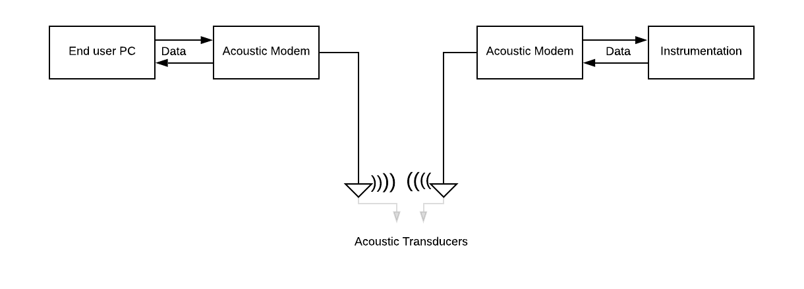

Figure 2.1.5 Structure of underwater communication

### Flood Detection and Security enhancement of Floating devices

Flood is aging natural disaster that every human kinds know. It mainly caused due to heavy perception, strong windstorm and other changing geological conditions. Therefore, any of the human kind could not stop to happen flood or could not escape from it. Because it hinge on natural conditions which caused for excessive rain and ruptured dam to overwhelm a river and spread it over a landscape. Through this product, we are able to predict flood for human acknowledgment. We cannot stop the flood but we are able to notify the residents whoever diggings in flood prone areas. We cannot save the resident’s home but we are expecting to through this product to save human lives. To process this task we need past and current data for prediction. Here is the basic structure of this flood alerting system

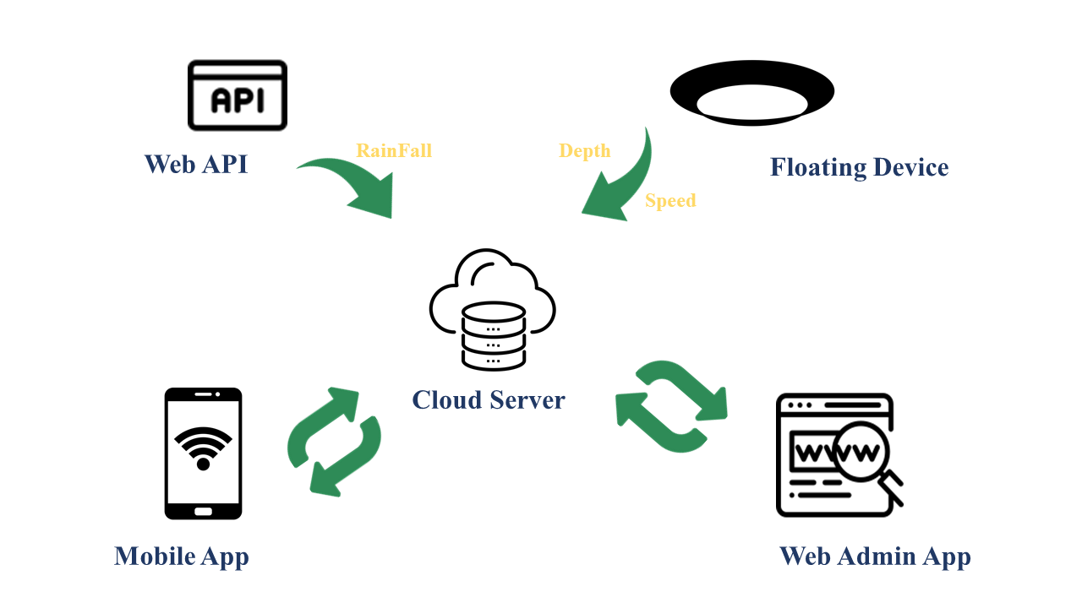

Figure 2.1.6 Structure of flood prediction

#### A. Data Collection

We can achieve this task via the data received from floating devices. Floating devices is an intermediary source for the communication between under water and server and it is float on river or lake at fixed place. This device has a sensors to collect data according to change of river situation to predict the flood. Those are,

* Depth of water: Ultrasonic Sonar sensor has ability to measure the depth of water where the floating device is fixed on river. It is an instrument that measures the distance to an object using ultrasonic sound waves. Ultra sonic sensor is reliably implemented for the feature of water level sensing
* Rainfall: To measure the perception we are using API from a website. It measures rainfall intensity by operating as a switch when raindrop falls.
* Streamflow Speed: Water flow sensor is used to measure the speed of water flow. When the water flows through the rolls, it speed change according different rate of flow. The half effect sensor output the pulse signal to determine the speed.
* Location: GSM Module support to locate the floating device to determine the device location and flood area location

To train and evaluate the proposed predication platform we need historical statistics of aforementioned data in every Sri Lanka Rivers. However, as the first step, we decided to carry out our case study at Kelaniya area. We collected statistics related to weather of these areas from different sources. All the data sets include data of year 2016 to 2019. Area wise rainfall and water level of Kelani River were collected from Disaster Relief Management Department, Meteorology Department and Irrigation Department of Kelaniya, Sri Lanka.

|  |  |  |
| --- | --- | --- |
| Date | Kelaniya | |
| RainFall | WaterDepth |
| 1/1/2017 | 2.2 | 2.4 |
| 1/2/2017 | 0 | 2.15 |
| 1/3/2017 | 0 | 2.11 |
| 1/4/2017 | 1.8 | 2.11 |
| 1/5/2017 | 2.2 | 2.22 |
| 1/6/2017 | 2 | 2.28 |
| 1/7/2017 | 2.6 | 2.28 |
| 1/8/2017 | 2.1 | 2.32 |
| 1/9/2017 | 0 | 2.22 |
| 1/10/2017 | 0 | 2.11 |

Table 2 Collected Data set for Flood

## Commercialization aspects of the product

We have identified numerous opportunities that we can commercialize our product.

We can introduce our product to

* Hotels situated around lakes and rivers as well as oceans

By doing this they can demand the safety of their customer. Not just keeping a Lifeguard standing on the beach or riverbank, they can demand a lifeguard who is monitoring their customers when they are in water.

* Travelers

We hope to introduce this product to travelers who do waterfall hunting like adventurous activities so they can use our product and ensure their safety.

* Rescue Groups

Since this product is capable of finding the depth of unclear water also, we can use this product in rescue missions in floods as well as rescue missions.

Since safety in aquatic environments is a critical topic that draws attention and since there are no product or research undergoing which is similar to our product Smart Guardian will gain a higher market value.

## Testing & Implementation

### Wearable device Implementation

For the implementation of the Wearable device, below mentioned hardware components have used.

* Arduino Mega 2560 micro controller
* JSN-SR04T -2 Water Proof Sonar Sensor
* Pulse Sensor
* 0.91 Inch OLED LCD Display Module
* MPU6050 - Triple Axis Accelerometer & Gyro Breakout

### Floating Device Implementation

Following are the Hardware used for the floating device. Parts list:

* Water Flow Sensor Flowmeter Hall Flow Sensor 1/2″ 1-30L/min
* GSM Module SIM900A
* SIM800 Quad-Band GSM GPRS Module with Antenna
* One Arduino Mega

### Underwater Communication Implementation

Following are the Hardware used for Acoustic Underwater Communication System In between wearable and floating devices. Parts list:

* + Ultrasonic transducer TX and RX (disordered from a HC-SR04 module)
  + LM386 to amplify the received signal
  + LM393 for comparing the signal once amplified
  + Two Arduino Uno
  + 10K pot for the tuning
  + LED
  + 220 Ohms’ resistor
  + 100nF cap
  + 10K resistor

#### A. Ultrasonic Data Transmitter & Receiver

For the transmitter, the ultrasonic transducer is simply tied to one of the digital pins on the Arduino. The receiver is a bit more complex, requiring a LM386 amplifier and LM393 comparator to create a clean signal for the second Arduino to read.

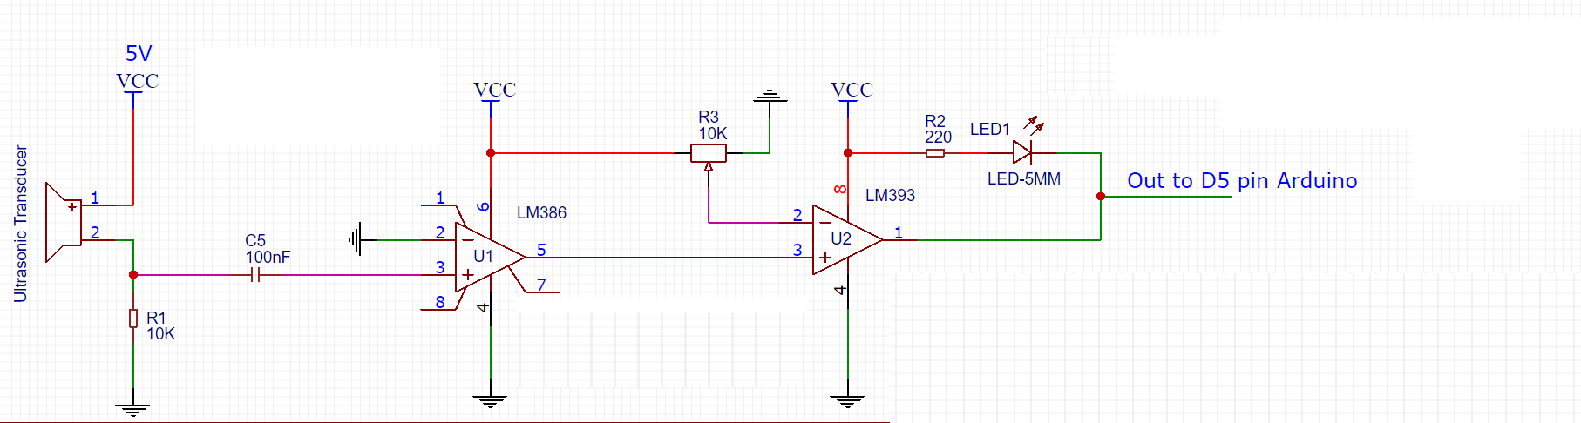

#### 

Figure 2.3.1 Circuit of ultrasonic data receiver

**TX Source code RX Source Code**

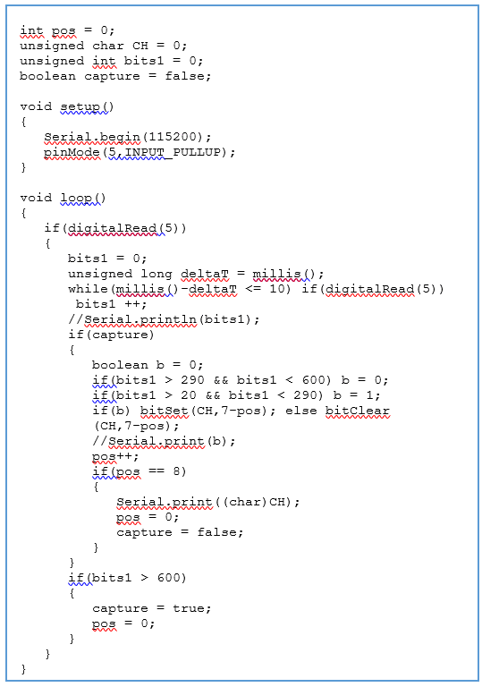

void setup()

{

Serial.begin(115200);

pinMode(3,OUTPUT);

}

void send(String msg)

{

byte ch;

unsigned int pos = 0;

unsigned int sz = msg.length();

while(pos<sz)

{

ch = msg.charAt(pos);

Serial.print((char)ch);

tone(3,40000);

delay(10);

noTone(3);

for(int i=0;i<8;i++)

{

boolean b;

b = bitRead(ch,7-i);

if(b)

{

tone(3,40000);

delay(2);

}

else

{

tone(3,40000);

delay(4);

}

noTone(3);

delay(11);

}

pos++;

}

Looking through the source code for the transmitter and receiver, it’s concerning as basic because it gets. The transmitter Arduino breaks down a given string into individual characters, then any converts the ASCII to eight binary bits.

These bits are sent out as tones and are picked au fait the receiving finish. Once the receiver has collected a good chunk of tones, it works through them and turns the binary values back to ASCII characters that get drop over serial. It’s slow, however, it’s straightforward.

### Flood prediction Implementation

#### A. Backend Implementation

Prediction of flood is depend on the data of past and current value of aforementioned parameters. Through past data we analyzed the pattern by testing the past data. In this scenario we are using time series analysis methods because the flood prediction is based on realistic time situations that person can become acquainted with the sufficient time for preparation. Therefore we used Seasonal ARIMA model to analyze the past data and provide the prediction value. This model is capable of modeling a wide range of seasonal data and identify the best model that fit for flood prediction pattern with higher accuracy levels and also it is used to get a feel for the intricacies involved in smoothing, de-seasoning, de-trending, de-noising, and forecasting

We started the process with a data set, which reports the rain on each season for last 3 years at Kelaniya, Sri Lanka. The data included the date, and the factors that affects for the flood.

The list of raw data as follows for each row,

**1. Date**

**2. Rainfall:** average rainfall of each date take from the web api

**3. Water depth:** average river depth of each date taken from respective floating device

**4. Stream flow speed:** average river stream flow speed of each date taken from respective floating device

When preparing the data set, initially we used the date as an index in pandas (the python library used for the data analysis) then all the null values in data was marked as “0”. We dropped all the fields that are not important for our prediction.

Notation of SARIMA model,

**Seasonal Arima Model (p, d, q) × (P, D, Q)m**

Equation 3 SARIMA Notation

In here p=non-seasonal Auto Regressive(AR) order , d= non-seasonal differencing, q= non-seasonal Moving Average (MA)order, P= Seasonal AR Order, D= Seasonal Differencing, Q= Seasonal MA order m= repeating seasonal patter time span

This model depend on the seasonal time series. This can be yearly, quarterly, monthly, weekly, daily etc. based on this case study we are focusing on monthly time series pattern for forecasting. It determine the regular pattern of changes that repeat over respective time period. ARIMA model is a liner regression model that it uses its own lags as their own predictors.

Next step is to determine the value of p, d, q, which represent non-seasonal part of the data and P, D, Q, which represent the seasonal part of the data. This is done by using Gridsearch to find the most optimum parameters to use in our SARIMAX Mode. then make the model fit. When there is a stationary value on the data set only the SARIMA model give the results. values will be passed to forward without comparing. The error rate of algorithm for the data set will be calculated by getting predicted value for current existing values using past days. Lowest average error rate is going to selected as best fit value .Once it’s fitted we try to predict the number of observations to the future by calling the predict function. We applied this model for flood factors, which are rainfall, water depth and water flow speed predictions. Because flood is a qualitative measurement. By applying SARIMA into Flood factors we can covey that output of the flood prediction have higher reliability.

Before directly applying this model to the flood prediction to enhance the accuracy, we use Naïve-Bayes Algorithm. It is an intelligent method that uses the probability of each factors to make a prediction.

**Bayes Theorem,**

**P(A|B) = P(B|A)*P(A) / P(B)**

Equation 4 Bayes Theorem Notation

For our flood possibility determination we are using following advanced equation expand from Bayes theorem.

**Flood = F**

**RainFall =R**

**Water Depth =D**

**Stream Flow Speed =S**

**P(F) = P(F|R)*P(R) + P(F|D)*P(D) + P(F|S)*P(S)**

Equation 5 Flood Probability Calculation

Training and testing last 12 months each factors data to evaluate by it Mean the possibility of flood and tie it on to the Seasonal Arima Model for the prediction result with better accuracy.

Another function is to determine the service down floating device. This task is achieved by the reading time stamp comes from the float device data. Once python end point determined that server is receiving the data in perseverate manner.

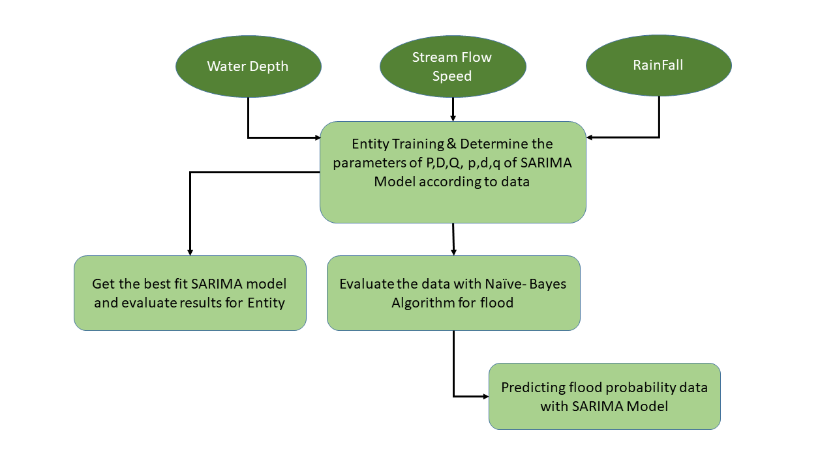

Figure 2.3.2 Flow of flood prediction system

#### B. Frontend Implementation

For frontend implementation, we used Django Framework, which is used for python web framework. It specifically based on HTML, CSS, JavaScript, Ajax, python. SmartGuardian Flood Alerting Admin Web system as follows,

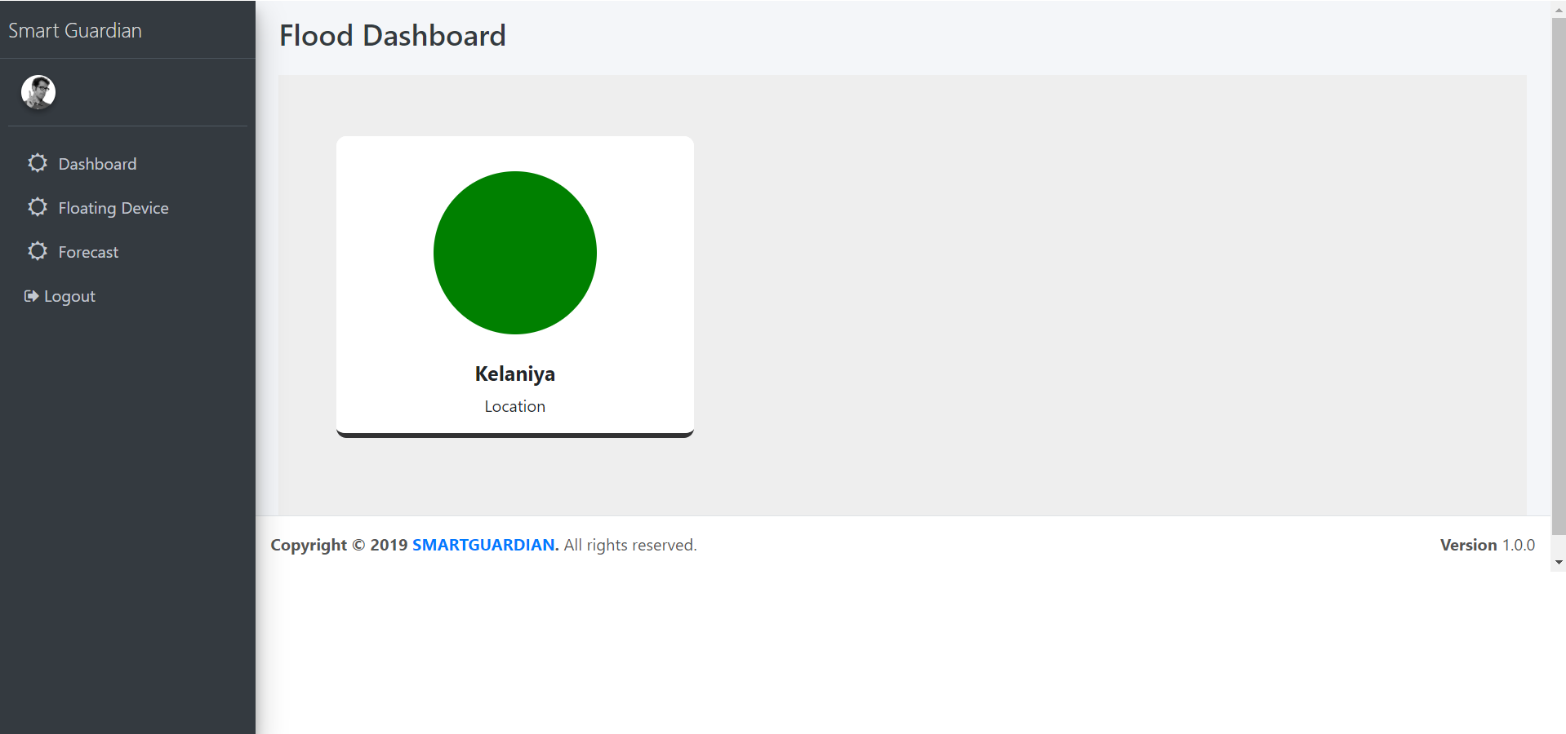

Figure 2.3.3 Frontend Interface 01 - Flood Dashboard

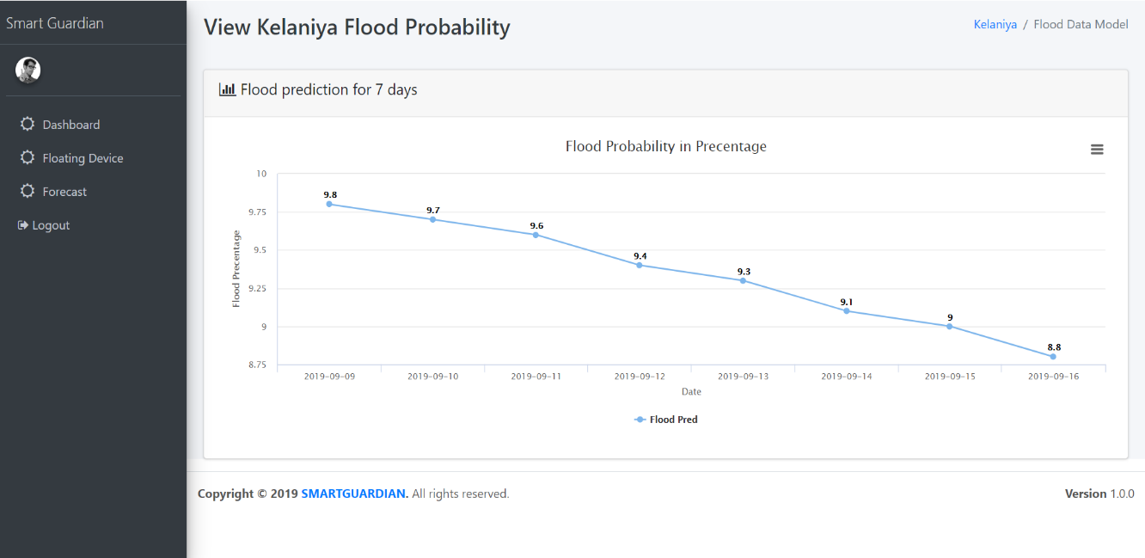

Figure 2.3.4Frontend Interface 02 - Flood Probability Results

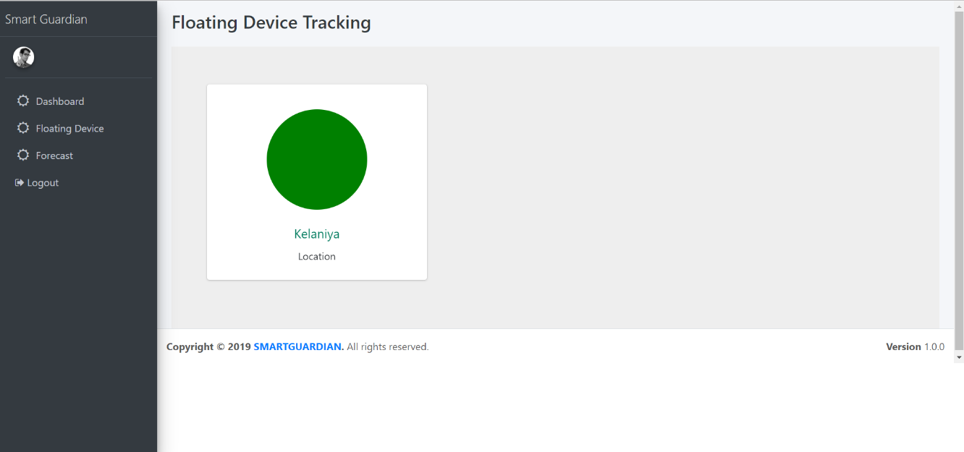

Figure 2.3.5 Frontend Interface 03 - Floating Device Tracking Dashboard

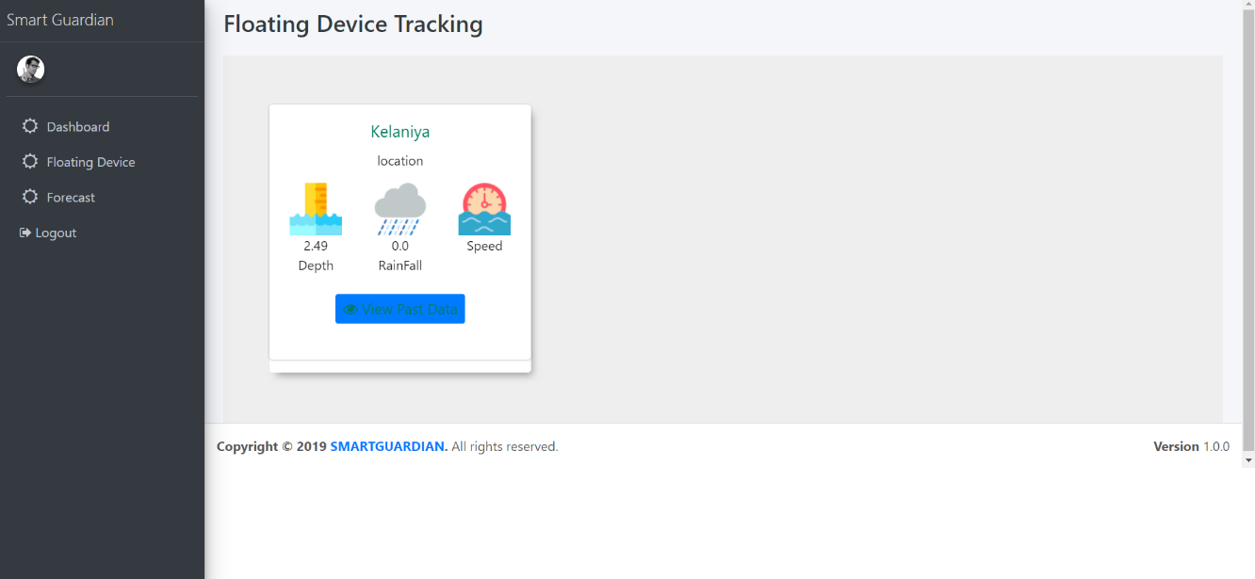

Figure 2.3.6 Frontend Interface 04 - Current data of each attribute comes from floating device

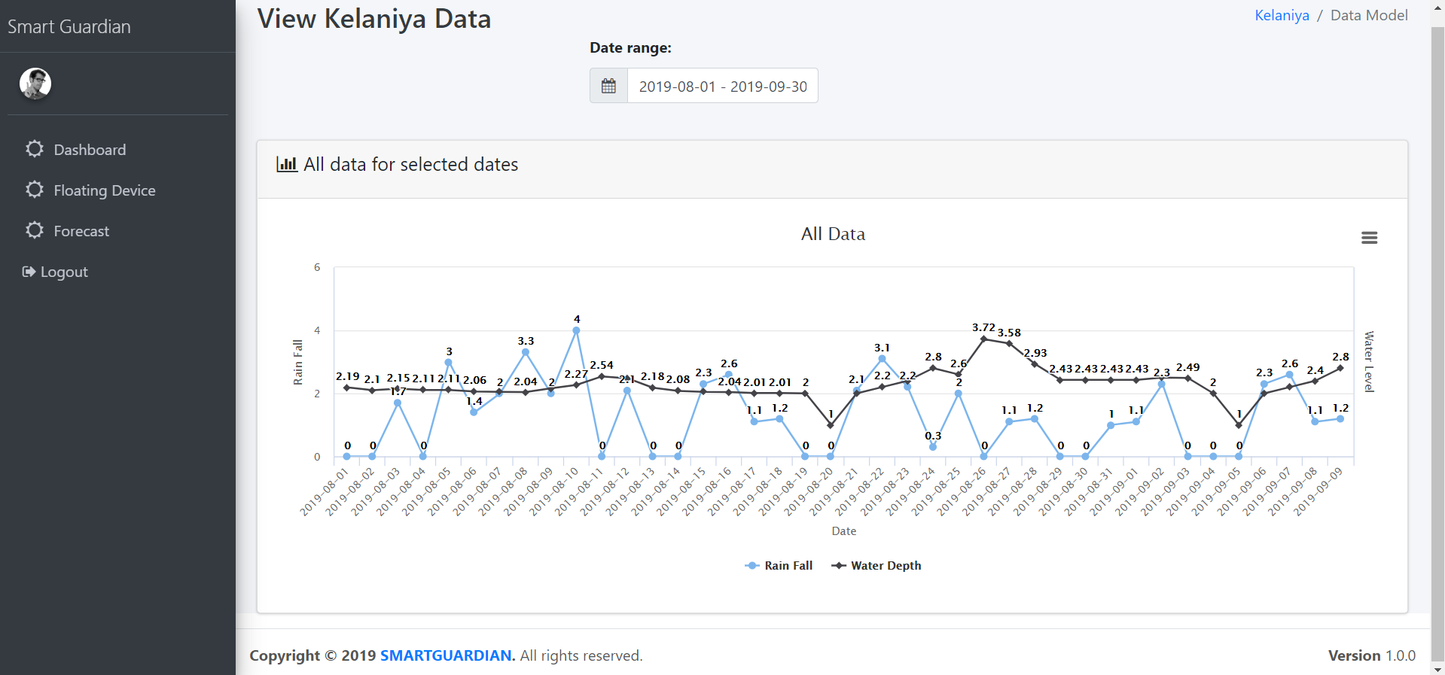

Figure 2.3.7 Frontend Interface 05 - View All factors real data

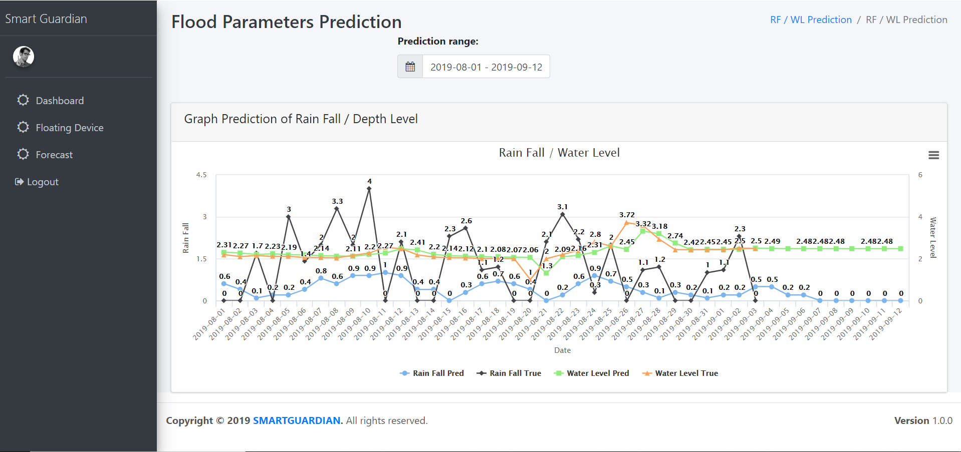

Figure 2.3.8Frontend Interface 06 - View predicted flood factors with real data

# Results & Discussions

## Result and Discussions

### Results obtained from the Wearable Device

### Results obtained from the Floating Device

### Results obtained from the Underwater communication

### Results obtained from the SARIMA Prediction Algorithm

Comparison of actual values with relevant predicted values which are obtained from the Seasonal Auto Regressive Integrated Moving Average can be seen from below graphs with respective to the rainfall occurrence to the Kelaniya, Sri Lanka. Testing is done in three different periods to find the optimal result.

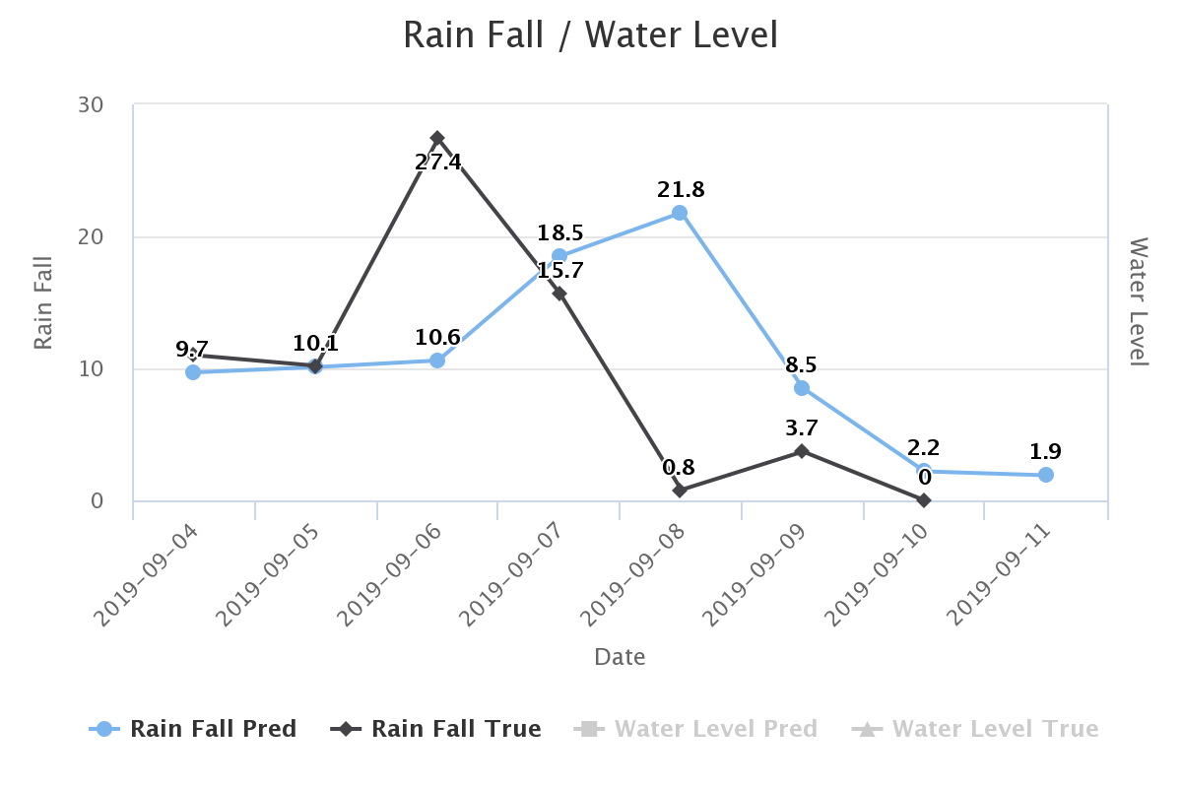

Figure 3.1.1 RainFall 7 Days Calibration

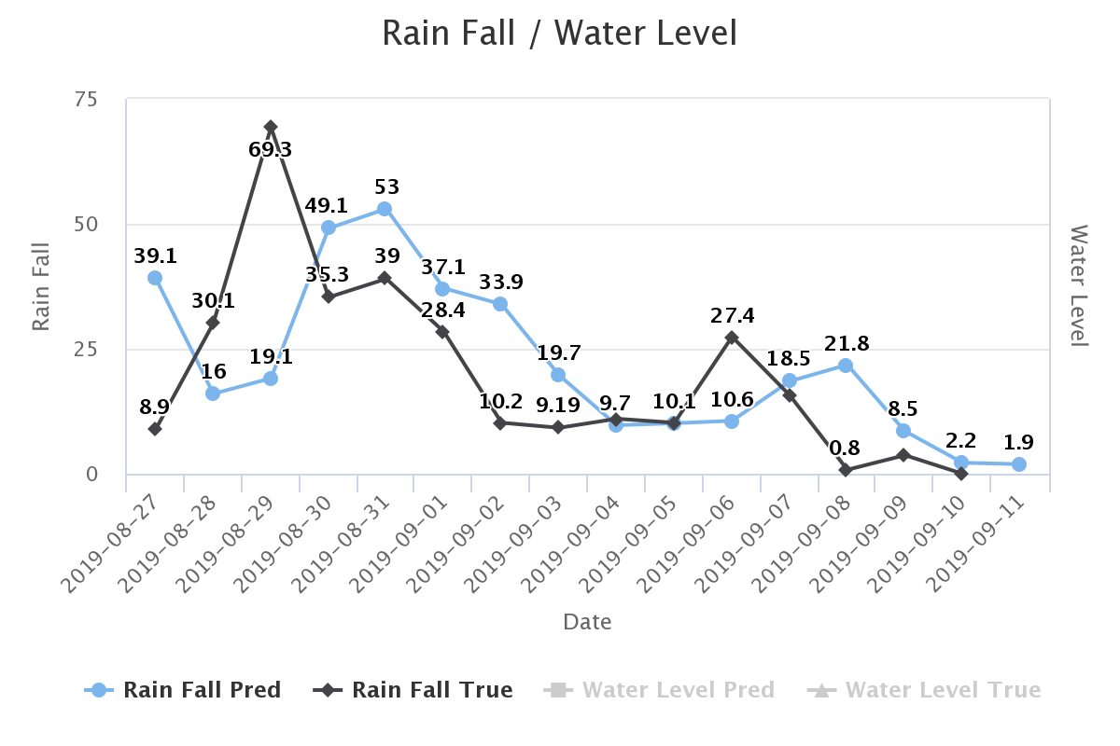

Figure 3.1.2 RainFall 15 Days Calibration

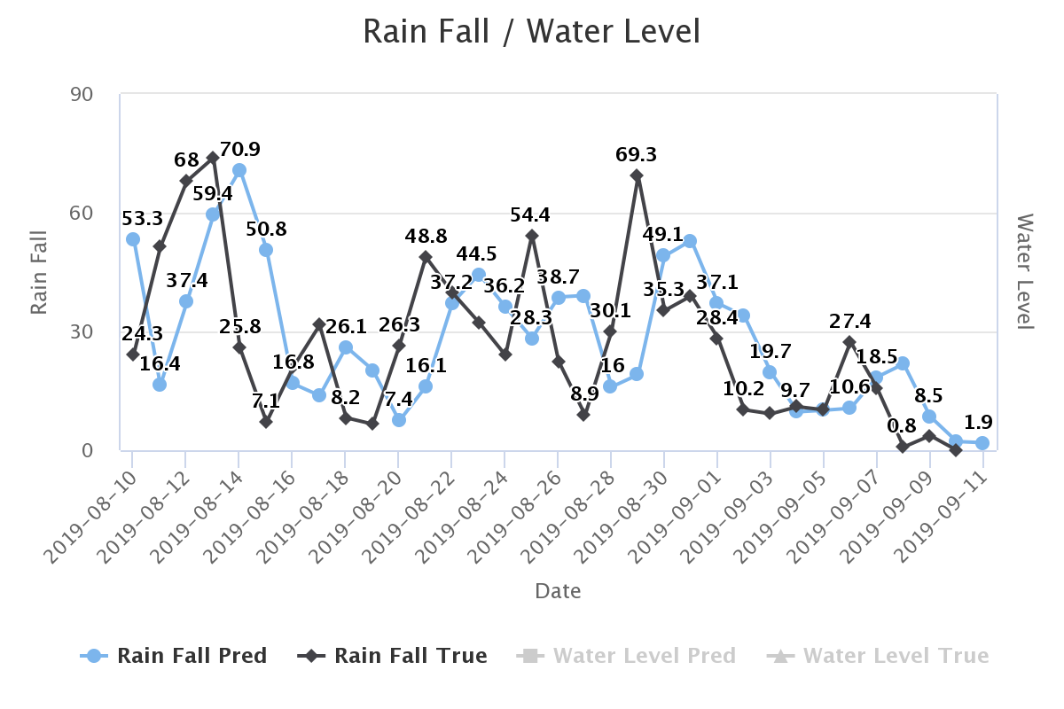

Figure 3.1.3 RainFall 30 days Calibration

Comparison of actual values with relevant predicted values which are obtained from the SARIMA can be seen from below graphs with respective to the Water Depth occurrence to the Kelaniya, Sri Lanka. Testing is done in three different periods to find the optimal result.

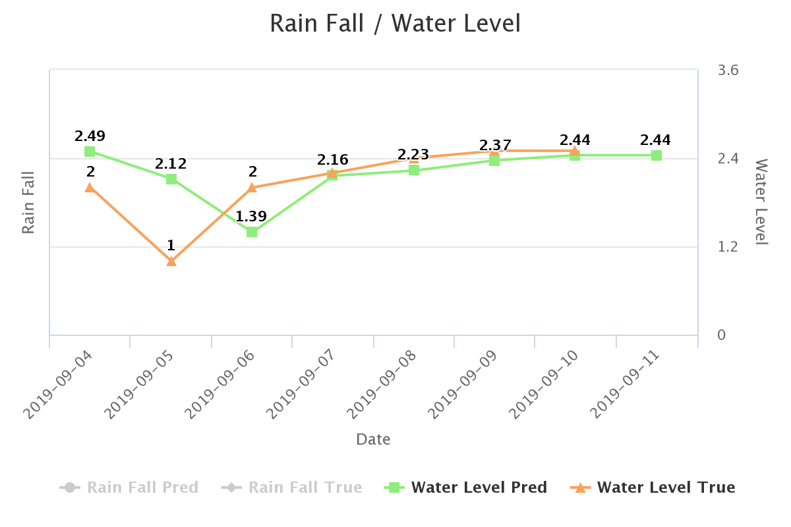

Figure 3.1.4 Water Depth 7 days Calibration

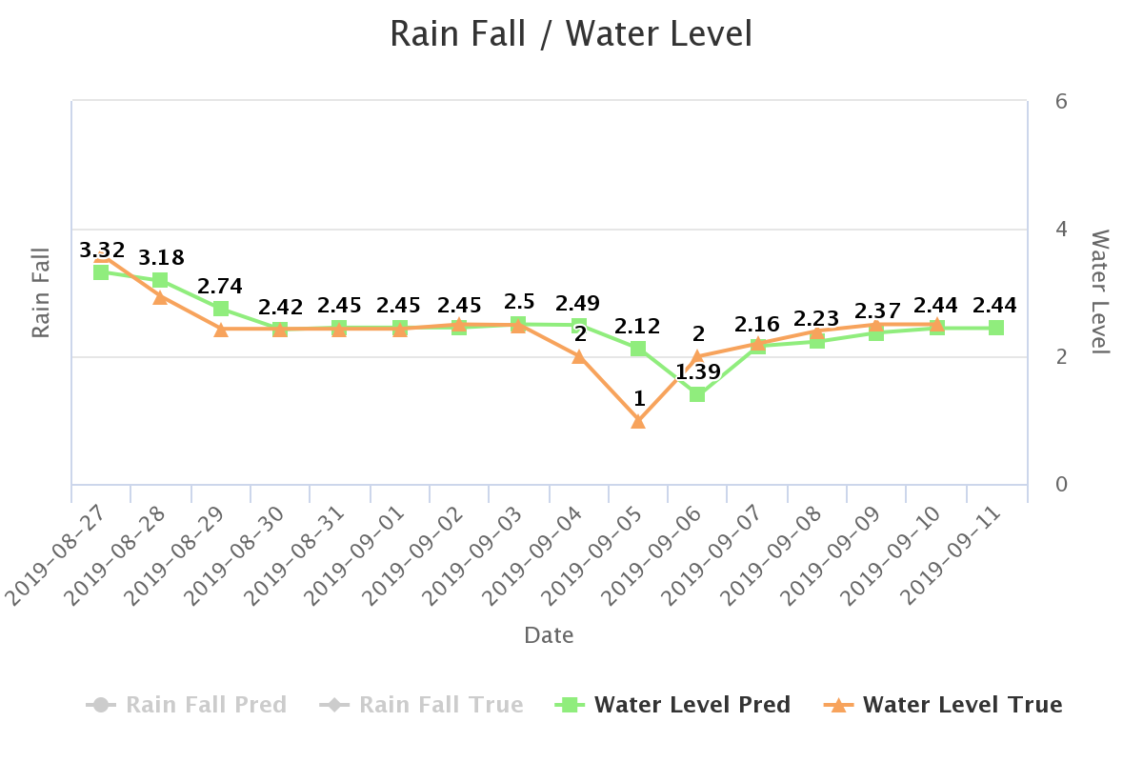

Figure 3.1.5 Water Depth 15 days Calibration

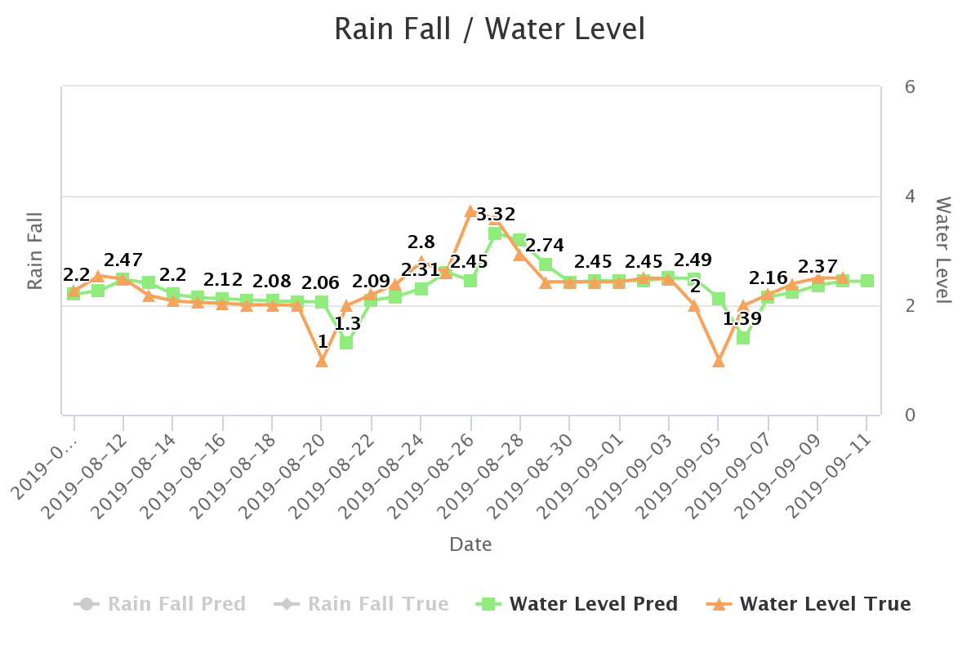

Figure 3.1.6 Water Depth 30 days Calibration

### Results obtained from the Naïve-Bayes & SARIMA Algorithm combination

Following is the result of flood prediction by considering above accuracy.

Comparison of actual values with relevant predicted values which are obtained from the SARIMA with above results we were including Naïve- Bayes algorithm for higher accuracy prediction. Algorithm results can be seen from below graphs with respective to the flood occurrence in percentage manner to the Kelaniya, Sri Lanka.

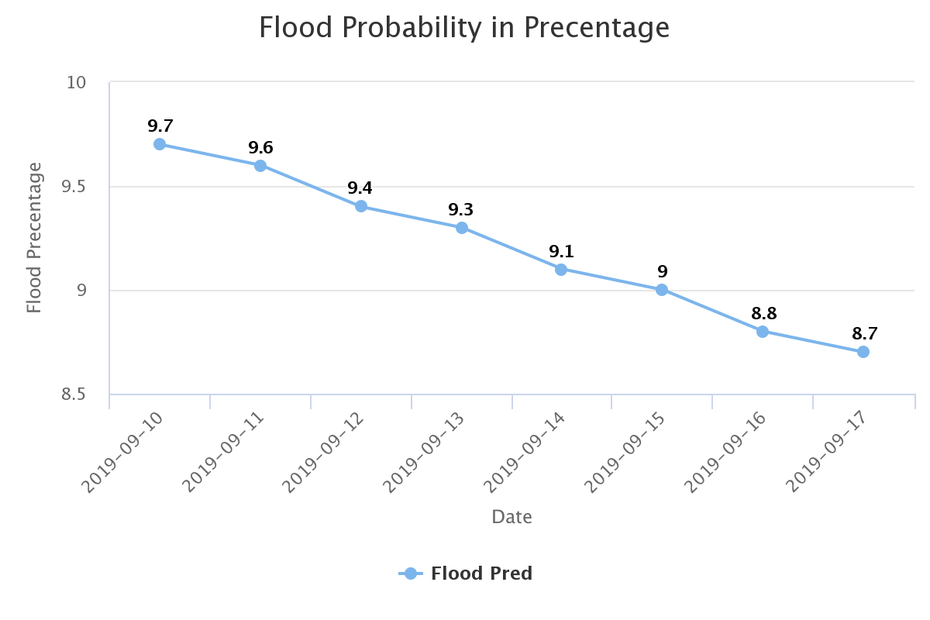

Figure 3.1.7 Flood Prediction results in percentage

## Research Findings

## Summary of each student contribution

# Conclusion

The drown prevention module is implemented mainly based on Wearable device. It is capable of collecting pulse from user to determine the user current situation. As in the aforementioned introduction a child drowns every minute in the world. When comes to the Sri Lanka mostly we can seek on news that at least once a week child is killed by drowning. By proposing this product we want to reduce these distrait deaths caused from drowning in next 5 years by 75%.

The flood prediction module is implemented based on Seasonal Auto Regressive Integrated Moving Average and Naïve-Bayes Algorithm with the real data set gathered from Disaster Relief Management Department, Meteorology Department and Irrigation Department of Kelaniya, Sri Lanka and sensor data collected from floating devices. Every year we can hear minority deaths caused and majority of damage for property due to flood. For the last 3 years flood was being recurred for the Kelaniya area but no one could not able to acknowledge impending situation. To achieve this task we are introducing SmartGuardian Flood Alerting System in trusted manner to survive human lives from flood. People would be able to prepare themselves and their most valuable property that would be able to take with them by predicting the flood situation. We could not break off flood but we could try to save 65% of human life via this proposed system caused due to flood. As the proposal explains this product is suitable for every man kind in Sri Lanka that ultimately provide efficient solutions to mitigate drowning death and also disaster solution which will minimize the number of deaths and damages due to Flood.

# References

[1] Emarketer.com, 'Social Networking Reaches Nearly One in Four Around the World', 2014. [Online]. Available: https://www.digital.nyc/startups/iswimband. [Accessed: 24- Feb - 2019].

[2] Anam-dong, Sungbuk-gu, Seoul, Kore, “An Ultrasonic Sensor Based Low-Power Acoustic Modem for Underwater Communication in Underwater Wireless Sensor Networks” , pp. 136-701 , 2007.

[5] Matt Beaumont-Gay,” A Comparison of SYN Flood Detection Algorithms” in International Conference on Internet Monitoring and Protection, August. 2007, DOI: 10.1109/ICIMP.2007.1

[6] Mohammed Khalaf, Abir Jaafar Hussain, Dhiya Al-Jumeily, Paul Fergus, Ibrahim Olatunji Idowu , “Advance Flood Detection and Notification System based on Sensor Technology and Machine Learning Algorithm ” DOI: 10.1109/IWSSIP.2015.7314188 , September 2015.

[5] Opentextbc.ca, 'Speed of Sound, Frequency, and Wavelength'. [Online]. Available: <https://opentextbc.ca/physicstestbook2/chap>

[7] S H BARI1,MT RAHMAN2, MM HUSSAIN2, SOURAV RAY , “Forecasting Monthly Precipitation in Sylhet City Using ARIMA Model” ISSN 2224-5790 (Paper) ISSN 2225-0514 (Online) 2015.

[8] Sri Supatmi1,2(&) , Rongtao Huo1, and Irfan Dwiguna Sumitra3, “Implementation of Multiplicative Seasonal ARIMA Modeling and Flood Prediction Based on Long-Term Time Series Data in Indonesia”

[8] Kirti Bhausaheb Gavali, “SMS Flood Alerting System in Flood Affected Area”, *Department of Electronics and Telecommunication, SVIT College of Enginnering, Chincholi, Nashik, November 2015*

[9] Wahidah Md. Shah , F. Arif , A.A. Shahrin and Aslinda Hassan, “The Implementation of an IoT-Based Flood AlertSystem” Universiti Teknikal Malaysia Melaka, Department of Industrial EngineeringInstitut Teknologi Nasional Bandung, Indonesia , 2018

[10] “Automatic prevention of drowning by inflatable wrist band system ” in *2019 5th International Conference on Advanced Computing & Communication Systems ,* *Coimbatore, India, India*, *15-16 March 2019* , J. Geetha Ramani , J.Gayathri ,R.Aswanth , M.Gunasekaran DOI: 10.1109/ICACCS.2019.8728368

[11] Emarketer.com, 'Social Networking Reaches Nearly One in Four Around the World', 2014. [Online]. Available:

# Glossary

# Appendices