**SMART GUARDIAN**

Project ID: 19-099

Design and Development of Wearable device to measure depth and Collect user condition

Final Report

K.D. Samarasinghe

Bachelor of Science Special (Honors) in Information Technology

Department of Information Technology

Sri Lanka Institute of Information Technology

Sri Lanka

August 2019

**SMART GUARDIAN**

Project ID: 19-099

Design and Development of Wearable device to measure depth and Collect user condition

Final Report

(Final Report documentation submitted in partial fulfillment of the requirement for the

Degree of Bachelor Science Special (honors)

In Information Technology)

Bachelor of Science Special (Honors) in Information Technology

Department of Information Technology

Sri Lanka Institute of Information Technology

Sri Lanka

August 2019

**DECLARATION, COPYRIGHT STATEMENT AND THE STATEMENT OF THE SUPERVISOR**

I declare that this is our own work and this proposal does not incorporate without acknowledgement any material previously submitted for a degree or diploma in any other university or Institute of higher learning and to the best of our knowledge and belief it does not contain any material previously published or written by another person except where the acknowledgement is made in the text.

|  |  |  |
| --- | --- | --- |
| Name | Student ID | Signature |
| K.D. Samarasinghe | IT16059214 |  |

The supervisor/s should certify the proposal report with the following declaration

The above candidates are carrying out research for the undergraduate Dissertation under my supervision

Signature of the supervisor: Date:

# ACKNOWLEDGMENTS

This research has become a possibility with the assistance and dedication of numerous individuals with great intention of giving something valuable for the mankind and their survival in tough situations. As research groups members we had to go through hard times on this path.

First I want to express my heartfelt gratitude to our Supervisor Dr. Pradeep Abeygunawardana for his invaluable guidance and accepting our research idea in the first place. Our proposed idea has become a reality and proof of concept with the guidance of our supervisor and the immense support given by him.

And then would like to thank my team colleagues Maheshi Gamage, Tharushi Mudalige and Pasan De silva for them help, discussions and comments in each part of my work. It was a great pleasure working with them.

I am truly humbled and grateful to have so many extraordinary people in my life

# ABSTRACT

Drowning has become a serious concern when considering about the deaths occur in aquatic environments. We cannot be sure about the depth of the each are until get there and measure the depth. In case of enjoying the aquatic environments like lakes, rivers etc. we cannot measure the depth all the time and it’s a risky task to do so. But if we can know the depth of the area before we get to that deeper area?

As my research problem I came up with this issue and my solution to this issue is a wearable device that can measure the depth of water before getting into a deeper area. In brief, the wearable device can measure the depth of the area and alert the wearer if he/she is going into a deeper area.

In addition, this wearable device can measure the pulse rate of the user. This wearable device later comes as a part of the IOT Solution of Smart Guardian – Drown Prevention and Flood Detection System

**TABLE OF CONTENTS**

ABSTRACT 2

ACKNOWLEDGMENTS 2

LIST OF FIGURES 5

LIST OF TABLES 5

LIST OF ABBREVIATIONS 5

LIST OF APPENDICES 5

1. INTRODUCTION 6

1.1. BACKGROUND LITERATURE 6

1.2. RESEARCH GAP 7

1.3. RESEARCH PROBLEM 8

1.4. RESEARCH OBJECTIVES 9

2. METHODOLOGY 10

2.1. METHODOLOGY 10

2.1.1. Estimating the depth of the water 10

2.2. COMMERCIALIZATION ASPECTS OF THE PRODUCT 11

2.3. TESTING AND IMPLEMENTATION 12

2.3.1. Implementation 12

3. RESULTS AND DISCUSSION 13

3.1. RESULTS 13

3.2. RESEARCH FINDINGS 14

3.3. DISCUSSION 15

4. SUMMARY OF EACH STUDENT’S CONTRIBUTION **Error! Bookmark not defined.**

5. CONCLUSION 16

6. REFERENCES 17

7. GLOSSARY 18

8. APPENDICES 19

# LIST OF FIGURES

# LIST OF TABLES

# LIST OF ABBREVIATIONS

# LIST OF APPENDICES

# INTRODUCTION

## BACKGROUND LITERATURE

One of the most important factors is keep safety while we are enjoying in water. Hence, through our project we elected the specific area, which is water. This area all about accidents happened due to water. Initially as a team, we discussed to focus on accidents. Accidents can be happened in several ways therefore we elect few types of accidents. It was car accident, natural adversity, drown and gas leak injuries. We were figured several product developed for car accidents and for the gas leak injuries as well. Drowning is the second leading cause of accidental deaths in the world, next to road accidents. Even WHO highlighted drowning, as a major cause of death in the Global Report on Drowning (2014). However, there is not a specific product to prevent people drowning from the aquatic body. Especially for the drowning from the ocean or a lake or a river. Most of them are children, teenagers and female. A child drowns every minute in the world, and drowning is the main cause of death from accidents in children under five.

If we analyze the causes of a number of deaths reported daily, the root cause for them is negligence. Those certain accidents can be avoided if the person is really mindful, but it will not behave as we expect. Ocean looks so calm that it seems fascinating, but at times, it is so rough and threatens to bring death to a few lives.

For the use case of Smart Guardian – Drown Prevention and flood detection system is two hardware devices are required. Which is Floating device and the Wearable device.

In this document, the main goal is to provide all details about the wearable device like Methodology, functionality and the importance of wearable device to the commercialization aspect of the whole system.

## RESEARCH GAP

Currently created systems are implemented for swimming pools rather than rivers lakes and beaches. Laser light, LDR and water pressure sensors are mounted in top of the walls of the pool. The application is not wearable.

Then another research has been done to implement an inflatable wrist band system SNS College of Technology Coimbatore, India. Which triggers to open a small air bag when the user is drowning . In here only the person wearing the wrist band knows that he/she is drowning . [1]

Another product “i swim band” was launched in 2013 to prevent drowning of children in swimming pools. This has been developed by Paul Chu [2].This is a waterproof device is known as the iSwimband. It sits around the head of a child and has a Bluetooth-enabled sensor at the front. When the device detects the kid has fallen into water, it sends associate in nursing alert right away to the parent so that they will come back and rescue them. For the interactive features, such as sensor is paired with a compatible Bluetooth-enabled smart device running the free iSwimband app. It has a battery life of hundreds of hours of active monitoring [2].

In our proposed system the wearable device alerts the life guard to gain his/her attention where wider range of people can be alerted when a user is in danger.

Smart Guardian wearable device calculates the depth of water and collects the pulse rate of the user. After calculating the depth of the water, user will be alerted if he/she is going to a deeper area through a vibration ins the wearable device.

## RESEARCH PROBLEM

Drowning has become a serious concern of these days. And some of the main reasons for drowning is not being able to swim, not knowing the depth of the water and not being able to predict the behavior of the water and negligence of above factors.

Because of above mentioned reasons we can hear numerous accidents occurring in water bodies such as lakes, rivers and oceans from the media nowadays.

There are many other types of accidents that cause death or fatal damages to humans such as Vehicle accidents, Accidents at working places etc. and many researches have been done and numerous products and implementations have been done to overcome these problems. But still there haven’t been done proper researches and implementations to ensure the safety of humans on aquatic environments specially drowning.

Drowning is generally considered to be a ‘silent death’ for a person who is about to drown is unable to shout for help because he tries to save all his energy and the decreasing amount of oxygen in the lungs to keep his head above water. Drowning is designated the human life into danger. Therefore, we conducted a survey to identify both necessity of this proposal and the key areas to be considered in this project. The survey has been published publicly and several important information was gathered for the necessity of a SmartGuardian.

## RESEARCH OBJECTIVES

Main objective of this implementation of Wearable device to provide necessary data for the Smart Guardian system and perform the basic requirement of the Smart Guardian System which is measuring and analyzing the depth of the front area of the user when user is in the water and alert if he is going to a deeper are through a vibration in the wearable device.

And also come up with a method to predict the user condition by pulse rates by using the pulse rates taken from the wearable device

# METHODOLOGY

## METHODOLOGY

### Estimating the depth of the water

People are basically unaware about the depth of the water where they are stands. Hence, this could be have a higher probability of drowning. The wearable device is capable of measure the depth of the water. If the user is going through deeper area, it will trigger an alert through vibration of the device. This wearable device is waterproof and it feasible to use any user.

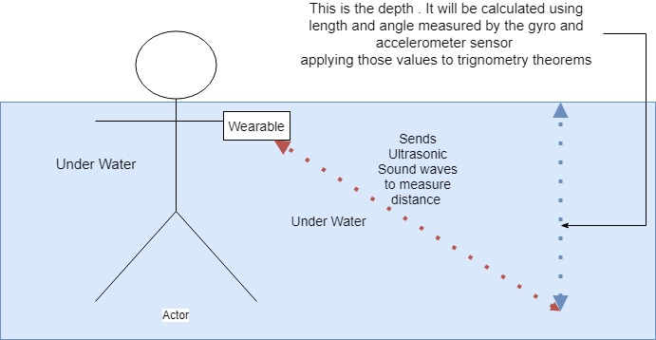

Sonar sensor is used to measure the distance from the wearable device and the bottom of the water body (riverbed, ocean floor and lakebed) assume that distance as x.

Imagine a triangle as in figure 3, the slant of the triangle will be x. therefore, to find the estimated depth (h) in the front area, we have to use trigonometry.

Degree of angle (m) is calculated by the Gyro and Accelerometer Sensor (MPU-6050).

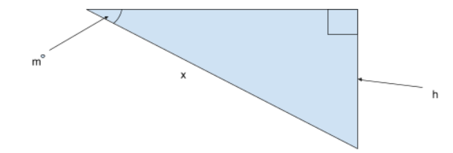

### 

Figure 3.4: How to estimate the depth

Since we acquire the degree of angle and the slant (hypotenuse) using the respective sensors we can estimate the depth of the water (side opposite) according to trigonometry using below formula.

*Sin(m) = h/x*

*Hence, h = x.Sin(m)*

Wearable device should be turned on while it in the water and for more accurate estimation device should be positioned as it in the Figure 3.5.

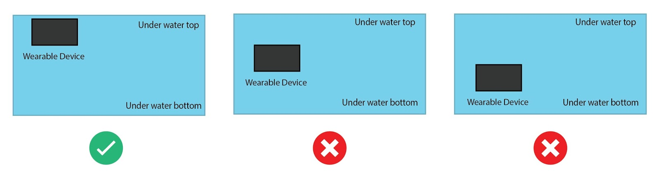

Wearable device has a small screen to display the depth of the water and once the device identify the depth as dangerous it will vibrate the device according to the alert

## COMMERCIALIZATION ASPECTS OF THE PRODUCT

## TESTING AND IMPLEMENTATION

## Implementation

For the implementation of the Wearable device, below mentioned hardware components have used.

* Arduino Mega 2560 micro controller
* JSN-SR04T -2 Water Proof Sonar Sensor
* Pulse Sensor
* 0.91 Inch OLED LCD Display Module
* MPU6050 - Triple Axis Accelerometer & Gyro Breakout

# RESULTS AND DISCUSSION

## RESULTS

## RESEARCH FINDINGS

## DISCUSSION

# CONCLUSION

# REFERENCES

[1] “Automatic prevention of drowning by inflatable wrist band system ” in *2019 5th International Conference on Advanced Computing & Communication Systems ,* *Coimbatore, India, India*, *15-16 March 2019* , J. Geetha Ramani , J.Gayathri ,R.Aswanth , M.Gunasekaran DOI: 10.1109/ICACCS.2019.8728368

[2] Emarketer.com, 'Social Networking Reaches Nearly One in Four Around the World', 2014. [Online]. Available: https://www.digital.nyc/startups/iswimband. [Accessed: 24- Feb - 2019].

[3] L. Liu and H. Miao, "A specification based approach to testing polymorphic attributes," in Formal Methods and Software Engineering: Proceedings of the 6th International Conference on Formal Engineering Methods, ICFEM 2004, Seattle, WA, USA, November 8-12, 2004, J. Davies, W. Schulte, M. Barnett, Eds. Berlin: Springer, 2004. pp. 306-19

[4] Mohammed Khalaf, Abir Jaafar Hussain, Dhiya Al-Jumeily, Paul Fergus, Ibrahim Olatunji Idowu , “Advance Flood Detection and Notification System based on Sensor Technology and Machine Learning Algorithm ” DOI: 10.1109/IWSSIP.2015.7314188 , September 2015.

# GLOSSARY

# APPENDICES