**Drown prevention and flood detection monitoring system**

**( SmartGuardian )**

Project ID:19-099

Preliminary Progress Review (PPR)

Student Name: P.M. De Silva

Student ID: IT16041080

**BSc. (Hons) in Information Technology Specializing in**

**Information Technology**

Department of Information Technology

Sri Lanka Institute of Information Technology

Submitted on 13th May 2019

**Drown prevention and flood detection monitoring system**

**( SmartGuardian )**

Project ID: 2019-099

Preliminary Progress Review (PPR)

Author:

|  |  |  |
| --- | --- | --- |
| Name | Student ID | Signature |
| P.M De Silva | IT16041080 |  |

Supervisor

……………………………………………………..

Dr.Pradeep Abeygunawardhana

**BSc. (Hons) in Information Technology Specializing in**

**Information Technology**

**Contents**

1. Introduction 1

1.1. Purpose 1

1.2. Scope 1

1.3. Overview 1

2. Statement of the work 3

2.1. Background information and overview of previous work based on literature survey. 3

2.2. Identification and significance of the problem. 3

2.3. Technical Objectives. 4

3. Research Methodology 5

3.2. Predicting user condition 6

3.3. Design and development of Waterproof Wearable Device 6

4. Test data & analysis 6

5. Anticipated benefits 7

6. Project Plan or schedule 7

7. Research Constrains 8

8. Specified deliverables 8

References 8

## Introduction

## Purpose

The purpose of this document is to give a detailed description of Smart Guardian,This document will describe the purpose and complete declaration of development of the system to give an in-depth insight of “Smart Guardian “,It will also explain the overview, literature review, research question,research methodology, research objective, technologies to be use, benefits of the system ,scope and specified deliverables, research constraints ,project plan and issues related to the current system and actions to be performed by the development team are described in order to come up with a better solution.In the Development team’s perspective, PPR is valuable as it describes the scope of the project, plan system’s design and implementation.

## Scope

There are four main components in smart guardian,all of which have an essential part in delivering perfect results.This document is going to cover how the floating device is going to work as an intermediary communication device,and how it is going to receive data from the wearable device and read data from the floating device itself and sends data to the server.

## Overview

Preliminary Progress Review document is organized in a proper manner. First of all this

document includes the introduction and the purpose of the Preliminary Progress Review

doucument.it is explain how this Preliminary Progress Review is importance of this document. After that it contains about the literature survey. The literature survey is about the similar life saving systems and it has explained about the models and the technologies they have used and how they have use it like-wise. And after that this Preliminary Progress Review document is include about the research problem and about the research objectives.it has mentioned about How new or unique is the idea, How significant is the technical challenges.And also I have mentioned how research objectives includes about the main objective of our research and specific objective of my function. In the research methodology contains the section outlines of the methods

# Statement of the work

# Background information and overview of previous work based on literature survey.

Once somebody starts to drown, the end result is often fatal. not like different injuries,

survival is determined virtually completely at the scene of the incident but there are many actions to prevent drowning and as well as the flooding.In here we are introducing a product

which can help to survive from drowning and flooding.this product includes of two physical devices,a wearable device and a floating device.this document is going to cover the floating device is and its status.there are number of safety featured wearable devices that one can wear.but almost all of those can't communicate when they are inside water because the speed of the sound in determined by a combination of the mediums rigidity and its density, the more rigid the medium faster the speed of the sound, the speed of the sound in air is low because  air is compressible, and because liquids and solids are very rigid it is very difficult to compress, the speed of sound in such area are generally greater than in gases,

So the  floating device is there to overcome that problem by using acoustic waves to communicate between the wearable and the floating devices.

## Identification and significance of the problem.

This product mainly focuses on people who are likely to go swimming in known or unknown water areas.

Smart guardian product is going to help those people in many ways,the problem that we are going to tackle through this is drowning and unexpected floods,essentially  this product is a drown prevention and a flood detecting system.when this product work like its intended it will monitor someone whose is water by using the wearable device and get all the sensor readings and notifiy the nearest lifeguard who will have the smart guardian app installed on their phone.

## Technical Objectives.

Floating device will be based on Arduino Uno board because of its computational power. Also, the floating device consists of GPS module, Sonar Sensor, water flow sensor, RF Transceiver, GSM module and an acoustic modem receiver.

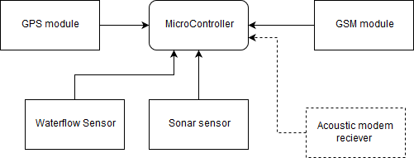

# Research Methodology

We implement this device because the server could not be able to communicate with the devices, which are in the water. The floating device in with a set of sensors for each task. To determine the depth of the water it has a sensor called depth-sensing sonar sensor and to determine the speed of the water flow it has a sensor called the water flow sensor. Floating device capture the data, which are received from the wearable device at the same time sends all data to the server.

This is not the only purpose of this device, which is capable of doing. If someone drowning, we trigger the alert to our mobile application. However, we need to locate the affected person. Therefore keeping track of a person in the underwater is an essential part of this process. To achieve this we follow a process as below that how we tackle this problem.

* A GPS tracker In the floating device so we’ll know the exact location of each floating device.
* When a user data gets sent to the floating device a timestamp will also be included in the data file
* After receiving the data file, the timestamp will be converted to local time and compare with the time received and calculate how much time did it take the data to arrive.
* With this result, we are going to calculate an approximate value and show it in a radius respective to a floating device.

As mentioned earlier, the floating device has two communication modules to communicate with the wearable device, which is the underwater communication and RF communication to capture the data from the sensors in a wearable device to send data to the server.

### Flood Data

To detect a flood the water level and pressure sensor will collect data and send that data to the back end for further calculations.

#### **3.2 Detecting user location**

When a user data gets sent to the floating device a timestamp will also be included in the data file. After receiving the data file, the timestamp will be converted to local time and compare with the time received and calculate how much time did it take the data to arrive.

With this result, we are going to calculate an approximate value and show it in a radius respective to a floating device.

# Test data & analysis

For the algorithm that uses for the flood prediction, will get the data from the water level and pressure sensor

# Anticipated benefits

* Will be able to know before hand and alert authorities if there is a possibility of a flood.
* We will be able to locate the user wearing the wearable device.

# Project Plan or schedule

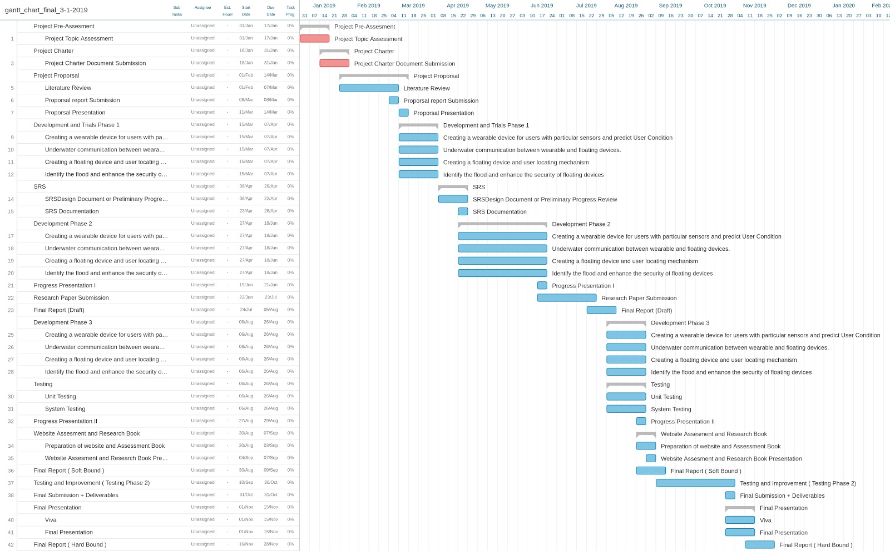

# Research Constrains

* As we were instructed, initially the device will be tested on a Swimming pool.
* Due to high-cost of underwater sonar sensors, low cost waterproof sonar sensors will be used.

# Specified deliverables

The final outcomes of the research component are,

* A floating device to get data from the water, and act as an intermediary device