**Drown prevention and flood detection monitoring system**

**( SmartGuardian )**

Project ID: 19-099

Preliminary Progress Review (PPR)

Student Name: K.D.Samarasinghe

Student ID: IT16059214

**BSc. (Hons) in Information Technology Specializing in**

**Information Technology**

Department of Information Technology

Sri Lanka Institute of Information Technology

Submitted on 13th May 2019

**Drown prevention and flood detection monitoring system**

**( SmartGuardian )**

Project ID: 2019-099

Preliminary Progress Review (PPR)

Author:

|  |  |  |
| --- | --- | --- |
| Name | Student ID | Signature |
| K.D.Samarasinghe | IT16059214 |  |

Supervisor

……………………………………………………..

Dr.Pradeep Abeygunawardhana

**BSc. (Hons) in Information Technology Specializing in**

**Information Technology**

**Contents**

1. Introduction 1

1.1. Purpose 1

1.2. Scope 1

1.3. Overview 1

2. Statement of the work 3

2.1. Background information and overview of previous work based on literature survey. 3

2.2. Identification and significance of the problem. 3

2.3. Technical Objectives. 4

3. Research Methodology 5

3.2. Predicting user condition 6

3.3. Design and development of Waterproof Wearable Device 6

4. Test data & analysis 6

5. Anticipated benefits 7

6. Project Plan or schedule 7

7. Research Constrains 8

8. Specified deliverables 8

References 8

## Introduction

## Purpose

The purpose of the document is to give a detailed understanding about the wearable device and the user condition prediction algorithm which will be used in the *Smart Guardian*. And this document will explain the previous attempts done to overcome the problem addressed by Smart Guardian and development methodology. The main target of this document is the stakeholders of the research, research supervisors, team members and CDAP team.

## Scope

This document covers how the wearable device will be designed and developed, the practicality of the wearable device, how it alerts the wearer and the other users of the Smart Guardian and how the user condition prediction algorithm works and the users get the alerts if someone using the wearable device in danger.

## Overview

The main objective of proposed product is introducing a full featured smart guardian system comprise with two devices which can be effective for ensure the people protection from aquatic environment. Identify the user condition and the flood prediction

In the Wearable device, it’s main goal to measure the depth of front area and alert the wearer if he/she is going to a deeper area. The wearer will be alerted through a vibration sensor and the mobile app also will get notified. It also collects the pulse rate of the user to feed the algorithm to predict the user condition.

An algorithm to predict if user will be facing any difficulty will be implemented in the server. The pulse readings collected from the wearable device will be sent to the server using acoustic underwater communication and a GSM module placed in a floating device on the water (explained in another PPR of Floating Device and DD of Acoustic Underwater communication module)

# Statement of the work

# Background information and overview of previous work based on literature survey.

Speaking of safety in aquatic environments, the only step which was taken as a wearable device is the iSwimBand [1]. Which only capable of alerting parents if their children is drowning in the home pool.

But our proposed product, SmartGuardian demands the safety of in aquatic environments like rivers, lakes and oceans where children and elders might know how deep they are going to. So if they cannot swim and if they are reaching towards a deeper area they can take safety precautions before getting drowned.

## Identification and significance of the problem.

Aquatic safety is a critical matter that people should consider when they enjoy themselves in aquatic environments like rivers, lakes etc. But still there’s only attention for children’s safety on aquatic environments as well as swimming pools. Drowning is the major accident that may occur in aquatic environments and not only children, but also adults face accidents due to not being able to swim and not knowing their health conditions.  
Also, there are rivers that occurs rapid floods so we can see that numerous lives have been lost because of rapid floods.  
Sometimes people get helpless in water when they face sudden difficulties like breathing difficulties, muscle pains etc. and they even might get drowned.

## Technical Objectives.

Wearable device will be based on Arduino Uno board because of its computational power. Also, the wearable device consists of Pulse Sensor, Sonar Sensor, Vibration motor, RF Transceiver.

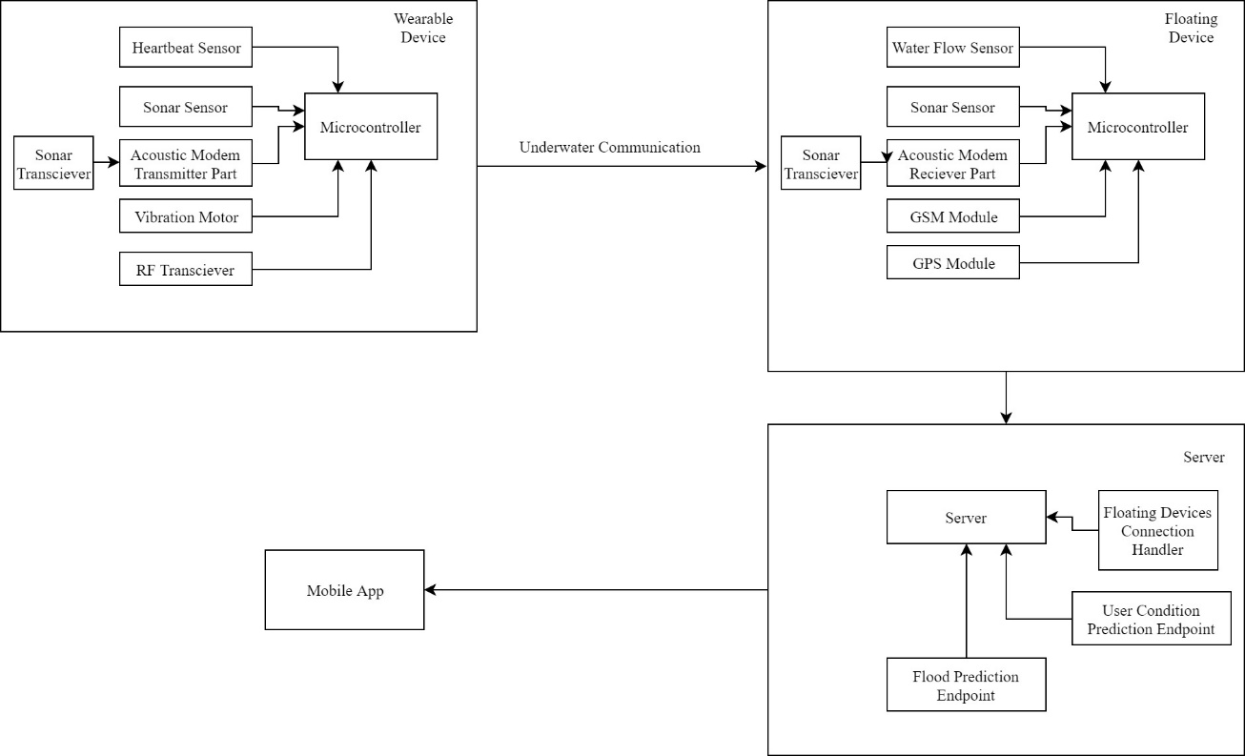

# Research Methodology

* 1. **Estimating the depth of water**

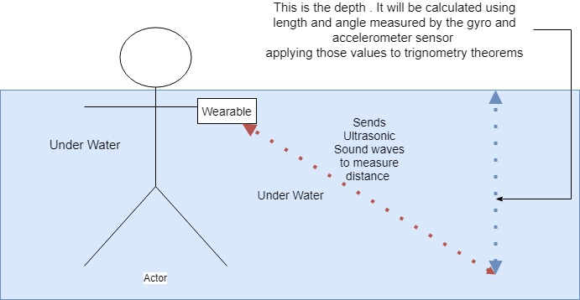

Sonar Sensor is used to measure the distance from the wearable device.

Calculation of the depth of waterbody is done using trigonometry theorems.

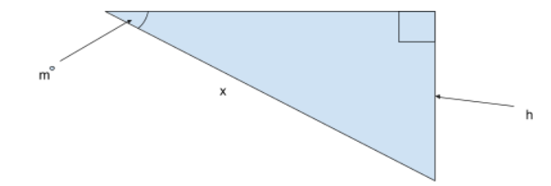

Suppose that the angle of wearable device is *m* and the distance from riverbed to wearabale device is *x* and the depth is *h*

Degree of angle (m) is calculated by the Gyro and Accelerometer Sensor (MPU-6050).

Since we acquire the degree of angle and the slant (hypotenuse) using the respective sensors we can estimate the depth of the water (side opposite) according to trigonometry using below formula.

*Sin(m) = h/x*

*Hence, h = x.Sin(m)*

To measure the depth, the wearable device should be placed as follows.

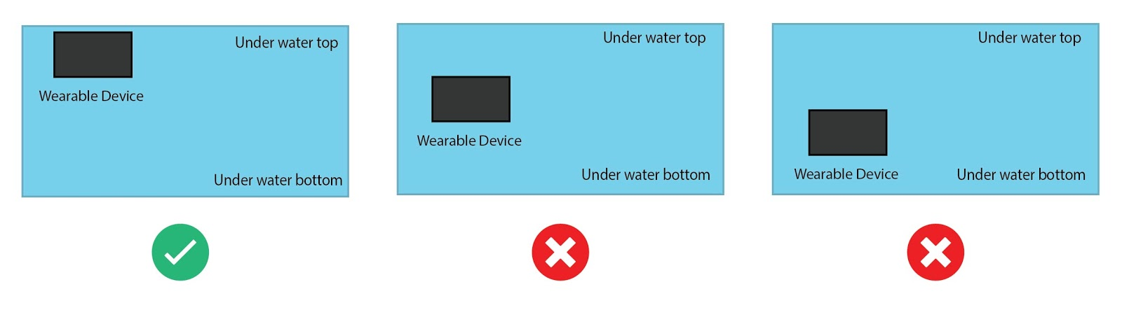

Wearable device has a small screen to display the depth of the water and once the device identify the depth as dangerous it will vibrate the device according to the alert.

### Predicting user condition

Pulse rate will be captured from the pulse sensor, and it will be transmitted to the server.

In server, an algorithm will be implemented to predict each user’s condition using the change of pulse rate at each timestamp.

### Design and development of Waterproof Wearable Device

Since wearable device will be used underwater and it consists of numerous electric components, one and each electric component should be placed inside a waterproof vessel. And also, the wearable device should be minimal in size as much as possible to be a proper wearable device. So, the vessel of the wearable device will be designed using 3D modeling tools and will be 3D printed. By doing that, all electric components can be placed using minimum space.

# Test data & analysis

For the algorithm that predicts user condition, the pulse rate is collected from the wearable device and it will be transmitted to the server. The Pulse rate is captured from the pulse sensor and it will be wrapped with the timestamp and wearable device id.

# Anticipated benefits

* User of wearable device will be able to know he/she is going to a deeper area.
* Life saver / person who has the mobile app will be able to know that a person in water ( if he/she is wearing the wearable device) is in a potential threat ( Health / Environmental threat like rapid floods ).

# Project Plan or schedule

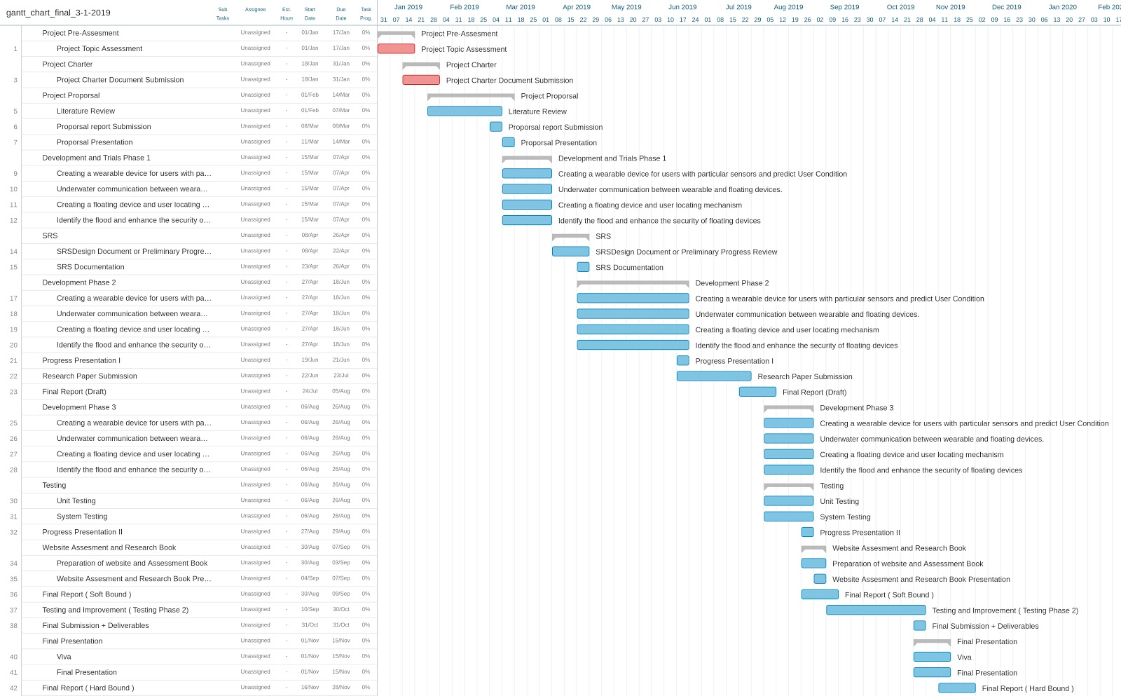

# Research Constrains

* As we were instructed, initially the device will be tested on a Swimming pool.
* Due to high-cost of underwater sonar sensors, low cost waterproof sonar sensors will be used.

# Specified deliverables

The final outcomes of the research component are,

* Wearable device to estimate the depth of water and collect user pulse data.
* Algorithm to predict the user condition using collected pulse data.

# References

[1] Emarketer.com, 'Social Networking Reaches Nearly One in Four Around the World', 2014. [Online]. Available: https://www.digital.nyc/startups/iswimband. [Accessed: 24- Feb - 2019].