**Drown prevention and flood detection monitoring system**

**( SmartGuardian )**

Project ID: 19-099

Software Requirements Specification

T.U Mudalige

Bachelor of Science Special (Honors) in Information Technology

Department of Information Technology

Sri Lanka Institute of Information Technology

Sri Lanka

March 2019

**DECLARATION, COPYRIGHT STATEMENT AND THE STATEMENT OF THE SUPERVISOR**

I declare that this is our own work and this proposal does not incorporate without acknowledgement any material previously submitted for a degree or diploma in any other university or Institute of higher learning and to the best of our knowledge and belief it does not contain any material previously published or written by another person except where the acknowledgement is made in the text.

|  |  |  |
| --- | --- | --- |
| Name | Student ID | Signature |
| T.U Mudalige | IT16102842 |  |

The supervisor/s should certify the proposal report with the following declaration

The above candidates are carrying out research for the undergraduate Dissertation under my supervision

Signature of the supervisor: Date:

Contents

1. Introduction 1

1.1 Purpose 1

1.2 Scope 1

1.3 Definitions, Acronyms and Abbreviations 2

2. Overall Description 3

2.1 Product Perspective 4

2.1.1 System interface 5

2.1.2 User Interface 6

2.1.3 Hardware Interface 9

2.1.4 Software Interface 9

2.1.5 Communication Interface 9

2.1.6 Memory Constraints 10

2.1.7 Operations 10

2.1.8 Site Adaption Requirements 10

2.2 Product Functions 11

2.3 User Characteristics 16

2.4 Constraints 16

2.5 Assumptions and dependencies 16

2.6 Apportioning of requirements 17

3. Specific Requirements 18

3.1 External Interface Requirements 18

3.1.1 User Interface 18

3.1.2 Hardware Interface 18

3.1.3 Software Interface 18

3.1.4 Communication Interface 19

3.2 Classes/ Objects 19

3.3 Performance Requirements 20

3.4 Design Constraints 20

3.5 Software system attributes 20

3.5.1 Reliability 20

3.5.2 Availability 21

3.5.3 Security 21

3.5.4 Maintainability 21

3.6 Other Requirements 21

4. Supporting Information 22

4.1 References 22

# Introduction

## Purpose

SRS is a description of a software system to be developed. SRS is conclude of which identifies what the suggested system must do and organize and requirements reach at the time of requirement analysis. Therefore, SRS is a legal contract in between client and the developer. Introduction segment will provide clear understand about on purpose of the research project and overview of the development of project.

The purpose of this document is to describe the functionality of “Flood Detection and security enhancement of devices”. Explain the features of the system, several interface of the system and the constraints under which it must operate.

This is includes Use Cases which is functional requirement to describe the interaction between users and the software. Addition to that SRS conclude with non-functional requirement, which impose constraints on the design or implementation. This document intend for the project supervisor, project coordinator and research team.

This document will helpful for users and developers to acknowledge about the functionality of “flood detection and security enhancement of devices.”

## Scope

Our product smart guardian is mainly base on the concept of “Drown prevention and Flood detection monitoring system”. This product consist with two devices, which is a floating device and a wearable device. One of this component is “Flood detection and security enhancement of devices.” In here, our goals are to detect the flood and trigger the alert to user via the mobile application and to prevent the interference from third party of floating devices. To detect the flood we are using an algorithm. It analyze the relevant data sends from floating device and identify the water level and the speed of water then it predict if the river has possibility of flooding then trigger the alert relevant to output from algorithm.

Devices are being plugged into the IoT. Therefore, if it has less security then it can be lead entire product into failure. In order to prevent the interference we secure and centralized the access logs, use encrypted protocol to secure the communication and create more effective and password policies.

## Definitions, Acronyms and Abbreviations

|  |  |
| --- | --- |
| SRS | Software Requirement Specification |
| IoT | Internet of Thing |
| App | Application |

* 1. **Overview**

The main objective of this SRS document to provide full specification about the software aspect of “flood detection and security enhancement of device” research component. All the functional and non-functional requirements are gathered in clear description.

First Segment: Demonstrate the purpose of composing this SRS document. It describe scope of the “flood detection and security enhancement of device” and the demonstration of how the SRS is assembled and explain the remaining part of this document in brief manner.

Second Segment: Demonstrate the user requirements in generally, which is comprehensible to the user. It contains product perspective, product functions, user characteristics, constraints, assumptions and dependencies, apportioning of requirements. Overall, description about each system functionality and interfaces that used for this product.

Third Segment: Demonstrate the specific requirements in developer viewpoint. It contains external interface requirements, software system attributes, performance requirements and design constrains. In here, indicate the system reliability, availability, maintenance and security of proposed product.

Fourth Segment: includes supporting information that can help the readers of SRS. References include a list of bibliography in the IEEE format

# Overall Description

Smart Guardian is a product with two devices for the concept of “Drown prevention and Flood detection monitoring system”. We proposed this product by researching main problem that mostly people are facing when they are entertained themselves in an aquatic environment. Smart Guardian is capable of acquire information from wearable device and floating device, provide user condition and flood prediction. This system is try to negotiate numerous serious injuries, death occurred due to drowning, and this helps to notify the user to acknowledge flood prediction to prepare to defend themselves.

Objectives of our product are,

* + Measure the depth and notify the user about the deeper.
  + Identify user condition.
  + Predict the flood and give a notification to the user.
  + High security product

This section describe the whole overview of the component of “Flood Detection and security enhancement of devices”.

In this segment, include several significant procedures. Such as how the several types of interfaces and system component activities are interact with the user, how the operations are proceeding to be execute and control, which system requirements like external and internal memory that need to be acquired and how these component is interact with other components.

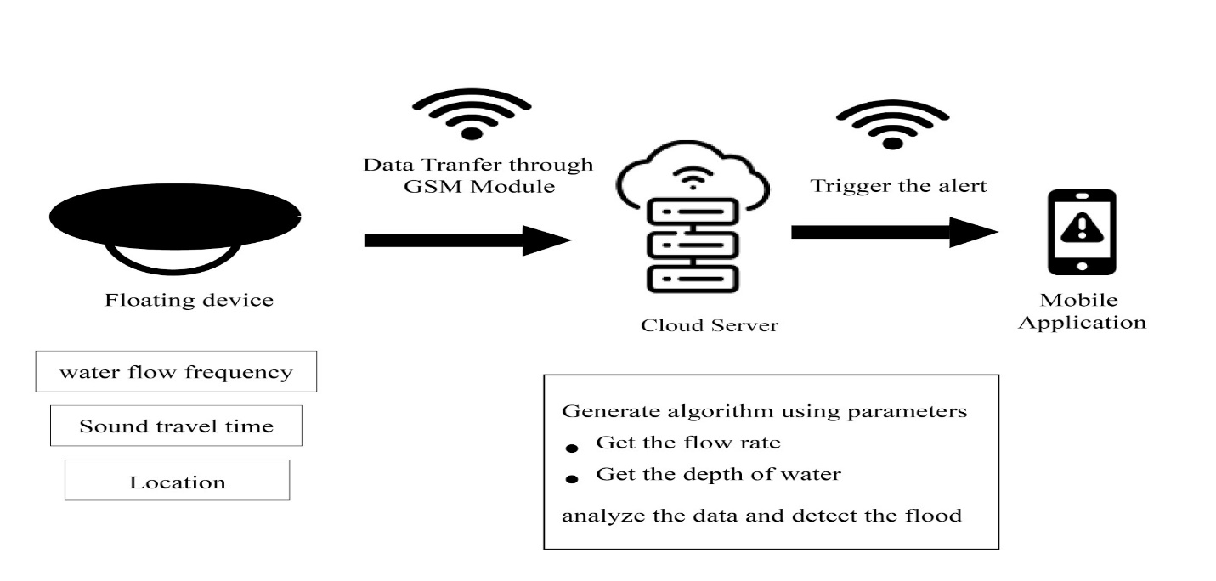

*Figure 01 Architectural diagram of flood detection*

* 1. Product Perspective

This section describes the summary of the flood detection and security of floating devices. Here describe existing systems and the way they move with this element.

Referring to this document, developers, and users will simply perceive, how this element goes on.

The following paragraph describes an actual study mentioned the novel features in brief by comparing with the latest Flood Prediction which have developed in 2014[1].

SYN Flood Detection Algorithms has been produced by Matt Beaumont-Gay [1]. He implemented three SYN flood detection algorithms such as SynFinDiff, SynRate, and PCF.SynFinDiff has good detection speed but takes a very long time to return to a non-alert state. SynRate is significantly and negatively affected by attacks that create high variance in the traffic rate, but is faster than SynFinDiff at signalling the end of an attack and PCF performs very well with regards to both detection time and quiescence time. In our proposed product, developing flood detection algorithm by using some of features.

Advance Flood Detection and Notification System based on Sensor Technology and Machine Learning Algorithm was developed by Mohammed Khalaf, Abir Jaafar Hussain, Dhiya Al-Jumeily in 2014 [2]. This basically flood detection system designed for immediate notification to the native authorities. It determined the present water level victimisation sensing element network, that provides notification via SMS and internet base public network through GSM electronic equipment. SMS and internet base public network area unit valuable alert communication tools which will distribute the knowledge to the floods victims among specific space. Four machine-learning algorithms were utilized to classify flood knowledge. For our project we applied some of the features such as GSM module, PS module to track the location etc.

Speed of the sound is determined by the by a combination of the mediums rigidity and its density, the more rigid the medium faster the speed of the sound, the speed of the sound in air is low because air is compressible, and because liquids and solids are very rigid it is very difficult to compress, the speed of sound in such area are generally greater than in gases. [3]

## System interface

Smart Guardian is basically consist with four components with Mobile app and Web App. Mobile app will run on android platform. For the hardware component will run on Arduino platform. All applications are connected with the cloud server that provides services for those applications.

## User Interface

All the user interface of the Smart Guardian will be created using the android mobile development platform.

* + Current status of flood detection area

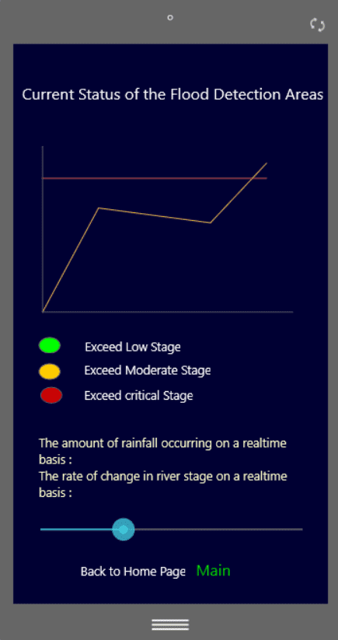

*Figure 02 Current status of flood detection area*

* Notifications of alert

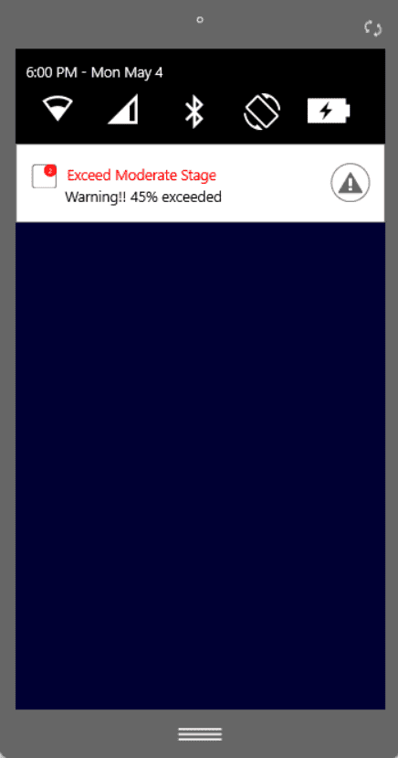

*Figure 03 receiving notification of flood stage*

All the Admin interface of the Smart Guardian will be created using the web platform.

* Admin Dashboard

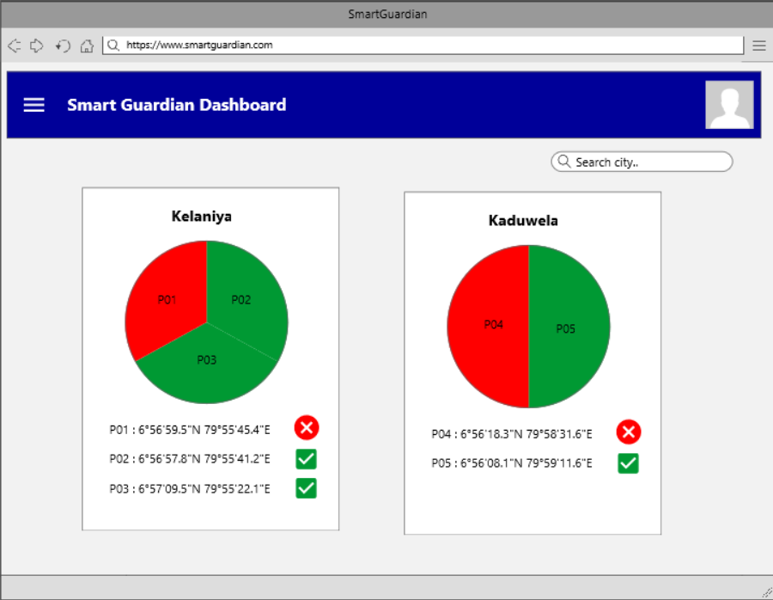

*Figure 04 Admin Dashboard for floating devices*

## Hardware Interface

There will be no special hardware requirements to build this flood detection and device security component.

However, I require data for analyzing to implement the flood detection from relevant hardware, which used in other components.

* + - * Smart phone
      * Internet or LAN Connection.
      * Ultrasonic sonar sensor
      * Water flow sensor
      * GPS Module

## Software Interface

|  |  |
| --- | --- |
| Ionic | Framework for Android mobile app |
| Mongo DB | NoSQL Database management |
| Visual Studio Code | Developing Android mobile app |
| Nodejs | Develop for Android app |

***Table 01 Software Interfaces***

## Communication Interface

In this product IoT communication technology is used for communication purpose.

Therefore,

* Between the Mobile application and the Database, internet connection will be used.
* Between the floating devices and cloud server internet connection will be used

## Memory Constraints

* 2GB RAM
* Processor with speed 1.8GHz
* 256GB Hard Drive

## Operations

In the “Smart Guardian” mobile application user has only few set of operations to do, related to “Flood detection” component.

* System will show the exceeded water level from low to moderate and moderate to critical level and notify the user via the notification
* In mobile app menu, there is a button for flood chart. It shows the statistic of the currently ongoing flood details.

## Site Adaption Requirements

* English will be used for the notifications and the application interfaces.
* The database should be created and connected with the smartphone.
* For the communication purpose, Active internet connection should be enabled.

## Product Functions

In this component, there are two main functions. They are,

* Flood Prediction

To archive this, an algorithm will be generated by using following parameters.

|  |  |
| --- | --- |
| Input | Water flow speed, depth of the water, GPS location |
| Process | Input data will be analyzed by an algorithm |
| Output | Get the stage of the current condition at the with the location |

***Table 02 Predict the Flood***

* Generate Chart

|  |  |
| --- | --- |
| Input | Statistic of related river water level |
| Process | Input data will be graphically implementing |
| Output | Get the stage of current condition whether it is in low or moderate or critical level. |

***Table 03 Generate Chart***

* Calculate Reponses Time

|  |  |
| --- | --- |
| Input | Time stamp in between SYN and ACK of floating device and server, location of floating device |
| Process | Input data will be analyzed by and algorithm to check whether availability of floating devices |
| Output | Get the output of floating device availability |

***Table 03 Generate Chart***

Use case scenario – Login to the system

|  |  |
| --- | --- |
| Use Case no | 01 |
| Use Case Name | Login to the system |
| Actors | User |
| Pre-Condition | The user should be already registered with the application |
| Main Scenario | 1. Give the username and password on the login page 2. Click “Login” button to log on to the system 3. The system prompts message “login is success” |
| Post Condition | The user has successfully logged on to the application |
| Extensions | 1.a.1 if the password don’t match with the correct password the system prompts to re-enter the password  1.a.2 if the user enters incorrect password thrice the system prompts to enter email address to reset the password |

***Table 04 User Login to the system***

Use case scenario – view the flood chart

|  |  |
| --- | --- |
| Use Case no | 02 |
| Use Case Name | View the flood chart |
| Actors | User |
| Pre-Condition | The user should be already be login to the application |
| Main Scenario | 1. Click on received notification to redirect to the flood chart page 2. The system will show the flood chart page relevant to the alert |
| Post Condition | The user can view the flood chart |

***Table 05 View the flood chart***

Use case scenario – view the multiple charts

|  |  |
| --- | --- |
| Use Case no | 03 |
| Use Case Name | View multiple flood chart |
| Actors | User |
| Pre-Condition | The user should be already be login to the application |
| Main Scenario | 1. Click on “Current status of Flood ” tab 2. The system will show the moderate and critical charts on the page 3. Click on the button user wish to check 4. The system will show the flood chart page relevant to the location |
| Post Condition | The user can view the flood chart |
| Extensions | 2.a.1 if there is no flood in moderate or critical stage page will be display empty |

***Table 06 View the multiple charts***

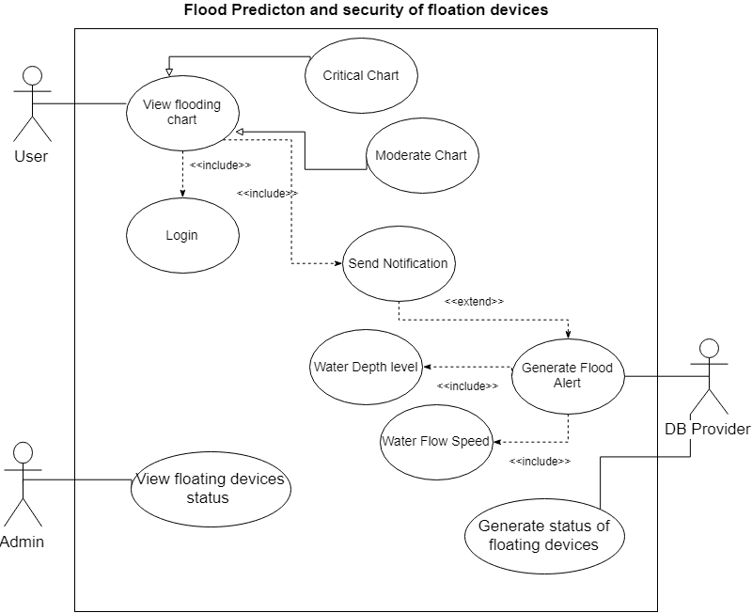

***Figure 05 Use case diagram of flood predication and security enhancement***

## User Characteristics

This product is much more helpful for human beings to when they are at aquatic environment. This product can be used without any age limitations, but we are mainly focused on teenagers for the wearable device and other components for adults. A mobile phone will be used for flood and user condition notification process. We focused on teenagers to wear the wearable device because with the age they are negligent while in the water. Therefore, this will be much more helpful to them because that kind of situations will be handled through this.

## Constraints

* A smartphone is required with enough battery life for the communication purpose.
* For the mobile application development, android will be used.
* For the Database configuration, mongoDB will be used
* With the limited phone memory, the application should be able to run without any effect on the other operations and the processing speed.
* Internet connectivity should always be enabled for communication purpose in between smart phone and cloud server and also for in between floating device and cloud server.

## Assumptions and dependencies

* The smartphone is switch on throughout the day as well as have the enough power of battery.
* WIFI or Mobile data connectivity is enabled always
* Floating device is places at fixed location without any interruption

## Apportioning of requirements

1. Initially relevant information should be gathered to predict the flood. Water flow speed and depth of the water, location of floating device will be gathered through the sensors, which is connected to floating device. By analyzing all these values, flood stage are going to be predicted using an algorithm. Therefore, it will give an output whether water levels exceed moderate level or critical level on relevant river and also provide predicted time period when will the flood will occur. According to the output, we are revealing which location will be affected by the flood.
2. We are using timestamp of the communication between server and floating device to detect which floating device is down. We used more effective password polices for floating device and user authentication to secure our product. And also used encrypted protocol to secure communication.

# Specific Requirements

## External Interface Requirements

## User Interface

1. Current status of flood detection area: show the water level of the affected river via the chart.
2. Notification of water level: User will be notified which river is affected from flood and the stage of water level
3. Floating device dashboard: this is used by the admin to notify which floating device is down.

### Hardware Interface

* Development team must have at least a desktop/ laptop with minimum 1.8GHz processing power and 256GB hard drive space.
* Ultrasonic sonar sensor : to identify the depth of water
* Water rotor roll sensor : to identify the water flow speed
* GPS Module: to get the location of floating device
* Smartphone for communication purpose.

### Software Interface

|  |  |
| --- | --- |
| Chrome /Firefox | Used for the web application development and testing |
| Ionic | Framework for android app |
| Nodejs | Android app development |
| mongoDB | Database configuration |

***Table 07 Software interfaces***

### Communication Interface

Communication between the application and databases, database and devices, internet facility should be enabled.

## Classes/ Objects

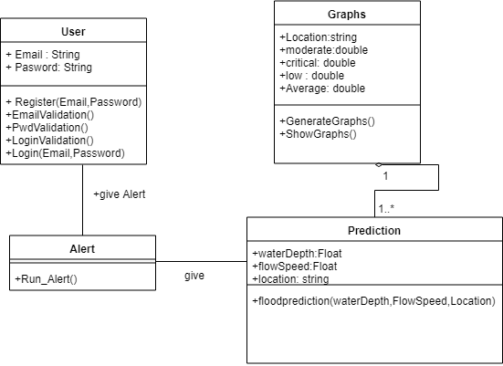

*Figure 06 Class diagram of flood prediction*

## Performance Requirements

The performance of the proposed product and system will depend on the performance of the mobile such as battery life, the speed of the mobile RAM, and internet connectivity. The sensor readings must be correct and trustworthy

## Design Constraints

In this research component, developers have to come up with some constraints. As this proposed product is focused on people without any age limitation, the user interfaces of the mobile application have to be simple, attractive as well as user-friendly. Therefore, the people will be able to work with the proposed product easily and effectively with the use of these designed user interfaces. While developing the mobile application, the performance of the memory should be considered.

## Software system attributes

### Reliability

As this product address to a common issue, the reliability of the proposed product is important. According to this research component,

* The sensor reading must be 100% accurate because most important actions are based on them.
* The proposed product will be tested using several techniques to make sure the product’s probability of failure is low and identify the failures, which can be occurred.
* At a time of failure, there should be a way to overcome through that immediately.

### Availability

The user has to sign up for the system at the first time of opening the application. Location of the floating devices should be stored in databases. If the user buys a new mobile or resets the mobile, the user will have the ability to recover his or her data as firebase will be used as the database.

### Security

Floating devices has a device ID. To access those there is a effective password policies to secure the devices. User must provide email and password to sign up for the application. Those passwords are saved in database as encrypted format.

### Maintainability

In this component, some algorithms will be used and all of them are going to be used in the backend. Therefore, maintenance will be easy and user-friendly because as the algorithms will be in the backend the maintenances can be done through the backend server. No need to update the user interfaces of the application.

## Other Requirements

The requirements which are explained in this section are the requirements which are good to have and recognized standards.

• User-friendly interfaces for the mobile application

• Interfaces are analyzed with the prototypes

• The mobile should be with enough memory, RAM, and battery power.

# Supporting Information

## References

1. [1] Matt Beaumont-Gay,” A Comparison of SYN Flood Detection Algorithms” in *International Conference on Internet Monitoring and Protection* , August. 2007, DOI: 10.1109/ICIMP.2007.1

2. [2] Mohammed Khalaf, Abir Jaafar Hussain, Dhiya Al-Jumeily, Paul Fergus, Ibrahim Olatunji Idowu , “Advance Flood Detection and Notification System based on Sensor Technology and Machine Learning Algorithm ” DOI: 10.1109/IWSSIP.2015.7314188 , September 2015.

3. [5] Opentextbc.ca, 'Speed of Sound, Frequency, and Wavelength'. [Online]. Available: https://opentextbc.ca/physicstestbook2/chapter/speed-of-sound-frequency-and-wavelength/. [Accessed: 8- March- 2019].