
Government of Karnataka
Department of School Education

Lesson Based Assessment Material

2025-26
10th Standard


(English Medium)

Department of State Educational and Research Training, Bengaluru-560085

ಪರಿಕಲ್ಪನೆ ಮತ್ತು ಮಾರ್ಗದರ್ಗನ
ಶ್ರೀಮತಿ ರಶ್ಿ ಮಹೆೀಶ ಭಾ.ಆ.ಸೆೀ
ಸರ್ಕಾರದ ಪ್ರಧಕನ ರ್ಕರ್ಾದರ್ಶಾಗಳು, ಶಕಲಕ ರ್ಶಕ್ಷಣ ಮತ್ತು ಸಕಕ್ಷರತಕ ಇಲಕಖೆ
ಡಾ. ತಿರಲೆsೀಕ ಚಂದರ K V., ಭಕ.ಆ.ಸೆೇ ಆರ್ತಕ್ುರತ,  ಶಕಲಕ ರ್ಶಕ್ಷಣ ಇಲಕಖೆ, ಬೆೆಂಗಳೂರತ | ಶ್ರೀ ಗೆsೀಪಾಲ್ಕೃಷ್ಣ H N,  ನಿರೆೇಾಶಕ್ರತ,  DSERT, ಬೆೆಂಗಳೂರತ
ಡಯಟ ಸಹಕಾರ
ಪಾರಂರ್ತಪಾಲ್ರತ  ಶ್ರೀ ಎಂ. ನಾಸಿರತದ್ದೀನ ಉಪ್ನಿರೆೇಾಶಕ್ರತ(ಅಭಿವೃದ್ಧಿ) ಡರ್ಟ ಚಿತ್ರದತಗಾ | ಮಂಟರ  ಶ್ರೀಮತಿ ಎಂ.ಎನ. ಶ್ವಲೀಲ್  ಉಪ್ನ್ಕಾಸಕ್ರತ ಡರ್ಟ ಚಿತ್ರದತಗಾ
ಸಂಯೀಜನೆ
ಶ್ರೀಮತಿ ರಾಧಾ P,
ಹಿರಿರ್ ಸಹಕರ್ಕ್ ನಿರೆೇಾಶಕ್ರತ,
DSERT, ಬೆೆಂಗಳೂರತ
ಪಾಠ ಆಧಾರಿತ್ ಮೌಲಾಯಂಕನ ಸಾಮಗ್ರರ ರಚನಾ ಸಂಪನsಿಲ್ ತ್ಂಡ
- ಶ್ರೀ ನಾರ್ಭsಷ್ಣ್ ಕೆ.ಟಿ, ಸರ್ಕಾರಿ ಪ್ರರಢಶಕಲೆ, ರೆೇಖಲಗೆರೆ ಲೆಂಬಕಣಿಹಟ್ಟಿ, ಚಳಳರ್ೆರೆ
- ಶ್ರೀ ಶ್ರೀನಿವಾಸ್ ಟಿ, ಚಿನತುಲಕದ್ಧರ ರಕಷ್ಟ್ರೇರ್ ಪ್ರರಢಶಕಲೆ, ಚಿತ್ರದತಗಾ
- ಶ್ರೀ ಮತಿ ಜಯಚಿತ್ರ ಕೆ.ಪಿ, ಸರ್ಕಾರಿ ಪ್ರರಢಶಕಲೆ, ನ್ೆಲಗೆೇತ್ನಹಟ್ಟಿ, ಚಳಳರ್ೆರೆ
- ಶ್ರೀ ಕತಮಾರಸಾಾಮಿ ಎಂ.ಹೆಚ್, ಸರ್ಕಾರಿ ಪ್ರರಢಶಕಲೆ, ಎನ್.ಜಿ.ಹಳ್ಳಳ, ಹೆೊಳಲೆೆರೆ
- ಶ್ರೀ ವೀರಣ್ಣ.ಸಿ, ಸರ್ಕಾರಿ ಪ್ರರಢಶಕಲೆ, ಕ್ಲಮರಹಳ್ಳಳ, ಚಳಳರ್ೆರೆ
- ಶ್ರೀ ಕಾಂತ್ರಾಜತ ಕೆ.ಸಿ, ಸರ್ಕಾರಿ ಪ್ರರಢಶಕಲೆ, ಎನ್ ರೆೇವರಹಳ್ಳಳ, ಚಳಳರ್ೆರೆ
- ಶ್ರೀ ರಾಜೆೀಶ ಎಲ್.ಎನ, ಸರ್ಕಾರಿ ಪ್ದವಿ ಪ್ೊವಾ ರ್ಕಲೆೇಜತ (ಪ್ರರಢಶಕಲಕ ವಿಭಕಗ) ತ್ತರತವನೊರತ, ಚಿತ್ರದತಗಾ
- ಶ್ರೀ ಡಾ|| ಮಹೆೀಶ ಕೆ.ಎನ, ಆೆಂಜನ್ೆೇರ್ ಪ್ರರಢಶಕಲೆ,ಕ್ಡ್ೆೆಗತದತು, ಚಿತ್ರದತಗಾ
- ಶ್ರೀ ಮತತ್ತುರಾಜ ಸಿ, ಸರ್ಕಾರಿ ಪ್ರರಢಶಕಲೆ, ಅಲೊರತ, ಹಿರಿರ್ೊರತ
- ಶ್ರೀ ಸಯೈದ ಸಾದ್ಕ, ಶರಣಬಸವೆೇಶವರ ಚಿತ್ರಹಳ್ಳಳ, ಚಿತ್ರದತಗಾ
- ಶ್ರೀ ನವೀನ.ಪಿ.ಎಸ್, ಸರ್ಕಾರಿ ಪ್ರರಢಶಕಲೆ, ಬೆೇತ್ೊರತ ಪ್ಕಳಾ, ಹಿರಿರ್ೊರತ
- ಶ್ರೀಮತಿ ರsಪ.ಸಿ, ಸರ್ಕಾರಿ ಪ್ರರಢಶಕಲೆ ಮೆಂಗಸೆಂದರ, ಹೆೊಸದತಗಾ
- ಶ್ರೀ ಡಾ|| ಅನಿಲ್ ಕತಮಾರ ಸಿ.ಎನ, ಸರ್ಕಾರಿ ಪ್ರರಢಶಕಲೆ, ಭರಮಸಕಗರ, ಚಿತ್ರದತಗಾ
- ಶ್ರೀ ಮೃತ್ತಯಂಜಯ ಸಾಾಮಿ, ಪ್ಟೆೇಲ ಬಸಣಣ ಪ್ರರಢಶಕಲೆ, ಮಕಡನ್ಕರ್ಕ್ನಹಳ್ಳಳ, ಚಿತ್ರದತಗಾ
- ಶ್ರೀ ಅಶೆsೀಕ ಎ.ಟಿ, ರ್ಶರೇ ವಕಸವಿ ವಿರಕಾ ಸೆಂಸೆೆ, ಚಿತ್ರದತಗಾ
- ಶ್ರೀ ಯೀಗೆೀಶ ಎಸ್ ಹೆಚ್, ಸ.ಶ್., ಸರ್ಕಾರಿ ಪ್ರರಢಶಕಲೆ, ಹಕನಗಲತೆ, ಅರಕ್ಲಗೊಡತ ತಕಲೊೆಕ್ತ, ಹಕಸನ ಜಿಲೆೆ
ಮಾರ್ಗದರ್ಗಕರತ ಹಾರ್s ಪರಿಶ್ೀಲ್ಕರತ
ಶ್ರೀ ಚಲ್ತವನಾರಾಯಣ್ಸಾಾಮಿ.ಪಿ, ಉಪ್ ಪ್ಕರೆಂಶತಪ್ಕಲರತ ರ್ೆ.ಪಿ.ಎಸ, ಕಿರ್ೆೆೇರಿ, ರ್ೆ.ಆರ.ಪ್ೆೇಟೆ, ಮೆಂಡಾ ಜಿಲೆೆ
ಶ್ರೀ ಚನೆನೀಗೌಡ. ನಿವೃತ್ು ಮತಖಾ ರ್ಶಕ್ಷಕ್ರತ, ರ್ಶರೇ ಗೆಂಗಕಧರೆೇಶವರ ಪ್ರರಢಶಕಲೆ, ಮಕಗಡಿ, ಬೆೆಂಗಳೂರತ ದಕ್ಷಿಣ ಜಿಲೆೆ.

INDEX

Sl. No. | Chapter name | Page Number
Sl. No. | Chapter name | Questions | Answers
Chapter - 1 | Chemical Reactions and Equations | 1 | 63
Chapter - 2 | Acids, Bases and Salts | 6 | 67
Chapter - 5 | Life Processes | 10 | 71
Chapter - 6 | Control and Coordination | 15 | 78
Chapter - 11 | Electricity | 20 | 83
Chapter - 12 | Magnetic Effect of Electric Current | 27 | 90
Chapter - 3 | Metals and Non-metals | 31 | 93
Chapter - 4 | Carbon and its Compounds | 36 | 98
Chapter - 7 | How do Organisms Reproduce? | 41 | 103
Chapter - 8 | Heredity | 45 | 108
Chapter - 9 | Light Reflection and Refraction | 48 | 111
Chapter - 10 | Human Eye and Colourful World | 55 | 119
Chapter - 13 | Our Environment | 60 | 123

LEARNING OUTCOMES

Sl. No. Of Chapters | Learning outcomes
Chapter – 1 Chemical Equations and  Reactions | - Will be able to understand the meaning chemical equation.  - Will be able to identify and balance chemical equations.  - Differentiate the types of chemical reactions with examples.  - Recall the endothermic and exothermic reactions.  - Explain oxidation and reduction and redox reactions  - Record the observations of Experiments  - Observe the effects of oxidation reaction in day-to-day life.
Chapter – 2  Acids, Bases and Salts | - Will be able to understand the physical properties of acids and bases.  - Learn about indicators to identify acids and bases.  - Understand through experiments about the reaction of Acids and bases with Carbonates and Hydrogen carbonates of metals.  - Understand about neutralisation reactions.  - Explain with the help of Chlor-alkali process that Aquatic solutions of acids and bases are good conductors of electricity.  - Understand the importance of pH value and predict the daily uses of it.  - List the uses of different salts
Chapter – 5 Life Processes | - Understand the meaning of life processes, Explain the process of  - Digestion, respiration, circulation and excretion in human beings.  - Draws the diagrams of the cross-sectional view of Human heart, and structure of Nephron  - Explain about digestion, respiration, circulation and excretion processes in plants and compare them with those of animals.  - Appreciate the importance of enzymes that help in the process of digestion  in human beings
Chapter – 6 Controle and Coordination | - Learn the meaning of control and coordination in Plants and animals.  - Understand the importance of nervous system in animals.  - Come to know about reflex arc and reflex reaction.  - Draws the diagram human brain and understands the functions of different parts of it  - Classify the plant and animal hormones and list their functions.  - Discuss about the secretions and functions of endocrinal glands.
Chapter – 11 Electricity | - Understand the meaning of electric current, electric potential, potential difference, electric charge, electric power, their Chapters  - Draw the schematic diagram of electric circuit and symbols of circuit elements.  - State Ohm’s law and Joules law  - Learns about the resistance, factors on which resistance depends, Draw the schematic diagram of Resistors connected in series and parallel and learns their advantages and disadvantages.  - Solves problems related to heating effect of electric current and lists the  practical applications of it.
Chapter – 12 Electromagnetic Effect of Current | - Understands the meaning of Magnetic field and properties of magnetic field lines.  - Understand the flow of electric current and magnetic force occurred around Straight and circular conductor.  - Explain the meaning of Solenoid and its functions.

- State Fleming’s left-hand rule and right-hand thumb rule
- Discuss about domestic electric circuits
Chapter – 3  Metals and Non-metals | - Recall the physical properties of metals and non-metals and classify them.  - Understand the physical and chemical properties of metals and non-metals explain using chemical equations.  - Learn about reactivity series of metals, the availability of metals and methods of their extraction.  - Understand the causes of corrosion of metals and learns how to protect them from corrosion  - Draw the diagram of copper extraction apparatus and label the parts.
Chapter – 4  Carbon and its Compounds | - Learns the importance of carbon, write electron dot structure for different types of carbonic compounds and explain its nature.  - Define catenation  - Differentiate between saturated and unsaturated compounds.  - Learn to name the organic compounds.  - Discuss the properties of carbon compounds and their uses.  - Understand the properties and uses of Ethanol and ethanoic acid.  - Apply the functions soaps and detergents in daily life
Chapter – 7 How do Organisms  Reproduce? | - Understand the significance of diversity.  - Identify the reproductive methods found in unicellular organisms and classify nature of their properties.  - Understands the meaning of sexual reproduction and their significance.  - Draw the structure of typical flower and label its parts.  - Explains the structure and functions of male and female reproductive systems in human beings  - Learn the precautions reproduction and sexual health.
Chapter – 8 Heredity | - understands the convergence of differences in the context of reproduction.  - Appreciates and explains the meaning of heredity, traits and Mendel’s contribution to heredity.  - Understands how sex of a child is determined in Humans.
Chapter – 9 Light, Reflection And  Refraction | - State the laws of reflection and refraction of light.  - Understands the meaning and uses of spherical mirrors and lenses.  - Solve problems related to image formation in spherical mirrors and lenses magnification and power of lenses.  - Draw the schematic diagram of image formation in mirrors and lenses
Chapter - 10  Human Eye and Colourful World | - Understands the structure and function of human eye.  - Explains the accommodation capacity of the human eye.  - Understands the defects of human eye and their remedies.  - Observe the phenomenon of refraction, dispersion of light and scattering in atmosphere and explain their applications
Chapter – 13 Our Environment | - Understands the meaning of environmental system and its components.  - Differentiates between food chains and food webs  - Reasons out how human activities are impacting the environment  - Discuss the proper management of the waste we produce.

Chapter-1: Chemical Reactions and Equations

Learning points:
- Chemical Equations
- Balancing Chemical Equations
- Types of Chemical Reactions
- Endothermic and Exothermic Reactions
- Oxidation and Reduction and Redox Reactions
- Effects of Oxidation Reactions in Daily Life

Weightage –Difficulty level:
Difficulty level | No. of questions | Marks | %
Easy (E) | 20 | 32 | 25
Average (A) | 33 | 66 | 51
Difficulty (D) | 19 | 31 | 24

- Multiple Choice Questions. (One-mark questions.)
  - An example for chemical change among the following is
    - Dissolving salt in water B. Tearing of paper
C. Rusting of iron D. Boiling of water.
  - This is not a property of a chemical reaction among the following.
    - Change in colour B. Release of heat
C. Change in shape D. Release of gas.
  - Fe2O3 + 2Al → Al2O3 +2Fe
The above chemical reaction is an example for
    - Combination reaction B. Decomposition reaction
C. Displacement reaction D. Double displacement reaction.
  - The group of reactants among the following which react with each other to exchange ions and form a precipitate is
    - BaCl2 and Na2SO4 B. Al2O3 and HCl
C. NaOH and H2SO4 D. Na2O and CO2
  - The evolution of Oxygen and Hydrogen gases in the electrolysis of water is
    - Double displacement reaction B. Exothermic reaction
C. Displacement reaction D. Decomposition reaction
  - The chemical reaction that takes place when reactants exchange their ions mutually is
    - Double displacement reaction B. Dissociation reaction
C. Dissociation reaction D. Combination reaction
  - CuO + H2 → Cu+ H2O
In this reaction, the reactants that undergo oxidation and reduction respectively are
A. CuO + H2 B. H2 + CuO C. Cu + H2O D. H2O+ Cu
  - Silver nitrate turns into grey colour in the presence of sunlight because
    - Silver chloride decomposes to form silver.
    - Silver chloride decomposes to form chlorine.
    - Silver chloride undergoes oxidation.
    - Silver chloride undergoes reduction.
  - The ratio of hydrogen and oxygen gases released in the electrolysis of water is
    - Hydrogen : Oxygen:: 1 : 2 B. Oxygen : Hydrogen:: 2 : 3
C. Hydrogen : Oxygen :: 2 : 1 D. Oxygen : Hydrogen:: 3 : 2

{A}

{A}

{A}

{D}

{E}

{A}

{D}

{D}

{D}

  - The conversion of vegetable waste into compost is an example for {A}

    - Reduction reaction B. Exothermic reaction
C. Endothermic reaction D. Redox reaction.
  - The gas released at the cathode in the electrolysis of water is
A. Oxygen B. Hydrogen C. Chlorine D. Nitrogen
  - Identify the chemical equation in which the chemical reaction takes place in the following
    - FeSO4 + Pb → PbSO4 +Fe B. ZnSO4 + Fe → FeSO4 +Zn
C. 2AgNO3 + Cu → Cu(NO3)2 + Ag D. PbCl2+ Cu → CuCl2 + Pb
  - When dilute hydrochloric acid is added to iron fillings
    - Hydrogen gas and Iron chloride are produced
    - Chlorine gas and ferric hydroxide are produced.
    - No reaction takes place
    - Ferrous salt and water are produced.
  - The metal that displaces copper from copper sulphate
A. Gold B. Silver C. Copper D. Iron
  - Ferrous sulphate crystals lose their green colour when heated because this compound
    - Breaks down into simpler compounds B. Loses water molecules
C. Releases sulphur dioxide gas D. Produces brown smoke
  - Chip manufacturers flush bags of chips with nitrogen gas because,
    - To prevent corrosion B. To prevent oxidation
C. To cause corrosion. D. To prevent reduction.
  - The chemical reaction in which iron undergoes corrosion is
- combination and redox reaction. B) displacement and redox reaction.
C) redox and oxidation reaction. D) displacement and oxidation reaction.
  - MnO₂ + 4HCl → MnCl₂ + 2H₂O + Cl₂; Oxidized and reduced compounds in this reaction respectively are,

{A}

{D}

{A}

{D}

{D}

{E}

{A}

{D}

(A) MnO₂ and HCl (B) HCl and MnO₂
(C) MnO₂ and H₂O (D) MnO₂ and Cl₂
  - Pb(NO3)2 Heat b PbO + c NO2 + d O2
When this equation is balanced, the number of atoms at positions a, b, c and d respectively
(A) 2, 2, 3, 2 (B) 2, 2, 4, 1
(C) 3, 2, 3, 1 (D) 2, 2, 3, 3

Answer the following. (One mark questions)

{D}

- What is a chemical reaction? {E}
- What is a chemical equation? {E}
- Why should a magnesium ribbon be cleaned with sandpaper before burning it in air? {A}
- Chemical equations are to be balanced. Why? {D}

- The decomposition of vegetable matter into compost and the respiration process are exothermic reactions. Why?
{D}

- What is precipitation reaction? Give an example. {E}
- What is corrosion? {E}
- Manufactures of chips flush the pockets of chips with nitrogen. Why? {E}
- Iron articles are to be painted. Why? {A}
- What is rancidity? {E}
- Suggest any two methods to prevent rancidity. {E}

- Zn + CO → ZnO + C
Identify the substances that are oxidized and reduced in the above chemical reaction.
- When sodium sulphate solution is added to barium chloride solution, a white precipitate of barium sulphate is formed. Which are the ions responsible for this precipitate formation?
{D}

{A}

- Name the product formed when calcium oxide reacts with water. {E}

- The magnesium ribbon burns with a dazzling white flame in air and changes into magnesium oxide. Identify the type of reaction.
35 What is the reason for the formation of brown coloured fume in the experiment shown through the below given figure?
{E}

{A}

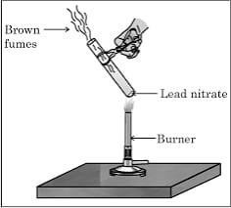

Answer the following questions (Two-mark questions)
- List out the observations that help us to determine that a chemical reaction has taken place. {E}
- What is a combination reaction? Give an example. {E}
- What is a decomposition reaction? Give an example. {E}
- What is a displacement reaction? Give an example. {E}

- Why does an iron nail change its colour when immersed in copper sulphate solution? Write the chemical equation for this reaction.
- FeSO4 + Cu → CuSO4 +Fe
Is it possible for the above chemical reaction to take place? Justify your answer.
{E}

{D}

- What is a double displacement reaction? Give an example. {E}

- Which coloured precipitation is formed, when the lead nitrate solution is mixed with Potassium iodide solution? Name the precipitate and identify the type of chemical reaction.
- Name the brown fumes liberated when lead nitrate is heated. Write the balanced chemical equation for this reaction.
{A}

{A}

- What are endothermic and exothermic reactions? Give an example for each. {A}

- When calcium carbonate is heated, calcium oxide and carbon dioxide are produced. Write the balanced chemical equation for this reaction and state the type of chemical reaction.
{A}

- What is a redox reaction? Give an example. {A}

- The chemical reaction that takes place between sodium sulphate solution and barium chloride solution is called double displacement reaction. Why? Write the balanced chemical equation for this reaction.
- Which is the type of chemical reaction where quicklime is obtained from limestone Calcium carbonate? Write the chemical equation for this reaction.
{D}

{A}

- Mention any two measures to prevent Corrosion. {A}

- A shiny brown coloured element X on heating in air becomes a black coloured compound Y. Then
  - Name the element X
  - Name the compound Y.
- The given equation represents the reaction of copper sulphate with an element X.
CuSO4 + X → Cu +Y
  - Which element is represented by X among Fe and Ag? Justify your answer.
  - Write the molecular formula of the compound Y.
{A}

{D}

- Draw a diagram of the apparatus used in electrolysis of water and label the parts. {A}

- Write balanced chemical equations for the following.
- Manganese oxide + hydrochloric acid → manganese chloride + chlorine + water
- Calcium hydroxide + carbon dioxide → calcium carbonate + water
- Convert the following into chemical equations.
- Nitrogen gas reacts with hydrogen gas to form ammonia.
- Sodium oxide reacts with water to form sodium hydroxide and hydrogen gas.

Answer the following questions. (Three marks questions)
{A}

{A}

- To a solution of 5 ml of Sodium sulphate solution if the same amount of barium chloride is added, {A}

Then

- Name the white precipitate formed.
- Name the ions responsible for the formation of white precipitate.
- Mention the type of chemical reaction.

- Strips of zinc, iron, magnesium and copper are taken in test tubes A, B, C and D respectively. Equal amount of ferrous sulphate solution is added to these test tubes. In which of these test tubes does the chemical reaction take place. Why? Write the chemical equations for the reactions taking place here.
- Explain with an example each for the decomposition reactions that take place when energy is supplied in the form of heat, light and electricity.
- Name the salts that are used in black and white photography. Write the equations for the reactions when they are exposed to sunlight?
- A solution of substance Z is used for white washing.
- Name the substance Z
- Write its molecular formula.
- Write the balanced chemical equation when Z is reacts with water.
- What type of chemical reaction takes place when an iron nail is immersed in a copper sulphate solution? Why? Write balanced chemical equation for this chemical reaction.
- The reaction of barium chloride with aluminium sulphate solution is an example for which type of chemical reaction? Why? Write the balanced chemical equation for this reaction.
- Write balanced chemical equations for the following chemical reactions.
- Calcium carbonate → Calcium oxide + carbon dioxide
- Hydrogen + chlorine → Hydrogen chloride
- Magnesium + hydrochloric acid → Magnesium chloride+ Hydrogen
- Balance the following chemical equations.
- H2 + O2 → H2O
- Na2CO3 + HCl → NaCl + H2O + CO2
- N2 + H2 → NH3
- Write balanced equations for the following chemical reactions.
- Quicklime has reacted with water.
- Zinc flakes were added to copper sulphate solution.
- Sodium chloride solution is added to silver nitrate solution.
- Translate the following statements into balanced chemical equations
- Hydrogen sulphide gas burns in air to give water and sulphur dioxide.
- Barium chloride reacts with aluminium sulphate to give aluminum chloride and barium sulphate.
- Potassium metal reacts with water to give potassium hydroxide and hydrogen gas.
- Write the balanced equation for the following chemical reactions.
- Combustion of natural gas
- Reaction of potassium metal with water
- Reaction of iron with copper sulphate.
- Explain the following with chemical equation.
i. Oxidation ii. Reduction.
- Balance the following equations
- Na + O2 → Na2O
- Mg + HCl → MgCl2 + H2
- Al + O2 → Al2O3

Answer the following questions. (Four marks questions)
- Lead nitrate is mixed with potassium iodide solution‖ Answer the following questions related to the above chemical reaction.
{D}

{A}

{A}

{A}

{E}

{A}

{E}

{E}

{D}

{A}

{D}

{A}

{A}

{D}

- Write the balanced equation for this reaction.
- Name the precipitate formed in this reaction.
- Name the colour of the precipitate
- What type of chemical reaction this is?
- Write the balanced chemical equations for the following chemical reactions and identify the type of reaction in each case.
- Hydrogen + oxygen → water
- Zinc sulphate + copper → copper sulphate + zinc
- Zinc carbonate → zinc oxide + Carbon dioxide
- Sodium chloride + Silver nitrate → Silver chloride + Sodium nitrate.
- Give a reason
- Objects made of copper lose their lustre when exposed to air.
- An iron nail placed in a solution of copper sulphate slowly turns brown.

{A}

{A}

Chapter-2: Acids, Bases and Salts

Learning points
- Physical properties of acids and bases
- Chemical properties of acids and bases
- How strong are solutions of acids and bases
- Importance of pH in daily life
- More about salts
- Uses of salts

Weightage –Difficulty level:
Difficulty level | No. of questions | Marks | %
Easy (E) | 20 | 35 | 26
Average (A) | 35 | 59 | 43
Difficulty (D) | 23 | 42 | 31

- Four alternative answers are given to the following questions or incomplete statements. Write the correct answer in alphabetical order along with the complete answer.
  - The chemical equation that represents neutralization reaction among the following is
    - BaCl2 + H2SO4 → BaSO4 + 2HCl (B) MnO2 + 4HCl → MnCl2 + 2H2O + Cl2
(C) 2NaOH + H2SO4 → Na2SO4 + 2H2O (D) AgNO3 + HCl → AgCl + HNO3
  - As the pH value of a neutral solution increases,
    - basic property decreases and number of OH− ions increases
    - acidic property increases and number of H+ ions decreases
    - basic property increases and number of OH− ions increases
    - acidic property decreases and number of H+ ions increases.
  - A compound that reacts with both acids as well as bases to produce salts and water is
(A) Aluminium Oxide (B) Copper Oxide (C) Iron Oxide (D) Sodium Oxide
  - The gas liberated when sodium carbonate reacts with dilute hydrochloric acid is
(A) Carbon Dioxide (B) Nitrogen Dioxide (C) Hydrogen (D) Chlorine
  - The substance that converts blue litmus paper into red colour is
    - Lime water (B) Pure water
(C) Sodium hydroxide solution (D) Gastric juice
  - An acid present in the stinging hair of nettle plant leaves is
(A) Methanoic acid (B) Oxalic acid (C) Citric acid (D) Lactic acid
  - The compound used to remove the permanent hardness of water is
    - Sodium carbonate (B) Sodium hydroxide
(C) Sodium hydrogen carbonate (D) sodium chloride
  - The pH value range of an acid.
(A) 0-7 (B) 2-12 (C) 7-14 (D) 12 - 14
  - As the number of hydrogen ions increases in a solution, then it
    - becomes neutral (B) increases acidity
(C) Increases the basicity (D) reduces acidity
  - Gas released when the dilute sulphuric acid is mixed with lead is
(A) oxygen (B) nitrogen (C) Hydrogen (D) carbon
  - The product obtained when an acid is mixed with a metal is
    - Metal oxide & water (B) Salt & water
(C) Metal oxide & hydrogen gas (D) Salt & hydrogen gas

{D}

{D}

{A}

{A}

{A}

{E}

{A}

{E}

{A}

{A}

{A}

  - The molecular formula of lime water is {E}

(A) CaO (B) Ca(OH)2 (C) CaCO3 (D) CO2
  - When hydrochloric acid is added to a copper oxide solution, its colour turns into blue-green due to
(A) Copper oxide (B) Water (C) Copper hydroxide (D) Copper chloride
  - Acid should be added to water, not water to acid. Because it is
    - Exothermic and may explode. (B) Endothermic and may explode
(C) It does not mix (D) Mixes very slowly

{D}

{A}

15. | An acidic salt is to be obtained. Then the kinds of acid and base that have to be reacted with each | {D}
 | other are
 | (A) Weak base and weak acid
 | (B) Weak acid and strong base
 | (C) Strong acid and strong base
 | (D) Strong acid and weak base
16. | A change that can be observed when red and blue litmus papers are dipped one after the other in | {D}
 | two solutions M and N is
 | (A) If M is a metallic oxide solution, the blue litmus turns red.
 | (B) If N is a metallic oxide solution, the red litmus does not change colour
 | (C) If M is a non-metallic oxide solution, the blue litmus turns red
 | (D) If N is a non-metallic oxide solution, the red litmus turns blue
II. | Answer the following questions. (1 Mark)
17. | What is neutralisation reaction? | {E}
18. | Plaster of Paris should be stored in a moisture-proof container. Give scientific reason. (JUNE 2019) | {A}
19. | What are amphoteric oxides? | {E}
20. | Can detergents be used to detect the permanent hardness of water? Give reason. | {D}
21. | Name the ions responsible for acidic and basic natures of the substances. | {E}
22. | Write any two uses of washing soda. | {E}
23. | 1ml of acetic acid is mixed with 1ml of sodium hydroxide solution. Determine the nature of the salt | {D}
 | forms here with suitable reason.
24. | How is concentrated acid diluted? | {A}
25. | How do you detect acid with litmus paper? | {D}
26. | What is an acid? | {E}
27. | Write a chemical equation for the reaction of a metal with a base. | {A}
28. | What is the reaction product when air is blown into lime water? | {A}
29. | Which is the gas released when acids react with metal carbonate and metal hydrogen carbonate? | {A}
30. | Why is a metal oxide called a basic oxide? | {A}
31. | Why is a non-metal oxide called an acidic oxide? | {A}
32. | What are bases? | {E}
33. | What is the ion formed when an acid dissolves in water? | {A}
34. | What happens as the number of hydroxide ions in a solution increases? | {A}
35. | What is the pH value of acid rain? | {E}
36. | What is the chemical name of baking powder? | {E}
37. | Write the chemical equation for the preparation of bleaching powder. | {A}
38. | What is baking powder? | {E}
39. | Give the molecular formula and chemical name of washing soda. | {A}
40. | Which salt is used in fire extinguishers? | {A}
41. | Why does baking soda swell when mixed with bread dough? | {A}
42. | 20 ml of concentrated sodium hydroxide solution is added to a beaker containing 100 ml of water.  How does this affect the concentration and the strength of OH⁻ ions in that solution? | {A}
43. | How are the released gases P and Q detected in the experiments depicted in the following figures? | {D}

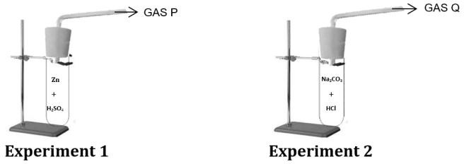

Answer the following questions. (2 Marks)
- Give scientific reason: While diluting an acid, the acid should be added to water. {D}

- Agricultural scientists have suggested to add a certain amount of lime powder to an agricultural field. What may be the reasons for this? Explain.
- The PH values of the solutions A, B and C are 5, 6 and 7 respectively. Which of these solutions has the most acidic nature and why?
{D}

{D}

- State the properties of acids. {E}
- State the properties of bases. {E}

- You are given three test tubes, one containing distilled water and the other two containing acidic and basic solutions respectively. If you are given only red litmus paper, how will you identify each sample in the test tube?
- HCl, HNO3 etc. exhibit acidic properties in aqueous solution but compounds like alcohol and glucose do not exhibit acidic properties. Why?
{D}

{D}

- Rain water conducts electric current but distilled water does not. Why? {D}
- The pH of fresh milk is 6. How does its pH change as it curdles? Explain? {D}
- A milkman adds a small amount of baking soda to fresh milk. {D}
- Write the equations for preparing sodium hydroxide and baking soda from sodium chloride. {D}

- A solution of baking soda is commonly applied to the area of a honeybee stung area. Justify this action.
- When an aqueous solution of 'P' is subjected to electrolysis in the chlor-alkali process, then the gases 'Q' and 'R' released at cathode and anode respectively
  - Name P, Q and R.
  - Write any one use of the gas Q.
- Solutions A, B, C and D have pH values of 5.6, 1.8, 13.5 and 8.1 respectively.
- Which of these solutions used to neutralize the acidity of the stomach?
- Predict the change in the concentration of H+ and OH- ions in the solution that forms when solutions B and D are mixed in equal volumes.
- When carbon dioxide is passed through the lime water, then a white precipitate forms first. If passing Carbon dioxide is continued, then precipitate disappears. What is the reason for this effect? Name the final product of this reaction.
- When an acid is diluted with distilled water what happens on the H+ ions concentration of that solution? Is there any change in the pH value of this solution? Clarify.

Answer the following questions. (3 Marks)
- Draw the diagram of arrangement of the apparatus to show the reaction of zinc granules with dilute sulphuric acid and testing hydrogen gas by burning. Label the parts.
- Name the gas liberated when an acid reacts with metal carbonate. Write the chemical equation of the reaction when this gas is passed through lime water. What is the colour of the precipitate obtained in this reaction?
- There is no change in the colour of red litmus and blue litmus paper when dipped into an aqueous solution of sodium chloride. After passing direct current through the same solution, red litmus changes to blue colour. Which product is responsible for this change? Mention any two uses of this product.
{D}

{A}

{A}

{A}

{A}

{A}

{A}

{D}

- What is a strong acid? Explain how tooth decay is caused. How can it be prevented? {E}
- Write the molecular formulae and two uses of each of the following compounds {E}

a) Bleaching powder b) Plaster of Paris.
- What is neutralisation reaction? Give an example. {E}
- What is the common name of the compound that has molecular formula CaSO4. ½H2O. {E}

- How are concentrated acids and weak acids different? State the precautions to be taken while concentrating an acid.
- Name the salts used in the following situations and write their molecular formula:
- To remove permanent hardness of water.
- To make drinking water free from germs.
- To support fractured bones in their right position.
- The pH values of four solutions are given in the below table.

Solutions | pH value
e | 5
f | 13
g | 9
h | 2
- Classify these into acidic and basic solutions:
- Name the antacid used to neutralise excess of acid in the stomach. (MAIN - 2023)
- Simultaneously red and blue litmus papers are dipped in the brine solution and in the aqueous product produced by subjecting that solution to electrolysis. What changes do you observe in litmus papers? Support your answer with reasons.
- Observe the pH values of four solutions given in the following table and answer the questions below.
Solutions | pH value
p | 10.0
q | 13.7
r | 7.0
s | 1.2
  - Which solution can be used to prepare an antacid? Why?
  - Which two solutions can be used to get a neutral salt? Why?
- Name the acid present in the following substances.
  - Curd
  - Gastric juice
- Solutions A, B, C and D are having pH values of 2, 6, 8 and 13 respectively. Then,
  - Which solution has more H+ and which solution has more OH− ions concentration? Why?
  - Which solutions can be made to react each other to get neutral salts?
- Four solutions A, B, C and D when tested with universal indicator showed pH as 5, 2, 7 and 11 respectively. Which solution
- has more hydronium ions?
- is neutral?
- is the strong acid?

Answer the following questions. (4 Marks)
{A}

{A}

{D}

{D}

{A}

{E}

{A}

{A}

- Name the products of chlor - alkali process. Write one use of each. {E}

- NaOH, Ca(OH)2, H2 and Cl2 materials are given to you. By using which of these materials you can prepare bleaching powder? Write the chemical name and one use of the bleaching powder.
- i) How do you identify a solution as basic solution by using blue litmus paper?
ii) Under what condition does a farmer treat the soil of his field with slaked lime.
{A}

{D}

- Write the differences between acid and base. {A}

Chapter-5: Life Processes

LEARNING POINTS
- Nutrition,
- Autotrophic nutrition and heterotrophic nutrition
- How organisms obtain their nutrition
- Nutrition in humans
- Transportation in humans and transport in plants
- Excretion, excretion in humans, excretion in plants

Weightage –Difficulty level:
Difficulty level | No. of questions | Marks | %
Easy (E) | 29 | 52 | 26
Average (A) | 50 | 106 | 54
Difficulty (D) | 23 | 39 | 20

- Four alternative answers are given to the following questions or incomplete statements. Write the correct answer in alphabetical order along with the complete answer.
  - The correct statement regarding digestion that takes place in the small intestine is
    - Acidic food becomes alkaline due to bile.
    - Food becomes acidic due to hydrochloric acid.
    - Starch is digested by the action of amylase.
    - Protein is digested by the action of pepsin.
  - The place where carbohydrates, proteins and fats are completely digested.
A. Stomach B. Large intestine C. Small intestine D. Liver
  - Blood vessels that carry blood from all parts of the human body to the heart
A. Arteries B. Capillaries C. Pulmonary arteries D. Veins
  - Blood vessels in the human body that carry deoxygenated blood from the heart to the lungs.
A. Pulmonary veins B. Aorta C. Pulmonary arteries D. Veins
  - Transport of soluble photosynthesis products in plants
A. Evaporation B. Osmosis C. Diffusion D. Translocation
  - Important function of xylem in plants
    - Water transport B. Food transport
C. Amino acid transport D. Oxygen transport
  - The main function of the kidney in humans is
A. Nutrition B. Respiration C. Excretion D. Transport
  - The place where carbon dioxide and water are released from the breakdown of pyruvate is
A. cytoplasm B. mitochondria C. chloroplast D. nucleus
  - Which of the following is a function of the kidney?
    - Excretion of undigested food materials B. Excretion of urea in the form of urine
C. Excretion of carbon dioxide D. Production of hormones
  - Function of stomata.
    - Exchange of gases B. Transport of water
C. Transport of food D. Transport of oxygen
  - Structural and functional unit of Kidney is
A. Neuron B. Nephron C. Cell D. Muscle cell
  - A colourless, low-protein fluid in the circulatory system is
A. Red blood cells B. Plasma C. Lymph D. Platelets

{D}

{A}

{A}

{A}

{A}

{A}

{E}

{A}

{A}

{E}

{E}

{E}

  - The blood vessel that carries oxygenated blood from the heart is {A}

A. Pulmonary vein B. Aorta C. Superior vena cava D. Small vessel
  - The important role of stomata in photosynthesis is
    - Creating upward tension B. Absorbing carbon dioxide
C. Releasing oxygen D. Continuous transpiration.
  - Part of the excretory system that stores nitrogenous wastes dissolved in water
A. Kidney B. Ureter C. Urinary bladder D. Urethra
  - Transpiration process in plant body
    - Balancing the amount of oxygen and water
    - To establish a water column in the xylem tissue
    - To help in the transport of soluble photosynthesis products
    - To create osmotic pressure
  - Plants release excess water through this process.
A. Transpiration B. Photosynthesis C. Respiration D. Metabolism
  - The need for suction pressure in plants is,
    - To overcome the difference in ion concentration between the root and the soil
    - To transport food in two directions
    - To carry water to higher parts
    - To remove excess water from the leaves

Answer the following questions (one mark questions)

{A}

{A}

{D}

{A}

{D}

- When is lactic acid produced in muscle cells? {A}
- How is oxygen supply more efficient in birds and mammals? {D}
- Name the products of anaerobic respiration. (JUNE -2019) {E}
- Why do deer and rabbits have longer small intestines than tigers/lions? {D}
- Why is the respiration rate of aquatic animals faster than that of terrestrial animals? (APR-2020) {A}
- Write the function of the platelets. {A}
- Name the type of transport where food material transported from the leaves to other parts? {E}
- What is transpiration? {E}
- What is double circulation? {E}
- What is excretion? {E}
- What is the function of guard cells? {A}
- When does stomata close? {A}
- What is the function of the air sacs or alveoli in the lungs? {A}

- Osmotic pressure in the phloem tissues of plants helps in the transport of materials. Justify your answer
{D}

- There is a time to absorb oxygen and release carbon dioxide at the beginning of respiration. Justify. {D}
- What is the finger-like structures in the small intestine called? {E}
- Write the function of villi? {A}
- Humans can't digest grass like plants. Give Reason. {D}
- Diffusion is not enough to meet the oxygen requirement in multicellular organisms Why? {D}
- Enzymes are biological catalysts. Justify. {A}
- What are life processes? {E}
- Name the two types of respiration {E}
- Name the product released when the 6-carbon molecule of glucose is broken down in cytoplasm? {E}
- What is nutrition? {E}
- Name the two types of vascular tissues in plants {E}
- What is photosynthesis? {E}
- What is cellular respiration? {E}
- What are parasites? {E}
- The haemoglobin content in the blood of two persons A and B is found to be 9gm/dl and 13 gm/dl {D}

respectively. Which statement is correct regarding the oxygen supply in their body?
  - More in Person A than in B
  - More in Person B than in A
- The schematic representation of blood circulation in the mammals is given below.

{D}

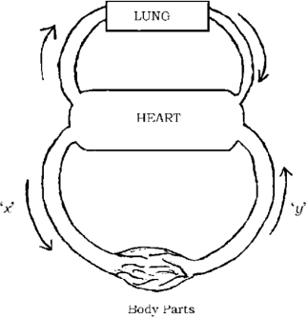
- Name the blood vessels x and y.
- Which blood vessel has a valve?
- State the importance of transpiration in plants. {A}

- How does the transpiration process contributes to both transportation of water and excretion processes in plants?

Answer the following questions (two marks questions)
{A}

- Draw the diagram of open stomata and label the parts. (JUNE-2019)(MAY-2025) {A}

- The approximate lengths of the small intestines of animals x and Y are given in the table. Observe the table and answer the questions
{D}

Animals | Small intestine  length
X | 20 to 40 feet
Y | 5 to 8 feet
Identify the herbivorous and carnivorous animals in the table and support your conclusions with scientific reasons.
- Chapati tastes sweeter when chewed slowly. Why? (SEP-2020) {D}

- Give reason: (APR-2022)
- The ventricles of the human heart have thick walls.
- In mammals and birds, it is necessary to separate oxygenated and deoxygenated blood.
{A}

- Name the enzyme present in Saliva. Write its function. {E}

- Observe the pictures given below:
{D}

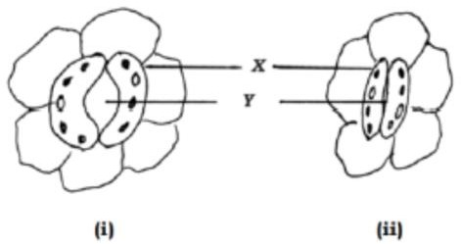
- Which picture indicates a high rate of gas exchange? Why?
- Name the parts X and Y and what is the function of the part X? (MARCH- 2023)
- Draw a diagram of nephron and label the parts. (JUNE-2023) {A}
- What is the function of bile juice? {E}
- How are oxygen and carbon dioxide transported in humans? {A}
- The body temperature of frogs and lizards depends on the environment temperature. Justify. {D}
- Why does the heart have different chambers? {A}
- State the importance of double circulation. {A}
- If humans had a three-chambered heart like a frog, then how would be the blood circulation? {D}

- Herbivores like sheep have long small intestines, while animals like tigers have short small intestines. Write the reason for this difference?
{D}

- Photosynthesis does not occur in plants growing in deserts as it does in normal plants. Give reason {D}

- What is photosynthesis? What is the product released in this process? Write the function of this product. (MAR-2020)
- Lymph plays an important role in maintaining the body's immune system. Justify this statement.

(2016)
{A}

{D}

- Write the difference between arteries and veins. {A}
- What is the role of hydrochloric acid in our stomach? {A}

- How does ATP synthesize in the cells by cellular respiration in our body? Is the role of these molecules essential in the transportation of food in plants? Support your answer.
- Mention any three strategies by which the food is taken in and used in hetrotrophs with an example for each.

Answer the following questions (Three marks questions)
- Draw a diagram showing the schematic sectional view of the human heart. Label the parts.

(MAR-2020)
{D}

{A}

{A}

- Explain the process of digestion that takes place in the small intestine of a human. (Apr-2019) {A}
- Explain the process of transport of nutrients in plants. (Apr-2019) {A}

- The pictures given below represent the hearts of three different animals. Observe them and answer the questions. (JUNE-2019)
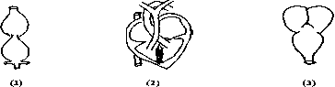
Which of these hearts is useful for an animal that needs a lot of energy and why?
- How are the functions of arteries, veins and capillaries related to each other in blood circulation?

(SEP-2020)
{D}

{E}

- How is water transported to the higher parts of a plant? Explain. (SEP-2020) {A}
- State the differences between the circulatory systems of fish and humans. (JUNE-2022) {A}
- Explain the stages of 'double circulation' in humans. (JUNE-2022) {E}

- In plants, state the events that take place in photosynthesis. What are the methods used by plants to eliminate waste products?
- a) In what form do waste products accumulate in the old xylem of plants?
b) How are the products of photosynthesis transported to all parts of the plant?
{A}

{A}

- Explain the structure and function of nephron. (MPQ 2023) {E}
- Explain the mode of nutrition process in amoeba. {A}
- How do the quantity of urine production in humans is controlled? {A}

- In two animals P and Q, the small intestine is 85 feet and 15 feet long respectively, in which animal the digestion process is slow and fast? Why? Explain with suitable answer.
- What is the role of the following enzymes in the human digestive track?
i) Trypsin ii) Amylase iii) Lipase (APR-2025)
{D}

{E}

- What are the differences between nutrition in autotrophs and nutrition in heterotrophs? {A}
- Draw a schematic diagram showing the breakdown of glucose by various pathways. {A}

- a) State any two methods used by plants to excrete waste products.
b) Which process helps in transporting water to the higher parts of the plant? (MAY-2025)
- a) How is urine produced in the human body? Explain.
- State the function of the following digestive juices in the human digestive track:
  - Gastric juice ii) Intestinal juice
{E}

{A}

- State three ways in which parasite or heterotrophs consume food and utilize. Give 3 examples. {E}

Answer the following questions (4 marks questions)

- In the first stage of cellular respiration, the glucose molecule is broken down into which molecule in the cytoplasm? Mention the types of respiration and write any two differences between them.

(APRIL-2022)
- What are the elements required for photosynthesis? State the events that take place in this process. Express this process through a balanced chemical equation. (APRIL-2022)
- a) Compare the functions of xylem tissue with those of phloem tissue.
b) Explain the process of gas exchange in plants through stomata.
- a) How does the structure of the human heart help in the transport of oxygenated and deoxygenated Blood? Explain.
b) How is digested food absorbed into the blood in humans? Explain the function of blood in the transport of essential substances.
{A}

{E}

{D}

{E}

- Name the components of blood and write their functions. {A}
- Briefly explain the role of haemoglobin pigments in our blood. {A}

- a) Compare the air sacs in the lungs and the nephrons in the kidneys on the basis of structure and function.
b) The muscle cramps occur in the legs of a football player due to continuous practice. Give a suitable reason.
- a) What is anaerobic respiration? What are the products produced in this process?
b) What is double circulation? How is this type of blood circulation useful in birds and mammals?
- What are the advantages that terrestrial animals have compared to aquatic animals in terms of obtaining oxygen for respiration?
{E}

{A}

{A}

- How are the lungs designed in humans to increase the area for gas exchange? {A}

Answer the following questions (5 marks questions)

- a) How is glucose converted into energy molecules in aerobic respiration? What is the role of stomata in the process of respiration in plants?
b) What are the different excretion methods found in plants? (AUG-2024)
{A}

Chapter-6: Control and Coordination

Learning points
- Animals – Nervous System
- Reflex action-reflex arc
- Coordination in plants
- Hormones in plants and their functions
- Hormones in animals and their functions

Weightage –Difficulty level:
Difficulty level | No. of questions | Marks | %
Easy (E) | 27 | 45 | 30
Average (A) | 41 | 73 | 50
Difficulty (D) | 17 | 29 | 20

I. | Multiple Choice Questions. (One-mark questions.)
1. | The brain is responsible for | {A}
 | A. Thinking. B. Regulating the heartbeat.
 | C. Balancing the body. D. all of the above.
2. | The incorrect statement related to thyroxin hormone among the following is (MAIN- 2020) | {A}
 | A. it regulates fat metabolism B its deficiency leads to goitre
 | C. it is secreted by parathyroid gland D. iodine in the food is essential for its production.
3. | The gap between two neurons is | {E}
 | A. dendrite B. axon C. synapse D. cell body
4. | The following is an example of reflex action | {E}
 | A. Folding the chair. B. Pulling hand back when touching a sharp object.
 | C. Tasting food D. Applause at the end of the program.
5. | The centre of reflex action is | {E}
 | A. Cerebrum B. spinal cord C. Cerebellum D. Hypothalamus
6. | The hormone that regulates carbohydrate, protein and fat metabolism in the human body. | {A}
 | A. Testosterone B. Adrenaline C. Thyroxine D. Insulin
7. | If the roots of a plant grow towards an area of nitrate concentration, it is | {A}
 | A. Phototropism B. Hydrotropism C. Thigmotropism D. Chemotropism
8. | Which of the following is a mismatched pair? | {A}
 | A. Adrenaline - Pituitary gland B. Testosterone – Testis
 | C. Insulin - Pancreas D. Thyroxine - Thyroid gland
9. | Correct path of transmission of nerve impulses in the neuron (MAIN 2019 SUP- 2021) | {D}
 | A. Dendrite → nerve ending → cell body → axon
 | B. Dendrite → Axon → Cell body → Nerve ending
 | C. Dendrite → Cell body → Axon → Nerve ending
 | D. Nerve ending → Cell body → Axon → dendrite
10. | Correct path of reflex arc in the figure given below | 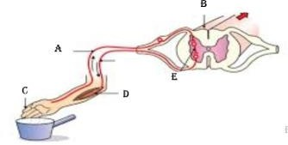  {D}
 | A. A → B → C → D → E
 | B. C → A → B → E → D
 | C. C → A → B → D → E
 | D. C → D → A → D → E
11. | An example of positive geotropism in plants is | {E}
 | A. Growth of the stem B. Growth of roots deep into the soil
 | C. Growth of shoots of veins D. Upward growth of roots

- The part of the human brain responsible for the accuracy of voluntary actions and maintaining body posture and balance is
A. Pons B. cerebrum C. Hypothalamus D. cerebellum
- A pot that has growing seedling is kept in a dark room. A burning candle is placed near it for a few days. The top part of the seedling bends towards the light of burning candle. This is
A. Chemotropism B. Phototropism C. Geotropism D. Hydrotropism
- A person immediately starts running soon after observing a snake. The correct transmission path of reflex impulse in this situation is
  - Receptor → Sensory neuron → Brain → Relay neuron → Motor neuron → Effector
  - Receptor → Sensory neuron → Spinal cord → Relay neuron → Motor neuron → Effector
  - Effector → Spinal cord → Sensory neuron → Relay neuron → Motor neuron → Receptor
  - Effector → Motor neuron → Relay neuron → Brain → Sensory neuron → Receptor
- Blood sugar level increases : Under secretion of insulin hormone :: Swelling of the neck : ……………
  - Under secretion of thyroxine hormone B. More secretion of insulin hormone
C. More secretion of thyroxine hormone D. Excess intake of iodine.
- The hormone secreted by the pancreas,
  - regulates metabolic activities B. regulates blood sugar level
C. stimulates the growth in the body organs D. increases breathing rate
- Which of the following is a plant hormone?
A. Insulin B. Thyroxine C. Cytokinin D. Estrogen
- The correct path of the movement of nerve impulses in the following diagram is

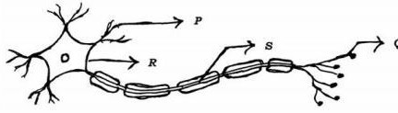
  - Q → S → R → P B. P → Q → R → S
C. S → R → Q → P D. P → R → S → Q
- The part of the brain that controls activities such as Riding a bicycle, writing with a pen grip is
A. Cerebrum B. Cerebellum C. Medulla D. Pans
- This part of the brain is responsible for making your mouth water when you see tamarind.
A. Cerebrum B. Cerebellum C. Medulla D. Pans
- The movement of pollen grains towards the ovary in plants.
A. Phototropism B. Geotropism C. Hydrotropism D. Chemotropism
- The plant hormone responsible for Phototropism in plants is
A. Auxin B. Cytokinin C. Abscisic acid D. Gibberellin
- The information sensed by receptors in the body is carried through
  - Through electrical signals B. Through blood
C. Through lymph D. Through vessels
- Upward growth of stem in plants
  - Negative geotropism and positive hydrotropism
  - Positive geotropism and negative hydrotropism
  - Negative phototropism and positive gravity transduction
  - Negative geotropism and positive phototropism
- Identify the correct statement regarding plant hormones.
  - Cytokinin promotes leaf wilting B. Auxin inhibits stem elongation
C. Abscisic acid inhibits plant growth. D. Gibberellin promotes leaf abscission.
- The pattern of root responses in plants
  - Directed and negative phototropism B. Positive phototropism and negative geotropism
C. Undirected and positive geotropism D. Growth-dependent and positive hydrotropism
{E}

{D}

{D}

{A}

{E}

{E}

{D}

{A}

{A}

{A}

{E}

{A}

{D}

{D}

{D}

- The response that does not occur in plants based on their growth is, {D}

  - Stems bending towards light B. Roots going down into the soil
C. Leaves tingle when touched D. The shoots of a vine rising.
- In the figure below, the name and function of the part ‘X’ are:

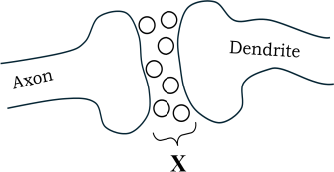
- Neuron and transmits chemicals into electrical impulses
- synapse and transmits electrical signals generated at the axon terminal to the dendrite
- Neuron and transmits electrical impulses into chemicals
- synapse and transmits chemical signals generated at the axon terminal to the dendrite
- Bending of young stems of plants towards light : Phototropism :: folding of the leaves of touch me not plant : -------------
(A) Thigmotropism (B) Hydrotropism
(C) Geotropism (D) Chemotropism

{D}

{A}

II. | Answer the Following (One Mark Questions)
30. | What are the tropism movements necessary for growth in the roots and shoots of plants? | {E}
31. | What is geotropism? | {E}
32. | What is neuron? | {E}
33. | Which hormone inhibits the growth of plants? | {E}
34. | What is reflex action? Give an example. | {E}
35. | How does chemical coordination occur in plants? | {A}
36. | Name the mineral necessary for the production of thyroxine hormone. | {E}
37. | What is the role of abscisic acid in plants? | {A}
38. | What is the function of pancreas as an endocrine gland? | {A}
39. | How do muscle cells respond to nerve impulses? | {A}
40. | What is voluntary action? | {E}
41. | What is involuntary action? | {E}
42. | Name the parts of the human brain that control voluntary and involuntary actions. | {E}
43. | What is the role of receptors in our body? | {E}
44. | Name the plant hormones that promote growth. | {E}
45. | What is the difference between reflex action and walking? | {A}
46. | Which part of the brain maintains body posture and balance? | {A}
47. | The folding up of leaves of sensitive plant (touch-me-not plant) on touching with a finger is not a | {A}
 | trophism. Why?
48. | Observe the below figure. How does tendril contribute for the growth of plant parts that are away | {D}
 | from the support?
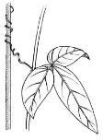
- Which process takes place in the part labelled as K among the below given images of neuron? {A}
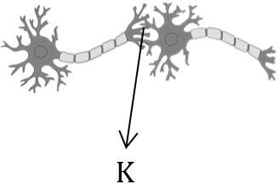

Answer the Fallowing (TWO MARK QUESTIONS)
- A doctor advises an elderly person to consume less sugar in the diet. What disorder is that person suffering from? Name the hormone responsible for this condition.

{A}

- How is the function of thyroid gland helpful for balanced body growth in humans? {A}

- A person’s face has become pale, and his breathing rate has increased due to fear. Analyse the
process which enables the person to deal with this situation.
{A}

- How does chemical coordination take place in animals? {D}
- Write two differences of functions between the endocrine glands and the nervous system. {A}
- Write the functions of medulla and cerebellum of the human brain. {A}

- The part of a neuron that helps the nerve impulse pass through it is
A. Towards the cell B. Away from the cell.
{A}

- How does adrenaline help an athlete to prepare for a race? {A}
- How does the movement of the leaves of the sensitive plant when touched? {A}
- Phototropism is beneficial for plants. Justify your answer with suitable reasons. {A}
- What causes mouth watering at the sight of delicious food? Which part of the brain controls this? {A}
- What causes a person who has consumed more alcohol to lose control over his body? {A}
- What causes the stem of a plant to grow towards the light and the roots towards the ground? {E}
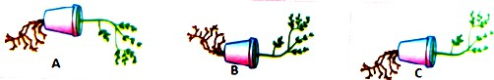
- Which of the following figures shows the correct tropic movements and why? {D}
- Write two differences between the central nervous system and the peripheral nervous system. {A}
- Write two differences between the endocrine glands and the nervous system. {A}

- Mention the function of the following plant hormones:
  - Auxin ii) Cytokinin.
{A}

- How do auxins promote the growth of tendrils of climbing plants around a support? {A}

- How does our body respond when adrenaline is secreted into the blood?
(How does our body prepare to deal the situations of stress and anxiety? Explain.)

Answer the following questions (THREE MARKS QUESTIONS)
- Functioning of Reflex arc is more effective than thinking process of the brain. Clarify this statement with scientific reason.
- In multicellular organisms, chemical communication is more stable and continuous. Compared to electrical Communication. Give reason.
- How is phototropism, thigmotropism and chemo tropism coordinated in the apparent movement of creepers (climber plants) towards a particular direction?
- Name the structure given below. What is its common function? Mention the function of the part A and C.
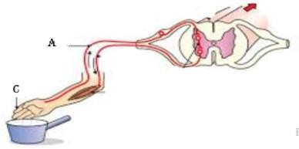
- Draw a diagram of the structure of the human brain and label the parts.
(Exam-1, 2, 3 2025, Main 2023, March-2022, June 2020)
{A}

{A}

{A}

{D}

{E}

{A}

- What is the role of insulin, estrogen and thyroxine hormones in our body? {E}

- Imagine the following situations:
  - Clapping at the end of a programme.
  - Fluctuating blood pressure in the body.
{E}

How these situations are functionally different? Give reason.
- We withdraw our leg when stepped on thorn unknowingly.
- Trace the sequences of events which occur in this action.
- Which part of human nervous system controls this action?

{D}

- Name the three major parts of the human brain. Write one function of each part. {E}

Answer the following questions. (Four Mark Questions)

- Name the hormones that control the following activities in humans.
- Control the level of sugar in the blood.
- Control the menstrual cycle.
- Prepare the body to face the emergency situation
- Control metabolism.
- Name the structural and functional unit of nervous tissue.
  - Write the path of transmission of nerve impulses in this unit
  - State its function.
- What is reflex arc? Trace the sequence of events that occur in this structure, when a bright light is focused on our eyes.
- How is the movement of leaves of a touch me not plant different from the movement of a shoot towards light?
- Name the given structure. What is its general function? Mention the function of the parts labelled as A and B. (MAIN-2020)
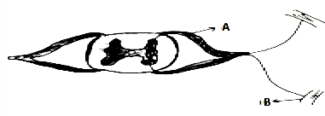
- a) As the growth advances in a climbing plant (creeper) that appears as the plant is moving towards a particular direction. How?
b) Explain the necessity of chemical communication in animals. (JUNE-2023)
- a) ‘Reflective arcs can be considered more effective for rapid responses.’ Justify.
b) When a plant perceives light from one direction, it appears to bend towards the direction of the light. Analyse the reason for this process. (MQP-4-2025)

FIVE Marks question:
- a) How do climbing plants (creepers) show directional movement? Explain. (MODEL QP-4 -2025)
b) Mention the function of thyroxine and adrenaline hormones in the human body.
{E}

{E}

{E}

{A}

{A}

{D}

{D}

{A}

Chapter-11: Electricity

Learning points
- Electric current, electric circuit, electric potential, potential difference, electric charge, electric capacity and their SI units.
- Electric circuit and their symbols
- Ohm’s law and Joule’s law of heat generation
- Resistance of a conductor, types of Resistors circuit, advantages and disadvantages of series and parallel circuits
- Series and parallel circuit connections diagrams
- Thermal effects of electric current and its practical applications.

Weightage –Difficulty level:
Difficulty level | No. of questions | Marks | %
Easy (E) | 33 | 44 | 27
Average (A) | 45 | 69 | 43
Difficulty (D) | 28 | 50 | 30

- Multiple Choice Questions. (One-mark questions.)
  - SI unit of Electric current
A. Ampere (A) B. ohm (Ω) C. Volt (V) D. Watt (W)
  - SI unit of Power
A. Ampere (A) B. ohm(Ω) C. Volt (V) D. Watt (W)
  - The property of the conductor that opposes the flow of charges through it is called
    - electric current B. electric potential difference
C. electric resistance D. electric power
  - Rate of flow of electric charges called
A. Electric current B. Electric potential C. Electric resistance D. Electric power
  - The work done in bringing an unit charge from one point to another through conductor is called
A. electric current B. electric potential C. electric resistance D. electric power
  - Rate of consumption of energy is called
    - electric current B. electric potential difference
C. electric resistance D. electric power
  - The symbol used to represent Electric cell
    - B. C. D.

{E}

{E}

{E}

{E}

{A}

{A}

{A}

  - The symbol for closed circuit in electric circuit
    - B. C. D.
  - The symbol used to represent dry cell in a circuit
    - B. C. D.
  - Symbol in electric circuit represents
A. resistor B. ammeter C. dry cell D. voltameter
  - In an electric circuit the ammeter and voltmeter are generally connected like this
    - both are connected in parallel B. both are connected in series
{A}

{A}

{A}

{A}

C. ammeter in series & voltmeter in parallel D. ammeter in parallel & voltmeter in series
  - Formula that is not applicable to represent ohm’s law is
A. V/I = R B. V = IR C. I = V/R D. V = I/R
  - The net resistance when 2 Ω & 4 Ω resistors are connected in series and a 4 Ω resistor is connected in parallel is
A. 2Ω B. 2.4 Ω C. 4 Ω D. 10Ω
  - 6 Ω the resistance of a conductor is 27Ω. If it is cut into three equal parts and connected in parallel, then its total resistance is
A. 6Ω B. 3 Ω C. 9 Ω D. 27Ω
  - The net resistance when 2 Ω & 3 Ω resistors are connected in parallel and a 2 Ω resistor is
connected in series
A. 3.2 Ω B. 2 Ω C. 3 Ω D. 1 Ω
  - A piece of metallic wire of resistance R is cut into 3 equal parts. These parts are then connected in parallel. If the total resistance of this combination is Rl, then the value of R : Rl is
A. 1:3 B. 1:9 C. 9:1 D. 3:1 (June-2019)
  - An electric circuit of 6V potential difference does the work of 24J, then the amount of charges flown
A. 2 C B. 4 C C. 6 C D. 10 C
  - If 10C of charges flow through an electric circuit of 4V potential difference, then the amount of work done is
A. 10 J B. 20 J C. 40 J D. 30 J
  - An electric lamp whose resistance is 30 Ω and a conductor of 6 Ω resistance are connected in series
to 9V battery as shown in the figure. The total current flowing in the circuit is

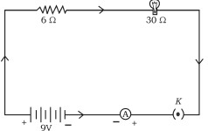
A. 4 A B. 36 A C. 0.25 A D. 0.6 A
  - In a conductor if the amount of electric current is 4A then the resistance is 12 Ω. If the resistance is doubled then the electric current would be
A. 2 A B. 3 A C. 4 A D. 8 A
  - The resistance of a conductor of length 4l is 4 Ω, if the length becomes 2l then the resistance will be
A. 0.5 Ω B. 2 Ω C. 4 Ω D. 8 Ω
  - Device used to measure the potential difference
A. Galvanometer B. Ammeter C. Speedometer D. Voltmeter
  - The formula for electric power is
A. P=I R B. VI= P C. P = VR D. VR =P
  - The correct statement related to resistance is it is
    - directly proportional to potential difference but inversely proportional to current
    - inversely proportional to potential difference but directly proportional to current
    - inversely proportional to both potential difference and current
    - directly proportional to both potential difference and current
  - The safety device used to avoid short circuit.
A. fuse B. switch C. resistor D. transistor
  - The formula used to measure electric current
A. E=VIt B. E=Pt C. E=RCt D. E=Vt

{A}

{D}

{D}

{D}

{D}

{D}

{D}

{D}

{D}

{D}

{E}

{E}

{D}

{E}

{A}

  - A device used to change the resistance in the electric circuit is
A. Voltameter B. Ammeter C. Galvanometer D. rheostat
  - ‘Ohm’ is the SI unit of
    - Electric Charge B. Resistance
C. Electric Current D. Electric Potential Difference
  - The metal used in the filament of an electric bulb is
A. Manganese B. Tungsten C. Nickel D. Chromium
  - The SI unit of electric potential difference is
A. Volt B. Ampere C. Ohm D. Coulomb
  - The resistance of an electric heater coil is 110 Ω. Then electric current, that an electric heater draws from a 220 V source is,
(Sep-2021)
A. 0.5 A B. 0.11 A C. 2 A D. 3 A
  - A device that is connected in series in an electric circuit is
A. Voltmeter B. Bar Magnet C. Turbine D. Ammeter
  - Observe the following table :

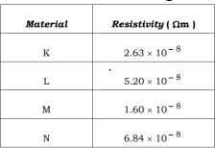
The best conductor of electricity among these materials is
A. N B. M C. K D. L
  - The function of fuse in an electric circuit is that it
    - Reverses the direction of an electric current
    - Shows the direction of motion of the electric current
    - Measures the potential difference
    - Protects the electrical appliances
  - The correct formula that shows the relationship between potential difference, electric current and resistance in an electric circuit is
A. I = V/ R B. I = VR C. V = R I D. R = I V
  - The device used to measure the rate of current in a circuit is
A. Ammeter B. Voltmeter C. Galvanometer D. Battery
  - The SI unit of resistivity is
A. ohm B. volt C. watt D. ohm-metre.
  - Ohm's law gives the relationship between
    - potential difference and electric charge B. potential difference and resistance
C. electric current and potential difference D. electric current and electric power
  - In an electric circuit to get an equivalent resistance Rs four resistors of 2 Ω each are first connected in series. Later to get an equivalent resistance of Rp the same resistors are connected in parallel. Then the ratio of Rs /Rp is
    - 6:1 B. 2:1 C. 4:1 D. 8:1
  - SI unit of electric charge is
A. Coulomb B. Ampere C. Joule D. Volt
  - The rate of energy consumed in an electric circuit is, electric
(A) current (B) potential difference
(C) resistance (D) power
{E}

{E}

{E}

{E}

{A}

{E}

{D}

{E}

{A}

{E}

{E}

{A}

{A}

{E}

{A}

  - When three resistors of different resistance are connected in parallel, the quantity that remains the same in all the resistors is
(A) current (B) potential Difference
(C) resistance (D) resistivity
  - A correct statement related to the conductors X and Y given in the below figures is
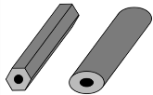

X Y
- Since the cross section of the conductor X is less the flow of current is more in this conductor
- The cross section of conductor Y is more and hence resistance in it is more
- Since the cross section of the conductor X is small it has a low resistance
- The conductor Y has more cross section than the conductor X and hence the flow of current is more in it

One-mark Questions:
- Two connecting wires of same length and same diameter are made up of copper and iron. Among these two which is having more resistance? Give reason.
- Two students A and B conduct experiment connecting R1 and R2 resistors in series and parallel and plot the graph of V-I as below. Who has plotted the graph correctly?
{A}

{D}

{A}

{D}

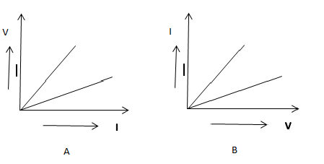
- How many joules does 1 unit (kWh) have? {E}
- Define 1 ohm? {E}
- What is the meaning of 1 Ampere? {E}
- How many electrons does 1 coulomb (C) have? {E}
- The potential difference between two points of connecting wire is 1 volt. Define the statement. {E}
- Name the devices used to measure electric current and potential difference. {E}
- What is the resistance of a conductor? {E}
- When did the resistance of a conductor becomes 1 Ω? {E}
- Why is the nitrogen or argon gas filled inside the electric bulb? {A}
- Name the commercial unit of electricity. {E}
- How is fuse connected in an electric circuit? {E}
- What are the uses of fuse in domestic electric circuit? {E}
- Why are tungsten wires used in electric bulb? {E}

- Write the symbols for the following terms in electric circuit.
  - A wire joint ii) electric bulb.
{A}

- Write the diagram of the symbol of resistors used in electric circuit. {A}

- What is the SI unit of potential difference? Name the device used to measure the potential difference.
{A}

- Suggest any two measures to avoid overloading in domestic circuits. {A}
- What are the reasons for occurring overload in an electric circuit? {A}

- Write the symbols of the following components used in an electric circuit.
  - Rheostat ii) Wires crossing without joining
{A}

- Write the symbols of the following components used in an electric circuit. {A}

  - Electric cell ii) Voltameter
- Draw the symbol diagram of two electric cells connected in series in an electric circuit.
(MQP2-25)
- Can an electric heater of 2kW capacity be connected to an electric circuit of 15A rating, 220V potential difference? Justify your answer. (Mar/Apr-2024)
- What happens if the fuse is connected to the neutral wire instead of connecting it to the live wire in the meter board of the house?
- When the number of turns of a current carrying circular loop is increased by ten times what change that occurs in the magnetic field of it?

Two marks Questions:
- What is electric circuit? Write the schematic diagram of an electric circuit comprising cell, electric bulb, ammeter & plug key. (Main-
2022)
- In which of the below devices the electric energy is used maximum?

Electric devices | Electric power | Time used
TV | 250W | 1 Hour
Toaster | 1200W | 10 Minutes
- Which of the below electrical appliances consume more energy?

Electric devices | Electric power | Time used
TV | 250W | 4 hours
Toaster | 1200W | 1 hour
- 2 Ω, 3 Ω & 4 Ω resistors are connected in parallel & then in series. In which connection does their
total resistance will be less than their resistance?
- 2 Ω and 4 Ω resistors are connected in parallel. If 6 Ω resistor is used in place of 4 Ω, find the
difference of total resistance of two types of connections.
- Resistivity of copper 1.63 x 10-8 Ωm & its cross section is 10.3 x 10-5cm3. Calculate the length of
wire needed to make a coil of 10 Ω resistance.
- Electrical resistivity of some substances at 200C is given below.

{A}

{A}

{A}

{A}

{E}

{D}

{D}

{A}

{D}

{A}

{D}

Materials | Resistivity
Silver | 1.60 X 10-8 Ωm
Copper | 1.63 X 10-8 Ωm
Tungsten | 5.2 X 10-8 Ωm
Nichrome | 100 X 10-6 Ωm
  - Among silver and copper which is the good conductor. Why?
  - Which material is suitable for electrical heating. Why?
- Explain the working principle of electric fuse. {A}
- Define electric resistance and resistivity. How are they interrelated? {A}
- Explain the working mechanism of an electric bulb. {A}

- In domestic electric circuit it is suitable to connect electrical devices in parallel. Mention two reasons for it.
- State Joule’s law of heating. How fuse is connected in an electrical circuit. Mention the metal used
in a filament of an electric bulb and the gas filled in the bulb.
- A bulb is marked 220 V and 40 W. Calculate the current flowing through the bulb and it‘s
resistance.

If an electrical fan consumes energy at a rate of 880W in voltage 220V, calculate the electric current and electric resistance.
- The resistivity of manganese wire of length 1 m is 1·84 × 10-2 m at 20°C. If the diameter of the wire is 3 × 10-4 Ω m, what will be the resistance of the wire at that temperature?
{A}

{E}

{A}

{A}

{D}

- The resistance of a metal wire of length 2 m is 28 Ω at 20°C. The cross-sectional area of the wire is
1.26 × 10⁻⁹ m².
- Calculate the resistivity of the metal.
- Find the resistance of the same wire if its length is 3m.
- Observe the given circuit:

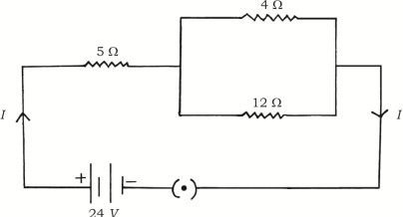
Calculate the total resistance in the circuit and the total current flowing in the circuit.
- Observe the diagram of below given electric circuit. Find the total resistance and the total current of the circuit.
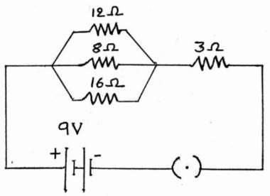
- An electric bulb with a resistance of 50 Ω is connected to 10 V battery in an electric circuit.
Calculate the electric current flowing through the electric bulb and electric power of the bulb.
(June/July-2022)
- 1000 J of heat is produced each 2 seconds in a 5 Ω resistor. Find the potential difference across the
resistor. (JUNE-2023)
- A wire of given material having length ‘l’ and area of cross section ‘A’ has a resistance of ‗4 Ω. Find
the resistance of another wire of the same material having length ½ and area of cross-section ‘2A’.
(JUNE-2023)
{D}

{A}

{A}

{D}

{D}

{D}

- Placing a fuse in domestic electric circuits is essential. Why? Explain. (August-2024) {A}

Three marks questions:
- Find out amount of electric current flowing through below circuit. {D}

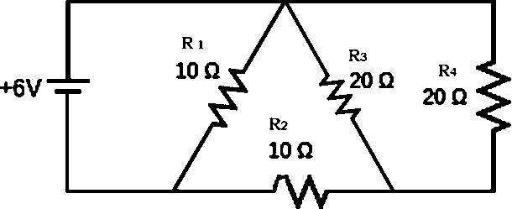

- The value of resistors R1, R2 & R3 are 5 Ω, 10 Ω & 30 Ω. If they are connected to dry cell of 12V potential difference. Calculate
  - Electric current flowing through each resistor
  - Total electric current through circuit.
  - Total resistance of entire circuit.
- A Refrigerator of 400 Watt works 10 hrs daily; an electric fan of 80 Watt works 6 hrs daily and an electric bulb of 18 Watt glows 6 hrs daily. If the rate of per unit is 3 rupees, then what is the amount of electric bill the owner has to pay in the month of June?
- A 350W bread toaster is used 6 hours a day. A 250W iron box is used 4 hours a day. If these appliances are used for 30 days, calculate the total cost if the rate is Rs. 4 for 1kWh.
- An electric fan rated 50 W is used for 6 hours in a day. What is the cost of the energy it consumes for 30 days at Rs.4 per 1kWh?
{A}

{D}

{D}

{D}

- Among iron, silver and nichrome which one is utilised inside an electric iron box which works on the heating effect of electric current. Justify your answer with 3 reasons.
- A connecting wire of 20 Ω resistance is drawn to double its length. Calculate the resistance in new
situation.
- i) State ohm’s law. (Mar / Apr-2025, Main-2024, Sep-2019)
  - List the factors on which the resistance of conductor depends.
{A}

{D}

{E}

- State Joule’s law of heating. Explain the working of electric filament bulb. {A}

- The resistors R1, R2 and R3 have the values 10 Ω, 20 Ω and 60 Ω respectively, which have been parallelly connected to a battery of 24 V in an electric circuit. Then calculate the following:
  - The current flowing through each resistor
  - The total current in the circuit
  - The total resistance of the circuit. (MARCH-2023)
102 Resistance of a metal wire of length 2 m is 28 Ω at 20°C. If the diameter of the wire is 0.04 mm then
what will be the resistivity of the metal at that temperature? (MQP4-25)

Four marks questions:
- a) Name any two devices that work on the application of Joule’s law.
  - Why are the alloys like nichrome used in electrical heating devices?
- a) A bread-toaster rated 350 W is used for 15 hours a day. An electric iron box rated 250 W is used for 5 hours a day. Calculate the cost of using these appliances for 30 days, if the cost of 1 kWh is Rs. 4.
  - In which method the resistors R1 and R2 could be connected so that the equivalent resistance of that electric circuit becomes low? What is the change in the value of current in the circuit by this type of connection? (JUNE-2023)
- An electric heater connected to a 220 V generator draws a current of 10 A. What is the power of the electric heater? If it is used for 8 hours a day, then calculate the total cost of using it for 30 days at Rs. 5.00 per 1 kWh. (MQP1-25)

Answer the following questions. (5 Marks)
- i) What is the meaning of the statement ―The potential difference between two points is 1V?
- Name the device used to measure potential difference.
- What is resistance of a conductor?
- What is electric power?
- Write three formulae used to find it.
{A}

{A}

{E}

{A}

{D}

{E}

Chapter-12: Magnetic Effects of Electric Current

Learning points
- Magnetic field and magnetic lines of force
- Magnetic field due to a current carrying conductor
- Magnetic field due to current flowing in a straight conductor
- Right hand rule
- Magnetic field due to current in a circular conductor
- Magnetic field due to current in a solenoid
- Force on a current carrying conductor in a magnetic field
- Household electrical circuits

Weightage –Difficulty level:
Difficulty level | No. of questions | Marks | %
Easy (E) | 17 | 24 | 32
Average (A) | 23 | 36 | 47
Difficulty (D) | 11 | 16 | 21

- Multiple Choice Questions. (One-mark questions.)
  - Observe the given figure

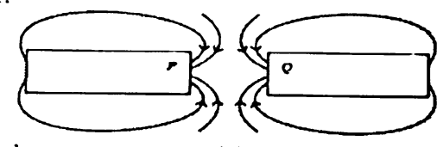
The magnetic poles represented by P and Q are
    - South (S) and South (S) B) North (N) respectively and South (S)
C) North (N) and North (N) D) South (S) and North (N)
  - Inside a solenoid, the magnetic lines of force are parallel straight lines. Therefore, the magnetic field inside the solenoid is
    - Very high B) Uniform
C) Zero D) Caused by electric current.
  - Which of these is not a characteristic of magnetic lines of force?
    - Magnetic lines of force are dense near the poles.
    - Magnetic lines of force are closed networks.
    - Magnetic lines of force intersect each other.
    - Magnetic lines of force are emitted at the north pole and merge at the south pole.
  - Assume that you are holding a straight conductor carrying current with your right thumb pointing upwards. Then the direction of the magnetic force lines of the magnetic field.
    - Downward. B) Upward. C) Anticlockwise. D) Clockwise.
  - The magnetic field inside a long straight solenoid carrying an electric current is
    - Downward and equal at all points B) Zero
C) Decreases as we move towards its end. D) Increases as we move towards its end.
  - In Fleming's left hand rule, the direction in which the middle finger points is
    - Magnetic field B) Electric current
C) Motion of a conductor D) Induced electric current
  - A rod carrying an electric current is placed between the poles of a horseshoe magnet. The angle between the direction of the current and the direction of the magnetic field for the maximum displacement of the rod is

{E}

{A}

{A}

{D}

{A}

{E}

{D}

    - 0° B) 45° C) 90° D) 180°
  - If the number of turns in a circular conductor carrying current is increased by 10 times, then the magnetic field produced increases by
    - 100 times B) 10 times C) 20 times D) 1000 times
  - When a magnetic needle is brought near a current-carrying wire, it is deflected. The direction of deflection of the needle depends on
    - Length of the conductor B) Amount of current in the conductor
C) Direction of current in the conductor D) Strength of the needle
  - If the density of magnetic lines of force is high, the strength of the magnetic field is
    - High B) Low C) Neutral D) None
  - In Fleming's left hand rule, the finger that represents the magnetic field is
    - Index finger B) Thumb C) Middle finger D) All
  - Safety method used to prevent damage caused by overload in domestic electrical appliances
    - Providing earthing system B) Installing electrical transformers
C) Use of fuses D) Installing electricity meter
  - Which of the following electrical appliances is not suitable for use in circuits that allow 5A current to flow.
    - Bulb B) Mixer C) Fan D) Geyser
  - In case of short circuit, the current in the circuit
    - becomes very low. B) remains neutral C) becomes very high. D) changes continuously
  - The part where the magnetic force is maximum in a bar magnet is
    - At the N end B) At the S end C) Between N and S D) At both ends
  - Which of the following correctly describes the magnetic field around a long straight wire?
    - The magnetic field consists of straight lines perpendicular to the wire.
    - The magnetic field consists of lines parallel to the wire.
    - The magnetic field consists of lines like rays emanating from the wire.
    - The wire is the centre of the concentric magnetic force lines of the magnetic field.
  - Which of the following conclusions does a student come to after observing the following picture
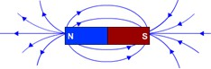
- Magnetic force lines are emitted at the north pole and merge at the south pole.
- The strength of the magnetic field is greater when the density of magnetic lines is greater.
- No two magnetic lines of force intersect each other
- All of the above are correct
  - The magnetic field around a current carrying circular loop can be increased by
- increasing the radius of the coil
- converting the coil into straight wire
- decreasing the radius of the coil
- reducing the amount of electric through the coil

Answer the following questions (One Mark)

{D}

{D}

{E}

{E}

{A}

{E}

{A}

{A}

{A}

{E}

{D}

- Why do magnetic lines of force not intersect each other? {A}
- State any 2 measures to avoid overload in a domestic electrical circuit. {A}
- What is the cause of overload in an electrical circuit? {A}
- What does the thumb indicate in the right-hand thumb rule? {E}
- Write the characteristics of the magnetic lines of force around a solenoid carrying current. {E}

- Observe the circuit diagram given below. State the direction of the magnetic field around the point P and around the point Q of the conducting wire.
{D}

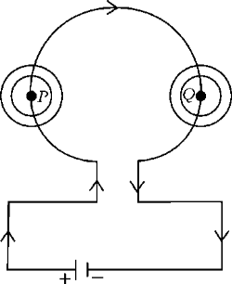

25. | What is a magnetic field? | {E}
26. | What are magnetic lines of force? | {E}
27. | When does a current-carrying conductor experience a greater force when placed in a large | {A}
 | magnetic field?
28. | Name some instruments using a current-carrying conductor and a magnetic field. | {E}
29. | Why does a compass needle move when brought near a bar magnet? | {A}
30. | Draw magnetic lines of force around a bar magnet. | {A}
31. | List two methods of producing a magnetic field. | {A}
32. | ‘The magnetic field is equal at every point inside the solenoid.’ Give reason. | {A}
III. | Answer the following questions (Two marks)
33. | What are the causes of overload and short circuit in an electrical circuit? | {A}
34. | State two properties of magnetic lines of force. | {E}
35. | What are the reasons for overload in an electrical circuit? | {E}
36. | Electrical appliances with a metal surface are connected to the earth wire. Why? | {D}
37. | Observe the figure and state the direction of the force acting on the current carrying wire AB. | {D}
 | Name the law that helped you to know the direction of the force.
38. | What is a solenoid? How can it be converted into an electromagnet? | {E}
39. | Observe the given picture and answer the questions given below. | {A}
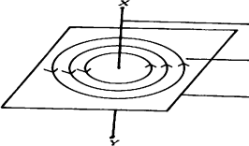
  - Mention the direction of the electric current flowing in the conductor.
  - State the rule that helps in determining the direction of the electric current.
- What are the methods of increasing the magnetic field in a solenoid? {E}

- Draw a diagram showing the magnetic lines of force around a straight conductor. Label the following.
  - Direction of magnetic lines of force B) Direction of electric current.
{A}

- List the magnetic lines of force and the characteristics of the magnetic field inside a solenoid. {E}

- A microwave oven with a current rating of 5A and a power of 2 KW is used in a domestic electrical circuit (220V). What effect would you expect?
- Write the rules used to determine the directions of the following.
  - Magnetic field around a current-carrying straight conductor.
  - Force experienced when a current-carrying straight conductor is placed perpendicular to the magnetic field.
- In the figure given below, are the poles marked as P and Q are the north pole or the south pole? Justify your answer.
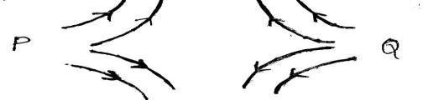
- A student who observes the magnetic field lines around a bar magnet as shown in the figure below states that the magnetic field at point A` is greater than that at point B. Is the student's statement correct? Justify your answer.
{D}

{A}

{D}

{D}

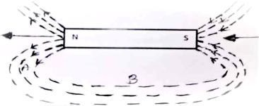

- One end of the bar magnet is brought near the south pole of a magnetic needle. Then this end of the magnetic needle deflects away from the end of the bar magnet. Name the pole of the bar magnet that has been directed towards the south pole of this magnetic needle. Give reason for your answer.

IV. Answer the following questions (Three Mark)
{A}

- How do you identify the magnetic field lines around a bar magnet using a compass? Explain. {A}

- a) Which factor helps in determining the relative strength of a magnetic field?
b) State the right-hand thumb rule. Write any two characteristics of magnetic force lines.

IV. Answer the following questions (Four Marks)
{E}

- Explain the function of the earth wire. {A}

- Explain an experiment to show that a conductor carrying an electric current experience a force when it is placed in a magnetic field.
{A}

Chapter-3: Metals and Non-metals

Learning points
- Physical properties-metals and nonmetals
- Chemical properties of metals.
- What happens when metals are burned in air
- What happens when metals react with water
- What happens when metals react with acids
- Metals react with solutions of other metallic salts
- Reactivity series
- How metals and nonmetals react
- Alloys and their units
- Availability of metals, metallization, enrichment of ores
- Corrosion and prevention

Weightage –Difficulty level:
Difficulty level | No. of questions | Marks | %
Easy (E) | 27 | 43 | 31
Average (A) | 30 | 67 | 48
Difficulty (D) | 18 | 29 | 21

- Multiple Choice Questions. (One-mark questions.)
  - Which of the following pairs causes a displacement reaction.
    - NaCl solution and copper metal B. MgCl2 solution and aluminum metal
C. FeSO4 solution and silver metal D. AgNO3 solution and copper metal.
  - Which of the following methods is suitable for preventing rusting of iron tava pan.?
A. Applying grease. B. Painting. C. Coating with zinc. D. All of the above.
  - Food cans are coated with tin and not with copper. Reasons are
    - Zinc is more expensive than tin
    - The melting point of zinc is higher than that of tin.
    - Zinc is more reactive than tin.
    - Zinc is less reactive than tin.
  - The gas released when metals react with acids.
A. H2 B. CO2 C. SO2 D. NO2
  - A green layer is formed when copper reacts with moist carbon dioxide in the air.
A. Copper carbonate B. Copper chloride C. Copper nitrate D. Copper oxide
  - Which of the following pairs causes a displacement reaction?
A. NaCl + Cu B. MgCl2 + Al C. FeSO4 + Ag D. AgNO3 + Cu
  - Observe the following equations and identify the correct statement.
CuSO4 + Fe → FeSO4 + Cu 2AgNO3 + Cu → Cu(NO3)2 + 2Ag
    - More reactive than iron and silver.
    - Iron is less reactive than copper and silver.
    - Copper is more reactive than silver but less reactive than iron.
    - Silver is more reactive than copper and iron.
  - The electron configuration of element X is 2, 8, 8, 1 and the electron configuration of element Y is 2, 8, 7. Then what is the type of bond formed between these elements?
A. Covalent bond B. Metallic bond C. Hydrogen bond D. Ionic bond

{D}

{E}

{D}

{E}

{E}

{D}

{D}

{A}

  - The correct order to write these metals in increasing order of reactivity is Al, Na, K, Ca, Mg.
    - Al<Mg <Ca< Na <K B. K < Mg <Ca< Na < Al
C. K < Na <Ca< Mg < Al D. Al < Na < Mg <Ca< K
  - A process used to convert metal sulfide ores into their oxides.
A. Calcination B. Roasting C. Reduction D. Electrolysis
  - Which metal displaces copper from copper sulphate solution
A. Mercury B. Gold C. Iron D. Silver
  - Observe the following chemical reactions
Fe + CuSO4 → FeSO4 + Cu Zn + FeSO4 → ZnSO4 + Fe
The order of decreasing reactivity of the metals in the above reactions is
A. Zn>Fe>Cu B. Fe>Cu>Zn C. Zn>Cu>Fe D. Cu>Fe>Zn
  - Observe the equations of the following chemical reactions:
Zn + FeSO4 → ZnSO4 + Fe
2Al + 3ZnSO4 → Al2(SO4)3 + 3Zn
The order of increasing reactivity of the metals in the above reactions is
A. Fe < Zn < Al B. Al < Zn < Fe C. Zn< Fe < Al D. Al < Fe < Zn
  - Aluminum, iron, magnesium and zinc metals reacted with concentrated hydrochloric acid. Write the reactivity of these metals in decreasing order.
A. Mg > Al > Zn > Fe B. Al > Mg > Fe > Zn C. Fe > Zn > Al > Mg D. Fe > Mg > Zn > Al
  - Which of the following chemical reactions is possible?
    - FeSO4 + Pb —---> PbSO4 + Fe B. ZnSO4 + Fe > FeSO4 + Zn
C. 2AgNO3 + Cu —---->Cu(NO3)2 + 2Ag D. PbCl2 + Cu > CuCl2 + Pb
  - The electron configurations of elements A, B and C are 2, 8, 2; 2, 8 and 2,8,7 respectively. Among these, the elements which react with each other to form an ionic compound are
A. Elements A and B B. Elements B and C C. Elements A and C D. Elements A and C
  - For iron to be hard and strong
- some carbon is added to pure iron
- nothing is added to pure iron
- ductility and malleability properties are given to pure iron
- pure iron is obtained by reduction.
  - The equations of displacement reactions involving the elements A, B, X and Y are given below. Analyze them. Among these elements the most reactive element is
- A + BSO4 → ASO4 + B
- X + ASO4 → X2(SO4)3 + A
- Y + X2(SO4)3 → YSO4 + X
(A) Y (B) A (C) X (D) B
  - When dilute hydrochloric acid is added to a compound ‘X’, gas ‘Y’ is released. This gas ‘Y’ is passed through lime water then a white precipitate forms. Here X and Y respectively are,
- Sodium carbonate, Hydrogen
- Sodium hydrogen carbonate, Oxygen
- Sodium carbonate, Carbon dioxide
- Sodium hydrogen carbonate, Chlorine

Answer the following questions: (One-mark questions).
{D}

{A}

{A}

{D}

{D}

{D}

{A}

{A}

{A}

{D}

{D}

- What are amphoteric oxides? {A}
- Name two metals that react with highly concentrated nitric acid. {A}
- Name the good conductors of heat and the poor conductors of heat. {E}
- Name the non-metal that conducts electricity. {E}
- What is ductility? {E}

- What are ionic compounds? {E}
- An iron ring needs to be plated with copper. How can this be done without using electricity? {D}
- What is thermite reaction? {E}
- Which metals do not corrode easily? {E}
- What is an alloy? {E}
- Name the metals that are found in the free state. {E}
- What is the chemical method used to obtain a metal from its oxide? {E}
- Ionic compounds have the highest melting points. Why? {D}
- What is roasting in metallurgy? {E}
- Ores of most metals are available in the form of oxides. {A}
- What are the applications of thermite reaction? {A}

III Answer the following questions: (Two marks questions)

- Which gas is released when concentrated hydrochloric acid is added to a reactive metal? Write the balanced chemical equation for the reaction of iron with concentrated H2SO4
- Write the balanced equation for the chemical reaction of aluminum oxide reacting with acid and base.
{E}

{E}

- Mention any 4 properties of ionic compounds. {E}

- Why does calcium metal do not ignite and burn even though it releases hydrogen gas when it reacts with water? Write its chemical equation.
- Name two metals that react quickly with cold water. Write the products formed when these metals react with cold water.
- Which physical properties of metals are used in the following situations? (April-2020)
  - Gold is used in making jewellery.
  - Nickel is used in guitar strings.
{A}

{E}

{A}

- List any four physical properties of metals. (March-2025) {E}
- State any 4 physical properties of non-metals. {E}

- Name the metals that match the following physical properties.
- It is liquid at room temperature.
- It can be easily cut with a knife.
- It is a good conductor of heat.
- It is a poor conductor of heat.
- Write chemical equations for the following reactions.
- Reaction of iron with steam
- Reaction of calcium with water
- Carbon cannot reduce oxides of metals like sodium, magnesium, aluminium etc. Why? Then how are these metals separated from their ores?
- Name two metals that displace hydrogen from concentrated acids and name two metals that do not displace hydrogen.
- In the electrolytic purification of metal 'M', which would you take as anode, cathode and electrolytic solution?
{E}

{E}

{D}

{A}

{A}

- Write the steps to be taken to prevent iron from rusting. {A}

- 250 ml of water is taken in beaker A and beaker B. 5 grams of sodium metal is added to beaker A and 5 grams of calcium metal is added to beaker B. What is the reason for the observations made here?
- i. When a metal reacts with concentrated nitric acid, hydrogen gas is not released. Give a reason.
ii. Write a balanced chemical equation for the reaction of aluminium with concentrated hydrochloric acid.
{A}

{E}

- What is galvanization? How does it help in preventing iron from rusting? {A}

- A metal reduces iron oxide. This reaction is used in the repair of broken railway tracks. Name the metal and the reaction used here. Write the equation of this reaction.
{A}

- What are alloys? Name the constituent elements in bronze and solder. {E}

- What are ores? Write the methods of converting sulphide ores of metals and carbonates into their oxides in order.
{E}

- State the difference between calcination and roasting. {A}
- State the method of reducing cinnabar. {E}

- Pieces of zinc, iron, magnesium and copper are taken in test tubes A, B, C and D respectively. The same amount of ferrous sulphate solution is added to these test tubes. In what quantities does the chemical reaction take place. Why? Write the chemical equations for the reaction taking place here.
- Observe the test tubes A, B & C in the pictures given below:
{D}

{D}

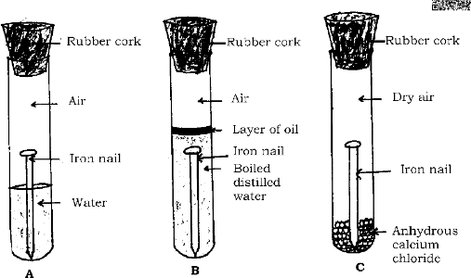
- Which iron nail in which test tube rusts? Why?
- The iron nails in the other two test tubes do not rust. Why?
- Write the chemical equations that show the reaction of aluminium oxide with acid and base. {A}

- Define the following.
- Malleability
- Sonorous

Answer the following questions (Three marks questions)
- Give a scientific reason for these.
- Ionic compounds are electrical insulators when in solid state and good conductors of electricity when in liquid state.
- Sodium/potassium metals are stored in kerosene.
- Although aluminium is a reactive metal, it is used in the manufacture of cooking utensils.
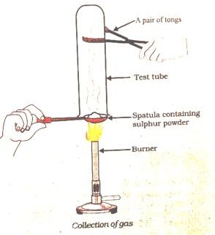
- A student took sulphur powder in a spoon used in the laboratory and stirred it. He inverted the test tube as shown in the figure and collected the gas released.

- How do the collected gases behave on these?
  - Dry litmus paper
  - Wet litmus paper
- Write the balanced chemical equation of the reaction taking place here.
{E}

{A}

{D}

- Draw a diagram showing the behaviour of steam on a metal and label the parts. {A}
- Draw a diagram showing the electrolysis of copper and label the parts {A}
- How are metals in the middle of the reactivity series treated with their alloys? Explain. {A}

- a) How do silver and copper objects lose their surface lustre?
- How does galvanization protect iron objects?
- Aluminum oxide is a double oxide. Why?

Answer the following questions: Four marks questions.
- A. Show the formation of Na2O and MgO by the transfer of electrons.
B. What are the ions present in these compounds?
{A}

{A}

- Pieces of four metals A, B, C and D are taken and placed one after the other in the following {D}

solution. The resulting solution is listed below.
Metals | Iron II Sulphate | Copper II sulfate | Zinc sulfate | Silver nitrate
A | No reaction | Displacement
B | Displacement | No reaction
C | No reaction | No reaction | No reaction | Displacement
D | No reaction | No reaction | No reaction | No reaction

Using the above table, answer the following questions related to metals A, B, C and D.
- Which is the most reactive metal?
- What will you observe if B is placed in a solution of copper II. sulphate.
- Write the metals A, B, C and D in the order of decreasing reactivity.
- a) Draw the electron dot structure of sodium, oxygen and magnesium.
- Explain the following:
  - Minerals
  - Iron
  - Mud
- In which cases can displacement reactions be observed when oxides of metals such as zinc, magnesium and copper are treated with the following metals?
Metals | Zinc | Magnesium | Copper
Zinc Oxide
Magnesium Oxide
Copper Oxide
- Give reason:
- Iron alloys are more useful than pure iron.
- Copper gradually loses its brown layer when exposed to air.
- Aluminium oxide is called amphoteric oxide.
- Hydrogen gas is not released when a metal reacts with concentrated nitric acid.

{A}

{D}

{E}

- Express the formation of magnesium chloride with the help of electron dot pattern. {A}

Answer the following questions: (Five marks questions)

- State the difference between calcination and roasting. How are these processes used in the extraction of zinc? Explain with the help of equations. Is reduction necessary to obtain zinc after these processes? Why?
- a) Explain the formation of ionic bond between sodium and chlorine atoms Sodium atomic number 11 Chlorine atomic number 17.
b) Write the properties of ionic compounds.
{A}

{A}

Chapter-4: Carbon and its compounds

Learning points
- Bonding in carbon-the covalent bond
- Versatile nature of carbon
- Saturated and unsaturated carbon compounds
- Chains, branches, and rings
- Functional groups
- Homologous series
- Nomenclature of carbon compounds
- Combustion
- Oxidation
- Addition reaction
- Substitution reaction
- Properties of ethanol
- Properties of ethanoic acid
- Soaps and detergents

Weightage –Difficulty level:
Difficulty level | No. of questions | Marks | %
Easy (E) | 16 | 26 | 24
Average (A) | 29 | 55 | 52
Difficulty (D) | 19 | 26 | 24

- Four alternatives are given for each of the following questions / incomplete statements. Choose the correct alternative and write the complete answer along with its letter of alphabet.
  - The number of valence electrons present in a carbon atom is
(A) 1 (B) 2 (C) 3 (D) 4
  - The diatomic molecule formed by the formation of double bond is
(A) chlorine (B) oxygen (C) nitrogen (D) ammonia
  - The major component of bio-gas is (MQP2020-21, MAIN EXAM2021, SUP EXAM202)
(A) propane (B) butane (C) methane (D) ethane
  - Carbon can form bonds with other atoms of carbon giving rise to large molecules. This unique property of carbon is (MQP2020-21,2024-25)
A. saponification B. catenation C. hydrogenation D. esterification
  - An unsaturated compound in which double bond is found between Carbon-Carbon atoms
A. methane B. ethane C. ethene D. ethyne
  - Functional group found in halo-alkanes
(A) -Cl or -Br (B) -OH (C)-CHO (D)-COOH
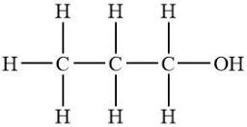
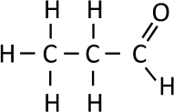
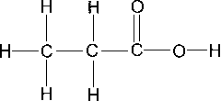
  - Structure of propanol is (MAIN EXAM 2021)

{E}

{E}

{E}

{E}

{A}

{A}

{D}

A) | B)
C) | D)

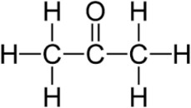
  - Name of this compound is {A}

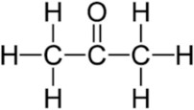

A. propanone B. propanol C. propanal D. propanoic acid
  - The number of single bonds and double bonds present in a structure of benzene molecule respectively (MQP2020-21, MAIN EXAM2021)
A. 6 and 6 B. 9 and 3 C. 7 and 5 D. 3 and 9
  - The number of single bonds present in the structure of a cyclohexane (MQP2020-2)
A. 12 B. 18 C. 24 D. 6
  - The number of carbon and hydrogen atoms that are present in the molecule of fifth member of

alkene is |  |  | ( MQP2024-25)
A. five and ten | B. five and twelve | C. six and twelve | D. six and six
  - The molecular formula of both cyclohexane and hexane (MQP2020-21, SUP EXAM2021) A C6H12 B C6H14 C. C6H10 D. C6H6
  - Difference between molecular formula of two successive compounds in homologous series A CH2 B CH4 C C2H2 D C2H4
  - The group of compounds which are in homologous series is (MQP2019-20, 2020-21)
(A) CH4, C2H4, C3H4 (B) CH3OH, C2H5CHO, C3H7COOH
(C) C2H2, C2H6, CH4 (D) C2H2, C3H4, C4H6
  - The correct group of saturated hydrocarbons (MQP2020-21, SUP EXAM2021)
    - methane, ethene, ethyne B. ethane, propane, butane
C. ethyne, ethane, methane D. ethyne, propene, butyne
  - General formula of alkyne is (MAIN EXAM 2021)
(A) CnH2n-2 (B) CnH2n+2 (C) CnH2n (D) CnH2n+1
  - The molecular formula of three carbon compounds which are in homologous series are C2H6, C3H8, C4H10. The suitable general formula for these compounds is (MAIN EXAM 2020)
(A) CnH2n (B) CnH2n-1 (C) CnH2n-2 (D) CnH2n+2
  - Organic compounds obtained by the reaction between carboxylic acid and alcohol (EXAM-1 2024)
A. aldehydes B. ketones C. esters D. halo-alkanes

Answer the following questions (1 Mark each)

{D}

{D}

{D}

{D}

{A}

{D}

{A}

{A}

{D}

{E}

- Write the electron dot structure of methane. (MQP2022-23, EXAM-1 2024, 2025) {A}

- Mention the number of single bonds and double bonds present in the structure of C2H5COOH molecule. (MQP2022-23)
{D}

- Write the structural formula of ethene molecule. (MAIN EXAM 2022) {E}
- Name the below given organic compounds (MQP2024-25) {E}
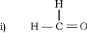
- Write the structural formula of the ketone having three carbon atoms. (MQP2024-25) {D}

- In a homologous series, if the first member of hydrocarbon group has the molecular formula of C2H4, then find the molecular formula of fifth member. (MQP2024-25)
- The first member of a group of carbon compounds is CH3Cl. Write the molecular formula and name of the third member of this group.
{D}

{D}

- Write the molecular and structural formula of benzene. (MQP2024-25) {E}
- Hydrocarbon compounds are usually used as fuels. Why? {A}
- Give reason why addition reaction is used in hydrogenation of vegetable oils? {A}
- Why is ethanoic acid known as glacial acetic acid? {A}
- The solution of 5-8% acetic acid in water is called as? {D}

- When ethanol reacts with sodium leads to evolution of gas. Name the gas and how will you test the presence of this gas?
{A}

- Name the compound which is produced when ethanoic acid reacts with base? {E}

- The molecular formulae of three carbon compounds that are in homologous series are C2H6, C3H8 and C4H10. Then write the general formula for this homologous series.
{A}

- Carbon forms covalent compounds only. Give reason. {A}

- An activity is conducted in the test tubes P and Q as shown in the below figures. Observe. In which test tube insoluble precipitate and in which test tube excessive foam will be formed? Determine.
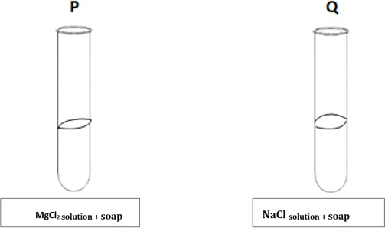

Answer the following questions (2 Marks each)
- Give reason:
  - The melting point and boiling point of covalent compounds are low
  - Covalent compounds are generally poor conductors of electricity
{D}

{A}

- Write the two important factors that can be observed in carbon? {E}

- Give reason:
  - As the molecular mass increases in homologous series a gradation in physical properties are seen.
  - Chemical properties determined solely by the functional group remain similar in homologous series.
- Write the electron dot structure of the following molecules: (MQP2024-25)
- Hydrogen ii. Ethane
- What are functional groups? Name the functional group present in propanal and propanol.
(MQP2024-25)
- What are functional groups? Write the structural formula of the compound obtained whenone atom of hydrogen in ‘ethane’ is replaced by −CHO group. (SUP EXAM-2017)
- In a specific group of unsaturated hydrocarbons, though the ratio of carbon and hydrogen atoms is 1:2, CH2 is not the first member of those hydrocarbons. What is the reason for this? Write the structural formula of the first member of that hydrocarbon group. (SUP EXAM-2017)
- The molecular formula of the first member of a certain group of organic compounds is CH2O (HCHO). Determine the name and the molecular formula of the third member of this group if the members of this group are in homologous series. What is the general name for this group of organic compounds? (MAIN EXAM-2018)
- CH4 + Cl2 → CH3Cl + HCl in the presence of sunlight
State whether this reaction is addition reaction or substitution reaction. Justify your answer
- What are alkynes? Name the first member of alkynes and write its molecular formula.
(SUP EXAM-2019)
- Complete the following reaction and give reason why this reaction is called saponification reaction. CH2COOC2H5 + NaOH → C2H5OH + X
- Observe the following chemical reactions. Answer the question. (MQP2024-25)

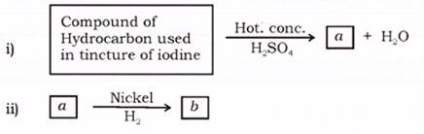
Name ‘a’ and ‘b’ products. Identify saturated and unsaturated product in ‘a’ and ‘b’.
{D}

{A}

{E}

{A}

{D}

{D}

{A}

{E}

{A}

{A}

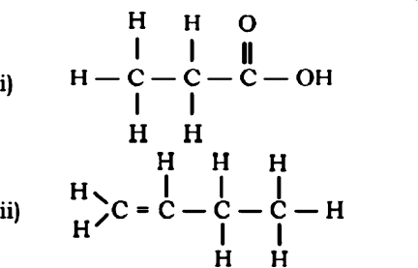
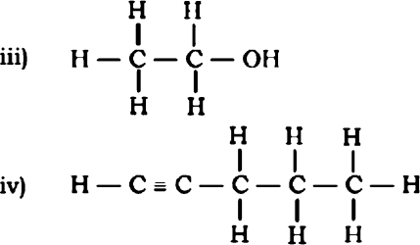
- Name the carbon compounds having the following structures. (MQP2023-24) {A}
- Write an activity to show the formation of ester. Explain how it can be detected? {A}

- Explain the reaction of ethanoic acid with sodium carbonate and sodium hydrogen carbonate using balanced chemical equations.
{D}

- What is esterification? Mention the uses of esters. (MQP2024-25) {E}

- Name the substance that do not undergo a chemical change that is used in the reaction of convertinga compound containing a carbon-carbon double bond into a compound containing only single bonds. Write an example for this reaction in the form of an equation.
- Write the molecular formula and structures of the following carbon compounds.
i) Chlorobutane ii) Propanol
- What is your observation in the following situations?
  - Ethene is subjected to addition reaction.
  - Methane is made to react with chlorine in the presence of UV rays.
{D}

{A}

{A}

- Carbon compounds are found in the larger number in the nature. Why? Clarify the reasons. {A}

Answer the following questions (3 Marks each)

- Generally large number of compounds are obtained due to interlinking of carbon atoms to each other in environment if so,
  - This property of carbon is called as?
  - Give reason why this property is seen to the extent in carbon atoms?
  - Name the arrangements of carbon atoms these compounds may have.
- a) What are saturated carbon compounds? (MQP2023-24)
- Define the following:
  - Homologous series
  - Esters
- a) What are micelles? (MQP2023-24)
b) What is covalent bond? Write any two properties of covalent compounds.
- a) What are substitution reactions? (MQP2024-25)
- Name the simplest hydrocarbon and write its molecular formula.
- What are oxidising agents?
- An experiment is performed using ethene and hydrogen in the presence of a palladium catalyst.
- Name the product formed in this reaction. Is this saturated or unsaturated compound? What type of reaction is this?
- When hydrogen atoms of the in product in this reaction or displaced by aldehyde functional group then name the carbon compound that forms and write its structure.

Answer the following questions (4 Marks each)
- a) The conversion of ethanol to ethanoic acid is an oxidation reaction. Why?
b) What are structural isomers? Write the structural isomers of butane.
(MQP2022-23, 2024-25, SUP EXAM2020, MAIN EXAM2021, 2022, EXAM-1 2025)
- a) Explain the mechanism of cleaning action of soaps. (MQP2024-25,SUP EXAM2019)
b) Which are the salts responsible for hardness of water? Detergents are effective even in hard water. Why?
{A}

{E}

{E}

{E}

{D}

{A}

{A}

- a) Carbon atoms do not form C4- anion and C4+ cation. Why? (MIAN EXAM2019, EXAM-1 2024) {A}

b) Write the electron dot structure of nitrogen molecule and ethene molecule.

Answer the following questions (5 Marks)
- a) Write any two differences between saturated and unsaturated carbon compounds.
(MQP2024-25, MAIN EXAM 2017, 2019, SUP EXAM2022, EXAM-3 2024, EXAM-1 2025)
- Write the molecular formula and structural formula for the following carbon compounds
  - propanoic acid ii. cyclohexane iii. pentane. (MQP2021-22, EXAM-3 2024)

{A}

Chapter-7: How do Organisms Reproduce?

Learning points
- Reproduction and the importance of Variation.
- Types of asexual reproduction: fission, budding, Fragmentation, Regeneration,
- Spore formation, vegetative reproduction.
- Sexual reproduction in flowering plants.
- Sexual reproduction in Male and female - Structure and function.
- What happens when egg is not fertilized?
- What happens when egg is fertilized?
- Reproductive health.
- Sexually transmitted diseases.
- Methods of contraception.

Weightage –Difficulty level:
Difficulty level | No. of questions | Marks | %
Easy {E} | 19 | 29 | 26
Average {A} | 30 | 61 | 56
Difficulty {D} | 11 | 20 | 18

- Multiple Choice Questions:
  - The group of organisms that reproduce through fission only is (June-2019)
    - Amoeba, Hydra, Spirogyra B. Leishmania, Amoeba, Yeast
C. Amoeba, Plasmodium, Planaria D. Plasmodium, Amoeba, Leishmania.
  - In the given figure of Cotyledon the parts labelled as A and B respectively are (April -2020)
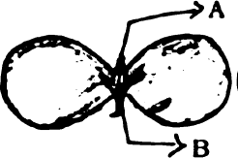
    - fruit, shoot B. primary shoot, primary root
C. secondary root, primary shoot D. bud, leaf.
  - The type of reproduction found in Spirogyra is (Sep-2020, April-2025)
    - Budding B. Fragmentation
C. Vegetative reproduction D. Spore formation.
  - The common passage for both sperms and urine in human male reproductive system is (Jul-2021)
A. Urethra B. Ureter C. Vas deferens D. Urinary bladder
  - The correct sequence found in the process of sexual reproduction in a flower is (Jul-2021)
    - pollination, fertilization, seed, embryo B. seed, embryo, fertilization, pollination
C. embryo, seed, pollination, fertilization D. pollination, fertilization, embryo, seed
  - In the human female reproductive system, the egg is carried from ovary to the uterus through this part (Sep-2021)
A. cervix B. fallopian tube C. placenta D. vagina
  - A common bacterial infection that spreads through sexual contact in human beings is (Sep-2021)
A. Gonorrhoea B. AIDS C. Hepatitis-B D. Warts
  - In humans, sexually transmitted viral infection is (April-2022)
A. AIDS B. Syphilis C. Tuberculosis D. Gonorrhoea

{A}

{A}

{E}

{E}

{A}

{E}

{E}

{E}

  - The parts that develop into fruit and seed in a flower respectively are (Sep-2021, Jun-2022) {E}

A. Stamen and ovary B. ovule and ovary C. ovary and ovule D. stamen and ovule
  - In humans, the testes are located outside the lower abdomen in the scrotum because (March-2023)
    - to protect testes from mechanical shocks
    - to increase the production of sperms
    - to maintain the secretion of testosterone hormone
    - to maintain the temperature required for sperm production.
  - Biological process that has been shown in the diagram is (June-2023)
    - production of progenies by fragmentation method
    - production of progenies by multiple fission method
    - regeneration of tissues by development in specialized cells D asexual reproduction by vegetative propagation.
  - The correct order of binary fission in Leishmania is
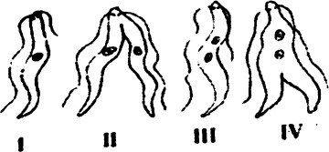
A. II, III, IV, B. I, III, IV, II C. IV, I, III, II D. III, I, II, IV
  - AIDS : Virus :: Warts : (March-2022)
A. Bacteria B. Fungus C. Protozoan D. Virus
  - Part of flower that develops into fruit and part of the seed that develops into root respectively are
(March-2019)
A. Ovary and Plumule B. Plumule and radicle C. Ovary and radicle D. Ovary and ovule
  - The process that occurs in the production of new individuals of planaria is (MQP-2024)
A. binary fission B. regeneration C. budding D. fragmentation
  - The embryo gets nutrition from the mother’s blood with the help of special part called (March-2021)
A. Fallopian tube B. Ovary C. Uterus D. Placenta
  - Observe the structures of the female reproductive system given in Figure-A and Figure-B.
The correct statement regarding these figures is (MQP-2025)

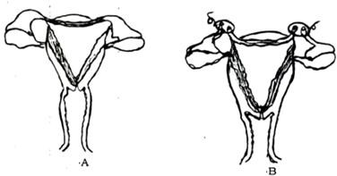

- Fertilization of the egg is possible in both the structures
- Fertilization of the egg is possible only in the structure shown in Figure-B
- Fertilization of the egg is possible only in the structure shown in Figure-A
D. Fertilization of the egg is not possible in both the structures
  - Asexual reproduction
- occurs in flowering plants
- occurs in all animals
- causes more variation
- causes less variation.
  - The process of producing new individuals in Rhizopus is
(A) Spore formation (B) Vegetative propagation
(C) Binary Fission (D) Regeneration
  - Observe the below given diagram. The type of tropic movement that helps the movement of C present on A towards B

{A}

{D}

{D}

{E}

{E}

{E}

{A}

{D}

{D}

{E}

{D}

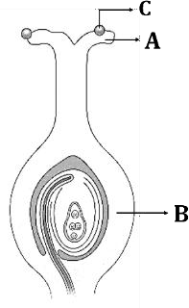
(a) Phototropism (b) Geotropism
(c) Chemotropism (d) Hydrotropism
- Answer the following questions. (One mark)
- Write two examples for the organisms that reproduce by binary fission. (March-2023) {E}
- Is self-pollination possible in flowers that have only stamens? Justify your answer. (S-2024) {A}
- What function do the testicles perform in humans? {A}
- Sexual reproduction causes more variation in organisms. Why? {D}
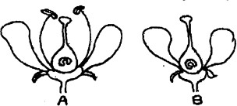
- Among the flowers A and B which flower undergoes self-pollination? (May-2025) {A}
- What is sexual reproduction? {E}
- Name any two viral infections that are transmitted through unprotected sexual contact. {E}
- If a woman uses Copper-T, will it help protect her from sexually transmitted diseases? {A}
- Sex determination at birth should not be done. Justify this statement. {D}

- In which of the following situations more variations are observed among the progenies of next generation? Clarify your answer.
  - When the mother amoeba cell produces the offsprings.
  - When plant generations are produced through pollination.
- Drumstick plants are grown from the seeds and the stems separately. Which of these plants show variations and why?
- A type of amoeba has 30 chromosomes. Human parent cells have 23 pairs of chromosomes. Then how many chromosomes are found in the amoeba daughter cells and in the gametes that produce in the human body?

Answer the following questions. (Two marks)
- Growth of thread-like structures along with the gradual spoilage of tomato can be observed when a cut tomato is kept aside for four days. Interpret the causes for this change. (April-2019)
{A}

{A}

{A}

{A}

- Why does menstruation occur? (June 2020) {A}

- How does the uterus prepare to receive a fertilized egg in women? What happens if the egg is not fertilized? Explain. (June-2022)
{A}

- How is the budding process in Hydra different from that of Bryophyllum? (June 2020) {A}
- How do germ cell receive half the amount of DNA ? What is the need of this process? {A}

- Draw the diagram showing the germination of pollen on stigma and label the parts.
(MQP-2019, June-2019)
{E}

- Explain the stages in which a fertilized egg develops into an embryo. (Sept-2020) {A}

- How can pregnancy be prevented using surgical methods of contraception in humans?
(June-2020, Sept-2020)
- Is surgical contraception a better method of contraception than Physical contraception?
(MQP -2024)
{E}

{A}

- How is pollination different from fertilization? Justify this statement. {A}
- It is a good practice to follow safe sexual contact. Justify this statement. {A}

Answer the following questions (Three marks)

- In sustaining reproductive fertility of a person, (June2019 )
- position of the testis in the body
- secretion of the testosterone
- secretion of the prostate gland are supplementary to each other. Explain scientifically.
{A}

- What is pollination? What are the changes that occur in the flower after pollination? (Mr-2023) {A}

- Justify the following statements: (April-2025)
  - Sexual type of reproduction leads to more variations.
  - In woman's uterus the role of placenta is significant for the development of foetus.
{D}

- How is the reproductive process different in Hydra and Planaria? Explain. {A}

- How does a fertilized egg in a female develop into an embryo in the uterus? How does this embryo get nourishment in the mother's womb? Explain. (Sept-2024)
- What are the advantages of sexual reproduction over asexual reproduction?
{A}

{D}

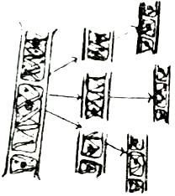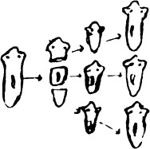
Spirogyra Planaria
Are the reproductive methods shown in the above two pictures similar or different? Write a justification for your answer. (MQP-2023)
- Distinguish between self and cross pollination. (June-2019) {E}
- What are the changes that occur in a flower after fertilization? (March-2023) {E}

- A student assumes that an organism reproduces through spores. How would another student evaluate whether this statement is true or false?
{D}

- What is DNA replication? How does the number of chromosomes rearrange in sexual reproduction? {E}

- What is the placenta? What is its function? In the human body, the testicles are located outside the abdomen in the scrotum. Why? (May-2025)
- Name the following parts of the human male reproductive system:
- The organ that produces sperms.
- The part that serves as a common passage for both sperms and urine.
- The glands that secrete fluids to nourish the sperms.
- Answer the following questions: (four marks)
- Explain the important function of each structure of the male reproductive system in humans.
(April-2020)
- “Reaching sexual maturity is a necessary event for mammals such as humans.” Justify this statement.
(June-2023)
{E}

{A}

{A}

{D}

- Explain the structure and function of the female reproductive system in humans. (SQP-2023) {A}

- In ‘Human Reproduction, the placenta plays an important role in the development of a foetus into a child.” Justify this statement. (March-2024)
{A}

- State the advantages of Vegetative reproduction. How it is favour for formers in agricultural field? {A}

Chapter-8: Heredity

Learning points
- Combination of differences during reproduction
- Heredity- Inherited traits
- Traits Laws of Inheritance- Mendel's contributions
- Sex determination

Weightage –Difficulty level:
Difficulty level | No. of questions | Marks | %
Easy (E) | 15 | 15 | 22
Average (A) | 17 | 33 | 48
Difficulty (D) | 12 | 21 | 30

- Multiple choice questions
  - He is called the father of modern genetics.
    - Mendeleev B) Gregor Mendel C) Lamarck D) Charles Darwin
  - The plant used by Mendel for his experiment
    - Rose B) Pea C) Hibiscus D) Sunflower
  - The ratio of tall and short plants obtained in Mendel's monohybrid experiment was
    - 2:1 B) 9:3:3:1 C) 3:1 D) 1:1
  - When a pure tall (TT) plant in pea plants is crossed with a pure short plant, what is the ratio of pure tall plants to pure short plants in the second generation?
    - 1:3 B) 3:1 C) 1:1 D) 2:1
  - The transfer of many traits from ancestors to their next generation is called
    - DNA replication B) Mutation C) Transposition D) Heredity
  - Factors that determine the sex of a male child
    - XX B) XY C) YY D) XXY
  - When a tall pea plant is crossed with a short pea plant, all the plants obtained from the seeds are tall. Because,
    - The trait for height is dominant B) The trait for height is dominant
C) The trait for height is recessive D) None of the above
  - In one of Mendel's experiments, dwarf plants with white flowers were taken along with tall plants with purple flowers. All the offspring obtained from these have purple flowers. But half are dwarf. The genetics of a tall plant are (MARCH 2023)
    - TTWW B) TTww C) TTww D) TtWw
  - A trait that is found in many generations of offspring is (MQP 4 2025)
    - Dominant trait B) Weak trait C) Acquired trait D) Intermediate trait
  - The source of information for the production of proteins in the cell is (MARCH 2025)
    - Gene B) Chromosome C) DNA D) Ribosome
  - Mendel used the following types of reproduction in his experiments to obtain second generation varieties
    - Self-pollination B) Cross-pollination C) Fragmentation D) Asexual reproduction
  - In which of the following generations did Mendel use cross-pollination
    - F₁ B) F2 C) F3 D) F4

{E}

{E}

{E}

{E}

{E}

{E}

{E}

{E}

{D}

{E}

{E}

{A}

  - A pure dominant pea plant producing round yellow seeds is crossed with a pure recessive pea plant producing wrinkled green seeds. The number of plants with round green seeds in the F1 generation of Mendel's experiment is (APRIL-2019)
    - 0 B) 1 C) 3 D) 9
  - When a round green pea plant (RRyy) is crossed with a wrinkled yellow pea plant, the seeds produced in the F generation are (rrYY) (MARCH 2021)
    - Round and green seeds B) wrinkled and yellow seeds
C) Round and yellow seeds D) wrinkled and green seeds
  - Pea plants with round seeds (RR) are crossed with a wrinkled pea plant (rr) F, Percentage of plants with RR trait in generation (MARCH 2024 A)
    - 25% B) 50% C) 30% D) 75%
  - The father has black eyes of the ‘BB’ genotype and the mother has brown eyes of the ‘bb’ genotype. The dominant colour of the eye in the F1 generation is
    - brown B) black C) green D) blue
  - A study found that children with light-coloured eyes are likely to have parents with light-coloured eyes. Because
- the gene responsible for light-coloured eyes is dominant
- the gene responsible for light-coloured eyes is weak
- the gene responsible for light-coloured eyes is present in all humans
- the gene responsible for light-coloured eyes is given in the form of medicines.
  - Organisms that reproduce sexually are more likely to survive in their environment because: in sexual reproduction these organisms,
- do not produce any variations.
- will have the maximum number of successful variations in the next generation.
- will have the same body structure in all generations.
- will not have any errors during DNA replication.

Answer the following questions (One-mark questions)
- Observe the table below showing different forms of pea plants (Jun-2019)
{D}

{D}

{D}

{A}

{D}

{D}

{A}

Seed colour | Flower position
Green (G) | Middle of stem (A)
Yellow (g) | Top of stem (a)
Write the indicator of the trait having green seeds and flowers at the top of the stem.
- What is the sex of a child born with the X chromosome from the father? (JUNE 2022) {E}
- Only the father is responsible for determining the sex of the child. Why? (MQP 4 2025) {A}
- What is the ratio of the expressed form of the plants obtained in monotypic crossing? {E}
- What is the ratio of the gene pattern of the plants obtained in monotypic crossing? {E}
- Is cross-pollination possible in flowers with only stamens? Justify your answer? {A}

- “In sexual reproduction, copies of offspring that are completely identical to the parent organism cannot be produced.” Justify. (MQP 3 2025)
{D}

- What is a gene? {E}
- Explain the meaning of heredity. {E}
- How is the sex of a male child determined in humans? {A}

Answer the following questions (Two marks questions)

- What is monohybrid cross? What is the ratio of plants obtained in the F2 generation of Mendel's dimorphism experiment?
- What is di hybrid cross? What is the ratio of plants obtained in the F2 generation of Mendel's dimorphism experiment? (APRIL 2022)
{A}

{A}

- According to Mendel, what are dominant and recessive traits? {A}

- A tall pea plant with red flowers (TTRR) is crossed with a short pea plant with white flowers (ttrr) From these (MQP-3 2025)
  - State the types of plants obtained in the F1 generation.
  - When the plants obtained in the F1 generation are crossed, write the ratio of plants obtained in the F2 generation and name the types of plants.
- Explain that differences due to sexual reproduction are more efficient than differences due to asexual reproduction.
{A}

{D}

- Write the differences between male sex chromosomes and female sex chromosomes. (Apr-2019) {A}

- Answer the given questions by observing the table below

F2 Generation / Gametes | B (black coloured dog) | b (white coloured dog)
B (black coloured dog) | BB | Bb
b (white coloured dog) | Bb | bb
  - What is the number of pure white dogs in the expressed ratio?
  - Name the types of dogs found in the gene pattern.

Answer the following questions (Three marks questions)
- A pure short pea plant (tt) is crossed with a pure tall pea plant (TT) Express the result obtained in the F2 generation of monocrossing on a checkerboard and state the ratio of the types of plants.
(APR-2022, JUNE-2022, MQP 1,4,2025)
- Plants producing round yellow seeds (RrYy) are self-pollinated Express the result obtained in the F2 generation of dicrossing with the help of a checkerboard State the types of plants obtained in the F2 generation. (APRIL A 2020, JUNE-2023 MQP- 2025)
- Mendel crossed plants with red flowers (TTRR) with plants with white flowers (ttrr) and produced offspring from them. The plants with red flowers obtained in the F1 generation were different from the plants with red flowers of the parent generation, why? Explain with reasons. (MQP 1 2025)
- Mendel crossed plants with red flowers (RR) with plants with white flowers (rr) and produced offspring from them. The plants with red flowers obtained in the F1 generation were different from the plants with red flowers of the parent generation, why? Explain with reasons.
(Sep-2020, MQP1 2025)
{A}

{A}

{D}

{A}

{A}

- Explain “Chromosomes inherited from the father determine the sex of a child” {A}

- How do Mendel’s experiments show that traits can be dominant or recessive?
(APRIL B 2020, AUG 2024)
- A pea plant with a dominant trait that produces round seeds is crossed with a pea plant with a recessive trait that produces dry seeds. Draw a checkerboard showing the results of the F generation and write the gene pattern ratio. (SEP 2020)
- When Mendel crossed tall plants with round seeds (TTRR) with short plants with flat seeds (ttrr) Express the types of plants obtained in the F2 generation with the help of a chalk board?
- When Mendel crossed tall plants with yellow seeds (TTYY) with short plants with flat seeds (ttyy) Express the types of plants obtained in the F2 generation with the help of a chalk board?
{D}

{A}

{D}

{D}

Chapter-9: Light – Reflection and Refraction

Learning points
- Reflection of light
- Spherical mirrors
- Reflection by spherical mirrors
- Representing reflections by spherical mirrors using diagrams
- Conventional symbols for reflection by spherical mirrors
- Reflection formula and magnification
- Refraction of light - Refraction by a rectangular glass slab
- Laws of refraction and refractive index
- Refraction by spherical lenses
- Formation of images by lenses
- Lens formula and magnification
- Power of lens

Weightage –Difficulty level:
Difficulty level | No. of questions | Marks | %
Easy (E) | 29 | 41 | 26
Average (A) | 42 | 83 | 52
Difficulty (D) | 26 | 36 | 22

- Four alternatives are given for each of the following questions or incomplete statements. Choose the correct alternative and write the complete answer along with its letter of alphabet.
  - In order to obtain an image smaller than the object in a concave mirror, the object should be placed. (F=principal confluence, C=centre of curvature, P=pole) (April-2019)
    - Between C and F B) Far from C C) Between P and F. D) At F2.
  - Identify the emergent ray in this image. (June-2019)
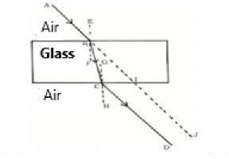
    - CD B) BC C) AB D) IJ
  - An object is placed in front of a concave mirror at the centre of curvature, what is the position and nature of the image formed? (April-2020)
(A) Between F and C and inverted (B) Behind the mirror and erect
(C) Between F and P and erect (D) At the centre of curvature and inverted
  - The convergence distance of a lens is +0.50m. Then the power and type of the lens are. (Apr- 2020)
(A) +2.0 D and a convex lens (B) +2.0 D and a concave lens
(C) -2.0 D and a concave lens (D) -2.0 D and a convex lens
  - The nature and size of the image formed when an object is placed between the principal focus F1 and the focal point O of a convex lens is (APRIL-2021)
(A) virtual, erect and large. (B) Real, inverted and small.
(C) Virtual, inverted and small. (D) Real, inverted and large.

{A}

{D}

{A}

{D}

{D}

  - Observe the table below. (APRIL 2021)

Material Medium | Refractive index
P | 1.52
Q | 1.44
R | 2.42
S | 1.33
In which material medium the velocity of light is high?
    - Q B) P C) S D) R
  - Which of the following is a property of a convex lens? (APRIL 2021)
(A) Diverged light rays (B) Thick at the edges and thin in the middle
(C) Produces a real and erect image (D) Thin at the edges and thick in the middle.
  - To obtain a small and real image of an object from a concave lens, the object should be placed
(MARCH 2022)
{A}

{E}

{A}

- At the principal focus F1
- Between the principal focus F1 and 2F1
- Beyond 2F1
- Between the principal focus F1 and the focal point O
  - Which of the following is the correct statement regarding your lens? (JUNE 2022)
(A) Converges light rays. (B) Diverges light rays.
(C) Produces inverted image (D) Produces real image
  - A mirror produces erect and enlarged image of an object. Then the type of that mirror and the nature of that image is (JUNE-2023)
(A) Concave mirror and virtual image (B) Convex mirror and real image
(C) Plane mirror and real image (D) Convex mirror and virtual image
  - If a ray of light enters a rarer medium from a denser medium, then the speed of that ray of light
(MARCH-2023)

{A}

{A}

{D}

    - Decreases and bends towards the normal
    - Increases and bends away from the normal
    - Decreases and bends away from the normal
    - Increases and bends towards the normal
  - Type of mirror used in the rear-view mirror of a vehicle is (AUGUST-2024)
(A) Plane mirror (B) Convex mirror
(C) Concave mirror (D) Plane Concave mirror
  - Convex mirrors are used in. (APRIL -2025)
    - Torches (B) Rear view mirrors of vehicles
C) Inspection lamps (D) Shaving mirrors
  - The reflecting surface of a spherical mirror is (MQP -1)
    - Centre of curvature B) Pole
C) Radius of curvature D) Aperture
  - Which of the following is the correct statement regarding a concave lens (JUNE 2022)
    - Converges light rays. B) Diverges light rays.
C) Produces an inverted image D) Produces a real image
  - The distance between the principal focus and the focal point of the lens is
    - Radius of curvature B) Focal length
C) Object distance D) Image distance
  - The image formed by the concave mirror is virtual, real and larger than an object. Then the position of the object is
    - At C B) Between C and F C) At F D) Between F and O

{E}

{E}

{E}

{A}

{A}

{D}

  - The relationship between the centre of curvature and the principal focus distance is {A}

    - R=2f B) R=1/2f C) f=2R D) f=2/3R
  - SI unit of power of the lens is
    - Meter B) Dioptre C) Ohm D) Centimetre
  - The power of the lens prescribed by the ophthalmologist for vision correction is +2D. Then the focal distance of that lens is
    - 2 m. B) 0.2m C) 0.50m D) 5m
  - The object distance and the image distance of an object placed in front of a lens are -60 cm and - 20 cm respectively. Then the magnification of the image is
    - -0.33 B) +3.0 C) +0.33 D) +4.0
  - The refractive index of some media is given. In which medium the speed of light is minimum and maximum respectively
K -1.62 | L -1.81 | M -1.94 | N- 2.43
    - K and N B) N and K C) N and L D) M and N
  - Which of the following is correct regarding the optical density of the transparent media in the figure below?
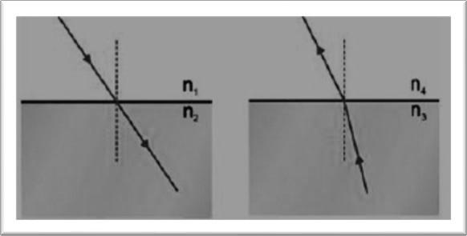
    - n1 = n2 & n3 > n4 B) n1 >n2 & n3 > n4
C) n1 = n2 & n3 < n4 D) n1 = n2 & n3 = n4
  - P The focal lengths of 4 convex lenses P, Q, R and S are 20 cm, 15 cm, 5 cm and 10 cm respectively. The lens with the highest power is
    - Q B) P C) R D) S
  - The position of an object that produces the image obtained at infinity in a convex lens is
    - Beyond 2F1 B) Between 2F1 and F1
C) At F1 D) Between F1 and O
  - In the process of refraction of light the angle between the incident ray and the perpendicular drawn to the point of incidence is 400 but the angle between the reflected ray and the mirror surface is
    - 400 B) 500 C) 600 D) 900
  - If a spherical mirror with a focal length of 30 cm is to be considered for an experiment, its aperture should be
    - 30 cm B) 40 cm C) 60 cm D) 25 cm
  - A student is standing in front of a plane mirror at a distance of 2 m. The distance between the student and his image is
    - 2 m. B) 3 m. C) 4 m. D) 6 m.
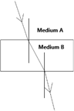
  - ​

The correct statement regarding the above image is
    - The speed of light is higher in medium A. B) The speed of light is higher in medium B
C) A is optically rarer medium D) B is optically denser medium

{E}

{A}

{A}

{D}

{D}

{D}

{D}

{D}

{D}

{D}

{E}

  - The image of the English letter L in a concave mirror looks like this. (September-2020) {A}
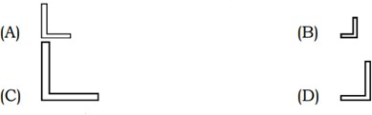

  - The magnification of the image formed by a mirror is 1.73 then the nature of this image is (MQP 3)
(A) Real and enlarged (B) Real and diminished
(C) Virtual and enlarged (D) virtual and diminished
  - The power of a lens is - 2.5 D. Then the focal length and type of the lens are. (SUP 2021)
(A) + 0.40 m and convex lens (B) – 0.40 m and convex lens
(C) + 0.40 m and concave lens (D) – 0.40 m and concave lens
  - Which of the following is a property of concave lens (SUP 2021)
(A) Converges light rays (B) Thick at the edges and thin in the middle
(C) Thin at the edges and thick in the middle. (D) produces a real and inverted image
  - The focal length of a lens is + 0:50 m Then the power and type of the lens is (MAR-2021)
(A) + 2.0 D and convex lens (B) + 2.0 D and concave lens
(C) - 2:0 D and concave lens (D) - 20 D and convex lens
  - To obtain a real image of the same size of an object from a convex lens an object is to be placed at the position of
(A) At F1 (B) At 2F1
(C) Between F1 and 2 F1 (D) Beyond 2F1

Answer the following questions. (1-mark questions)
{D}

{D}

{A}

{A}

{A}

- Why is a convex mirror generally used as a rear-view mirror of vehicles? (April-2019) {E}
- What is the centre of curvature of a spherical mirror? (June-2019) {E}

- Observe the given incomplete diagram and complete the diagram by drawing the rays of refraction and show the image formed. (September-2020)
{A}

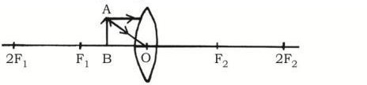
- Find the power of a convex lens with a focal length of + 0.5 m. (JUNE 2022) {A}
- Find the radius of curvature of a spherical mirror whose focal length is 25 cm. (MQP 2) {A}
- What is reflection of light? {E}
- What is lateral inversion? {E}
- What is spherical mirror? {E}
- Define the principal focus of a concave mirror. {E}
- Define the principal focus of a convex mirror. {E}
- What is an aperture of a spherical mirror? {E}
- What is Refractive index? Write the formula to find the focal length of a mirror. {E}

- When light passes through two different media having the same refractive index, it does not undergo refraction. Why?
- In the experiment on refraction of light from a rectangular glass slab, the incident ray and the emergent ray are parallel. Why?
- How does the position of the image change as an object is brought from an infinite distance to pole of a mirror in convex mirror?
{E}

{D}

{A}

- What is the principal focus of a convex lens? {E}

- What is the principal focus of a concave lens? {E}

- Same quantity of light is incident on two convex lenses A and B with focal lengths 10 cm and 30 cm respectively. The light becomes more convergent in which of these lenses? Justify your answer.
- The refractive indices of the media A and B are nA = 1.36 and nB =1.65 respectively. Then in which of the medium the speed of light is more? Justify your answer.

Answer the following questions. (2 marks questions)
{D}

{D}

- State the two laws of reflection of light. {E}

- The focal distance of a concave lens is 30 cm. How far should the object be placed from the lens so that the image is formed at a distance of 20 cm from the lens? Find the magnification produced by the lens. (April-2019/June 2019)
- An object is placed perpendicular to principal axis of a convex lens of focal length 40cm. If the distance of image is to be 80cm, then at what distance the object is to be placed from the lens?
- Draw the diagram of the image formed when an object is placed at the following positions of a convex lens.
  - Between F1 and 2F1 ii) When placed at 2F1 (June 2019)
- The object distance and image distance of a lens are -30cm and -10cm respectively. Find the magnification and determine the type of lens used and the nature of the image.
- An object is placed 25 cm in front of a mirror with a focal length of 15cm. How far should the screen be raised from the mirror to obtain a clear image?
- How far should the object be placed from the concave lens having focal length of 30cm, so that the image is formed at a distance of 10 cm from the lens. (March-2022)
- Light is entering benzene from air with refractive index of 1.50. Calculate the speed of light in benzene. (Speed of light in air: 3 x 108 m/s) (MARCH-2023)
- A concave lens of focal length 12cm. How far should the object be placed from the lens so that the image is 9cm away from the lens?
- Define the following with respect to a lens: i] Focal point ii) Aperture
{A}

{A}

{A}

{D}

{D}

{A}

{D}

{D}

{E}

- What is the refraction of light? State Snell's law of refraction. (JUNE-2022) {E}
- Write any two differences between a convex mirror and concave mirrors. (JUNE-2022) {A}
- What are spherical mirrors? Write its 2 types. {E}
- List the uses of concave mirror. {E}
- Write any two differences between a convex lens and a concave lens. {E}
- Write the difference between real and virtual images? {E}

- The refractive index of ice is 1.31 and the refractive index of water is 1.33. In which of the two media does light travel faster?
- State two rays that can be considered to determine the position of the reflection while drawing diagrams of reflections caused by spherical mirrors.
- Why does a pencil partially immersed in water appear to be displaced? What is the name of this phenomenon?
- Draw any two rays that can be considered while drawing diagrams of reflections caused by convex lenses.
{A}

{E}

{A}

{E}

- Write the nature of image formed by a plane mirror. {E}

- The ratio between the refractive indices of two transparent media P and Q is 1.82 and the speed of light in medium Q is 2.25×108 m./s. Then find out the speed of light in medium P.
(Speed of light in air C = 3×108 ms-1)
{D}

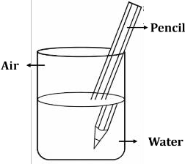
- {D}

Observe the above figure. Name the phenomenon responsible for the pencil to appear as shown in the figure at the interface of air and water. What is the cause for this phenomenon.
- Analyse the data in the table below and classify the given materials into conductors and insulators.

Materials | Resistivity (in Ωm)
L | 1010 -1014
M | 1.84×10 -8
N | 12.9×10 -8
O | 1013 -1016
- a) Which mirror is to be kept at the position X in the ray diagram given below?
b) Write the nature and the position of the image formed if the object BA is placed between C and F.
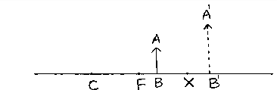

Answer the following questions. (Three marks questions)
- The magnification of the image formed by a spherical mirror is -1. If this mirror forms an image of an object at a distance of 50 cm.
  - What is the type of mirror?
  - At what distance is the object placed?
  - State the nature and size of the image.
- Draw a diagram of the image formed when an object is placed at the following positions of a convex lens.
  - At the principal focus F1. (JUNE-2019)
  - beyond 2F1 (JUNE-2023/MAR-2023)
- An object is placed on the principal axis in front of concave mirror with a focal distance of 12cm. If the object is 18cm away from the mirror, calculate the distance of the image formed and determine the nature of the image by finding the magnification caused by the mirror. APRIL 2020
- Draw a diagram of the image formed when an object is placed at the following positions of a convex lens. i) Between F1 and 2F1 (APRIL 2020)
- A doctor has prescribed a corrective lens of power -0.5 D to a person. Find the focal distance of the lens. Is it a converging lens? or a diverging lens? Give a reason. How is this property of the lens used in correcting eye defects? (APRIL 2020)
- a) Explain the laws of refraction of light. (SEP-2020)
b) In the given figure, AB is the incident ray, BC is the curved ray and MN is the perpendicular drawn at the point of incidence. Which medium is denser? Why?

{D}

{D}

{A}

{A}

{D}

{E}

{A}

{A}

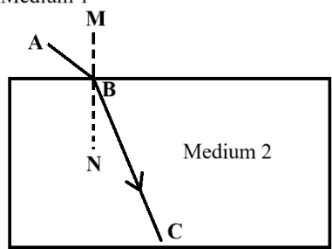
- Write any 3 new Cartesian symbols for spherical mirrors. {A}

- Draw a diagram of the image formed when an object is placed between C and F in front of concave mirror. Find out the position and nature of the image with the help of the diagram.
- Draw a diagram of the image formed when an object is placed at C in front of a concave mirror. Find out the position and nature of the image with the help of the diagram.
{A}

{A}

- Draw a diagram of the image formed when an object is placed beyond C in front of concave mirror. Find out the position and nature of the image with the help of the diagram.
- Draw a diagram of the image formed when an object is placed at F in front of concave mirror. Find out the position and nature of the image with the help of the diagram.
[ F: Principal confluence of the mirror; C: Centre of curvature of the mirror ]
- Draw a diagram of the image formed when an object is placed between F and P in front of concave mirror. Find out the position and nature of the image with the help of the diagram.
[ F: Principal confluence of the mirror; P is the polar of the mirror ]
- Draw the diagram and position nature of the image formed when an object is placed between F1 and O in front of a convex lens.
- If the magnification of the image formed by a convex mirror is 0.5 and the object is 15 cm away from the mirror, find the focal length of the convex mirror and write the nature and size of the image.
{A}

{A}

{A}

{A}

{A}

- Explain the activity of a convex lens converges parallel light rays. {A}
- Explain the activity of finding the approximate focal length of a concave mirror. {A}

Answer the following questions. (Questions of four marks)
- Explain the activity of refraction of light by a rectangular glass slab. {A}

- a) What is magnification? If the magnification of an image produced by a lens is +2 then, mention the type of this lens.
b) The refractive index of medium A is lesser than that of medium B. Then which medium is optically denser? In which medium is the speed of light more?
{A}

Chapter-10: Human Eye and Colourful World

Learning points
- Human Eye
- Accommodative Ability of the Eye
- Visual Defects and Their Solutions
- Refraction of Light through a Plate
- Refraction of Light through a Glass Plate
- Scattering of Light - Tyndall effect, why is the colour of a clear sky blue?

Weightage –Difficulty level:
Difficulty level | No. of questions | Marks | %
Easy (E) | 23 | 28 | 27
Average (A) | 28 | 49 | 47
Difficulty (D) | 13 | 28 | 26

I. | Four alternatives are given for each of the following questions/incomplete statements. Only
 | one of them is correct or most appropriate. Choose the correct alternative and write the
 | complete answer along with its letter of alphabet. (1 Marks)
1. | The area where the image is formed in the eye | {E}
 | A. cornea B. retina C. iris D. lens
2. | The part of the eye that forms an inverted real image of the object on the retina | {E}
 | A. eye lens B. pupil C. iris D. cornea
3. | The lens used to correct near sightedness: | {E}
 | A. biconvex lens B. plano-convex lens C. concave lens D. none of the above
4. | In old age, sometimes the eye lens becomes cloudy and whitish like milk. This condition is called | {E}
 | A. hypermetropia B. myopia C. presbyopia D. cataract
5. | A person can only see objects clearly that are between 40cm and 80cm from there eyes what is the | {A}
 | default
 | A. near-sightedness and use of concave lens
 | B. farsightedness and use of appropriate convex lens
 | C. presbyopia and use of appropriate bifocal lens
 | D. eye surgery
6. | Structure that controls change in focal length of the eye lens | {E}
 | A. Ciliary muscles B. Eyelid C. Retina D. Iris
7. | Why the sun is visible two minutes before actual sunrise and after actual sunset | {A}
 | A. Refraction of light B. Reflection of light
 | C. Scattering of light D. Dispersion of light
8. | Colour of the sky seen from the surface of the moon is (MP-2024) | {A}
 | A. Blue B. Red C. Black D. Violet
9. | Colour that bends the least in a glass prism: | {A}
 | A. Violet B. Blue C. Green D. Red
10. | The following change in the eye takes place while viewing distant object (April 2020) | {A}
 | A. Decrease in focal length of the eye lens B. Increase in curvature of the lens
 | C. Increase in focal length of the eye lens D. Relaxation of ciliary muscles
11. | The correct statement regarding scattering of light and particle size is (April 2024) | {A}
 | A. small particles scatter red light
 | B. Large particles scatter blue light

C. Large particles scatter violet light
D. Very large particles scatter all colours equally
- Nature of the image formed by the eye lens on the retina (MP – 2023)
  - Real and inverted B. Virtual and upright
C. Real and upright D. Virtual and inverted
- The colour that is least scattered by fog and smoke is
A. orange B. blue C. red D. violet
- Identify the wrong statement among the following statements regarding refraction and dispersion of light. (June- 2024)
  - Stars twinkle
  - sky appears blue to an astronaut flying at very high altitudes
  - the sun is visible to us about two minutes before the actual sunrise
  - planets do not twinkle
- In the following diagram, the angle of deviation is

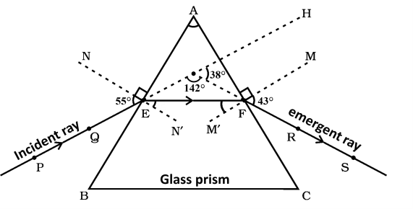
(A) 38^{೦} (B) 43^{೦} (C) 55^{೦} (D) 142^{೦}
- Below given image shows the dispersion of colours when white light is passed through a prism.
Here the colours represented by H and M are

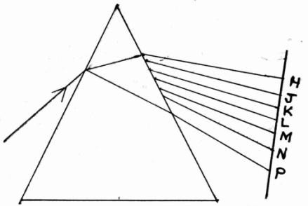
(A) Violet and Yellow (B) Red and Blue
(C) Indigo and Green (D) Yellow and orange

{A}

{E}

{A}

{D}

{A}

II. | Answer the following questions (One mark)
17. | What is the near point of the eye? State the value of near point of the normal eye. |  | {E}
18. | What is the far point of the eye? State the value for normal eye. |  | {E}
19. | What is the spectrum of white light? | April (2024) | {E}
20. | What are common defects of vision? |  | {E}
21. | What is the angle of deviation? |  | {E}
22. | What is the angle of prism? |  | {E}
23. | What is the emergent angle? |  | {E}
24. | Name eye part of the following: |  | {E}
 | a) It forms the transparent bulge on the front surface of the eyeball
 | b) It is a dark muscular diaphragm
25. | Identify the eye in the image and mention its remedy. |  | {A}
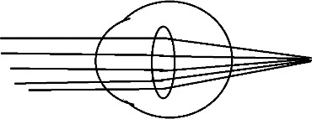
- What is dispersion of light? (SP-2023) {E}

- Can this phenomenon be observed on the moon? Justify your answer. {D}
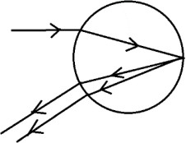
- What are the near point and far point of a person with normal vision? (June 2019, March 2024) {A}
- Name any two atmospheric phenomena caused by light refraction. (March 2019, 2024) {E}
- What is accommodation of the eye? (June 2019) {E}
- What colour is used in danger signals and why? {A}

- A student at the back bench struggle to read the blackboard. What is the defect and how can this defect be corrected? (June 2024)
{D}

- Identify the eye defect shown in the image and suggest a remedy? {A}
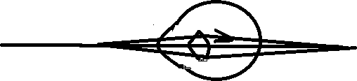
- What is the function of the pupil in the human eye? (June 2019) {A}

- Observe the below figure showing the refraction of light through a glass prism.
{D}

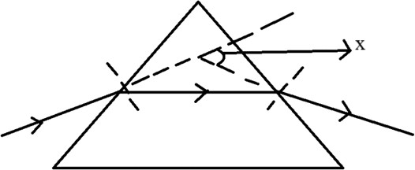
Name the angle represented as angle X and give reason for the formation of that angle.
- What is cataract? (March 2024) {E}

- After the light is split in a prism, state the colour of the light that is least bent and the colour of the light that is most bent. (March 2019, 2023, June 2019)
- Glass prisms A, B and C are arranged as shown in the figure below. When a beam of white light is passed through the prism A, will a spectrum of light be produced on the screen? Give the reason.
(May 2025)

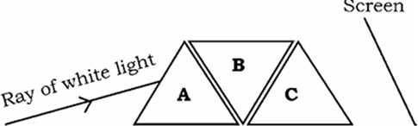

43 Explain the experiment that Newton did to determine that white light consists of seven colours.
39. | Define dispersion of light. |  | {E}
III. | Answer the following questions (Two mark)
40. | What is hypermetropia? What are its causes? | (June 2019) | {E}
41. | What is myopia? What are its causes? |  | {A}
42. | Explain the formation of a rainbow in nature | (March 2023, June2023) | {A}

(M-2020)
{E}

{D}

{A}

- Describe newton’s experiment to show the recombination of white light. (A-2025) {A}
- Write the differences between the myopic eye and hypermetropic eye. (April 2025) {E}

- Identify and justify the type of eye shown in the diagrams: normal, near-sightedness, farsightedness.
{A}

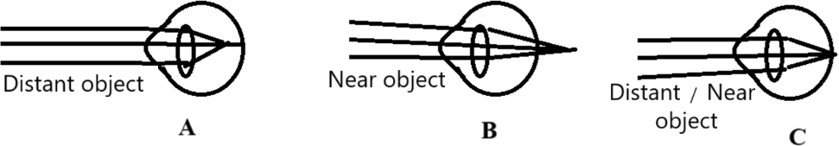

- A person with eye defect purchases spectacles with a lens power of -2.0 D. which lens is suitable for the given eye defect? Analyse. (A-2024)

- Explain how the human eye lens adjusts for viewing near and distant objects.
(March2023, June2023, August 2024)
{D}

{A}

- Observe the given figure. Identify the eye defect indicated in this figure. {A}
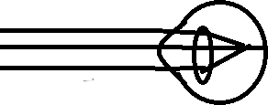
- At the time of sunrise and sunset the sky appears red. Why? {A}

Answer the following questions (Three mark)
- What is the Tyndall effect? Give two examples. (March 2019) {A}
- Why the clear sky is blue in colour? Explain {A}
- Draw the diagram to show the recombination of white light. (June-2024) {A}
- Why do stars twinkle but planets do not? Explain. (August 2024) {A}
- What is presbyopia? What are its causes? Mention the remedy {A}

- A doctor prescribes a lens with power -0.5 D. Find its focal length. Is it a converging and diverging lens? Justify. How does a concave lens correct near-sightedness (March 2020)
- a) Why can’t we see objects clearly closer than 25cm with normal eye?
b) Explain the relationship between the colour of light scattered in the atmosphere and the size of the scattering particles.
- 1) a) What is the reason for the whiteness of the sun’s rays on the scalp in the afternoon?
b) What is the working principle of the human eye?
  - Write the main function of each of the following
    - iris b) pupil c) cornea
- A short beam of white light PQ passes through a glass prism as shown in the figure.
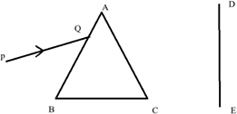

Redraw this and draw the resulting ray path that can be viewed on the DE screen.
  - Name the phenomenon seen here
  - Write the reasons.
- a) A student clearly reads letters in a textbook only after a distance of 50 cm from the eyes without difficulty. Then
- Identify this defect of the eye and mention its cause.
- Suggest a remedy for this defect.
    - When sunlight passes through the trees of a dense forest on a foggy morning then the path of the beam of light appears between the trees.
      - What is this phenomenon called?
{D}

{D}

{D}

{D}

{D}

      - This same phenomenon is not normally visible in air. Why? Write your analysis.
- a) The apparent position of an object seen through hot air above a flame fluctuates. Justify this statement.
b) When white light is passed through the given arrangement of three prisms (X, Y, and Z) as shown in the below figure, spectrum of light is seen on the screen. What is the role of prism Z here?
- a) Imagine when a mass of thorn ignited it is burning brightly. If a tree present on the other side of the fire is observed through the hot air on the fire, then the positions of the parts of that tree appear to be changed apparently. Why? Explain.
b) When green, yellow and red rays are incident at the same angle separately on a glass prism which of these rays forms greater angle of deviation? Why?

Answer the following questions (Four marks)
- a) Explain the phenomenon of formation of the rainbow in the atmosphere.
b) Why do stars twinkle? (May 2025)
- a) What is near-sightedness (myopia)? Mention the causes for this defect? How can this defect be corrected
b) What is power of accommodation of the eye? What are the changes that occur in the eye while seeing the distant objects? (May 2025)

{D}

{D}

{A}

{E}

Chapter-13: Our Environment

Learning points
- Ecosystem – what are its components
- Food chains and food webs
- How do our activities affect the environment
- Ozone layer and how it is getting depleted
- Waste management

Weightage –Difficulty level:
Difficulty level | No. of questions | Marks | %
Easy (E) | 9 | 15 | 20
Average (A) | 31 | 46 | 61
Difficulty (D) | 9 | 14 | 19

- Four alternatives are given for each of the following questions/incomplete statements. Only one of them is correct or most appropriate. Choose the correct alternative and write the complete answer along with its letter of alphabet. (1 Mark)
  - Observe the food chain given below: (SUP-2019) Grass → Grasshopper → Frog → Snake → Eagle.
If the energy available at first strophic level is 5000 J, then the amount of energy available for snake is
A. 500 J B.5 J C. 0·5 J D. 50 J.
  - The correct statement with respect to biodegradable substances among the following. These substances (MAIN- 2021)
    - undergo recycling naturally in the environment
    - harm various organisms in the ecosystem
    - increase the density of harmful chemicals in different tropic levels
    - remain inert in the environment for a long time
  - The materials that change slowly their form and structure in the environment are (SUP- 2021)
    - Plant fibres B. Peels of vegetables
C. Waste papers D. Used tea leaves
  - Atmospheric layer that absorbs ultraviolet radiations coming from the sunlight is made up of this molecule. (Main-2022)
A. N2 B. H2 C. O3 D. O2
  - Primary consumers in any food chain are always (SUP- 2022)
A. carnivores B. herbivores C. higher carnivores D. producers.
  - Producers of aquatic eco-system are (SUP-2023)
A. algae B. small fishes C. larvae D. protozoa.
  - The second trophic level of a food chain consists of (2025-MODEL-4)
    - Producers B. Herbivores
C. Secondary consumer D. Primary carnivores
  - Algae → Small insects → Large insects → Small fish → Large fish → Humans The arrangement of trophic levels in this food chain is
    - In the order of increasing energy availability.
    - In the order of increasing both energy availability and accumulation of harmful chemicals.
    - In the order of increasing accumulation of harmful chemicals.
    - In the order of decreasing both energy availability and accumulation of harmful chemicals.

{D}

{A}

{E}

{A}

{A}

{A}

{A}

{A}

  - Which of the following groups contain only biodegradable materials
    - Grass, flowers and leather B. Grass, wood and plastic
C. Fruit peel, cake and lemon juice. D. Cake, tree and grass
  - Which of the following can form a food chain
    - Grass, wheat and mango B. Grass, goat and human
C. Goat, cow and elephant D. Grass, fish and goat.
  - Which of the following are eco-friendly practices
    - Carrying cloth bags to store the items purchased while shopping.
    - Switching off unnecessary electric lights and fans.
    - Walking instead of taking your mother's two-wheeler to school.
    - All of the above.
  - The flow of energy in an ecosystem is unidirectional.
    - The number of predators is constant
    - The number of organisms is less
    - The available energy is used completely by predators
    - The loss of energy is more than the amount of energy available.
  - A correct statement related to non-biodegradable materials among the following is, they
- recycle naturally in the environment
- do not cause harm to the organisms of the ecosystem
- increase the concentration of harmful chemicals in various trophic levels
- do not persist in the environment for long time

Answer the following questions (One Mark Questions)
{A}

{A}

{D}

{A}

{A}

- Micro-organisms like bacteria are called decomposers. Why? (SUP-2019) {A}
- What is the role of decomposers in an ecosystem? (Main -2022) {A}
- Nowadays Chlorofluorocarbon (CFC) free refrigerators are being manufactured. Why? (SUP-2022) {D}
- What is ‘biological magnification’? (SUP-2022, 2023) {E}

- “Though ozone is a deadly poison, it is essential for life on the earth.” Justify this statement.
(2024-EXAM-1)
- “The number of organisms decreases by reaching higher trophic level of a food chain in an ecosystem.” Why? (2024-EXAM-1)
{E}

{A}

- What is a food chain? {E}
- State the 10% law? {D}
- The use of CFCs in refrigeration units is mandatory banned. Why? (2024-EXAM-2) {A}

- Grass → Frog → Snake; If the amount of energy in the first trophic level of this food chain is about 100 J, find the amount of the energy of the organism at the third trophic level.
- Students buried some banana peels and a plastic pen in a pit. When they opened the pit after a few months, they found only the plastic pen unchanged. Why?
{A}

{A}

- In a food chain with four trophic levels which level shows the highest biomagnification? {A}

- Name the following:
  - The component of the ecosystem that captures the energy of the sun.
  - The chemical that causes depletion of ozone.

Answer the following questions (Two Mark Questions)
- A food chain in a polluted aquatic ecosystem is given. Observe and answer the following questions. Fresh water → Algae → Fishes → Birds. (MAIN-2019)
- Which organisms are disturbed more due to biomagnification? Why?
- This ecosystem will be destroyed gradually due to biomagnification. Why?
- A student places a piece of cucumber, a glass piece, a banana peel and a plastic pen in a pit and closes it. What changes can be observed in these materials after a month? Give scientific reason for these changes. (Main-2019)
{A}

{A}

{D}

- “As energy moves progressively through various trophic levels of food chain it is no longer available to the previous level.” Give reasons.
{D}

- Mention any two effects of non-biodegradable substances on the environment. (SUP- 2022) {E}
- Mention any two methods that reduce the problems caused while disposing the wastes. {E}

- Give an example for a food chain of grassland ecosystem. If there is an increase in the number of organisms in the second trophic level, how does this affect on that food chain? (Main - 2023)
- In an aquatic eco-system the organisms such as fishes, chain using these organisms. If 10 calories of energy is available to the tertiary consumers in this food chain, what amount of energy was produced in the first trophic level? (2024-exam-2)
- Observe the given food chain and answer the following questions: (2024-exam-3) Green plants → Deer → Tiger
T1 T2 T3
- What is the amount of energy do green plants have ifthe energy available to the tiger is 700 kJ?
- The organism of which trophic level has the maximum accumulation of harmful chemicals? Why?
- Construct a food chain using the organisms; snake, frog, grass and grasshopper. Which organism has more accumulation of harmful chemicals in this food chain? (2025-exam-1)
{A}

{A}

{A}

{A}

- Use of non-biodegradable substances should be minimised. Why? (2025-model-1) {D}
- How is ozone layer formed? Protection of ozone layer is necessary. Why? (2025-Model-1) {E}
- State the impact of biodegradable substances on the environment. {A}
- Food chains usually consist of only three or four levels. Why? {D}

- What will happen if we kill all the organisms in a trophic level? OR
Will the effect of removing all the organisms in a trophic level be different in different trophic levels?
- If all the wastes we produce were biodegradable, would it not have any impact on the environment?
- Why is the damage to the ozone layer a cause for concern? What steps are being taken to limits this damage?
{A}

{D}

{A}

- How can you help reduce waste disposal? Mention any two ways. {E}
- What is an ecosystem? What are its components? {A}
- Why does a interconnection between food chain occur in an ecosystem? {A}
- How does energy flow in a food chain? {A}

Answer the following questions (Three marks questions)

- Give reason: (Sup-2020)
- Food chains generally consist of only three or four steps.
- Decomposers play an important role in an ecosystem.
- Protecting of ozone layer is necessary.
{A}

- What is trophic level? Flow of energy in an ecosystem is always unidirectional. Why? Explain. {E}
- Differentiate between biodegradable and non-biodegradable materials. {A}

Model Key Answer
Chapter -1: Chemical Reactions and Equations

Multiple Choice Questions.
  - C. Rusting of iron
  - C. Change in Shape
  - C. Displacement reaction
  - A. BaCl2 and Na2SO4
  - C. Endothermic reaction
  - A. Double displacement reaction
  - B. H2 + CuO
  - A. Silver chloride decomposes to form silver.
  - C. Hydrogen: Oxygen:: 2 : 1
  - B. Exothermic reaction
  - B. Hydrogen
  - C. 2AgNO3 + Cu Cu NO3.2 + Ag
  - A. Hydrogen gas and iron chloride are formed
  - D. Iron
  - B. Loses water molecules
  - B. To prevent chips from getting oxidized.
  - B) displacement and redox reaction.
  - A) MnO₂ and HCl
  - B) 2, 2, 4, 1

Answer the followings. One mark questions.
- A process that involves the rearrangement of atoms and molecules to form a new substance with different properties.
- Chemical equation is a symbolic representation of a chemical reactions using chemical formulas and symbols.
- To remove Oxide layer deposited on Magnesium ribbon.
- To justify the law of conservation of mass OR
The total mass of reactants must be equal to the total mass of products
- Because in both the processes, the heat is liberated. Hence, they are exothermic reactions
- The reaction in which insoluble substance product. is produced is called the Precipitation reaction. Na2SO4 +BaCl2 → BaSO4 + 2NaCl
- When a metal is attacked by substances around it such as moisture, air, acid, etc this phenomenon is called corrosion OR Corrosion is the gradual deterioration of metals Caused by action of air, moisture or acid.
- To prevent rancidity / to prevent chips from getting oxidized.
- To prevent rusting of Iron.
- Undesirable change in the smell and taste of food containing oil and fats due to oxidation is called rancidity. OR
The process by which oil and fat items oxidize and change their smell and taste.
- Using antioxidants like nitrogen
Keeping the food in airtight containers.
- ZnO is reduced C is Oxidized
- SO42- and Ba2+ ions.
- Calcium hydroxide / Ca(OH)2
- Combination reaction /Oxidation reaction.
- Due to the release of nitrogen oxide gas

Answer the following questions. Two Mark Questions.
- i. Change of state
  - Change of colour

  - Evolution of gas
  - Change in temperature
- A chemical reaction in which two or more reactants react to give a single product. 2Mg + O2 2MgO
- A reaction in which single reactant breaks down to give two or more products is called decomposition reaction
CaCO3 CaO+CO2
- A reaction in which a more reactive element displaces a less reactive element from its compound. CuSO4 + Fe FeSO4 +Cu
- Iron displaces Copper from copper sulphate. CuSO4 + Fe FeSO4 +Cu 1
- No. Because
Iron is more reactive then Copper OR Copper is less reactive than iron.
- A reaction in which the reactants exchange their ions mutually to produce New compounds/ A chemical reaction that occurs when reactants exchange their ions with each other.
Na2SO4 + BaCl2 BaSO4 + 2NaCl
- Yellow precipitate.
Lead iodide. /PbI2
Double displacement.
- Nitrogen dioxide
2Pb NO3.2 2PbO + 4NO2+ O2
- Endothermic reaction: A chemical reaction that releases heat. CaCO3 CaO + CO2
Exothermic reaction: A chemical reaction that absorbs heat. CH4 + 2O2 CO2 + 2H2O + heat
- CaCO3 CaO + CO2
Thermal decomposition reaction.
- A chemical reaction in which oxidation and reduction reactions take place simultaneously. ZnO + C Zn +CO.
C is oxidized. ZnO is reduced.
- Sodium sulphate and barium chloride exchange their ions with each other. Na2SO4 + BaCl2 BaSO4 + 2NaCl
- Decomposition reaction
CaCO3 CaO + CO2
- The process by which metals are attacked by their surroundings such as moisture, acids etc.
  - Painting
  - Greasing
  - Oil-coating
  - Anodizing
  - Galvanization
  - Making alloys

- i. X element –Copper
ii. Copper oxide/ CuO
- Fe
Because the reactivity of iron (Fe) is higher than that of silver (Ag). FeSO4

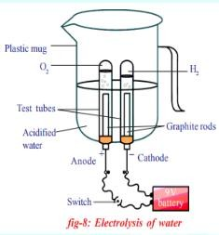
- ​

- (i) MnO2 + 4HCl → MnCl2 + Cl2 + 2H2O
(ii) Ca(OH)2 + CO2 → CaCO3 + H2O
- (i) N2 + 3H2 → 2NH3
(ii) Na₂O + H₂O → 2NaOH

Answer the following questions. Three marks questions.
- i. Barium sulphate /BaSO4
- SO42- and Ba2+
- Double displacement reaction.
- The chemical reactions occur in test tubes A and C.
Because iron (Fe) is less reactive than zinc (Zn) and magnesium (Mg) / magnesium and zinc are found above the reactivity series.
Zn + FeSO4 ZnSO4 + Fe
Mg + FeSO4 MgSO4 + Fe
- a. Chemical reaction that takes place using heat.
calcium carbonate on heating gives calcium oxide and carbon dioxide.
CaCO3 CaO + CO2
- Chemical reaction that takes place using light. Silver chloride is split into silver and chlorine. 2AgCl 2 Ag + Cl2
- Chemical reaction that takes place using electricity. 2H2 + O2 2H2O.
- Silver chloride. Silver bromide.
- 2AgCl 2Ag + Cl2
- 2AgBr 2Ag + Br2
- i. Z is calcium oxide.
- Molecular formula CaO
- CaO + H2O Ca(OH)2
- Displacement reaction
Iron nail reacts with copper sulphate blue colour to displace copper. CuSO4 + Fe FeSO4 +Cu
- ​
Double displacement
The reactants exchange their ions with each other. 3BaCl2 + Al2 SO4. BaSO4 + 2AlCl3.
- ​
- CaCO3 CaO+CO2
- H2 + 2Cl 2HCl
- Mg + 2HCl MgCl2 + H2
- ​
Balance the following chemical equations.
- 2H2 + O2 2H2O
- Na2CO3+ 2HCl 2NaCl + H2O + CO2
- N2+ 3H2 2NH3
- ​
- CaO + H2O Ca OH.2
- CuSO4 + Zn ZnSO4 + Cu

- NaCl + AgNO3 NaNO3 + AgCl
- ​
- 2H2S + 3O2 SO2 + 2H2O
ii.3BaCl2 + Al2 SO4.3 3BaSO4 + 2AlCl3
iii.2K + 2H2O 2KOH + H2
- ​
- CH4 + 2O2 2H2O +CO2
- 2K + 2H2O 2KOH + H2
- CuSO4 + Fe FeSO4 +Cu
- Oxidation: addition of oxygen 2Cu + O2 2CuO
Reduction: Removal of Oxygen 2MgO 2Mg + O2
- (i) 4Na + O2 → 2Na2O
- Mg + 2HCl → MgCl2 + H2
- 4Al + 3O2 → 2Al2O3

Answer the following questions. Four Mark Questions.
- i. Pb (NO3)2 + 2KI PbI2 + 2KNO3
- PbI2/ Lead iodide.
- Yellow
- Double displacement reaction.
- i. 2H2 + O2 2H2O
- ZnSO4 + Cu CuSO4 + Zn
- ZnCO3 ZnO + CO2
- NaCl + AgNO3 NaNO3 + AgCl
- a. i. CaCO3 CaO+CO2
ii. CH4 + 2O2 2H2O +CO2
b i. Copper objects react with air in the atmosphere to form
Copper oxide CuO. OR Copper carbonate CaCO3. OR Copper is oxidized OR Copper undergoes corrosion
ii. A displacement reaction has taken place OR
Iron displaces copper from copper sulphate solution

CHAPTER-2: ACIDS, BASES AND SALTS MODEL KEY ANSWERS

Multiple choice questions:
  - (C) 2 NaOH + H2SO4 → Na2SO4 + 2H2O
  - (C) basic property increases and number of OH− ions increases
  - (A) Aluminium Oxide
  - (A) Carbon dioxide
  - (D) Gastric juice
  - (A) Methanoic acid
  - (A) Sodium carbonate
  - (A) 0-7
  - (D) reduces acidity
  - (C) Hydrogen
  - (C) Metal oxide & hydrogen gas
  - (B) Ca(OH)2
  - (C) Copper hydroxide
  - (A) Exothermic and may explode.
  - (D) Strong acid and weak base
  - (C) If M is a non-metallic oxide solution, the blue litmus turns red

- Answer the following questions. (1 Mark)
- The reaction between an acid and a base to produce salt and water is called neutralization
- Plaster of Paris reacts with moisture and becomes hard.
- Metallic oxides that show both acidic and basic behaviour are called amphoteric oxides
- No. It gives foam in both soft and hard waters.
- Acidic — H+ / H3O+ / Hydrogen / Hydronium
- i) In glass, soap and paper industries.
ii) In the manufacture of sodium compounds such as borax.
- It is a basic salt.
because sodium hydroxide is a strong base.
- By adding the acid slowly to the water with constant stirring.
- Blue litmus paper turns red when dipped in acid./ Red litmus paper does not change colour when dipped in acid.
- A solution with a pH value ranging from 0 to 7 is called an acid.
- 2NaOH + Zn → Na2ZnO2 + H2
- Calcium carbonate (CaCO3)
- Carbon dioxide
- A metal oxide is called a primary oxide because it reacts with an acid like a primary acid to form a salt and water.
- Non-metal oxides react with an acid like an acid to form a salt and water.
- Have hydroxide ions
- Hydronium ion (H+)
- The basicity of the solution increases. Or the pH value increases.
- Less than 5.5.
- Calciumoxychloride
- Ca(OH)2 + Cl → CaOCl2 + H2O
- Baking powder is an edible mixture of baking soda and tartaric acid.
- NaHCO3 - Sodium hydrogen carbonate
- NaHCO3 - Sodium hydrogen carbonate
- Because baking soda reacts with water to produce carbon dioxide gas
- The concentration and the strength of OH⁻ ions in that solution decreases.

P: H₂

Q: CO₂

Answer the following questions. (Two-marks questions)
- If water is added to concentrated acid the heat generated may cause the mixture to splash out and cause burns.
The glass container may also break due to excessive local heating.
(ii) Otherwise, it reacts with moisture and changes to gypsum which is a solid mass.
- ​
- Plants require a specific pH range for their healthy growth.
- Soil of his land is acidic.
- Lime powder is a base.
- So, adding lime powder to the soil, decreases the acidic property / soil is neutralized.
- The solution A is acidic because the more concentration of hydrogen ions.
- Properties of Acids
- Acids have a sour taste
- Turns blue litmus paper red
- Have hydrogen ions
- Acids are good conductors of electricity
- Properties of Bases
- Bases have a bitter taste
- Turns red litmus paper to blue
- Have hydroxide ions,
- These are insulators
- First dip the litmus paper one by one in a test tube and take it out and wash it in neutral water before dipping it in another test tube.
- If the colour does not change, then distilled water is neutral
- If the red litmus turns blue, then it is a base
- If the blue litmus paper turns red, then it is an acid)
- HCl, HNO3 etc. produce hydrogen ions in aqueous solution Compounds like alcohol and glucose contain hydrogen, so they do not produce hydrogen ions, so they do not exhibit acidic properties.
- In solution, electric current is carried by ions. Rainwater contains dissolved salts which dissociate into ions and carry electric current, but in distilled water, no electric current flows as ions are not formed.
- As milk curdles, its pH decreases because as milk curdles, the lactose in the milk is converted to lactic acid. Acids have a low pH.
- To increase the shelf life of milk, the pH of fresh milk is changed to alkaline. Since milk is slightly more alkaline, it takes longer.
- NaCl + H2O → NaOH + H2 + Cl2
NaCl + NH3 + H2O + CO2 → NaHCO3 + NH4Cl
- When a bee stings, it releases methanoic acid. Baking soda is a mild base. Baking soda reacts with the methanoic acid to form salt and water, which reduces inflammation.
- i) P: Sodium chloride solution Q: Hydrogen
R: Chlorine
ii) used as a fuel, margarine, ammonia for fertilizers
- a) D
b) Concentration of ions decreases.
- Calcium hydrogen carbonate is formed and dissolved in water.
- Concentration of H+ ions decreases in the solution. pH value increases.

Answer the following questions. (3 Marks)

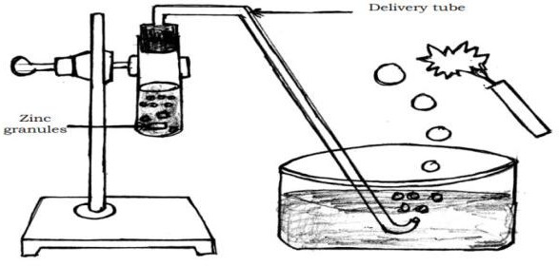
- ​
- Carbon dioxide or CO2
Ca(OH)2 + CO2 → CaCO3 + H2O
White precipitate
- Sodium hydroxide / NaOH.
(i) De-greasing metals (ii) Soaps and detergents (iii) Paper making (iv) Artificial fibres.
- Acid that gives rise to more H+ ions is said to be strong acid.
Bacteria present in the mouth produce acids by degradation of sugar and food particles remaining in the mouth after eating. So, the pH in the mouth decreases and the tooth enamel gets corroded.
Using toothpastes which are generally basic, for cleaning the teeth.
- a) Bleaching powder: CaOCl2 Uses
- for bleaching cotton and linen in the textile industry,
- for bleaching wood pulp in paper factories and for bleaching washed clothes in laundry.
- as an oxidizing agent in many chemical industries
- to make drinking water free from germs.
b) CaSO4. ½H2O
Uses
- for making toys
- making materials for decoration
- for making surfaces smooth.
- a) Reaction between acids and bases to form salt and water is called neutralization reaction. Base + Acid → Salt + water.
Ex: NaOH + HCl → NaCl + H 2 O.
[Consider any suitable example]
- Calcium sulphate hemihydrate or Plaster of Paris.
- An acid that contains more water and less acid is called a concentrated acid. Acids that produce fewer H+ ions are also called weak acids.
Be careful when adding acid to water. Always add acid slowly to water with constant stirring.
- a. sodium hydroxide
b. bleaching powder
c. plaster of paris
- a) Acidic solutions- e h
Basic solutions –h g
b) Milk of magnesia / Magnesium hydroxide / Mg (OH) 2

- No colour change is observed in the litmus papers dipped in the brine solution. Because it is a neutral solution. Red litmus paper dipped in aqueous product obtained by electrolysis of brine solution turns to blue colour. Because it is a basic solution
- i) Solution ‘P’ can be used to prepare an antacid. Because it is a mild base.
ii) Solution ‘Q’ and ‘S’ can be used to get a neutral salt. Because ‘Q’ is a strong base and ‘S’ is a strong acid
- i) Curd: Lactic acid
ii) Gastric juice: Hydrochloric acid (HCl)
73: i) Solution ‘A’ has more H + ions concentration.
Reason: If pH value is less, then H+ concentration is more. Solution ‘D’ has more OH− ions concentration.

Reason: As the pH value increases from 7 to 14, there is an increase in OH− ions concentration.
ii) Solutions ‘A’ and ‘D’. Solutions ‘B’ and ‘C
- (i) B
(ii) C
(iii) D

Four marks questions.
- (i) The reaction between an acid and a base to give salt and water is known as a neutralization reaction.
  - The products of chlor-alkali process are:
    - hydrogen
    - chlorine
    - brine containing NaOH. Uses of hydrogen:
    - used as a fuel
    - margarine
    - ammonia for fertilizers Uses of chlorine:
    - used in water treatment
    - used as a cleaning agent in swimming pools
    - used in making PVC, CFCs
    - used as a disinfectant
    - used as a pesticide

Uses of NaOH:
    - used for degreasing metals
    - used for making paper
    - used for making soaps and detergents
    - used for making artificial fibers
- a) Bleaching powder is produced by the action of chlorine on dry slaked lime. OR
Ca(OH)2 + Cl2 → CaOCl2 + H2O
Uses:
- For bleaching cotton and linen in the textile industry, wood pulp in paper factories. For bleaching washed clothes in laundry
- As an oxidizing agent in chemical industry
- to make drinking water free from germs.
- The salt solution is a neutral solution.
  - NaOH + HCl → NaCl + H2O.
- i) The blue litmus paper does not change its colour in basic solution.
ii) When acidic property of soil increases when pH value of soil decreases when the concentration of H +/ H 3O+ ions in soil increases.

- ​
Acids | Bases
Acids have a sour taste | Bases have a bitter taste
Turns blue litmus paper red | Turns red litmus paper blue
Contains hydrogen ions | Contains hydroxide ions
Acids are good conductors of electricity | These are insulators

- MULTIPLE CHOICE

CHAPTER 5: Life Processes KEY ANSWERS

  - A) Acidic food becomes alkaline due to bile.
  - C) Small intestine
  - D) veins
  - D) pulmonary arteries
- A) Water transport
- C) Excretion
- B) Mitochondria
- B) Excretion of urea in urine
- A) Exchange of gases
- B) Nephron
- C) Lymph
- C) Aorta
- A) Creating upward tension
- C) Urinary bladder
- B) To organize water column in xylem tissue
- A) Evaporation
- C) To carry water to higher places

I. Answer the following questions (one-mark questions) Key answers
- Lactic acid is produced when there is a lack of oxygen in muscle cells.
- The left and right sides of the heart are separated, so oxygenated and deoxygenated blood do not mix.
- In anaerobic respiration (in yeast cells), a molecule of glucose is broken down to produce ethanol and carbon dioxide.
- To digest cellulose
- The amount of oxygen in water is less than the amount of oxygen in air. Therefore, aquatic organisms breathe faster to get more oxygen.
- Blood clots in injured areas and stops the leakage
- Translocation.
- The loss of water in the form of vapor from plant parts exposed to the atmosphere is called transpiration
- Blood passes through the heart twice to circulate completely through the body once. This is called double circulation.
- The process by which organisms remove waste products produced by their metabolic processes from the body.
- The opening and closing of stomata perform the function
- The stomata close when carbon dioxide is not needed for photosynthesis.
- The exchange of carbon dioxide and oxygen gases between the blood and the cells.
- Osmotic pressure in plants causes materials to move from the phloem to tissues of lower pressure, thereby transporting food.
- The lungs always retain a small amount of air as they inhale and exhale during the respiratory cycle.
- Villi
- Villi increase the surface area needed to absorb digested food.
- Because humans do not have the enzyme cellulase to digest starch or the enzyme to digest cellulose
- In multicellular organisms, not all cells can be in contact with the surrounding environment.
- Enzymes are called biological catalysts because they help in the conversion of complex food into simpler forms so that it can be absorbed by the digestive tract.
- The maintenance processes that take place in living organisms are called life processes
- 1. Aerobic respiration 2. Anaerobic respiration
- Pyruvate
- The process of consuming, digesting and utilizing food is called nutrition.
- Xylem and Phloem

- The process by which plants make food using carbon dioxide, water, sunlight, and chlorophyll is called photosynthesis.
- The process by which glucose reacts with oxygen in a cell to release energy.
- Organisms that depend on other organisms for their food are called parasitoids.
- A) Person A is more likely to be in B than in A
- 1) x = artery y = vein
2) Veins have valves
- i) Excreting excess water in plants
ii) Helping in the upward movement of water
- It transports water by creating pressure for the upward movement of water through transpiration and excretes water through stomata.

- Answer the following questions (two marks questions) Key answers

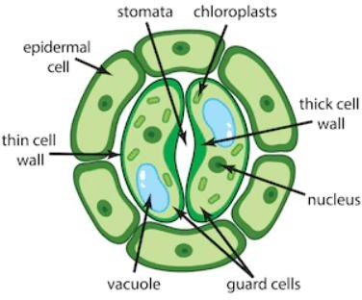
- Animal X = Herbivorous Animal Animal Y = Carnivorous Animal
The length of the small intestine in herbivorous animals is longer than that in carnivorous animals
- a) The saliva released while chewing chapati contains the enzyme amylase
  - This enzyme breaks down the starch in chapati and converts it into simple sugar.
- a) Because the heart has to pump blood into several organs
  - Because it requires a lot of energy to maintain its body temperature.
- Amylase is an enzyme found in saliva.
Function: Breaks down the complex molecule starch and releases sugar.
- a) Figure (1) / Open stomata Since stomata are open
  - X– Guard cell Y – Stomata
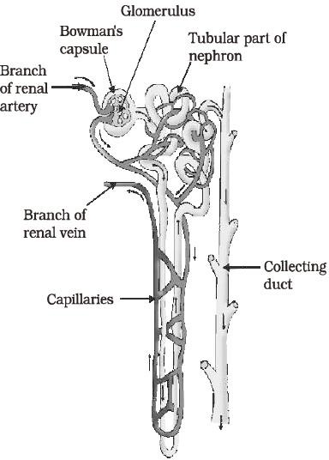

- * Alkalizing food and
* Breaking down large fat particles into smaller particles to increase the efficiency of enzymes
- * Hemoglobin in red blood cells has a high affinity for oxygen, which carries oxygen from the lungs to other parts of the body.
* Carbon dioxide is more soluble in water than oxygen, so it is transported to the lungs through the blood plasma

- * They have a three-chambered heart.
* Oxygenated and deoxygenated blood mix to some extent.
- * Since both oxygen and carbon dioxide must be transported through the blood,
* The heart has separate chambers to prevent oxygen-rich blood from mixing with carbon dioxide- depleted blood.
- * Double circulation helps in the rapid delivery of oxygenated blood to all parts of the body. This enables organisms to meet their high energy needs.
* Double circulation in mammals and birds helps regulate body temperature
- * The blood circulation was incomplete, as pure and impure blood was mixed.
* Double blood circulation was not observed
- * Herbivores that eat grass have a long small intestine to digest cellulose.
* But carnivores like tigers digest meat easily. So carnivores have a short small intestine
- * As plants growing in deserts face water scarcity, stomata close in the morning, preventing transpiration.
* At night, they take in carbon dioxide and produce an intermediate substance, which is then absorbed by chlorophyll during the day, and the energy acts on this substance.
- * The process by which green plants make food using carbon dioxide and water with the help of sunlight and chlorophyll (a pigment in leaves) is called photosynthesis.
- Carbohydrates | Glucose
- Carbohydrates are used to meet energy needs in plants.
- A) Produces antibodies.
B) Lymphocyte cells eliminate bacteria and unnecessary substances

Artery | Vein
* Carries blood away from the heart. | *Carries blood to the heart
*Have thick walls | *Have thin walls
*Does not have valves | *Does have valves
- * Creates an acidic environment to promote the action of the enzyme pepsin.
* Destroys microorganisms that enter the stomach with food.
- ATP is synthesized during cellular respiration, which break down glucose to generate a large amount of usable energy. In plants, ATP is crucial for active transport, providing the necessary energy for moving nutrients, such as the food molecules produced during photosynthesis, against their concentration gradients from the leaves to other parts of the plant.
- Some organisms break-down the food material outside the body and then absorb it. Examples are fungi like bread moulds, yeast and mushrooms. Others take in whole material and break it down inside their bodies. What can be taken in and broken down depends on the body design and functioning. Some other organisms derive nutrition from plants or animals without killing them. This parasitic nutritive strategy is used by a wide variety of organisms like cuscuta (amar-bel), ticks, lice, leeches and tapeworms.

- Answer the following questions (Three marks questions) 72.
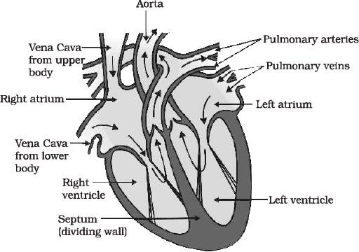
- * The small intestine is the place where proteins, carbohydrates and fats in food are completely digested.
- Enzymes in intestinal juice convert proteins into amino acids, fats into fatty acids, and complex carbohydrates into glucose.
- Villi in the inner wall of the small intestine absorbs digested food.

- * The translocation of food substances in plants takes place in the phloem tissue.
- The translocation of food and other substances takes place in both upward and downward directions with the help of the lateral companion cells of the phloem
- This action is achieved by Osmotic pressure.
- * Heart -
- Oxygenated and deoxygenated blood are transported separately.
- Provides maximum oxygen to the body.
- * Arteries carry blood from the heart to various organs of the body. Once an artery reaches a tissue, it divides into smaller vessels to bring the blood into contact with each cell.
- The exchange of substances between the blood and the surrounding cells takes place through the thin walls of very small vessels called capillaries. The capillaries then join together to form veins.
- Arteries carry blood away from an organ or tissue. Veins collect blood from different organs and bring it back to the heart.
- *Cells in contact with the soil or in the roots actively absorb ions. This creates a difference in the concentration of ions between the roots and the soil.
*To overcome this difference, water moves from the soil to the roots. There, the constant movement of water within the xylem of the roots creates a column of water that continually pushes water upward.
* In transpiration, water molecules evaporating from the stomata of leaves cause absorption, which draws water from the xylem cells of the roots.

Fish | Human
* Two-chambered heart | * Four-chambered heart
*Double blood circulation is not seen | *Double blood circulation is seen.
*Blood containing acid moves directly from the gills to the body parts | *Blood containing oxygen is supplied to the heart through the respiratory system and  then reaches the body parts
- Stages of blood transport in the heart:
- Oxygen-rich blood enters the left atrium from the lungs.
- When the left atrium relaxes and contracts, the left ventricle dilates, and blood is pumped out.
- When the left ventricle contracts, blood is pumped into the body through the aorta.
- Deoxygenated blood enters the right atrium through the superior vena cava and the inferior vena cava.
- When the right atrium contracts, blood is pumped into the right ventricle.
- vi)When the right ventricle contracts, the blood reaches the lungs to be oxygenated.

- Absorption of solar energy by chlorophyll.
- Conversion of light energy into chemical energy / decomposition into water, oxygen and hydrogen molecules.
- Carbon dioxide is converted into starch. Wastes generated in plants such as excess water is removed by evaporation. Oxygen and carbon dioxide gases are released through stomata.
- Wastes and dead cells in the alders shed leaves/bark.
- Resins and gums accumulate in old Xylems
- Some excrete wastes into the soil around them.
- a) Waste materials accumulate in the form of resins and gums in the old xylem of plants.
b) *Transferring a substance like sucrose to the phloem tissue using energy from ATP.
* Then the convective pressure of the tissue increases, and water enters it. This pressure causes substances to move from the phloem to tissues with lower pressure.
- * Nephrons are the structural and functional units of the kidneys.
- Nephrons are the blood-purifying units of the kidney, consisting of the glomerulus, Bowman's capsule, and the loops of Henle.
- These are the kidneys that remove nitrogenous wastes such as urea or uric acid from the blood.
- * Amoeba ingests food using temporary finger-like cell surface protrusions.
- These structures engulf and fuse food particles, forming a food sac

- In the alimentary canal, complex food substances are broken down into simple food substances, which are then diffused into the cell membrane. The remaining undigested substances move to the cell surface and are excreted.
- * The amount of urine excreted is less than the amount of urine produced in Bowman's capsule
- The amount of urine produced depends on the water content of the body.
- The more water content in the body, the more urine produced.
- Digestion is slow in animal P. This is because this animal is herbivorous and cellulose needs time to digest in the small intestine.
The digestive process is faster in animal Q. Because this animal is a carnivore, meat is easily digested in the small intestine.
- i) Digests protein in food.
- Breaks down complex molecules called starch and releases sugar.
- Breaks down emulsified unsaturated fats

Nutrition in autotrophs | Nutrition in heterotrophs
* Producing their own food | * Depends on other organisms for food
* Organic food is made from inorganic sources. | * Organic food is obtained from plant and  animal sources.
* Autotropism occurs in all green plants. | * Heterotrophism occurs in non-green plants  and all animals
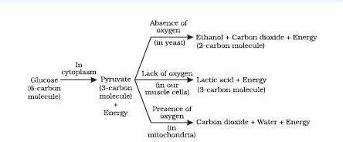
- a) * Accumulation of waste in the form of glue and resins in old xylem
- By shedding leaves
- By releasing waste into the soil around them
- Increased water loss through evaporation
- Oxygen through photosynthesis
- Carbon dioxide through respiration
b) Evaporation
- * Filtration of blood by a group of blood capillaries in the goblet cells of the nephron.
- The filtered fluid contains sugars, amino acids, salts, and excess water reabsorbed by the nephron's tubule.
- The remaining water and salts are excreted in the urine.
b) i) * Hydrochloric acid creates an acidic medium and helps the action of pepsin enzyme.
* Protein breakdown by pepsin enzyme
- * Converting proteins into amino acids
  - Converting carbohydrates into glucose
  - Converting fats into fatty acids and glycerol
- * Some organisms break down food substances outside the body and then absorb them Ex: Bread mold, yeast
- Some organisms consume food and break it down within their bodies. Ex: Humans and higher animals
- Some organisms obtain nutrition from plants and animals without killing them. E.g. lice, leeches
- Answer the following questions (4 marks questions)
- Pyruvate is broken down into molecules.
Two types: i) Aerobic respiration ii) Abiotic respiration

Aerobic respiration | Anaerobic respiration
Atmospheric oxygen is used | Atmospheric oxygen is not used
With high energy, carbon dioxide and water are  released. | With low energy, ethanol and carbon  dioxide are released
Occurs in mitochondria. | Occurs in cytoplasm
Found in higher organisms | Found in lower organisms such as yeast.

- The elements required for photosynthesis are:
Carbon dioxide, water, minerals, sunlight, and (leaf) chlorophyll.
Events that occur in photosynthesis
- Absorption of light energy by chlorophyll.
- Light energy is converted into chemical energy
- Water molecules are split into hydrogen and oxygen molecules.
- Carbon dioxide is reduced to carbohydrates.
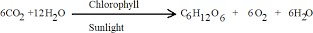

Xylem | Phloem
Transports water and salts/inorganic  substances. | Transports food/organic substances
One-way flow of materials | Two-way flow of materials
Xylem vessels and phloem transport  materials from the root to the stem | Sieve vessels and companion cells transport  materials from the leaves to all parts
Operation by suction pressure | Operation by Osmotic pressure
- * Large intercellular spaces in plants allow all cells to be in contact with air, so that carbon dioxide and oxygen can be exchanged by diffusion. That is,
* These gases move in and out of the cell into the atmosphere/air.
or
- * The heart has different chambers.
  - Valves between the chambers prevent the backflow of blood.
  - Has a dividing wall called a septum.
  - A structure called a septum creates separate pathways for the transport of oxygenated and deoxygenated blood.
- * Absorbed by finger-shaped structures called villi in the small intestine.
  - Blood plasma - transports food, carbon dioxide, and nitrogenous wastes.
  - RBC - transports oxygen
Blood carries many other substances, such as salts.
- Amylase: Converts the complex molecule starch into sugar
- Pepsin: Digests protein
- Trypsin: Digests protein
- Lipase: Fat emulsification
- * Plasma: Transport of food, carbon dioxide and nitrogenous wastes
- Red blood cells: Transport of oxygen
- White blood cells: protect the body from pathogenic microorganisms
- Platelets: help blood clotting.
- a) * Hemoglobin pigment gives blood its red color and is highly attracted to oxygen.
* It dissolves in blood and supplies oxygen to all the cells of the body through blood circulation.
- * Excess water is removed through evaporation.
  - Plant waste products accumulate in the cell sap.
  - Waste products accumulate in the leaves and fall off.
  - Waste materials accumulate in the form of resins and glues in old trees.
  - Plants release some waste into the soil around them.

- a)
Air sacs | Nephrons
Functional units of the lungs | Functional units of the excretory system
Function: Exchange of gases | Function: Separation of nitrogenous wastes  from the blood
Has a large surface area and blood supply | Has a large surface area and blood supply
b) His legs are deprived of oxygen due to constant exercise and lactic acid builds up.
- a) * Respiration in the absence of oxygen is called anaerobic respiration.
* Alcohol, carbon dioxide and energy
- * To provide the body with pure blood, the blood passes through the heart twice. This is called double circulation.
  - To provide more energy.
  - To maintain a constant temperature in the body.
- * Aquatic organisms use oxygen dissolved in water.
- Terrestrial organisms use free oxygen in the environment.
- The amount of oxygen in the land area is more than the oxygen dissolved in water.
- Since it is free oxygen, it does not require any further modification in the body
- * Lungs The trachea branches into bronchioles
- The bronchioles eventually become balloon-like structures called air sacs.
- These air sacs provide a surface
- The walls of the alveoli have an extensive network of blood vessels. Here gas exchange takes place
- Answer the following questions (5 marks questions)
- a) * The six-carbon molecule glucose is broken down into three-carbon molecules pyruvate in the Cytoplasm.
*Pyruvate is broken down in the mitochondria to produce carbon dioxide and water
*The energy released during respiration is used to synthesize a molecule called ATP.
*Glucose Cytoplasam Pyruvate
*Pyruvate Mitochondria CO2+H2O+energy
*ADP + P Energy ATP
The walls of the air sacs have a network of blood vessels, providing a surface for gas exchange.
- * Excess water is released by plants through transpiration.
  - Plant waste products are stored in the cell sap.
  - Waste materials accumulate in the leaves, and they fall off.
  - Waste materials accumulate in the form of resin and mucus in old leaves.
  - Plants use tissues with dead cells for waste, losing parts such as leaves
  - Plants also release some waste products into the soil around them.

Multiple choice
  - D. All the above

CHAPTER – 6: CONTROL AND COORDINATION KEY ANSWER

  - C. it is secreted by parathyroid gland
  - b) synapse
  - b) b) Pulling hand back when touching a sharp object.
  - b) spinal cord
  - c) Thyroxine
  - d) Chemotropism.
  - a) Adrenaline - Pituitary gland
  - c) Dendrite→ Cell body → Axon → Nerve ending
  - b) C→ A → B → E → D
  - b) Growth of roots deep into the soil
  - B) cerebellum
  - B. Phototropism
  - B. Receptor → Sensory neuron → Spinal cord → Relay neuron → Motor neuron → Effector
  - A. Under secretion of thyroxine hormone
  - B. regulates blood sugar level
  - C. Cytokinin
  - D. P → R → S → Q
  - C. cerebellum
  - C. Medulla
  - D. Chemotropism
  - A. Auxin
  - A Through electrical signals
  - D. Negative geotropism and positive phototropism
  - C. Abscisic acid inhibits plant growth.
  - C. Undirected and positive geotropism
  - C. Leaves tingle when touched
  - D. synapse and transmits chemical signals generated at the axon terminal to the dendrite
  - A. Thigmotropism

ONE MARK QUESTIONS
- Geotropism and phototropism.
- The movement of plant part in response to gravity is called geotropism.
- The structural and functional unit of nervous system / nerve tissue
- Abscisic acid
- A sudden response for stimulation is called Reflex action. Eg: With holding hands when touching sharp or hot objects.
- Chemical coordination takes place by the production of hormones in plants.
- Iodine
- Inhibits growth. Example – wilting of leaves
- Pancreas produces insulin hormone which helps in controlling blood sugar level.
- Muscle cells contain special proteins that cause movement by changing both their shape and composition within the cell in response to electrical impulses from nerves.
- The actions which are in our control are called as voluntary actions.
- The actions which are not in our control are called as involuntary actions. 42.
- The part of the brain that controls voluntary actions – the cerebrum
- The part of the brain that controls involuntary actions – the medulla
- Receive stimulus in our body.

- Growth promoting plant hormones –auxin, gibberellin, cytokinin 45.
Reflex action | Walking
Voluntary action is controlled by the cerebellum  of the brain. | An involuntary response to a stimulus. It is  controlled by the spinal cord.
- This movement is independent of growth and non-directional.
- This movement does not involve growth and is not a directed movement.
- Contribute to the remaining parts of the stem in growth and protection above the ground.
- Messages are transmitted from one neuron to another in the form of chemical messengers.

TWO MARK QUESTIONS
- The person suffers from diabetes.
This disease is caused by low secretion of the hormone insulin.
- Thyroid gland produces thyroxine hormone. Thyroxine regulates carbohydrate, protein and fat metabolism in our body and helps in balanced growth of human body.
- Adrenaline hormone prepares the body to deal with fear, anger, stress situations.The adrenal gland produces the hormone adrenaline.
- In animals, chemical adaptation occurs through hormones secreted by the endocrine glands, which diffuse directly into the blood and help to produce an appropriate response to a stimulus.
- ​
Nervous system | Hormones coordination
Communication takes place through electrical  impulses | Communication takes place through chemicals
Only reaches connected cells | Reaches every cell in the body
Cannot continuously generate and transmit electrical  impulses | Communication is continuous and more consistent
- Medulla : Controls involuntary actions. Cerebellum : Controls posture and balance.
- A. Towards the cell – dendrite
B. Away from the cell – axon
- Adrenaline increases the heart rate, which results in more oxygen being delivered to the muscles, preventing them from tiring.
It also dilates the blood vessels in the legs, allowing blood from the stomach to be supplied to the muscle cells in the legs.
- If touched, the sensitive plant moves its leaves in response to the touch.
These plant cells change their shape by changing the amount of water inside them. As a result, they change their shape by bulging or folding.
- When growing plants detect light, a hormone called auxin, synthesised at the shoot tip, helps the cells to grow longer.
When light is coming from one side of the plant, auxin diffuses towards the shady side of the shoot i.e. phototropism.
- Since salivation is an involuntary action, the mouth waters as soon as the sight of delicious food appears. The part of the brain that controls this action is the medulla oblongata.
- The cerebellum, which is responsible for the accuracy of voluntary actions and maintaining body posture and balance, is not functioning properly as a result of alcohol consumption, causing the person to lose control over body.
- Positive phototropic movements cause a plant stem to respond by growing towards the light, while negative phototropic movements cause a plant root to respond by growing towards the ground.
- Figure C shows the correct tropical movement of plants, plant roots towards grow towards gravity, which is positive geotropism. Similarly, stem growth is growth against gravity, which is negative geotropism.

Central nervous system | Peripheral nervous system
Includes the brain and spinal cord. | Contains 12 pairs of cranial nerves and 31 pairs  of spinal nerves

They receive information from all parts of the body and integrate it. | The peripheral nervous system facilitates communication between the central nervous  system and the rest of the body.

Endocrine glands | Nervous system
Messages are carried through specific  chemicals. | Messages are carried through nerve impulses.
The long-term effect is that messages are transmitted slowly and reactions occur slowly. | The short-term effect is that messages are  transmitted very quickly. And reactions occur very quickly.
- i) Auxin: Helps the cells in the stems and the cells in the many parts of the plant body to grow longer.
ii) Cytokinin: Promotes cell division in fruits and seeds • Helps in promoting overall growth of plants.
- When growing plants detect light, auxin is synthesised at the shoot tip and it helps the cells to grow longer.
  - When light is coming from one side of the plant, auxin diffuses towards the shady side of the shoot. This concentration of auxin stimulates the cells to grow longer on the side of the shoot which is away from the light.
- Adrenaline is directly secreted into the blood. The blood to the skin is reduced due to contraction of muscles around small arteries.
  - The breathing rate increases because of the contractions of the diaphragm and the rib muscles. The heart beats faster, resulting in supply of more oxygen to the muscles.

THREE MARK QUESTIONS
- “Immediate response to the stimuli is called reflex action. This process is controlled by spinal cord.
  - Thinking is a complex activity, and reflexive arcs have naturally evolved by spinal cord in animals because the brain's thinking process is not fast enough.
  - Therefore, they arise spontaneously in the spinal cord. So, the performance is very fast, and the responses are quick. It helps organisms to respond quickly to environmental changes.
- Advantage of chemical communication in multicellular organisms, electrical communication is more stable and continuous.
There are some limitations of electric communication –
- They reach only the cells in the animal body that are connected by nerve cells.
- Cells cannot continuously generate and propagate electrical impulses.
- But chemical communication reaches all the cells of the body. This can be done consistently and continuously.
- When growing plants perceive light, auxin hormone synthesis at the tip of its stem helps the cells to grow longer.
- When light coming from one side of the plant, auxin diffuses towards the shady side of the stem (photo tropism). This stimulates the cells in the stem to grow longer, making the plant appear bent towards the light i.e. phototropism.
- The auxin concentration increases in the cells opposite to the apex where the tendrils of theie photo come into contact and grow longer so that the tendrils wrap around the base in a circle and adheres to it. Thus, photo tropism, thigmotropism and chemo tropism are coordinated in the orientational movement of vine plants.
- The above structure is reflex arc-
C - sensory nerve: carries messages (stimuli) to the brain stem A - Effector: expresses the appropriate impulse response
- Diagram of brain

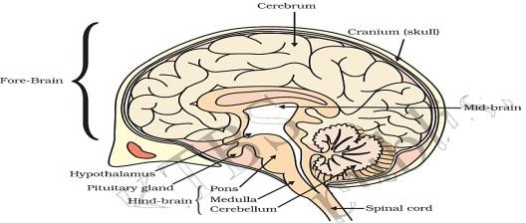
- Insulin – regulates the blood sugar level.
Estrogen – changes associated with puberty in females, regulates menstrual cycle. Thyroxin - regulates carbohydrate, protein and fat metabolism.
- i) Voluntary action:
Based on deciding what to do next (Action performed based on thinking) Controlled by forebrain.
ii) Involuntary action:
Action without thinking control Controlled by hind brain.
- a. (i) Receptors receive the stimulus of pain
- Messages reach spinal cord through sensory neuron.
- Responses reach motor neuron through association neuron.
- Responses reach effector through motor neuron.
- Muscles withdraw their legs.
(b) Spinal cord / reflex arc.
77. Forebrain: Remembering, understanding
Midbrain: Sending messages between the forebrain and hindbrain Hindbrain: Controls voluntary and involuntary actions of the body

FOUR MARK QUESTIONS
- The hormones that control the following activities in humans.
  - Controlling blood sugar levels. – Insulin
  - Controlling the menstrual cycle - Estrogen
  - Preparing the body to face the situation - Adrenaline
  - Controlling metabolism. –Thyroxine
- ​
- Neuron
- Dendrite→cell body →axon→ nerve terminal
Neuron transmits nerve impulses from the brain to all parts of the body, enabling the process of consciousness.
- ​
Reflex Arc: The pathway of nerve impulses in a reflex action.
- Receptors in the eye receive the stimulus of bright light.
- Messages reach spinal cord through sensory neuron.
- Responses reach motor neuron through association neuron.
- Responses reach effector through motor neuron.
- Muscles of eye close the eyelid.
- ​
 | Movement of leaves of a sensitive plant | Movement of a shoot towards light
1 | It does not depend on the direction of stimulus  applied. | Depends on the direction of stimulus  applied.
2 | Thigmotropism | Phototropism
3 | Touch is the stimulus | Light is the stimulus
4 | Caused by the sudden loss of water from the  swellings at the base of leaves | Caused by the unequal growth on the two  sides of the shoot.
5 | Not a growth movement | Growth movement
6 | Occurs very fast | Occurs slowly

- Reflex arc It gives sudden action in response to the event happening in the environment.
- Sensory neuron: It conducts the impulse of stimulus from receptor to the spinal cord.
- Effectors: Which shows the sudden visible response.
Reflex arcs have evolved in animals because the thinking process of brain is not fast enough in many animals. Meanwhile many animals have very little of the complex neuron network needed for thinking. So, it can function in the absence of true thought process and increase the chance of survival.
- a) For a touch / thigmotropism, when the tendrils of creeper plants come in contact with a support, the plant circles around it and grows faster.
- When tendrils get attached to a support then, tips of the plant synthesis auxin hormone at higher concentration and stimulates the elongation of cells, then the plant shows directional movement / growth towards light.
b. In animals, chemical communication is necessary. In animals electrical impulses will reach only the cells that
- are connected by nervous tissue but not each and every cell.
- Nerve cells cannot create and transmit electrical impulses continuously therefore, chemical communication is
- necessary in transmitting stimulus continuously to each and every cell.
- a) The reflex arc shows very quick response, and the thinking process of the brain is not fast enough.
b) The directional movement of the plant in response to light is called phototropism.
When light falls on growing plants, a hormone called auxin, synthesized at the shoot tip, helps the cells to grow longer.
When light is coming from one side of the plant, auxin diffuses towards the opposite side to the light.
This concentration of auxin stimulates the cells to grow longer on the side of the shoot which is away from light.
This leads the plant appears to bend towards light.

FIVE MARKS QUESTIONS
- A) When the tendrils of creeper plants come in contact with a support, the plant circles around it and grows faster.
When tendrils get attached to a support then, tips of the plant synthesize auxin hormone at higher concentration and stimulates the elongation of cells, then the plant shows directional movement.
- Thyroxine _ Regulates carbohydrate, protein and fat metabolism.
Adrenaline - Increase heartbeat, blood pressure, breathing rate, and prepare the body to face the situation.

CHAPTER – 11: ELECTRICITY MODEL KEY ANSWER

Multiple Choice Questions:
  - A. Ampere (A)
  - D. Watt (W)
  - C. Electric resistance
  - A. Electric current
  - B. Electric potential difference
  - D. Electric power
  - D.
  - A. 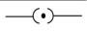
  - C.
  - a) resistor
  - c)ammeter in series &voltameter in parallel
  - d) V = I/R
  - b) 2.4 Ω
  - B) 3 Ω
  - a) 3.2 Ω
  - B) 9 : 1
  - b) 4C
  - ​
c) 40 J
  - C. 0.25
  - ​
a) 2 A
b) 2 Ω
a) Voltameter
b) VI = P
a) resistance directly proportional to potential difference but inversely proportional to current
a) fuse

  - ​
  - ​
  - ​
  - ​
  - ​
  - b) E=Pt
  - D. Rheostat
  - B. Resistance
  - B. Tungsten
  - A. Volt
  - C. 2 A
  - D. Ammeter
  - B. M
  - D. Protects the electrical appliances
  - D. R = ^{𝑉}
𝐼
  - A. Ammeter
  - D. ohm-metre
  - C. electric current and potential difference
  - A.16:1
  - A. Coulomb
  - D. power
  - B. potential Difference

  - D. The conductor Y has more cross section than the conductor X and hence the flow of current is more in it.

One-mark Questions:
- Iron because the resistivity of iron is more compared to copper.
- Both are correct. ΔV/ΔI = R. The resistance is more in series and less in parallel.
- 3.6 X 106 J
- If the potential difference across the two ends is 1V & the current through it is 1A then the resistance is said to be 1Ω.
- Flow of one coulomb of charge per second is 1 Ampere.
- 6 x 1018 electrons.
- Means that when 1 Joule of work is done to move a charge of 1 coulomb from one point to another.
- Electric current - Ammeter potential difference- Voltameter
- It is the property of the conductor to resist the flow of charges through it.
- If the potential difference is 1V & the current through it is 1A then the resistance becomes 1 Ω.
- To prolong the life of filament.
- Kilo watt per hour (kwh)
- In series.
- Fuse melts when excess of current flows through the circuit due to heating effect of electric current ensures the safety of electric devices.
- Due to its high resistivity, it is used in electric bulb.
- a) 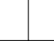b)
- ​
- Volt (V), Voltameter
- • Live and neutral wires should not come into direct contact.
OR
  - There should not be any short-circuit in the circuit.
  - Too many appliances should not be connected to a single socket.
  - Should always use quality wires and good quality electrical appliances. (Any two)
- • Accidental hike in the supply voltage
  - Connecting too many appliances to a single socket
  - When live wire and neutral wire come into direct contact. ( Any two )
- ​
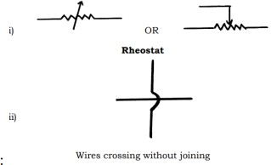
- ​
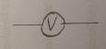

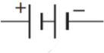
- ​
- Yes,
Because the circuit rating is less than 15 A

- If fuse wire is connected to the neutral wire instead of live wire, then even when the fuse burns out the appliance remains connected to the live wire and the current supply will not be disrupted due to overloading.
- The magnetic field strength increases by ten times.

Two-marks questions:
- A continuous and closed path of an electric current.
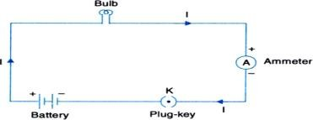
- TV - 250 W X 1 h = 0.25 kWh
Toaster- 1200 W X 10 min = 1.2 Kw X0.16h =0.192kWh Therefore, TV consumes more energy.
- Try as in the above question.
- Resistors connected in series = 2Ω + 4 Ω + 3 Ω = 9 Ω
Resistors in parallel: 1/Rp = 1/2 Ω + 1/4 Ω + 1/3 Ω
= 6/12 Ω +3/12 Ω +4/12 Ω
= 13/12 Ω
Therefore Rp = 12/13 Ω = 0.92 Ω

1
- ​
= 1 + 1 = 1 + 1 = 2+1 = 3

𝑅𝑝1
𝑅1 𝑅2 2 4 4 4
4

𝑅𝑝1 =
= 1.33 Ω
3

1 = 1 + 1 = 1 + 1 = 3+1 = 4 = 2

𝑅𝑝2
𝑅1 𝑅2 2 6 6 6 3
3

𝑅𝑝2 =
= 1.5 Ω
2

𝑅𝑝2 − 𝑅𝑝1 = 1.5 − 1.33 = 0.17Ω
74. ϼ =1.63 X 10-8 Ωm, A= 10.3 X 10-5cm2 = 10.3 X 10-5 X 10-3 m2, R = 20Ω, l=?
Formula R = ϼ l/ A Therefore l = R A/ ϼ
= 20 X 10.3 X 10-5 X 10-3 /1.63 X
= 20 X 10.3 X 10-8 /1.63 X 10-8 =126.38 m
- i) Silver because its resistivity is more.
ii) Nichrome because it is having high resistivity.
- If a current larger than the specified value flows through the circuit the temper of the fuse wire increases. This melts the fuse wire and breaks the circuit. Connect to live wire in meter board. Because as soon as electric current overflows the fuse melts and makes the circuit to break.
- a) It is the property of the conductor to resist the flow of charges through it.
b) It is the characteristic property of the material which is a constant of proportionality.
Resistance measures how much it opposes the flow of current. whereas resistivity is an intrinsic property of material.
- The melting point and resistivity of tungsten are very high. It does not melt readily at a high temperature. The electric lamps glow at very high temperature. Hence tungsten is mainly used as heating element of electric bulbs.
- In domestic electric circuits, the different electric components need widely different electric current values to operate property. When one component fails, the circuit is broken and none of the components works. Therefore, the series arrangement is not used for domestic electric circuits.
  - The appliances connected in series need currents of widely different values to operate properly.

  - In a series circuit, if one component fails, the circuit is broken and none of the components work.
  - But in a parallel circuit current divides through the electrical gadgets.
  - This is helpful particularly when each gadget has different resistance and requires different current to operate properly / Each electrical appliance can be operated separately.
- According to this law, the heat generated in a resistor
- is directly proportional to the square of the current flowing through a given resistance.
- The resistance is directly proportional to the current flowing through the resistor.
- The time taken for the current to flow through the resistor is directly proportional to the current. H = I2Rt
- Tungsten
- Nitrogen / N, or Argon / Ar (consider if He / Ne / Kr is written)
- ​
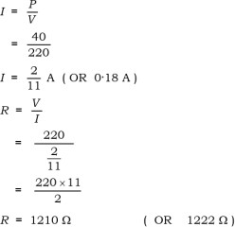

- Try as in the above question.
- Resistance
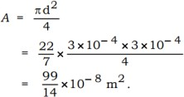
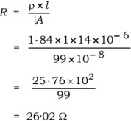

- Try as in the above question.
- Here, R1 = 5 Ω, R2 = 4 Ω, R3 = 12 Ω, V =24 V.
Total resistance of the circuit RT = ?
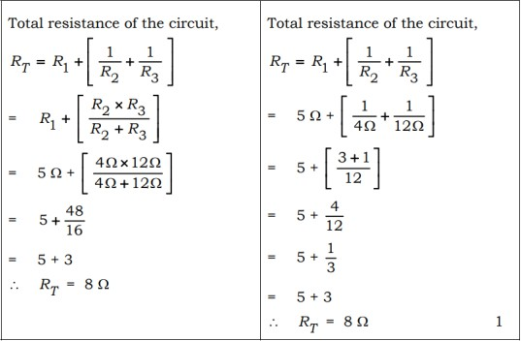
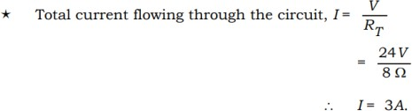
Total current flowing through the circuit, I = ?
- Try as in the above question.

- ​
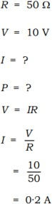
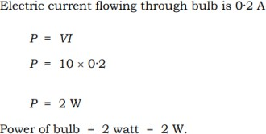

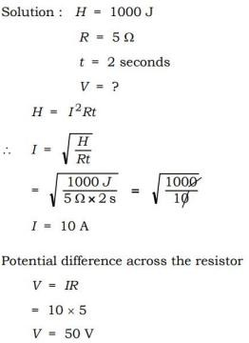

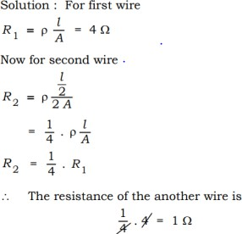

- Fuse is a safety device which protects electric circuits and electric appliances by stopping the flow of any unduly high electric current. It is a piece of wire made of a metal or an alloy of appropriate melting point, placed in series with the device. If current larger than the specified value flows, the temperature of fuse wire increases. This melts the fuse wire and breaks the circuit. Thus, placing of fuse is must in electric circuits

Three marks Questions:
- R1 and R3 are in series: RS1 = R1 + R3= 10 Ω +20 Ω = 30 Ω .
RS1 & R2 are in parallel connection: 1/ RP = 1/ RS1 +1/R2 = 1/30 Ω + 1/10 Ω
= 1/30+3/30 =4/30 Ω
Therefore, Rp = 30/4 = 7.5 Ω Rp and R4 are in series.
Their total resistance Rs2 = Rp + R4 =7.5Ω + 20Ω =27.5 Ω
Current flows through the circuit is I =V/R = 6/Rs2 = 6/27.5 = 0.218 A
- R1 = 5Ω , R2 = 10Ω , R3 = 30Ω.
Voltage between each resistor is , v=12 v .
Electric current through R 1 is I1 = V/R 1 = 12 v/5Ω = 2.4 A Electric current through R 2 I2 = V/R 2 = 12 v/10Ω = 1.2 A

Electric current through R 3 I3 = V/R 3 = 12 v/30Ω = 0.4 A
Total electric current through I= I1+ I2 + I3
= 2.4 A + 1.2 A + 0.4 A = 4 A
Total resistance 1/Rp = 1/ R1 + 1/ R2 + 1/ R3 = 1/5 + 1/10 + 1/30
= 6/30 +3/30 +1/30 = 10/30 = 1/3 Ω
Therefore Rp = 3 Ω
- Refrigerator 400 W = 0.4kw unit = kwh =0.4 X 10 = 4 kwh Electric fan 80w = 0.08kW, 0.08 X 6 = 0.48kwh.
Electric bulb 18w = 0.018kW, 0.018 X 6 = 0.108 kwh. 4 kwh +0.48kwh +0.108 kwh =4.588 kWh.
days in June 30 X 4.588 =137.64 kwh.
rupees per unit 137.64 X 3 = 412.92 rupees.
- Try as in the above question.
- Try as in the above question.
- Using Nichrome.
Because: i) due to high resistivity high amount of heat is produced.
- high melting point.
- In high temperature it will not melt easily.
- R= 20 Ω R=ρl/A
L1=2l R1=ρl1/ A1 = 4ρl/A A1=A/2 R1/R= 4/1
R1=80 Ω
- a) The potential difference across the wire in an electric circuit is directly proportional to the current flowing through it provided if the temperature remains the same.
- The Resistance of the conductor depends on
  - its length
  - area of crosssection
  - nature of the material
  - its temperature.
- Joule’s law of heating: H=I2RT
Heat produced by the Resistor is directly proportional to the
- Square of the current for a given resistor.
- Resistance for a given current.
- time taken to flow the current through the resistor Working of Electric filament bulb:
In an incandescent type of bulb an electric current is passed through a thin metal filament heating the
filament until it glows and produces light. filament has a lot of resistance to electricity. As a result of their resistance, the filament heats up & starts glowing by converting electrical energy to light energy
- Tungsten • Nitrogen / N OR Argon / Ar
- ​
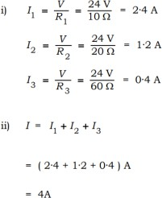
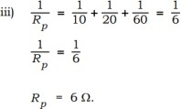

- Given - R = 28 Ω, d= 0.04 mm , l =2m, 𝜌 = ?. r = 𝑑/ 2 = 0.04/ 2 = 0.02 mm = 2 x 10-5 m
𝐴=𝜋𝑟2 =3.14×(2 x 10-5 ) 2=12.56 x 10 -10 𝑚2
𝑅= 𝜌𝑙𝐴⇒𝜌 = 𝑅𝐴𝑙 = 28 𝑥 12.56 𝑥 10 -10 / 2 = 175.84 x 10 -10 = 1.758 x 10 -8Ωm

Four marks questions.
- a) The heat produced in a resistor is
- directly proportional to the square of current for a given resistance
- directly proportional to the resistance for a given current
- directly proportional to the time for which the current flows through the resistor H = I2Rt [ 1 mark can be allotted for formula ]
The devices that work on this law are Electric Toaster, Electric Oven, Electric Kettle, Electric Bulb, Electric Fuse.
b) Resistivity of alloys are more than / higher than that of metals. Alloys do not oxidise ( burn) readily at high temperature. Alloys have high melting point.
- a) Solution:
The energy consumed by the bread-toaster in 30 days = 350 W × 15 hours × 30 days
= 157500 Wh = 157·5 kWh
The energy consumed by the iron box in 30 days = 250 W × 5 hours × 30 days = 37500 Wh = 37·5 kWh 1 The total cost of energy at the rate of Rs. 4·00 for 1 kWh for 30 days. = ( 157·5 + 37·5 ) kWh × 4
= 195 × 4 = Rs. 780
b) Parallel connection.
- V= 220V, I = 10A, P= ?, E = ?
P = VI = 220 x 10 = 2200W = 2.2 kw
Total energy consumed by the electric heater in 30 days would be
2.2 W × 8 hours/day × 30 days = 528 kWh
Thus, the cost of energy to operate the refrigerator for 30 days is = 528 kWh × Rs. 5.00
= Rs. 2640.

Five marks questions.
- • If 1 Joule (1J) of work is done to move a charge of 1 Coulomb (1C) from one point to another point in a current carrying conductor, the potential difference between the two points is 1 volt
- The device used to measure it is voltmeter.
- The property of a conductor to restrain or to retard the motion of electric charges flowing through it is called resistance of a conductor.
- The rate at which electric energy is dissipated or consumed in an electric circuit is called electric power.
- Three formulae used to find electric power are → P = VI or P = IV / P = W/ t → P = I2R → P = V2 / R

Chapter-12: Magnetic Effects of Electric Current Points Key Answers

Multiple Choice Questions
  - A. South (S) and South (S)
  - B. Uniform.
  - C. Magnetic lines of force intersect each other
  - A. Direction of induced current in a conductor
  - C. Anticlockwise
7. A. Same at all points
- B. Electric current
- C. 90°
- B. 10 times
- C. Direction of electric current in a conductor
- A. High
- A. Index finger
- C. Use of fuses
- D. Geyser
- D. Very high.
- D. At both ends
- D. The wire is the centre of the concentric magnetic lines of force of the magnetic field
- D. All of the above are correct
- C. decreasing the radius of the coil

One Mark questions.
- At the point of intersection, the needle of the compass should point in both directions but this is not possible.
- ​
  - It should be ensured that both the live wire and the neutral wire do not come into direct contact.
  - Several appliances should not be connected to the same socket
  - Good quality wire and electrical appliances should be used.
- Sudden increase in the supply voltage. Connecting many appliances to the same socket. Overload occurs when both the live wire and the neutral wire come into direct contact.
- Direction of electric current 23.
  - At the ends / poles of a solenoid, the magnetic force lines appear as concentric circles.
  - At the centre / inside the solenoid, the magnetic force lines appear as parallel straight lines.
- At point P, it is anticlockwise. At point Q, it is clockwise.
- The area of magnetic force around a bar magnet.
- The imaginary lines representing the magnetic field around a magnet are called the lines of force of the magnet
- The electric current experiences the greatest force when its direction is perpendicular to the direction of the magnetic field.
- Electric motors, electric generators, loudspeakers, microphones and electrical meters. etc.
- A compass is a small bar magnet, the magnetic fields of the compass and the bar magnet interact, so that when the compass is brought near the bar magnet, it moves.
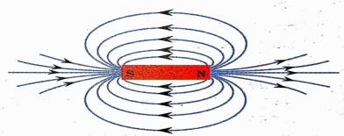
- ​
- i) Permanent magnet method
ii) Electromagnetic method

- Because the magnetic field lines are parallel, straight, and equally spaced, making the field uniform.

lII. Two Mark Questions
- Reasons for short circuit:
  - When the live and neutral wires in the circuit come into direct contact.
  - When the insulating covering on the wires is damaged.
  - When there is a fault in the electrical appliances.
  - When many appliances are connected to the same socket.
- Properties of magnetic lines of force:
  - No two magnetic lines of force intersect each other.
  - The density of magnetic lines of force is higher at the magnetic poles.
  - Magnetic lines of force are emitted at the north pole and merge at the south pole.
  - Inside the magnet, there are magnetic lines of force from the south pole of the magnet to the north pole.
  - Magnetic lines of force are a closed network
- Overload can occur when both the live wire and the neutral wire come into direct contact.
  - This happens when the insulating covering on the wires is damaged or there is any fault in the electrical equipment.
  - This can happen due to a sudden increase in the supplied voltage
  - Overload can occur when the current in the circuit suddenly increases too much.
- The earth wire connected to the metal surface creates a path of low resistance for the electric current.
  - Thus, if any kind of electrical leakage occurs to the equipment having a metal surface, its potential difference equalizes to the earth potential difference and the user does not get a severe electric shock
- Left. (or) is towards the magnet (or towards the north pole of the magnet) Rule:- Fleming's left hand rule
- A solenoid is a cylindrical coil of copper wire with many turns wound around it. A piece of soft iron, a magnetic material, can be placed inside a current-carrying solenoid to make it an electromagnet.
- i) Figure (B) shows the direction of the magnetic field correctly.
ii) “Right-hand thumb rule”
- ​
  - The number of turns of the coils Increasing.
  - Increasing the current flowing in the coil.
- ​
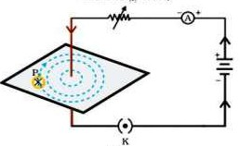
- ​
  - At the ends/poles of a solenoid, the magnetic field lines appear as concentric circles.
  - In the centre/inside of the solenoid, the magnetic field lines appear as parallel lines
  - The magnetic lines of force inside the solenoid are parallel to each other.
  - This shows that the magnetic field is equal at each point inside the solenoid. (Uniform).
- P = 2KW = 2000W V = 220V I = P/V = 2000/220 I = 9.09A
The rating of the circuit is 5A. However, a current of 9.09A is flowing in it. Since the current is flowing more than the capacity, it causes overload and generates more heat.
- A) Maxwell's right-hand law
B) Fleming's left-hand law.
- P and Q are north poles, because the magnetic lines of force are repulsive.

- The student's statement is correct, since the density of magnetic lines of force is higher at the poles of the magnet, the magnetic field at end A is higher than at end B.
- Pole: South
Same poles repel reach other.

Three-mark questions
- ​
  - Take a small compass and a bar magnet. Place the bar magnet on a white sheet attached to a drawing sheet and mark the boundary around the bar magnet.
  - Place the compass near the north pole of the bar magnet and mark the position of the two ends of the compass.
  - The compass should be moved so that the south pole of the compass occupies the position previously occupied by the north pole of the compass.
  - Similarly, the compass should be continued until it reaches the south pole of the bar magnet. The marked points should be joined by a smooth curve. This represents the magnetic lines of force.
  - By repeating the above procedure, we can measure a sufficient number of lines of force
- a) The magnetic field produced in a solenoid by an electric current is the same as the magnetic field produced around a bar magnet.
The magnetic field is uniform inside the solenoid.
Two ways to increase the magnetic field in a solenoid:-
b) Right-hand thumb rule:- When a current-carrying conductor is held in the right hand, the thumb indicates the direction of the current. The fingers are wrapped around the conductor in the direction of the magnetic field. Law of magnetic force lines:- Magnetic force lines are emitted at the north pole and merge at the south pole.
  - They are closed networks.
  - Have direction and magnitude.
No two magnetic lines of force intersect each other.
The density of magnetic lines of force is higher at the magnetic poles. Magnetic lines of force are emitted at the north pole and merge at the south pole.
Inside the magnet, magnetic lines of force are present from the south pole of the magnet to the north pole.

Four Mark Questions
- Functions of earth wire:-
  - It is used for the safety of electrical appliances having a metal surface in the domestic electrical circuit.
  - It creates a path of low resistance for electric current.
  - If there is any kind of electrical leakage in the appliance, its potential difference is equal to the potential difference of the earth and the user does not get a severe electric shock.
- ​
  - A small rod of aluminium is suspended with the help of two conducting wires.
  - Take a powerful horseshoe magnet and place it between the two poles with its magnetic field facing upwards.
  - The aluminium bar is connected in series to a battery, switch and rheostat.
  - Now, current is passed through the aluminium bar in a particular direction.
  - The bar is displaced in one direction.
  - When the direction of the current in the bar is changed, it is displaced in the opposite direction.
  - Therefore, a bar carrying an electric current experience a force perpendicular to its length in a magnetic field

Metals and Non-metals Model Answers

Multiple Choice Questions. (One-mark questions.)
  - D. AgNO3 solution and copper metal.
  - C. Coating with zinc.
  - C. Zinc is more reactive than tin.
  - A. H2
  - A. Copper carbonate
  - D. AgNO3 + Cu
  - C. Copper is more reactive than silver but less reactive than iron.
  - D. Ionic bond
  - A. Al<Mg <Ca< Na <K
  - B. Roasting
  - C. Iron
  - A. Zn>Fe>Cu
  - A. Fe < Zn < Al
  - A. Mg > Al > Zn > Fe
  - C. 2AgNO3 + Cu → Cu(NO3)2 + 2Ag
  - C. Elements A and C
  - A. some carbon is added to pure iron
  - A. Y
  - C. Sodium carbonate, Carbon dioxide

Answer the following questions: (One-mark questions).
- Oxides which react with acids and basic acids to produce salt and water are called amphoteric oxides.
- Magnesium (Mg) and Manganese (Mn)
- Good conductors of heat : Silver and copper Poor conductors of heat : Lead and mercury
- Graphite
- The property of being able to be made into thin wires.
- Compounds formed by the transfer of electrons from a metal to a non-metal are called ionic compounds or electrovalent compounds.
- An iron ring should be immersed in a copper sulphate solution. Copper is displaced from the salt solution and is coated on the iron ring.
- A highly exothermic displacement reaction.
- Gold and platinum
- An alloy is a homogeneous mixture of two or more metals or non-metals.
- Gold, silver and platinum
- Reduction method
- Because it requires more energy to break the strong ionic bond between molecules.
- The process of heating the ore in a large amount of air at high temperature to convert the metal sulfide into its oxide is called metallurgy.
- Metals are highly reactive with oxygen. Oxygen is abundant in the atmosphere.
- They are used to fix railway tracks and fix broken machine parts.

Answer the following questions: (Two marks questions).
- Hydrogen gas
Fe + H2SO4 → FeSO4 + H2
- Al2O3 + 6HCI → 2AlCl3 + 3H2O Al2O3 + NaOH → NaAlO2 + H2O
- o Have high melting and boiling points.
  - Formed by strong electrostatic forces between atoms.
  - Compounds that dissolve easily in water.

  - Have a specific crystal structure.
  - Good conductors of electricity in the solid state.
  - Poor conductors of electricity in the molten state.
- Calcium metal reacts with water at a low intensity to form calcium hydroxide and releases hydrogen gas. Since the intensity of heat released in this reaction is low, hydrogen gas does not ignite and burn.
Ca + 2H2O → Ca(OH)2+ H2
- Sodium and potassium.
Sodium and potassium metals react rapidly with cold water to form their hydroxides and release hydrogen gas.
2Na + 2H2O → NaOH + H₂ K + H₂O → KOH + H₂O
- i) Shiny surface or metallic lustre, ductility and malleability.
ii) Sound and ductility
- o Metals are generally hard.
  - Are in solid state (mercury is liquid at room temperature)
  - Metals are shiny (lustre).
  - Metals have malleability and ductility.
  - Metals are good conductors of heat and electricity.
  - Metals have high melting and boiling points.
- o Non-metals are in solid or gaseous form. (Bromine is a liquid non-metal)
  - Non-metals are not shiny. (Iodine is shiny)
  - Non-metals are bad conductors of heat and electricity. (Graphite is a good conductor)
  - Non-metals do not have malleability and ductility.
  - Have low melting and boiling points.
- i) It is liquid at room temperature : Mercury
- These can be easily cut with a knife : Sodium
- These are good conductors of heat : Silver and copper
- These are poor conductors of heat : Lead and mercury
- i) 3Fe + 4H2O → Fe3O4 + 4H2
ii) 2K + 2H2O → 2KOH + H2
- These metals have a greater affinity for oxygen than for carbon. Hence, they cannot be reduced by carbon. These metals are separated from their ores by electrolysis.
- Metals that displace hydrogen: Magnesium (Mg) and Manganese (Mn) Metals that do not displace hydrogen: Copper, Silver.
- In the electrolytic purification of metal 'M',
Anode: A thick impure 'M' metal plate of impure metal 'M' Cathode: A thin pure 'M' metal plate
Electrolytic solution: A solution of metallic salt of 'M'.
- Painting, oiling, applying grease, galvanization, chromium plating, anodization and making alloys.
- Beaker A: The reaction of sodium metal with water is highly exothermic, so the hydrogen gas released ignites immediately and burns.
Beaker B: The reaction of calcium metal with water is less intense. The heat released is not enough to ignite the hydrogen gas.
- i) Nitric acid is a strong oxidant. It oxidizes the hydrogen produced to produce water and itself is reduced to one of the products.
ii) 2Al + 6HCl → 2AlCl3 + 3H2
- The process of coating zinc on iron is called galvanization.
Zinc reacts with air to form a layer of zinc oxide. This layer prevents iron from rusting.
- Metal used: Aluminum
Name of reaction: Thermite reaction
Equation: Fe2O3 + 2AI → 2Fe + Al2O3 + Heat
- A homogeneous mixture of two or more metals or non-metals. Bronze : Copper and Tin / Cu and Sn
Solder : Lead and Tin / Pb and Sn

Stainless steel : Iron, Carbon, Chromium and Nickel / Fe, C, Cr and Ni Brass : Copper and Zinc / Cu and Zn
- Minerals that contain a very high amount of a particular metal and can be extracted profitably. During roasting, the zinc sulphide is converted into zinc oxide.
ZnS + O2 → ZnO + SO2
During calcination, the zinc carbonate is converted into zinc oxide.
ZnCO3 → ZnO + CO2
- ​
Calcination | Roasting
Less oxygen, more temperature | More oxygen, more temperature
To convert carbonate ore into metal oxide | To convert sulfide ore into metal oxide
ZnCO3 → ZnO + CO2 | ZnS + O2 → ZnO + SO2
- Cinnabar (HgS) is an ore of mercury. When it is smelted in air, it first converts into mercury oxide (HgO). When mercuric chloride is further smelted, it is reduced to mercury.
2HgS + 3O2 → 2H2O + 2SO2
2HgO → 2Hg + O2
- The chemical reaction takes place in test tubes A and C because zinc and magnesium are more reactive than iron / Zinc and magnesium are found above iron in the reactivity series of metals.
Zn + FeSO4 → ZnSO4 + Fe Mg + FeSO4 → MgSO4 + Fe
- i) * The iron nail in test tube A rusts.
* Because both air and moisture are available
ii) * There is moisture in test tube B but no air
* There is air in test tube C but no moisture.
- Al2O3 + HCl → AlCl3 + H2O Al2O3 + NaOH → NaAlO2 + H2O
- a) The property of metals to be formed into sheets
b) The property of metals to produce sound

Answer the following questions (Three marks questions)
- i) When ionic compounds are in solid state, there is a strong force of attraction between positive and negative ions, making them rigid. Due to this, the movement of ions is not possible. In
the molten state, the electrical attraction between the oppositely charged ions is broken by heat.
So, the ions move freely and allow the electricity to flow.
- Sodium/Potassium metals react quickly with air and water, but do not react with organic solvents. Since kerosene is an organic solvent, it does not react with it. Therefore, it is stored in kerosene.
- Aluminum reacts with oxygen to form a layer of aluminum oxide. This layer then prevents the aluminum from further corrosion and it does not react with cold or hot water. It is very light and is a good conductor of heat.
- A) i) No change in dry litmus paper.
ii) Wet litmus paper turns blue litmus paper to red.
B) Sulphur + Oxygen → Sulphur dioxide (S + O2 → SO2)
- ​
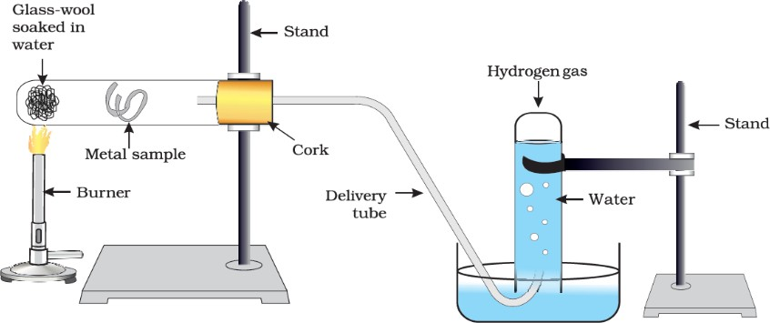
- ​

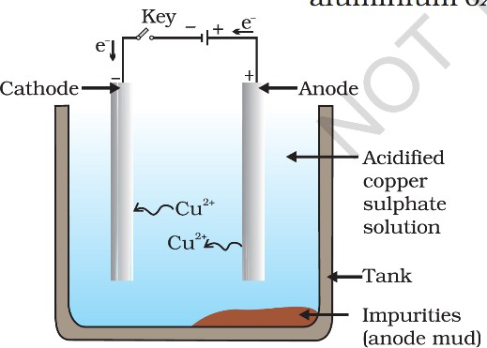
- o Metals in the middle of the reactivity series are usually converted to copper oxides by roasting ores of carbonates at high temperatures in high air.
  - Carbonate ores are converted to copper oxides by calcination at high temperatures in low air.
  - Metal oxides are reduced to their respective metals using a suitable reducing agent such as carbon.
- a) When silver objects are exposed to air, it reacts with sulfur in the air to form a black layer of sulfur sulphide.
Copper reacts with moist carbon dioxide in the air to form a green layer of copper carbonate.
- The zinc coating formed by galvanization reacts with oxygen to form a layer of zinc oxide, which prevents further oxidation.
- Aluminum oxide reacts with both acids and bases to produce salt and water.

Answer the following questions: Four marks questions.
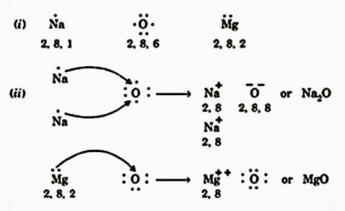
- ​

- A. Most reactive metal: Metal B
- 'B' displaces copper from a solution of copper sulphate. Reason: 'B' is more reactive than copper.
- B > A > C > D

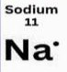
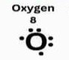
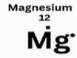
- a) 2, 8 2,6 2,8,2
- i) Minerals: Elements or compounds found naturally in the earth's crust.
  - Ore: Minerals that contain specific metals in very high quantities and can be extracted profitably.
  - Clay: Unwanted impurities such as soil, sand etc. present in ores.

- ​
Metals | Zinc | Magnesium | Copper
Zinc Oxide | No reaction | Displacement | No reaction
Magnesium Oxide | No reaction | No reaction | No reaction
Copper Oxide | Displacement | Displacement | No reaction

- A. Pure iron is very soft and expands easily on heating, but alloys are hard. This is because iron changes its properties when mixed with other substances.
- Copper reacts with moist carbon dioxide in the air to lose its brown layer and copper carbonate is formed.

- Zinc oxide
- Nitric acid is a strong oxidising agent. It oxidizes the hydrogen produced to produce water and itself is reduced to some oxide.

- ​
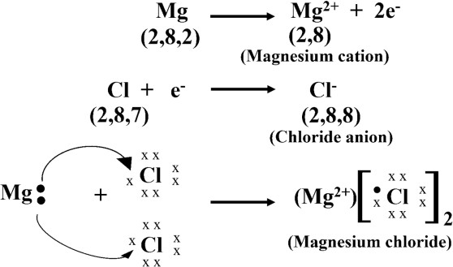

Answer the following questions: (Five marks questions)
- Q. No. 51, 50
ZnO + C → Zn + CO
Coke is added as reducing agent. It reduces zinc oxide to form zinc.

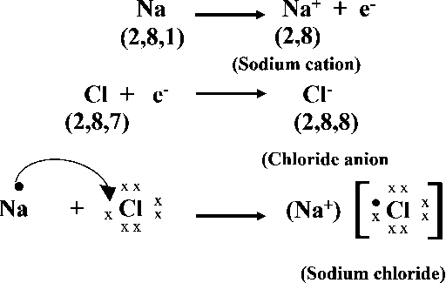
- a)

- o Have high melting and boiling points.
  - Formed by strong electrostatic forces between atoms.
  - Compounds that dissolve easily in water.
  - Have a specific crystal structure.
  - Good conductors of electricity in the solid state.
  - Poor conductors of electricity in the molten state.

CHAPTER- 4: CARBON AND ITS COMPOUNDS

Model key answer

Multiple choice questions (1Mark each.)
  - D. 4
  - B. oxygen
  - C. methane
  - B. catenation
  - C. ethene
  - A. −Cl or –Br
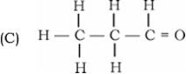
  - ​

  - A. propanone
  - B. 9 and 3
  - B. 18
  - C. six and twelve
  - A. C6H12
  - A. CH2
  - D. C2H4, C3H6, C4H10
  - B. ethane, propane, butane
  - A. CnH2n-2
  - D. CnH2n +2
  - C. esters

Answer the following questions (1 Mark each.)
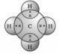
19.

20. Nine single bonds and one double bond / 9 and 1

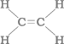
21.

22. i. Methanal
ii. Bromoethane

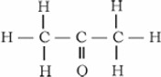
23.

- C6H12
- C3H7Cl and chloropropane

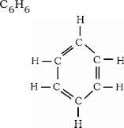
- ​

- Hydrocarbon compounds are usually used as fuels because in combustion reaction they release large amount of heat and light.
- Generally vegetable oils contain unsaturated carbon chain compounds these compounds can be converted into saturated carbon chain compounds by addition reaction therefore it is used in hydrogenation.
- The melting point of pure ethanoic acid is 290 K hence it often freezes during winter therefore it is called as glacial acetic acid.
- Vinegar
- Hydrogen
If we bring a burning candle near the gas it will burn with a pop sound.
- Salt and water are produced /NaOH + CH3COOH→ CH3COONa + H2O
- CnH2n+2
- Tetravalent property
- Insoluble precipitate: P Excessive foam: Q

Answer the following questions (2 Marks each.)
- a. The inter molecular forces are low in covalently bonded molecules therefore they have low melting and boiling points
b. Covalently bonded molecules do not have charged particles therefore they are generally poor conductors of electricity.
- i. Carbon atoms form bonds with other atoms of carbon in catenation process to produce large molecules
  - Carbon has a four valency therefore it is capable of bonding with four other atoms to form compounds with specific properties.
- i. The melting and boiling points increase with increasing molecular mass therefore a gradation in physical properties is seen in homologous series
  - If there is a same functional group in the compounds of homologous series then the chemical properties are similar therefore there is no change in chemical properties.
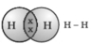
- i. Hydrogen

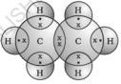
  - Ethane

- The heteroatoms and group containing these confer specific properties to the compound regardless of the length and nature of the carbon chain these are called functional groups.1 ketone and alcohol /
−CHO and −OH.
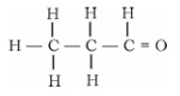
- The heteroatoms and group containing these confer specific properties to the compound regardless of the length and nature of the carbon chain these are called functional groups.

- The tetravalent property of carbon is not satisfied / carbon cannot form double bond with hydrogen atom

- C2H5OH / C2H6O
These two compounds have difference of one CH2 group. Therefore, these two compounds are in homologous series.
- Substitution reaction.
In this reaction chlorine takes the place of hydrogen atom in CH4 molecule therefore it is substitution reaction.
- The unsaturated hydrocarbons which contain one or more triple bonds are called alkynes. Ethyne / acetylene
C2H2
- CH3COOC2H5+NaOH → C2H5OH+ CH3COONa
This reaction is known as saponification because it is used in the preparation of soap.
- i. ‘a’- ethene-unsaturated
  - ‘b’-ethane-saturated
- i. Propanoic acid
  - Butene
  - Ethanol
  - Pentyne
- Take 1 mL of ethanol absolute alcohol. and 1 mL glacial acetic acid along with a few drops of concentrated sulphuric acid in a test tube and heat the mixture in a water bath for at least five minutes the ester will be formed.
Pour the product into a beaker containing 20-25 mL water and smell the resulting mixture if it has sweet smell then ester is confirmed.
- Ethanoic acid reacts with sodium carbonate and sodium hydrogen carbonate to give rise to a sodium acetate, carbon dioxide and water
2CH3COOH +Na2CO3 → 2CH3COONa + H2O + CO2 CH3COOH +NaHCO3 → CH3COONa + H2O + CO2
- The reaction in which carboxylic acids react with an alcohol to give rise to esters is called esterification.
Esters are used in making perfumes and flavouring agents.
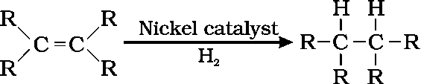
- Nickle or Palladium
- ​
i)
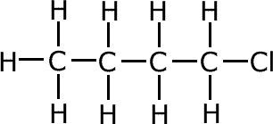
ii)
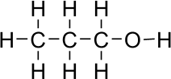
- a) Ethene converts into ethane.
b) Methane converts into chloromethane.
- This capability is primarily due to four properties: catenation, tetravalency, the ability to form multiple bonds, and isomerism.

Answer the following questions (3 Marks each.)
- a. Catenation
- The carbon-carbon bond is very strong and stable hence catenation in carbon atoms is seen to the extent
- i. Long chain
- Branched chain

- Ring chain.
- a. The compounds of carbon having only single bond between the carbon atoms are known as saturated carbon compounds.
b. i. Series of carbon compounds having similar chemical properties but in between successive members molecular formulae one CH2unit difference is found these are generally known as homologous
series.
ii. Esters are sweet-smelling compounds formed by the reaction of carboxylic acids and alcohol.
- a. The molecules of soap are Sodium or Potassium salts of long-chain Carboxylic acids in this molecule the ionic end of soap interacts with water while the Carbon chain interacts with oil these structures are
called as micelles.
b. Bond which is formed by the sharing of an electron pair between two atoms is known as covalent bond.
covalent compounds,
- have low melting and boiling points
- are generally poor conductors of electricity.
- a. The reactions in which hydrogen atoms of hydrocarbons can be displaced by other atoms or group of atoms is called as substitution reactions.
b. Methane and CH4
c. The substances those can add oxygen to others are called as oxidising agents.
- i) Ethane, Saturated, Addition reaction
ii) Propanal
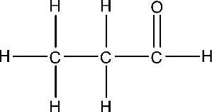

Answer the following questions (4 Marks each.)
- a. In this reaction ethanol is converted into ethanoic acid by adding oxygen therefore, it is oxidation reaction.
b. * Ethanoic acid belongs to the group of acids called carboxylic acid
* The melting point of ethanoic acid is 290K
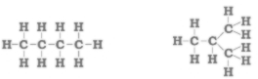
Compounds with identical molecular formula but different structures are called structural isomers. Structural isomers of butane,
- a. The molecules of soap are Sodium or Potassium salts of long-chain Carboxylic acids in this molecule the ionic end of soap interacts with water while the Carbon chain interacts with oil thus, it forms micelles this forms emulsion in water after that using excess water micelles removes dirt by pulling it.
b. Calcium and magnesium salts,
Usually, detergents do not form precipitate in hard water like soap it cleans effectively therefore it is effective in hard water.
- a. It is difficult for nucleus of carbon atom to hold gained four extra electrons and it is so difficult to remove four electrons from carbon atom therefore it cannot form C4-anion or C4+cation.
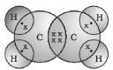
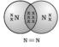
b.

Answer the following questions 5 Marks.
- a.
Saturated carbon compounds | Unsaturated carbon compounds
Have single bond between carbon-  carbon atoms | Have double or triple bond between carbon-  carbon atoms
Less reactive | More reactive
Undergo substitution reaction | Undergo addition and substitution reaction
Gives blue flame on combustion | Gives yellow / red flame on combustion
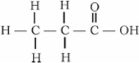
- i. C2H5COOH

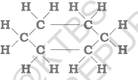
  - C6H12

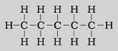
  - C5H12

CHAPTER-7: HOW DO ORGANISMS REPRODUCE?
KEY ANSWER

Multiple Choice Questions:
  - D. Plasmodium, Amoeba, Leishmania
  - B. primary shoot, primary root
  - B. Fragmentation
  - A. Urethra
  - D. pollination, fertilization, embryo, seed
  - B fallopian tube
  - A Gonorrhoea
  - A. AIDS
  - C. ovary and ovule
  - D to maintain the temperature required for sperm production.
  - C. regeneration of tissues by development in specialized cells
  - B. I, III, IV, II
  - A. Bacteria
  - C. Ovary and radicle
  - B. regeneration
  - D. Placenta
  - C. Fertilization of the egg is possible only in the structure shown in Figure-A
  - D. causes less variation
  - A. Spore formation
  - C. Chemotropism

- Answer the following questions (One mark)
- Amoeba, and Leishmania
- No.
Reason: For self-pollination, a flower must have stamens and pistils / the flower must be bisexual.
- The testicles produce hormone testosterone.
They produce sperm cells, which are the male sex cells.
- Sexual reproduction involves the combining of genetic material from two organisms. Sex cells are produced by meiosis.
- Flower A undergoes self-pollination, because it is a bisexual flower (has both male and female reproductive parts)
- Reproduction that occurs through the union of male and female sex cells is called sexual reproduction.
- AIDS and Warts
- No. This is because the copper T is inserted into the uterus to prevent pregnancy. Sexually transmitted diseases can be prevented by using a condom.
- The government has banned prenatal sex determination to eliminate sex discrimination caused by female foeticide, which is a low ratio of females to males.
- b) When plant generations are produced through pollination. Because variations are greater through sexual reproduction.
- Plants that grow from seeds exhibit variation.
This is because sexual reproduction produces more variation.
- Amoeba: 30
Gamete: 23

Answer the following questions.(Two marks)
- ​
  - The thread like structures that grow on the tomato are hyphae of Rhizopus ( Bread mould )
  - They have blob like structures called sporangia Sporangia contain spores, they reproductive structures
  - When spores come into contact with moist surface, they begin to grow

  - Therefore cut tomato gets spoiled gradually.
- ​
  - If the egg is not fertilized, the lining slowly breaks down and is shed through the vagina in the form
  - of blood and mucus.
  - This cycle occurs approximately every month and is called menstruation.
- ​
  - In women who have reached puberty, an egg is produced every twenty-eight days.
  - The uterus prepares itself every month to receive a fertilized egg.
  - Its lining becomes thick and spongy.
  - This preparation is necessary to nourish the egg if it is fertilized.

  - A bud develops as an outgrowth by repeated cell division in a specific part of the Hydra.
  - These buds develop into small organisms and after full growth, they separate from the parent body and become new independent organisms.
  - Buds are produced in the cavities along the leaf margin in the Bryophyllum.
  - These buds fall to the soil and grow into new plants.

- ​
  - Germ cells receive half the amount of DNA by a process of cell division called meiosis.
  - This is necessary to ensure that the number of chromosomes and the amount of DNA in the new generation are reassigned
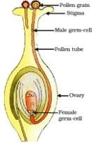
- * The fertilized egg is called a zygote. The zygote cell continues to divide and becomes a ball of cells
* It reaches the uterus and implants in the uterine lining. Then slowly body parts begin to appear
- ​
  - In men, a vasectomy surgery is to block the vas deferens and prevent the transport of sperm.
  - In women, a tubectomy surgery is to block the fallopian tubes and prevent the transport of eggs.
- ​
  - Physical contraceptive methods have side effects.
  - Contraceptive devices such as the IUCD or Copper-T are inserted into the uterus to prevent pregnancy. They can cause side effects due to uterine irritation.
- ​
  - Pollination is the process by which the pollen grains of stamens in a flower are transferred to the stigma of pistil. It occurs through wind, water, and insects.
  - Fertilization occurs in the ovary by the union of male and female gametes.
- * Avoids unwanted pregnancy.
* Do not spreads sexually transmitted diseases.

Answer the following questions (Three marks)
- (a) Sperm formation requires a lower temperature than body temperature.
- Testosterone regulates / stimulates the formation of sperm.
- Secretion of Prostate gland makes the transportation of sperm easier.
Thus reproductive fertility is sustained by the formation, stimulation to the formation and proper transportation of sperms.

- ​
  - The transfer of pollen from the stamen to the stigma.
  - Germination of the pollen: Pollen tube develops.
  - Fertilization: Pollen grain enters the ovary through pollen tube and fuses with the ovum / egg. Zygote is formed.
  - Ovum develops into seed. Ovary grows rapidly and ripens into fruit.
  - Petals, sepals, stamen, style and stigma may shrivel and fall off.
- a) Sexual reproduction has the involvement of DNA molecules from two different organisms. (The combination of male and female gametes with different genes takes place)
The variations in each generation of population of organisms increase due to new combination of genes.
b) Placenta: Provides a large surface area for glucose and oxygen to pass from the mother to the embryo. Removes waste substances generated by the developing embryo by transferring into the mother's blood

- Hydra:
- Reproduction by budding
- Development of an external bud by repeated cell division in a specific part
- The bud develops into an independent organism.
Planaria :
  - Reproduction by regeneration.
- Specialized cells grow.
- Differentiated cells undergo changes and become tissues / development.
- Many parts of the organism grow into separate organisms.

- The fertilized egg (zygote) divides and becomes an embryo.
- The embryo attaches to the lining of the uterus.
- Continues to grow and develop organs, becoming an embryo.
Nutrition:
- Through the placenta, a special plate-shaped organ.
- The fetal tissue has villi and the maternal tissue has blood vessels.
- It provides glucose and oxygen to the growing fetus.

  - Sexual reproduction is the process by which DNA molecules are replicated. Variations occur.
  - Variations can lead to the creation of new species.
  - Sexual reproduction is responsible for ensuring the survival of species.
The reproductive methods shown in the two images above are different from each other.
Spirogyra | Planaria
Reproduces by fragmentation | Reproduces by regeneration
After growth, they divide into small pieces.  These pieces grow into new organisms. | When broken into many pieces, each piece grows  into a complete organism.

- Pollination is the process by which pollen grains from the stamens of a flower are transferred to the
stigma of a pistil.
Self-Pollination | Cross pollination
The pollen grains in the stamen of a flower are transferred to the pistil of the same  flower. | The pollen grains in the stamen of one flower are transferred to the pistil of another flower.
No external media required | External media is required.

- ​
  - After fertilization, the zygote divides several times inside the egg, producing an embryo.
  - The egg develops a thick layer that slowly changes into a seed.

  - The ovary grows rapidly, matures, and ripens. Meanwhile, the petals, sepals, stamens, pistils, and stigmas fall off easily.
- ​
  - Spores are produced in large numbers. This increases the number of organisms of this species.
  - Spores are covered with a thick wall that protects them until they come into contact with moisture and begin to grow.
  - Spores are dispersed over long distances by the wind, which results in the spread of organisms over long distances.
- ​
  - The process by which the mother cell's DNA copies itself during the preparatory phase of cell division.
  - In sex cells, meiosis results in the number of original chromosomes being half.
  - In sexual reproduction, when male and female gametes fuse, the number of chromosomes is restored to the original number.
- ​
  - The placenta is a specialized, plate-like tissue embedded in the wall of the uterus.
  - It provides nutrients to it, removes waste products produced in the fetus into the mother's blood.
  - Because sperm formation requires a lower temperature than the normal body temperature.

- i) Testis
- Penis
- Prostate gland and Seminal vesicle

- Answer the following questions: (four marks)

  - Testis : They produce sperms and testosterone hormone which is responsible for male characters.
  - Scrotum : They regulate temperature necessary for production of sperms.
  - Urethra and vas deferens: Transport sperm from testis.
  - Prostate gland and seminal vesicle : They add their secretion to make the sperm transport easier and provide nutrition.
  - Penis : Delivers the sperms to the site of fertilization.
- Sexual maturity is necessary because,
In Males:
  - Development of testicles for sperm production/testosterone production.
  - Development of testicles for reproduction.
  - To develop secondary male sexual characteristics.
- ​
  - Ovary: Produces eggs (female sex cells) and some hormones.
  - Fallopian tube: The passage way through which the egg travels and where fertilization occurs.
  - Uterus: A distendable sac-like structure where a fertilized egg attaches and develops into an embryo.

  - Vagina: The part that receives sperm during sexual intercourse.
- Structure of the placenta: -
  - The foetus receives nourishment from the mother's blood through the placenta, a specialized tissue.
  - It is a plate-like structure embedded in the uterine wall.
  - It is bordered by the foetal tissue.
Functions of the placenta: -
- Provides nutrition (glucose) and oxygen from the mother to the foetus.
- Removes waste products from the foetus.

  - They produce flower and fruit quickly.
  - This method is useful in plants that do not produce seeds.
  - They are genetically similar to the parent plant.

  - They produce high-yielding, disease-free plants.
  - A large number of plants can be grown in less time and at lower cost.

Multiple Choice Questions
  - B. Gregor Mendel
  - B. Pea
  - C. 3 : 1
  - D. 1 : 1
  - D. Heredity
  - B. XY
  - A. trit for height is dominant
  - D) TtWw
  - A) Dominant
  - C) DNA
  - D) Self-pollination
  - A) F1
  - A) 0
  - C) Round and yellow seeds
  - A) 25%
  - B) black

CHAPTER-8: Heredity Key Answers

  - A) the gene responsible for light-colored eyes is dominant
  - B) will have the maximum number of successful variations in the next generation.

One Mark Questions
- Ggaa
- Female
- Because the father has different chromosomes (XY)
The child who gets the X chromosome from the father will be a girl. A child who receives a Y chromosome from the father will be a boy.
- 3 : 1
- 1 : 2 : 1
- Flowers with only stamens cannot be pollinated because they do not have pistils
- Changes in asexual tissues are not transferred to the DNA of the gametes.
- The unit of DNA that provides the information required for the production of proteins is called a gene
- The transfer of characteristics of organisms from one generation to another is called heredity
- If the gamete receives a Y chromosome from the father, then the gamete will be a boy.

Two Mark Questions
- Crossbreeding of parents showing different traits for one trait is called monohybrid cross. Phenotypic ratio: 3 : 1
- Crossbreeding of parents showing different traits for two traits is called dihybrid cross. Ratio: 9 : 3 : 3 : 1
- Dominant Traits: If one of the two copies of a trait shows more of the visible trait in the offspring, it is a dominant trait
Weak Trait: If one of the two copies of a trait shows less of the visible trait in the offspring, it is a weak trait
- i) Types of plants obtained in the F1 generation: Tall pea plants with red flowers
ii) The ratio of plants obtained in the F2 generation is 9 : 3 : 3 : 1 Types of plants Red Tall – 9 Red Short-3 White Tall-3 White Short-1
- In sexual reproduction, organisms with two different characteristics mate. This is the reason for more differences in the generation. During the production of sex cells, the DNA molecules recombine to produce the favourable traits.
- ​
Male sex chromosomes | Female sex chromosomes
There is a pair of mismatched sex chromosomes | There is a complete pair of sex chromosomes

There is a normal size X chromosome and a smaller size  Y chromosome. | There are XX chromosomes of equal size
- a) Pure white dog breed with expression ratio 1: 1
b) Dog breed types found in gene pattern
1 : 2 : 3
Pure black dog : Mixed black dog : Pure white dog

Three Mark Questions
- ​
Gametes | T | t
T | TT | Tt
t | Tt | tt
Phenotypic ratio: 3 : 1
Genotypic ratio: 1 : 2: 1

- ​
Gamets | RY | Ry | rY | ry
RY | RRYY | RRYy | RrYY | RrYy
Ry | RRYy | RRyy | RrYy | Rryy
rY | RrYY | RrYy | rrYY | rrYy
ry | RrYy | Ryyy | rrYy | rryy
Ratio: 9 : 3 : 3 : 1 Round yellow seed-9 Round green seed-3 Dry yellow seed-3
Dry green seed-1
- ​
  - In the parent plants, the trait for red flowering is dominant and the trait for white flowering is weak
  - The sex genes of the parent organism have only one copy of these traits.
  - The plant in the generation has one copy of the dominant trait (R) and one copy of the weak trait (r).
  - All the plants in the F1 generation produce red flowers.
  - The gene pattern of the parent organism that produces red flowers is RR
  - The gene pattern of the F1 generation plant is Rr
- ​

Red × White
RR × rr
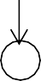
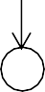

R

r
Rr F₁ (All red)
Reason: Because in the F1 generation, the red flower gene (R) is combined with the white flower gene (r). The red flower gene is dominant and expressed.
- In humans, females have two X chromosomes and males have one X and one Y chromosome. During meiosis, the chromosomes are halved.
The female produces an X and the male produces an X or Y, so sex is determined by the male chromosomes. If the male's X combines with the female's X, the child will be a girl.
If the male's Y combines with the female's X, the child will be a boy.
- * Mendel crossed pure tall and dwarf pea plants. He sowed the seeds obtained from them and called the resulting plants the first generation (F1).

- All these plants were tall. He made sure that the tall plants were self-pollinating. When the resulting seeds were sown, he called the resulting generation the second generation (F2).
- Not all of these plants were as tall as the first generation. Instead, about a quarter of them were dwarfs.
- From this experiment, Mendel concluded that the tall plants obtained in the first generation were not pure plants. Instead, they had both the tall and dwarf traits. The reason they were all tall was because the tall trait was strong and the dwarf trait was weak.
- ​
F₂ generation | R | r
R | RR | Rr
r | Rr | rr
Genotypic ratio: 1 : 2 : 1
1Pure round seed plant : 2 Mixed round seed plant : 1 Pure wrinkled plant
- Refer Q.No. 34 and do it yourself.
- Refer Q.No. 34 and do it yourself.

CHAPTER – 9: Light Reflection and Refraction Key Answers

Multiple choice questions.
  - B) Beyond C
  - A) CD
  - D) At the centre of curvature and inverted.
  - B) +2.0 D and convex lens
  - A) Virtual, erect and enlarged.
  - C) S
  - D) Thin at the edges and thick in the middle
  - C) Beyond 2F1
  - B) Diverges the light rays.
  - A) Concave mirror and virtual image
  - B). Increases and bends away from the normal
  - B) Convex mirror
  - B) Rear view mirrors of vehicles
14. B) Pole
- B) Diverges the light rays.
- B) Focus
- D) Between F and O
- A) R=2f
- B) Dioptre
- C) 0.50m
- B) +3.0
- B) N and K
- A) n1 = n2 & n3 > n4
- C) R
- C) In F1
- B) 500
- D) 25 cm.
- C) 4 m.
- B) Speed of light is more in medium B
- ​
- (A) Real and enlarged.
- (D) – 0.40 m and concave lens
- (B) is thick at the edges and thin in the middle
- (A)+ 2.0 D and convex lens
- (B) At 2F1

Answer the following questions. (1-mark questions)
- ​
  - Produces diminished and erect images.
  - The field of view is very large due to curvature towards the outer edge.
- The reflecting surface of a spherical mirror forms a part of a sphere. The centre of this sphere is called the centre of curvature.
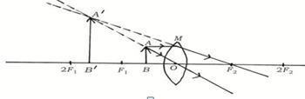
- ​

- Converging distance of the lens (f) = + 0.5 m Power of the lens = P = 1/f
=1/0.5
P = + 2D

- f= 25, R=?

R = 2f
= 2 x 25 = 50 cm

- The phenomenon of light falling on a surface returning back to same medium.
- The fact that the sides of the image are exchanged with the sides of the object is called lateral inversion
- If the reflecting surface of a mirror is a surface of a spherical mirror, it is called a spherical mirror.
- Parallel light rays falling on a concave mirror are reflected and meet at a point on the principal axis. This point is called the principal focus.
- Parallel light rays falling on a convex mirror are reflected as if they had come from a point on the principal axis. This point is called the principal focus of the convex mirror.
- The diameter of the reflecting surface of the spherical mirror.
- 1/f=1/V+1/u
- ​
  - Because the velocity of light is the same in both the media.
  - There is no change in the direction of propagation of light.
- The opposite faces of the glass slab are parallel, and the bending of the light ray is equal and opposite.
- The image moves from the principal focus towards the mirror.
- Parallel light rays passing through a convex lens are refracted and intersect at a point on the principal axis. This point is the focal point. 1
- Parallel light rays passing through a concave lens are refracted as if they were coming from a point on the principal axis. This point is the focal point of the concave lens.
- 10cm
A lens with a shorter focal length converges light more strongly, while a lens with a longer focal length converges it less strongly.
- The speed of light is faster in medium A.
Because it has a lower refractive index compared to medium B.

Answer the following questions. (2 Mark Questions)
- i. The angle of incidence is equal to the angle of reflection.
ii. The incident ray, the reflected ray and the perpendicular drawn at the point of incidence lie in the same plane.

- ​
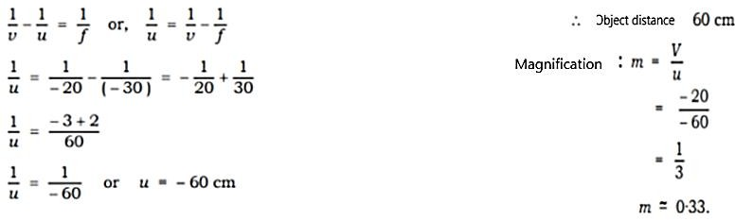
- Try as in the above question. 58)

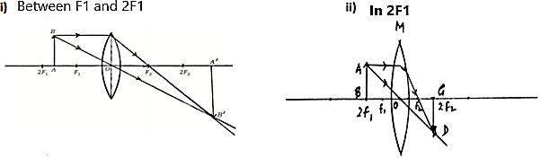
59)
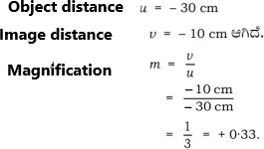
Since v and u are negative, the lens used is concave lens. Since the magnification is also positive and less than one, the image is erect and diminished virtual.
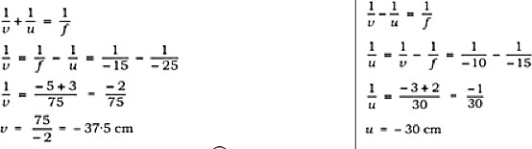
60)
- ​
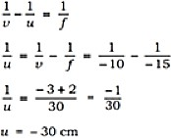
- ​
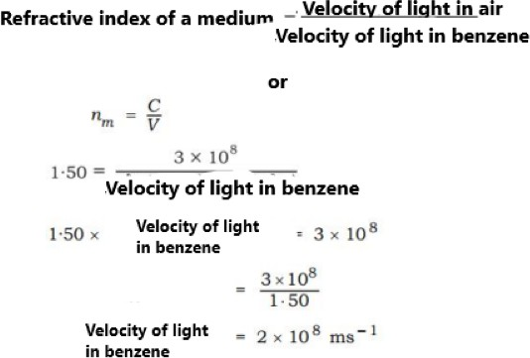
- ​

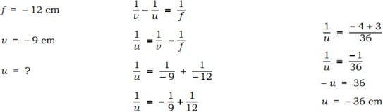

- ​
- The central point of a lens is called optic centre.
- The diameter of the circular boundary of a spherical lens is called its aperture.
- When light travels obliquely from one medium to another, the direction of propagation in the second medium changes.
For a given colour of light and a given pair of media, the ratio of the sine of the angle of incidence to the sine of the angle of refraction is constant.
Sini / sinr = constant
- ​
Convex mirror | Concave mirror
The reflecting surface is bent outwards | The reflecting surface is bent inwards. It is bent.
diverges the rays of light. | converges the rays of light.
Always produces virtual and erect image | Always produces a real and inverted image.
- Mirrors with curved surfaces are called spherical mirrors, Types: Concave mirror convex mirror
68)
  - Used in torches, searchlights, and vehicle headlights to produce a powerful parallel beam of light.
  - Used by doctors to examine cavities in teeth
  - Used to get a large image of a face in a barber shop
  - To focus the sun's rays in solar ovens.
69)
Convex lens | Concave lens
Thin at the edge and thick in the middle | Thick at the edge and thin in the middle
converges the rays of light | Diverges the rays of light
Producesreal and inverted image | Produces false and direct image

70)
Real image | virtual image
Inverted image | Erect image
Image that can be obtained on a screen | Image that cannot be obtained on a screen

71)
  - Light travels faster through ice.
  - Because the refractive index of ice is less than that of water, light travels faster in optically rarer medium than in a optically denser medium.
72)
  - The reflected ray through the principal focus of a ray incident parallel ray to the principal axis
  - The reflected ray of a ray incident through the principal focus.
  - The reflected ray in the same direction as the ray incident through the center of curvature.
  - The reflected ray of a ray incident obliquely on the pole of a mirror.

73)
  - The light coming towards us from the part of a pencil immersed in water appears to come from a different direction than the surface adjacent to the outside of the pencil.
  - Refraction of light

74)

75)

- ​

- The ray refracted through F2 coming from an object parallel to the principal axis.
- The refracted ray of a ray passing through the principal focus from an object.
- The ray passing through the optical centre from an object.

- Virtual and erect.
- The image is equal to the size of the object.
- The image is formed at the same distance behind the mirror as the object is in front of the mirror.
- It has a lateral inversion.

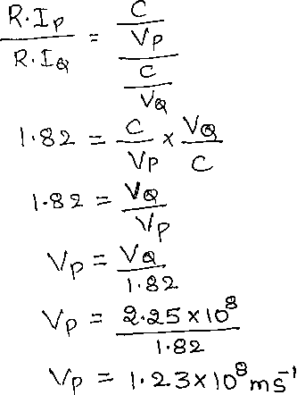
- The phenomenon is caused by the refraction of light.
Density of the mediums is different and light is passing through the both mediums.
- Conductors: M, N
Insulators: L, O
- a) concave mirror
b) virtual and erect, behind the mirror.

Answer the following questions. (Three marks questions)
- i) Concave mirror
- 50 cm
- Virtual, erect and same size as the object.
- ​
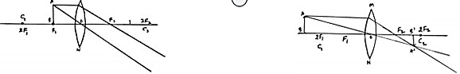
- ​
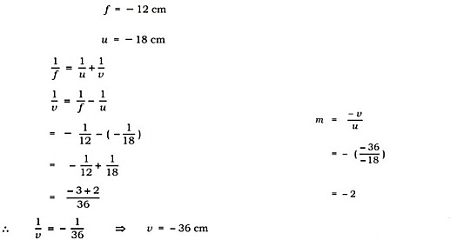

- ​
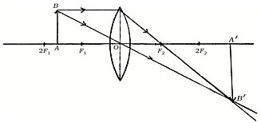
Beyond the 2F2
Real inverted and diminished
- This is a diverging lens.
Because the power is negative, covcavelen
The diverging property of concave lens is to correct nearsightedness. The image of the object is formed on the retina, in front of the retina. Your lens of appropriate power produces a diverging image on the retina.
- a) The laws of refraction of light are as follows.
- The incident ray, the refracted ray, and the perpendicular drawn to the point of incidence at the point of contact of the two media are all in the same plane.
- For a given color of light and a given pair of media, the ratio of the sine of the angle of incidence to the sine of the angle of refraction is constant. This is called Snell's law of refraction.
b) Medium one is denser because when a ray of light enters a denser medium from a rarer medium, it bends towards the vertical.
- ​
  - The object is always placed on the left side of the mirror. This indicates that the light from the object always falls from the left side.
  - All distances parallel to the principal axis are measured from the mirror pole.
  - All distances measured to the right of the origin (+X) are taken as positive and all distances measured to the left of the origin (-X) are taken as negative.
  - Distances measured perpendicular to or above the principal axis are taken as positive.
  - Distances measured perpendicular to or below the principal axis are taken as negative.
- ​
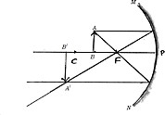
Beyond C
Real, inverted and enlarged
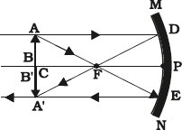
- ​
At C
Real, inverted and same size

- ​
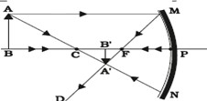
Real, inverted
Smaller than object
- ​
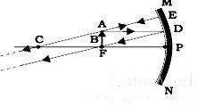
Real, Inverted, Enlarged At infinite
- ​

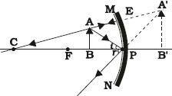
Virtual and Erect
Back side of the mirror
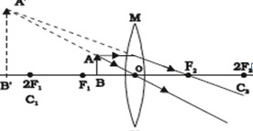
- ​
Virtual and Erect Enlarged
- Solution.
Magnification of image = m = -0.5 Object distance u= - 15 cm
Image distance v =? F= ?
m=- v/u
-v=m×u 1
= 0.5×-15
- v= -7.5 cm v= 7.5 cm
Convergence distance

1/f=1/v+1/u
1/f =1/7.5-1/15
f= 5cm
Nature of image – virtual and erect Size:- Diminished
- ​
  - A convex lens is held in the hand and directed towards the solar image.
  - The rays of sunlight are focused on a sheet of paper.
  - A bright and sharp solar image is obtained on the sheet.
  - The paper and the lens are held in this position for some time.
  - The sheet of paper starts burning, emitting smoke.
  - The parallel rays of the sun are focused and a sharp solar reflection is formed
- ​
  - Hold a concave mirror in your hand and point its reflecting surface towards the sun.
  - Direct the reflected rays to fall on a sheet of paper held close to the mirror.
  - Slowly move the sheet of paper back and forth until a sharp point of bright light rays is seen on the sheet.
  - Hold the mirror and the sheet of paper in this position for a few minutes.
  - The paper will start to burn, producing smoke.
  - The mirror will focus the sunlight.
  - The distance between the mirror and the paper is the approximate focal length of the mirror.

IV. Answer the following questions. (Questions of four marks)
- ​
  - Fix a sheet of white paper on a drawing board with the help of drawing pins.
  - Place a rectangular glass plate in the middle of the sheet.
  - Draw lines around the glass plate with the help of a pencil.
  - Take four identical ballpoint pens and pierce two of them in such a way that they form a slanted line with the upper edge perpendicular to the sheet.
  - Look at the reflections of the pierced pins from the opposite edge of the plate and pierce the other two pins so that they are in line with the reflections of the first pins.
  - Remove the pins and the glass plate.
  - Join the ends of the upper pins to the upper edge and the ends of the lower pins to the lower edge.
  - Join the two points of the glass plate.
- a) Magnification is the ratio of the size of an image to the size of an object. magnification of +2 means a convex lens.
b) Medium B, Medium A

CHAPTER – 10: HUMAN EYE AND COLOURFUL WORLD MODEL KEY ANSWERS

MULTIPLE CHOICE QUESTIONS
  - B. retina
  - A. eye lens
  - C. concave lens
  - D. cataract
  - B. farsightedness and use of appropriate convex lens
  - A. ciliary muscles
  - A. refraction of light
  - C. black
  - D. red
  - C. focal length of the lens increases
  - D. very large particles scatter all colours equally
  - A. real and inverted
  - C. red
  - B. sky appears blue to an astronaut flying at very high altitudes
  - A. 380
  - B. Red and Blue

Answer the following questions (One mark)
- The minimum distance at which an object can be clearly seen by the eye is called the near point .The minimum point of normal vision is 25cm.
- The maximum distance at which the eye can see clearly is called the far point. The maximum point of normal vision is infinity
- The spectrum of white light is the list of coloured components obtained when light is dispersed through a glass prism.
- There are three common defects of vision
  - Myopia
  - Hypermetropia
  - Presbyopia
- The particular shape of the prism makes the emergent ray bend at an angle to the direction of the incident ray. This angle is called angle of the deviation.
- The angle between its two lateral faces is called the angle of the prism.
- The emergent angle of the prism is the angle at which a light ray exits the prism.
- a) cornea
b) iris
- farsighted eye; remedy is a using convex lens
- The splitting of white light into its constituent colours.
- No, rainbows are not observed on the moon as there is no atmosphere.
- Near point: 25 cm far point: Infinity
- Rainbow, blue sky, atmospheric refraction twinkling of stars, blue sky
- Adjustment of the lens focal length to clearly focus near or distant objects
- Red, because it scatters the least and is visible from long distances even in fog
- Student can’t read the blackboard from back: suffer from near-sightedness. It can be corrected with the concave lens
- Farsightedness can be corrected with concave lens
- to control the amount of light entering the eye
- X- angle of deviation
The particular shape of the prism makes the emergent ray bend at an angle to the direction of the incident ray.
- Sometimes the crystalline lens of people at old age becomes milky and cloudy. This condition is called cataract.

- least bent colour is red, and most bent colour is violet
- Yes / The spectrum of light forms on the screen.
Prism A disperses the white light into 7 colours; Prism B recombines the 7 colours of the spectrum to form the white light and Prism C disperses this white light into 7 colours and hence we see the spectrum of light on the screen.
- Dispersion of light is the phenomenon where white light splits into its constituent colours (the spectrum) as it passes through a medium like a prism.

Answer the following questions (Two mark)
- Farsightedness is the ability to see distant object clearly but not nearby objects. Cause: the eye lens is too short or the eyeball is too small.
- Near-sightedness is the ability to see nearby objects but not distant object. Cause: The eye lens is too long or the eyeballs is too elongated.
42 A rainbow forms when the sunlight is refracted, dispersed, and reflected inside water droplets, causing a spectrum of colours.
- Newton used prisms to separate white light into its spectrum and recombine it back into white light.
- Isaac Newton was the first to use to obtain the spectrum of sunlight. He tried to split glass prism the colours of the spectrum of white light further by using another similar prism. However he could not get any more colours. He then placed a second identical prism in an inverted position with respect to the first prism. He allowed the colours of the spectrum to pass through the second prism. He found a beam of while light emerging from the other side of the second prism. This observation gave Newton the idea that sunlight is made up of 7 colours.
- Near-sightedness: clear near vesion; corrected with concave lens. Farsightedness: clear distant vision; corrected with convex lens.
- A: nearsighted eye, the image forms in front of retina B: farsighted eye, the image forms behind retina
C: normal eye, the image forms on retina
- A -2.0 D lens is a concave lens, used for nearsightedness. The conditions described is farsightedness requiring a convex lens. Hence this lens is not suitable for correcting that defect.
- To see distant objects: ciliary muscles relax, lens become thin, focal length increases To see near objects: ciliary muscles contract, lens become thick, focal length decreases
- The correct option is c) myopia
Predominately young folks suffer from myopia which occous due to elongation of eye balls or bulging of cornea. When the normal curvature of the cornea bulgers, the light are refracted so that the image is formed in front of the cornea. The rods and cones of eyes have areas where the image has the best clarity when the image is focoused. Thus as the image of the distant objects is not formed at the right spot, it is decoated as blurry.
- At sunrise and sunset, the sky appears red because sunlight travels a longer distance through the atmosphere, causing blue light (shorter wavelengths) to be scattered away more effectively by air particles.

Answer the following questions (Three mark)
- The scattering of light by tiny particles in a colloid or in the atmosphere is the Tyndall effect. Ex: blue sky, smoke from engines, light in milk
- The molecules of air and other fine particles in the atmosphere have size smaller than the wavelength of visible light. These are more effective in scattering light of shorter wavelength at the blue end than light of longer wavelengths at the red end. The red light has a wavelength about 1.8 times greater than blue light. Thus, when sunlight passes through the atmosphere, the fine particles in air scatter the blue colour more strongly than red. The scattered blue light enters our eye.

- ​

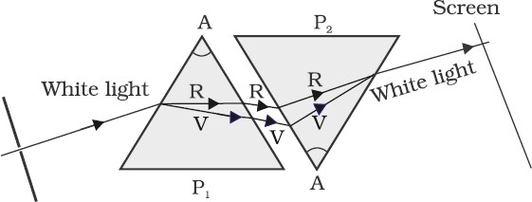
- Stars are far away and appear as point sources of light. As there light enters the earths atmosphere, it gets refracted continuously due to air layers. This causes their positions and brightness to fluctuate hence they twinkle.
Planets are closer and appear as extend sources. The light from different parts of a planet averages out, so they appear steady and do not twinkle.
- Presbyopia is age-related farsightedness caused by the hardening of the eye lens or weakening of ciliary muscles. It is corrected with bifocal lenses. A condition usually seen in older people where they can’t see nearby objects clearly
Causes: weakening of ciliary muscles, loss of flexibility in the lens Remedy: use of bi focal lenses
- Power (P)= -0.5 D
Focal length(f)= 1/P = 1/-0.5 = -2 meters Since the power is negative it is a concave lens
In myopia image forms in front of retina. A concave lens diverges incoming light rays so they focus correctly on the retina, not in front of it.
- a) A normal eye cannot focus on objects closer than 25 cm due to the limits of the eye's lens to adjust its focal length. This distance is called the least distance of distinct vision.
  - Smaller particles scatter shorter wavelengths (like blue and violet) more, which is why the sky appears blue. Larger particles scatter all wavelengths equally, leading to white light.
- 1). a) At noon, sunlight travels a shorter distance through the atmosphere, so there is minimal scattering of colors. As a result, all wavelengths reach our eyes, and the sun appears white.
  - The human eye functions like a camera. The convex lens focuses light onto the retina. The eye adjusts the lens's shape to focus on objects at various distances (accommodation).
- a) Iris – Controls the amount of light entering the eye by adjusting the pupil size.
  - Pupil – The opening through which light enters the eye.
  - Cornea – Transparent front layer of the eye that helps in focusing light onto the retina.
- ​
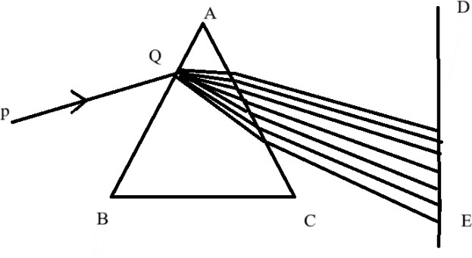
- Name the phenomenon seen here.
- Dispersion of light.
- Write the reasons.
- Different colours (wavelengths) of light refract at different angles when passing through the prism, resulting in the separation of white light into its constituent colours (VIBGYOR)
- a) i) The student has myopia (near-sightedness).
This is caused by the eye's lens having too much converging power or the eyeball being too long.
ii) The defect can be corrected by using a concave lens.
b) i) This phenomenon is called the Tyndall effect.
ii) The Tyndall effect is not normally visible in clean, clear air because the air is a true solution, not a colloid.

- a) Because the hot air is constantly rising and mixing with cooler air, creating a turbulent medium with a continually changing refractive index.
  - Splits white light into components.
- a) This is because of the atmospheric refraction of light. This happens because the air near the fire is heated, causing it to become less dense than the cooler air surrounding it.
  - The green ray will have a greater angle of deviation than the yellow and red rays. The deviation for each color depends on its wavelength and the refractive index of the glass.

Answer the following questions (Four mark)
- a) Phenomenon of formation of rainbow in the atmosphere: Rainbow is caused by the dispersion of sunlight by tiny water droplets present in the atmosphere. The water droplets act like small prisms; they refract and disperse the incident sunlight, then reflect it internally and finally refract it again when it comes out of the raindrop. Due to the dispersion of light and internal reflection, different colours reach the observer’s eye.
  - Twinkling of stars: The twinkling of stars is due to atmospheric refraction of starlight. The starlight on entering the earth’s atmosphere, undergoes refraction continuously before it reaches the earth.
The atmospheric refraction occurs in a medium of gradually changing refractive index as the path of rays of light coming from the star goes on varying slightly, the apparent position of the star fluctuates and the amount of starlight entering the eye flickers. This is the twinkling effect of stars.
- a) Myopia: Myopia is a defect of vision; a person with this defect can see nearby objects clearly but cannot see distant objects distinctly. A person with this defect has the far point nearer than infinity. Total In a myopic eye, the image of a distant object is formed in front of the retina and not at the retina itself. Causes for myopia:
- Excessive curvature of the eye lens.
- Elongation of the eyeball.
b) Power of accommodation of eye: The ability of the eye lens to adjust its focal length. While seeing the distant objects
- the curvature of the eye lens gets modified / decreases by ciliary muscles
- the focal length of the eye lens increases
- the eye lens becomes thin

CHAPTER – 13: OUR ENVIRONMENT KEY ANSWER

Multiple choice questions (one mark)
  - B. 5 J
  - A. undergo recycling naturally in the environment
  - A. Plant fibers
  - C. O3
  - B. herbivores
  - A. algae
  - B. Herbivores
  - C. In the order of increasing accumulation of harm full chemicals
  - D. Cake, tree and grass
  - B. Grass, goat and human
  - D. All of the above.
  - D. The loss of energy is more than the amount of energy available.
  - C. increase the concentration of harmful chemicals in various trophic levels

Answer the following questions (One Mark)
- Break down the complex organic substances into simple inorganic substances. Break down dead remains and wastes of organisms.
- Decompose dead wastes (organic) of plants and animals thus keep surroundings clean and maintain ecological balance.
- Chlorofluorocarbon -CFC’s are responsible for the decrease in the amount of ozone layer which protects the earth from ultraviolet rays of sun.
- The process of increasing the storage of harmful chemicals in the organisms that found in trophic levels of various food chains.
- Ozone protects the earth's surface from ultraviolet radiation from sunlight at high levels of the atmosphere. In this way, it protects living things on earth.
- Because as reaching to high trophic level of food chain, the amount of available energy goes on decreasing.
- The transfer of food energy from one level to another in a food chain is called a food chain.
- At each trophic level of a food chain, 10 percent of the energy is lost. Due to this, the availability of energy for the next trophic levels decreases.
- CFCs cause the thinning of the ozone layer.
- 1 J
- Plastic pen is non-biodegradable thing.
- Fourth tropic level
- i) Producers / Plants
ii) CFC

Answer the following questions (two marks)
- (i) Birds are disturbed more due to biomagnification. As the birds occupy the topmost level in the given food chain, the maximum concentration of harmful chemicals causing bio magnification get accumulated in their body.
(ii) Biomagnification is the process of accumulation of non degradable chemicals in the various trophic levels of food chain.
As the chemicals are non-degradable or cannot be washed, they cannot be removed from the organisms of the food chain. This leads to gradual destroying of the ecosystem.
- ​
  - Cucumber piece and banana peel are organic substances.
  - They are biodegradable substances and are ecofriendly.
  - Glass piece and plastic pen are inorganic / synthetic substances.
  - They are non-biodegradable substances and cause soil pollution.
- ​

  - The flow of energy in the food chain is unidirectional.
  - The energy that is captured by autotrophs does not revert back to the solar input.
  - The energy which passes to the herbivores does not come back to autotrophs
  - The energy available at each trophic level gets diminished progressively due to loss of energy at each level.
- ​
  - These substances do not undergo natural recycling and remain inert in the environment.
  - May harm the various members by adding into different stages of ecosystem / cause ‘Biological magnification’.
  - Cause environmental pollution.
- By adopting following methods:
  - Segregation of dry wastes and wet wastes.
  - Reusing of wet wastes by converting them into manures.
  - Recycling dry wastes • Limiting the use of disposable materials
  - Following eco-friendly packaging.
- Grass → Grasshopper → Frog → Snake → Eagle •
  - If the number of organisms in the second trophic level increases, then the number of organisms in the first trophic level decreases.
  - Eventually population of the rest of the organisms in the trophic levels decreases and leads to ecological imbalance.
- 1000 calory according to law of 10%
- * Diatoms → Insect larvae → Fishes → Birds
Producers → Pri. Consumer → Sec. Consumer → Ter. Consumer 10,000 → 1000 → 100 → 10
* Organisms in the first trophic level that produced the energy was 10,000 calories
- green plants are having the amount of energy – 70000 kJ (Law of 10%)
- T / 3 Tiger
These chemicals are not degradable and get accumulated at each trophic level and hence the top level in any food chain the maximum concentration of these chemicals is accumulated.
- * Grass → Grasshopper → Frog → Snake
* Snake
- ​
  - remain inert in the environment.
  - cause ‘Biological magnification’.
  - cause environmental pollution
- ​
  - The higher energy UV radiations split apart some molecular oxygen (O2) into free oxygen (O) atoms. These atoms then combine with the molecular oxygen to form ozone.
  - Ozone protects the earth's surface from ultraviolet radiation of the sun
- Bio-degradable substances: Decomposed by microorganisms, do not cause bio magnification ,can be converted into compost.
Ex: Kitchen wastes, paper, sewage
Non-degradable substances: Not decomposed by microorganisms, cause bio magnification, can be recycled.
Ex: Plastic, metal cans, glass, polymer
- ​
  - The flow of energy in the food chain is unidirectional.
  - Only 10% of energy is available to the next trophic level.
  - Amount of harmful chemicals increases in the food chain at the higher trophic levels.
- Created ecological imbalance in the environment. yes, because the primary, secondary and tertiary consumers are getting food from the producers so they cannot survive in the ecological balance so it will be cherished away

- Biodegradable materials release bad smell and some harmful gases when they decompose. This causes air pollution.
Areas where biodegradable materials decompose cause soil and water pollution, which in turn leads to an increase in harmful insects, rats and other pests.
- Ozone is a molecule formed by three oxygen atoms. Ozone is formed when ultraviolet radiation in the upper atmosphere breaks down oxygen molecules into oxygen atoms and combines with them to form ozone.
- These are not naturally recycled and remain inactive in the environment for a long time. They can harm many organisms at different levels in the ecosystem and bring about biological enrichment. These cause environmental pollution.
- Any unit in nature that interacts between biotic and abiotic components is called an ecosystem. Its main components are biotic and abiotic components.
- Biotic component: All units that have the characteristics of living things For example: plants, animals and microorganisms.
- Abiotic components: Components without living things Ex: air, water, soil, heat
- ​
  - The flow of energy in a food chain is one-way.
  - The energy captured by autotrophs does not return to the solar energy.
  - The energy that is absorbed by herbivores does not return to their parents.
  - The energy available at each trophic level gradually decreases due to energy loss at each level.
- Since only a small amount (10%) of energy is available to the next level of predators and the energy consumed at each level is high, a minimum amount of energy from the four trophic levels is left for use.

III. Answer the following questions (Three marks questions)
- a)
  - Very little energy is available (10%) for the next level of consumers. Or the loss of energy at each step is so great that very little usable energy remains after four trophic levels.

c)

- ​

- ​
b)
  - Decomposers breakdown the dead remains and waste products of organisms / Decomposers breakdown the complex organic substances into simple inorganic substances.
  - These substances are used up once more by the plants / Decomposers help in the natural replenishment of the soil.

  - Ozone layer shields the surface of the earth from ultraviolet radiation from the sun. This radiation is highly damaging to organisms.

  - Each step of the food chain is called a trophic level(T).
  - The energy that is captured by autotrophs does not revert back to the solar input.
  - The energy which passes to the herbivores does not come back to autotrophs.
  - The energy available at each trophic level gets diminished progressively due to loss of energy at each level.

Biodegradable materials | Non-biodegradable materials
Break down by biological processes | Does not break down by biological processes
Does not remain intact in the environment for a long  time | Remain intact in the environment for a long  time
Less harmful | More harmful
Less polluting | More polluting

