Subject Code | : | ITUE301 | Semester | : | 5 | Academic Year | : | 2026-27
Subject Name | : | Advanced Web Framework

Practical 1 | Practical 1: Introduction to React and Component Architecture
Problem Statement | Set up a React development environment using Vite and build a static student portfolio page using independently structured, reusable React components.  Component Tree:  App.jsx -> Header.jsx, About.jsx, Skills.jsx, Footer.jsx  Key Requirements:  - Use Vite as the build tool and dev server  - Create separate .jsx component files for Header, About, Skills, and Footer  - Pass data from App to children via props (name, title, tagline, themeColor, skills array, etc.)  - Demonstrate reusable, modular component architecture  - Use array iteration (map) to render the skills list dynamically
Main Code | // File: App.jsx (Root Component with Props)  import React, { useState, useEffect, lazy, Suspense } from 'react';  import { Routes, Route } from 'react-router-dom';  import NavBar from './components/NavBar';  import Footer from './components/Footer';  import PageFallback from './components/PageFallback';  // Route-based Code Splitting using React.lazy() (Practical 8 Core Requirement)  const Home = lazy(() => import('./pages/Home'));  const Projects = lazy(() => import('./components/Projects'));  const TaskManager = lazy(() => import('./pages/TaskManager'));  const Contact = lazy(() => import('./pages/Contact'));  const AuthPage = lazy(() => import('./pages/AuthPage'));  const NotFound = lazy(() => import('./pages/NotFound'));  // Supplementary: Heavy Component Lazy Loading on Demand  const PerformanceProfiler = lazy(() => import('./components/PerformanceProfiler'));  function App() {  // useState variable for theme mode toggle (Supplementary requirement)  const [darkMode, setDarkMode] = useState(true);  // Practical 7: Authentication state management  const [authUser, setAuthUser] = useState(() => {  try {  const stored = localStorage.getItem('awf_auth_user');  return stored ? JSON.parse(stored) : null;  } catch {  return null;  }  });  // Practical 8: State to trigger on-demand lazy loaded profiler component  const [showProfiler, setShowProfiler] = useState(false);  const handleLogout = () => {  localStorage.removeItem('awf_auth_token');  localStorage.removeItem('awf_auth_user');  setAuthUser(null);  };  const studentData = {  name: 'Kavya Chauhan',  title: 'Full Stack Web Developer & Computer Engineering Student',  tagline: 'Passionate about building scalable modern web applications with React, Node.js, and cloud technologies.',  themeColor: '#6366f1',  bio: 'I am a 3rd-year student pursuing Information Technology / Computer Engineering at Charotar University of Science and Technology (CHARUSAT). I focus on modern frontend frameworks, RESTful API architecture, and scalable full-stack applications.',  education: {  degree: 'B.Tech in Computer Engineering',  institution: 'Charotar University of Science and Technology (CHARUSAT)',  field: 'Advanced Web Development Frameworks (ITUE301)'  },  location: 'Gujarat, India',  experienceYear: 2,  skills: [  { name: 'React.js', level: 'Advanced' },  { name: 'JavaScript (ES6+)', level: 'Advanced' },  { name: 'Node.js & Express', level: 'Intermediate' },  { name: 'MongoDB & Mongoose', level: 'Intermediate' },  { name: 'HTML5 & Modern CSS3', level: 'Advanced' },  { name: 'Git & GitHub', level: 'Intermediate' },  { name: 'REST APIs & JWT Auth', level: 'Intermediate' },  { name: 'Vite & Modern Tooling', level: 'Advanced' }  ],  email: 'chauhankavya9116@gmail.com',  github: 'https://github.com/kavy009',  rollNo: '24CE017'  };  const handleToggleTheme = () => {  setDarkMode((prev) => !prev);  };  useEffect(() => {  if (darkMode) {  document.body.classList.remove('light-mode');  document.body.classList.add('dark-mode');  } else {  document.body.classList.remove('dark-mode');  document.body.classList.add('light-mode');  }  }, [darkMode]);  return (  <div className={`portfolio-app ${darkMode ? 'theme-dark' : 'theme-light'}`}>  <NavBar  darkMode={darkMode}  onToggleTheme={handleToggleTheme}  authUser={authUser}  />  {/* Floating button to trigger on-demand lazy loaded profiler */}  <button  type="button"  className="floating-profiler-btn"  onClick={() => setShowProfiler(true)}  title="Open Lazy-Loaded Performance Profiler (Practical 8)"  >  ⚡ Performance Profiler  </button>  {/* Lazy loaded Heavy Component wrapped in Suspense */}  {showProfiler && (  <Suspense fallback={<div className="profiler-loading">Loading Profiler Chunk...</div>}>  <PerformanceProfiler onClose={() => setShowProfiler(false)} />  </Suspense>  )}  <main className="main-content">  {/* Suspense wrapper with fallback UI for lazy-loaded route chunks */}  <Suspense fallback={<PageFallback />}>  <Routes>  <Route path="/" element={<Home studentData={studentData} />} />  <Route path="/projects" element={<Projects />} />  <Route path="/tasks" element={<TaskManager authUser={authUser} />} />  <Route  path="/auth"  element={  <AuthPage  user={authUser}  onAuthSuccess={setAuthUser}  onLogout={handleLogout}  />  }  />  <Route path="/contact" element={<Contact studentEmail={studentData.email} />} />  {/* Supplementary 404 Route */}  <Route path="*" element={<NotFound />} />  </Routes>  </Suspense>  </main>  <Footer  email={studentData.email}  github={studentData.github}  studentName={studentData.name}  rollNo={studentData.rollNo}  />  </div>  );  }  export default App;  // File: components/Header.jsx  import React from 'react';  function Header({ name, title, tagline, themeColor }) {  return (  <header id="header" className="hero-header" style={{ borderColor: themeColor }}>  <div className="hero-content">  <span className="badge" style={{ backgroundColor: `${themeColor}22`, color: themeColor }}>  Welcome to my portfolio  </span>  <h1 className="hero-title">  Hi, I'm <span style={{ color: themeColor }}>{name}</span>  </h1>  <h2 className="hero-subtitle">{title}</h2>  <p className="hero-tagline">{tagline}</p>  <div className="hero-actions">  <a  href="#projects"  className="btn btn-primary"  style={{ backgroundColor: themeColor, borderColor: themeColor }}  >  View Projects  </a>  <a href="#about" className="btn btn-secondary">  Learn More  </a>  </div>  </div>  </header>  );  }  export default Header;  // File: components/About.jsx  import React from 'react';  function About({ bio, education, location, experienceYear }) {  return (  <section id="about" className="section about-section">  <div className="section-header">  <h2 className="section-title">About Me</h2>  <p className="section-subtitle">Get to know more about my journey and background</p>  </div>  <div className="about-grid">  <div className="about-card main-bio">  <h3>Background & Passion</h3>  <p>{bio}</p>  <div className="stats-row">  <div className="stat-item">  <span className="stat-number">{experienceYear}+</span>  <span className="stat-label">Years of Coding</span>  </div>  <div className="stat-item">  <span className="stat-number">15+</span>  <span className="stat-label">Projects Built</span>  </div>  <div className="stat-item">  <span className="stat-number">100%</span>  <span className="stat-label">Dedication</span>  </div>  </div>  </div>  <div className="about-card education-card">  <h3>Education & Details</h3>  <ul className="details-list">  <li>  <strong>Degree:</strong> {education.degree}  </li>  <li>  <strong>Institution:</strong> {education.institution}  </li>  <li>  <strong>Specialization:</strong> {education.field}  </li>  <li>  <strong>Location:</strong> {location}  </li>  </ul>  </div>  </div>  </section>  );  }  export default About;  // File: components/Skills.jsx  import React from 'react';  function Skills({ skillList }) {  return (  <section id="skills" className="section skills-section">  <div className="section-header">  <h2 className="section-title">Technical Skills</h2>  <p className="section-subtitle">Technologies and tools I work with</p>  </div>  <div className="skills-container">  <ul className="skills-list">  {skillList && skillList.map((skill, index) => (  <li key={typeof skill === 'string' ? skill : index} className="skill-item">  <span className="skill-dot"></span>  <span className="skill-name">{typeof skill === 'string' ? skill : skill.name}</span>  {skill.level && <span className="skill-level">{skill.level}</span>}  </li>  ))}  </ul>  </div>  </section>  );  }  export default Skills;  // File: components/Footer.jsx  import React from 'react';  function Footer({ email, github, studentName, rollNo }) {  const currentYear = new Date().getFullYear();  return (  <footer id="contact" className="site-footer">  <div className="footer-container">  <div className="footer-info">  <h3>Get In Touch</h3>  <p>Interested in collaborating or discussing web development projects?</p>  <div className="footer-links">  {email && (  <a href={`mailto:${email}`} className="footer-link">  ✉️ {email}  </a>  )}  {github && (  <a href={github} target="_blank" rel="noopener noreferrer" className="footer-link">  💻 GitHub Profile  </a>  )}  </div>  </div>  <div className="footer-bottom">  <p>  &copy; {currentYear} {studentName} ({rollNo}). ITUE301 Advanced Web Development Frameworks.  </p>  <p className="built-with">Built with Vite + React 18</p>  </div>  </div>  </footer>  );  }  export default Footer;  // File: main.jsx (Entry Point)  import { StrictMode } from 'react'  import { createRoot } from 'react-dom/client'  import { BrowserRouter } from 'react-router-dom'  import './index.css'  import App from './App.jsx'  createRoot(document.getElementById('root')).render(  <StrictMode>  <BrowserRouter>  <App />  </BrowserRouter>  </StrictMode>,  )

Output | A fully rendered student portfolio page with:  - Hero header showing student name, title, and tagline with dynamic themeColor prop styling  - About section displaying bio, education details, and experience stats  - Skills section dynamically rendering a list of technical skills using .map()  - Footer with email, GitHub link, and copyright  - All data passed via props from App.jsx to child components  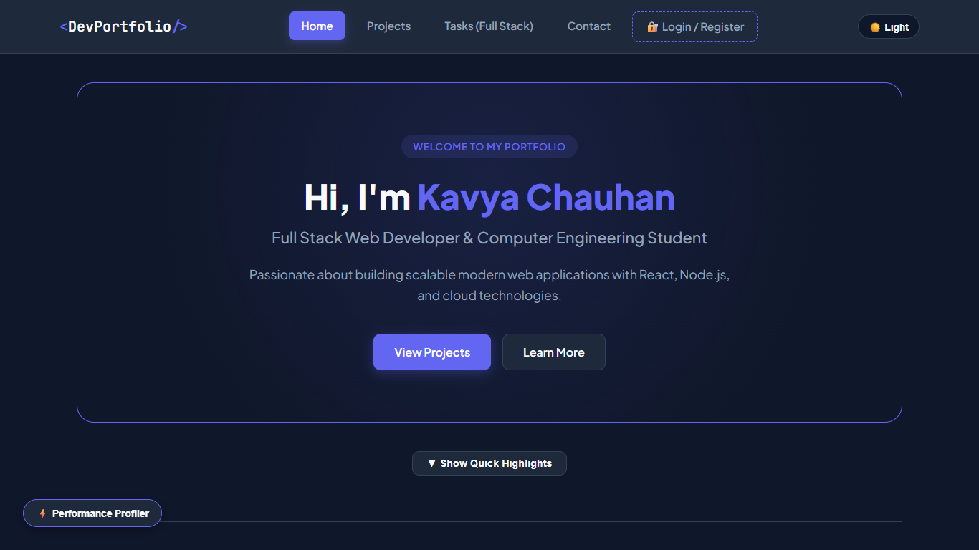  Figure: P1 Hero  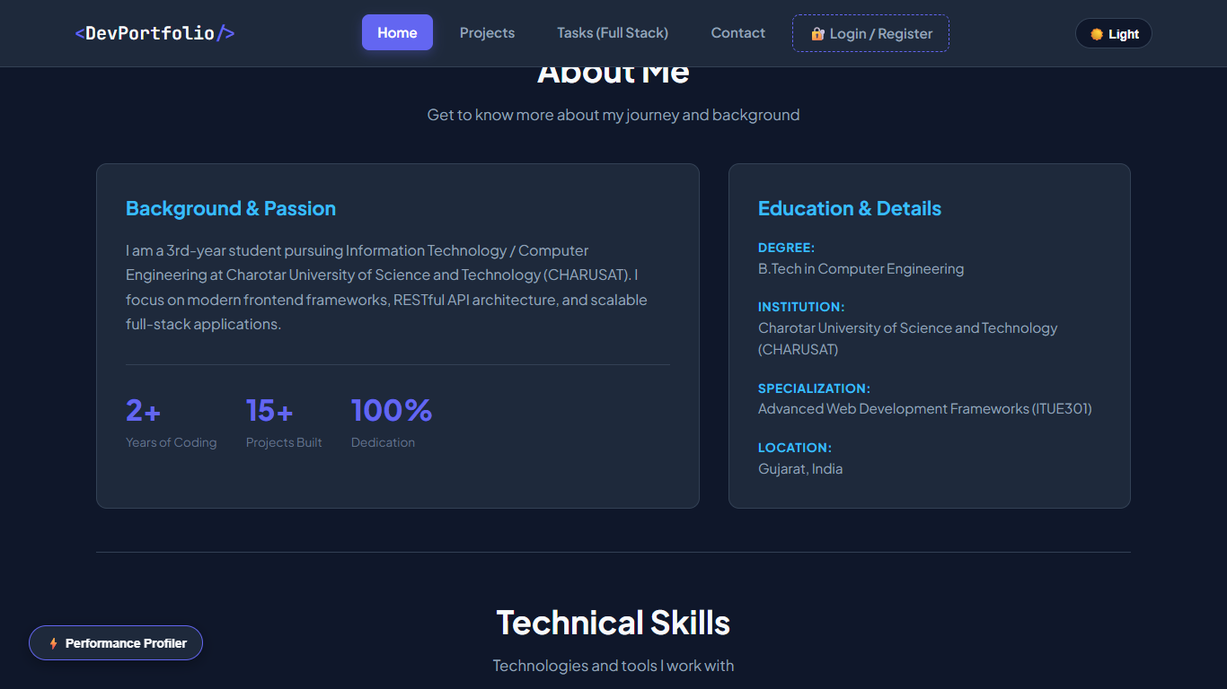  Figure: P1 About  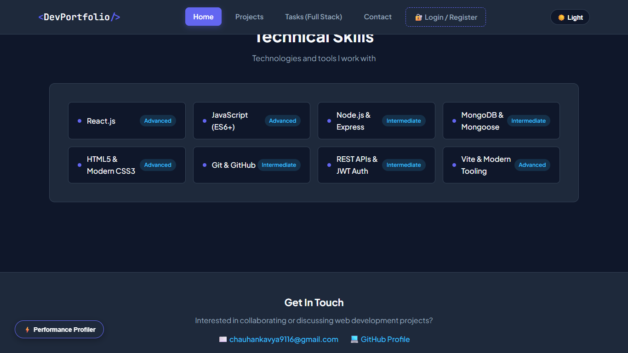  Figure: P1 Skills  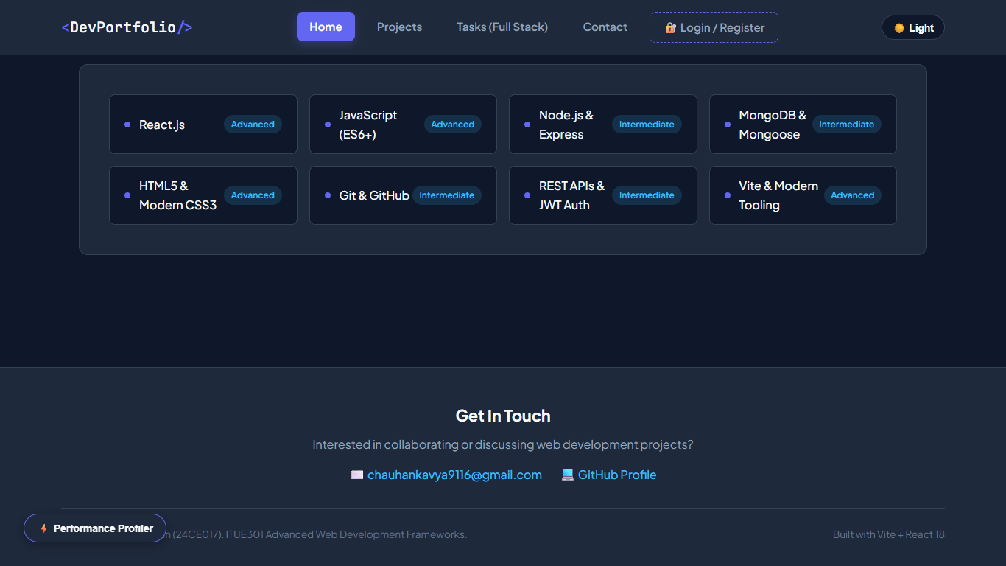  Figure: P1 Footer

