Subject Code | : | ITUE301 | Semester | : | 5 | Academic Year | : | 2026-27
Subject Name | : | Advanced Web Framework

Practical 2 | Practical 2: State Management and Routing in React
Problem Statement | Extend the portfolio application with multi-page navigation using React Router v6 and local state management using the useState hook.  Key Requirements:  - Install and configure react-router-dom v6 with BrowserRouter  - Define multiple routes: /, /projects, /tasks, /contact, /auth  - Use <NavLink> for navigation with active link styling  - Implement dark/light mode toggle using useState  - Build a controlled form on the Contact page using useState  - Add a toggleable UI section with useState (Show/Hide Quick Highlights)
Main Code | // File: App.jsx (React Router + useState)  import React, { useState, useEffect, lazy, Suspense } from 'react';  import { Routes, Route } from 'react-router-dom';  import NavBar from './components/NavBar';  import Footer from './components/Footer';  import PageFallback from './components/PageFallback';  // Route-based Code Splitting using React.lazy() (Practical 8 Core Requirement)  const Home = lazy(() => import('./pages/Home'));  const Projects = lazy(() => import('./components/Projects'));  const TaskManager = lazy(() => import('./pages/TaskManager'));  const Contact = lazy(() => import('./pages/Contact'));  const AuthPage = lazy(() => import('./pages/AuthPage'));  const NotFound = lazy(() => import('./pages/NotFound'));  // Supplementary: Heavy Component Lazy Loading on Demand  const PerformanceProfiler = lazy(() => import('./components/PerformanceProfiler'));  function App() {  // useState variable for theme mode toggle (Supplementary requirement)  const [darkMode, setDarkMode] = useState(true);  // Practical 7: Authentication state management  const [authUser, setAuthUser] = useState(() => {  try {  const stored = localStorage.getItem('awf_auth_user');  return stored ? JSON.parse(stored) : null;  } catch {  return null;  }  });  // Practical 8: State to trigger on-demand lazy loaded profiler component  const [showProfiler, setShowProfiler] = useState(false);  const handleLogout = () => {  localStorage.removeItem('awf_auth_token');  localStorage.removeItem('awf_auth_user');  setAuthUser(null);  };  const studentData = {  name: 'Kavya Chauhan',  title: 'Full Stack Web Developer & Computer Engineering Student',  tagline: 'Passionate about building scalable modern web applications with React, Node.js, and cloud technologies.',  themeColor: '#6366f1',  bio: 'I am a 3rd-year student pursuing Information Technology / Computer Engineering at Charotar University of Science and Technology (CHARUSAT). I focus on modern frontend frameworks, RESTful API architecture, and scalable full-stack applications.',  education: {  degree: 'B.Tech in Computer Engineering',  institution: 'Charotar University of Science and Technology (CHARUSAT)',  field: 'Advanced Web Development Frameworks (ITUE301)'  },  location: 'Gujarat, India',  experienceYear: 2,  skills: [  { name: 'React.js', level: 'Advanced' },  { name: 'JavaScript (ES6+)', level: 'Advanced' },  { name: 'Node.js & Express', level: 'Intermediate' },  { name: 'MongoDB & Mongoose', level: 'Intermediate' },  { name: 'HTML5 & Modern CSS3', level: 'Advanced' },  { name: 'Git & GitHub', level: 'Intermediate' },  { name: 'REST APIs & JWT Auth', level: 'Intermediate' },  { name: 'Vite & Modern Tooling', level: 'Advanced' }  ],  email: 'chauhankavya9116@gmail.com',  github: 'https://github.com/kavy009',  rollNo: '24CE017'  };  const handleToggleTheme = () => {  setDarkMode((prev) => !prev);  };  useEffect(() => {  if (darkMode) {  document.body.classList.remove('light-mode');  document.body.classList.add('dark-mode');  } else {  document.body.classList.remove('dark-mode');  document.body.classList.add('light-mode');  }  }, [darkMode]);  return (  <div className={`portfolio-app ${darkMode ? 'theme-dark' : 'theme-light'}`}>  <NavBar  darkMode={darkMode}  onToggleTheme={handleToggleTheme}  authUser={authUser}  />  {/* Floating button to trigger on-demand lazy loaded profiler */}  <button  type="button"  className="floating-profiler-btn"  onClick={() => setShowProfiler(true)}  title="Open Lazy-Loaded Performance Profiler (Practical 8)"  >  ⚡ Performance Profiler  </button>  {/* Lazy loaded Heavy Component wrapped in Suspense */}  {showProfiler && (  <Suspense fallback={<div className="profiler-loading">Loading Profiler Chunk...</div>}>  <PerformanceProfiler onClose={() => setShowProfiler(false)} />  </Suspense>  )}  <main className="main-content">  {/* Suspense wrapper with fallback UI for lazy-loaded route chunks */}  <Suspense fallback={<PageFallback />}>  <Routes>  <Route path="/" element={<Home studentData={studentData} />} />  <Route path="/projects" element={<Projects />} />  <Route path="/tasks" element={<TaskManager authUser={authUser} />} />  <Route  path="/auth"  element={  <AuthPage  user={authUser}  onAuthSuccess={setAuthUser}  onLogout={handleLogout}  />  }  />  <Route path="/contact" element={<Contact studentEmail={studentData.email} />} />  {/* Supplementary 404 Route */}  <Route path="*" element={<NotFound />} />  </Routes>  </Suspense>  </main>  <Footer  email={studentData.email}  github={studentData.github}  studentName={studentData.name}  rollNo={studentData.rollNo}  />  </div>  );  }  export default App;  // File: main.jsx (BrowserRouter Setup)  import { StrictMode } from 'react'  import { createRoot } from 'react-dom/client'  import { BrowserRouter } from 'react-router-dom'  import './index.css'  import App from './App.jsx'  createRoot(document.getElementById('root')).render(  <StrictMode>  <BrowserRouter>  <App />  </BrowserRouter>  </StrictMode>,  )  // File: components/NavBar.jsx (NavLink with Active State)  import React from 'react';  import { NavLink, Link } from 'react-router-dom';  function NavBar({ darkMode, onToggleTheme, authUser }) {  return (  <nav className="navbar">  <div className="nav-container">  <Link to="/" className="nav-logo">  <span className="logo-accent">&lt;</span>DevPortfolio<span className="logo-accent">/&gt;</span>  </Link>  <ul className="nav-links">  <li>  <NavLink  to="/"  className={({ isActive }) =>  isActive ? 'nav-link-btn active' : 'nav-link-btn'  }  >  Home  </NavLink>  </li>  <li>  <NavLink  to="/projects"  className={({ isActive }) =>  isActive ? 'nav-link-btn active' : 'nav-link-btn'  }  >  Projects  </NavLink>  </li>  <li>  <NavLink  to="/tasks"  className={({ isActive }) =>  isActive ? 'nav-link-btn active' : 'nav-link-btn'  }  >  Tasks (Full Stack)  </NavLink>  </li>  <li>  <NavLink  to="/contact"  className={({ isActive }) =>  isActive ? 'nav-link-btn active' : 'nav-link-btn'  }  >  Contact  </NavLink>  </li>  <li>  <NavLink  to="/auth"  className={({ isActive }) =>  isActive ? 'nav-link-btn active auth-nav-btn' : 'nav-link-btn auth-nav-btn'  }  >  {authUser ? `👤 ${authUser.name || 'Account'}` : '🔐 Login / Register'}  </NavLink>  </li>  </ul>  {/* Theme mode toggle button using useState in App */}  <div className="nav-actions">  <button  type="button"  className="theme-toggle-btn"  onClick={onToggleTheme}  aria-label="Toggle theme mode"  >  {darkMode ? '☀️ Light' : '🌙 Dark'}  </button>  </div>  </div>  </nav>  );  }  export default NavBar;  // File: pages/Home.jsx (useState Toggle)  import React, { useState } from 'react';  import Header from '../components/Header';  import About from '../components/About';  import Skills from '../components/Skills';  function Home({ studentData }) {  // useState variable for toggling UI visibility (additional info / highlights)  const [showMoreInfo, setShowMoreInfo] = useState(false);  return (  <div className="page home-page">  <Header  name={studentData.name}  title={studentData.title}  tagline={studentData.tagline}  themeColor={studentData.themeColor}  />  <div className="section-toggle-container">  <button  type="button"  className="btn btn-secondary toggle-btn"  onClick={() => setShowMoreInfo(!showMoreInfo)}  >  {showMoreInfo ? '▲ Hide Quick Highlights' : '▼ Show Quick Highlights'}  </button>  {showMoreInfo && (  <div className="toggleable-info-card">  <h4>💡 Quick Academic Highlights</h4>  <p>  Current Focus: Microservices, React 18, and scalable API pipelines.  Actively exploring performant client-side state caching and event-driven architectures.  </p>  </div>  )}  </div>  <About  bio={studentData.bio}  education={studentData.education}  location={studentData.location}  experienceYear={studentData.experienceYear}  />  <Skills skillList={studentData.skills} />  </div>  );  }  export default Home;  // File: pages/Contact.jsx (Controlled Form)  import React, { useState } from 'react';  function Contact({ studentEmail }) {  // useState 1: Controlled form fields  const [formData, setFormData] = useState({  senderName: '',  senderEmail: '',  message: ''  });  // useState 2: Toggle UI visibility (Help Tooltip)  const [showTooltip, setShowTooltip] = useState(false);  // Status message  const [submitted, setSubmitted] = useState(false);  const maxChars = 250;  const handleChange = (e) => {  const { name, value } = e.target;  setFormData((prev) => ({  ...prev,  [name]: value  }));  if (submitted) setSubmitted(false);  };  const handleSubmit = (e) => {  e.preventDefault();  if (!formData.senderName || !formData.message) return;  setSubmitted(true);  };  return (  <section className="section contact-page">  <div className="section-header">  <h2 className="section-title">Get in Touch</h2>  <p className="section-subtitle">  Feel free to reach out for collaborations or project discussions  </p>  </div>  <div className="contact-grid">  <div className="contact-form-card">  <div className="card-top-bar">  <h3>Send a Message</h3>  <button  type="button"  className="tooltip-toggle-btn"  onClick={() => setShowTooltip(!showTooltip)}  title="Click to toggle instructions tooltip"  >  ℹ️ {showTooltip ? 'Hide Help' : 'Help & Guidelines'}  </button>  </div>  {/* useState UI visibility toggle element */}  {showTooltip && (  <div className="help-tooltip-box">  <p>  <strong>Form Instructions:</strong> Please provide your name, valid email, and your  inquiry. All inputs are controlled via React <code>useState</code> and reflect in real-time.  </p>  </div>  )}  <form onSubmit={handleSubmit} className="contact-form">  <div className="form-group">  <label htmlFor="senderName">Your Name:</label>  <input  id="senderName"  type="text"  name="senderName"  placeholder="e.g. John Doe"  value={formData.senderName}  onChange={handleChange}  required  className="form-input"  />  </div>  <div className="form-group">  <label htmlFor="senderEmail">Your Email:</label>  <input  id="senderEmail"  type="email"  name="senderEmail"  placeholder="e.g. john@example.com"  value={formData.senderEmail}  onChange={handleChange}  required  className="form-input"  />  </div>  <div className="form-group">  <label htmlFor="message">Message:</label>  <textarea  id="message"  name="message"  rows="4"  maxLength={maxChars}  placeholder="Write your message here..."  value={formData.message}  onChange={handleChange}  required  className="form-textarea"  ></textarea>  {/* Live character count requirement */}  <div className="char-count-bar">  <span>  Character Count: <strong>{formData.message.length}</strong> / {maxChars}  </span>  <span className="remaining-text">  {maxChars - formData.message.length} characters remaining  </span>  </div>  </div>  <button type="submit" className="btn btn-primary submit-btn">  Send Message  </button>  {submitted && (  <div className="success-banner">  ✅ Thank you, {formData.senderName}! Your message was captured into React state.  </div>  )}  </form>  </div>  {/* Real-Time Live Preview showing controlled input reflection */}  <div className="live-preview-card">  <div className="preview-header">  <h3>⚡ Real-Time State Preview</h3>  <span className="live-indicator">LIVE</span>  </div>  <p className="preview-desc">  Demonstrates controlled component reactivity powered by <code>useState</code>:  </p>  <div className="preview-item">  <span className="preview-label">Name:</span>  <span className="preview-value">{formData.senderName || '(typing preview...)'}</span>  </div>  <div className="preview-item">  <span className="preview-label">Email:</span>  <span className="preview-value">{formData.senderEmail || '(typing preview...)'}</span>  </div>  <div className="preview-item">  <span className="preview-label">Live Message Stream:</span>  <div className="preview-message-box">  {formData.message || 'Start typing in the message box to see live state reflection...'}  </div>  </div>  <div className="preview-item">  <span className="preview-label">Direct Contact:</span>  <span className="preview-value">{studentEmail}</span>  </div>  </div>  </div>  </section>  );  }  export default Contact;

Output | A multi-page React application with:  - Navigation bar with active link highlighting across 5 routes  - Dark/Light mode toggle button in navbar using useState  - Home page with toggleable 'Quick Highlights' section (useState)  - Contact page with a controlled form (name, email, message fields)  - Seamless client-side page transitions without full page reloads  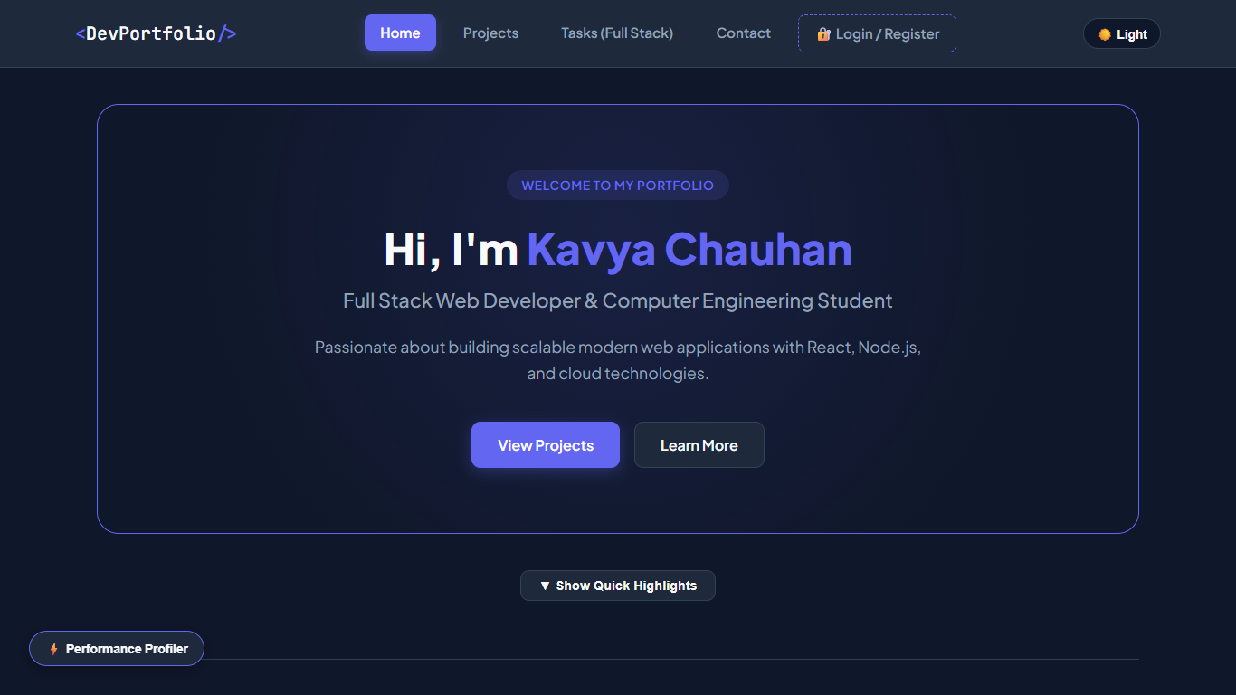  Figure: P2 Navbar Light  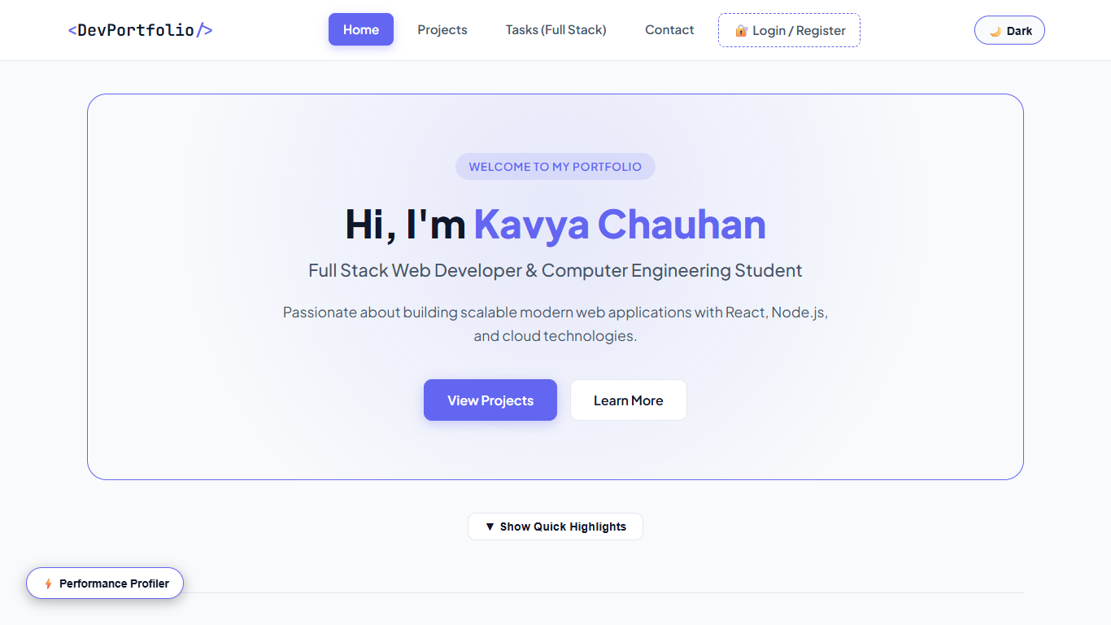  Figure: P2 Navbar Dark  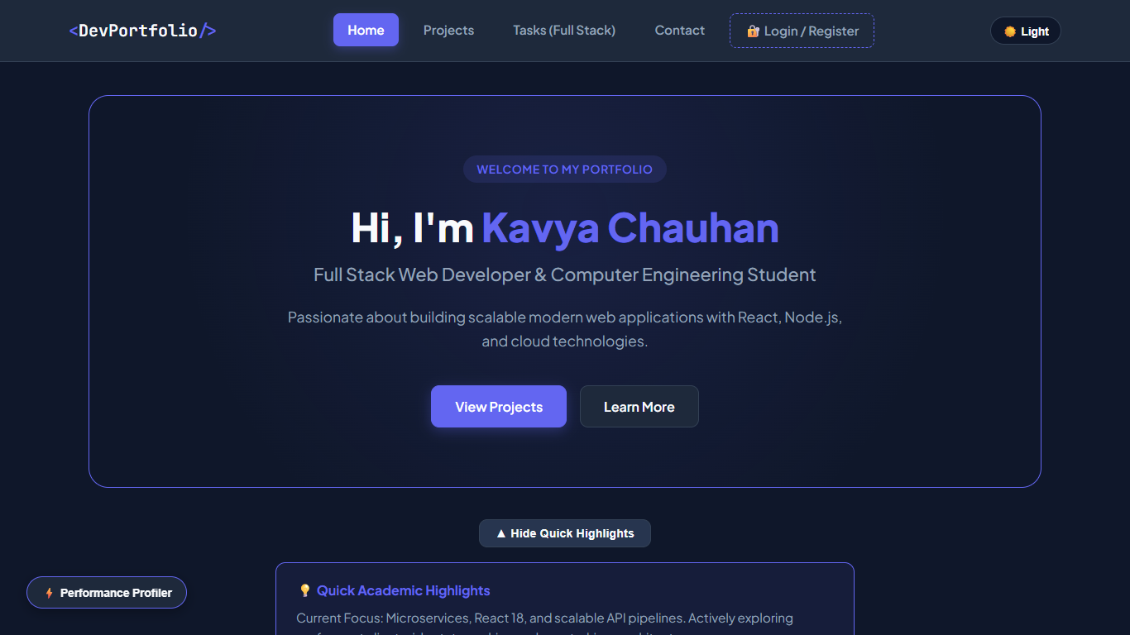  Figure: P2 Highlights  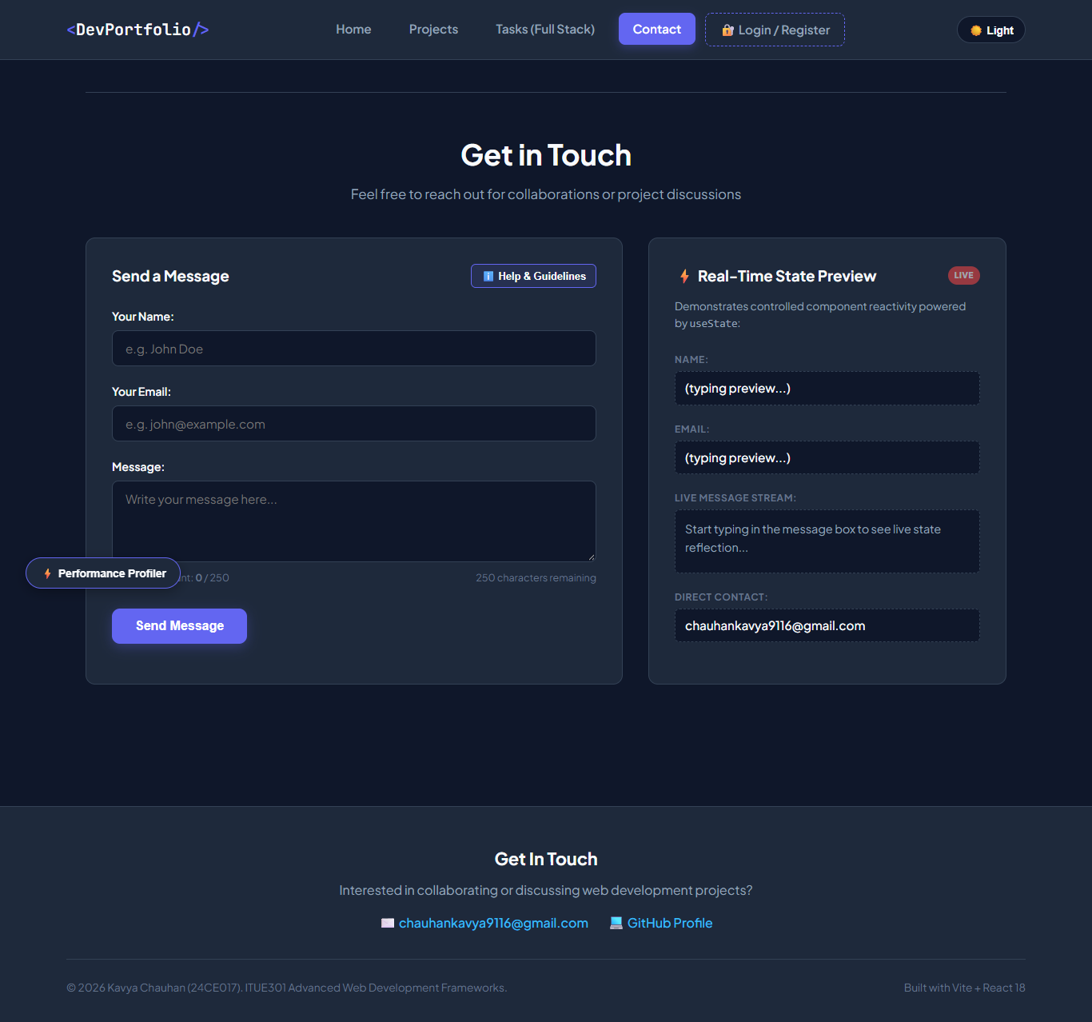  Figure: P2 Contact

