Subject Code | : | ITUE301 | Semester | : | 5 | Academic Year | : | 2026-27
Subject Name | : | Advanced Web Framework

Practical 3 | Practical 3: API Integration and Data Rendering
Problem Statement | Integrate a public REST API (GitHub API) into the React portfolio to fetch and display live data with proper loading, error, and empty states.  Key Requirements:  - Use fetch() with async/await to call the GitHub REST API  - Implement useEffect for data fetching on component mount  - Show a loading spinner while the API request is in progress  - Handle API errors gracefully with an error message + retry button  - Add a search filter to filter repositories dynamically  - Include a 'Simulate Error' button to test error state explicitly  - Render repository data with name, description, language, stars, and forks
Main Code | // File: components/Projects.jsx (API Fetch + useEffect + Error Handling)  import React, { useState, useEffect, useCallback } from 'react';  import Spinner from './Spinner';  import ErrorMessage from './ErrorMessage';  function Projects() {  const [repos, setRepos] = useState([]);  const [loading, setLoading] = useState(true);  const [error, setError] = useState(null);  const [searchTerm, setSearchTerm] = useState('');  const [simulateError, setSimulateError] = useState(false);  const username = 'kavy009';  const fetchRepositories = useCallback(() => {  setLoading(true);  setError(null);  // If simulateError is true, test the error state explicitly for viva / lab evaluation  const url = simulateError  ? 'https://api.github.com/invalid-url-for-testing-awf'  : `https://api.github.com/users/${username}/repos?sort=updated&per_page=30`;  fetch(url)  .then((res) => {  if (!res.ok) {  throw new Error(`GitHub API request failed with status: ${res.status} (${res.statusText})`);  }  return res.json();  })  .then((data) => {  if (Array.isArray(data)) {  setRepos(data);  } else {  setRepos([]);  }  })  .catch((err) => {  setError(err.message || 'Unable to fetch repositories.');  })  .finally(() => {  setLoading(false);  });  }, [simulateError]);  useEffect(() => {  fetchRepositories();  }, [fetchRepositories]);  // Filter repositories dynamically by name  const filteredRepos = repos.filter((repo) =>  repo.name.toLowerCase().includes(searchTerm.toLowerCase()) ||  (repo.description && repo.description.toLowerCase().includes(searchTerm.toLowerCase()))  );  return (  <section id="projects" className="section projects-section">  <div className="section-header">  <h2 className="section-title">GitHub Projects & Repositories</h2>  <p className="section-subtitle">  Live repository data fetched directly via GitHub REST API (Practical 3 Integration)  </p>  </div>  {/* Control bar: Search Filter + Simulated Error Toggle for Testing */}  <div className="projects-controls">  <div className="search-box">  <span className="search-icon">🔍</span>  <input  type="text"  className="search-input"  placeholder="Search repositories by name or keyword..."  value={searchTerm}  onChange={(e) => setSearchTerm(e.target.value)}  />  {searchTerm && (  <button  type="button"  className="clear-search-btn"  onClick={() => setSearchTerm('')}  >  ✕  </button>  )}  </div>  <div className="demo-controls">  <button  type="button"  className={`btn-test-error ${simulateError ? 'active' : ''}`}  onClick={() => setSimulateError((prev) => !prev)}  title="Toggle invalid endpoint to test Error Boundary / Error state"  >  {simulateError ? '⚠️ Revert to Valid API' : '🧪 Simulate API Error'}  </button>  <button  type="button"  className="btn btn-secondary reload-btn"  onClick={fetchRepositories}  disabled={loading}  >  🔄 Refresh  </button>  </div>  </div>  {/* Conditional Rendering based on state */}  {loading && <Spinner message="Fetching public repositories from api.github.com..." />}  {!loading && error && (  <ErrorMessage  message={error}  onRetry={fetchRepositories}  />  )}  {!loading && !error && filteredRepos.length === 0 && (  <div className="empty-state-card">  <p>No repositories found matching "<strong>{searchTerm}</strong>".</p>  </div>  )}  {!loading && !error && filteredRepos.length > 0 && (  <div className="projects-grid">  {filteredRepos.map((repo) => (  <div key={repo.id} className="project-card repo-card">  <div className="project-card-header">  <span className="repo-icon">📦</span>  <h3 className="project-title repo-title">  <a  href={repo.html_url}  target="_blank"  rel="noopener noreferrer"  className="repo-link"  >  {repo.name}  </a>  </h3>  </div>  <p className="project-desc repo-desc">  {repo.description || 'No description provided for this repository.'}  </p>  <div className="repo-metadata">  {repo.language && (  <span className="repo-meta-item">  <span className="lang-indicator"></span>  {repo.language}  </span>  )}  {/* Star count requirement */}  <span className="repo-meta-item stars-badge">  ⭐ {repo.stargazers_count || 0}  </span>  {repo.forks_count !== undefined && (  <span className="repo-meta-item forks-badge">  🍴 {repo.forks_count}  </span>  )}  </div>  <div className="project-card-footer">  <a  href={repo.html_url}  target="_blank"  rel="noopener noreferrer"  className="btn-external-link"  >  View on GitHub ↗  </a>  </div>  </div>  ))}  </div>  )}  </section>  );  }  export default Projects;  // File: components/Spinner.jsx (Loading State)  import React from 'react';  function Spinner({ message = 'Loading repositories from GitHub API...' }) {  return (  <div className="spinner-container">  <div className="loading-spinner"></div>  <p className="spinner-text">{message}</p>  </div>  );  }  export default Spinner;  // File: components/ErrorMessage.jsx (Error Fallback)  import React from 'react';  function ErrorMessage({ message, onRetry }) {  return (  <div className="error-card">  <div className="error-icon">⚠️</div>  <div className="error-content">  <h3 className="error-title">Failed to Load Repositories</h3>  <p className="error-desc">{message || 'An unexpected network error occurred while reaching GitHub API.'}</p>  {onRetry && (  <button type="button" className="btn btn-primary retry-btn" onClick={onRetry}>  🔄 Try Again  </button>  )}  </div>  </div>  );  }  export default ErrorMessage;

Output | The Projects page dynamically renders:  - Live GitHub repository cards fetched from api.github.com/users/kavy009/repos  - Loading spinner during API fetch  - Error message with retry button on API failure  - Search input to filter repositories by name or description  - Repository metadata: language badge, star count, fork count  - 'Simulate API Error' toggle button for testing error state  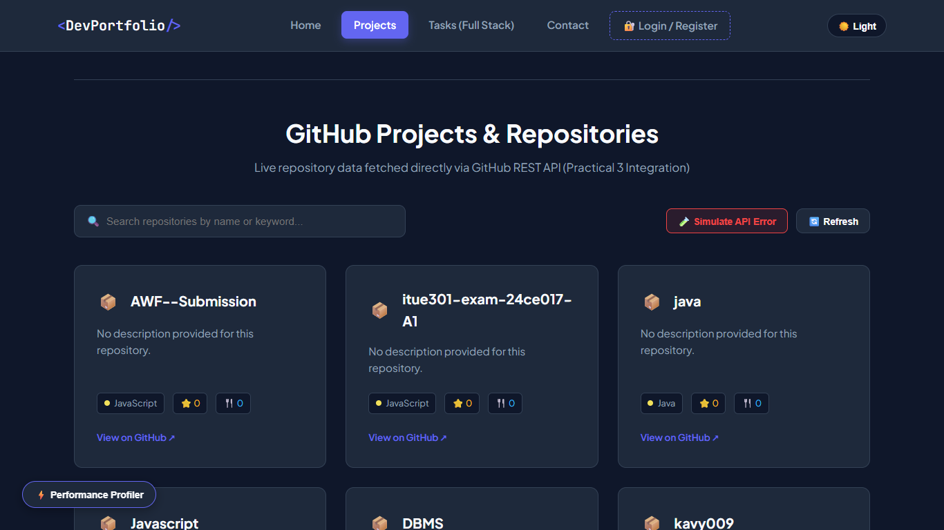  Figure: P3 Projects Top  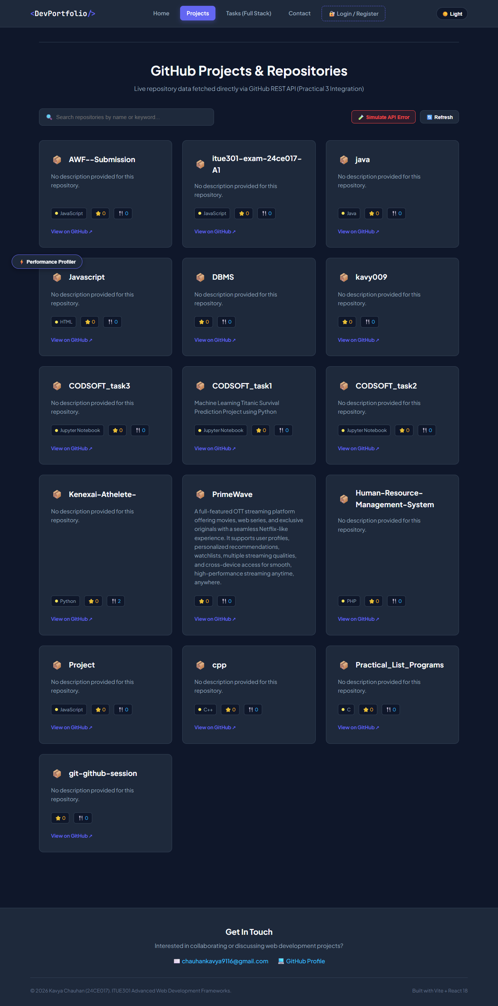  Figure: P3 Projects  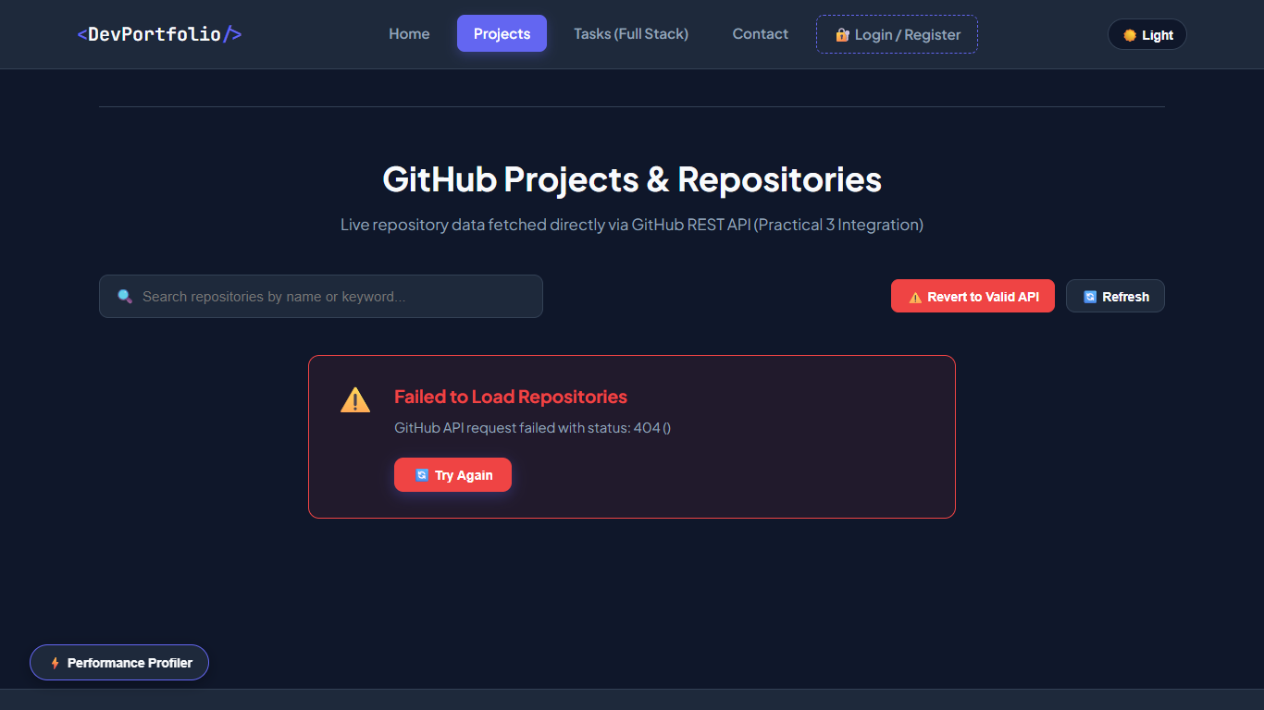  Figure: P3 Error

