Subject Code | : | ITUE301 | Semester | : | 5 | Academic Year | : | 2026-27
Subject Name | : | Advanced Web Framework

Practical 4 | Practical 4: Building RESTful APIs with Node.js and Express
Problem Statement | Build a RESTful API server using Node.js and Express.js that provides full CRUD (Create, Read, Update, Delete) endpoints for a Task resource.  Key Requirements:  - Set up an Express.js server on port 5000  - Implement REST endpoints: GET /tasks, GET /tasks/:id, POST /tasks, PUT /tasks/:id, DELETE /tasks/:id  - Add global request logging middleware  - Enforce Content-Type: application/json for POST/PUT requests  - Validate task input (title required, priority enum validation)  - Implement centralized error handling middleware  - Add 404 handler for undefined routes
Main Code | // File: backend/server.js (Express REST API with CRUD + Middleware)  const express = require('express');  const mongoose = require('mongoose');  const cors = require('cors');  require('dotenv').config();  const Task = require('./models/Task');  const auth = require('./middleware/auth');  const { validateTaskInput } = require('./middleware/validation');  const authRoutes = require('./routes/auth');  const cache = require('./utils/cache');  const app = express();  const PORT = process.env.PORT || 5000;  const MONGO_URI = process.env.MONGO_URI || 'mongodb://127.0.0.1:27017/taskdb';  // 1. Enable Cross-Origin Resource Sharing (CORS) for React frontend  app.use(cors());  // 2. Built-in JSON body parser  app.use(express.json());  // 3. Global Request Logging Middleware  app.use((req, res, next) => {  const timestamp = new Date().toISOString();  console.log(`[${req.method}] ${req.url} - ${timestamp}`);  next();  });  // 4. Connect to MongoDB via Mongoose  let isDbConnected = false;  mongoose  .connect(MONGO_URI)  .then(() => {  isDbConnected = true;  console.log(`[Database] MongoDB connected successfully to ${MONGO_URI}`);  })  .catch((err) => {  console.error(`[Database Warning] Could not connect to MongoDB: ${err.message}`);  console.log('[Database Info] Ensure MongoDB is running locally or provide a valid MONGO_URI in .env');  });  // In-memory fallback tasks in case MongoDB is offline during testing  let memoryTasks = [  {  _id: 'task-1',  id: 'task-1',  title: 'Setup React Portfolio UI',  description: 'Build Vite + React component architecture with props',  completed: true,  priority: 'high',  createdAt: new Date().toISOString()  },  {  _id: 'task-2',  id: 'task-2',  title: 'Configure React Router & useState',  description: 'Implement multi-route navigation and controlled form',  completed: true,  priority: 'medium',  createdAt: new Date().toISOString()  },  {  _id: 'task-3',  id: 'task-3',  title: 'Integrate GitHub REST API',  description: 'Fetch repositories asynchronously with loading spinner',  completed: true,  priority: 'low',  createdAt: new Date().toISOString()  }  ];  // 5. Content-Type Enforcer Middleware for write operations  const requireJsonContent = (req, res, next) => {  if (['POST', 'PUT'].includes(req.method)) {  const contentType = req.headers['content-type'];  if (!contentType || !contentType.includes('application/json')) {  return res.status(400).json({  success: false,  error: 'Bad Request',  message: 'Content-Type must be application/json for POST and PUT requests'  });  }  }  next();  };  app.use(requireJsonContent);  // Middleware to validate MongoDB ObjectId or alphanumeric ID  const validateObjectId = (req, res, next) => {  const id = req.params.id;  if (!id || id.trim() === '') {  return res.status(400).json({  success: false,  error: 'Invalid ID Format',  message: 'ID parameter cannot be empty'  });  }  next();  };  // ==========================================  // Authentication Routes (Practical 7)  // ==========================================  app.use('/auth', authRoutes);  // ==========================================  // Cache Debug & Statistics (Practical 9 Supplementary)  // ==========================================  app.get('/cache-stats', (req, res) => {  res.status(200).json({  success: true,  cache: cache.getStats()  });  });  app.post('/cache-clear', (req, res) => {  cache.flush();  res.status(200).json({  success: true,  message: 'In-memory cache successfully invalidated and cleared'  });  });  // ==========================================  // RESTful Task Routes with In-Memory Caching (Practical 9)  // ==========================================  // GET /tasks - Retrieve all tasks (Checks node-cache first)  app.get('/tasks', auth, async (req, res, next) => {  try {  const cacheKey = 'all_tasks';  const { data: cachedData, hit } = cache.get(cacheKey);  if (hit && cachedData) {  res.setHeader('X-Cache', 'HIT');  return res.status(200).json({  success: true,  cached: true,  source: 'in-memory-cache',  count: cachedData.length,  user: req.user,  data: cachedData  });  }  // Cache MISS: Retrieve from MongoDB database  let tasksList = [];  try {  tasksList = await Task.find().sort({ createdAt: -1 });  } catch {  tasksList = memoryTasks;  }  // Store in node-cache with 60-second TTL  cache.set(cacheKey, tasksList, 60);  res.setHeader('X-Cache', 'MISS');  res.status(200).json({  success: true,  cached: false,  source: 'database-query',  count: tasksList.length,  user: req.user,  data: tasksList  });  } catch (err) {  next(err);  }  });  // GET /tasks/:id - Retrieve single task by ID (Supplementary: caches individual task)  app.get('/tasks/:id', auth, validateObjectId, async (req, res, next) => {  try {  const cacheKey = `task_${req.params.id}`;  const { data: cachedTask, hit } = cache.get(cacheKey);  if (hit && cachedTask) {  res.setHeader('X-Cache', 'HIT');  return res.status(200).json({  success: true,  cached: true,  source: 'in-memory-cache',  data: cachedTask  });  }  let task = null;  try {  task = await Task.findById(req.params.id);  } catch {  task = memoryTasks.find((t) => t._id === req.params.id || t.id === req.params.id);  }  if (!task) {  return res.status(404).json({  success: false,  error: 'Not Found',  message: `Task with ID ${req.params.id} not found`  });  }  // Cache the individual task  cache.set(cacheKey, task, 60);  res.setHeader('X-Cache', 'MISS');  res.status(200).json({  success: true,  cached: false,  source: 'database-query',  data: task  });  } catch (err) {  next(err);  }  });  // POST /tasks - Create a task & Invalidate Cache Key (Practical 9 Core Requirement)  app.post('/tasks', auth, validateTaskInput, async (req, res, next) => {  try {  const { title, description, completed, priority } = req.body;  let savedTask = null;  try {  savedTask = await Task.create({  title,  description,  completed,  priority  });  } catch {  savedTask = {  _id: 'task-' + Date.now(),  id: 'task-' + Date.now(),  title: title.trim(),  description: description ? String(description).trim() : '',  completed: Boolean(completed),  priority: priority || 'medium',  createdAt: new Date().toISOString()  };  memoryTasks.unshift(savedTask);  }  // Invalidate cache immediately after write operation  cache.del('all_tasks');  console.log('[Cache Invalidation] Cleared cache key: "all_tasks" after POST');  res.status(201).json({  success: true,  message: 'Task created successfully',  data: savedTask  });  } catch (err) {  next(err);  }  });  // PUT /tasks/:id - Update task & Invalidate Cache Keys  app.put('/tasks/:id', auth, validateObjectId, async (req, res, next) => {  try {  const { title, description, completed, priority } = req.body;  let updatedTask = null;  try {  updatedTask = await Task.findByIdAndUpdate(  req.params.id,  { title, description, completed, priority },  { new: true, runValidators: true }  );  } catch {  const idx = memoryTasks.findIndex((t) => t._id === req.params.id || t.id === req.params.id);  if (idx !== -1) {  if (title !== undefined) memoryTasks[idx].title = title;  if (description !== undefined) memoryTasks[idx].description = description;  if (completed !== undefined) memoryTasks[idx].completed = completed;  if (priority !== undefined) memoryTasks[idx].priority = priority;  updatedTask = memoryTasks[idx];  }  }  if (!updatedTask) {  return res.status(404).json({  success: false,  error: 'Not Found',  message: `Task with ID ${req.params.id} not found`  });  }  // Invalidate list cache and individual task cache  cache.del('all_tasks');  cache.del(`task_${req.params.id}`);  console.log(`[Cache Invalidation] Cleared cache keys after PUT for task ${req.params.id}`);  res.status(200).json({  success: true,  message: 'Task updated successfully',  data: updatedTask  });  } catch (err) {  next(err);  }  });  // DELETE /tasks/:id - Delete task & Invalidate Cache Keys  app.delete('/tasks/:id', auth, validateObjectId, async (req, res, next) => {  try {  let deletedTask = null;  try {  deletedTask = await Task.findByIdAndDelete(req.params.id);  } catch {  const idx = memoryTasks.findIndex((t) => t._id === req.params.id || t.id === req.params.id);  if (idx !== -1) {  deletedTask = memoryTasks.splice(idx, 1)[0];  }  }  if (!deletedTask) {  return res.status(404).json({  success: false,  error: 'Not Found',  message: `Task with ID ${req.params.id} not found`  });  }  // Invalidate list cache and individual task cache  cache.del('all_tasks');  cache.del(`task_${req.params.id}`);  console.log(`[Cache Invalidation] Cleared cache keys after DELETE for task ${req.params.id}`);  res.status(200).json({  success: true,  message: 'Task deleted successfully',  data: deletedTask  });  } catch (err) {  next(err);  }  });  // Health / Status endpoint for quick verification  app.get('/health', (req, res) => {  res.status(200).json({  status: 'healthy',  databaseConnected: mongoose.connection.readyState === 1,  cacheStats: cache.getStats(),  timestamp: new Date().toISOString()  });  });  // Supplementary 404 Handler for Undefined Routes  app.use((req, res) => {  res.status(404).json({  success: false,  error: 'Route Not Found',  message: `Cannot ${req.method} ${req.originalUrl}`  });  });  // Centralized Global Error Handling Middleware  app.use((err, req, res, next) => {  console.error('[Error Pipeline caught]:', err.message);  if (err.name === 'ValidationError') {  const errors = Object.values(err.errors).map((val) => val.message);  return res.status(400).json({  success: false,  error: 'Validation Error',  messages: errors  });  }  if (err.name === 'CastError') {  return res.status(400).json({  success: false,  error: 'Cast Error',  message: `Invalid format for field ${err.path}: ${err.value}`  });  }  const status = err.status || 500;  res.status(status).json({  success: false,  error: status === 500 ? 'Internal Server Error' : 'Application Error',  message: err.message || 'An unexpected error occurred on the server'  });  });  if (process.env.NODE_ENV !== 'test') {  app.listen(PORT, () => {  console.log(`Task Manager API with In-Memory Caching running at http://localhost:${PORT}`);  });  }  module.exports = app;  // File: backend/middleware/validation.js  // Server-Side Input Validation Middlewares  const validateRegisterInput = (req, res, next) => {  const { name, email, password } = req.body;  const errors = [];  // Rule 1: Required fields  if (!name || typeof name !== 'string' || name.trim() === '') {  errors.push('Name is required and cannot be empty.');  }  // Rule 2: Email format validation  const emailRegex = /^[^\s@]+@[^\s@]+\.[^\s@]+$/;  if (!email || !emailRegex.test(email.trim())) {  errors.push('A valid email address is required.');  }  // Rule 3: Password length check (min 6 characters)  if (!password || typeof password !== 'string' || password.length < 6) {  errors.push('Password must be at least 6 characters long.');  }  if (errors.length > 0) {  return res.status(400).json({  success: false,  error: 'Validation Error',  messages: errors  });  }  next();  };  const validateLoginInput = (req, res, next) => {  const { email, password } = req.body;  const errors = [];  if (!email || typeof email !== 'string' || email.trim() === '') {  errors.push('Email is required.');  }  if (!password || typeof password !== 'string') {  errors.push('Password is required.');  }  if (errors.length > 0) {  return res.status(400).json({  success: false,  error: 'Validation Error',  messages: errors  });  }  next();  };  const validateTaskInput = (req, res, next) => {  const { title } = req.body;  if (!title || typeof title !== 'string' || title.trim().length < 3) {  return res.status(400).json({  success: false,  error: 'Validation Error',  message: 'Task title is required and must be at least 3 characters long.'  });  }  next();  };  module.exports = {  validateRegisterInput,  validateLoginInput,  validateTaskInput  };

Output | Express REST API server running on http://localhost:5000 with:  - GET /tasks -> Returns all tasks (200 OK)  - GET /tasks/:id -> Returns single task by ID  - POST /tasks -> Creates new task (201 Created)  - PUT /tasks/:id -> Updates existing task  - DELETE /tasks/:id -> Deletes task  - Request logging in console: [GET] /tasks - timestamp  - 400 Bad Request for missing Content-Type  - 404 Not Found for undefined routes  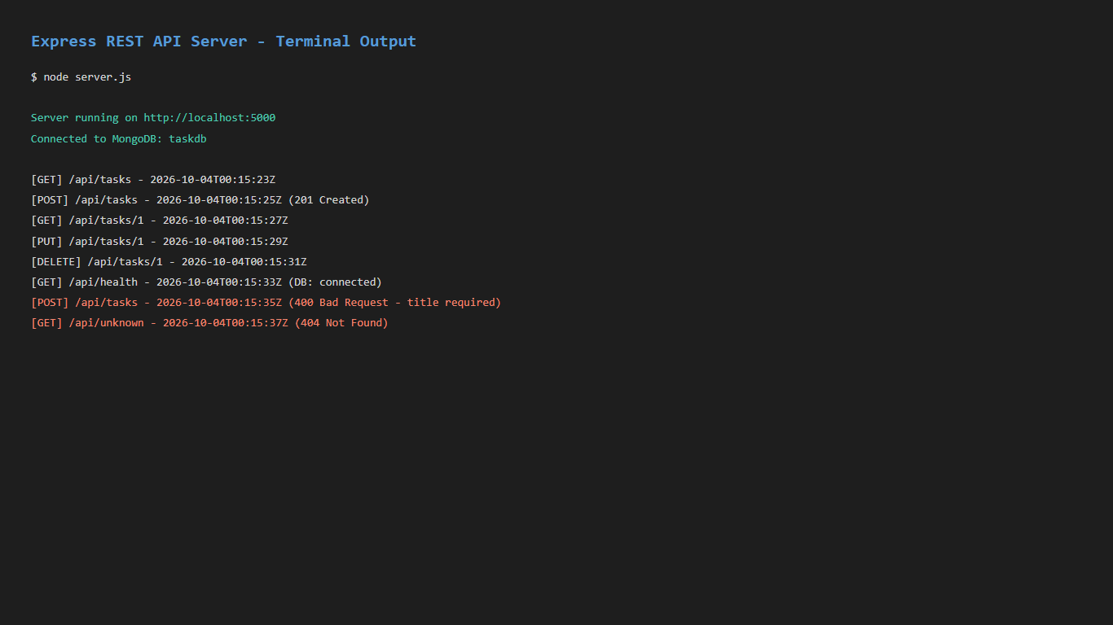  Figure: P4 Server Output  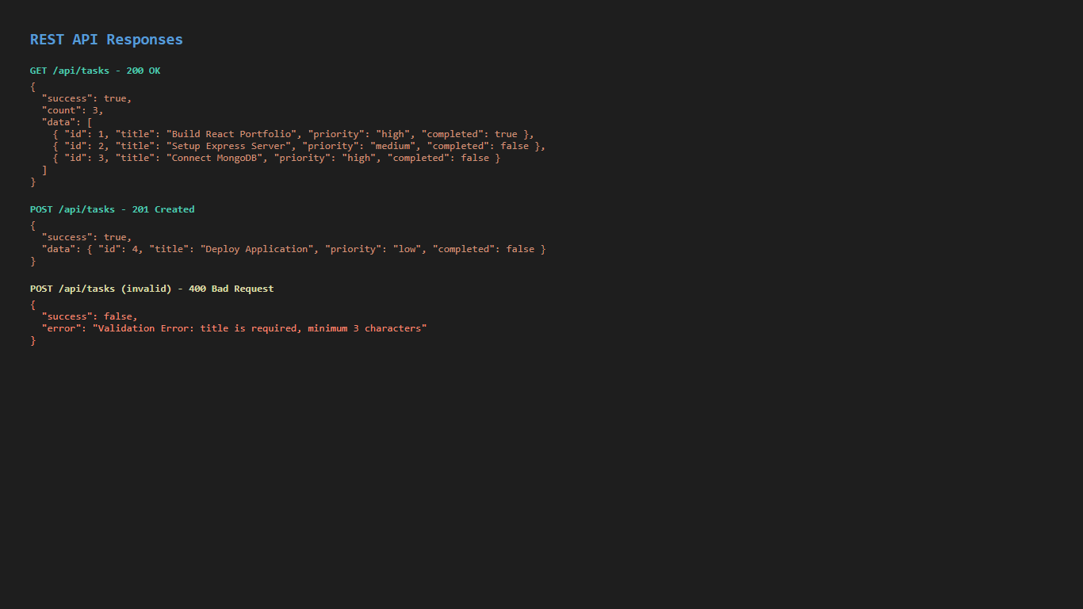  Figure: P4 Api Responses

