Subject Code | : | ITUE301 | Semester | : | 5 | Academic Year | : | 2026-27
Subject Name | : | Advanced Web Framework

Practical 6 | Practical 6: Full-Stack Integration (React + Express + MongoDB)
Problem Statement | Connect the React frontend to the Express + MongoDB backend to create a fully integrated full-stack Task Management application.  Key Requirements:  - Create a centralized API client (api.js) with functions for all CRUD operations  - Enable CORS on the Express server to allow frontend requests  - Build a TaskManager page with create task form and live task list  - Implement optimistic UI updates for create, toggle, and delete operations  - Add delete confirmation modal before removing tasks  - Implement Toast notifications for success/error feedback  - Add priority filter dropdown to filter tasks by priority level  - Handle authentication errors (401) with user-friendly messages
Main Code | // File: services/api.js (Centralized API Client)  // Central API client with JWT Authentication support (Practical 7)  const BASE_URL = 'http://localhost:5000';  function getAuthHeader() {  const token = localStorage.getItem('awf_auth_token');  return token ? { Authorization: `Bearer ${token}` } : {};  }  export const api = {  // Auth: POST /auth/register  async register(userData) {  const res = await fetch(`${BASE_URL}/auth/register`, {  method: 'POST',  headers: { 'Content-Type': 'application/json' },  body: JSON.stringify(userData)  });  const data = await res.json();  if (!res.ok) {  const msg = data.messages ? data.messages.join(' ') : (data.message || 'Registration failed');  throw new Error(msg);  }  return data;  },  // Auth: POST /auth/login  async login(credentials) {  const res = await fetch(`${BASE_URL}/auth/login`, {  method: 'POST',  headers: { 'Content-Type': 'application/json' },  body: JSON.stringify(credentials)  });  const data = await res.json();  if (!res.ok) {  throw new Error(data.message || 'Login failed');  }  return data;  },  // Auth: GET /auth/me (Supplementary)  async getMe() {  const res = await fetch(`${BASE_URL}/auth/me`, {  headers: { ...getAuthHeader() }  });  if (res.status === 401) {  localStorage.removeItem('awf_auth_token');  localStorage.removeItem('awf_auth_user');  throw new Error('Session expired. Please log in again.');  }  return res.json();  },  // Task: GET /tasks (Protected)  async getTasks() {  const res = await fetch(`${BASE_URL}/tasks`, {  headers: { ...getAuthHeader() }  });  if (res.status === 401) {  throw new Error('Authentication required. Please log in to view and manage tasks.');  }  if (!res.ok) {  const err = await res.json().catch(() => ({}));  throw new Error(err.message || `Failed to fetch tasks (HTTP ${res.status})`);  }  return res.json();  },  // Task: POST /tasks (Protected)  async createTask(taskData) {  const res = await fetch(`${BASE_URL}/tasks`, {  method: 'POST',  headers: {  'Content-Type': 'application/json',  ...getAuthHeader()  },  body: JSON.stringify(taskData)  });  if (res.status === 401) {  throw new Error('Unauthorized: please log in to add tasks.');  }  if (!res.ok) {  const err = await res.json().catch(() => ({}));  const msg = err.messages ? err.messages.join(', ') : (err.message || `Failed to create task`);  throw new Error(msg);  }  return res.json();  },  // Task: PUT /tasks/:id (Protected)  async updateTask(id, updateData) {  const res = await fetch(`${BASE_URL}/tasks/${id}`, {  method: 'PUT',  headers: {  'Content-Type': 'application/json',  ...getAuthHeader()  },  body: JSON.stringify(updateData)  });  if (res.status === 401) {  throw new Error('Unauthorized: please log in to modify tasks.');  }  if (!res.ok) {  const err = await res.json().catch(() => ({}));  throw new Error(err.message || `Failed to update task`);  }  return res.json();  },  // Task: DELETE /tasks/:id (Protected)  async deleteTask(id) {  const res = await fetch(`${BASE_URL}/tasks/${id}`, {  method: 'DELETE',  headers: { ...getAuthHeader() }  });  if (res.status === 401) {  throw new Error('Unauthorized: please log in to delete tasks.');  }  if (!res.ok) {  const err = await res.json().catch(() => ({}));  throw new Error(err.message || `Failed to delete task`);  }  return res.json();  }  };  export default api;  // File: pages/TaskManager.jsx (Full-Stack CRUD UI)  import React, { useState, useEffect, useCallback } from 'react';  import api from '../services/api';  import Spinner from '../components/Spinner';  import ErrorMessage from '../components/ErrorMessage';  import Toast from '../components/Toast';  function TaskManager() {  const [tasks, setTasks] = useState([]);  const [loading, setLoading] = useState(true);  const [error, setError] = useState(null);  // Form state  const [newTitle, setNewTitle] = useState('');  const [newDescription, setNewDescription] = useState('');  const [newPriority, setNewPriority] = useState('medium');  const [isSubmitting, setIsSubmitting] = useState(false);  // Delete confirmation state (Supplementary requirement)  const [taskToDelete, setTaskToDelete] = useState(null);  // Toast notification state (Supplementary requirement)  const [toast, setToast] = useState({ message: '', type: 'success' });  // Priority filter state  const [filterPriority, setFilterPriority] = useState('all');  const showToast = (message, type = 'success') => {  setToast({ message, type });  };  const clearToast = () => {  setToast({ message: '', type: 'success' });  };  // Fetch tasks from Express / MongoDB backend  const loadTasks = useCallback(async () => {  setLoading(true);  setError(null);  try {  const response = await api.getTasks();  // Handle both Mongoose data shape { success: true, data: [...] } and direct array  const taskList = response.data || response;  setTasks(Array.isArray(taskList) ? taskList : []);  } catch (err) {  setError(  `${err.message}. Make sure backend server is running at http://localhost:5000`  );  } finally {  setLoading(false);  }  }, []);  useEffect(() => {  loadTasks();  }, [loadTasks]);  // Create Task with Optimistic UI Update (Supplementary requirement)  const handleCreateTask = async (e) => {  e.preventDefault();  if (!newTitle.trim()) {  showToast('Task title is required', 'error');  return;  }  const tempId = 'temp-' + Date.now();  const optimisticTask = {  _id: tempId,  id: tempId,  title: newTitle.trim(),  description: newDescription.trim(),  priority: newPriority,  completed: false,  createdAt: new Date().toISOString(),  isOptimistic: true  };  // 1. Optimistic Update: Render immediately before server responds  setTasks((prev) => [optimisticTask, ...prev]);  const savedTitle = newTitle;  const savedDesc = newDescription;  const savedPriority = newPriority;  setNewTitle('');  setNewDescription('');  setIsSubmitting(true);  try {  const response = await api.createTask({  title: savedTitle,  description: savedDesc,  priority: savedPriority  });  const serverTask = response.data || response;  // Replace optimistic placeholder with confirmed server document  setTasks((prev) =>  prev.map((t) => (t._id === tempId || t.id === tempId ? serverTask : t))  );  showToast(`Task "${serverTask.title}" created successfully!`, 'success');  } catch (err) {  // Rollback on failure  setTasks((prev) => prev.filter((t) => t._id !== tempId && t.id !== tempId));  showToast(`Failed to create task: ${err.message}`, 'error');  } finally {  setIsSubmitting(false);  }  };  // Toggle Task Completion  const handleToggleComplete = async (task) => {  const taskId = task._id || task.id;  const updatedStatus = !task.completed;  // Optimistic toggle  setTasks((prev) =>  prev.map((t) => ((t._id || t.id) === taskId ? { ...t, completed: updatedStatus } : t))  );  try {  await api.updateTask(taskId, { completed: updatedStatus });  showToast(  `Task marked as ${updatedStatus ? 'completed' : 'pending'}`,  'success'  );  } catch (err) {  // Revert on error  setTasks((prev) =>  prev.map((t) => ((t._id || t.id) === taskId ? { ...t, completed: !updatedStatus } : t))  );  showToast(`Failed to update task: ${err.message}`, 'error');  }  };  // Delete Task with Confirmation (Supplementary requirement)  const confirmDelete = async () => {  if (!taskToDelete) return;  const taskId = taskToDelete._id || taskToDelete.id;  const taskTitle = taskToDelete.title;  setTaskToDelete(null);  // Optimistic remove  setTasks((prev) => prev.filter((t) => (t._id || t.id) !== taskId));  try {  await api.deleteTask(taskId);  showToast(`Task "${taskTitle}" deleted successfully`, 'success');  } catch (err) {  showToast(`Delete failed: ${err.message}`, 'error');  loadTasks(); // re-fetch if failed  }  };  // Filter tasks  const filteredTasks = tasks.filter((task) => {  if (filterPriority === 'all') return true;  return task.priority === filterPriority;  });  return (  <section className="section task-manager-section">  <Toast message={toast.message} type={toast.type} onClose={clearToast} />  {/* Confirmation Dialog Modal (Supplementary requirement) */}  {taskToDelete && (  <div className="modal-overlay">  <div className="modal-card">  <h3>⚠️ Confirm Delete</h3>  <p>  Are you sure you want to delete task:  <br />  <strong>"{taskToDelete.title}"</strong>?  </p>  <div className="modal-actions">  <button  type="button"  className="btn btn-secondary"  onClick={() => setTaskToDelete(null)}  >  Cancel  </button>  <button  type="button"  className="btn btn-primary btn-delete-confirm"  onClick={confirmDelete}  >  Yes, Delete  </button>  </div>  </div>  </div>  )}  <div className="section-header">  <h2 className="section-title">Full Stack Task Management</h2>  <p className="section-subtitle">  End-to-end integration between React Frontend and Express + MongoDB Backend (Practical 6)  </p>  </div>  <div className="task-manager-layout">  {/* Create Task Form */}  <div className="task-form-panel">  <h3>Create New Task</h3>  <p className="panel-desc">  Submit a new task to persist in MongoDB database. Supports optimistic UI update.  </p>  <form onSubmit={handleCreateTask} className="task-create-form">  <div className="form-group">  <label htmlFor="taskTitle">Task Title *</label>  <input  id="taskTitle"  type="text"  className="form-input"  placeholder="e.g. Design authentication middleware"  value={newTitle}  onChange={(e) => setNewTitle(e.target.value)}  required  />  </div>  <div className="form-group">  <label htmlFor="taskDesc">Description</label>  <textarea  id="taskDesc"  rows="3"  className="form-textarea"  placeholder="Add optional task details..."  value={newDescription}  onChange={(e) => setNewDescription(e.target.value)}  />  </div>  <div className="form-group">  <label htmlFor="taskPriority">Priority Level</label>  <select  id="taskPriority"  className="form-input select-priority"  value={newPriority}  onChange={(e) => setNewPriority(e.target.value)}  >  <option value="low">🟢 Low Priority</option>  <option value="medium">🟡 Medium Priority</option>  <option value="high">🔴 High Priority</option>  </select>  </div>  <button  type="submit"  className="btn btn-primary submit-task-btn"  disabled={isSubmitting}  >  {isSubmitting ? 'Saving to Database...' : '+ Add Task (Optimistic)'}  </button>  </form>  </div>  {/* Task List Panel */}  <div className="task-list-panel">  <div className="panel-top-controls">  <div className="panel-title-group">  <h3>Live Tasks ({filteredTasks.length})</h3>  <span className="api-badge">API: http://localhost:5000/tasks</span>  </div>  <div className="filter-controls">  <select  className="filter-select"  value={filterPriority}  onChange={(e) => setFilterPriority(e.target.value)}  >  <option value="all">All Priorities</option>  <option value="low">Low Priority</option>  <option value="medium">Medium Priority</option>  <option value="high">High Priority</option>  </select>  <button  type="button"  className="btn btn-secondary btn-sm"  onClick={loadTasks}  disabled={loading}  >  🔄 Refresh  </button>  </div>  </div>  {loading && <Spinner message="Fetching tasks from Express backend & MongoDB..." />}  {!loading && error && (  <ErrorMessage message={error} onRetry={loadTasks} />  )}  {!loading && !error && filteredTasks.length === 0 && (  <div className="empty-tasks-card">  <p>No tasks found. Create a new task on the left to test full-stack persistence!</p>  </div>  )}  {!loading && !error && filteredTasks.length > 0 && (  <div className="tasks-cards-container">  {filteredTasks.map((task) => {  const id = task._id || task.id;  return (  <div  key={id}  className={`task-item-card priority-${task.priority} ${  task.completed ? 'is-completed' : ''  }`}  >  <div className="task-checkbox-col">  <input  type="checkbox"  checked={Boolean(task.completed)}  onChange={() => handleToggleComplete(task)}  title="Click to toggle completion status"  className="task-checkbox"  />  </div>  <div className="task-details-col">  <div className="task-header-row">  <h4 className="task-card-title">{task.title}</h4>  <span className={`priority-tag tag-${task.priority}`}>  {task.priority}  </span>  </div>  {task.description && (  <p className="task-card-desc">{task.description}</p>  )}  <div className="task-footer-row">  <span className="task-date">  📅 {new Date(task.createdAt || Date.now()).toLocaleDateString()}  </span>  {task.isOptimistic && (  <span className="optimistic-badge">Syncing...</span>  )}  </div>  </div>  <div className="task-actions-col">  <button  type="button"  className="btn-delete-task"  onClick={() => setTaskToDelete(task)}  title="Delete task with confirmation"  >  🗑️  </button>  </div>  </div>  );  })}  </div>  )}  </div>  </div>  </section>  );  }  export default TaskManager;  // File: components/Toast.jsx (Notification Component)  import React, { useEffect } from 'react';  function Toast({ message, type = 'success', onClose }) {  useEffect(() => {  if (!message) return;  const timer = setTimeout(() => {  onClose();  }, 3500);  return () => clearTimeout(timer);  }, [message, onClose]);  if (!message) return null;  return (  <div className={`toast-notification toast-${type}`}>  <span className="toast-icon">  {type === 'success' ? '✅' : type === 'error' ? '❌' : 'ℹ️'}  </span>  <span className="toast-text">{message}</span>  <button type="button" className="toast-close-btn" onClick={onClose}>  ✕  </button>  </div>  );  }  export default Toast;

Output | Full-stack Task Management application:  - React frontend communicates with Express backend via fetch API  - Create task form persists data to MongoDB through REST API  - Task list displays live data with priority badges and completion checkboxes  - Optimistic UI: tasks appear/update instantly before server confirms  - Delete confirmation modal prevents accidental deletions  - Toast notifications for all CRUD operation feedback  - Priority filter dropdown: All / Low / Medium / High  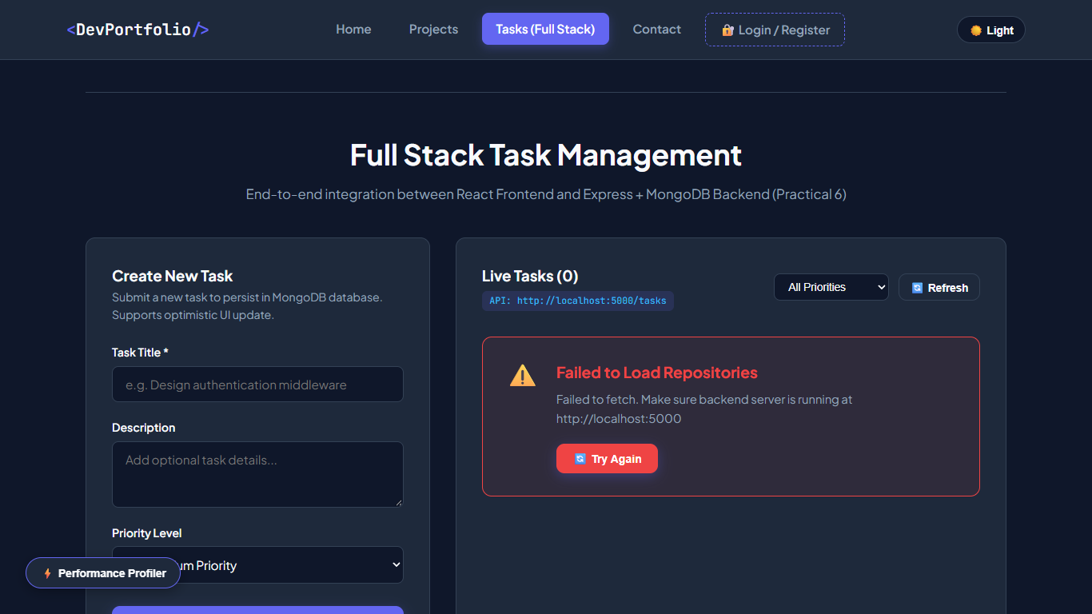  Figure: P6 Taskmanager Top  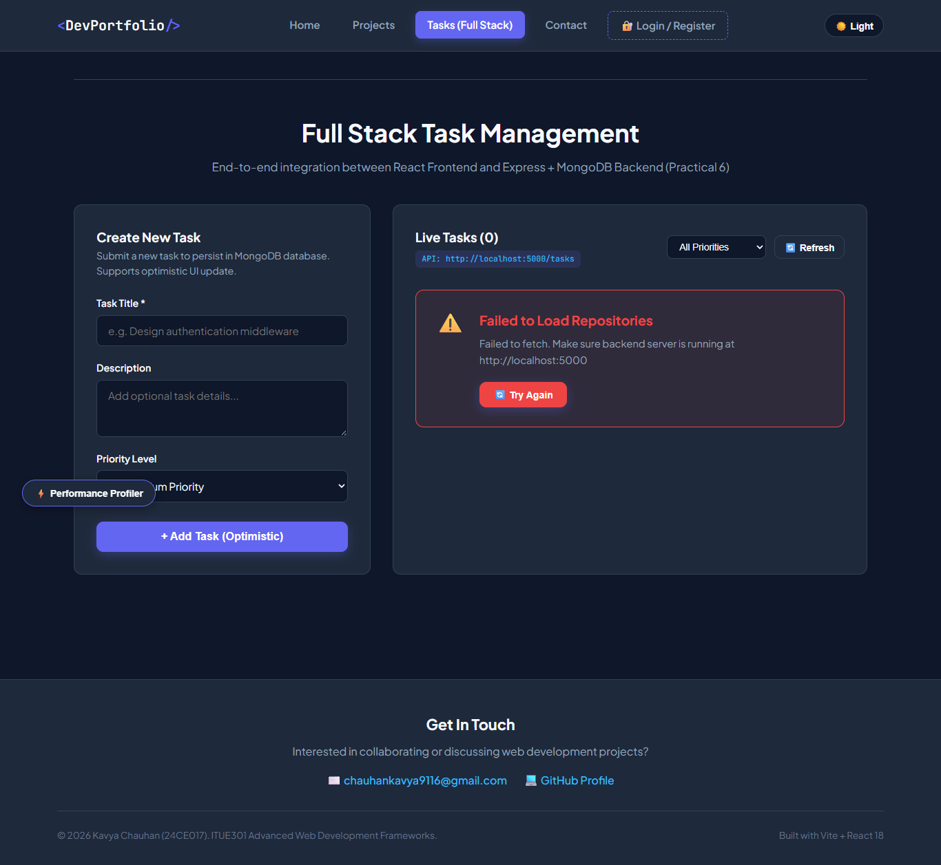  Figure: P6 Taskmanager

