Subject Code | : | ITUE301 | Semester | : | 5 | Academic Year | : | 2026-27 | Id: 24CE017
Subject Name | : | Advanced Web Framework

Practical 1 | Practical 1: Introduction to React and Component Architecture
Problem Statement | Set up a React development environment using Vite and build a static student portfolio page using independently structured, reusable React components.  Component Tree:  App.jsx -> Header.jsx, About.jsx, Skills.jsx, Footer.jsx  Key Requirements:  • Use Vite as the build tool and dev server  • Create separate .jsx component files for Header, About, Skills, and Footer  • Pass data from App to children via props (name, title, tagline, themeColor, skills array, etc.)  • Demonstrate reusable, modular component architecture  • Use array iteration (map) to render the skills list dynamically
Main Code | // File: App.jsx (Root Component with Props)  import React, { useState, useEffect, lazy, Suspense } from 'react';  import { Routes, Route } from 'react-router-dom';  import NavBar from './components/NavBar';  import Footer from './components/Footer';  import PageFallback from './components/PageFallback';  // Route-based Code Splitting using React.lazy() (Practical 8 Core Requirement)  const Home = lazy(() => import('./pages/Home'));  const Projects = lazy(() => import('./components/Projects'));  const TaskManager = lazy(() => import('./pages/TaskManager'));  const Contact = lazy(() => import('./pages/Contact'));  const AuthPage = lazy(() => import('./pages/AuthPage'));  const NotFound = lazy(() => import('./pages/NotFound'));  // Supplementary: Heavy Component Lazy Loading on Demand  const PerformanceProfiler = lazy(() => import('./components/PerformanceProfiler'));  function App() {  // useState variable for theme mode toggle (Supplementary requirement)  const [darkMode, setDarkMode] = useState(true);  // Practical 7: Authentication state management  const [authUser, setAuthUser] = useState(() => {  try {  const stored = localStorage.getItem('awf_auth_user');  return stored ? JSON.parse(stored) : null;  } catch {  return null;  }  });  // Practical 8: State to trigger on-demand lazy loaded profiler component  const [showProfiler, setShowProfiler] = useState(false);  const handleLogout = () => {  localStorage.removeItem('awf_auth_token');  localStorage.removeItem('awf_auth_user');  setAuthUser(null);  };  const studentData = {  name: 'Kavya Chauhan',  title: 'Full Stack Web Developer & Computer Engineering Student',  tagline: 'Passionate about building scalable modern web applications with React, Node.js, and cloud technologies.',  themeColor: '#6366f1',  bio: 'I am a 3rd-year student pursuing Information Technology / Computer Engineering at Charotar University of Science and Technology (CHARUSAT). I focus on modern frontend frameworks, RESTful API architecture, and scalable full-stack applications.',  education: {  degree: 'B.Tech in Computer Engineering',  institution: 'Charotar University of Science and Technology (CHARUSAT)',  field: 'Advanced Web Development Frameworks (ITUE301)'  },  location: 'Gujarat, India',  experienceYear: 2,  skills: [  { name: 'React.js', level: 'Advanced' },  { name: 'JavaScript (ES6+)', level: 'Advanced' },  { name: 'Node.js & Express', level: 'Intermediate' },  { name: 'MongoDB & Mongoose', level: 'Intermediate' },  { name: 'HTML5 & Modern CSS3', level: 'Advanced' },  { name: 'Git & GitHub', level: 'Intermediate' },  { name: 'REST APIs & JWT Auth', level: 'Intermediate' },  { name: 'Vite & Modern Tooling', level: 'Advanced' }  ],  email: 'chauhankavya9116@gmail.com',  github: 'https://github.com/kavy009',  rollNo: '24CE017'  };  const handleToggleTheme = () => {  setDarkMode((prev) => !prev);  };  useEffect(() => {  if (darkMode) {  document.body.classList.remove('light-mode');  document.body.classList.add('dark-mode');  } else {  document.body.classList.remove('dark-mode');  document.body.classList.add('light-mode');  }  }, [darkMode]);  return (  <div className={`portfolio-app ${darkMode ? 'theme-dark' : 'theme-light'}`}>  <NavBar  darkMode={darkMode}  onToggleTheme={handleToggleTheme}  authUser={authUser}  />  {/* Floating button to trigger on-demand lazy loaded profiler */}  <button  type="button"  className="floating-profiler-btn"  onClick={() => setShowProfiler(true)}  title="Open Lazy-Loaded Performance Profiler (Practical 8)"  >  ⚡ Performance Profiler  </button>  {/* Lazy loaded Heavy Component wrapped in Suspense */}  {showProfiler && (  <Suspense fallback={<div className="profiler-loading">Loading Profiler Chunk...</div>}>  <PerformanceProfiler onClose={() => setShowProfiler(false)} />  </Suspense>  )}  <main className="main-content">  {/* Suspense wrapper with fallback UI for lazy-loaded route chunks */}  <Suspense fallback={<PageFallback />}>  <Routes>  <Route path="/" element={<Home studentData={studentData} />} />  <Route path="/projects" element={<Projects />} />  <Route path="/tasks" element={<TaskManager authUser={authUser} />} />  <Route  path="/auth"  element={  <AuthPage  user={authUser}  onAuthSuccess={setAuthUser}  onLogout={handleLogout}  />  }  />  <Route path="/contact" element={<Contact studentEmail={studentData.email} />} />  {/* Supplementary 404 Route */}  <Route path="*" element={<NotFound />} />  </Routes>  </Suspense>  </main>  <Footer  email={studentData.email}  github={studentData.github}  studentName={studentData.name}  rollNo={studentData.rollNo}  />  </div>  );  }  export default App;  // File: components/Header.jsx  import React from 'react';  function Header({ name, title, tagline, themeColor }) {  return (  <header id="header" className="hero-header" style={{ borderColor: themeColor }}>  <div className="hero-content">  <span className="badge" style={{ backgroundColor: `${themeColor}22`, color: themeColor }}>  Welcome to my portfolio  </span>  <h1 className="hero-title">  Hi, I'm <span style={{ color: themeColor }}>{name}</span>  </h1>  <h2 className="hero-subtitle">{title}</h2>  <p className="hero-tagline">{tagline}</p>  <div className="hero-actions">  <a  href="#projects"  className="btn btn-primary"  style={{ backgroundColor: themeColor, borderColor: themeColor }}  >  View Projects  </a>  <a href="#about" className="btn btn-secondary">  Learn More  </a>  </div>  </div>  </header>  );  }  export default Header;  // File: components/About.jsx  import React from 'react';  function About({ bio, education, location, experienceYear }) {  return (  <section id="about" className="section about-section">  <div className="section-header">  <h2 className="section-title">About Me</h2>  <p className="section-subtitle">Get to know more about my journey and background</p>  </div>  <div className="about-grid">  <div className="about-card main-bio">  <h3>Background & Passion</h3>  <p>{bio}</p>  <div className="stats-row">  <div className="stat-item">  <span className="stat-number">{experienceYear}+</span>  <span className="stat-label">Years of Coding</span>  </div>  <div className="stat-item">  <span className="stat-number">15+</span>  <span className="stat-label">Projects Built</span>  </div>  <div className="stat-item">  <span className="stat-number">100%</span>  <span className="stat-label">Dedication</span>  </div>  </div>  </div>  <div className="about-card education-card">  <h3>Education & Details</h3>  <ul className="details-list">  <li>  <strong>Degree:</strong> {education.degree}  </li>  <li>  <strong>Institution:</strong> {education.institution}  </li>  <li>  <strong>Specialization:</strong> {education.field}  </li>  <li>  <strong>Location:</strong> {location}  </li>  </ul>  </div>  </div>  </section>  );  }  export default About;  // File: components/Skills.jsx  import React from 'react';  function Skills({ skillList }) {  return (  <section id="skills" className="section skills-section">  <div className="section-header">  <h2 className="section-title">Technical Skills</h2>  <p className="section-subtitle">Technologies and tools I work with</p>  </div>  <div className="skills-container">  <ul className="skills-list">  {skillList && skillList.map((skill, index) => (  <li key={typeof skill === 'string' ? skill : index} className="skill-item">  <span className="skill-dot"></span>  <span className="skill-name">{typeof skill === 'string' ? skill : skill.name}</span>  {skill.level && <span className="skill-level">{skill.level}</span>}  </li>  ))}  </ul>  </div>  </section>  );  }  export default Skills;  // File: components/Footer.jsx  import React from 'react';  function Footer({ email, github, studentName, rollNo }) {  const currentYear = new Date().getFullYear();  return (  <footer id="contact" className="site-footer">  <div className="footer-container">  <div className="footer-info">  <h3>Get In Touch</h3>  <p>Interested in collaborating or discussing web development projects?</p>  <div className="footer-links">  {email && (  <a href={`mailto:${email}`} className="footer-link">  ✉️ {email}  </a>  )}  {github && (  <a href={github} target="_blank" rel="noopener noreferrer" className="footer-link">  💻 GitHub Profile  </a>  )}  </div>  </div>  <div className="footer-bottom">  <p>  &copy; {currentYear} {studentName} ({rollNo}). ITUE301 Advanced Web Development Frameworks.  </p>  <p className="built-with">Built with Vite + React 18</p>  </div>  </div>  </footer>  );  }  export default Footer;  // File: main.jsx (Entry Point)  import { StrictMode } from 'react'  import { createRoot } from 'react-dom/client'  import { BrowserRouter } from 'react-router-dom'  import './index.css'  import App from './App.jsx'  createRoot(document.getElementById('root')).render(  <StrictMode>  <BrowserRouter>  <App />  </BrowserRouter>  </StrictMode>,  )

Output | A fully rendered student portfolio page with:  • Hero header showing student name, title, and tagline with dynamic themeColor prop styling  • About section displaying bio, education details, and experience stats  • Skills section dynamically rendering a list of technical skills using .map()  • Footer with email, GitHub link, and copyright  • All data passed via props from App.jsx to child components  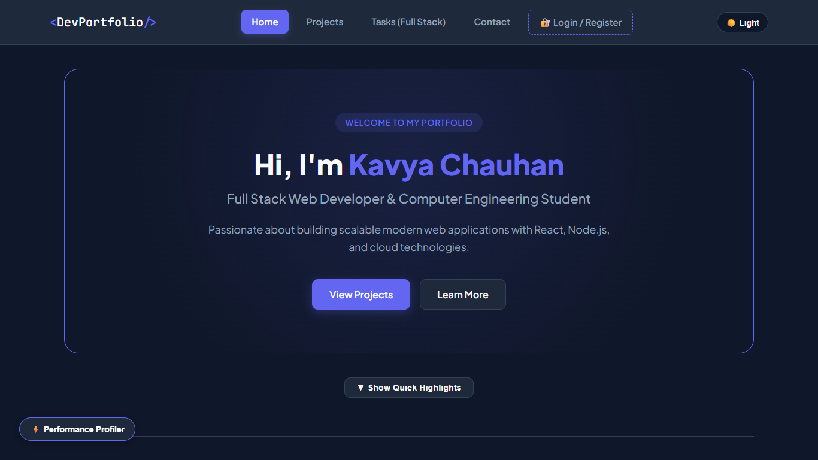  Figure 1.1: P1 Hero  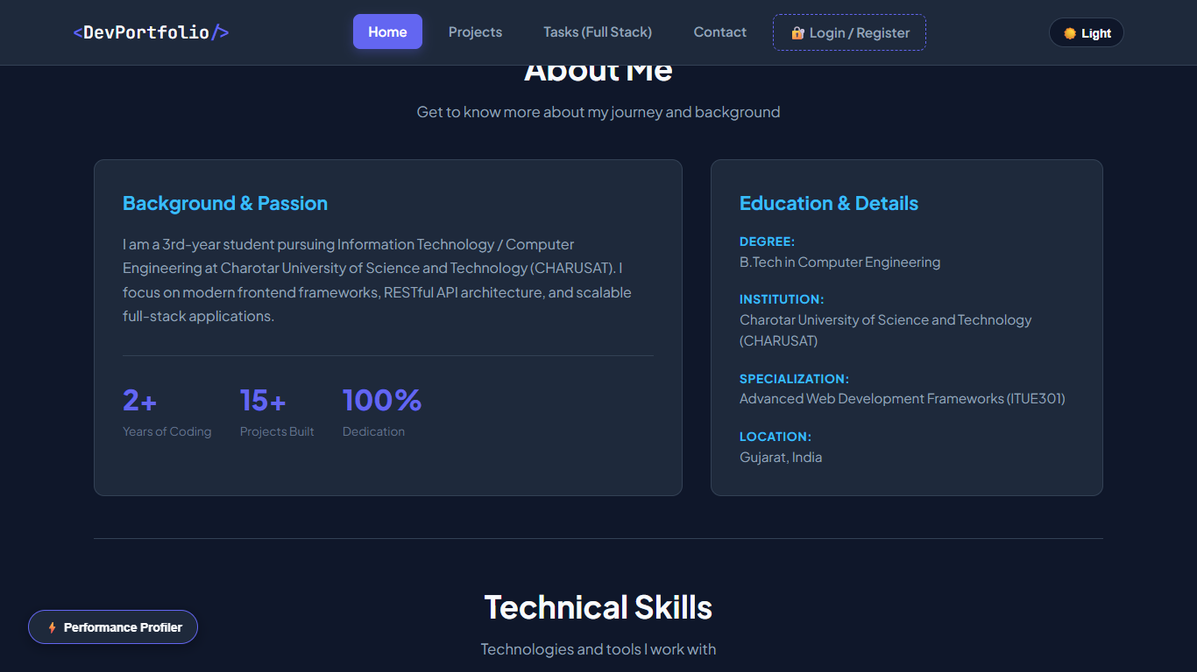  Figure 1.2: P1 About  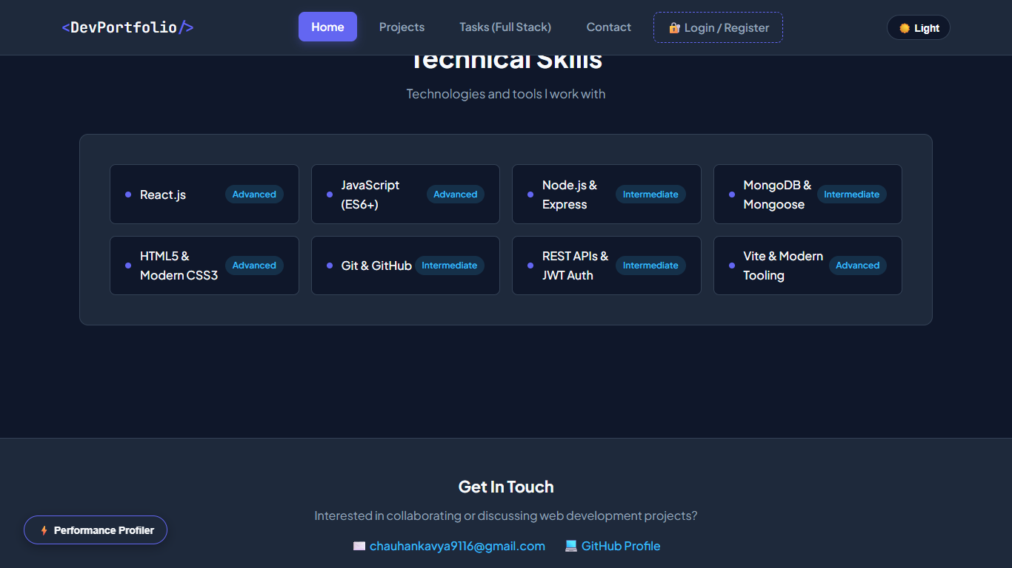  Figure 1.3: P1 Skills  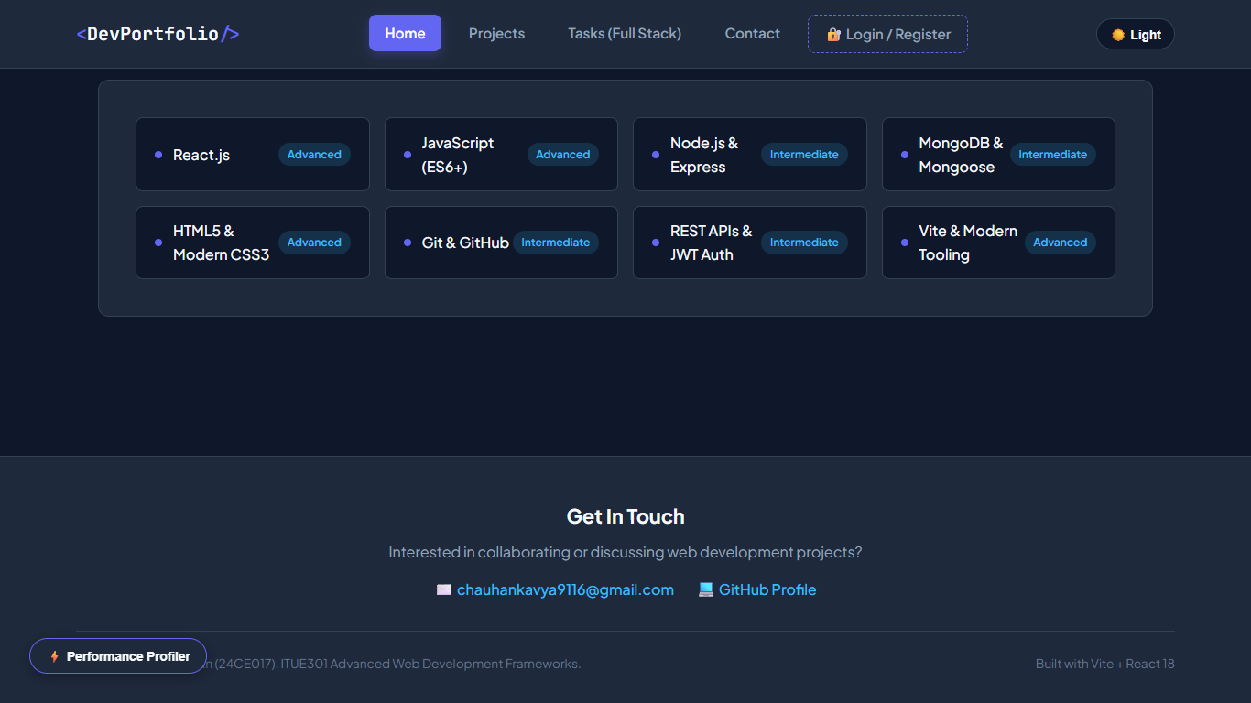  Figure 1.4: P1 Footer

Subject Code | : | ITUE301 | Semester | : | 5 | Academic Year | : | 2026-27
Subject Name | : | Advanced Web Framework

Practical 2 | Practical 2: State Management and Routing in React
Problem Statement | Extend the portfolio application with multi-page navigation using React Router v6 and local state management using the useState hook.  Key Requirements:  • Install and configure react-router-dom v6 with BrowserRouter  • Define multiple routes: /, /projects, /tasks, /contact, /auth  • Use <NavLink> for navigation with active link styling  • Implement dark/light mode toggle using useState  • Build a controlled form on the Contact page using useState  • Add a toggleable UI section with useState (Show/Hide Quick Highlights)
Main Code | // File: App.jsx (React Router + useState)  import React, { useState, useEffect, lazy, Suspense } from 'react';  import { Routes, Route } from 'react-router-dom';  import NavBar from './components/NavBar';  import Footer from './components/Footer';  import PageFallback from './components/PageFallback';  // Route-based Code Splitting using React.lazy() (Practical 8 Core Requirement)  const Home = lazy(() => import('./pages/Home'));  const Projects = lazy(() => import('./components/Projects'));  const TaskManager = lazy(() => import('./pages/TaskManager'));  const Contact = lazy(() => import('./pages/Contact'));  const AuthPage = lazy(() => import('./pages/AuthPage'));  const NotFound = lazy(() => import('./pages/NotFound'));  // Supplementary: Heavy Component Lazy Loading on Demand  const PerformanceProfiler = lazy(() => import('./components/PerformanceProfiler'));  function App() {  // useState variable for theme mode toggle (Supplementary requirement)  const [darkMode, setDarkMode] = useState(true);  // Practical 7: Authentication state management  const [authUser, setAuthUser] = useState(() => {  try {  const stored = localStorage.getItem('awf_auth_user');  return stored ? JSON.parse(stored) : null;  } catch {  return null;  }  });  // Practical 8: State to trigger on-demand lazy loaded profiler component  const [showProfiler, setShowProfiler] = useState(false);  const handleLogout = () => {  localStorage.removeItem('awf_auth_token');  localStorage.removeItem('awf_auth_user');  setAuthUser(null);  };  const studentData = {  name: 'Kavya Chauhan',  title: 'Full Stack Web Developer & Computer Engineering Student',  tagline: 'Passionate about building scalable modern web applications with React, Node.js, and cloud technologies.',  themeColor: '#6366f1',  bio: 'I am a 3rd-year student pursuing Information Technology / Computer Engineering at Charotar University of Science and Technology (CHARUSAT). I focus on modern frontend frameworks, RESTful API architecture, and scalable full-stack applications.',  education: {  degree: 'B.Tech in Computer Engineering',  institution: 'Charotar University of Science and Technology (CHARUSAT)',  field: 'Advanced Web Development Frameworks (ITUE301)'  },  location: 'Gujarat, India',  experienceYear: 2,  skills: [  { name: 'React.js', level: 'Advanced' },  { name: 'JavaScript (ES6+)', level: 'Advanced' },  { name: 'Node.js & Express', level: 'Intermediate' },  { name: 'MongoDB & Mongoose', level: 'Intermediate' },  { name: 'HTML5 & Modern CSS3', level: 'Advanced' },  { name: 'Git & GitHub', level: 'Intermediate' },  { name: 'REST APIs & JWT Auth', level: 'Intermediate' },  { name: 'Vite & Modern Tooling', level: 'Advanced' }  ],  email: 'chauhankavya9116@gmail.com',  github: 'https://github.com/kavy009',  rollNo: '24CE017'  };  const handleToggleTheme = () => {  setDarkMode((prev) => !prev);  };  useEffect(() => {  if (darkMode) {  document.body.classList.remove('light-mode');  document.body.classList.add('dark-mode');  } else {  document.body.classList.remove('dark-mode');  document.body.classList.add('light-mode');  }  }, [darkMode]);  return (  <div className={`portfolio-app ${darkMode ? 'theme-dark' : 'theme-light'}`}>  <NavBar  darkMode={darkMode}  onToggleTheme={handleToggleTheme}  authUser={authUser}  />  {/* Floating button to trigger on-demand lazy loaded profiler */}  <button  type="button"  className="floating-profiler-btn"  onClick={() => setShowProfiler(true)}  title="Open Lazy-Loaded Performance Profiler (Practical 8)"  >  ⚡ Performance Profiler  </button>  {/* Lazy loaded Heavy Component wrapped in Suspense */}  {showProfiler && (  <Suspense fallback={<div className="profiler-loading">Loading Profiler Chunk...</div>}>  <PerformanceProfiler onClose={() => setShowProfiler(false)} />  </Suspense>  )}  <main className="main-content">  {/* Suspense wrapper with fallback UI for lazy-loaded route chunks */}  <Suspense fallback={<PageFallback />}>  <Routes>  <Route path="/" element={<Home studentData={studentData} />} />  <Route path="/projects" element={<Projects />} />  <Route path="/tasks" element={<TaskManager authUser={authUser} />} />  <Route  path="/auth"  element={  <AuthPage  user={authUser}  onAuthSuccess={setAuthUser}  onLogout={handleLogout}  />  }  />  <Route path="/contact" element={<Contact studentEmail={studentData.email} />} />  {/* Supplementary 404 Route */}  <Route path="*" element={<NotFound />} />  </Routes>  </Suspense>  </main>  <Footer  email={studentData.email}  github={studentData.github}  studentName={studentData.name}  rollNo={studentData.rollNo}  />  </div>  );  }  export default App;  // File: main.jsx (BrowserRouter Setup)  import { StrictMode } from 'react'  import { createRoot } from 'react-dom/client'  import { BrowserRouter } from 'react-router-dom'  import './index.css'  import App from './App.jsx'  createRoot(document.getElementById('root')).render(  <StrictMode>  <BrowserRouter>  <App />  </BrowserRouter>  </StrictMode>,  )  // File: components/NavBar.jsx (NavLink with Active State)  import React from 'react';  import { NavLink, Link } from 'react-router-dom';  function NavBar({ darkMode, onToggleTheme, authUser }) {  return (  <nav className="navbar">  <div className="nav-container">  <Link to="/" className="nav-logo">  <span className="logo-accent">&lt;</span>DevPortfolio<span className="logo-accent">/&gt;</span>  </Link>  <ul className="nav-links">  <li>  <NavLink  to="/"  className={({ isActive }) =>  isActive ? 'nav-link-btn active' : 'nav-link-btn'  }  >  Home  </NavLink>  </li>  <li>  <NavLink  to="/projects"  className={({ isActive }) =>  isActive ? 'nav-link-btn active' : 'nav-link-btn'  }  >  Projects  </NavLink>  </li>  <li>  <NavLink  to="/tasks"  className={({ isActive }) =>  isActive ? 'nav-link-btn active' : 'nav-link-btn'  }  >  Tasks (Full Stack)  </NavLink>  </li>  <li>  <NavLink  to="/contact"  className={({ isActive }) =>  isActive ? 'nav-link-btn active' : 'nav-link-btn'  }  >  Contact  </NavLink>  </li>  <li>  <NavLink  to="/auth"  className={({ isActive }) =>  isActive ? 'nav-link-btn active auth-nav-btn' : 'nav-link-btn auth-nav-btn'  }  >  {authUser ? `👤 ${authUser.name || 'Account'}` : '🔐 Login / Register'}  </NavLink>  </li>  </ul>  {/* Theme mode toggle button using useState in App */}  <div className="nav-actions">  <button  type="button"  className="theme-toggle-btn"  onClick={onToggleTheme}  aria-label="Toggle theme mode"  >  {darkMode ? '☀️ Light' : '🌙 Dark'}  </button>  </div>  </div>  </nav>  );  }  export default NavBar;  // File: pages/Home.jsx (useState Toggle)  import React, { useState } from 'react';  import Header from '../components/Header';  import About from '../components/About';  import Skills from '../components/Skills';  function Home({ studentData }) {  // useState variable for toggling UI visibility (additional info / highlights)  const [showMoreInfo, setShowMoreInfo] = useState(false);  return (  <div className="page home-page">  <Header  name={studentData.name}  title={studentData.title}  tagline={studentData.tagline}  themeColor={studentData.themeColor}  />  <div className="section-toggle-container">  <button  type="button"  className="btn btn-secondary toggle-btn"  onClick={() => setShowMoreInfo(!showMoreInfo)}  >  {showMoreInfo ? '▲ Hide Quick Highlights' : '▼ Show Quick Highlights'}  </button>  {showMoreInfo && (  <div className="toggleable-info-card">  <h4>💡 Quick Academic Highlights</h4>  <p>  Current Focus: Microservices, React 18, and scalable API pipelines.  Actively exploring performant client-side state caching and event-driven architectures.  </p>  </div>  )}  </div>  <About  bio={studentData.bio}  education={studentData.education}  location={studentData.location}  experienceYear={studentData.experienceYear}  />  <Skills skillList={studentData.skills} />  </div>  );  }  export default Home;  // File: pages/Contact.jsx (Controlled Form)  import React, { useState } from 'react';  function Contact({ studentEmail }) {  // useState 1: Controlled form fields  const [formData, setFormData] = useState({  senderName: '',  senderEmail: '',  message: ''  });  // useState 2: Toggle UI visibility (Help Tooltip)  const [showTooltip, setShowTooltip] = useState(false);  // Status message  const [submitted, setSubmitted] = useState(false);  const maxChars = 250;  const handleChange = (e) => {  const { name, value } = e.target;  setFormData((prev) => ({  ...prev,  [name]: value  }));  if (submitted) setSubmitted(false);  };  const handleSubmit = (e) => {  e.preventDefault();  if (!formData.senderName || !formData.message) return;  setSubmitted(true);  };  return (  <section className="section contact-page">  <div className="section-header">  <h2 className="section-title">Get in Touch</h2>  <p className="section-subtitle">  Feel free to reach out for collaborations or project discussions  </p>  </div>  <div className="contact-grid">  <div className="contact-form-card">  <div className="card-top-bar">  <h3>Send a Message</h3>  <button  type="button"  className="tooltip-toggle-btn"  onClick={() => setShowTooltip(!showTooltip)}  title="Click to toggle instructions tooltip"  >  ℹ️ {showTooltip ? 'Hide Help' : 'Help & Guidelines'}  </button>  </div>  {/* useState UI visibility toggle element */}  {showTooltip && (  <div className="help-tooltip-box">  <p>  <strong>Form Instructions:</strong> Please provide your name, valid email, and your  inquiry. All inputs are controlled via React <code>useState</code> and reflect in real-time.  </p>  </div>  )}  <form onSubmit={handleSubmit} className="contact-form">  <div className="form-group">  <label htmlFor="senderName">Your Name:</label>  <input  id="senderName"  type="text"  name="senderName"  placeholder="e.g. John Doe"  value={formData.senderName}  onChange={handleChange}  required  className="form-input"  />  </div>  <div className="form-group">  <label htmlFor="senderEmail">Your Email:</label>  <input  id="senderEmail"  type="email"  name="senderEmail"  placeholder="e.g. john@example.com"  value={formData.senderEmail}  onChange={handleChange}  required  className="form-input"  />  </div>  <div className="form-group">  <label htmlFor="message">Message:</label>  <textarea  id="message"  name="message"  rows="4"  maxLength={maxChars}  placeholder="Write your message here..."  value={formData.message}  onChange={handleChange}  required  className="form-textarea"  ></textarea>  {/* Live character count requirement */}  <div className="char-count-bar">  <span>  Character Count: <strong>{formData.message.length}</strong> / {maxChars}  </span>  <span className="remaining-text">  {maxChars - formData.message.length} characters remaining  </span>  </div>  </div>  <button type="submit" className="btn btn-primary submit-btn">  Send Message  </button>  {submitted && (  <div className="success-banner">  ✅ Thank you, {formData.senderName}! Your message was captured into React state.  </div>  )}  </form>  </div>  {/* Real-Time Live Preview showing controlled input reflection */}  <div className="live-preview-card">  <div className="preview-header">  <h3>⚡ Real-Time State Preview</h3>  <span className="live-indicator">LIVE</span>  </div>  <p className="preview-desc">  Demonstrates controlled component reactivity powered by <code>useState</code>:  </p>  <div className="preview-item">  <span className="preview-label">Name:</span>  <span className="preview-value">{formData.senderName || '(typing preview...)'}</span>  </div>  <div className="preview-item">  <span className="preview-label">Email:</span>  <span className="preview-value">{formData.senderEmail || '(typing preview...)'}</span>  </div>  <div className="preview-item">  <span className="preview-label">Live Message Stream:</span>  <div className="preview-message-box">  {formData.message || 'Start typing in the message box to see live state reflection...'}  </div>  </div>  <div className="preview-item">  <span className="preview-label">Direct Contact:</span>  <span className="preview-value">{studentEmail}</span>  </div>  </div>  </div>  </section>  );  }  export default Contact;

Output | A multi-page React application with:  • Navigation bar with active link highlighting across 5 routes  • Dark/Light mode toggle button in navbar using useState  • Home page with toggleable 'Quick Highlights' section (useState)  • Contact page with a controlled form (name, email, message fields)  • Seamless client-side page transitions without full page reloads  Figure 2.1: P2 Navbar Light  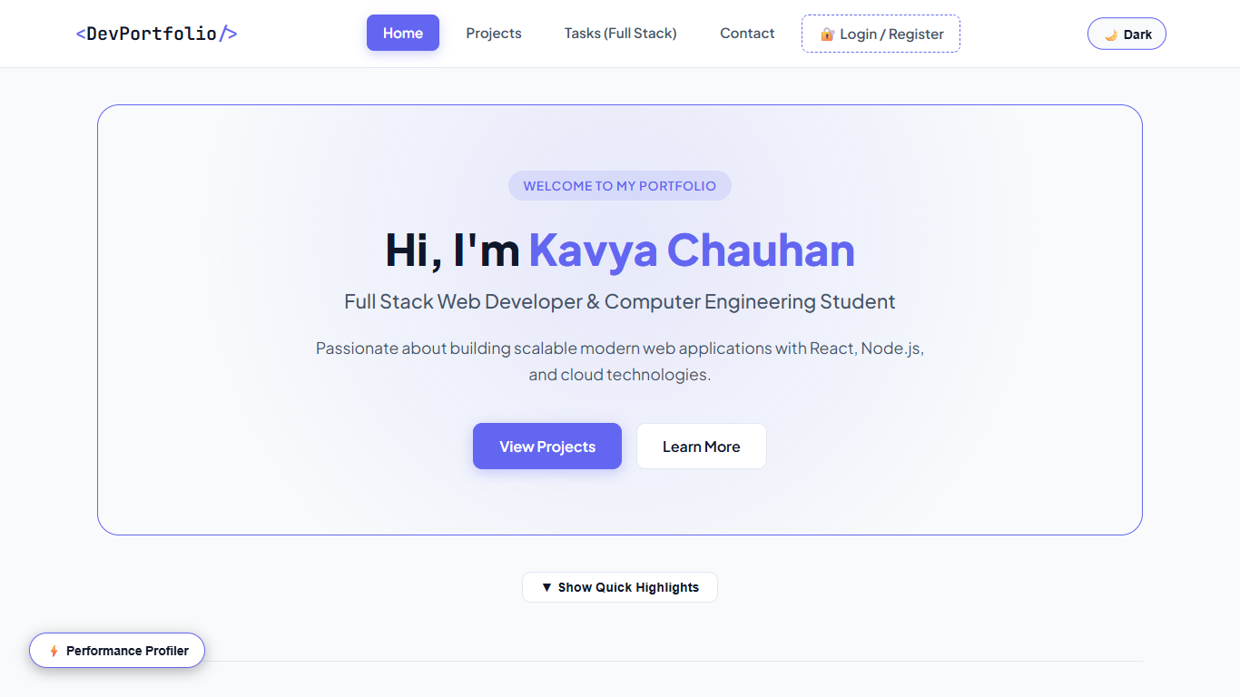  Figure 2.2: P2 Navbar Dark  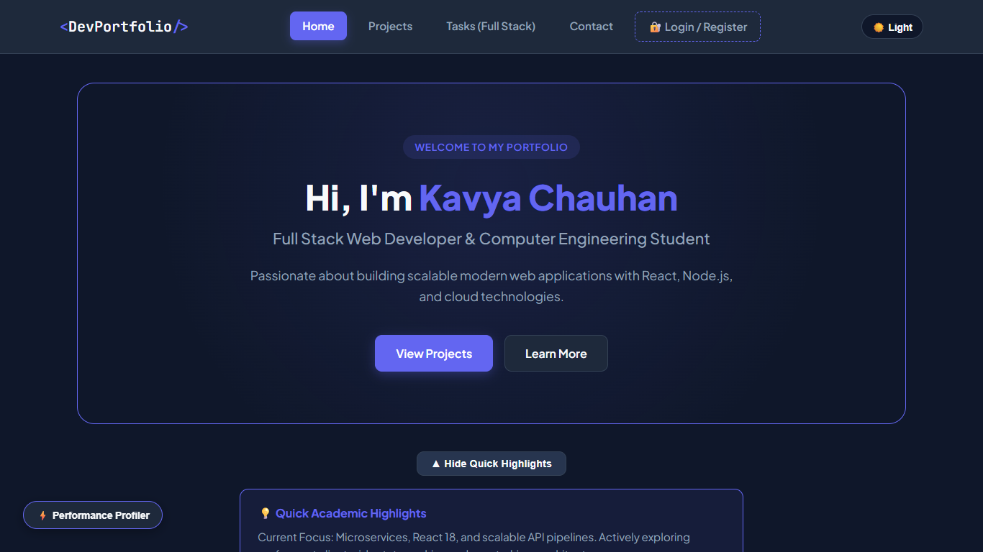  Figure 2.3: P2 Highlights  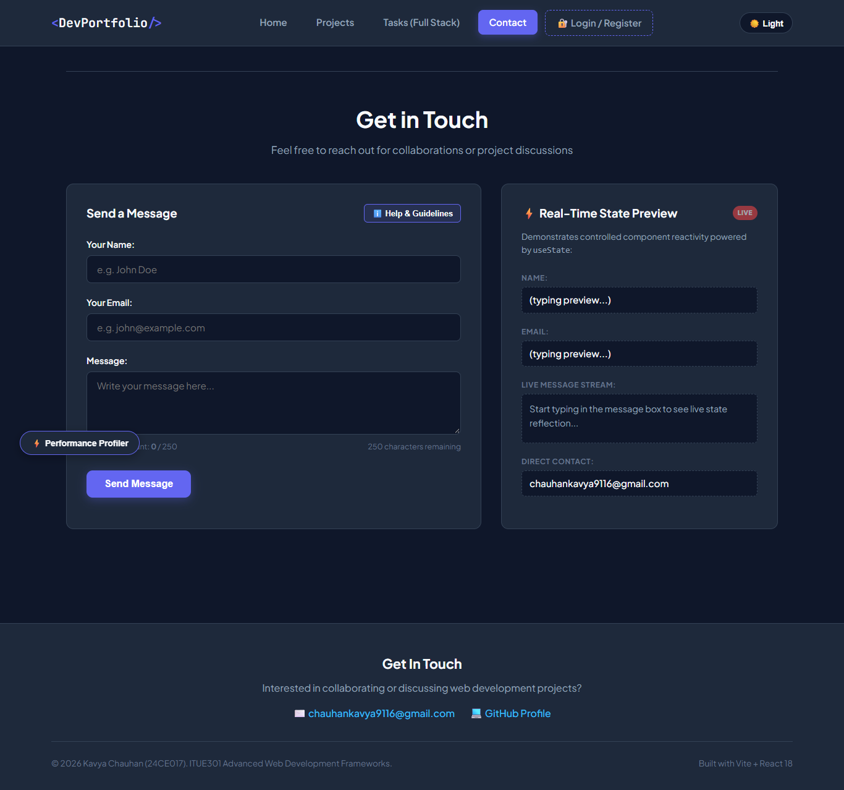  Figure 2.4: P2 Contact

Subject Code | : | ITUE301 | Semester | : | 5 | Academic Year | : | 2026-27
Subject Name | : | Advanced Web Framework

Practical 3 | Practical 3: API Integration and Data Rendering
Problem Statement | Integrate a public REST API (GitHub API) into the React portfolio to fetch and display live data with proper loading, error, and empty states.  Key Requirements:  • Use fetch() with async/await to call the GitHub REST API  • Implement useEffect for data fetching on component mount  • Show a loading spinner while the API request is in progress  • Handle API errors gracefully with an error message + retry button  • Add a search filter to filter repositories dynamically  • Include a 'Simulate Error' button to test error state explicitly  • Render repository data with name, description, language, stars, and forks
Main Code | // File: components/Projects.jsx (API Fetch + useEffect + Error Handling)  import React, { useState, useEffect, useCallback } from 'react';  import Spinner from './Spinner';  import ErrorMessage from './ErrorMessage';  function Projects() {  const [repos, setRepos] = useState([]);  const [loading, setLoading] = useState(true);  const [error, setError] = useState(null);  const [searchTerm, setSearchTerm] = useState('');  const [simulateError, setSimulateError] = useState(false);  const username = 'kavy009';  const fetchRepositories = useCallback(() => {  setLoading(true);  setError(null);  // If simulateError is true, test the error state explicitly for viva / lab evaluation  const url = simulateError  ? 'https://api.github.com/invalid-url-for-testing-awf'  : `https://api.github.com/users/${username}/repos?sort=updated&per_page=30`;  fetch(url)  .then((res) => {  if (!res.ok) {  throw new Error(`GitHub API request failed with status: ${res.status} (${res.statusText})`);  }  return res.json();  })  .then((data) => {  if (Array.isArray(data)) {  setRepos(data);  } else {  setRepos([]);  }  })  .catch((err) => {  setError(err.message || 'Unable to fetch repositories.');  })  .finally(() => {  setLoading(false);  });  }, [simulateError]);  useEffect(() => {  fetchRepositories();  }, [fetchRepositories]);  // Filter repositories dynamically by name  const filteredRepos = repos.filter((repo) =>  repo.name.toLowerCase().includes(searchTerm.toLowerCase()) ||  (repo.description && repo.description.toLowerCase().includes(searchTerm.toLowerCase()))  );  return (  <section id="projects" className="section projects-section">  <div className="section-header">  <h2 className="section-title">GitHub Projects & Repositories</h2>  <p className="section-subtitle">  Live repository data fetched directly via GitHub REST API (Practical 3 Integration)  </p>  </div>  {/* Control bar: Search Filter + Simulated Error Toggle for Testing */}  <div className="projects-controls">  <div className="search-box">  <span className="search-icon">🔍</span>  <input  type="text"  className="search-input"  placeholder="Search repositories by name or keyword..."  value={searchTerm}  onChange={(e) => setSearchTerm(e.target.value)}  />  {searchTerm && (  <button  type="button"  className="clear-search-btn"  onClick={() => setSearchTerm('')}  >  ✕  </button>  )}  </div>  <div className="demo-controls">  <button  type="button"  className={`btn-test-error ${simulateError ? 'active' : ''}`}  onClick={() => setSimulateError((prev) => !prev)}  title="Toggle invalid endpoint to test Error Boundary / Error state"  >  {simulateError ? '⚠️ Revert to Valid API' : '🧪 Simulate API Error'}  </button>  <button  type="button"  className="btn btn-secondary reload-btn"  onClick={fetchRepositories}  disabled={loading}  >  🔄 Refresh  </button>  </div>  </div>  {/* Conditional Rendering based on state */}  {loading && <Spinner message="Fetching public repositories from api.github.com..." />}  {!loading && error && (  <ErrorMessage  message={error}  onRetry={fetchRepositories}  />  )}  {!loading && !error && filteredRepos.length === 0 && (  <div className="empty-state-card">  <p>No repositories found matching "<strong>{searchTerm}</strong>".</p>  </div>  )}  {!loading && !error && filteredRepos.length > 0 && (  <div className="projects-grid">  {filteredRepos.map((repo) => (  <div key={repo.id} className="project-card repo-card">  <div className="project-card-header">  <span className="repo-icon">📦</span>  <h3 className="project-title repo-title">  <a  href={repo.html_url}  target="_blank"  rel="noopener noreferrer"  className="repo-link"  >  {repo.name}  </a>  </h3>  </div>  <p className="project-desc repo-desc">  {repo.description || 'No description provided for this repository.'}  </p>  <div className="repo-metadata">  {repo.language && (  <span className="repo-meta-item">  <span className="lang-indicator"></span>  {repo.language}  </span>  )}  {/* Star count requirement */}  <span className="repo-meta-item stars-badge">  ⭐ {repo.stargazers_count || 0}  </span>  {repo.forks_count !== undefined && (  <span className="repo-meta-item forks-badge">  🍴 {repo.forks_count}  </span>  )}  </div>  <div className="project-card-footer">  <a  href={repo.html_url}  target="_blank"  rel="noopener noreferrer"  className="btn-external-link"  >  View on GitHub ↗  </a>  </div>  </div>  ))}  </div>  )}  </section>  );  }  export default Projects;  // File: components/Spinner.jsx (Loading State)  import React from 'react';  function Spinner({ message = 'Loading repositories from GitHub API...' }) {  return (  <div className="spinner-container">  <div className="loading-spinner"></div>  <p className="spinner-text">{message}</p>  </div>  );  }  export default Spinner;  // File: components/ErrorMessage.jsx (Error Fallback)  import React from 'react';  function ErrorMessage({ message, onRetry }) {  return (  <div className="error-card">  <div className="error-icon">⚠️</div>  <div className="error-content">  <h3 className="error-title">Failed to Load Repositories</h3>  <p className="error-desc">{message || 'An unexpected network error occurred while reaching GitHub API.'}</p>  {onRetry && (  <button type="button" className="btn btn-primary retry-btn" onClick={onRetry}>  🔄 Try Again  </button>  )}  </div>  </div>  );  }  export default ErrorMessage;

Output | The Projects page dynamically renders:  • Live GitHub repository cards fetched from api.github.com/users/kavy009/repos  • Loading spinner during API fetch  • Error message with retry button on API failure  • Search input to filter repositories by name or description  • Repository metadata: language badge, star count, fork count  • 'Simulate API Error' toggle button for testing error state  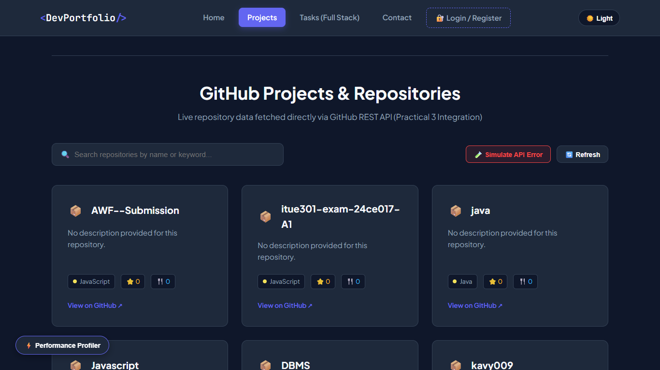  Figure 3.1: P3 Projects Top  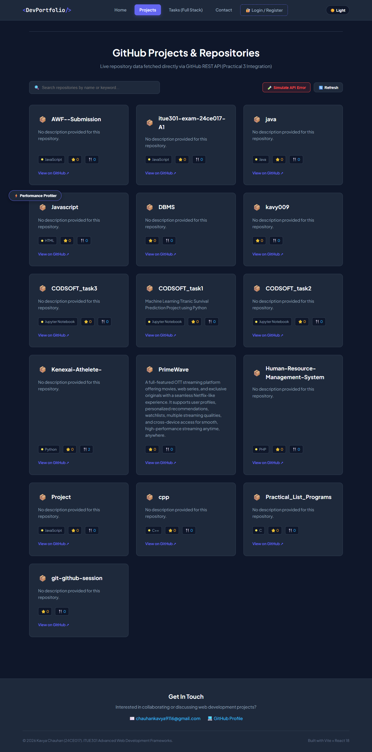  Figure 3.2: P3 Projects  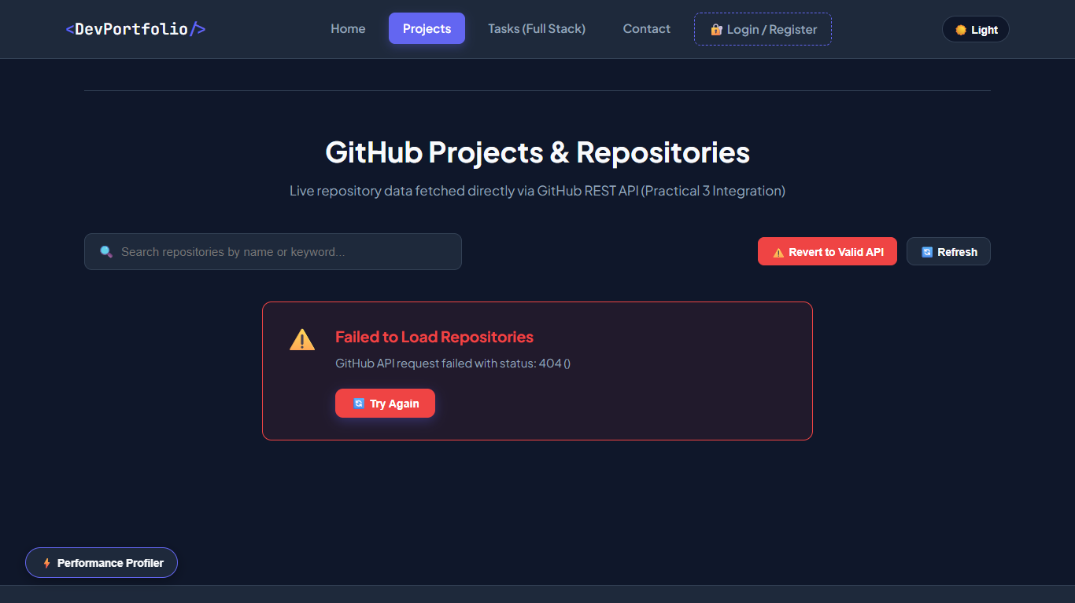  Figure 3.3: P3 Error

Subject Code | : | ITUE301 | Semester | : | 5 | Academic Year | : | 2026-27
Subject Name | : | Advanced Web Framework

Practical 4 | Practical 4: Building RESTful APIs with Node.js and Express
Problem Statement | Build a RESTful API server using Node.js and Express.js that provides full CRUD (Create, Read, Update, Delete) endpoints for a Task resource.  Key Requirements:  • Set up an Express.js server on port 5000  • Implement REST endpoints: GET /tasks, GET /tasks/:id, POST /tasks, PUT /tasks/:id, DELETE /tasks/:id  • Add global request logging middleware  • Enforce Content-Type: application/json for POST/PUT requests  • Validate task input (title required, priority enum validation)  • Implement centralized error handling middleware  • Add 404 handler for undefined routes
Main Code | // File: backend/server.js (Express REST API with CRUD + Middleware)  const express = require('express');  const mongoose = require('mongoose');  const cors = require('cors');  require('dotenv').config();  const Task = require('./models/Task');  const auth = require('./middleware/auth');  const { validateTaskInput } = require('./middleware/validation');  const authRoutes = require('./routes/auth');  const cache = require('./utils/cache');  const taskEvents = require('./events');  require('./listeners');  const app = express();  const PORT = process.env.PORT || 5000;  const MONGO_URI = process.env.MONGO_URI || 'mongodb://127.0.0.1:27017/taskdb';  // 1. Enable Cross-Origin Resource Sharing (CORS) for React frontend  app.use(cors());  // 2. Built-in JSON body parser  app.use(express.json());  // 3. Global Request Logging Middleware  app.use((req, res, next) => {  const timestamp = new Date().toISOString();  console.log(`[${req.method}] ${req.url} - ${timestamp}`);  next();  });  // 4. Connect to MongoDB via Mongoose  let isDbConnected = false;  mongoose  .connect(MONGO_URI)  .then(() => {  isDbConnected = true;  console.log(`[Database] MongoDB connected successfully to ${MONGO_URI}`);  })  .catch((err) => {  console.error(`[Database Warning] Could not connect to MongoDB: ${err.message}`);  console.log('[Database Info] Ensure MongoDB is running locally or provide a valid MONGO_URI in .env');  });  // In-memory fallback tasks in case MongoDB is offline during testing  let memoryTasks = [  {  _id: 'task-1',  id: 'task-1',  title: 'Setup React Portfolio UI',  description: 'Build Vite + React component architecture with props',  completed: true,  priority: 'high',  createdAt: new Date().toISOString()  },  {  _id: 'task-2',  id: 'task-2',  title: 'Configure React Router & useState',  description: 'Implement multi-route navigation and controlled form',  completed: true,  priority: 'medium',  createdAt: new Date().toISOString()  },  {  _id: 'task-3',  id: 'task-3',  title: 'Integrate GitHub REST API',  description: 'Fetch repositories asynchronously with loading spinner',  completed: true,  priority: 'low',  createdAt: new Date().toISOString()  }  ];  // 5. Content-Type Enforcer Middleware for write operations  const requireJsonContent = (req, res, next) => {  if (['POST', 'PUT'].includes(req.method)) {  const contentType = req.headers['content-type'];  if (!contentType || !contentType.includes('application/json')) {  return res.status(400).json({  success: false,  error: 'Bad Request',  message: 'Content-Type must be application/json for POST and PUT requests'  });  }  }  next();  };  app.use(requireJsonContent);  // Middleware to validate MongoDB ObjectId or alphanumeric ID  const validateObjectId = (req, res, next) => {  const id = req.params.id;  if (!id || id.trim() === '') {  return res.status(400).json({  success: false,  error: 'Invalid ID Format',  message: 'ID parameter cannot be empty'  });  }  next();  };  // ==========================================  // Authentication Routes (Practical 7)  // ==========================================  app.use('/auth', authRoutes);  // ==========================================  // Cache Debug & Statistics (Practical 9 Supplementary)  // ==========================================  app.get('/cache-stats', (req, res) => {  res.status(200).json({  success: true,  cache: cache.getStats()  });  });  app.post('/cache-clear', (req, res) => {  cache.flush();  res.status(200).json({  success: true,  message: 'In-memory cache successfully invalidated and cleared'  });  });  // ==========================================  // RESTful Task Routes with In-Memory Caching (Practical 9)  // ==========================================  // GET /tasks - Retrieve all tasks (Checks node-cache first)  app.get('/tasks', auth, async (req, res, next) => {  try {  const cacheKey = 'all_tasks';  const { data: cachedData, hit } = cache.get(cacheKey);  if (hit && cachedData) {  res.setHeader('X-Cache', 'HIT');  return res.status(200).json({  success: true,  cached: true,  source: 'in-memory-cache',  count: cachedData.length,  user: req.user,  data: cachedData  });  }  // Cache MISS: Retrieve from MongoDB database  let tasksList = [];  try {  tasksList = await Task.find().sort({ createdAt: -1 });  } catch {  tasksList = memoryTasks;  }  // Store in node-cache with 60-second TTL  cache.set(cacheKey, tasksList, 60);  res.setHeader('X-Cache', 'MISS');  res.status(200).json({  success: true,  cached: false,  source: 'database-query',  count: tasksList.length,  user: req.user,  data: tasksList  });  } catch (err) {  next(err);  }  });  // GET /tasks/:id - Retrieve single task by ID (Supplementary: caches individual task)  app.get('/tasks/:id', auth, validateObjectId, async (req, res, next) => {  try {  const cacheKey = `task_${req.params.id}`;  const { data: cachedTask, hit } = cache.get(cacheKey);  if (hit && cachedTask) {  res.setHeader('X-Cache', 'HIT');  return res.status(200).json({  success: true,  cached: true,  source: 'in-memory-cache',  data: cachedTask  });  }  let task = null;  try {  task = await Task.findById(req.params.id);  } catch {  task = memoryTasks.find((t) => t._id === req.params.id || t.id === req.params.id);  }  if (!task) {  return res.status(404).json({  success: false,  error: 'Not Found',  message: `Task with ID ${req.params.id} not found`  });  }  // Cache the individual task  cache.set(cacheKey, task, 60);  res.setHeader('X-Cache', 'MISS');  res.status(200).json({  success: true,  cached: false,  source: 'database-query',  data: task  });  } catch (err) {  next(err);  }  });  // POST /tasks - Create a task & Invalidate Cache Key (Practical 9 Core Requirement)  app.post('/tasks', auth, validateTaskInput, async (req, res, next) => {  try {  const { title, description, completed, priority } = req.body;  let savedTask = null;  try {  savedTask = await Task.create({  title,  description,  completed,  priority  });  } catch {  savedTask = {  _id: 'task-' + Date.now(),  id: 'task-' + Date.now(),  title: title.trim(),  description: description ? String(description).trim() : '',  completed: Boolean(completed),  priority: priority || 'medium',  createdAt: new Date().toISOString()  };  memoryTasks.unshift(savedTask);  }  // Invalidate cache immediately after write operation  cache.del('all_tasks');  console.log('[Cache Invalidation] Cleared cache key: "all_tasks" after POST');  const apiResponseTimestamp = new Date().toISOString();  console.log(`[API] Response sent for POST /tasks at ${apiResponseTimestamp}`);  res.status(201).json({  success: true,  message: 'Task created successfully',  apiResponseTimestamp,  data: savedTask  });  // Practical 10: Asynchronously emit task-created event AFTER response is sent  const taskPayload = savedTask && typeof savedTask.toObject === 'function' ? savedTask.toObject() : savedTask;  taskEvents.emit('task-created', {  ...taskPayload,  user: req.user,  apiResponseTimestamp  });  } catch (err) {  next(err);  }  });  // PUT /tasks/:id - Update task & Invalidate Cache Keys  app.put('/tasks/:id', auth, validateObjectId, async (req, res, next) => {  try {  const { title, description, completed, priority } = req.body;  let updatedTask = null;  try {  updatedTask = await Task.findByIdAndUpdate(  req.params.id,  { title, description, completed, priority },  { new: true, runValidators: true }  );  } catch {  const idx = memoryTasks.findIndex((t) => t._id === req.params.id || t.id === req.params.id);  if (idx !== -1) {  if (title !== undefined) memoryTasks[idx].title = title;  if (description !== undefined) memoryTasks[idx].description = description;  if (completed !== undefined) memoryTasks[idx].completed = completed;  if (priority !== undefined) memoryTasks[idx].priority = priority;  updatedTask = memoryTasks[idx];  }  }  if (!updatedTask) {  return res.status(404).json({  success: false,  error: 'Not Found',  message: `Task with ID ${req.params.id} not found`  });  }  // Invalidate list cache and individual task cache  cache.del('all_tasks');  cache.del(`task_${req.params.id}`);  console.log(`[Cache Invalidation] Cleared cache keys after PUT for task ${req.params.id}`);  res.status(200).json({  success: true,  message: 'Task updated successfully',  data: updatedTask  });  } catch (err) {  next(err);  }  });  // DELETE /tasks/:id - Delete task & Invalidate Cache Keys  app.delete('/tasks/:id', auth, validateObjectId, async (req, res, next) => {  try {  let deletedTask = null;  try {  deletedTask = await Task.findByIdAndDelete(req.params.id);  } catch {  const idx = memoryTasks.findIndex((t) => t._id === req.params.id || t.id === req.params.id);  if (idx !== -1) {  deletedTask = memoryTasks.splice(idx, 1)[0];  }  }  if (!deletedTask) {  return res.status(404).json({  success: false,  error: 'Not Found',  message: `Task with ID ${req.params.id} not found`  });  }  // Invalidate list cache and individual task cache  cache.del('all_tasks');  cache.del(`task_${req.params.id}`);  console.log(`[Cache Invalidation] Cleared cache keys after DELETE for task ${req.params.id}`);  const apiResponseTimestamp = new Date().toISOString();  console.log(`[API] Response sent for DELETE /tasks/${req.params.id} at ${apiResponseTimestamp}`);  res.status(200).json({  success: true,  message: 'Task deleted successfully',  apiResponseTimestamp,  data: deletedTask  });  // Practical 10 Supplementary: Emit task-deleted event asynchronously  const payload = deletedTask && typeof deletedTask.toObject === 'function' ? deletedTask.toObject() : deletedTask;  taskEvents.emit('task-deleted', {  ...payload,  user: req.user,  apiResponseTimestamp  });  } catch (err) {  next(err);  }  });  // ==========================================  // Event-Driven Architecture Telemetry Routes (Practical 10)  // ==========================================  // GET /events/logs - Fetch background event logs to verify non-blocking execution & timestamps  app.get('/events/logs', (req, res) => {  res.status(200).json({  success: true,  count: taskEvents.getEventLogs().length,  events: taskEvents.getEventLogs()  });  });  // DELETE /events/logs - Clear event logs history  app.delete('/events/logs', (req, res) => {  taskEvents.clearEventLogs();  res.status(200).json({  success: true,  message: 'Event logs successfully cleared'  });  });  // POST /events/simulate-error - Trigger a test error event to verify safe handling  app.post('/events/simulate-error', (req, res) => {  const errorMessage = req.body?.message || 'Simulated error in EventEmitter pipeline for testing';  console.log('[API] Triggering simulated EventEmitter error test...');  taskEvents.emit('error', new Error(errorMessage));  res.status(200).json({  success: true,  message: 'Simulated error emitted to EventEmitter error listener without crashing server',  emittedError: errorMessage  });  });  // Health / Status endpoint for quick verification  app.get('/health', (req, res) => {  res.status(200).json({  status: 'healthy',  databaseConnected: mongoose.connection.readyState === 1,  cacheStats: cache.getStats(),  eventStats: {  listeners: {  'task-created': taskEvents.listenerCount('task-created'),  'task-deleted': taskEvents.listenerCount('task-deleted'),  error: taskEvents.listenerCount('error')  },  totalEventsLogged: taskEvents.getEventLogs().length  },  timestamp: new Date().toISOString()  });  });  // Supplementary 404 Handler for Undefined Routes  app.use((req, res) => {  res.status(404).json({  success: false,  error: 'Route Not Found',  message: `Cannot ${req.method} ${req.originalUrl}`  });  });  // Centralized Global Error Handling Middleware  app.use((err, req, res, next) => {  console.error('[Error Pipeline caught]:', err.message);  if (err.name === 'ValidationError') {  const errors = Object.values(err.errors).map((val) => val.message);  return res.status(400).json({  success: false,  error: 'Validation Error',  messages: errors  });  }  if (err.name === 'CastError') {  return res.status(400).json({  success: false,  error: 'Cast Error',  message: `Invalid format for field ${err.path}: ${err.value}`  });  }  const status = err.status || 500;  res.status(status).json({  success: false,  error: status === 500 ? 'Internal Server Error' : 'Application Error',  message: err.message || 'An unexpected error occurred on the server'  });  });  if (process.env.NODE_ENV !== 'test') {  app.listen(PORT, () => {  console.log(`Task Manager API with In-Memory Caching running at http://localhost:${PORT}`);  });  }  module.exports = app;  // File: backend/middleware/validation.js  // Server-Side Input Validation Middlewares  const validateRegisterInput = (req, res, next) => {  const { name, email, password } = req.body;  const errors = [];  // Rule 1: Required fields  if (!name || typeof name !== 'string' || name.trim() === '') {  errors.push('Name is required and cannot be empty.');  }  // Rule 2: Email format validation  const emailRegex = /^[^\s@]+@[^\s@]+\.[^\s@]+$/;  if (!email || !emailRegex.test(email.trim())) {  errors.push('A valid email address is required.');  }  // Rule 3: Password length check (min 6 characters)  if (!password || typeof password !== 'string' || password.length < 6) {  errors.push('Password must be at least 6 characters long.');  }  if (errors.length > 0) {  return res.status(400).json({  success: false,  error: 'Validation Error',  messages: errors  });  }  next();  };  const validateLoginInput = (req, res, next) => {  const { email, password } = req.body;  const errors = [];  if (!email || typeof email !== 'string' || email.trim() === '') {  errors.push('Email is required.');  }  if (!password || typeof password !== 'string') {  errors.push('Password is required.');  }  if (errors.length > 0) {  return res.status(400).json({  success: false,  error: 'Validation Error',  messages: errors  });  }  next();  };  const validateTaskInput = (req, res, next) => {  const { title } = req.body;  if (!title || typeof title !== 'string' || title.trim().length < 3) {  return res.status(400).json({  success: false,  error: 'Validation Error',  message: 'Task title is required and must be at least 3 characters long.'  });  }  next();  };  module.exports = {  validateRegisterInput,  validateLoginInput,  validateTaskInput  };

Output | Express REST API server running on http://localhost:5000 with:  • GET /tasks -> Returns all tasks (200 OK)  • GET /tasks/:id -> Returns single task by ID  • POST /tasks -> Creates new task (201 Created)  • PUT /tasks/:id -> Updates existing task  • DELETE /tasks/:id -> Deletes task  • Request logging in console: [GET] /tasks - timestamp  • 400 Bad Request for missing Content-Type  • 404 Not Found for undefined routes  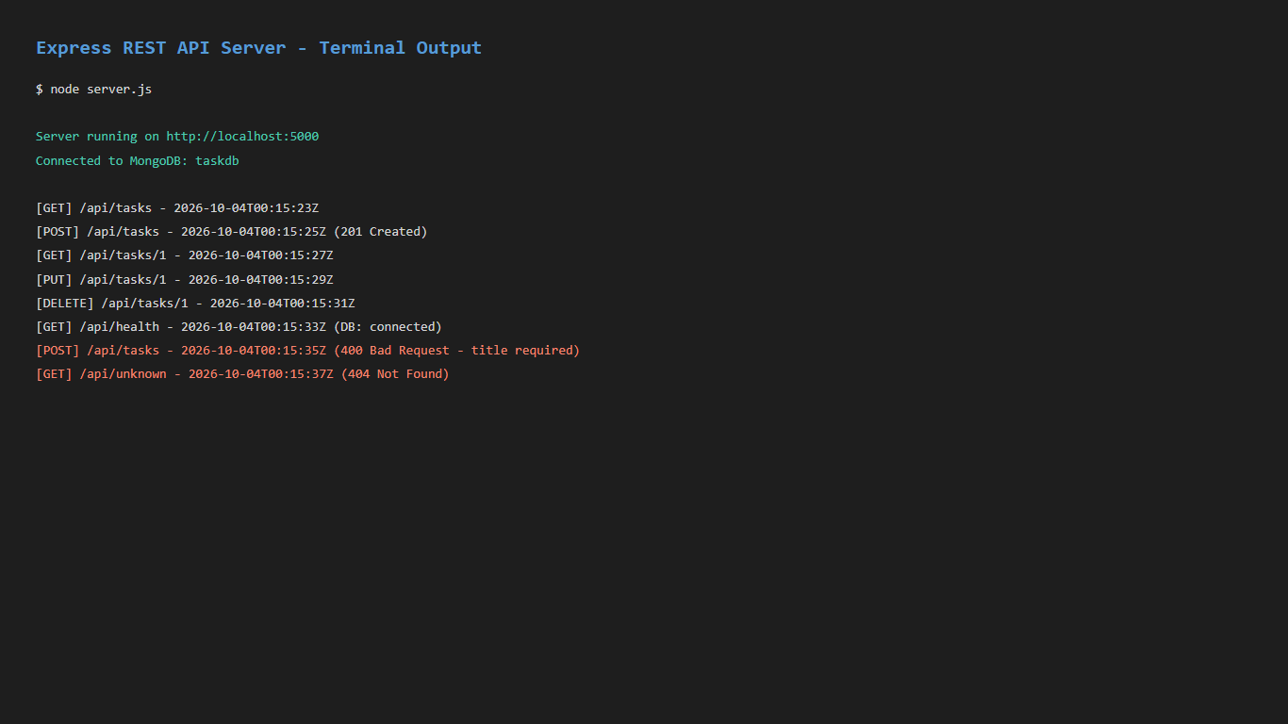  Figure 4.1: P4 Server Output  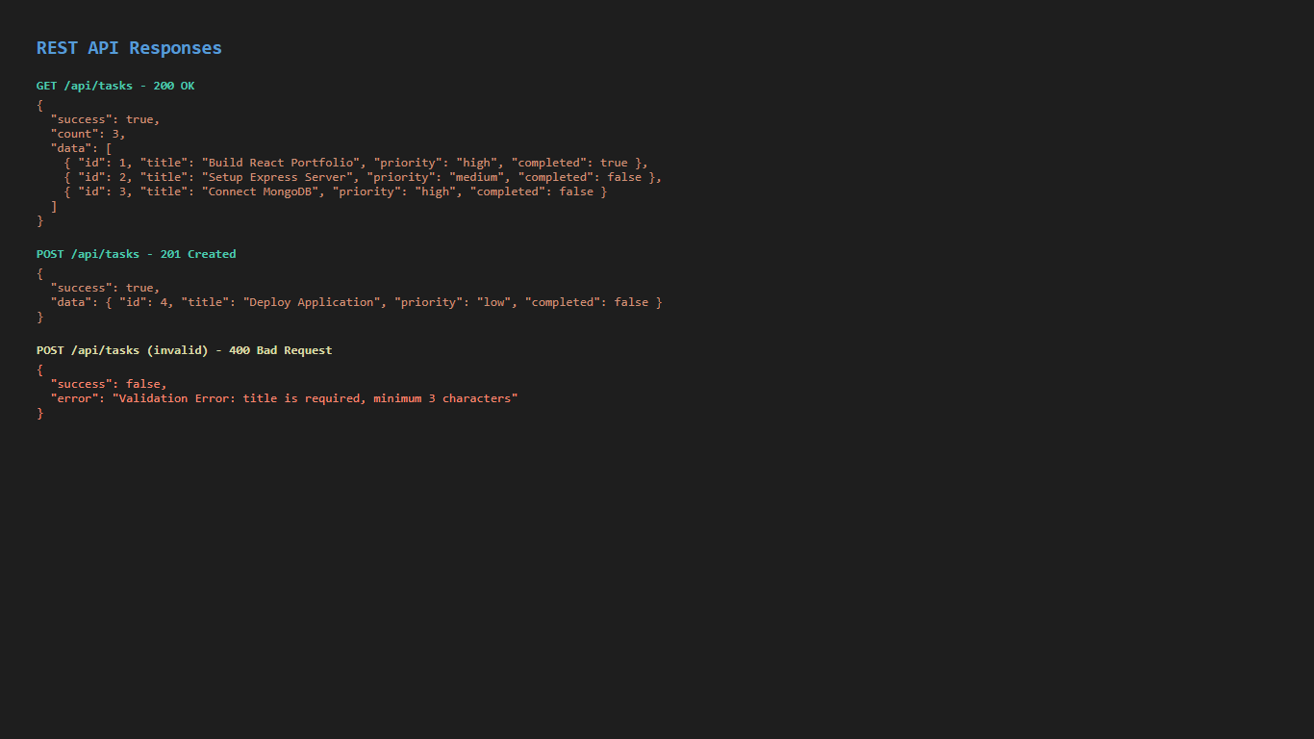  Figure 4.2: P4 Api Responses

Subject Code | : | ITUE301 | Semester | : | 5 | Academic Year | : | 2026-27
Subject Name | : | Advanced Web Framework

Practical 5 | Practical 5: MongoDB Integration and Schema Design with Mongoose
Problem Statement | Integrate MongoDB database into the Express REST API using Mongoose ODM for persistent data storage with schema validation.  Key Requirements:  • Connect to MongoDB using Mongoose (mongodb://127.0.0.1:27017/taskdb)  • Define a Mongoose schema for Task with fields: title, description, completed, priority, createdAt  • Add schema validations: required title (min 3 chars), priority enum (low/medium/high)  • Implement a pre-save hook for automatic title trimming  • Replace in-memory CRUD operations with Mongoose database operations  • Handle Mongoose ValidationError and CastError in the error pipeline  • Add a /health endpoint to check database connection status
Main Code | // File: backend/models/Task.js (Mongoose Schema + Hooks)  const mongoose = require('mongoose');  const taskSchema = new mongoose.Schema(  {  title: {  type: String,  required: [true, 'Task title is required'],  trim: true,  minlength: [3, 'Task title must be at least 3 characters long']  },  description: {  type: String,  trim: true,  default: ''  },  completed: {  type: Boolean,  default: false  },  priority: {  type: String,  enum: {  values: ['low', 'medium', 'high'],  message: 'Priority must be either low, medium, or high'  },  default: 'medium'  },  createdAt: {  type: Date,  default: Date.now  }  },  {  timestamps: true  }  );  // Supplementary Problem: Pre-save hook that automatically trims whitespace from title  taskSchema.pre('save', function (next) {  if (this.title) {  this.title = this.title.trim();  }  next();  });  module.exports = mongoose.model('Task', taskSchema);  // File: backend/server.js (MongoDB Connection + CRUD with Mongoose)  const express = require('express');  const mongoose = require('mongoose');  const cors = require('cors');  require('dotenv').config();  const Task = require('./models/Task');  const auth = require('./middleware/auth');  const { validateTaskInput } = require('./middleware/validation');  const authRoutes = require('./routes/auth');  const cache = require('./utils/cache');  const taskEvents = require('./events');  require('./listeners');  const app = express();  const PORT = process.env.PORT || 5000;  const MONGO_URI = process.env.MONGO_URI || 'mongodb://127.0.0.1:27017/taskdb';  // 1. Enable Cross-Origin Resource Sharing (CORS) for React frontend  app.use(cors());  // 2. Built-in JSON body parser  app.use(express.json());  // 3. Global Request Logging Middleware  app.use((req, res, next) => {  const timestamp = new Date().toISOString();  console.log(`[${req.method}] ${req.url} - ${timestamp}`);  next();  });  // 4. Connect to MongoDB via Mongoose  let isDbConnected = false;  mongoose  .connect(MONGO_URI)  .then(() => {  isDbConnected = true;  console.log(`[Database] MongoDB connected successfully to ${MONGO_URI}`);  })  .catch((err) => {  console.error(`[Database Warning] Could not connect to MongoDB: ${err.message}`);  console.log('[Database Info] Ensure MongoDB is running locally or provide a valid MONGO_URI in .env');  });  // In-memory fallback tasks in case MongoDB is offline during testing  let memoryTasks = [  {  _id: 'task-1',  id: 'task-1',  title: 'Setup React Portfolio UI',  description: 'Build Vite + React component architecture with props',  completed: true,  priority: 'high',  createdAt: new Date().toISOString()  },  {  _id: 'task-2',  id: 'task-2',  title: 'Configure React Router & useState',  description: 'Implement multi-route navigation and controlled form',  completed: true,  priority: 'medium',  createdAt: new Date().toISOString()  },  {  _id: 'task-3',  id: 'task-3',  title: 'Integrate GitHub REST API',  description: 'Fetch repositories asynchronously with loading spinner',  completed: true,  priority: 'low',  createdAt: new Date().toISOString()  }  ];  // 5. Content-Type Enforcer Middleware for write operations  const requireJsonContent = (req, res, next) => {  if (['POST', 'PUT'].includes(req.method)) {  const contentType = req.headers['content-type'];  if (!contentType || !contentType.includes('application/json')) {  return res.status(400).json({  success: false,  error: 'Bad Request',  message: 'Content-Type must be application/json for POST and PUT requests'  });  }  }  next();  };  app.use(requireJsonContent);  // Middleware to validate MongoDB ObjectId or alphanumeric ID  const validateObjectId = (req, res, next) => {  const id = req.params.id;  if (!id || id.trim() === '') {  return res.status(400).json({  success: false,  error: 'Invalid ID Format',  message: 'ID parameter cannot be empty'  });  }  next();  };  // ==========================================  // Authentication Routes (Practical 7)  // ==========================================  app.use('/auth', authRoutes);  // ==========================================  // Cache Debug & Statistics (Practical 9 Supplementary)  // ==========================================  app.get('/cache-stats', (req, res) => {  res.status(200).json({  success: true,  cache: cache.getStats()  });  });  app.post('/cache-clear', (req, res) => {  cache.flush();  res.status(200).json({  success: true,  message: 'In-memory cache successfully invalidated and cleared'  });  });  // ==========================================  // RESTful Task Routes with In-Memory Caching (Practical 9)  // ==========================================  // GET /tasks - Retrieve all tasks (Checks node-cache first)  app.get('/tasks', auth, async (req, res, next) => {  try {  const cacheKey = 'all_tasks';  const { data: cachedData, hit } = cache.get(cacheKey);  if (hit && cachedData) {  res.setHeader('X-Cache', 'HIT');  return res.status(200).json({  success: true,  cached: true,  source: 'in-memory-cache',  count: cachedData.length,  user: req.user,  data: cachedData  });  }  // Cache MISS: Retrieve from MongoDB database  let tasksList = [];  try {  tasksList = await Task.find().sort({ createdAt: -1 });  } catch {  tasksList = memoryTasks;  }  // Store in node-cache with 60-second TTL  cache.set(cacheKey, tasksList, 60);  res.setHeader('X-Cache', 'MISS');  res.status(200).json({  success: true,  cached: false,  source: 'database-query',  count: tasksList.length,  user: req.user,  data: tasksList  });  } catch (err) {  next(err);  }  });  // GET /tasks/:id - Retrieve single task by ID (Supplementary: caches individual task)  app.get('/tasks/:id', auth, validateObjectId, async (req, res, next) => {  try {  const cacheKey = `task_${req.params.id}`;  const { data: cachedTask, hit } = cache.get(cacheKey);  if (hit && cachedTask) {  res.setHeader('X-Cache', 'HIT');  return res.status(200).json({  success: true,  cached: true,  source: 'in-memory-cache',  data: cachedTask  });  }  let task = null;  try {  task = await Task.findById(req.params.id);  } catch {  task = memoryTasks.find((t) => t._id === req.params.id || t.id === req.params.id);  }  if (!task) {  return res.status(404).json({  success: false,  error: 'Not Found',  message: `Task with ID ${req.params.id} not found`  });  }  // Cache the individual task  cache.set(cacheKey, task, 60);  res.setHeader('X-Cache', 'MISS');  res.status(200).json({  success: true,  cached: false,  source: 'database-query',  data: task  });  } catch (err) {  next(err);  }  });  // POST /tasks - Create a task & Invalidate Cache Key (Practical 9 Core Requirement)  app.post('/tasks', auth, validateTaskInput, async (req, res, next) => {  try {  const { title, description, completed, priority } = req.body;  let savedTask = null;  try {  savedTask = await Task.create({  title,  description,  completed,  priority  });  } catch {  savedTask = {  _id: 'task-' + Date.now(),  id: 'task-' + Date.now(),  title: title.trim(),  description: description ? String(description).trim() : '',  completed: Boolean(completed),  priority: priority || 'medium',  createdAt: new Date().toISOString()  };  memoryTasks.unshift(savedTask);  }  // Invalidate cache immediately after write operation  cache.del('all_tasks');  console.log('[Cache Invalidation] Cleared cache key: "all_tasks" after POST');  const apiResponseTimestamp = new Date().toISOString();  console.log(`[API] Response sent for POST /tasks at ${apiResponseTimestamp}`);  res.status(201).json({  success: true,  message: 'Task created successfully',  apiResponseTimestamp,  data: savedTask  });  // Practical 10: Asynchronously emit task-created event AFTER response is sent  const taskPayload = savedTask && typeof savedTask.toObject === 'function' ? savedTask.toObject() : savedTask;  taskEvents.emit('task-created', {  ...taskPayload,  user: req.user,  apiResponseTimestamp  });  } catch (err) {  next(err);  }  });  // PUT /tasks/:id - Update task & Invalidate Cache Keys  app.put('/tasks/:id', auth, validateObjectId, async (req, res, next) => {  try {  const { title, description, completed, priority } = req.body;  let updatedTask = null;  try {  updatedTask = await Task.findByIdAndUpdate(  req.params.id,  { title, description, completed, priority },  { new: true, runValidators: true }  );  } catch {  const idx = memoryTasks.findIndex((t) => t._id === req.params.id || t.id === req.params.id);  if (idx !== -1) {  if (title !== undefined) memoryTasks[idx].title = title;  if (description !== undefined) memoryTasks[idx].description = description;  if (completed !== undefined) memoryTasks[idx].completed = completed;  if (priority !== undefined) memoryTasks[idx].priority = priority;  updatedTask = memoryTasks[idx];  }  }  if (!updatedTask) {  return res.status(404).json({  success: false,  error: 'Not Found',  message: `Task with ID ${req.params.id} not found`  });  }  // Invalidate list cache and individual task cache  cache.del('all_tasks');  cache.del(`task_${req.params.id}`);  console.log(`[Cache Invalidation] Cleared cache keys after PUT for task ${req.params.id}`);  res.status(200).json({  success: true,  message: 'Task updated successfully',  data: updatedTask  });  } catch (err) {  next(err);  }  });  // DELETE /tasks/:id - Delete task & Invalidate Cache Keys  app.delete('/tasks/:id', auth, validateObjectId, async (req, res, next) => {  try {  let deletedTask = null;  try {  deletedTask = await Task.findByIdAndDelete(req.params.id);  } catch {  const idx = memoryTasks.findIndex((t) => t._id === req.params.id || t.id === req.params.id);  if (idx !== -1) {  deletedTask = memoryTasks.splice(idx, 1)[0];  }  }  if (!deletedTask) {  return res.status(404).json({  success: false,  error: 'Not Found',  message: `Task with ID ${req.params.id} not found`  });  }  // Invalidate list cache and individual task cache  cache.del('all_tasks');  cache.del(`task_${req.params.id}`);  console.log(`[Cache Invalidation] Cleared cache keys after DELETE for task ${req.params.id}`);  const apiResponseTimestamp = new Date().toISOString();  console.log(`[API] Response sent for DELETE /tasks/${req.params.id} at ${apiResponseTimestamp}`);  res.status(200).json({  success: true,  message: 'Task deleted successfully',  apiResponseTimestamp,  data: deletedTask  });  // Practical 10 Supplementary: Emit task-deleted event asynchronously  const payload = deletedTask && typeof deletedTask.toObject === 'function' ? deletedTask.toObject() : deletedTask;  taskEvents.emit('task-deleted', {  ...payload,  user: req.user,  apiResponseTimestamp  });  } catch (err) {  next(err);  }  });  // ==========================================  // Event-Driven Architecture Telemetry Routes (Practical 10)  // ==========================================  // GET /events/logs - Fetch background event logs to verify non-blocking execution & timestamps  app.get('/events/logs', (req, res) => {  res.status(200).json({  success: true,  count: taskEvents.getEventLogs().length,  events: taskEvents.getEventLogs()  });  });  // DELETE /events/logs - Clear event logs history  app.delete('/events/logs', (req, res) => {  taskEvents.clearEventLogs();  res.status(200).json({  success: true,  message: 'Event logs successfully cleared'  });  });  // POST /events/simulate-error - Trigger a test error event to verify safe handling  app.post('/events/simulate-error', (req, res) => {  const errorMessage = req.body?.message || 'Simulated error in EventEmitter pipeline for testing';  console.log('[API] Triggering simulated EventEmitter error test...');  taskEvents.emit('error', new Error(errorMessage));  res.status(200).json({  success: true,  message: 'Simulated error emitted to EventEmitter error listener without crashing server',  emittedError: errorMessage  });  });  // Health / Status endpoint for quick verification  app.get('/health', (req, res) => {  res.status(200).json({  status: 'healthy',  databaseConnected: mongoose.connection.readyState === 1,  cacheStats: cache.getStats(),  eventStats: {  listeners: {  'task-created': taskEvents.listenerCount('task-created'),  'task-deleted': taskEvents.listenerCount('task-deleted'),  error: taskEvents.listenerCount('error')  },  totalEventsLogged: taskEvents.getEventLogs().length  },  timestamp: new Date().toISOString()  });  });  // Supplementary 404 Handler for Undefined Routes  app.use((req, res) => {  res.status(404).json({  success: false,  error: 'Route Not Found',  message: `Cannot ${req.method} ${req.originalUrl}`  });  });  // Centralized Global Error Handling Middleware  app.use((err, req, res, next) => {  console.error('[Error Pipeline caught]:', err.message);  if (err.name === 'ValidationError') {  const errors = Object.values(err.errors).map((val) => val.message);  return res.status(400).json({  success: false,  error: 'Validation Error',  messages: errors  });  }  if (err.name === 'CastError') {  return res.status(400).json({  success: false,  error: 'Cast Error',  message: `Invalid format for field ${err.path}: ${err.value}`  });  }  const status = err.status || 500;  res.status(status).json({  success: false,  error: status === 500 ? 'Internal Server Error' : 'Application Error',  message: err.message || 'An unexpected error occurred on the server'  });  });  if (process.env.NODE_ENV !== 'test') {  app.listen(PORT, () => {  console.log(`Task Manager API with In-Memory Caching running at http://localhost:${PORT}`);  });  }  module.exports = app;

Output | Backend server with persistent MongoDB storage:  • Tasks persisted in MongoDB 'taskdb' database  • Schema validation: title required (min 3 chars), priority must be low/medium/high  • Pre-save hook automatically trims whitespace from task titles  • GET /health returns database connection status  • Validation errors return structured 400 response with error messages  • Data persists across server restarts (unlike in-memory storage)  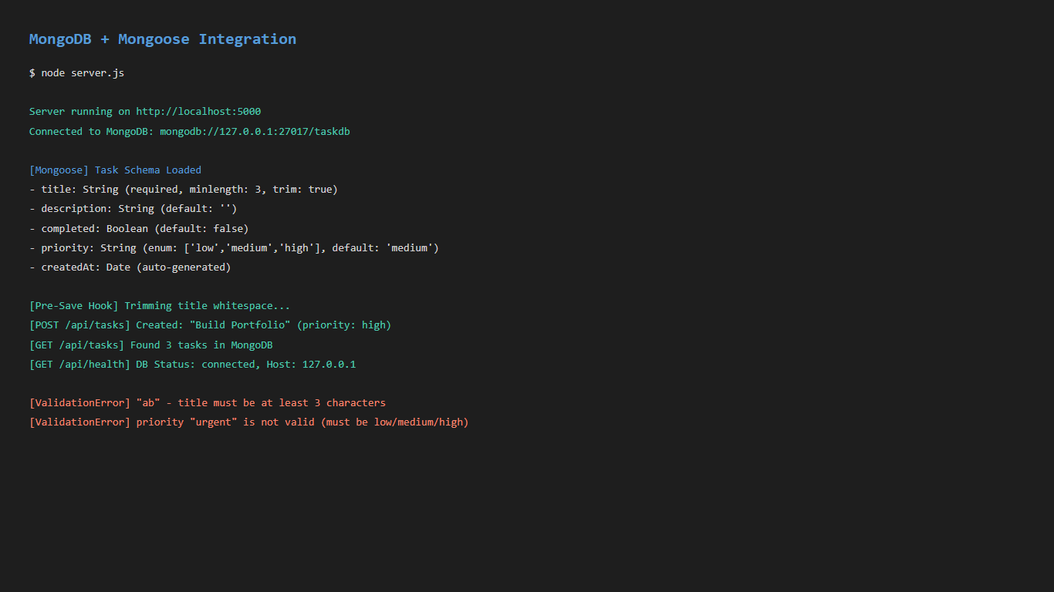  Figure 5.1: P5 Mongodb

Subject Code | : | ITUE301 | Semester | : | 5 | Academic Year | : | 2026-27
Subject Name | : | Advanced Web Framework

Practical 6 | Practical 6: Full-Stack Integration (React + Express + MongoDB)
Problem Statement | Connect the React frontend to the Express + MongoDB backend to create a fully integrated full-stack Task Management application.  Key Requirements:  • Create a centralized API client (api.js) with functions for all CRUD operations  • Enable CORS on the Express server to allow frontend requests  • Build a TaskManager page with create task form and live task list  • Implement optimistic UI updates for create, toggle, and delete operations  • Add delete confirmation modal before removing tasks  • Implement Toast notifications for success/error feedback  • Add priority filter dropdown to filter tasks by priority level  • Handle authentication errors (401) with user-friendly messages
Main Code | // File: services/api.js (Centralized API Client)  // Central API client with JWT Authentication support (Practical 7)  const BASE_URL = 'http://localhost:5000';  function getAuthHeader() {  const token = localStorage.getItem('awf_auth_token');  return token ? { Authorization: `Bearer ${token}` } : {};  }  export const api = {  // Auth: POST /auth/register  async register(userData) {  const res = await fetch(`${BASE_URL}/auth/register`, {  method: 'POST',  headers: { 'Content-Type': 'application/json' },  body: JSON.stringify(userData)  });  const data = await res.json();  if (!res.ok) {  const msg = data.messages ? data.messages.join(' ') : (data.message || 'Registration failed');  throw new Error(msg);  }  return data;  },  // Auth: POST /auth/login  async login(credentials) {  const res = await fetch(`${BASE_URL}/auth/login`, {  method: 'POST',  headers: { 'Content-Type': 'application/json' },  body: JSON.stringify(credentials)  });  const data = await res.json();  if (!res.ok) {  throw new Error(data.message || 'Login failed');  }  return data;  },  // Auth: GET /auth/me (Supplementary)  async getMe() {  const res = await fetch(`${BASE_URL}/auth/me`, {  headers: { ...getAuthHeader() }  });  if (res.status === 401) {  localStorage.removeItem('awf_auth_token');  localStorage.removeItem('awf_auth_user');  throw new Error('Session expired. Please log in again.');  }  return res.json();  },  // Task: GET /tasks (Protected)  async getTasks() {  const res = await fetch(`${BASE_URL}/tasks`, {  headers: { ...getAuthHeader() }  });  if (res.status === 401) {  throw new Error('Authentication required. Please log in to view and manage tasks.');  }  if (!res.ok) {  const err = await res.json().catch(() => ({}));  throw new Error(err.message || `Failed to fetch tasks (HTTP ${res.status})`);  }  return res.json();  },  // Task: POST /tasks (Protected)  async createTask(taskData) {  const res = await fetch(`${BASE_URL}/tasks`, {  method: 'POST',  headers: {  'Content-Type': 'application/json',  ...getAuthHeader()  },  body: JSON.stringify(taskData)  });  if (res.status === 401) {  throw new Error('Unauthorized: please log in to add tasks.');  }  if (!res.ok) {  const err = await res.json().catch(() => ({}));  const msg = err.messages ? err.messages.join(', ') : (err.message || `Failed to create task`);  throw new Error(msg);  }  return res.json();  },  // Task: PUT /tasks/:id (Protected)  async updateTask(id, updateData) {  const res = await fetch(`${BASE_URL}/tasks/${id}`, {  method: 'PUT',  headers: {  'Content-Type': 'application/json',  ...getAuthHeader()  },  body: JSON.stringify(updateData)  });  if (res.status === 401) {  throw new Error('Unauthorized: please log in to modify tasks.');  }  if (!res.ok) {  const err = await res.json().catch(() => ({}));  throw new Error(err.message || `Failed to update task`);  }  return res.json();  },  // Task: DELETE /tasks/:id (Protected)  async deleteTask(id) {  const res = await fetch(`${BASE_URL}/tasks/${id}`, {  method: 'DELETE',  headers: { ...getAuthHeader() }  });  if (res.status === 401) {  throw new Error('Unauthorized: please log in to delete tasks.');  }  if (!res.ok) {  const err = await res.json().catch(() => ({}));  throw new Error(err.message || `Failed to delete task`);  }  return res.json();  },  // Practical 10: Event-Driven Background Notifications Telemetry  async getEventLogs() {  const res = await fetch(`${BASE_URL}/events/logs`);  if (!res.ok) {  throw new Error('Failed to fetch event logs');  }  return res.json();  },  async clearEventLogs() {  const res = await fetch(`${BASE_URL}/events/logs`, { method: 'DELETE' });  return res.json();  },  async simulateEventError(message) {  const res = await fetch(`${BASE_URL}/events/simulate-error`, {  method: 'POST',  headers: { 'Content-Type': 'application/json' },  body: JSON.stringify({ message: message || 'Simulated error in EventEmitter pipeline' })  });  return res.json();  }  };  export default api;  // File: pages/TaskManager.jsx (Full-Stack CRUD UI)  import React, { useState, useEffect, useCallback } from 'react';  import api from '../services/api';  import Spinner from '../components/Spinner';  import ErrorMessage from '../components/ErrorMessage';  import Toast from '../components/Toast';  function TaskManager() {  const [tasks, setTasks] = useState([]);  const [loading, setLoading] = useState(true);  const [error, setError] = useState(null);  // Form state  const [newTitle, setNewTitle] = useState('');  const [newDescription, setNewDescription] = useState('');  const [newPriority, setNewPriority] = useState('medium');  const [isSubmitting, setIsSubmitting] = useState(false);  // Delete confirmation state (Supplementary requirement)  const [taskToDelete, setTaskToDelete] = useState(null);  // Toast notification state (Supplementary requirement)  const [toast, setToast] = useState({ message: '', type: 'success' });  // Priority filter state  const [filterPriority, setFilterPriority] = useState('all');  // Practical 10: Event-Driven Background Notifications State  const [eventLogs, setEventLogs] = useState([]);  const [showEvents, setShowEvents] = useState(true);  const showToast = (message, type = 'success') => {  setToast({ message, type });  };  const clearToast = () => {  setToast({ message: '', type: 'success' });  };  // Practical 10: Fetch background event logs  const loadEventLogs = useCallback(async () => {  try {  const res = await api.getEventLogs();  if (res && res.events) {  setEventLogs(res.events);  }  } catch {  // Backend may be offline or starting up  }  }, []);  // Fetch tasks from Express / MongoDB backend  const loadTasks = useCallback(async () => {  setLoading(true);  setError(null);  try {  const response = await api.getTasks();  // Handle both Mongoose data shape { success: true, data: [...] } and direct array  const taskList = response.data || response;  setTasks(Array.isArray(taskList) ? taskList : []);  } catch (err) {  setError(  `${err.message}. Make sure backend server is running at http://localhost:5000`  );  } finally {  setLoading(false);  }  }, []);  useEffect(() => {  loadTasks();  loadEventLogs();  }, [loadTasks, loadEventLogs]);  // Create Task with Optimistic UI Update (Supplementary requirement)  const handleCreateTask = async (e) => {  e.preventDefault();  if (!newTitle.trim()) {  showToast('Task title is required', 'error');  return;  }  const tempId = 'temp-' + Date.now();  const optimisticTask = {  _id: tempId,  id: tempId,  title: newTitle.trim(),  description: newDescription.trim(),  priority: newPriority,  completed: false,  createdAt: new Date().toISOString(),  isOptimistic: true  };  // 1. Optimistic Update: Render immediately before server responds  setTasks((prev) => [optimisticTask, ...prev]);  const savedTitle = newTitle;  const savedDesc = newDescription;  const savedPriority = newPriority;  setNewTitle('');  setNewDescription('');  setIsSubmitting(true);  try {  const response = await api.createTask({  title: savedTitle,  description: savedDesc,  priority: savedPriority  });  const serverTask = response.data || response;  // Replace optimistic placeholder with confirmed server document  setTasks((prev) =>  prev.map((t) => (t._id === tempId || t.id === tempId ? serverTask : t))  );  showToast(`Task "${serverTask.title}" created successfully!`, 'success');  setTimeout(loadEventLogs, 200);  setTimeout(loadEventLogs, 1800);  } catch (err) {  // Rollback on failure  setTasks((prev) => prev.filter((t) => t._id !== tempId && t.id !== tempId));  showToast(`Failed to create task: ${err.message}`, 'error');  } finally {  setIsSubmitting(false);  }  };  // Toggle Task Completion  const handleToggleComplete = async (task) => {  const taskId = task._id || task.id;  const updatedStatus = !task.completed;  // Optimistic toggle  setTasks((prev) =>  prev.map((t) => ((t._id || t.id) === taskId ? { ...t, completed: updatedStatus } : t))  );  try {  await api.updateTask(taskId, { completed: updatedStatus });  showToast(  `Task marked as ${updatedStatus ? 'completed' : 'pending'}`,  'success'  );  } catch (err) {  // Revert on error  setTasks((prev) =>  prev.map((t) => ((t._id || t.id) === taskId ? { ...t, completed: !updatedStatus } : t))  );  showToast(`Failed to update task: ${err.message}`, 'error');  }  };  // Delete Task with Confirmation (Supplementary requirement)  const confirmDelete = async () => {  if (!taskToDelete) return;  const taskId = taskToDelete._id || taskToDelete.id;  const taskTitle = taskToDelete.title;  setTaskToDelete(null);  // Optimistic remove  setTasks((prev) => prev.filter((t) => (t._id || t.id) !== taskId));  try {  await api.deleteTask(taskId);  showToast(`Task "${taskTitle}" deleted successfully`, 'success');  setTimeout(loadEventLogs, 200);  setTimeout(loadEventLogs, 1300);  } catch (err) {  showToast(`Delete failed: ${err.message}`, 'error');  loadTasks(); // re-fetch if failed  }  };  // Practical 10: Event Telemetry Handlers  const handleSimulateEventError = async () => {  try {  await api.simulateEventError('Simulated error from React UI to test EventEmitter error boundary');  showToast('Emitted error to EventEmitter! Server caught safely.', 'info');  setTimeout(loadEventLogs, 200);  } catch (err) {  showToast('Error test failed: ' + err.message, 'error');  }  };  const handleClearEventLogs = async () => {  try {  await api.clearEventLogs();  setEventLogs([]);  showToast('Event telemetry logs cleared', 'success');  } catch (err) {  showToast('Failed to clear logs: ' + err.message, 'error');  }  };  // Filter tasks  const filteredTasks = tasks.filter((task) => {  if (filterPriority === 'all') return true;  return task.priority === filterPriority;  });  return (  <section className="section task-manager-section">  <Toast message={toast.message} type={toast.type} onClose={clearToast} />  {/* Confirmation Dialog Modal (Supplementary requirement) */}  {taskToDelete && (  <div className="modal-overlay">  <div className="modal-card">  <h3>⚠️ Confirm Delete</h3>  <p>  Are you sure you want to delete task:  <br />  <strong>"{taskToDelete.title}"</strong>?  </p>  <div className="modal-actions">  <button  type="button"  className="btn btn-secondary"  onClick={() => setTaskToDelete(null)}  >  Cancel  </button>  <button  type="button"  className="btn btn-primary btn-delete-confirm"  onClick={confirmDelete}  >  Yes, Delete  </button>  </div>  </div>  </div>  )}  <div className="section-header">  <h2 className="section-title">Full Stack Task Management</h2>  <p className="section-subtitle">  End-to-end integration between React Frontend and Express + MongoDB Backend (Practical 6)  </p>  </div>  <div className="task-manager-layout">  {/* Create Task Form */}  <div className="task-form-panel">  <h3>Create New Task</h3>  <p className="panel-desc">  Submit a new task to persist in MongoDB database. Supports optimistic UI update.  </p>  <form onSubmit={handleCreateTask} className="task-create-form">  <div className="form-group">  <label htmlFor="taskTitle">Task Title *</label>  <input  id="taskTitle"  type="text"  className="form-input"  placeholder="e.g. Design authentication middleware"  value={newTitle}  onChange={(e) => setNewTitle(e.target.value)}  required  />  </div>  <div className="form-group">  <label htmlFor="taskDesc">Description</label>  <textarea  id="taskDesc"  rows="3"  className="form-textarea"  placeholder="Add optional task details..."  value={newDescription}  onChange={(e) => setNewDescription(e.target.value)}  />  </div>  <div className="form-group">  <label htmlFor="taskPriority">Priority Level</label>  <select  id="taskPriority"  className="form-input select-priority"  value={newPriority}  onChange={(e) => setNewPriority(e.target.value)}  >  <option value="low">🟢 Low Priority</option>  <option value="medium">🟡 Medium Priority</option>  <option value="high">🔴 High Priority</option>  </select>  </div>  <button  type="submit"  className="btn btn-primary submit-task-btn"  disabled={isSubmitting}  >  {isSubmitting ? 'Saving to Database...' : '+ Add Task (Optimistic)'}  </button>  </form>  </div>  {/* Task List Panel */}  <div className="task-list-panel">  <div className="panel-top-controls">  <div className="panel-title-group">  <h3>Live Tasks ({filteredTasks.length})</h3>  <span className="api-badge">API: http://localhost:5000/tasks</span>  </div>  <div className="filter-controls">  <select  className="filter-select"  value={filterPriority}  onChange={(e) => setFilterPriority(e.target.value)}  >  <option value="all">All Priorities</option>  <option value="low">Low Priority</option>  <option value="medium">Medium Priority</option>  <option value="high">High Priority</option>  </select>  <button  type="button"  className="btn btn-secondary btn-sm"  onClick={loadTasks}  disabled={loading}  >  🔄 Refresh  </button>  </div>  </div>  {loading && <Spinner message="Fetching tasks from Express backend & MongoDB..." />}  {!loading && error && (  <ErrorMessage message={error} onRetry={loadTasks} />  )}  {!loading && !error && filteredTasks.length === 0 && (  <div className="empty-tasks-card">  <p>No tasks found. Create a new task on the left to test full-stack persistence!</p>  </div>  )}  {!loading && !error && filteredTasks.length > 0 && (  <div className="tasks-cards-container">  {filteredTasks.map((task) => {  const id = task._id || task.id;  return (  <div  key={id}  className={`task-item-card priority-${task.priority} ${  task.completed ? 'is-completed' : ''  }`}  >  <div className="task-checkbox-col">  <input  type="checkbox"  checked={Boolean(task.completed)}  onChange={() => handleToggleComplete(task)}  title="Click to toggle completion status"  className="task-checkbox"  />  </div>  <div className="task-details-col">  <div className="task-header-row">  <h4 className="task-card-title">{task.title}</h4>  <span className={`priority-tag tag-${task.priority}`}>  {task.priority}  </span>  </div>  {task.description && (  <p className="task-card-desc">{task.description}</p>  )}  <div className="task-footer-row">  <span className="task-date">  📅 {new Date(task.createdAt || Date.now()).toLocaleDateString()}  </span>  {task.isOptimistic && (  <span className="optimistic-badge">Syncing...</span>  )}  </div>  </div>  <div className="task-actions-col">  <button  type="button"  className="btn-delete-task"  onClick={() => setTaskToDelete(task)}  title="Delete task with confirmation"  >  🗑️  </button>  </div>  </div>  );  })}  </div>  )}  </div>  </div>  {/* ========================================================= */}  {/* Practical 10: Event-Driven Background Notifications Panel */}  {/* ========================================================= */}  <div className="event-telemetry-panel">  <div className="event-panel-header">  <div className="event-header-info">  <span className="event-badge-title">⚡ Practical 10: Event-Driven Architecture</span>  <h3>Background Processing Telemetry (Node.js EventEmitter)</h3>  <p className="panel-desc">  Demonstrates asynchronous, non-blocking background notifications decoupled from the main request/response cycle.  Main API response returns immediately, while listeners dispatch notifications in the background.  </p>  </div>  <div className="event-header-actions">  <button  type="button"  className="btn btn-secondary btn-sm"  onClick={loadEventLogs}  title="Refresh background event logs"  >  🔄 Refresh Logs ({eventLogs.length})  </button>  <button  type="button"  className="btn btn-secondary btn-sm"  onClick={handleSimulateEventError}  title="Emit error event to test safe error boundary without crashing"  >  ⚠️ Test Error Boundary  </button>  {eventLogs.length > 0 && (  <button  type="button"  className="btn btn-secondary btn-sm"  onClick={handleClearEventLogs}  title="Clear all event telemetry"  >  🧹 Clear  </button>  )}  <button  type="button"  className="btn btn-secondary btn-sm"  onClick={() => setShowEvents(!showEvents)}  >  {showEvents ? 'Hide Details ▲' : 'Show Details ▼'}  </button>  </div>  </div>  {showEvents && (  <div className="event-panel-body">  {eventLogs.length === 0 ? (  <div className="event-empty-state">  <p>No background events logged yet. Create or delete a task above to see live EventEmitter notifications!</p>  </div>  ) : (  <div className="event-logs-grid">  {eventLogs.map((evt) => {  const isCreated = evt.event === 'task-created';  const isDeleted = evt.event === 'task-deleted';  const isError = evt.event === 'error';  return (  <div  key={evt.id}  className={`event-card event-${isCreated ? 'created' : isDeleted ? 'deleted' : 'error'}`}  >  <div className="event-card-header">  <span className={`event-type-tag tag-${evt.event}`}>  {isCreated && '🔔 task-created'}  {isDeleted && '🗑️ task-deleted'}  {isError && '⚠️ error-event'}  </span>  <span className="event-status-badge">{evt.status?.toUpperCase()}</span>  </div>  {evt.title && (  <div className="event-title-row">  <strong>"{evt.title}"</strong>  {evt.priority && (  <span className={`task-badge badge-${evt.priority}`}>  {evt.priority}  </span>  )}  </div>  )}  {evt.errorMessage && (  <div className="event-error-text">  {evt.errorMessage}  </div>  )}  <div className="event-timestamps">  {evt.apiResponseTimestamp && (  <div className="time-item">  <span className="time-label">1. API Response Sent:</span>  <span className="time-val">{evt.apiResponseTimestamp.split('T')[1]?.replace('Z', '')}</span>  </div>  )}  {evt.listenerReceivedAt && (  <div className="time-item">  <span className="time-label">2. Listener Received:</span>  <span className="time-val">{evt.listenerReceivedAt.split('T')[1]?.replace('Z', '')}</span>  </div>  )}  {evt.listenerCompletedAt && (  <div className="time-item highlight-time">  <span className="time-label">3. Worker Finished:</span>  <span className="time-val">{evt.listenerCompletedAt.split('T')[1]?.replace('Z', '')}</span>  </div>  )}  </div>  <div className="event-card-footer">  {evt.delayMs && (  <span className="event-delay-tag">⏱️ Simulated Async Delay: {evt.delayMs}ms</span>  )}  {evt.user && (  <span className="event-user-tag">👤 {evt.user}</span>  )}  </div>  </div>  );  })}  </div>  )}  </div>  )}  </div>  </section>  );  }  export default TaskManager;  // File: components/Toast.jsx (Notification Component)  import React, { useEffect } from 'react';  function Toast({ message, type = 'success', onClose }) {  useEffect(() => {  if (!message) return;  const timer = setTimeout(() => {  onClose();  }, 3500);  return () => clearTimeout(timer);  }, [message, onClose]);  if (!message) return null;  return (  <div className={`toast-notification toast-${type}`}>  <span className="toast-icon">  {type === 'success' ? '✅' : type === 'error' ? '❌' : 'ℹ️'}  </span>  <span className="toast-text">{message}</span>  <button type="button" className="toast-close-btn" onClick={onClose}>  ✕  </button>  </div>  );  }  export default Toast;

Output | Full-stack Task Management application:  • React frontend communicates with Express backend via fetch API  • Create task form persists data to MongoDB through REST API  • Task list displays live data with priority badges and completion checkboxes  • Optimistic UI: tasks appear/update instantly before server confirms  • Delete confirmation modal prevents accidental deletions  • Toast notifications for all CRUD operation feedback  • Priority filter dropdown: All / Low / Medium / High  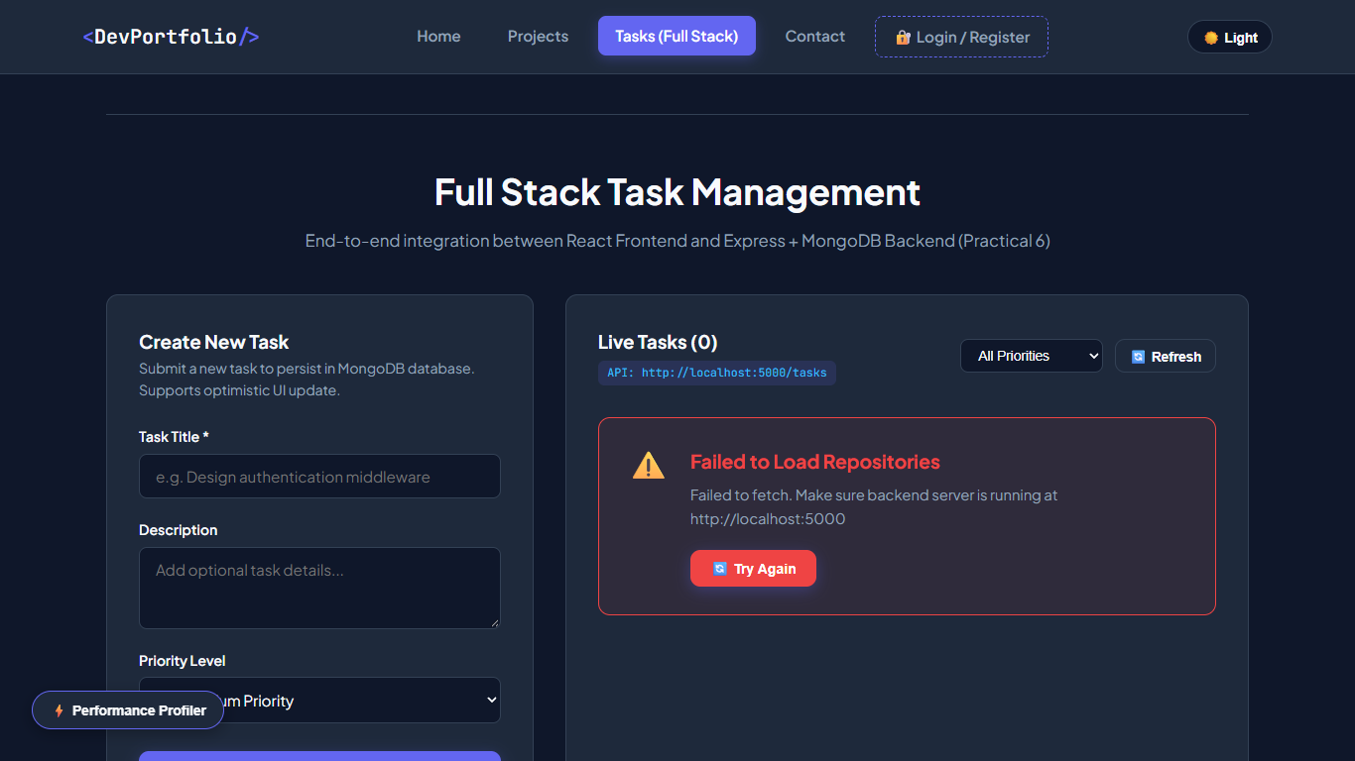  Figure 6.1: P6 Taskmanager Top  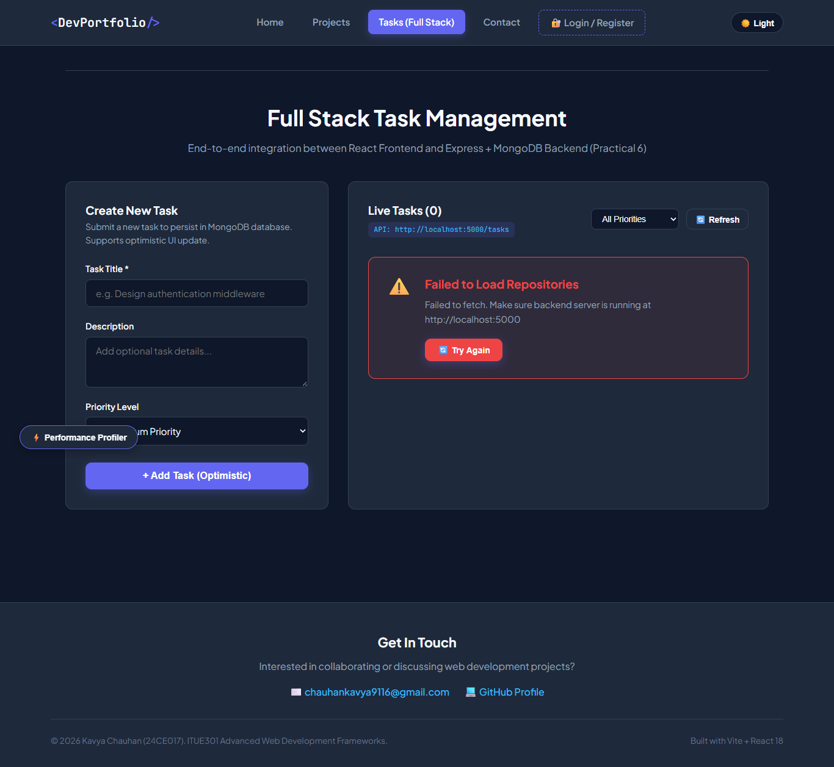  Figure 6.2: P6 Taskmanager

