**DAILY ONLINE ACTIVITIES SUMMARY**

|  |  |  |  |  |  |  |  |  |
| --- | --- | --- | --- | --- | --- | --- | --- | --- |
| **Date:** | **15 JULY** | | | | | **Name:** | **kavya** | |
| **Sem & Sec** | **6th Sem ‘A’ Sec** | | | | | **USN:** | **4AL17CS041** | |
| **Online Test Summary** | | | | | | | | |
| **Subject** | | **OR** | | | | | | |
| **Max. Marks** | | **30** | | **Score** | | |  | |
| **Certification Course Summary** | | | | | | | | |
| **Course** | Introduction to data science in python | | | | | | | |
| **Certificate Provider** | | | **coursera** | | **Duration** | | | **-** |
| **Coding Challenges** | | | | | | | | |
| **Problem Statement:** | | | | | | | | |
| **Status:** | | | | | | | | |
| **Uploaded the report in GitHub** | | | | | **yes** | | | |
| **If yes Repository name** | | | | | https://github.com/kavya-077/DAILY-STATUS | | | |
| **Uploaded the report in slack** | | | | | **yes** | | | |

**Online Certification Course**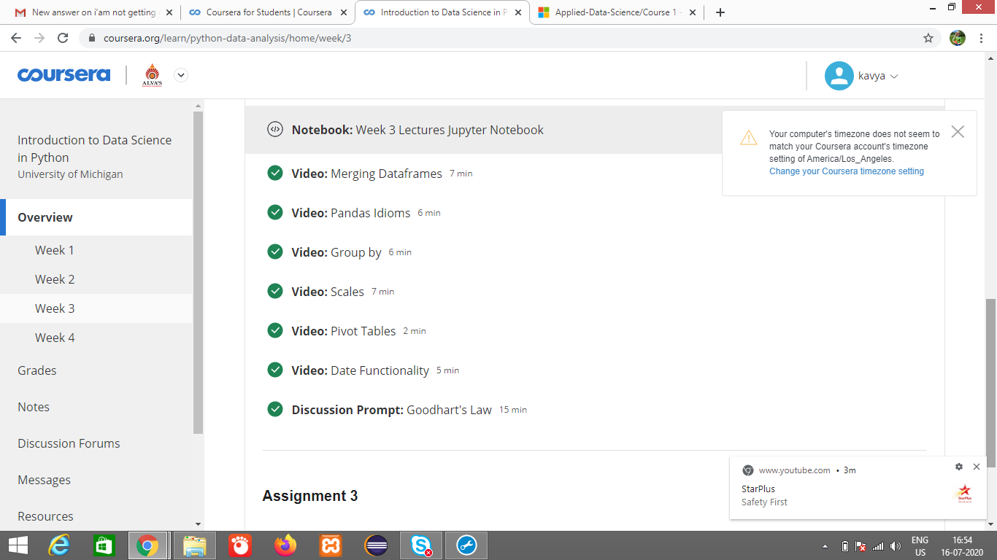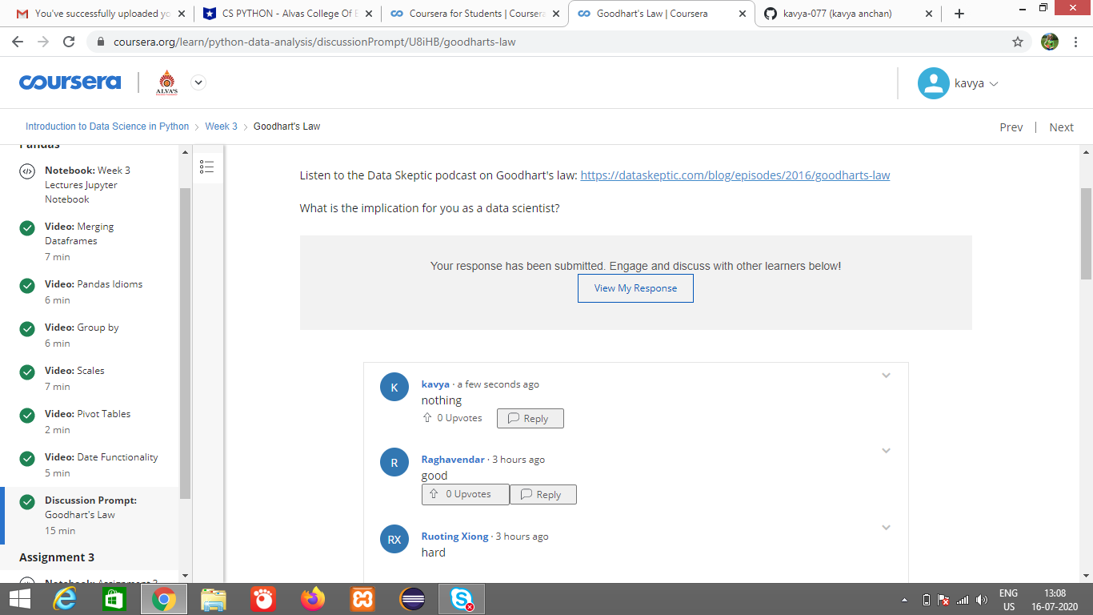

**1-For Report and daily coding challenges** 🡪

**https://github.com/kavya-077/DAILY-STATUS**