**DAILY ONLINE ACTIVITIES SUMMARY**

|  |  |  |  |  |  |  |  |  |
| --- | --- | --- | --- | --- | --- | --- | --- | --- |
| **Date:** | **18-05-2020** | | | | | **Name:** | **kavya** | |
| **Sem & Sec** | **6th & A** | | | | | **USN:** | **4al17cs041** | |
| **Online Test Summary** | | | | | | | | |
| **Subject** | | **Cryptography Network Security & Cyber Laws** | | | | | | |
| **Max. Marks** | | **60** | | **Score** | | | **46** | |
| **Certification Course Summary** | | | | | | | | |
| **Course** | **Face360 capsule** | | | | | | | |
| **Certificate Provider** | | | **Faceprep** | | **Duration** | | | **6th aprill-21st may** |
| **Coding Challenges** | | | | | | | | |
| **Problem Statement:** **1.Write a C Program to check whether two strings are anagram or not**  **2.Given an array of distinct integers. The task is to count all the triplets such that sum of two elements equals the third element.**  **3.** **Using methods charAt() & length() of String class, write a program to print the**  **frequency of each character in a string.**  **“Hello friend”**  **Output should be**  **-: 1**  **d: 1**  **e: 2**  **f: 1**  **4.** **Write down a java program to print even and odd numbers series respectively**  **from two threads: t1 and t2 synchronizing on a shared object**  **Let t1 print message “ping — >” and t2 print message “,—-pong”.**  **Take as command line arguments, the following inputs to the program:**  **Sleep Interval for thread t1**  **Write down a java program to print even and odd numbers series respectively from two**  **threads: t1 and t2 synchronizing on a shared object**  **Let t1 print message “ping — >” and t2 print message “,—-pong”.**  **Take as command line arguments, the following inputs to the program:**  **Sleep Interval for thread t1**  **Sleep Interval for thread t2**  **Message per cycle**  **No of cycles** | | | | | | | | |
| **Status: Yes, completed all the programs** | | | | | | | | |
| **Uploaded the report in Github** | | | | | **yes** | | | |
| **If yes Repository name** | | | | | **https://github.com/kavya-077/DAILY-STATUS** | | | |
| **Uploaded the report in slack** | | | | | **yes** | | | |

Online Test Details: (Attach the snapshot and briefly write the report for the same)

CNSC :MARKS SCORED 46/60

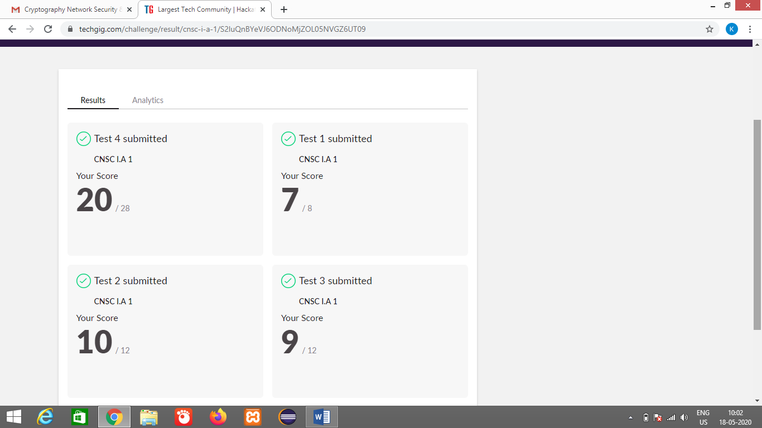

Certification Course Details: (Attach the snapshot and briefly write the report for the same)

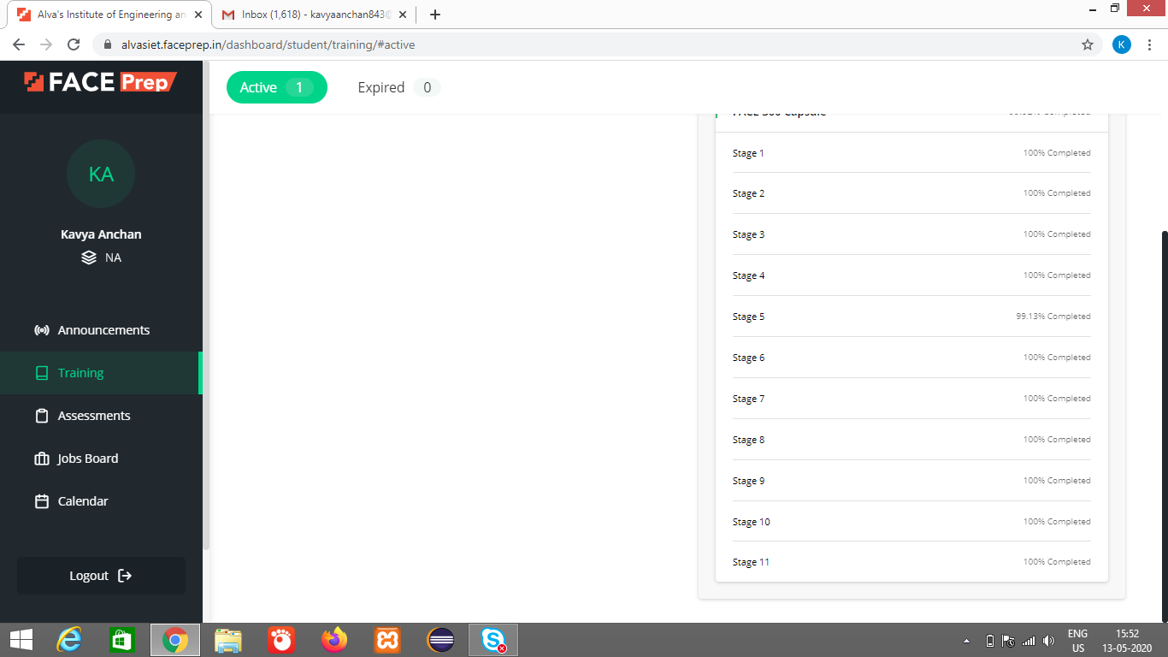

Face 360 capsule

A online course on CPP

Repository name: https://github.com/kavya-077/DAILY-STATUS

Coding Challenges Details: (Attach the snapshot and briefly write the report for the same)

Repository name:https://github.com/kavya-077/DAILY-STATUS