**DAILY ONLINE ACTIVITIES SUMMARY**

|  |  |  |  |  |  |  |  |  |
| --- | --- | --- | --- | --- | --- | --- | --- | --- |
| **Date:** | **19 June** | | | | | **Name:** | **Kavya** | |
| **Sem & Sec** | **6th Sem ‘A’ Sec** | | | | | **USN:** | **4AL17CS041** | |
| **Online Test Summary** | | | | | | | | |
| **Subject** | | **C programming Quiz and Python DA and ML workshop** | | | | | | |
| **Max. Marks** | | **--** | | **Score** | | | **--** | |
| **Certification Course Summary** | | | | | | | | |
| **Course** | **Workshop exercise solving** | | | | | | | |
| **Certificate Provider** | | | **--** | | **Duration** | | | **--** |
| **Coding Challenges** | | | | | | | | |
| **Problem Statement: 1 programs** | | | | | | | | |
| **Status: Executed** | | | | | | | | |
| **Uploaded the report in GitHub** | | | | | **yes** | | | |
| **If yes Repository name** | | | | | https://github.com/kavya-077/DAILY-STATUS | | | |
| **Uploaded the report in slack** | | | | | **yes** | | | |

**Class and Quiz Snapshots:**

**C programming:**

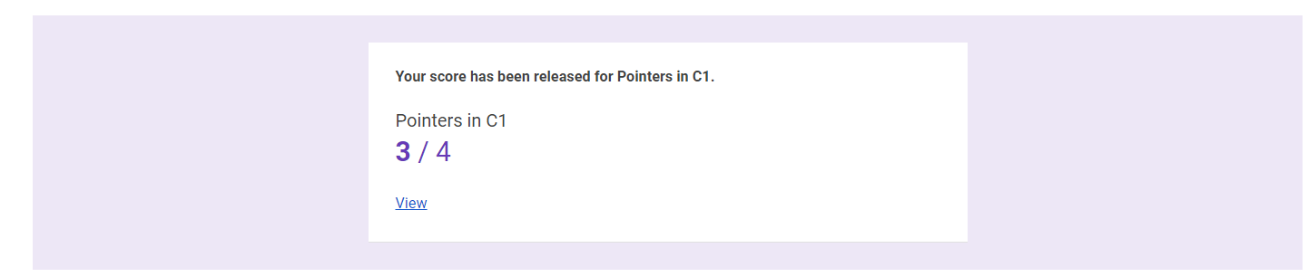

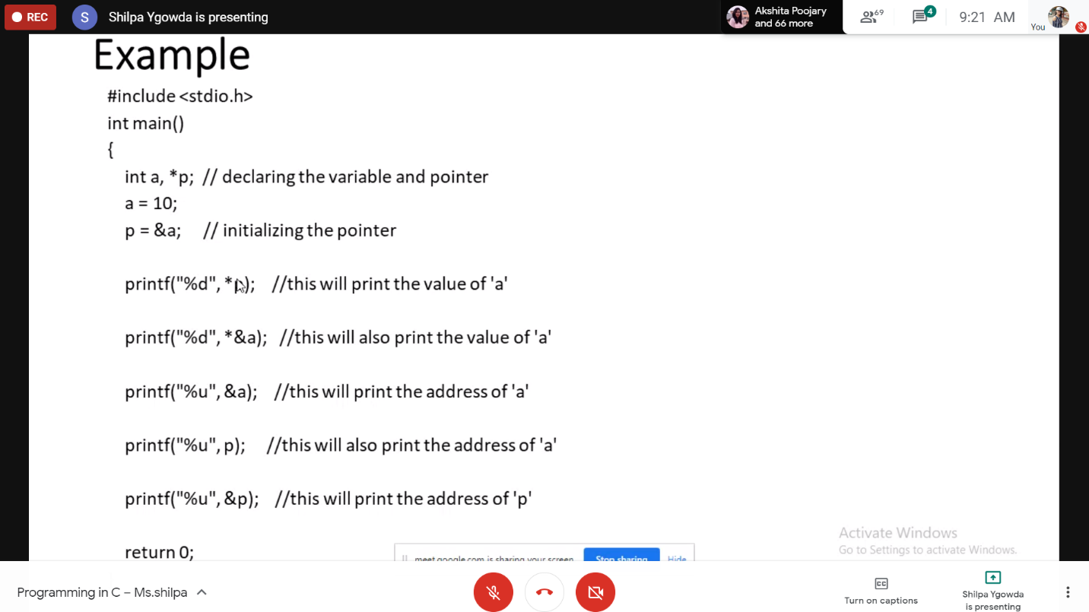

**Python workshop :**

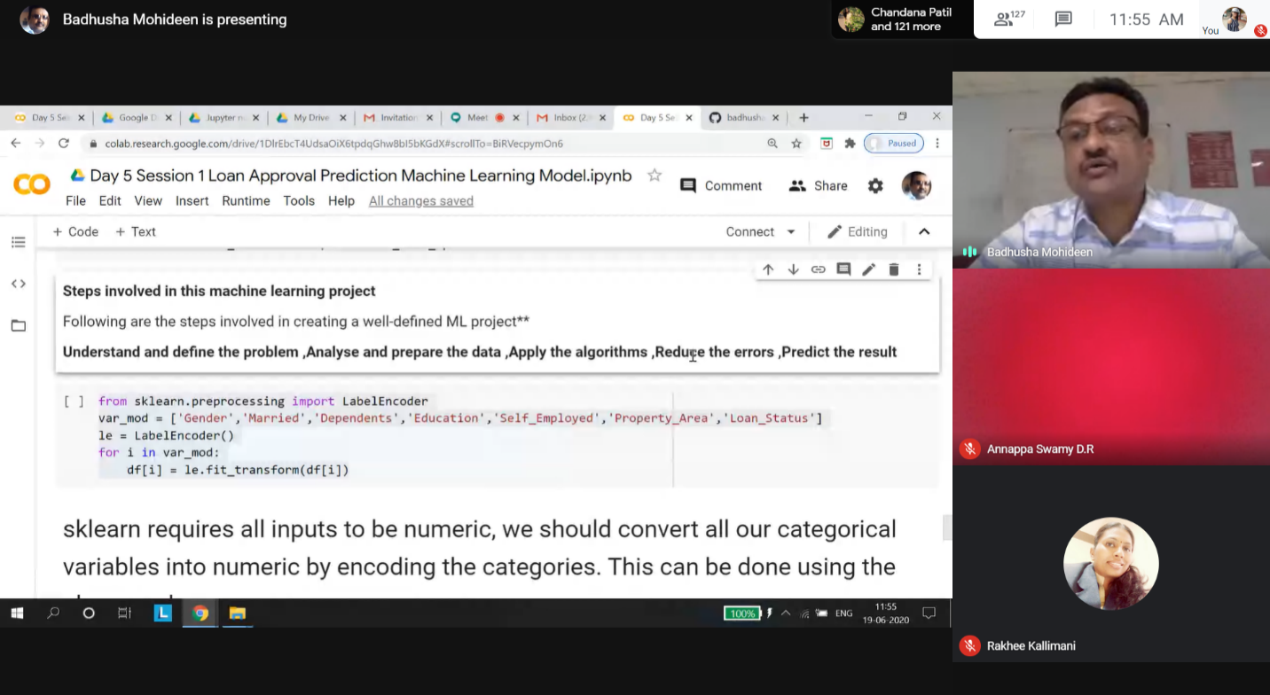

**Coding Challenges Details:**

19-June – Code:

**Program 1 -**

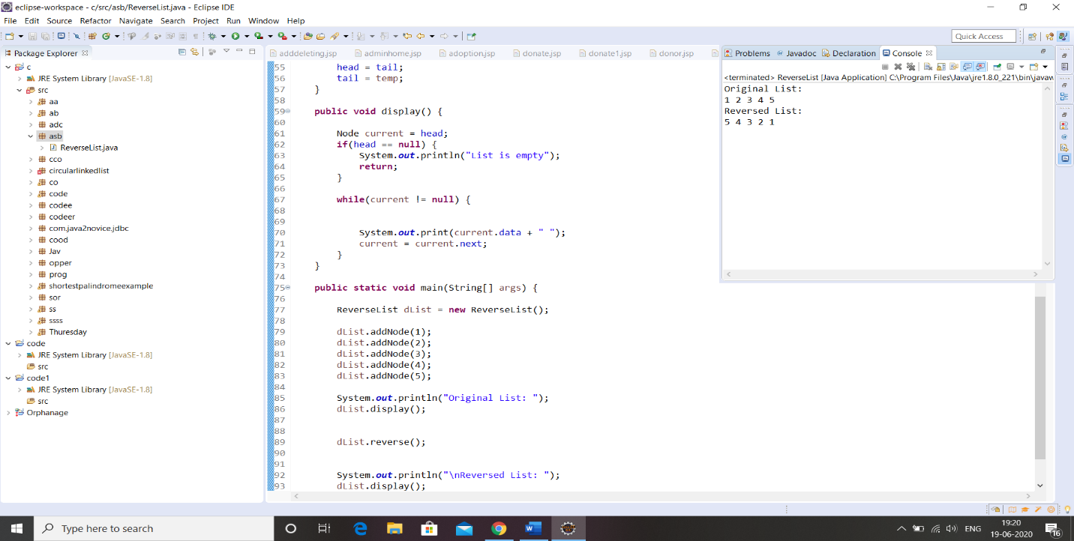

**1-For Report and daily coding challenges** 🡪

**https://github.com/kavya-077/DAILY-STATUS**

**2-For Exercises and Worked problems of workshop** 🡪

### <https://github.com/kavya-077/>[Applications-of-python-programming-in-DA-and-ML-Research-perspective](https://github.com/kavya-077/Applications-of-python-programming-in-DA-and-ML-Research-perspective)