**DAILY ONLINE ACTIVITIES SUMMARY**

|  |  |  |  |  |  |  |  |  |
| --- | --- | --- | --- | --- | --- | --- | --- | --- |
| **Date:** | **20-05-2020** | | | | | **Name:** | **kavya** | |
| **Sem & Sec** | **6th & A** | | | | | **USN:** | **4al17cs041** | |
| **Online Test Summary** | | | | | | | | |
| **Subject** | | **System Software And Compiler Design** | | | | | | |
| **Max. Marks** | | **30** | | **Score** | | | **23** | |
| **Certification Course Summary** | | | | | | | | |
| **Course** | **DART course for beginners** | | | | | | | |
| **Certificate Provider** | | | **Udemy** | | **Duration** | | | **2 hours** |
| **Coding Challenges** | | | | | | | | |
| **Problem Statement:** 1. Write a C Program to Reverse a Linked List in groups of given size.  **2.** Write a simple Python program to implement Diffie–Hellman Key Exchange Example  3. Write a Java Program which illustrates how to get column properties from ResultSet using ResultSetMetaData?  ResultSetMetaData is an object that can be used to get information about the types and properties of the columns in a ResultSet object. Below example shows how to get ResultSet column properties using ResultSetMetaData object.  4. Write Python Program to Reverse a Given Number This is a Python Program to reverse a given number. Problem Description The program takes a number and reverses it and store it in another variable and show it | | | | | | | | |
| **Status: Yes, completed all the programs** | | | | | | | | |
| **Uploaded the report in Github** | | | | | **yes** | | | |
| **If yes Repository name** | | | | | **kavya-OCA & kavya-onlinecourse** | | | |
| **Uploaded the report in slack** | | | | | **yes** | | | |

Online Test Details: (Attach the snapshot and briefly write the report for the same)

Marks scored:23/30

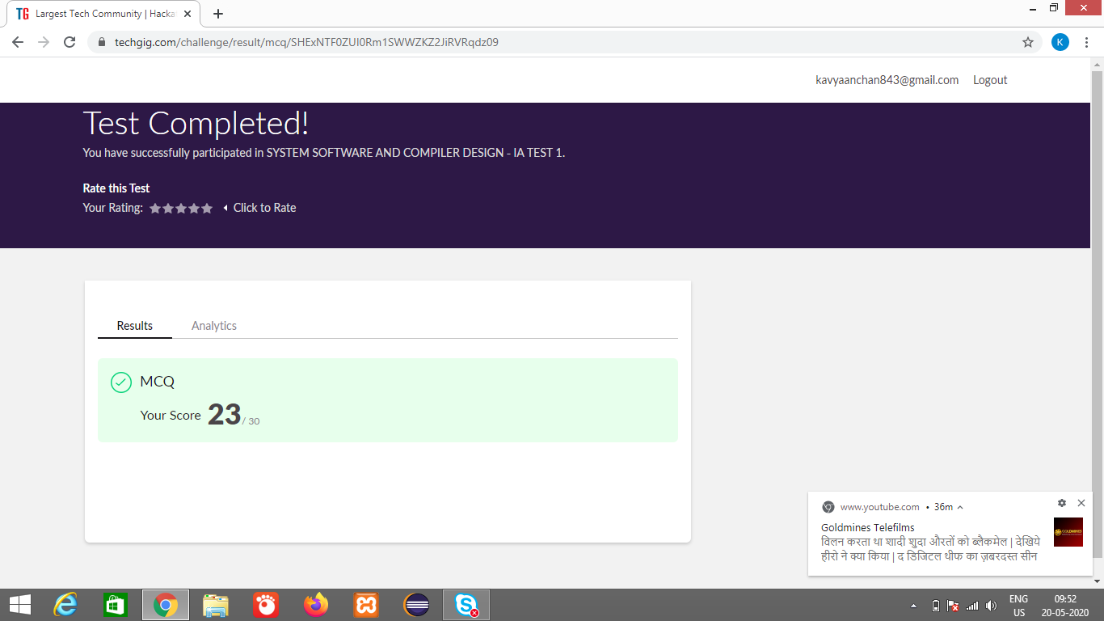

Certification Course Details: (Attach the snapshot and briefly write the report for the same)

**DART COURSE FOR BEGINNERS**

In this course, we will learn how to become an amazing dart programmer from scratch. This course will walk us through the general syntax of dart with tons of hands-on implementation. we can start with no coding knowledge and end up being an amazing coder who can then apply for a junior developer post.

What we’ll learn

learning how to code

Have a strong foundation on Dart and is capable of jump starting with flutter

Are there any course requirements or prerequisites?

No Prior Coding Knowledge Required

Windows / Mac / Linux Machine Required

Who this course is for:

Anyone interested in learning how to code

Anyone interested in learning a powerful language

Anyone who wants to dive into flutter and wants a strong foundation

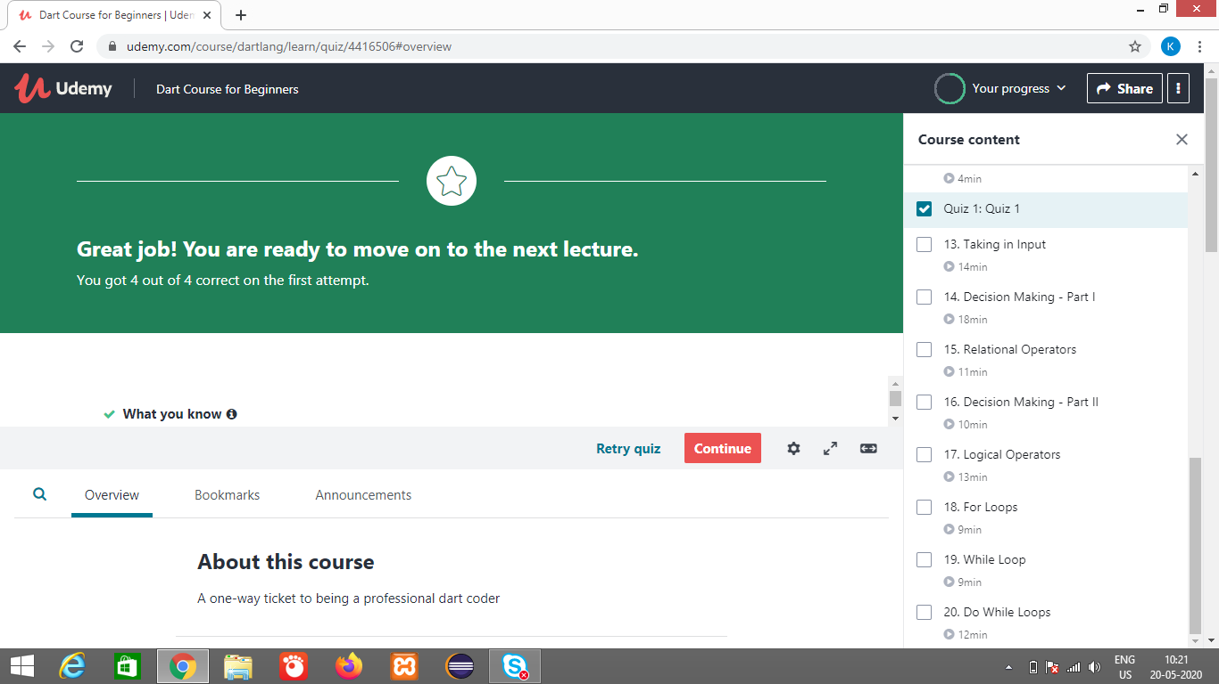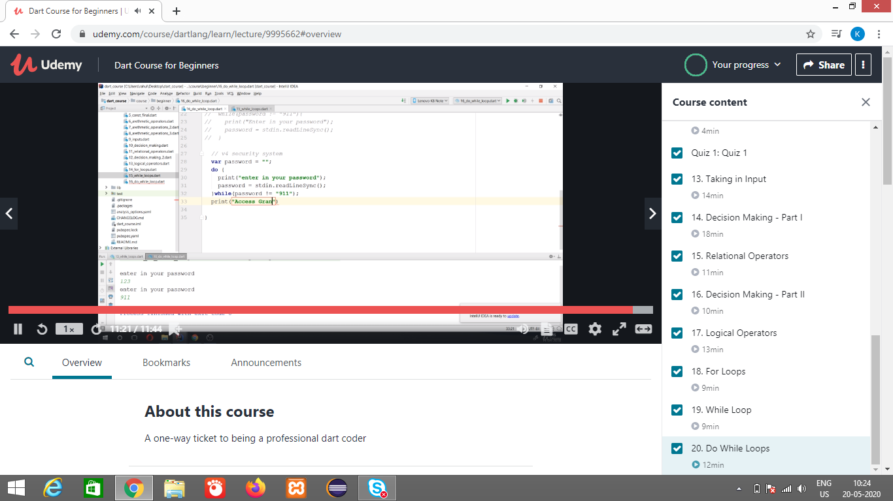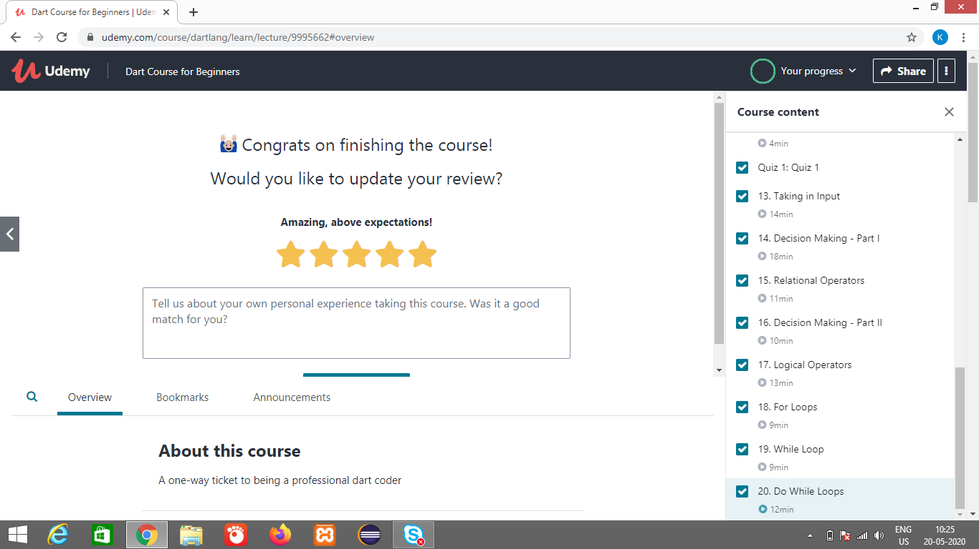

Coding Challenges Details: (Attach the snapshot and briefly write the report for the same)

Repository Name:

https://github.com/kavya-077/DAILY-STATUS