**DAILY ONLINE ACTIVITIES SUMMARY**

|  |  |  |  |  |  |  |  |  |
| --- | --- | --- | --- | --- | --- | --- | --- | --- |
| **Date:** | **23 June** | | | | | **Name:** | **kavya** | |
| **Sem & Sec** | **6th Sem ‘A’ Sec** | | | | | **USN:** | **4AL17CS041** | |
| **Online Test Summary** | | | | | | | | |
| **Subject** | | **Java Programming and Data Structures** | | | | | | |
| **Max. Marks** | | **--** | | **Score** | | | **----** | |
| **Certification Course Summary** | | | | | | | | |
| **Course** | **Placement Training** | | | | | | | |
| **Certificate Provider** | | | **Mr. Sharan Pais**  **Ms. Merlyn** | | **Duration** | | | **4 Hours** |
| **Coding Challenges** | | | | | | | | |
| **Problem Statement: 1 program** | | | | | | | | |
| **Status: Executed** | | | | | | | | |
| **Uploaded the report in GitHub** | | | | | **yes** | | | |
| **If yes Repository name** | | | | | https://github.com/kavya-077/DAILY-STATUS | | | |
| **Uploaded the report in slack** | | | | | **yes** | | | |

**Java programming Session 1:**

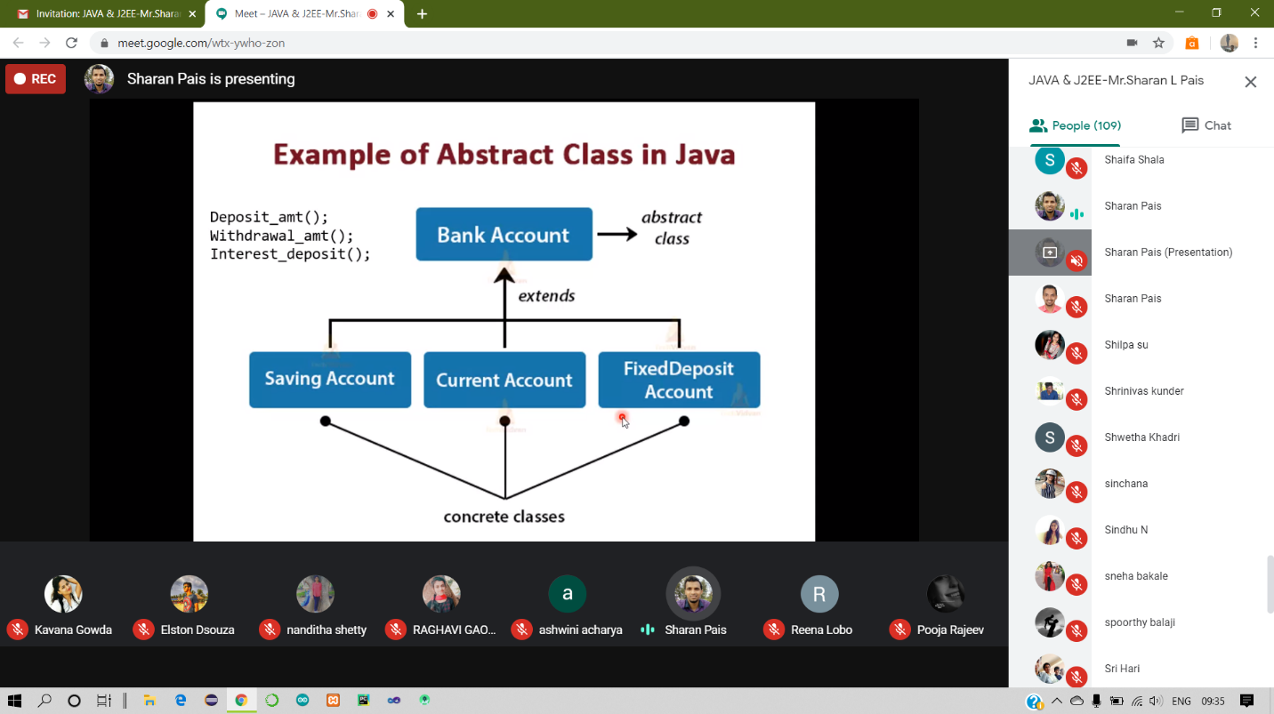

**Data Structures Session 2**

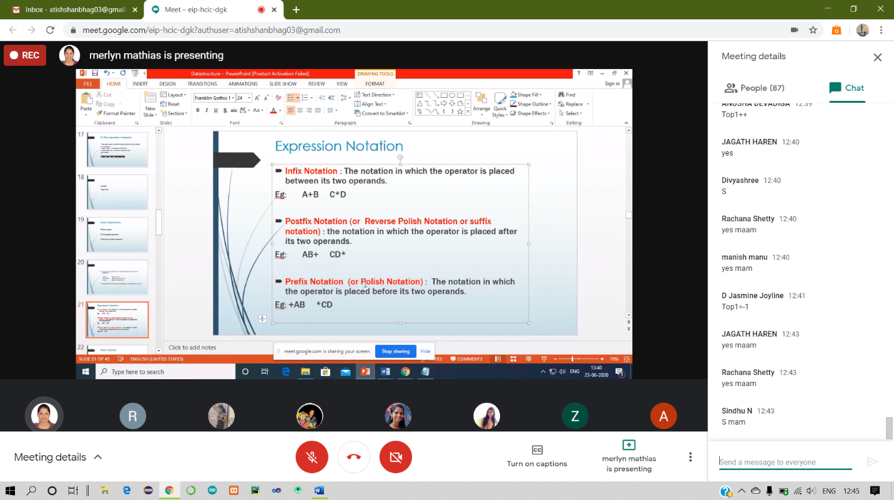

**PAP Assignment-4 Test**

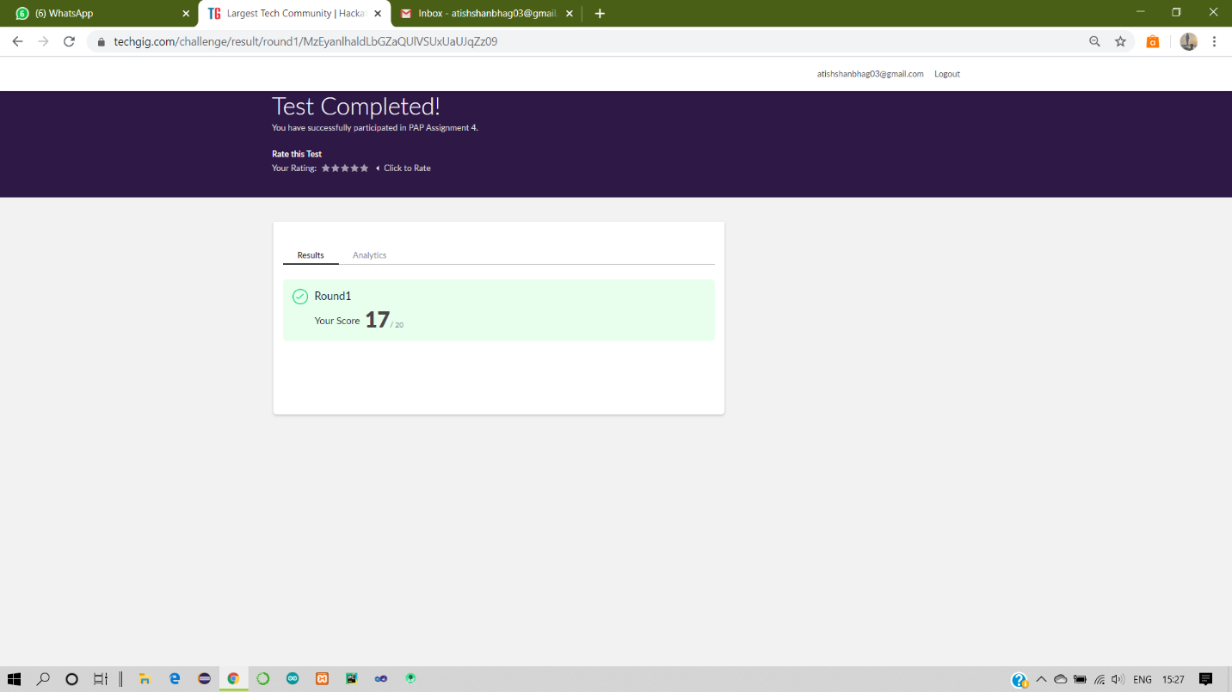

**WEBINAR**

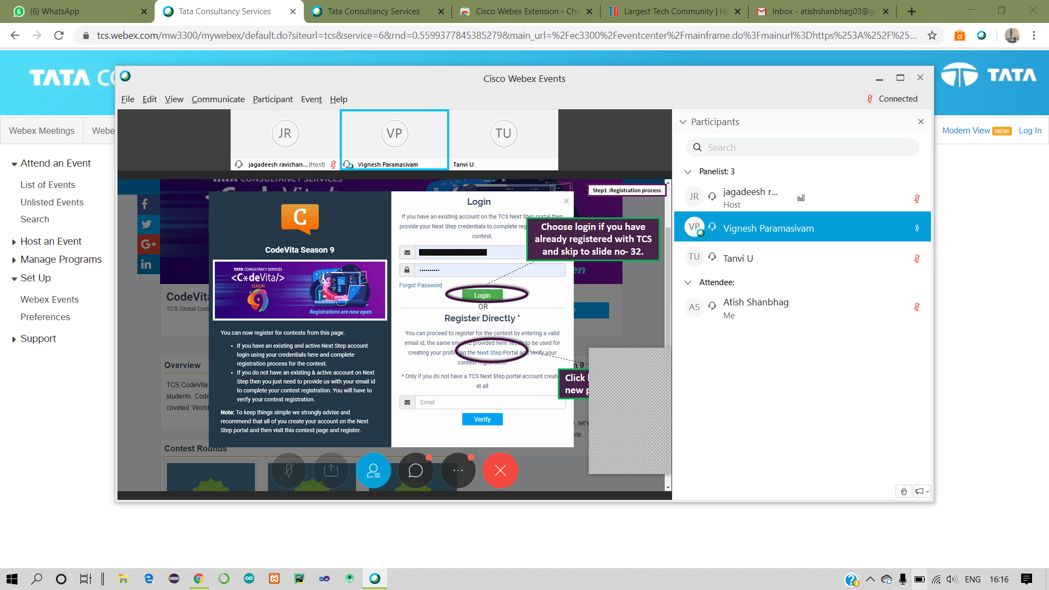

**Coding Challenges Details:**

23-June – Code:

**Program 1 -**

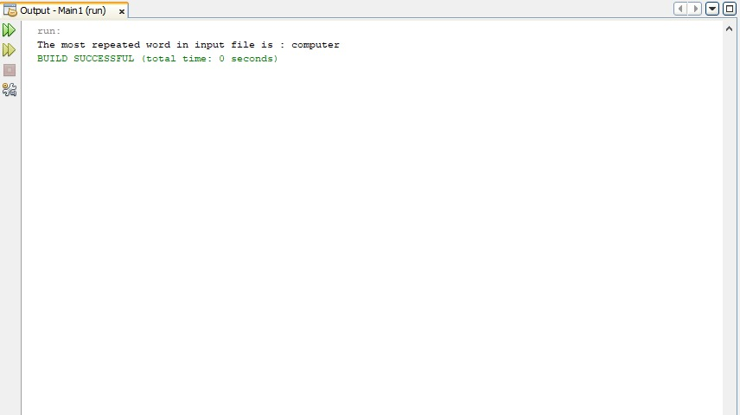

**1-For Report and daily coding challenges** 🡪

**https://github.com/kavya-077/DAILY-STATUS**