**DAILY ONLINE ACTIVITIES SUMMARY**

|  |  |  |  |  |  |  |  |  |
| --- | --- | --- | --- | --- | --- | --- | --- | --- |
| **Date:** | **27-05-2020** | | | | | **Name:** | **Kavya** | |
| **Sem & Sec** | **6th & A** | | | | | **USN:** | **4al17cs041** | |
| **Online Test Summary** | | | | | | | | |
| **Subject** | | **System Software And Compiler Design** | | | | | | |
| **Max. Marks** | | **30** | | **Score** | | | **17** | |
| **Certification Course Summary** | | | | | | | | |
| **Course** | **Flutter Beginner Tutorial-Build Own App** | | | | | | | |
| **Certificate Provider** | | | **Udemy** | | **Duration** | | | **3 hours** |
| **Coding Challenges** | | | | | | | | |
| **Problem Statement:1.** Given an array arr[] of the positive integers of size N, the task is to find the largest element on the left side of each index which is smaller than the element present at that index.  2. Write a C Program to sort an array of integers in ascending order and display the sorted array and Number of passes performed for sorting.  3. Write a Java program to implement Binary Tree using the Linked List | | | | | | | | |
| **Status:Yes I have uploaded all the programs** | | | | | | | | |
| **Uploaded the report in Github** | | | | | **yes** | | | |
| **If yes Repository name** | | | | | [**https://github.com/kavya-077/DAILY-STATUS**](https://github.com/kavya-077/DAILY-STATUS) | | | |
| **Uploaded the report in slack** | | | | | **yes** | | | |

Online Test Details: (Attach the snapshot and briefly write the report for the same)

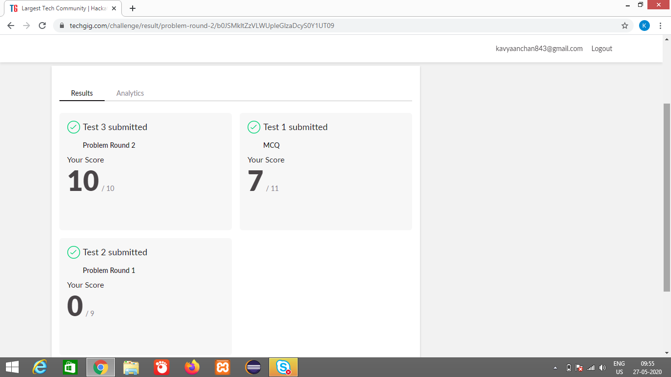

Certification Course Details: (Attach the snapshot and briefly write the report for the same)

First part of the series talks about the basics of dart so beginners can get up to speed for the flutter tutorials. After that we will install android studio and start with the basics of flutter. At the end of the course we will create a simple ToDo App with basic functionallity.

- learn dart basics

- learn flutter basics

- create own app

**What we’ll learn**

* Learn the basics of dart and flutter and build an complete ToDo App

**Are there any course requirements or prerequisites?**

* For beginners. No tools required

**Who this course is for:**

* If we are interested in Flutter and App development take this course

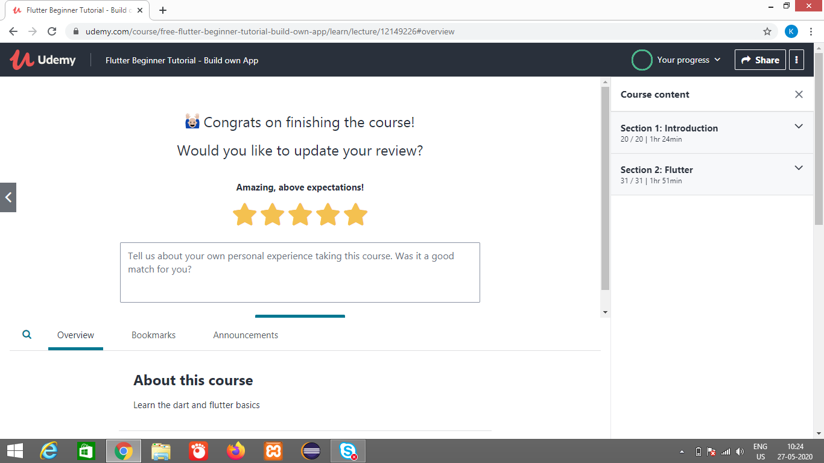

<https://github.com/alvas-education-foundation/kavya-onlinecourse>

<https://github.com/kavya-077/DAILY-STATUS>

Coding Challenges Details: (Attach the snapshot and briefly write the report for the same)

<https://github.com/alvas-education-foundation/kavya-OCA>

<https://github.com/kavya-077/DAILY-STATUS>