**DAILY ONLINE ACTIVITIES SUMMARY**

|  |  |  |  |  |  |  |  |  |
| --- | --- | --- | --- | --- | --- | --- | --- | --- |
| **Date:** | **28-05-2020** | | | | | **Name:** | **Kavya** | |
| **Sem & Sec** | **6th & A** | | | | | **USN:** | **4AL17CS041** | |
| **Online Test Summary** | | | | | | | | |
| **Subject** | | **Operating Systems** | | | | | | |
| **Max. Marks** | | **30** | | **Score** | | | **23** | |
| **Certification Course Summary** | | | | | | | | |
| **Course** | **Flutter: create Android / iOS apps with Google's new mobile SDK** | | | | | | | |
| **Certificate Provider** | | | **Udemy** | | **Duration** | | | **3 hours** |
| **Coding Challenges** | | | | | | | | |
| **Problem Statement:1.** Python program to find digital root of a number  2. Write a function that accepts a string consisting entiring of brackets ({}) and returns whether it is balanced. Every "opening" bracket must be followed by a closing bracket of the same type. There can also be nested brackets, which adhere to the same rule. | | | | | | | | |
| **Status:Yes, I have uploaded all the programs** | | | | | | | | |
| **Uploaded the report in Github** | | | | | **yes** | | | |
| **If yes Repository name** | | | | | [**https://github.com/kavya-077/DAILY-STATUS**](https://github.com/kavya-077/DAILY-STATUS) | | | |
| **Uploaded the report in slack** | | | | | **YES** | | | |

Online Test Details: (Attach the snapshot and briefly write the report for the same)

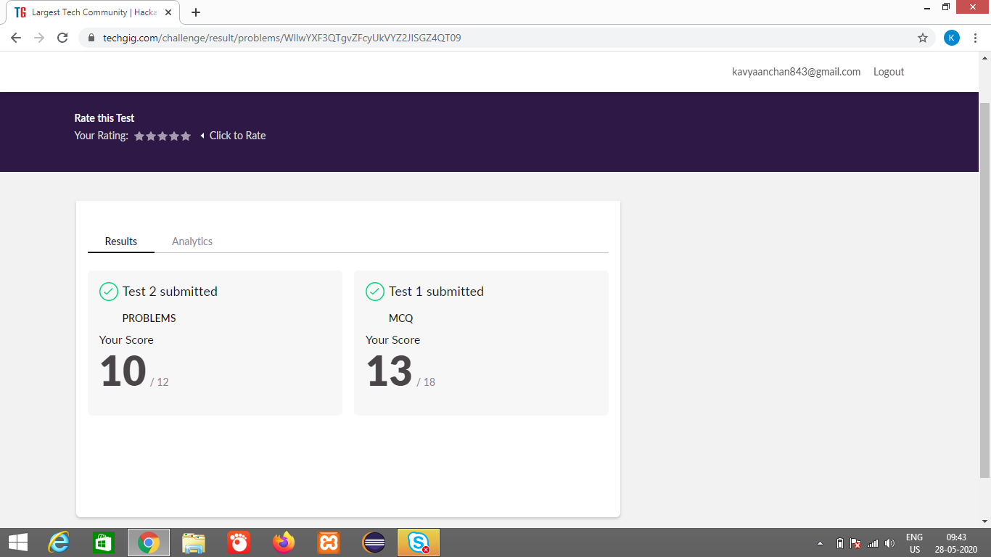

Certification Course Details: (Attach the snapshot and briefly write the report for the same)

**Flutter: create Android / iOS apps with Google's new mobile SDK**

We will Learn how to create beautiful, high-performance apps from complete hands-on projects

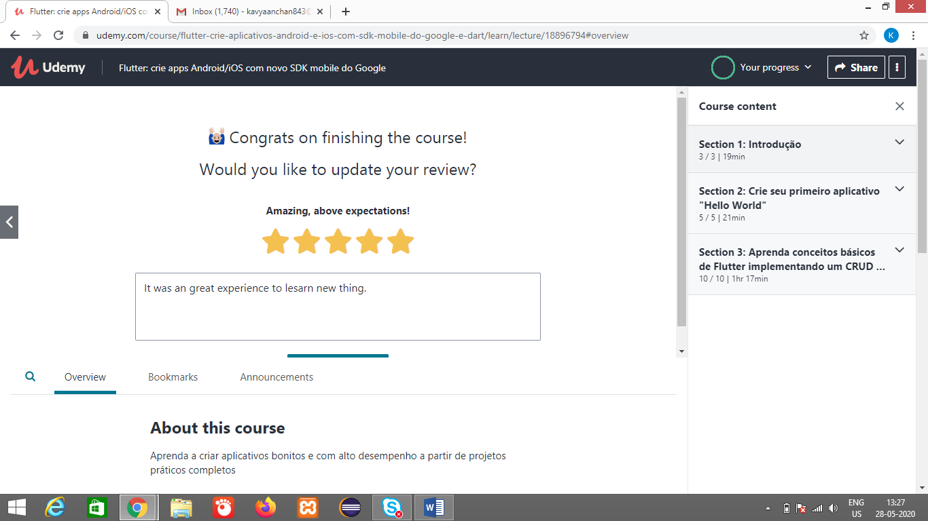

<https://github.com/kavya-077/DAILY-STATUS>

<https://github.com/alvas-education-foundation/kavya-onlinecourse>

Coding Challenges Details: (Attach the snapshot and briefly write the report for the same)

<https://github.com/alvas-education-foundation/kavya-OCA>

<https://github.com/kavya-077/DAILY-STATUS>