**DAILY ONLINE ACTIVITIES SUMMARY**

|  |  |  |  |  |  |  |  |  |
| --- | --- | --- | --- | --- | --- | --- | --- | --- |
| **Date:** | **30-05-2020** | | | | | **Name:** | **Kavya** | |
| **Sem & Sec** | **6th & A** | | | | | **USN:** | **4al17cs041** | |
| **Online Test Summary** | | | | | | | | |
| **Subject** | | **PAP** | | | | | | |
| **Max. Marks** | | **30** | | **Score** | | | **14** | |
| **Certification Course Summary** | | | | | | | | |
| **Course** | **Step Into Robotic Process Automation** | | | | | | | |
| **Certificate Provider** | | | **GUVI** | | **Duration** | | | **3Hours** |
| **Coding Challenges** | | | | | | | | |
| **Problem Statement: 1.** [Python program to read a number and print the pattern](https://github.com/orgs/alvas-education-foundation/teams/3rd-year/discussions/44)  **2**. write a java program to Count number of trailing zeros in product of array | | | | | | | | |
| **Status: Yes,I have uploaded all the programs** | | | | | | | | |
| **Uploaded the report in Github** | | | | | **Yes** | | | |
| **If yes Repository name** | | | | | [**https://github.com/kavya-077/DAILY-STATUS**](https://github.com/kavya-077/DAILY-STATUS) | | | |
| **Uploaded the report in slack** | | | | | **Yes** | | | |

Online Test Details: (Attach the snapshot and briefly write the report for the same)

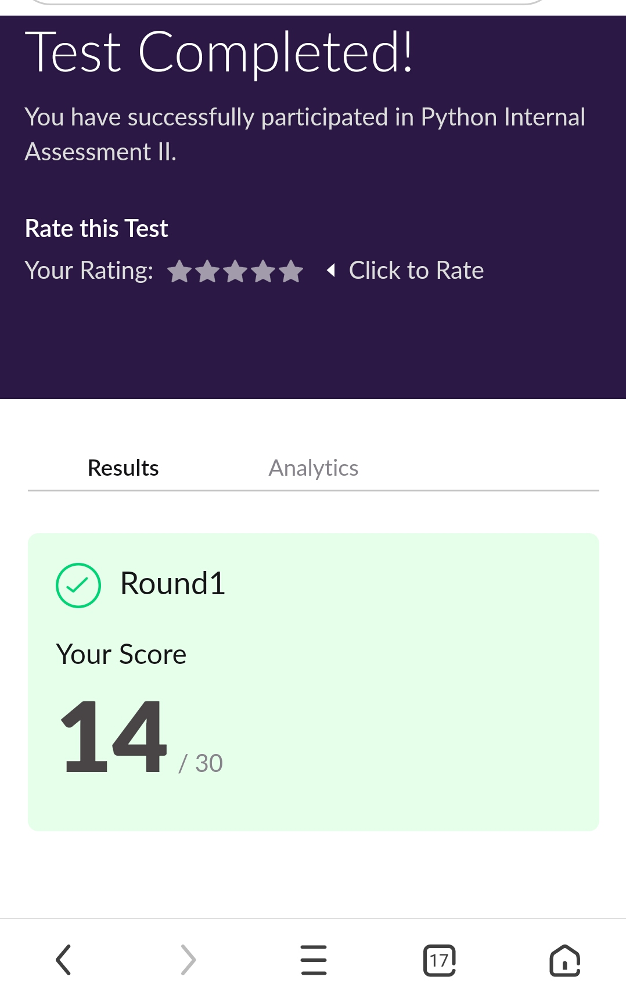

Certification Course Details: (Attach the snapshot and briefly write the report for the same)

Step into robotic process automation

**Key takeaways from this chapter**

By the end of this section, I’am able to

Understand Data persistence and its use in UiPath

Read and write to excel

Describe Selectors in UiPath

Understand the UI Explorer and when to use it

Create Robots for basic automation workflow



<https://github.com/kavya-077/DAILY-STATUS>

<https://github.com/alvas-education-foundation/kavya-onlinecourse>

Coding Challenges Details: (Attach the snapshot and briefly write the report for the same)

<https://github.com/kavya-077/DAILY-STATUS>

<https://github.com/alvas-education-foundation/kavya-OCA>