**PYTHON PROGRAMS(2/9/2020)(kavya:4al17cs041)**

**1.** fname = input("Input your First Name : ")

lname = input("Input your Last Name : ")

print ("Hello " + lname + " " + fname)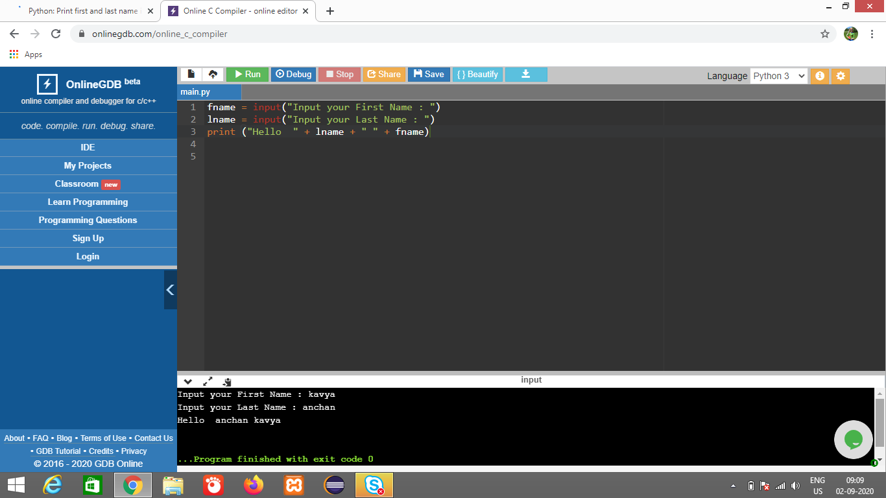

**2**.

from datetime import date

f_date = date(2014, 9, 7)

l_date = date(2014, 9, 21)

delta = l_date - f_date

print(delta.days)

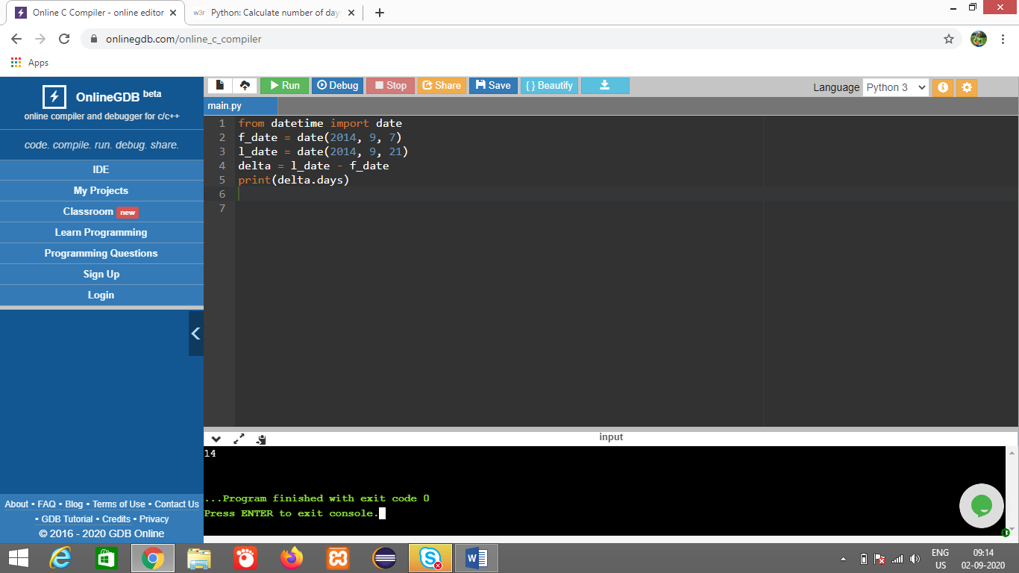

**3.** def is_vowel(char):

all_vowels = 'aeiou'

return char in all_vowels

print(is_vowel('k'))

print(is_vowel('i'))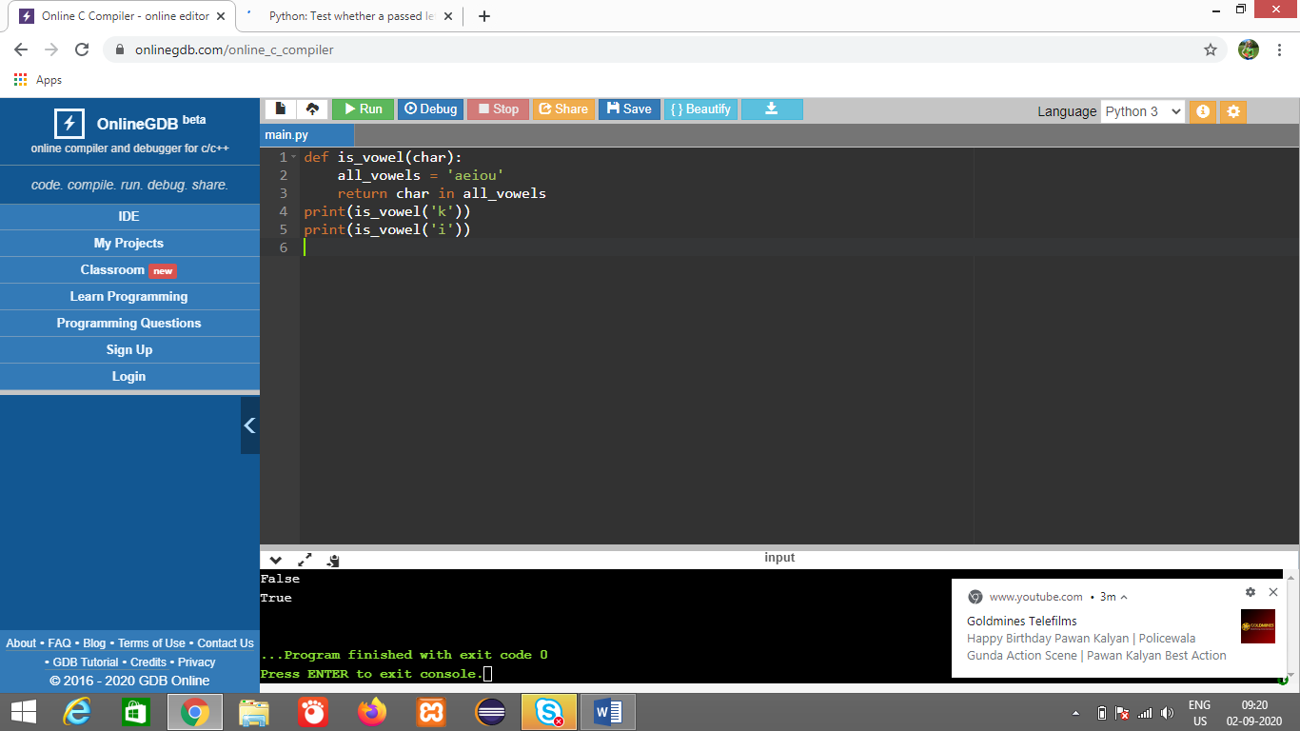

**4.** def sum(x, y, z):

if x == y or y == z or x==z:

sum = 0

else:

sum = x + y + z

return sum

print(sum(9, 1, 9))

print(sum(3, 8, 8))

print(sum(1, 2, 1))

print(sum(1, 2, 3))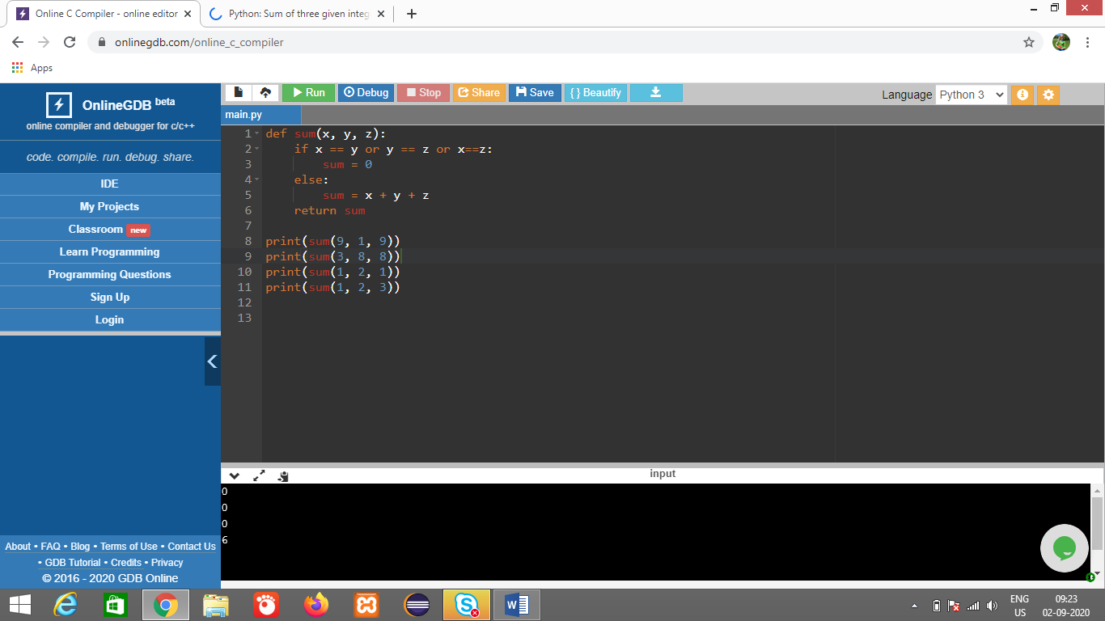

**5.** def char_frequency(str1):

dict = {}

for n in str1:

keys = dict.keys()

if n in keys:

dict[n] += 1

else:

dict[n] = 1

return dict

print(char_frequency('kavya anchan'))