Water Conservation CRM — Salesforce Implementation Playbook

Table of Contents
- Executive Summary
- Project Overview and Goals
- Delivery Methodology and Environment Strategy
- Phase 1: Problem Understanding & Industry Analysis
- Phase 2: Org Setup & Configuration
- Phase 3: Data Modeling & Relationships
- Phase 4: Process Automation (Admin)
- Phase 5: Apex Programming (Developer)
- Phase 6: User Interface Development
- Phase 7: Integration & External Access
- Phase 8: Data Management & Deployment
- Phase 9: Reporting, Dashboards & Security Review
- Phase 10: Quality assurance testing
- Governance, Security & Compliance
- KPIs and Success Metrics
- Appendices (Templates & Checklists)

Executive Summary
This playbook provides an end-to-end guide for planning, implementing, and launching the Water Conservation CRM on Salesforce. It is structured into 10 phases spanning discovery, architecture, configuration, custom development, integration, data, reporting, security, and final presentation. Each phase includes objectives, deliverables, activities, roles, acceptance criteria, risks, and checklists. The guidance follows Salesforce best practices, emphasizes security and data quality, and supports iterative delivery with clear milestones.

Project Overview and Goals
Objectives
- Centralize water conservation program data (customers, site assessments, rebates, conservation measures, field operations).
- Streamline workflows (intake, eligibility, inspections, approvals, payments).
- Improve reporting on conservation impact (water saved, program performance, compliance).
- Enable secure collaboration among departments and external partners.
- Ensure data privacy, auditability, and regulatory compliance.
Scope
- In scope: Salesforce setup, core data model, flows, Apex services, LWCs, API integrations, data migration, reports/dashboards, security hardening, CI/CD.
- Out of scope (initial release): Complex mobile offline, managed packaging for AppExchange, advanced AI features.
Constraints & Assumptions
- Phased rollout by program area; 2–3 week sprints; sandbox-first changes; Git-based version control; CI/CD with environment gates.
- Data from legacy systems available via export/API; SME availability for UAT; security policies approved by InfoSec.
Success Metrics
- Adoption: ≥80% weekly active users within 60 days of launch.
- Efficiency: ≥30% reduction in average case-to-approval time.
- Data quality: <1% critical duplicates; ≥95% required fields completed.
- Impact tracking: 100% of approved measures have verified water savings calculations.

Delivery Methodology and Environment Strategy
Approach
- Agile with iterative releases; Definition of Ready/Done at story and phase levels.
- Peer review for config and code; automated tests; quality gates.
- Documentation-first for data model and integration contracts.
Environments & Branching
- Dev sandboxes: Feature development and spikes.
- QA/UAT sandbox: Integrated testing and user acceptance.
- Staging (optional): Release candidate validation, performance tests.
- Production: Controlled releases with back-out plan.
- GitFlow (recommended): main (prod), develop (integration), feature/, release/, hotfix/*.
Release Cadence & CI/CD
- CI: Validate, lint, unit tests on pull request.
- CD: Promote metadata and source using SFDX; seed data via scripts; smoke tests post-deploy.
- Change approvals via pull requests + release notes.

Phase 1: Problem Understanding & Industry Analysis
Objective
Establish domain understanding, business objectives, regulatory context, and measurable outcomes to drive solution scope and priorities.
Key Deliverables
- Stakeholder map and RACI
- Business capability map (Programs, Assessments, Rebates, Field Ops, Finance)
- Current-state vs. target-state process maps
- Regulatory & compliance inventory (data retention, PII, audit)
- Success metrics and OKRs
- Prioritized backlog with epics and MVP definition
Activities
- Conduct discovery workshops and SME interviews.
- Analyze industry standards and peer utility programs.
- Map value streams: intake → assessment → approval → realization → reporting.
- Identify system landscape and integration candidates.
- Draft product vision, personas, and journey maps.
Roles
- Product Owner, Business Analyst, Solution Architect, Compliance Lead, Delivery Lead.
Acceptance & Exit Criteria
- Signed off problem statement, scope, and MVP.
- Backlog groomed for Phase 2 kickoff (Definition of Ready met).
- Risks logged with mitigation strategies.

Risks & Mitigations
- Ambiguous scope → timebox workshops; decision log; change control.
- Compliance constraints → early InfoSec review; privacy by design.
Checklist
- Stakeholders identified and engaged
- KPIs defined
- Process maps baselined
- Risk register opened

Phase 2: Org Setup & Configuration
Objective
Establish a secure, governed Salesforce foundation to support subsequent build activities.
Key Deliverables
- Org strategy (production + sandboxes) and access model
- Profiles/Permission Sets and Permission Set Groups
- Named Credentials/External Credentials baseline
- SSO/MFA plan; Session settings; Password policies
- Dev tooling: SFDX, Prettier, ESLint, PMD rules
- Scratch org definition files (if using Source-Tracked DX)
Activities
- Configure company settings, business hours, holidays, fiscal year.
- Set up users, roles, role hierarchy, public groups.
- Establish permission model: least privilege, PS > profiles where possible.
- Enable MFA and SSO (as applicable).
- Create baseline sandboxes; connect CI/CD.
- Define naming conventions and repo structure (force-app/main/default, unlocked packages if used).
Roles
- Admin, Security Architect, DevOps Engineer.
Acceptance & Exit Criteria
- Security baseline validated (Health Check score target, MFA enforced).
- CI pipeline passes for baseline metadata push.
- Access model documented and approved.

Risks & Mitigations
- Over-permissive access → permission reviews; automated policy checks.
- Misaligned environments → env matrix and refresh cadence.
Checklist
- MFA/SSO configured
- Profiles minimized; Permission Sets used
- CI/CD pipeline green
- Audit settings enabled

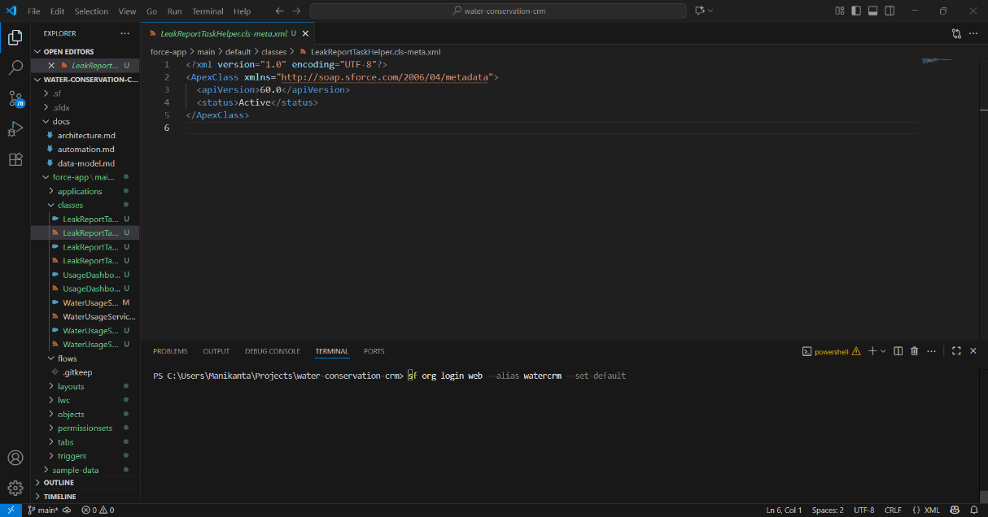

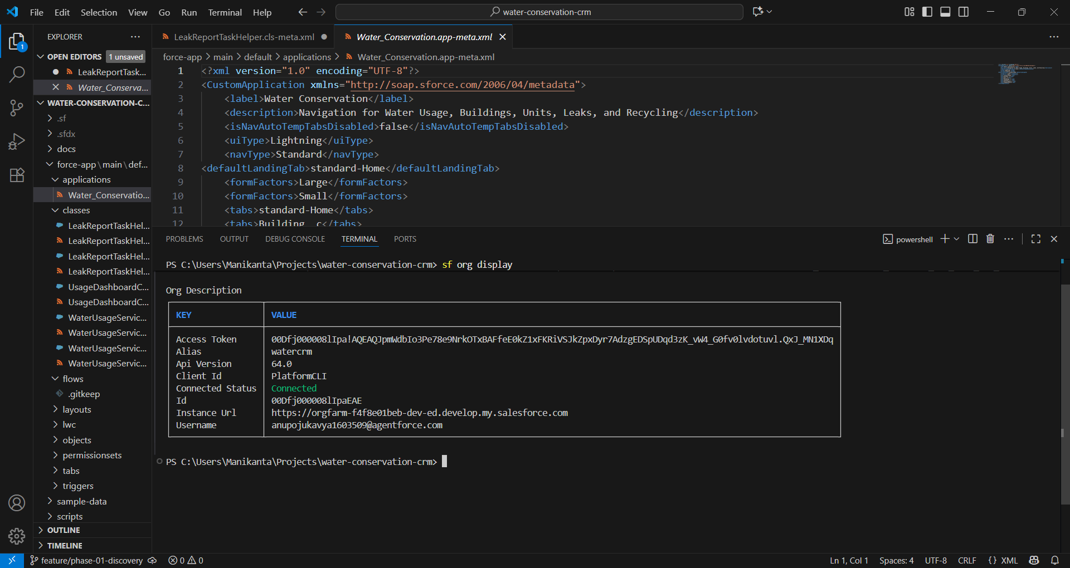
Phase 3: Data Modeling & Relationships
Objective
Design a scalable, secure data model to capture programs, participants, sites, measures, inspections, approvals, and financials.
Key Deliverables
- ERD with entities and relationships
- Object inventory (standard vs. custom) with rationale
- Field dictionary (API names, labels, types, help text)
- Record Types and Business Processes
- Validation rules and required fields
- Sharing model: OWD, criteria-based shares, teams
Activities
- Leverage standard objects (Accounts, Contacts, Cases) where possible.
- Create custom objects (e.g., Building__c, LeakReport__c, RecyclingLog__c, Unit__c, WaterUsage__c).
- Define lookups/master-detail and junction objects.
- Implement picklists with global value sets; help text for usability.
- Establish data quality rules and duplicate rules/matching rules.
Roles
- Solution Architect, Admin, Data Architect.
Acceptance & Exit Criteria
- ERD and dictionary peer-reviewed and approved.
- Sharing model yields correct record visibility in test scenarios.
- Validation rules cover critical data quality constraints.

Risks & Mitigations
- Over-customization → standard-first review gate.
- Future scalability → big object strategy if needed; selective indexes.
Checklist
- ERD merged to repo
- Object/field naming conventions applied
- Sharing and ownership tested
- Duplicate rules validated
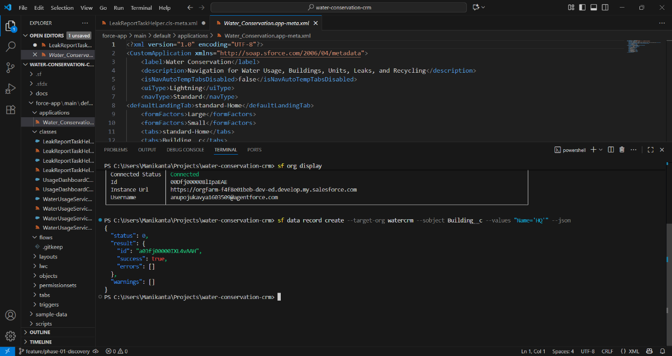
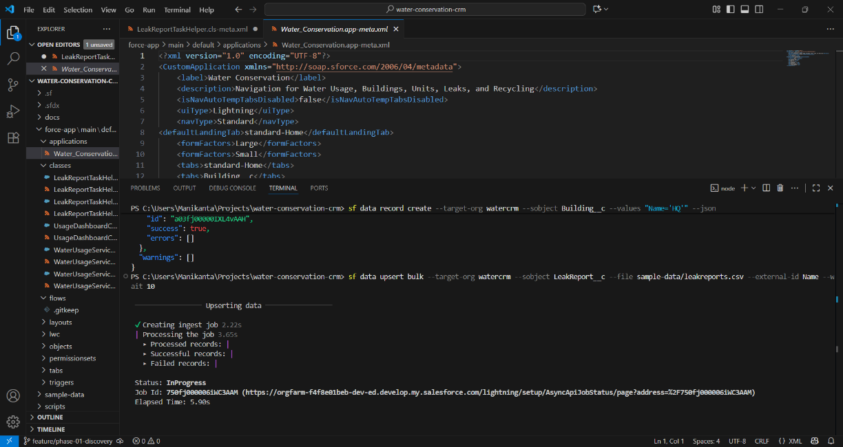
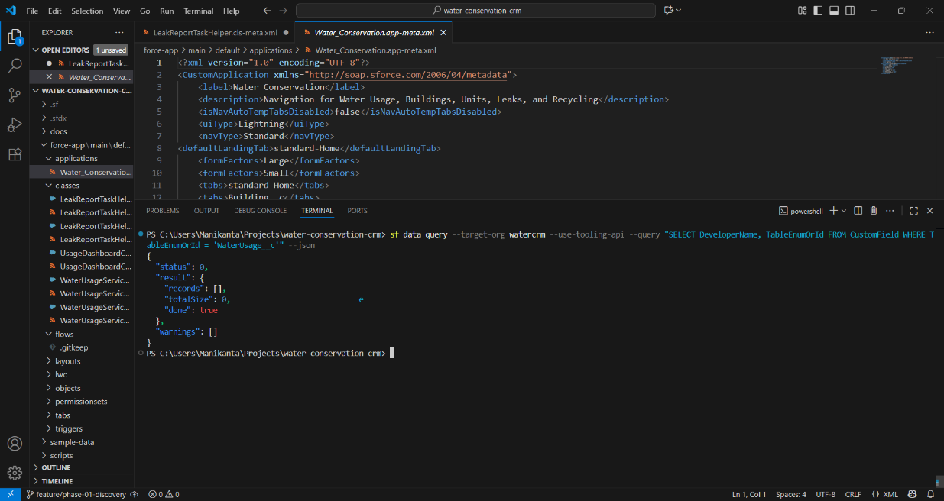

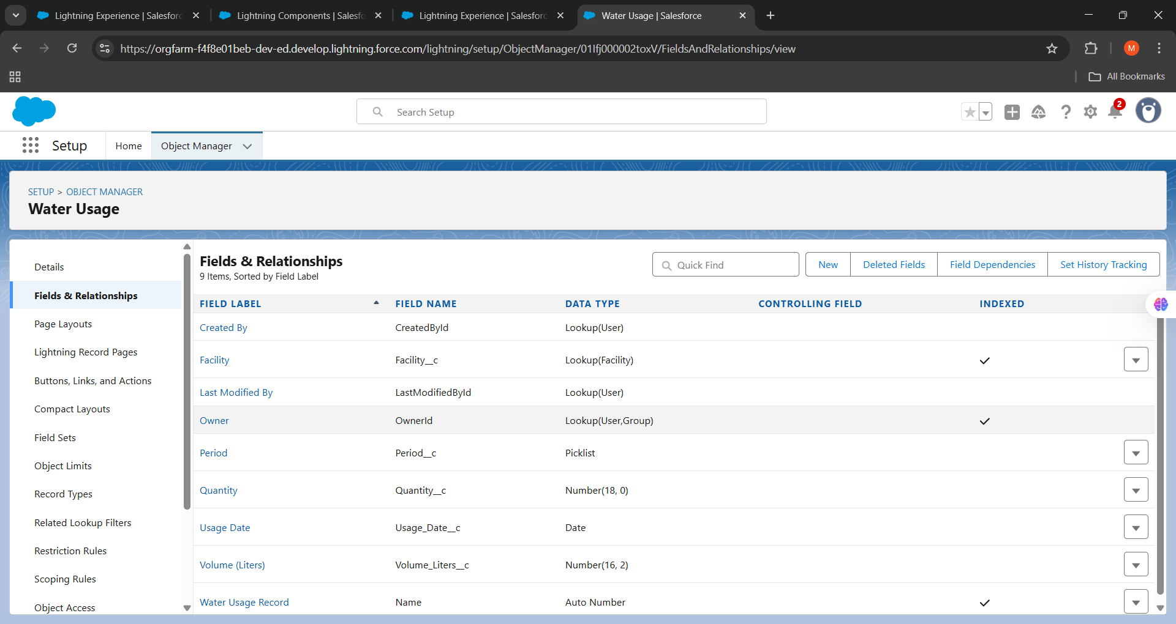

Phase 4: Process Automation (Admin)
Objective
Automate business processes using low-code first (Flows), reserving code for complex or bulk-safe needs.
Key Deliverables
- Record-Triggered Flows (create/update/delete)
- Screen Flows for guided intake and inspections
- Scheduled Flows for nightly syncs and recalculations
- Flow naming/versioning conventions and guardrails
- Declarative rollback approach (where feasible)
Activities
- Implement RT Flows for eligibility checks, status transitions, and derived fields.
- Build Screen Flows for guided applications, measure selection, and inspection forms.
- Use subflows for reuse; avoid recursion; set entry criteria precisely.
- Ensure bulkification in Flows: use collection operations, avoid per-record DML.
- Replace Workflow Rules/Process Builder; centralize in Flow.
Roles
- Admin, Solution Architect, QA.
Acceptance & Exit Criteria
- Flows pass unit and UAT cases; fault paths handled; errors surfaced to users.
- No SOQL/DML limits hit in bulk tests; scheduled flows complete within window.
- Audit logs for critical automations.
Risks & Mitigations
- Flow sprawl → catalog and governance; design reviews.
- Fault handling gaps → standard error handler subflow.
Checklist
- Naming and foldering standards
- Subflows for reusable logic
- Limits testing with data volumes
- Error handling and toasts/messages

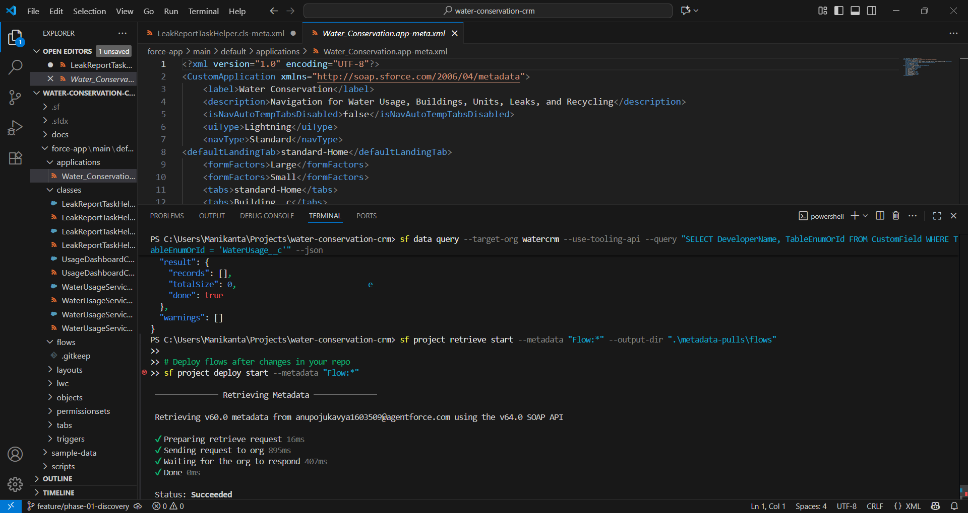

Phase 5: Apex Programming (Developer)
Objective
Implement robust, testable Apex for complex logic, integrations, and performance-sensitive operations.
Key Deliverables
- Service layer classes, domain triggers/handlers
- Queueables/Batch/Schedulable jobs for async/bulk
- Platform Event handling (if required)
- Comprehensive unit tests (≥85% overall; 100% for critical logic)
- Code quality reports (PMD, ESLint for LWC/JS)
Activities
- Adopt Trigger Framework (one trigger per object → handler pattern).
- Establish layers: Domain (SObject logic), Service (business ops), Selector (SOQL).
- Use Custom Metadata/Settings for feature flags and thresholds.
- Bulkify and cache reference data; governor-safe patterns.
- Implement error handling and logging (Platform Events, Custom Object, or Error Logging framework).
- Unit tests with FFLIB-like patterns: factory data, asserts on behavior, isolation.
Roles
- Developer, Technical Lead, Code Reviewer, QA.
Acceptance & Exit Criteria
- Tests green with coverage thresholds; static analysis passes.
- No critical PMD issues; peer review completed.
- Async patterns used for long-running tasks; retries where appropriate.

Risks & Mitigations
- Governor limits → bulk patterns; selective fields; indexed filters.
- Flaky tests → deterministic test data, SeeAllData=false, factories.
Checklist
- Trigger framework in place
- Service/selector patterns adopted
- Tests ≥85% coverage overall
- PMD and CI checks pass

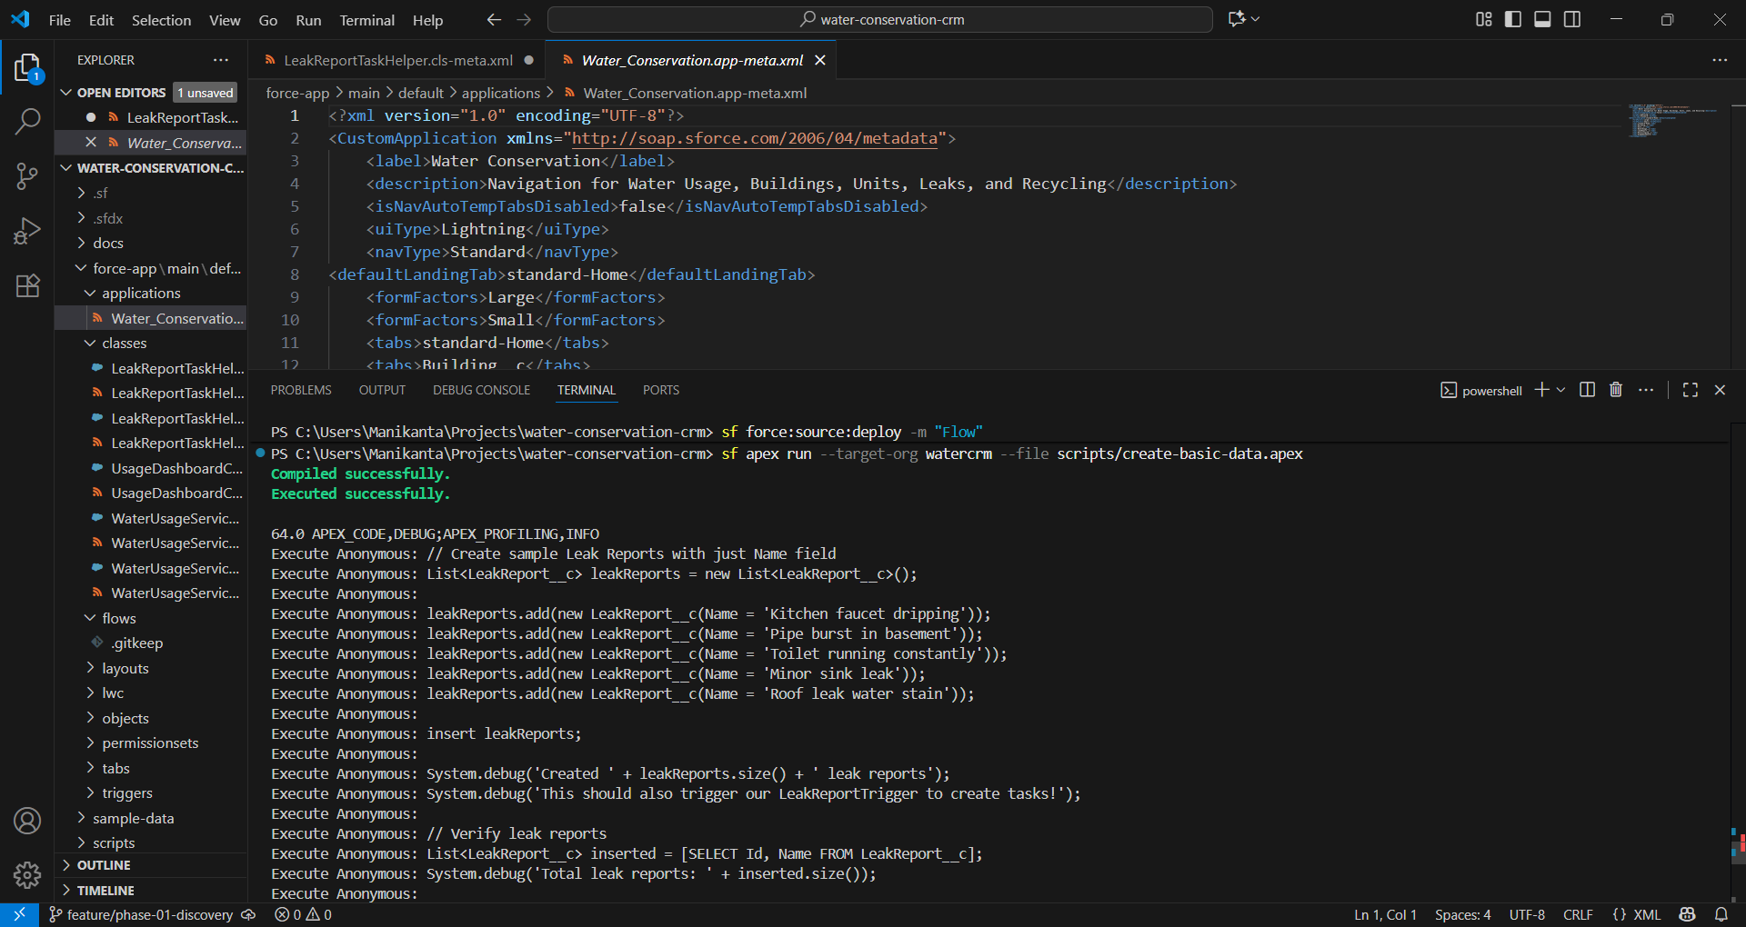

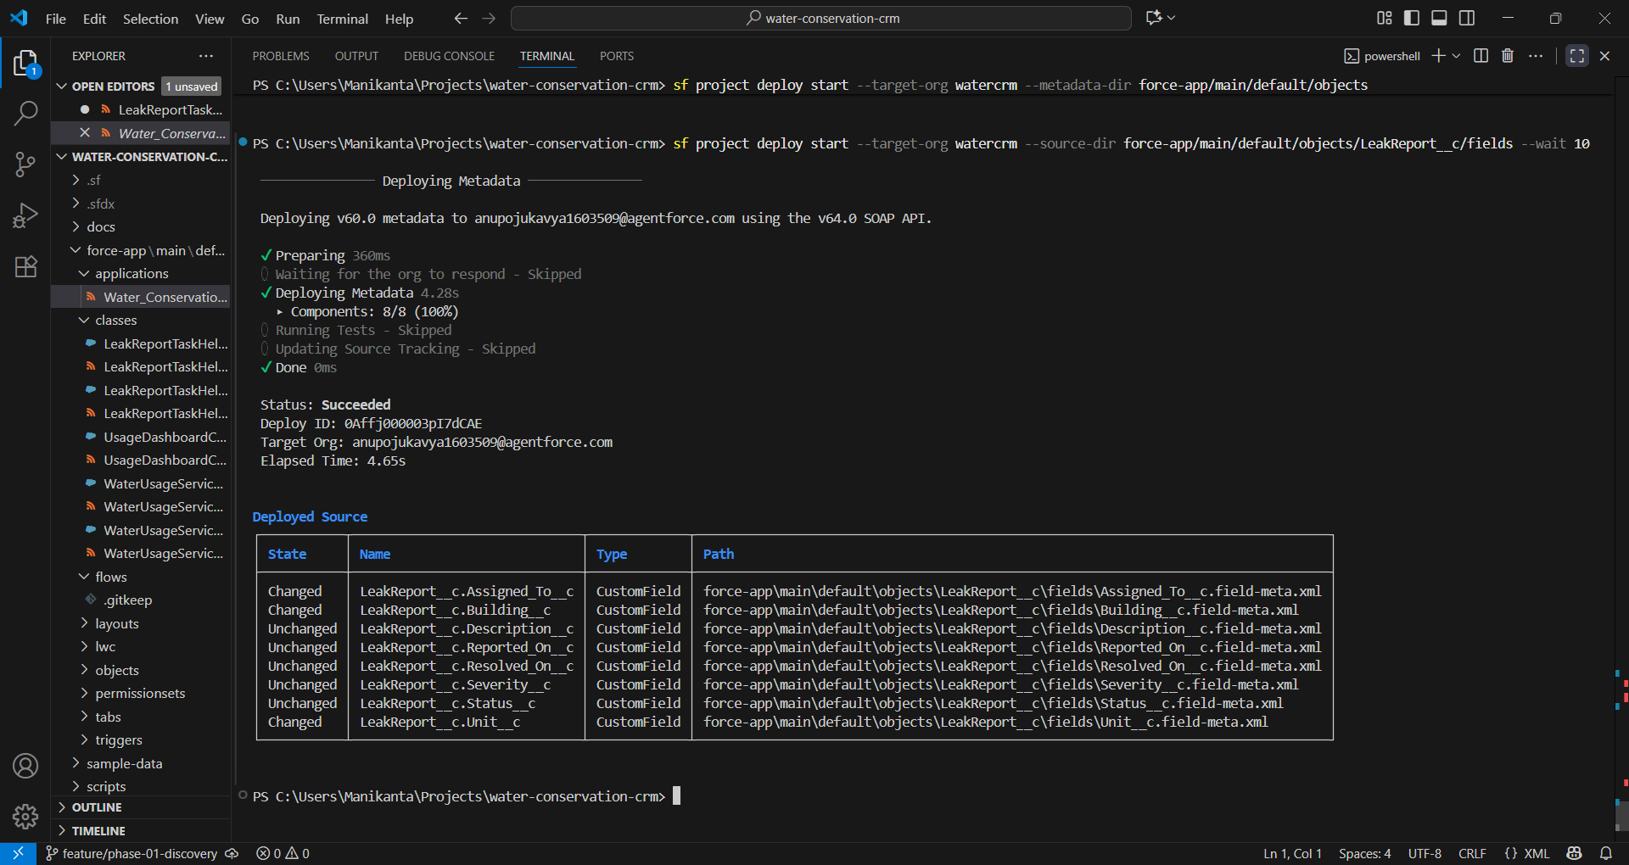
Phase 6: User Interface Development
Objective
Deliver intuitive, performant UIs using Lightning App Builder, LWCs, and dynamic forms.
Key Deliverables
- App pages, record pages, and utility items
- LWCs for specialized interactions (measure calculators, inspection capture)
- Dynamic forms and visibility rules
- Design system adherence (SLDS); accessibility compliance (WCAG)
Activities
- Layout optimization by persona; quick actions and related lists curated.
- LWC development with SLDS, wire adapters, Lightning Data Service.
- Caching strategies (lightning/ui* APIs; @wire with cache).
- Form validation and helpful error states; toast patterns.
- Performance checks: Lightning Usage App; LWC benchmarks.
Roles
- UX Designer, LWC Developer, Admin, Accessibility Reviewer.
Acceptance & Exit Criteria
- UAT sign-off by personas; Lighthouse/usage metrics within thresholds.
- Mobile responsiveness tested if applicable.
- Accessibility checks pass (keyboard nav, contrast, ARIA).
Risks & Mitigations
- UI sprawl → page templates and governance; component library.
- Performance → lazy loading, LDS, SOQL selectivity.

Checklist
- Persona-based pages
- SLDS-compliant components
- Accessibility verified
- Performance baseline recorded

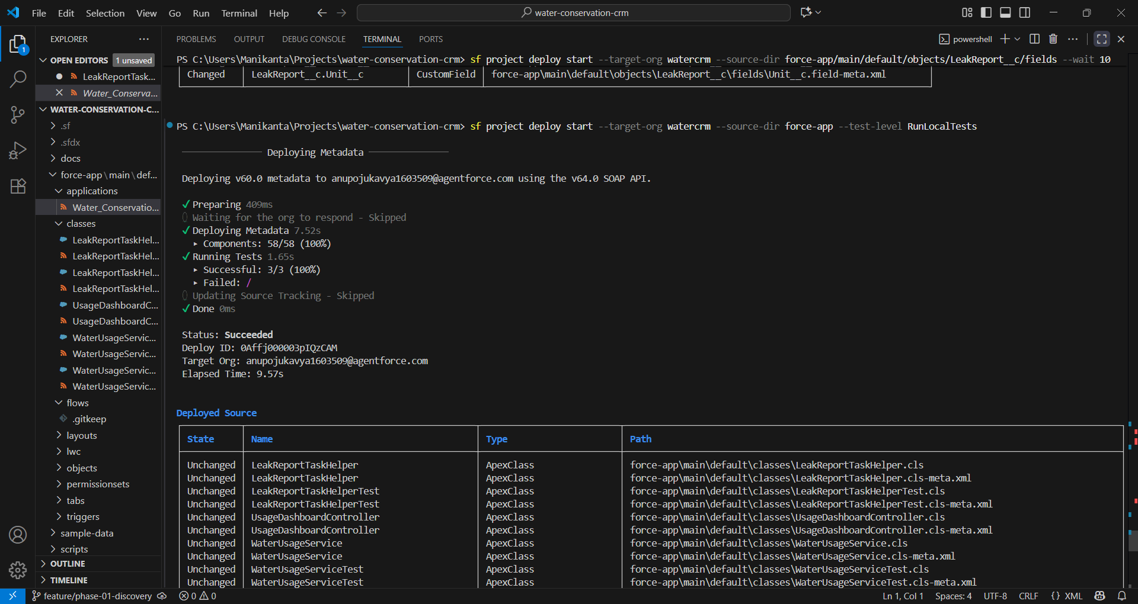

Phase 7: Integration & External Access
Objective
Connect Salesforce with external systems securely and reliably (billing, GIS, document management, payment gateways, analytics).
Key Deliverables
- Integration architecture (patterns, auth, rate limits)
- Named Credentials/External Credentials and Auth Providers
- REST/SOAP services (Apex) and/or External Services (OpenAPI)
- Event-driven patterns (Platform Events/Change Data Capture) where applicable
- Monitoring and alerting for integrations
Activities
- Select patterns: request/response, fire-and-forget, batch sync, event-driven.
- Define contracts (OpenAPI/JSON schemas); version endpoints.
- Implement retry/backoff; idempotency keys; dead-letter handling.
- Use Shield Platform Encryption/Field Encryption as needed.
- Secure external access via Experience Cloud or API Gateways with proper scopes.
Roles
- Integration Architect, Developer, Security Engineer, External Partner.
Acceptance & Exit Criteria
- Pen-tested endpoints; secrets managed (no hardcoding).
- Observability in place (logs, traces, dashboards).
- Error budgets and SLAs defined; graceful degradation paths.
Risks & Mitigations
- Rate limits → queuing/backpressure; composite APIs.
- Secrets exposure → Named Credentials, externalized configs, vaults.

Checklist
- Contracts versioned and documented
- Auth via Named Credentials
- Retry/idempotency implemented
- Monitoring and alerts configured

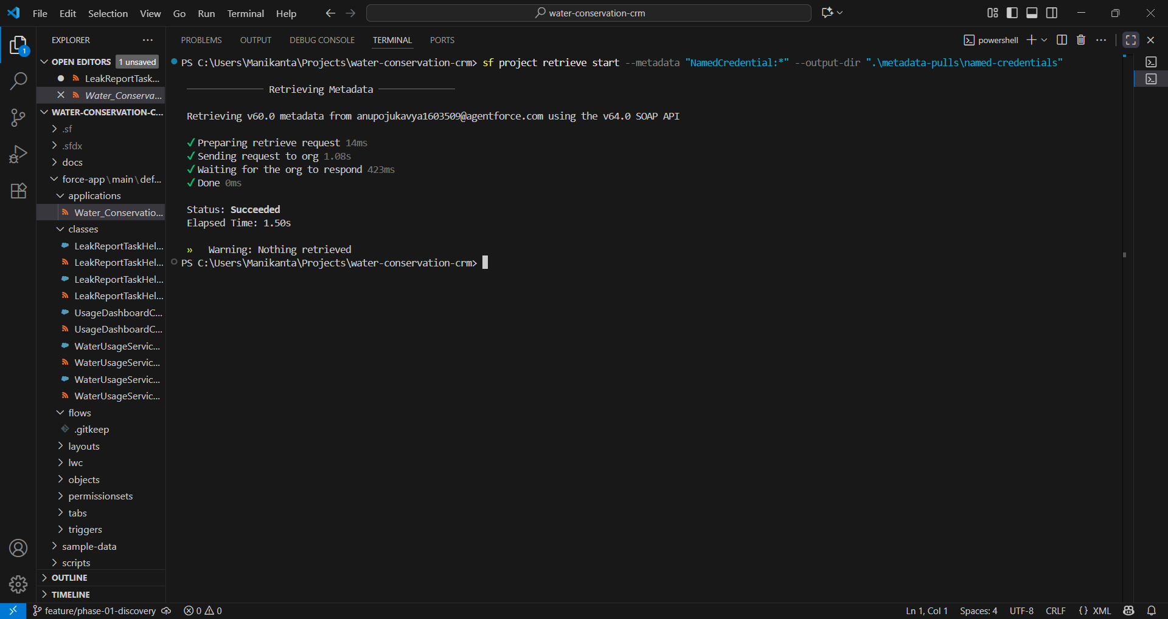

Phase 8: Data Management & Deployment
Objective
Migrate, seed, and protect data across environments; deploy changes safely with rollbacks.
Key Deliverables
- Data migration plan (profiles, volumes, sequencing, mapping)
- Data quality rules, deduping strategy
- Deployment runbooks and back-out plan
- Environment data seeding scripts (SFDX data tree, ETL)
- Backup and recovery strategy
Activities
- Define mapping from legacy to Salesforce; transform and cleanse.
- Load in order: reference → parents → children; handle external IDs.
- Use Bulk API 2.0 for large loads; monitor errors; reconcile.
- Practice cutover in UAT/Staging; measure timings.
- Validate profiles/perm sets post-deploy; smoke tests.
Roles
- Data Lead, Admin, DevOps, QA, Business Data Owners.
Acceptance & Exit Criteria
- UAT data migration sign-off; reconciliation within thresholds.
- Deployment rehearsals complete; MTTR and rollback validated.
- Backup/restore tested for critical objects.
Risks & Mitigations
- Dirty legacy data → cleansing rules, SME validation.
- Deployment drift → source of truth in Git, manifest-controlled deploys.

Checklist
- Field mapping and external IDs confirmed
- Dry runs completed
- Reconciliation reports
- Back-out plan tested

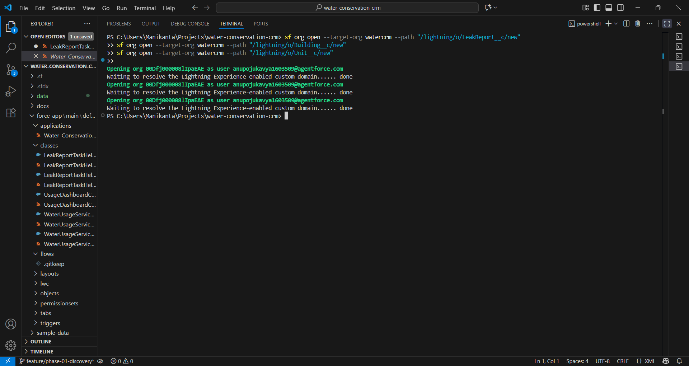
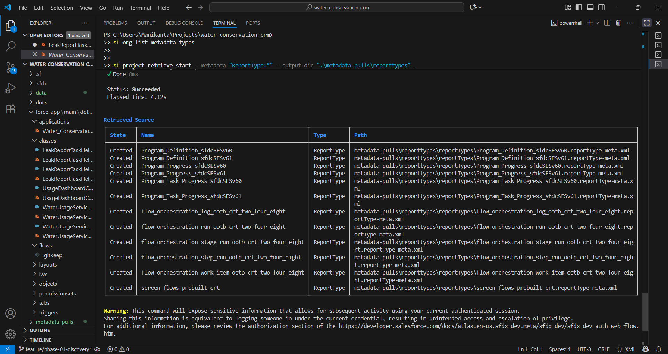
Phase 9: Reporting, Dashboards & Security Review
Objective
Deliver actionable analytics and complete a comprehensive security review prior to production launch.
Key Deliverables
- Report types and curated report library
- Executive dashboards (adoption, throughput, savings)
- Row-level security verified (sharing, filters)
- Security review artifacts: threat model, Health Check, vulnerabilities remediated
Activities
- Define KPIs aligned to program goals; map to fields and report types.
- Build dashboard pages for executives, program managers, and operations.
- Validate field-level and record-level access for reports.
- Run security assessments: session settings, CSP, clickjack, content sniffing.
- Static/dynamic scans (PMD, dependency checks, OWASP guidance for custom endpoints).
Roles
- Reporting Analyst, Admin, Security Architect, Product Owner.
Acceptance & Exit Criteria
- Dashboards approved by stakeholders; performance acceptable.
- No high/critical security findings outstanding.
- Data access in reports matches intended visibility.
Risks & Mitigations
- Misleading metrics → clear definitions and filters; data provenance notes.
- Overexposed data in reports → report folders, row-level filters, OWD review.

Checklist
- Report types curated
- Dashboard filters and sources validated
- Health Check ≥ target
- Vulnerabilities triaged and fixed

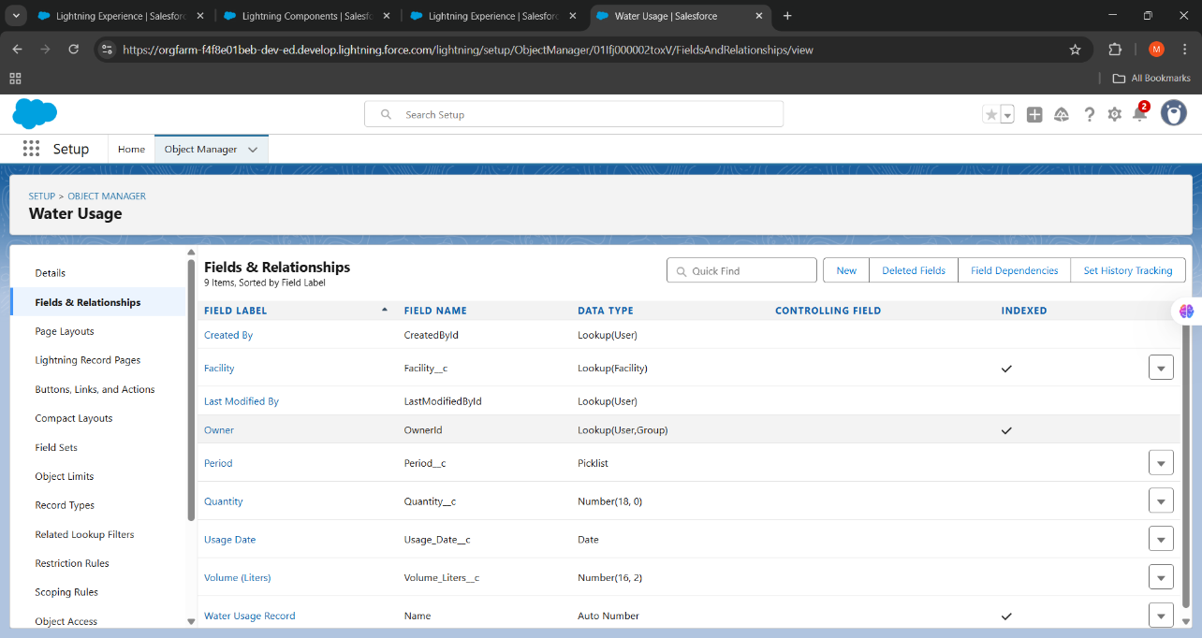
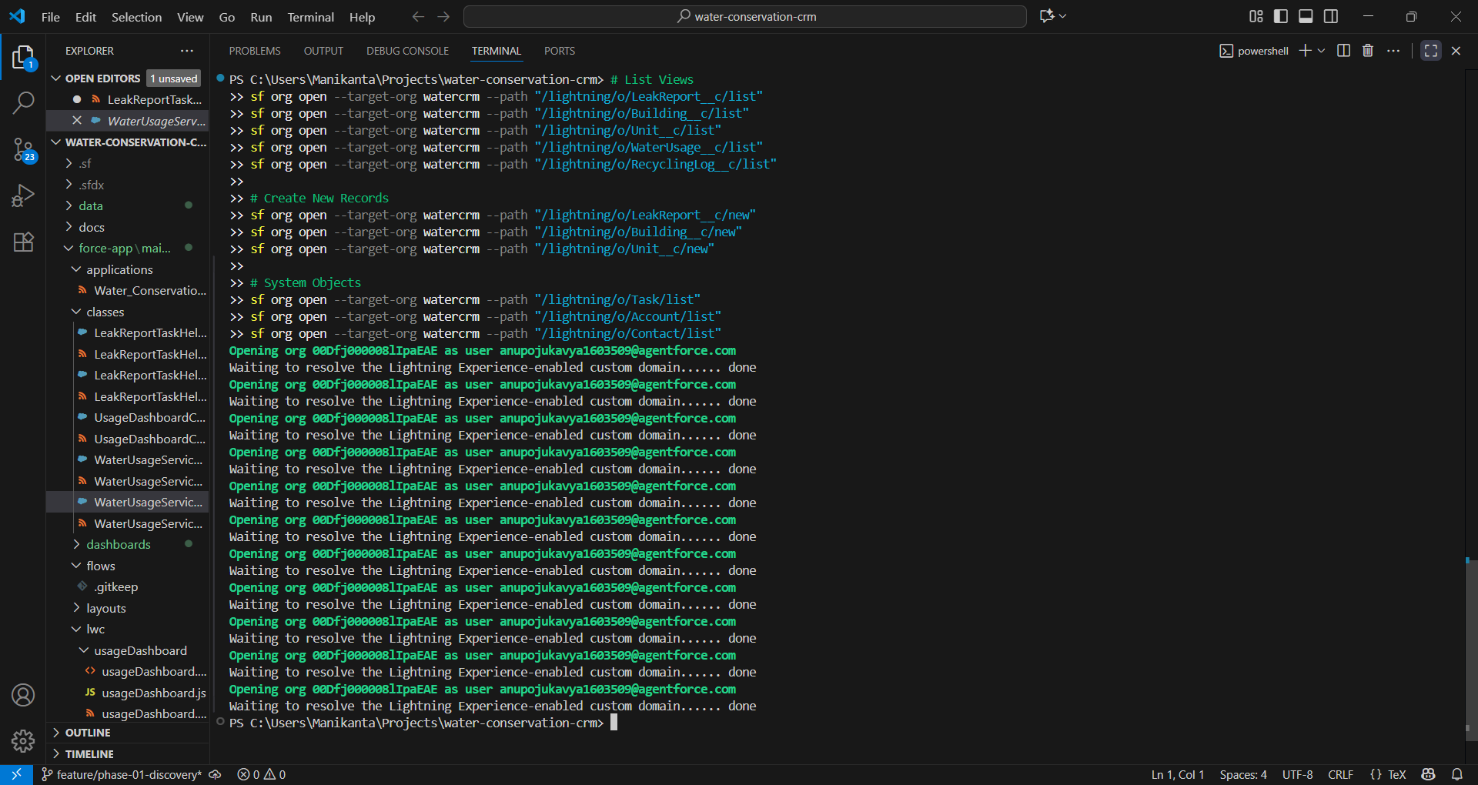

Phase 10: Quality Assurance Testing
Objective
Showcase the solution, validate outcomes against goals, and secure go-live approval.
Key Deliverables
- Demo script and scenario data
- Slide deck: objectives, approach, highlights, metrics, roadmap
- Live demo in sandbox or staging
- Go/No-Go checklist and sign-off
Activities
- Rehearse end-to-end flows: intake to savings reporting.
- Highlight usability, automation, integration, and analytics.
- Capture feedback; log follow-ups in backlog.
- Finalize release notes and support plan.
Roles
- Delivery Lead, Product Owner, SMEs, Executive Sponsor.
Acceptance & Exit Criteria
- Go-live approved with known issues documented and acceptable.
- Support model in place; hypercare schedule confirmed.
Checklist
- Demo data and script ready
- Sign-off received
- Release notes published
- Hypercare plan agreed

Governance, Security & Compliance
- Governance: Steering committee cadence; architecture/design reviews; change control board for production.
- Access: Principle of least privilege; permission set groups; field-level security review per object.
- Data protection: Encrypt sensitive fields; Shield (if licensed) for Platform Encryption, Event Monitoring.
- Compliance: Data retention policies; audit fields; consent tracking; legal holds process.
- Observability: Audit trails, login history monitoring, integration logs, error dashboards.

Quality, Testing, and Release Management
Testing Strategy
- Unit tests: Apex/services, LWC Jest tests, Flow test templates.
- Integration tests: API contract tests, event flow tests.
- UAT: Business scenario scripts with acceptance criteria.
- Performance: Data volume tests; query selectivity and Lightning Usage metrics.
Automation & Pipelines
- CI: Static analysis (PMD, ESLint), unit tests, packaging.
- CD: Manifest-based deploys, test level selection, post-deploy automation (assign perms, seed data).
- Release: Semantic versioning; release notes; feature toggles; maintenance windows.
Back-Out & Recovery
- Rollback plan per release; snapshot metadata; data backups; change freeze windows.
- Incident response: on-call ownership, comms templates, runbooks.

KPIs and Success Metrics
- Adoption: Weekly active users, time-on-task, report usage.
- Process: Lead/application cycle time, approval SLA adherence, first-pass yield.
- Data: Duplicate rate, validation error rate, completeness scores.
- Reliability: Deployment success rate, MTTR, defect escape rate.
- Impact: Estimated vs. verified water savings; program participation growth.

Appendices (Templates & Checklists)
A. Backlog Item Template
- User story, business value, acceptance criteria, dependencies, data changes, security impact, test notes.
B. Data Dictionary Template
- Object | Field Label | API Name | Type | Required | Help Text | Picklist Values | FLS | Validation | Owner.
C. Flow Naming Conventions
- RT_[Object][Purpose][When]; SCR_[Process][Step]; SUB[SharedLogic]_[Purpose].
- Version notes in description; guardrails documented.
D. Apex Standards
- One trigger per object → handler; service/selector/domain layers.
- Bulkify; no hard-coded IDs; custom metadata for constants; error handling patterns.
- Tests with factories; SeeAllData=false; descriptive assertions.
E. LWC Standards
- SLDS usage; wire adapters with caching; LDS preferred; error boundaries; accessibility checklist.
F. Integration Contract Template
- Endpoint, verb, auth, rate limits, request/response schema, error model, retries, idempotency, security, versioning.

G. Deployment Checklist
- Pre: PR approvals, tests green, release notes, feature flags.
- During: Deploy manifest, run post-deploy scripts, assign perms, smoke tests.
- Post: Monitor logs, reconcile data, enable flags, stakeholder comms.
H. UAT Script Template
- Scenario, preconditions, steps, expected results, data set, pass/fail, comments.
I. Security Review Pre-Check
- MFA/SSO enforced; no hard-coded secrets; CSP headers; clickjack protection; CRUD/FLS in Apex; REST endpoints authenticated/authorized; logging without PII leakage.
Notes
- This playbook is designed to be tailored to program-specific needs. Keep it current by updating phase deliverables and checklists as the program evolves.
