**WEEK_2_JUnit Testing Exercises**

**Exercise 1: Setting Up Junit**

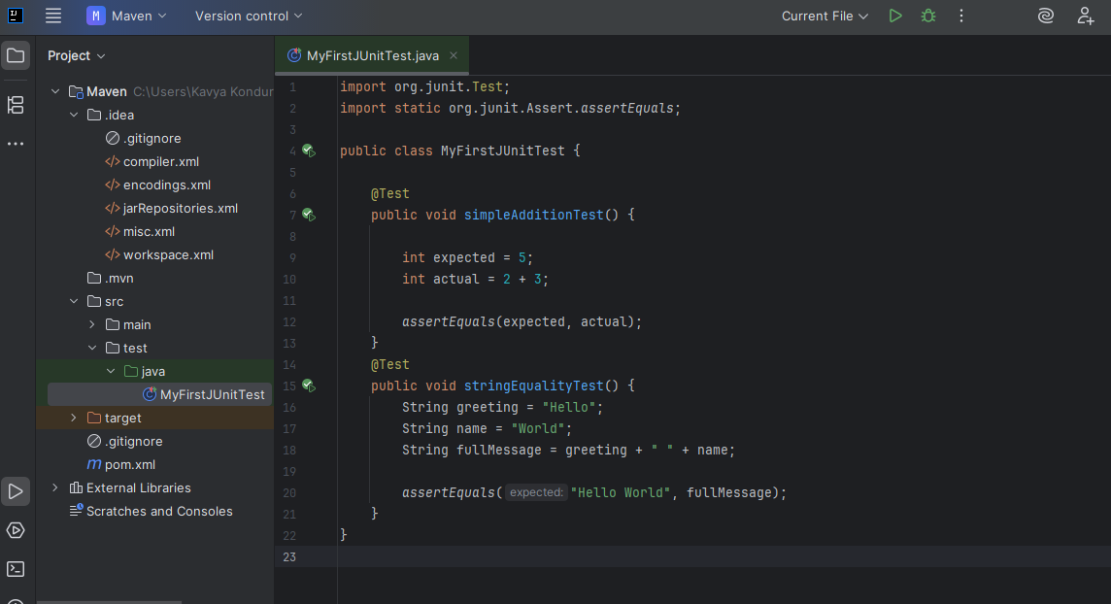

**OUTPUT:**

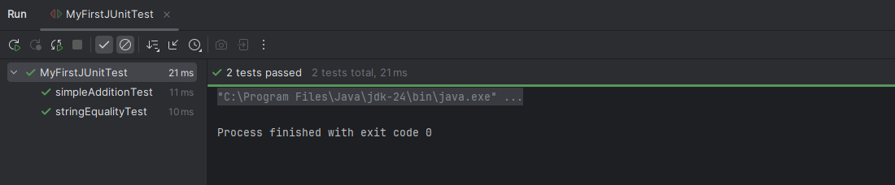

**Exercise 3: Assertions in JUnit** 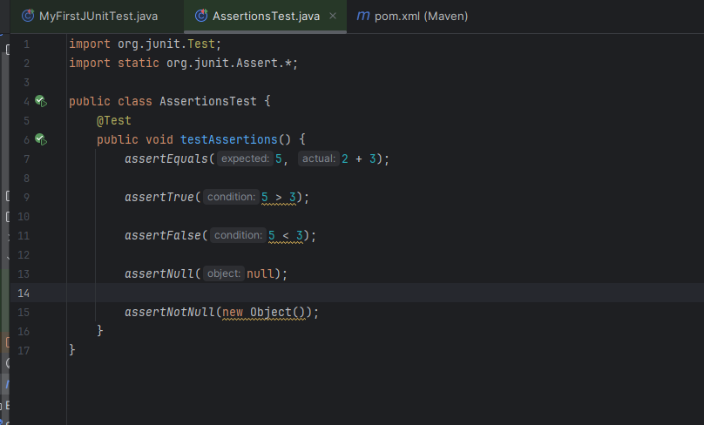

**OUTPUT:**

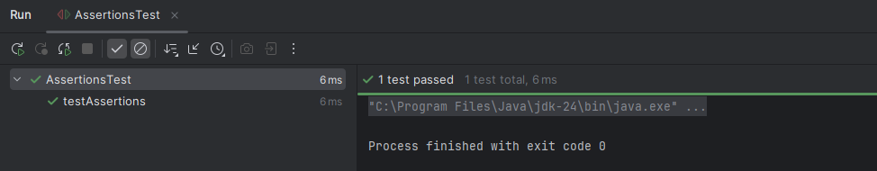

**Exercise 4: Arrange-Act-Assert (AAA) Pattern, Test Fixtures, Setup and Teardown Methods in Junit.**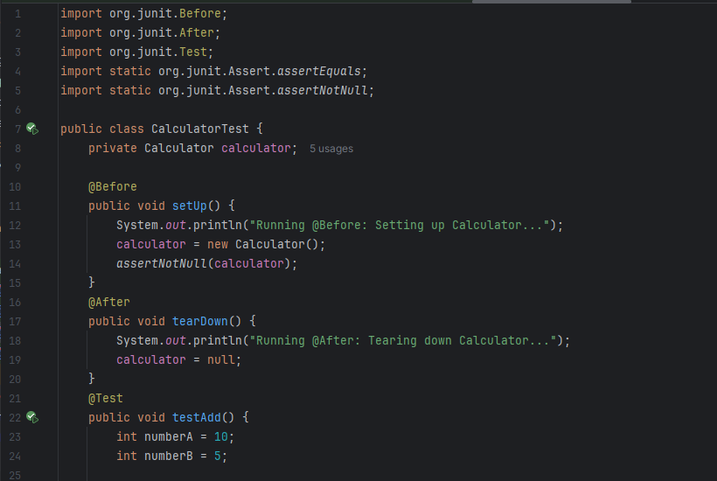

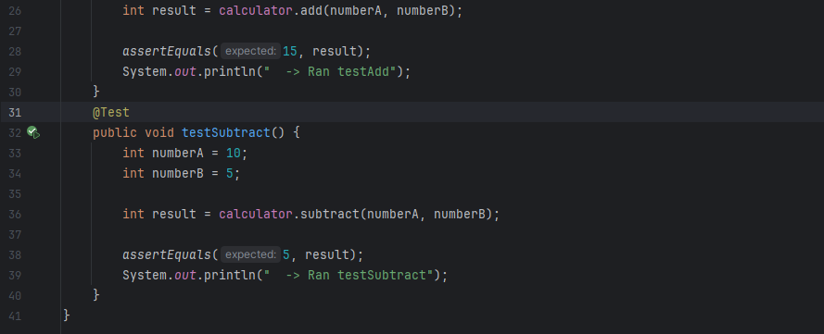

**OUTPUT:**

