**WEEK2_MOCKITO_EXERCISES**

**Exercise 1: Mocking and Stubbing Scenario:**

**You need to test a service that depends on an external API. Use Mockito to mock the external API and stub its methods.**

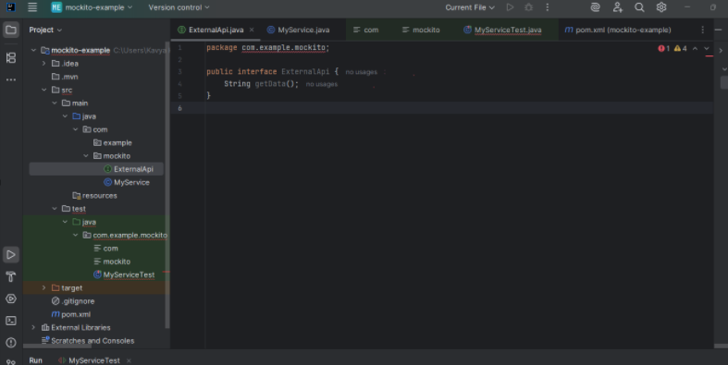

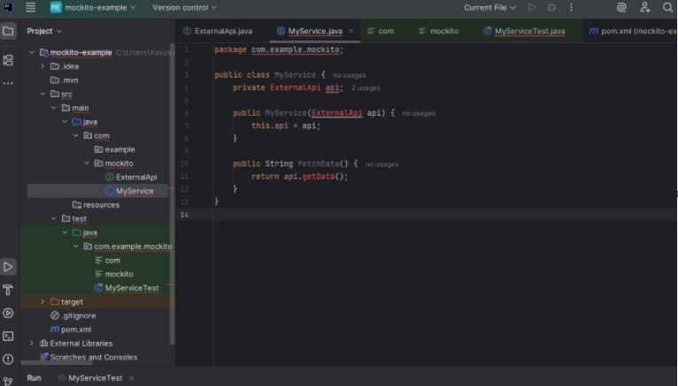

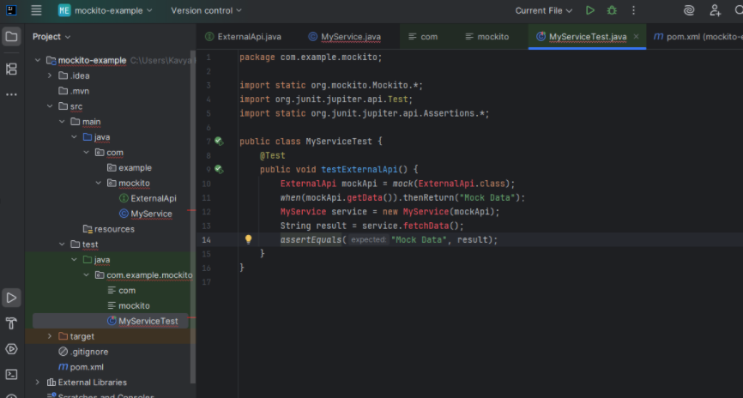

**OUTPUT:**

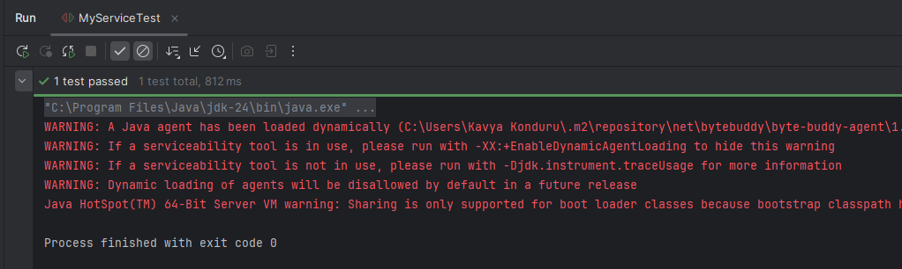

**Exercise 2: Verifying Interactions**

**Scenario: You need to ensure that a method is called with specific arguments. Steps:**

**1. Create a mock object.**

**2. Call the method with specific arguments.**

**3. Verify the interaction.**

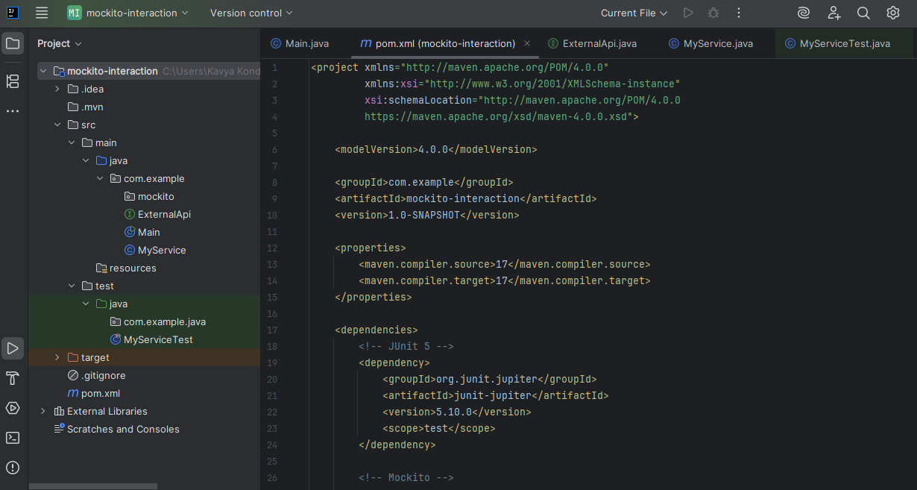

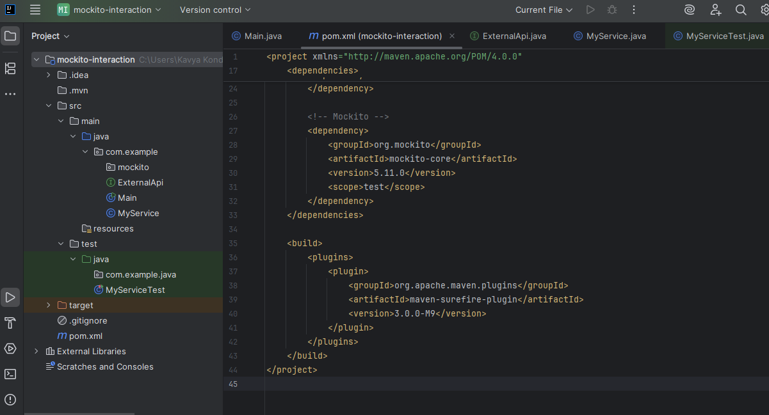

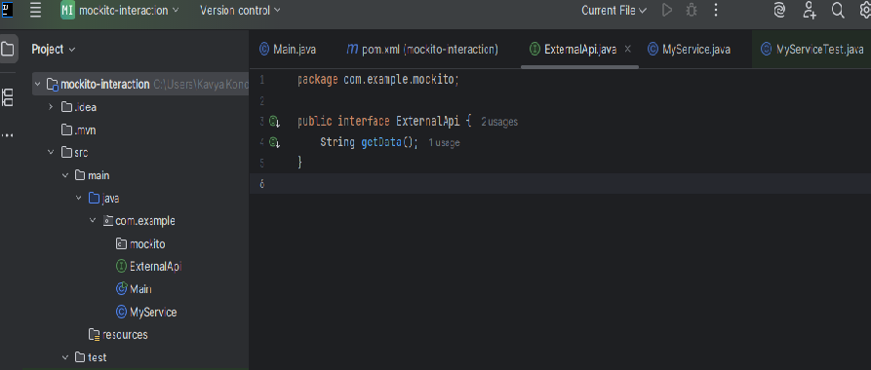

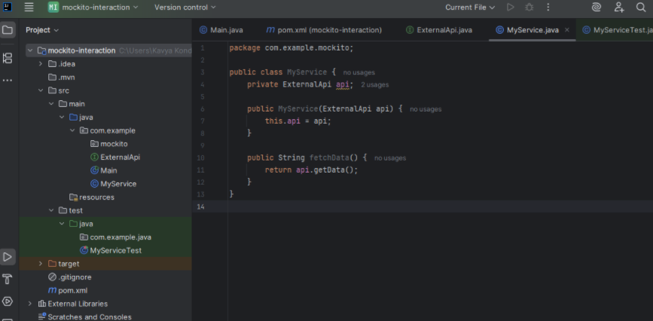

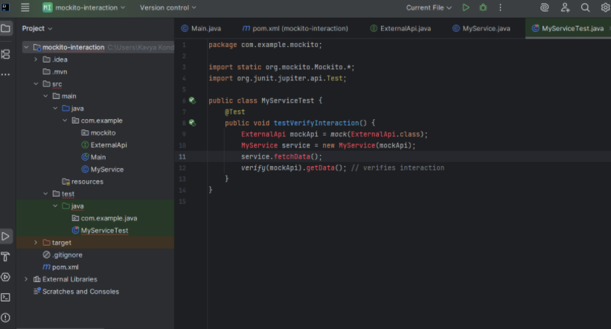

**OUTPUT:**

