**WEEK2_SL4J Logging exercises**

**Exercise 1: Logging Error Messages and Warning Levels Task: Write a Java application that demonstrates logging error messages and warning levels using SLF4J.**

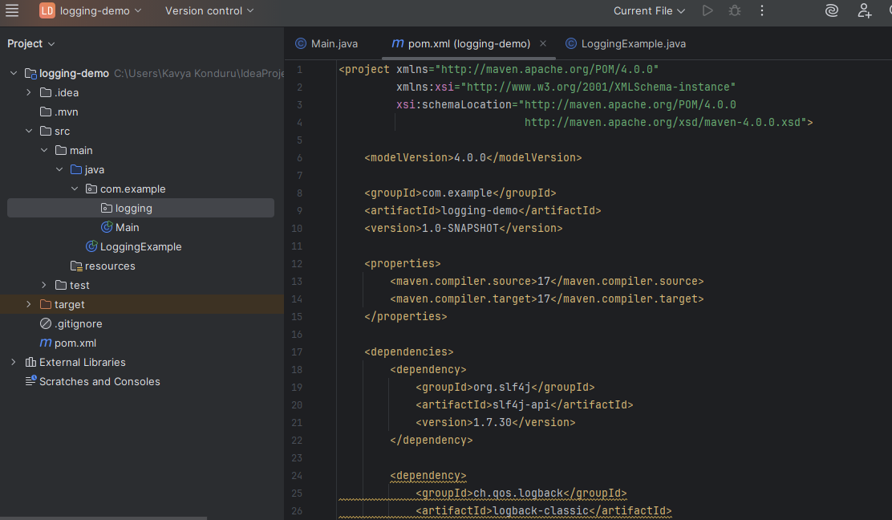

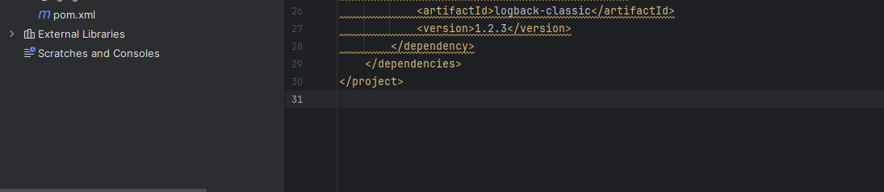

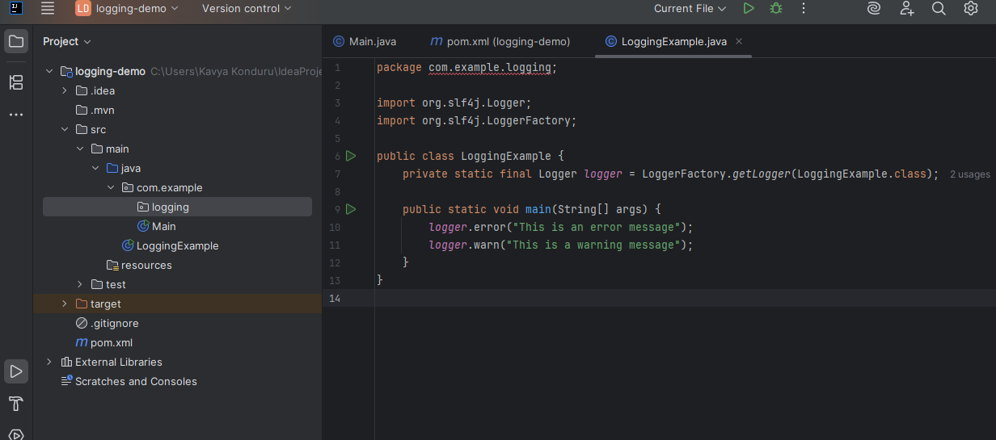

**OUTPUT:**

