**WEEK_3_SPRING-DATA-JPA-HANDSON**

**QUICK_EXAMPLE:**

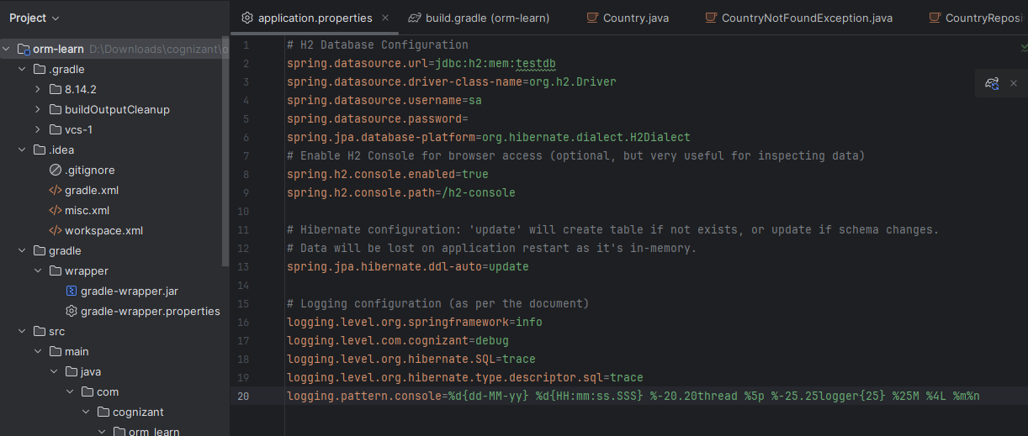

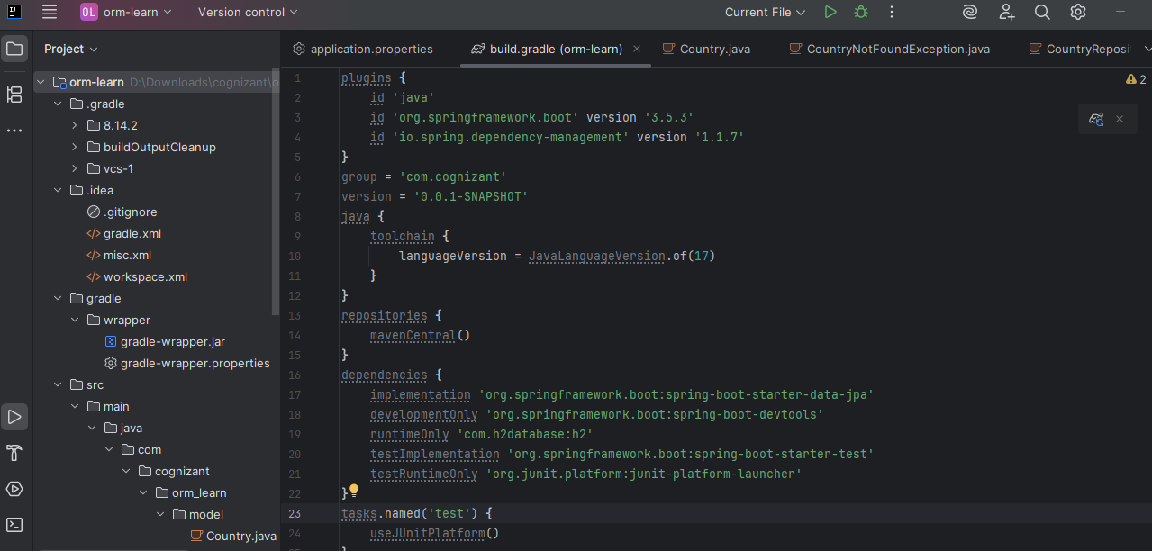

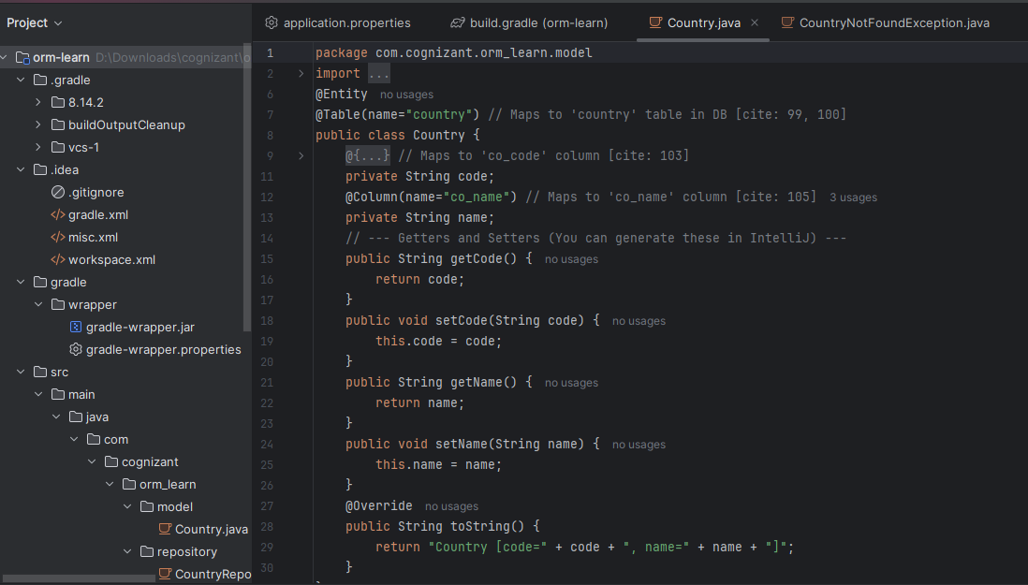

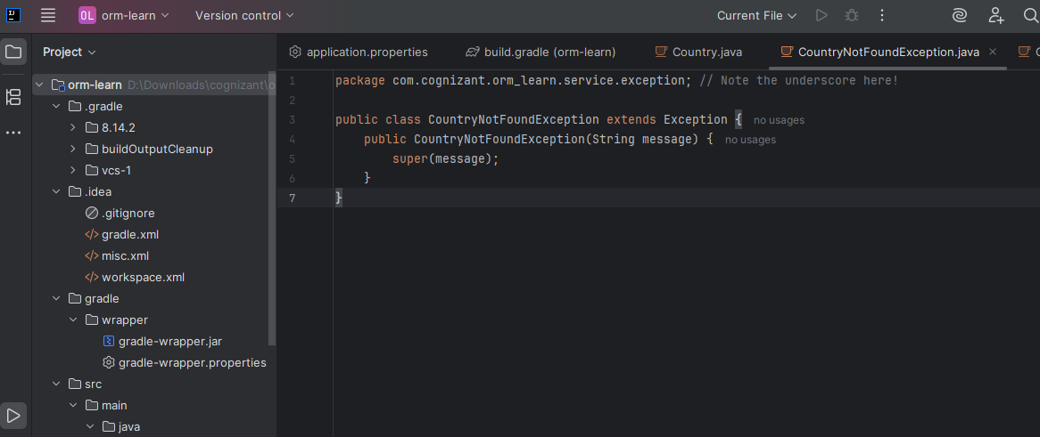

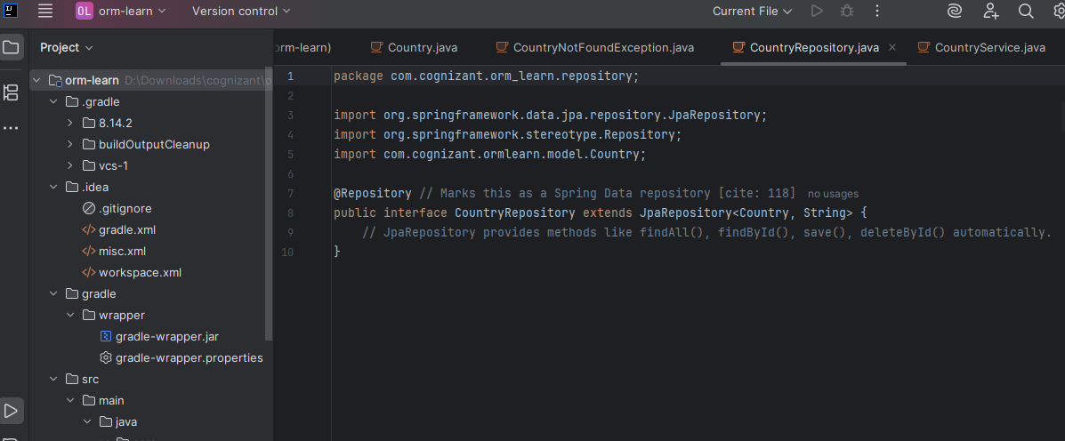

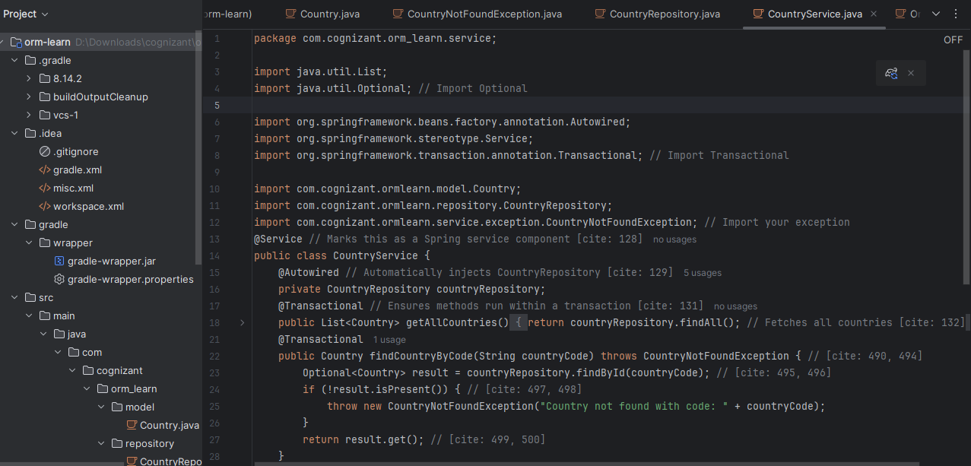

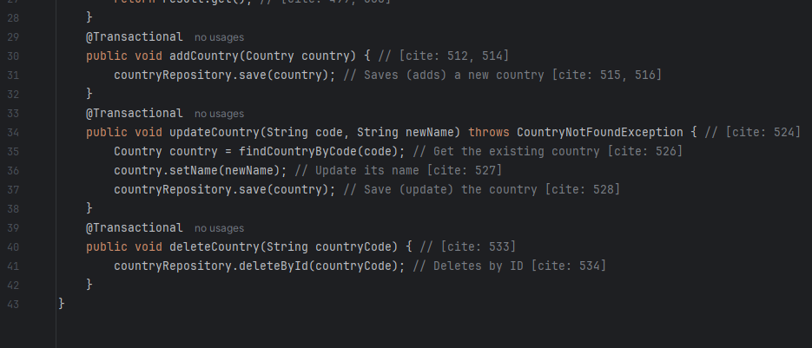

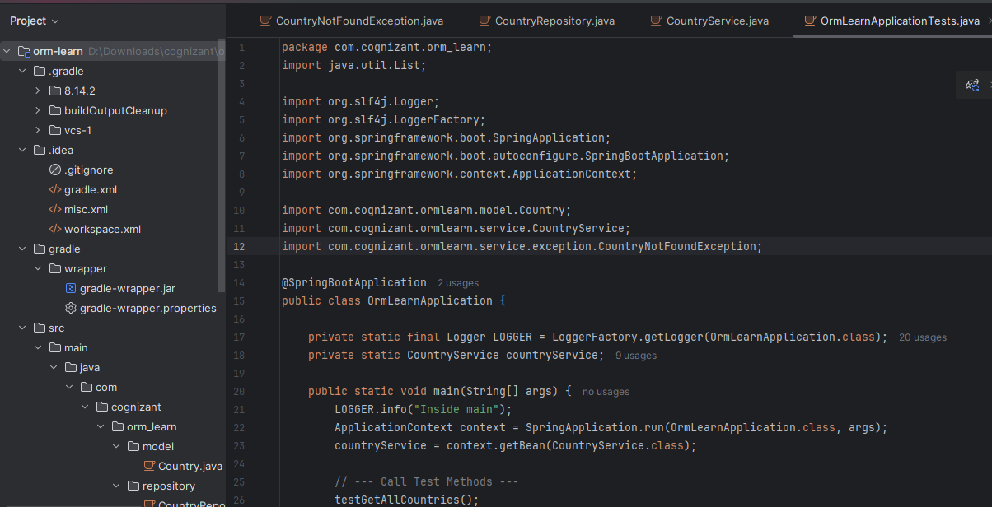

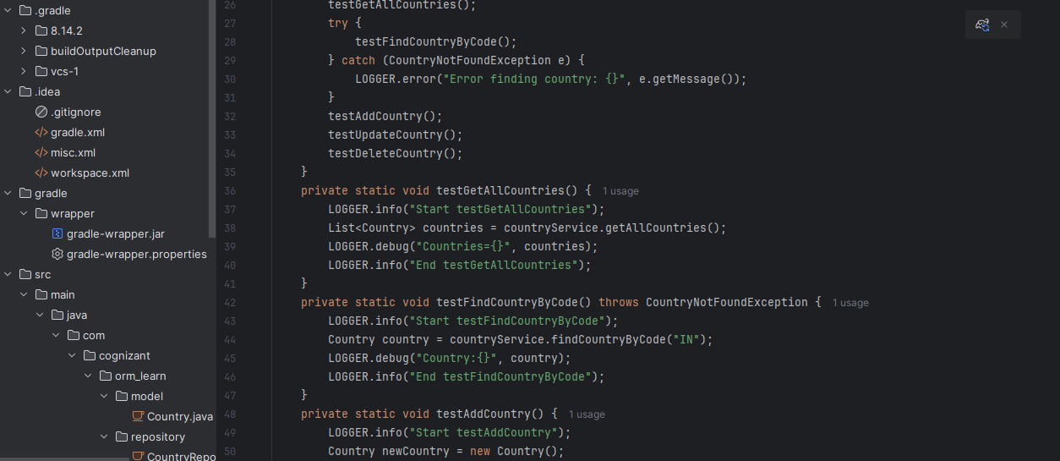

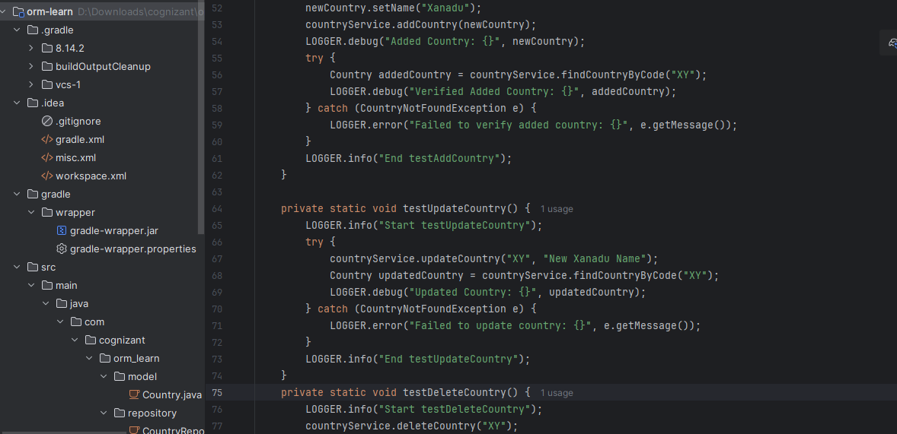

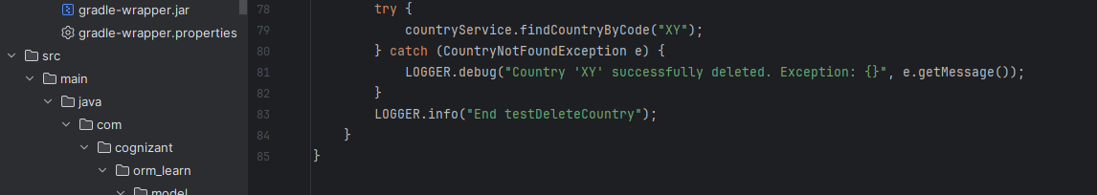

**OUTPUT:**

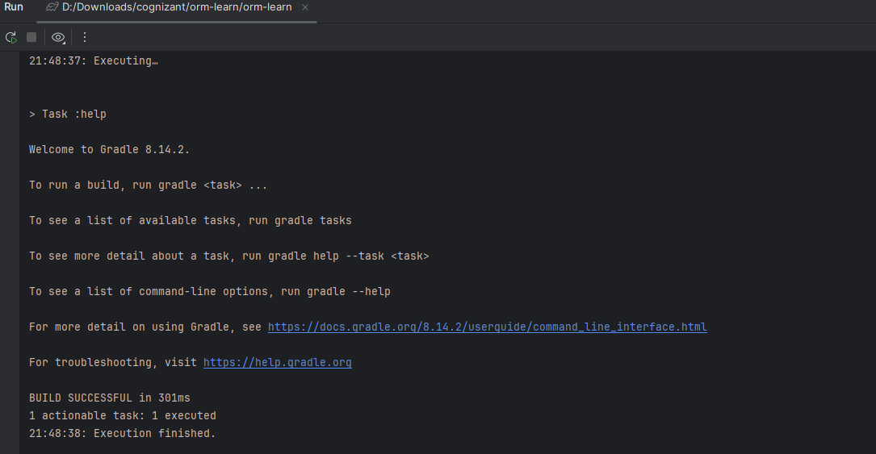

**Difference between JPA, Hibernate and Spring Data JPA**

|  |  |  |
| --- | --- | --- |
| JPA | **Hibernate** | **Spring Data JPA** |
| **Standard annotations (@Entity, @Id, @GeneratedValue, etc.)** | **Implements JPA**  **Offers native** | **Eliminates boilerplate for repository creation** |
| **Entity lifecycle management** | **Offers native features beyond JPA like:**   * **Caching (1st & 2nd level)** | **Spring Data JPA supports interface-based projections** |
| **Query language: JPQL (Java Persistence Query Language)** | * **Lazy/Eager fetching customization** | **Provides CrudRepository, JpaRepository, PagingAndSortingRepository** |
| **Basic CRUD operations** | * **Criteria API** | **Supports method query derivation (e.g., findByName)** |
| **Transaction management via EntityManager** | * **Interceptors, Filters, Batch processing** | **Easy integration with Spring Boot** |
| **JPA is just a specification — like a set of rules or guidelines** | **Hibernate is an implementation of JPA — it follows JPA rules but also adds its own features.** | **Built on top of JPA and typically uses Hibernate under the hood.** |
| **It defines how Java objects map to database tables.** | **Offers additional power: caching, HQL, filters, interceptors, etc.** | **Helps you avoid writing boilerplate code like EntityManager and queries.** |
| **It uses interfaces like EntityManager but doesn't do the actual work.** | **Can work with or without JPA.** | **You define interfaces; Spring auto-creates the repository code.** |
| **Needs an implementation like Hibernate to function.** | **Has its own configuration (hibernate.cfg.xml) and annotations.** | **Supports query methods like findByEmail(), pagination, sorting, etc.** |
| **Supported by many vendors (Hibernate, Eclipse Link, OpenJPA)** | **Widely used and mature ORM solution.** | **Works best with Spring Boot for rapid app development.** |

**SUBMITTED BY-**

**KONDURU KAVYA**

**6374347**