CONTACT

RAMISETTI KAVYA SRI



VATTIKUTI VARI STREET, NEAR N.T.R.PARK TANUKU TANUKU WEST GODAVARI DISTRICT ANDHRA PRADESH 534211

 9676693277

 [Kavyasrir](mailto:Kavyasriramisetti@gmail.com)[amisetti@gmail.com](mailto:amisetti@gmail.com)

OBJECTIVE

I seek challenging opportunities where I can fully use my skills for the success of the organization.

EDUCATION

2018

2018-2020

2020-2024



Bhashyam Public School

Ssc 77%



Pragathi Junior College

Intermdiate 63%



Sri Vasavi Engineering College

B-Tech

SKILLS

C

C±±

Java Python

PROJECTS



Music with voice recognition



ACHIEVEMENTS & AWARDS

Course completion certiﬁcate from AWS Academy cloud foundations

INTERESTS

Crafts

Photography

ACTIVITIES

Participated in the event 24 Hrs HACKTHON -”HACKOVERFLOW"

LANGUAGES

Telugu English



ADDITIONAL INFORMATION

DATE OF BIRTH : 17-04-2002 FATHER'S NAME: SUMAN NATIONALITY : India

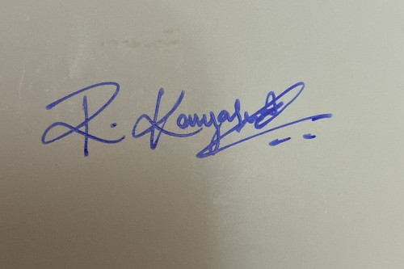

RAMISETTI KAVYA SRI