This is the screen of where we can see latitude and longitude.

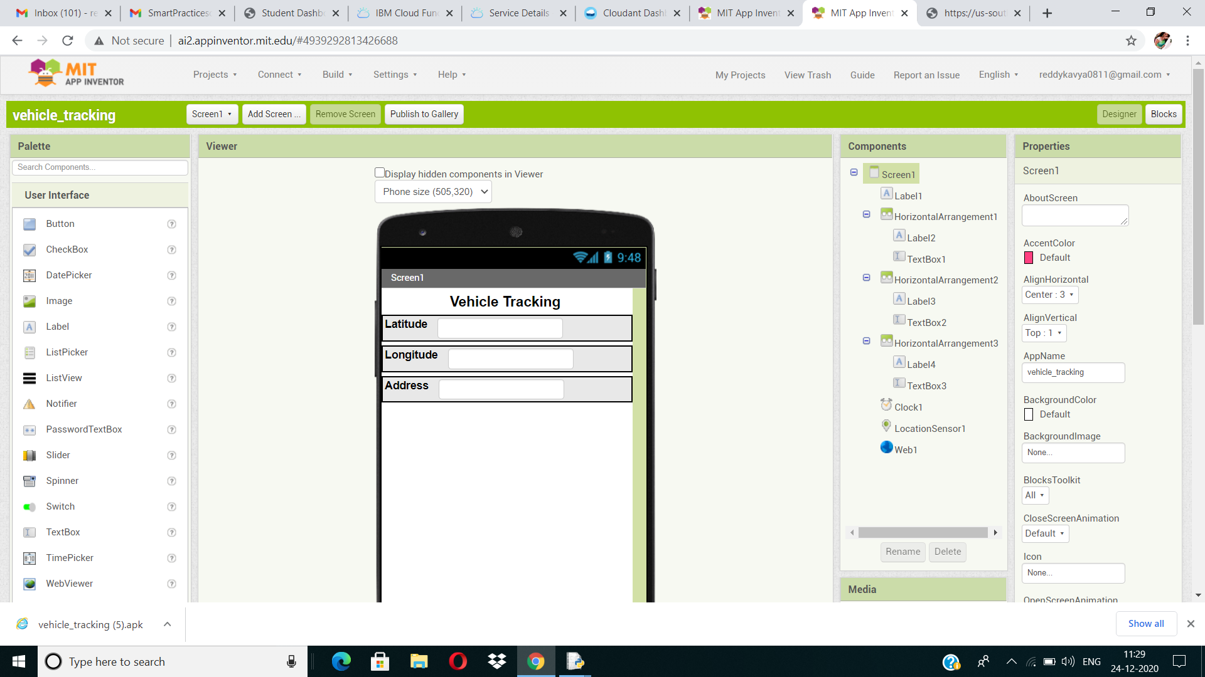

In this screen we can see what kind of blocks I have used.

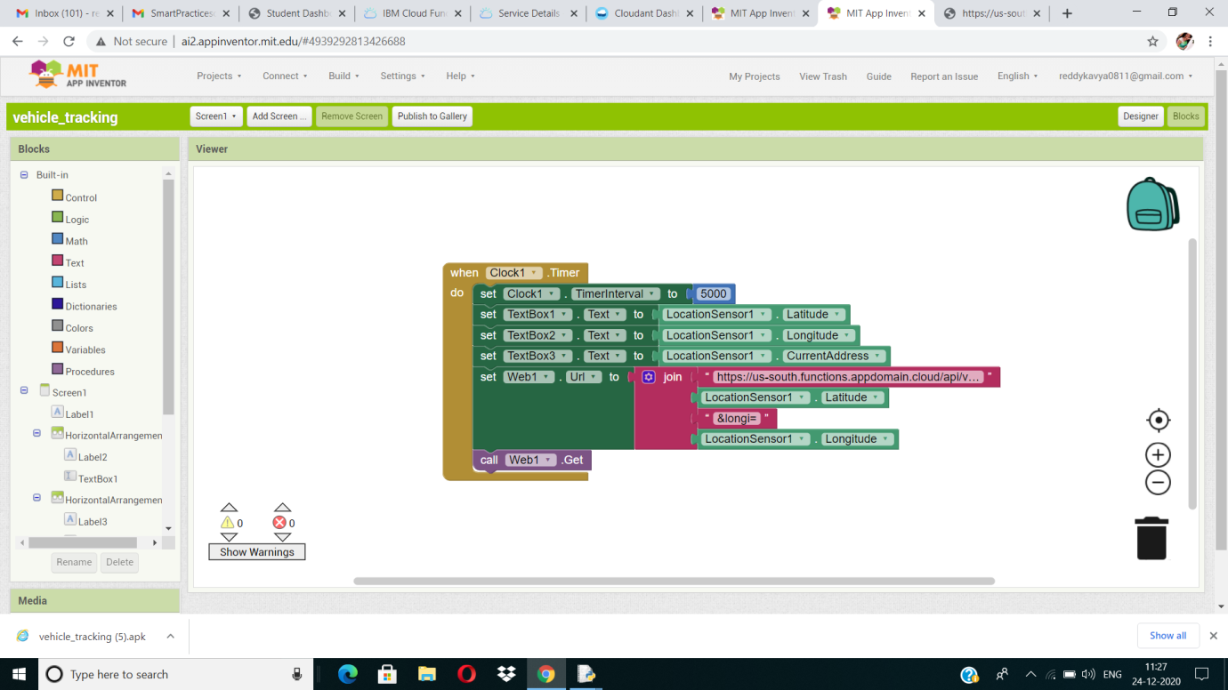

Below screenshot is taken from my phone. We can see latitude and longitude positions right now.

