Experiment 6
Title
Hospital Information System for SIMATS Hospital using Zoho Forms (SaaS)

Aim
To create a cloud-based Hospital Information System using the SaaS model for storing and managing patient information online.

Objective
- To understand the SaaS cloud computing model.
- To create an online patient registration form.
- To store patient records securely in the cloud.
- To access patient details from any device with internet connectivity.
Cloud Service Provider
Zoho Forms (SaaS)

Step 4: Form Settings
- Make required fields mandatory.
- Enable email notifications (optional).
- Save the form.

Step 5: Publish
Click Publish and copy the public link.

Steps to Create the Application

Step 1: Sign Up
- Open Zoho Forms.
- Create a free account or sign in.

Step 2: Create a New Form
- Click Create Form. • Select Blank Form.
- Name the form:
SIMATS Hospital Information System
OUTPUT
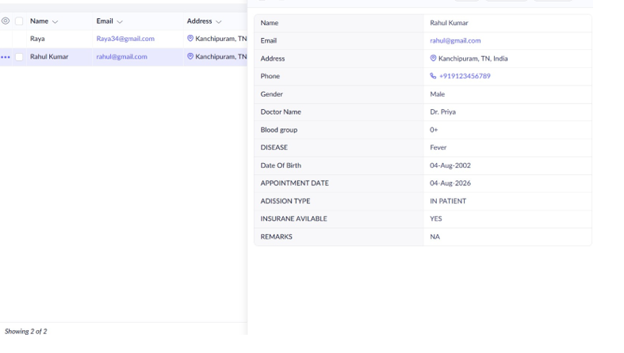

Result
A cloud-based Hospital Information System for SIMATS Hospital was successfully created using Zoho Forms, demonstrating the SaaS (Software as a Service) cloud model. Patient details such as name, age, address, phone number, email, attender details, doctor name, and disease information were collected, stored, and managed online through the cloud.

