Aim

To create a simple cloud-based software application and provide it as a service using a Cloud Service Provider, thereby demonstrating the Software as a Service (SaaS) model.

Procedure
Open Zoho Creator and create/sign in to an account.
Create a new application using the Blank Application option.
Name the application Student Information System.
Create a form named Student Details.
Add fields such as Student Name, Register Number, Department, Year, Email, Phone Number, and Address.
Add sample student information and submit the form.
The entered data is stored and managed on the cloud platform.
Open the application through a web browser to verify that the application is available as an online service.
Thus, the software is provided to users over the Internet without requiring local installation.
OUTPUT
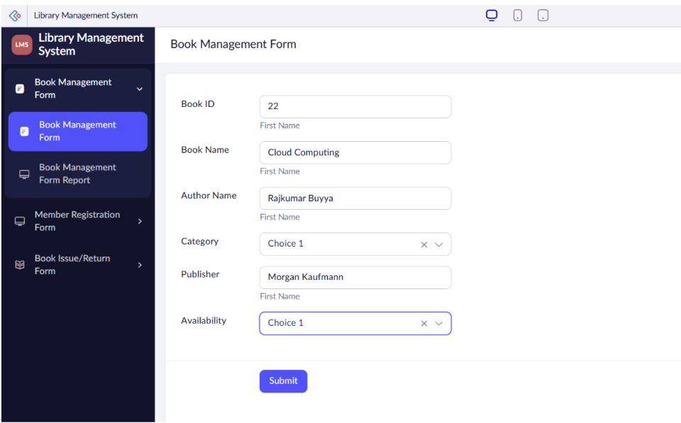
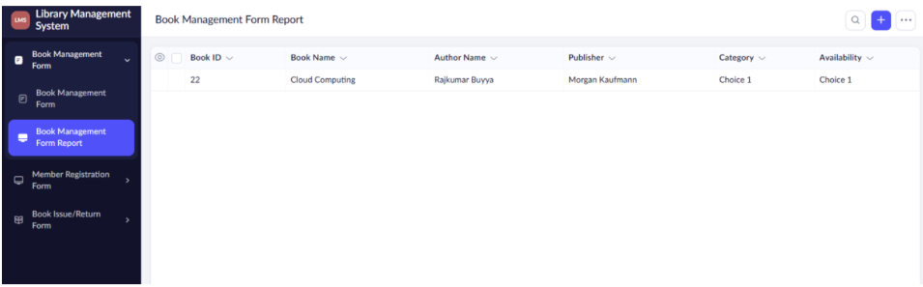

Result
The Student Information System was successfully created and deployed using Zoho Creator. The application was accessed through the Internet and data was stored on the cloud, successfully demonstrating the Software as a Service (SaaS) model.

