Aim
To create a simple cloud-based Flight Reservation System using a Cloud Service Provider and provide it as an online service to demonstrate the Software as a Service (SaaS) model.
Procedure
- Open Zoho Creator and sign in or create an account.
- Create a new application using the Blank Application option.
- Name the application Flight Reservation System.
- Create a form named Flight Booking Details.
- Add the following fields:
  - Passenger Name
  - Age
  - Gender
  - Phone Number
  - Email
  - Flight Number
  - Source
  - Destination
  - Travel Date
  - Class
  - Number of Tickets
- Create dropdown options for Class, such as Economy, Premium Economy, and Business.
- Enter sample passenger and flight booking details.
- Submit the form and verify that the booking information is stored in the cloud.
- Publish/access the application through a web browser.
- The application can now be used online without installing the software on the user's computer, demonstrating SaaS.
OUTPUT
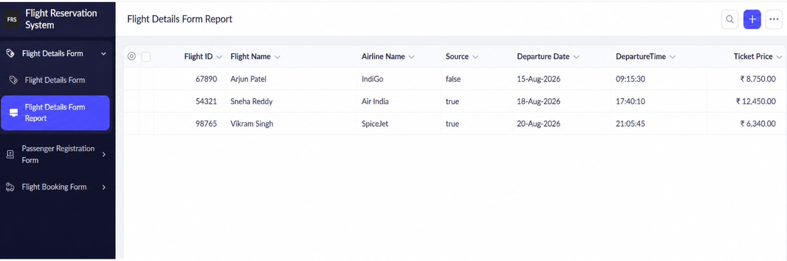

Result
The Flight Reservation System was successfully created and deployed using Zoho Creator. The application stores flight reservation details on the cloud and can be accessed through the Internet, thereby successfully demonstrating the Software as a Service (SaaS) model

