EXPERIMENT-3
Create a simple cloud software application for Property Buying &amp; Rental process (In Chennai city) using any Cloud Service Provider to demonstrate SaaS.
Aim
To create a simple cloud-based Property Buying and Rental System for Chennai City using a Cloud Service Provider and demonstrate the Software as a Service (SaaS) model.
Procedure
- Open Zoho Creator and sign in to your account.
- Create a new application using the Blank Application option.
- Enter the application name as Property Buying & Rental System – Chennai.
- Create a Property Details Form.
- Add fields for property ID, property name, property type, buying/rental option, location, owner details, contact number, price/rent, BHK, area, and availability status.
- Create a Client Registration Form to collect customer details and property requirements.
- Add Chennai locations to the location field.
- Create a Property Listings Report to display the properties stored in the application.
- Enter the required property and client details into the forms.
- Save and publish the application on the cloud.
- Access the application through a web browser using the provided application link.
- Verify that the property information can be stored, viewed, and managed online.
- Thus, the application is provided to users through the Internet without requiring local installation, demonstrating Software as a Service (SaaS
OUTPUT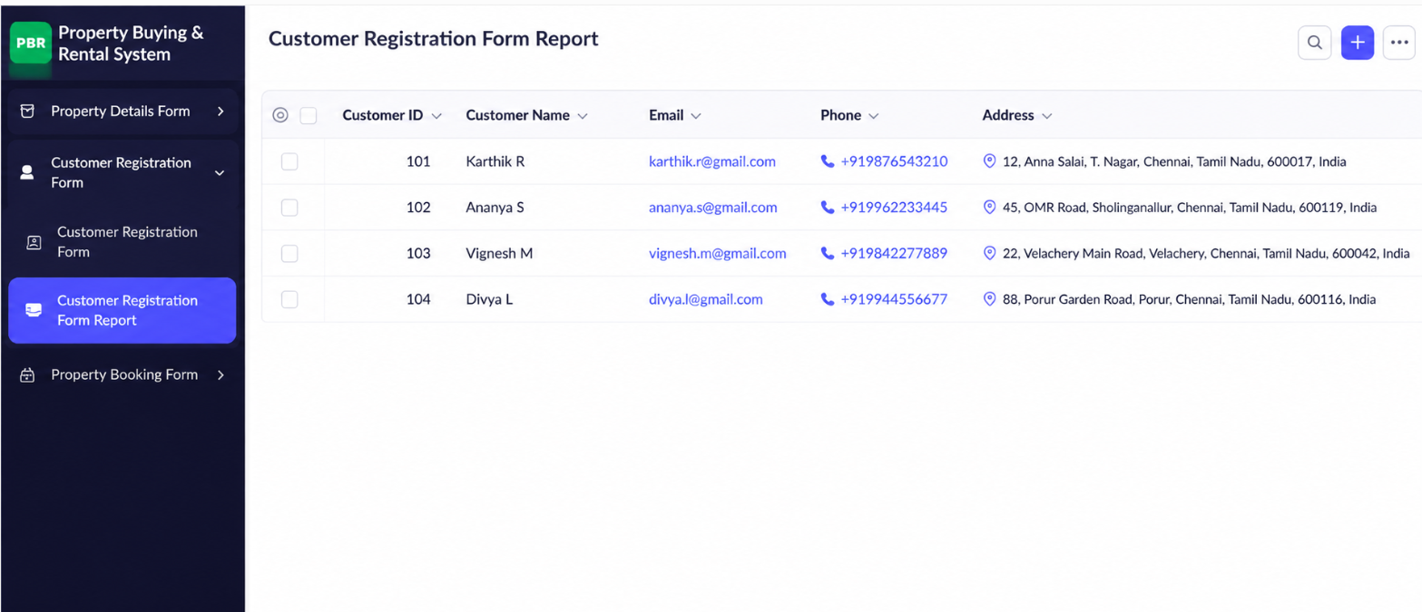

Result
The Property Buying & Rental System for Chennai City was successfully created using Zoho Creator. Property and client details were stored and managed on the cloud, and the application was accessed through the Internet without local installation, successfully demonstrating the Software as a Service (SaaS) model.

