EXPERIMENT-4
Create a simple cloud software application for Car Booking Reservation System using any Cloud Service Provider to demonstrate SaaS.
Aim
To create a simple cloud-based Car Booking Reservation System using a Cloud Service Provider and demonstrate the Software as a Service (SaaS) model.
Procedure
- Open Zoho Creator and sign in to your account.
- Create a new application using the Blank Application option.
- Enter the application name as Car Booking Reservation System.
- Create a Car Details Form.
- Add fields for Car ID, Car Name, Car Model, Car Type, Registration Number, Rental Price, and Availability Status.
- Create a Customer Registration Form to collect customer details.
- Add fields for Customer Name, Phone Number, Email, Address, and Driving Licence Number.
- Create a Car Booking Form to record booking information.
- Add fields for Booking ID, Customer Name, Car Name, Booking Date, Pickup Date, Return Date, Number of Days, Total Amount, and Payment Status.
- Create a Booking Report to display and manage the submitted booking records.
- Enter the required car, customer, and booking details into the respective forms.
- Save and publish the application on the cloud.
- Access the application through a web browser.
- Verify that car details, customer information, and booking records can be stored and managed online.
- Thus, the application is provided through the Internet without requiring local installation, demonstrating Software as a Service (SaaS).
OUTPUT
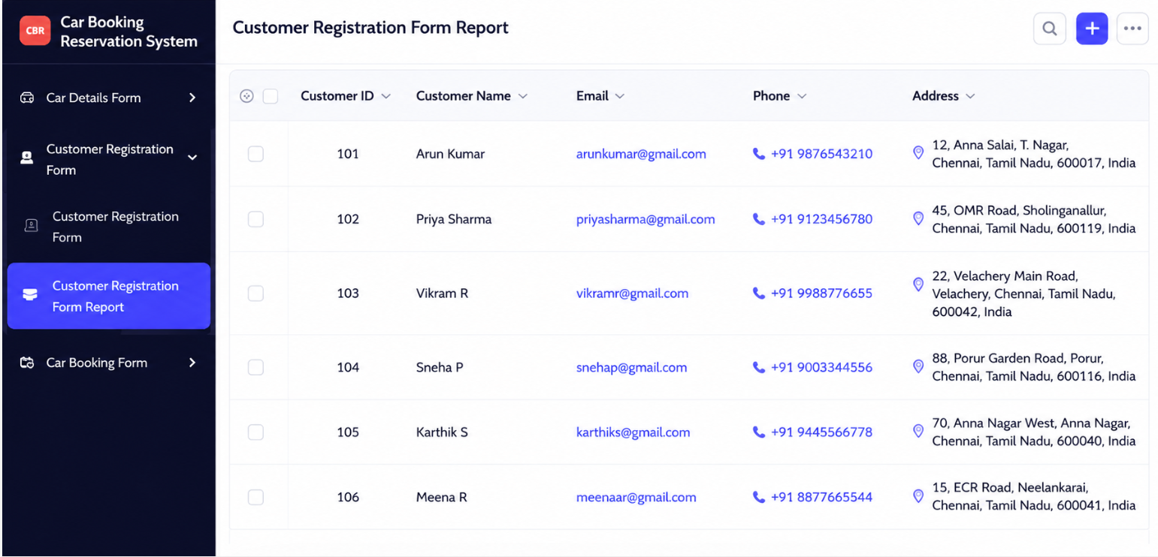

Result
- The Car Booking Reservation System was successfully created and deployed using Zoho Creator. The application stores and manages car, customer, and booking details on the cloud and can be accessed through the Internet, thereby successfully demonstrating the Software as a Service (SaaS) model.

